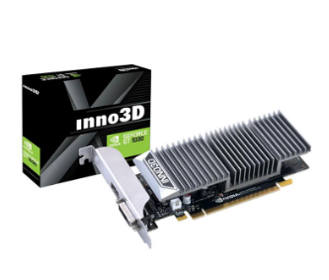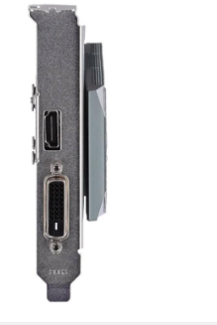

# INNO3D GEFORCE GT 1030 - 2GB GDDR5 (N1030-1DDV-E5BL)

Output: DVI x 1, HDMI x 1

Memory Size: 2GB

Memory Type: GDDR5

Bus Interface: PCI Express 3.0

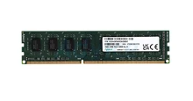

ควรจะมีแรมขั้นต่ำ 8GB