Problem Statement

- Identify aspects that will enable the Lending Club to ascertain whether prospective clients will default on a loan or not

Tool used for Data Cleaning and EDA
- Power BI Desktop was primarily used to undertake the EDA and data cleaning. Python was also employed, but it was mainly used to practice concepts taught and my confidence in the same is low

Data Cleaning

- The data was checked and the following issues were observed:-

  - Tenure of loan should be a number, thus 'months' has to be removed
  - Value of interest should be a number,'%' has to be removed
  - Employment length should be a number, '<,>, years, etc' is to be removed
  - NA in many places indicates that data is not available/ relevant and therefore was replaced with ‘null’

Identification and Analysis of Critical Variables

- The following columns were primarily analysed for resolving the problem statement:-

  - Status of Loan (loan_status). This was the primary column that indicated the quantum of fully paid loans (good customers) and the Charged Off (defaulters) loans.

  - Loan ID & Member ID (id, member_id). These unique identifiers were records of the loan and member. Analysis (flter and sorting) revealed that these IDs were uique and not repeated. The member IDs did not repeat indicating that no member had more than one loan ID against his/her name. Thus the loan ID was the ID used for comparative analysis. If the same analysis is done using member_id the results are same.

Univariate Analysis

- Overall, around 14% of loans are defaulted. This is univariate analysis based on count of entries marked ‘Charged Off’ in the loan status.
Fig 1. Analysis of loan_status

Bivariate Analyses

- The following variables/ aspects related to the loan were found to affect the loan status:-

  - Grade
    - Grade A, B, C cater for 70% of loans disbursed.
    - Grade D, E, F and G is minimum investment but has max default (>20%)
    - Grade A has best recovery
Fig 2. Analysis of loan_status wrt grade

  - Term. Loans between 5k – 10K with a loan term of 36months are more likely to be defaulted upon
Fig 3. Analysis of loan_status wrt term

  - Interest. Number of defaulters increase as interest rate increases.

Fig 4. Analysis of loan_status wrt interest

  - Instalments. Percentage of defaulters increases as instalment increases beyond 800
Fig 5. Analysis of loan_status wrt installments
  - Date of Issue of Loan. 50% of loan defaulters have been issued a loan in 2011
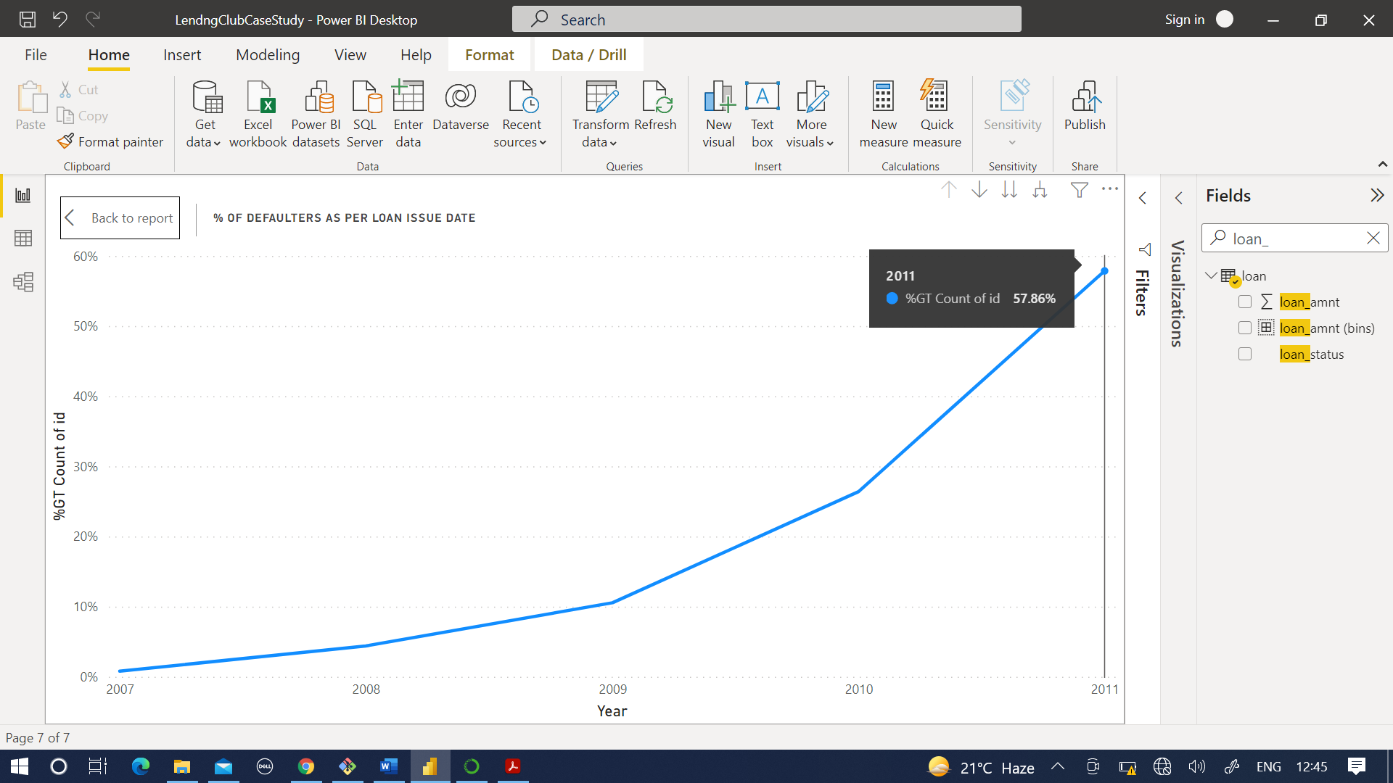
Fig 6. Analysis of loan_status wrt Date of Loan

  - Date of Last Payment. About 30% of defaulters have last paid only in 2012
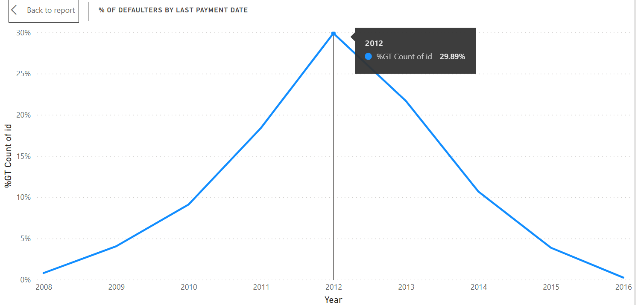
Fig 7. Analysis of loan_status wrt Date of Last Payment

- The following columns/ variables wrt Loan ID/Member ID were found to affect loan status

  - Employment Length. No significant changes in defaulters based on years of employment

  - Annual Inc. Defaulters drop sharply after annual inc of >60,000
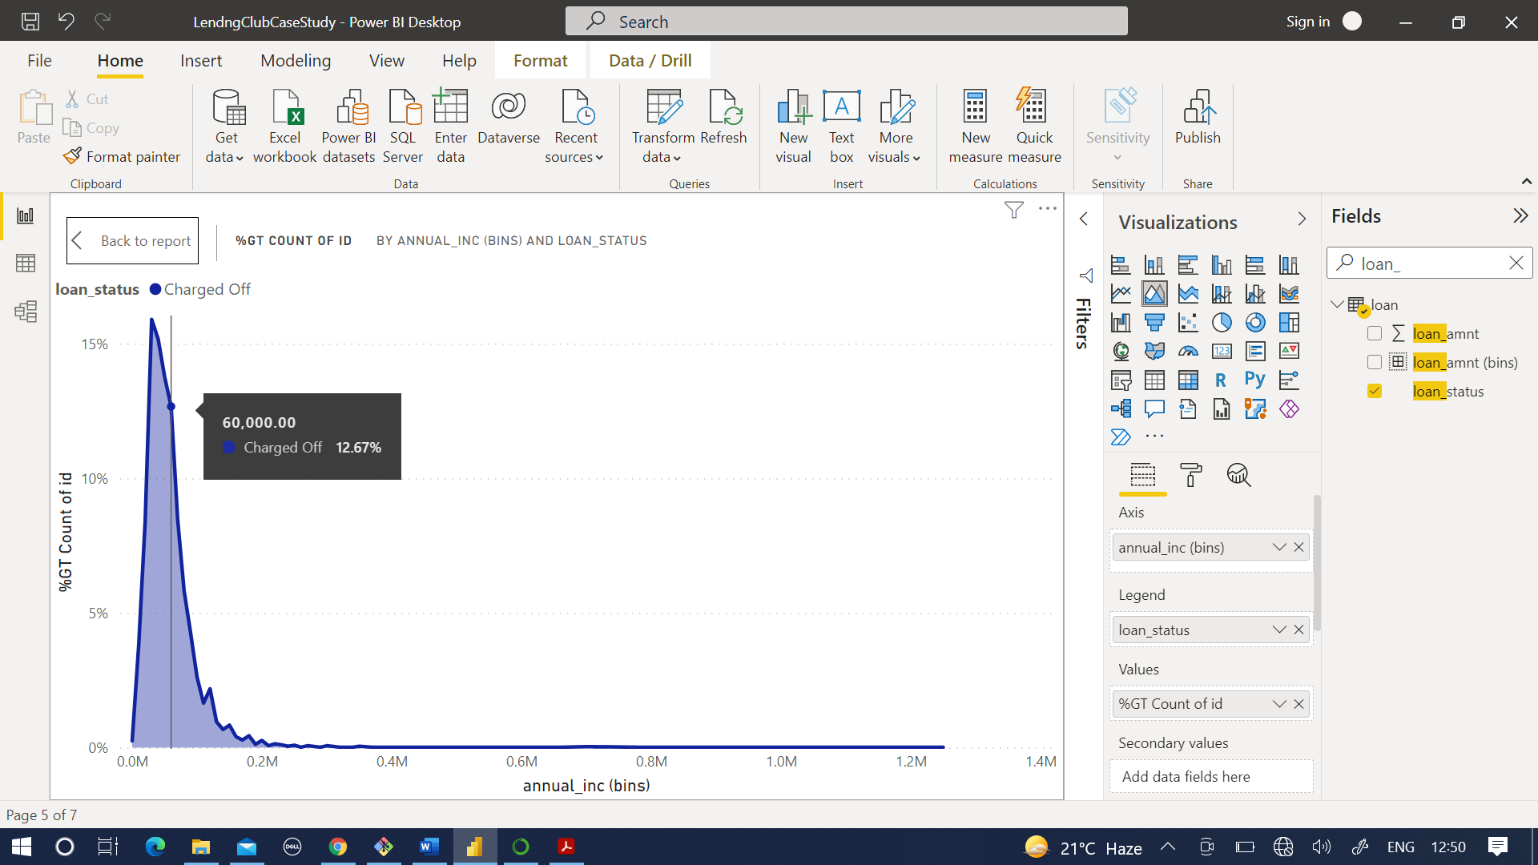
Fig 8. Analysis of loan_status wrt Annual Increment

  - Delinquency. The percentage of members defaulting on loan increases with higher number of delinquency counts

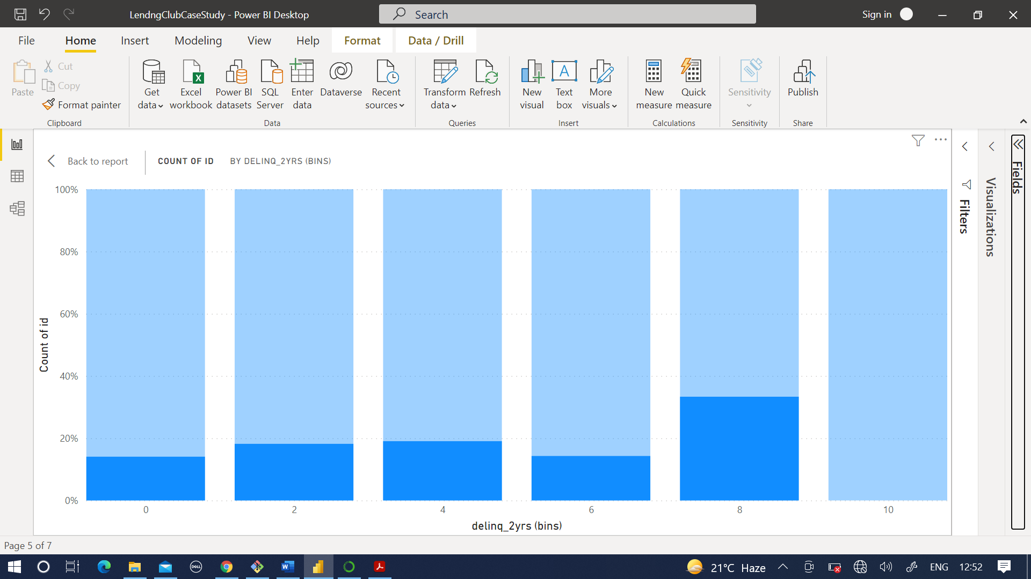
Fig 9. Analysis of loan_status wrt Delinquency

  - Home Ownership. Not much difference

  - Purpose.
    - 53% of loan amount is for debt consolidation
    - >18% of loans for Small Business and Renewable Energy have defaulted
Fig 10. Analysis of loan_status wrt Purpose of Loan

  - Area of Residence. People from NV, AK, SD, NE have a hgher percentage of defaulters (>18%)
Fig 11. Analysis of loan_status wrt State of Residence
  - Open Acc / Total Acc. 26% of members with more than 30 accounts defaulted on the loan
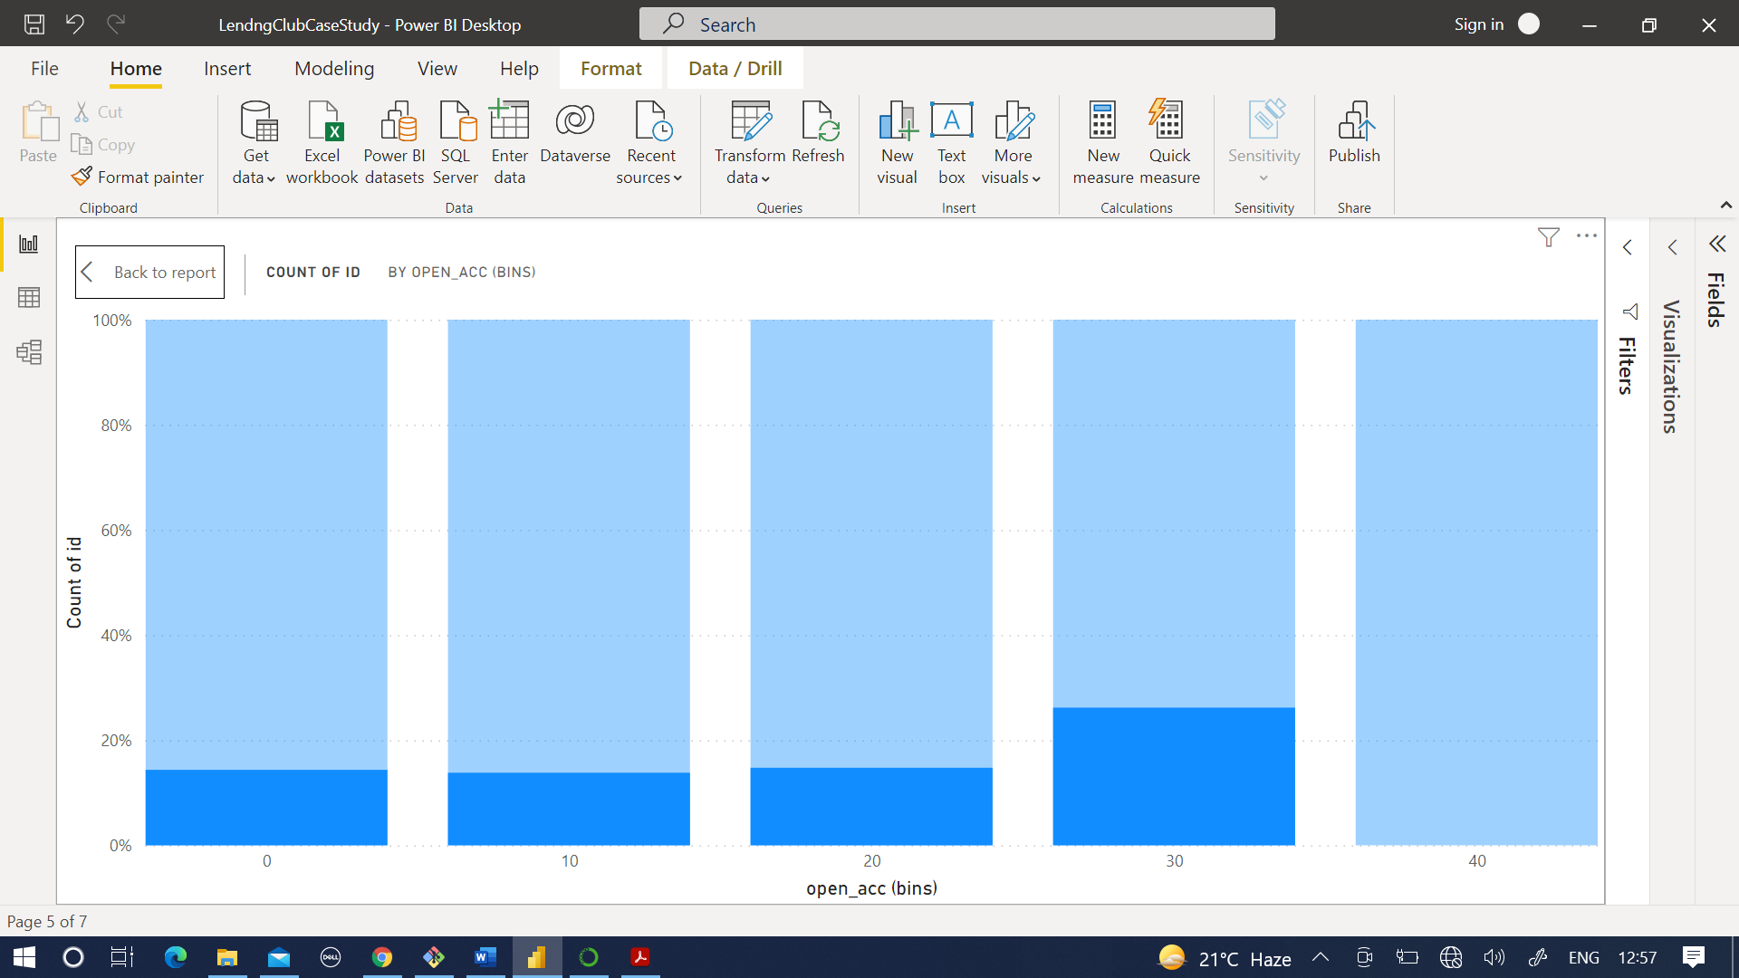
Fig 12. Analysis of loan_status wrt Number of Open Accounts

