CE/CS/SE 3354 · Software Engineering · Fall 2026
Project Milestone P2

Analysis and High-Level Design
[Project title]
Team | Team 06, section .005
Document version | 1.0 (baseline for P2; grows from your P1 version 0.x)
Date
Repository URL | https://github.com/[owner]/[repository]
Git tag for this milestone | p2 (points at the commit that contains this exact PDF)
Submitted on Canvas by | [one member only]

Team member | NetID | GitHub username
Thien An Mai | dal432725 | ThienAnMai
Nathan Nguyen | nqn220001 | NuQC_Lanh
Makeda Ogunlana | dal861444 | mari-ee
Avneet Kaur | axk230164 | avneetkaur17
Jordan Trinh | dal299996 | itsjordy29
Kaetlyn Gonzalez | kmg200006 | kaetlynmae

HOW TO USE THIS TEMPLATE
This is not a new document. P2 continues the document you baselined at P1. Copy your P1 sections 1 to 3 into this file (updated under change control), then fill in the new sections 4 to 9. Your P1 project plan, open questions and baseline move to the end and are renumbered:
P1 section 4 (project plan) becomes section 10. P1 section 5 (open questions) becomes 11. P1 section 6 (baseline) becomes 12.
Delete every guidance, example and warning box (blue, amber and red) and the two marking pages at the end before you submit. They are instructions, not content. Boxes or placeholders such as "[TBD]", "PR #[n]" or "[Member 3]" left in the submitted document lose document-quality points.
Length: sections 4 to 9 should add roughly 12 to 18 pages, diagrams included. Every section below carries a budget. A longer document is not a better one.
Diagrams: draw them in any tool (draw.io, Lucid, PlantUML, or a tidy hand drawing that is scanned). Export each as an image for this document and commit the source file to /docs/p2/diagrams. A diagram that cannot be read cannot be credited for its content.
Required structure: using this file is optional, but its section numbering is required, because the rubric refers to it.
Rubric: the marking pages at the end show where the 60 points sit. Read them before you divide the work.

WHAT P2 DOES NOT ASK FOR (DELETE THIS BOX BEFORE SUBMITTING)
P2 is analysis and high-level design. At this milestone we are NOT asking for:
design class diagrams with operations, parameter types or visibility, and design-level sequence diagrams with operation signatures (Chapter 9 detailed design; they enter the document during P3 work)
production code (the only code in P2 is the small architecture spike in section 8)
a test plan (P3, after Chapter 11)
screen mock-ups or a visual design (not graded at this milestone; add them only if they settle an open question)
design patterns from the Gang of Four catalog, ATAM or utility trees (not required; do not spend your time there)
Work placed in the wrong milestone is not credited. Spend the time on sections 4 to 9.

0 Revision History, Contribution Record and Changes Since P1
All three tables below are graded. The contribution record carries the individual 20% of this milestone and must agree with your repository history.
Version | Date | Author | Summary of change
0.x |  |  | P1 baseline (copy your last P1 row)
1.0 |  |  | P2 baseline: analysis and high-level design added

0.1 Individual contribution record (P2)
Team member | Sections and artifacts this person produced for P2 | Evidence in the repository (commit hashes, PR numbers) | Reviews given (PR numbers)
Makeda Ogunlana | Section 8 (Prototype Evidence): designed, built and ran architecture spike S-01. Wrote /spikes/S-01/MenuImportSpike.java, README.md, and the measured results. | https://github.com/NuQCLanh/3354.005-Team-6/commit/e363659bd9d5f2bf93be427d694a6fe3988e95c8
Nathan Nguyen | Section 6, Section 9 | 028e9eaaa813eb1c9abbe5b7d15bba5503f0e39f  b1dac0a80ff40a4341aefb3d89a40dabc92e099b

GUIDANCE: DELETE THIS BOX BEFORE SUBMITTING
Evidence means something a reader can open and that existed before the deadline: a commit hash, a pull request, a file in the repository. Issues you own count as indirect evidence; link the commits that close them for full credit.
Commit your own work from your own GitHub account. If one person uploads everyone's text from a shared document, the history shows one author and the other members have no verifiable evidence. A shared drafting document is fine; the final text of each section is committed by its owner.
Cite only what exists. Every commit, pull request, branch and file named in this table is checked. Citing evidence that is not in the repository is an academic-honesty matter, not a formatting slip.
Every member appears with a distinguishable contribution. Two rows with identical wording are marked as vague claims. If a member did not contribute, write that plainly in their row rather than leaving it blank or covering for them.

0.2 Changes since the P1 baseline
Change ID | What changed (IDs affected) | Why (P1 feedback, new finding, spike result) | Knock-on effect | Agreed on
CH-01
CH-02
CH-03

GUIDANCE: DELETE THIS BOX BEFORE SUBMITTING
Start with your P1 feedback. Every point raised in your P1 comment should appear here as a change, or with one sentence explaining why you kept the original. This table is where the baseline-and-change-control idea from Chapter 5 becomes real.
Requirement IDs are never reused. A removed requirement stays in section 3 marked "Withdrawn (CH-nn)" so the traceability matrix does not silently lose it.
Budget: half a page.

EXAMPLE (COMETPARK): DELETE BEFORE SUBMITTING
CH-02 · QR-02 rewritten as quality-attribute scenario QAS-01 · Why: P1 feedback said "fast enough" had no response measure · Knock-on: ADR-02 now cites QAS-01 · Agreed 30 Oct.

1 to 3 Introduction, Overall Description and Requirements (carried forward)
GUIDANCE: DELETE THIS BOX BEFORE SUBMITTING
Paste your P1 sections 1, 2 and 3 here and bring them up to date. Keep their numbering and IDs.
Fix before you build on it: any requirement that is still untestable, any source that still says "pending", any open question your P1 feedback flagged. Analysis and design inherit every ambiguity you leave in section 3.
Use cases: section 3.4 keeps the use-case diagram and the list at actor-goal level. The detailed expansion now lives in section 4; do not copy it twice.
Traceability: replace the P1 matrix in section 3.5 with a one-line pointer to section 9.1, where it is extended.
If nothing in a subsection changed, keep it and say so in one line under its heading ("Unchanged since v0.x").

1 Introduction
1.1 Purpose of this document and of the system
▸ WHAT GOES HERE
Two short paragraphs. The first says what this document is and who it is for. The second says what the system is for — the problem, and whose problem it is.
Budget: half a page.
Worked example: “CometLocker addresses the loss of parcels left at the campus post office counter, which currently requires a staffed desk during business hours and leaves students without a way to collect a delivery outside those hours.”

This document is for establishing the baseline and setting the expectations, limitations, and estimated project schedule for assembling and completing CometEats Menu as a functional system. Details for stakeholders, their needs, requirements, use-cases, and overall feasibility are documented for the sake of future traceability when moving forwards into later stages of the project for potential elements that may have been missed initially during development.

CometEats Menu is a service that presents a quick and easy way to access the menus of the campus dining halls from wherever the students might be, and will show nutritional information, dietary labels, and ratings based on student feedback.

1.2 Scope
▸ WHAT GOES HERE
A scope statement is only useful if it says what is excluded. Fill both columns. An empty right-hand column means you have not scoped anything.
Budget: the table, plus two sentences on why the exclusions were excluded.

In scope — we will build this | Out of scope — we will not, and why
Importing daily menus (dining hall, date, meal, station, dish) from UTD’s Dine on Campus pages. | Enter or edit menus by hand. Menus come only from Dine on Campus.
Showing the most recently imported menu, with the time it was imported, when Dine on Campus cannot be reached. | Online ordering and payment. UTD already offers ordering through the Boost app, and payments depend on meal-plan systems, the university controls.
Anyone can browse menus by dining hall, date and meal without an account. | Allergen guarantees. UTD does not publish top 9 allergen information online; it is only available from dining staff in person.
Students register and sign in with a UTD email, verified through a third-party sign-in service. | UTD single sign-on (SSO). UTD IT does not approve SSO access for student projects.
Signed-in students rate a dish from 1 to 5 stars and write a short review (up to 280 characters), at most one review per dish per day. | Photo uploads in reviews. Storing and checking images needs moderation the team cannot staff.
Every dish shows its average rating, number of reviews, and most recent reviews | Replies or comment threads and messaging between students. They turn reviews into a discussion forum that would need moderation.
Filtering dishes by dietary tags, where Dine on Campus provides them, with a disclaimer on every page that the tags are not an allergen guarantee. | Off-campus restaurants and food trucks. They are not on UTD’s menu pages.
Students can report a review; a review reported by 3 different students is hidden automatically.

Why the exclusions were excluded:
Each exclusion either duplicates something UTD already provides (Boost ordering, Dine on Campus menus), needs data or approvals we cannot get (allergens, SSO), or needs moderation we cannot staff (photos, threads). Off-campus vendors were left out because they are not on UTD’s menu pages.

1.3 Definitions, acronyms and abbreviations
▸ WHAT GOES HERE
Every term your stakeholders use in a way a newcomer would misread, and every abbreviation, expanded at first use. If a word in your domain has two meanings, that is a finding — record both meanings here and resolve it in section 5.

Term or abbreviation | Meaning as used in this project
Meal period | Breakfast, lunch, or dinner at one location on one date. One menu exists per location, date, and meal period.
Station | A serving counter within a location (e.g. grill, salad bar). Every dish belongs to exactly one station.
Dietary tag | A label such as Vegan or Halal, taken from Dine on Campus. The system never adds or edits tags.
Dine on Campus | The third-party website where UTD publishes dining menus; the system imports menus from it.
FR/ QR/ CON/ UC | Functional requirements/ quality requirements/ constraint requirements/ use cases.
Dietary label | Diet tags such as Vegan

1.4 References
▸ WHAT GOES HERE
Anything you relied on: a standard, a campus policy, an existing system's documentation, an interview transcript in your repository. Give each a number so requirements in section 3 can cite it as a source.

[R1] UTD Dining menus on Dine on Campus
https://dineoncampus.com/utdallasdining/whats-on-the-menu/dining-hall-west
[R2] FARE College Food Allergy Program, UT Dallas profile
https://college.foodallergy.org/schools/texas/university-texas-dallas
[R3] CometEats Menu — System Specification: Introduction & Scope
https://github.com/NuQCLanh/3354.005-Team-6/blob/main/P2/Sys_Spec_Intro%26Scope.md

2 Overall Description
2.1 Product perspective and context
▸ WHAT GOES HERE
Draw the context diagram: one box for your system, every external actor and external system around it, and a labelled line for each interface. Paste the image here.
This is the diagram that decides what you are responsible for. Anything inside the box is your work. Anything you call on and do not build is an external system — and it still goes on the diagram.
Budget: one diagram and one paragraph explaining the boundary choice.

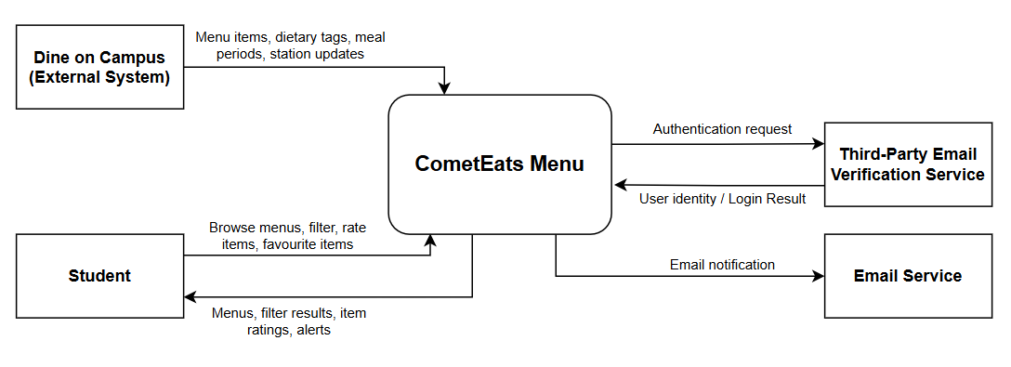

CometEats Menu covers the application, database, automated menu scraper. Students are the main external users who interact with the system to search menus, filter items, leave ratings and reviews. The two external systems outside our project boundary are Dine on Campus, which supplies all daily menu and dietary tag data automatically, and a Third-Party Email Verification Service, which checks UTD email accounts since UTD Single Sign-On is excluded.

2.2 Stakeholders and how you reached them
▸ WHAT GOES HERE
Everyone whose needs shape the system, including the ones who will never use it — whoever pays, whoever operates it, whoever has to comply with something because of it.
The last column is the one that earns marks. “We assumed” is an honest and acceptable answer at P1; “interviewed on 9 Oct, notes in /docs/elicitation” is a better one. An entry with no basis at all is not.

Stakeholder | Role in relation to the system | What they need from it | How you learned this
Students | Primary users of CometEats | Access campus menus, register/login and reading/submitting dish ratings and review. | Personal experience attempting to find daily campus menus (since Google Maps rarely shows them). We assumed that fellow students may face the same challenge.
Engineers | Maintainers of the system | Clear requirements baseline, and predictable data structure. | We analyzed the layout of the Dine on Campus website [R1] and reviewed our team's technical skills and project scope to see what we could realistically build.
Dining Services | External Content Source | Accurate display of their public menu items and dietary tags without unauthorized edits. | Since we import Dine on Campus data and do not verify menu items ourselves, we assumed the data must remain untouched.

2.3 User characteristics
▸ WHAT GOES HERE
Who the users are, what they already know, what they cannot be assumed to know, and anything about them that constrains the system — accessibility needs, the device they will be holding, the hurry they are in.
Budget: a short paragraph per user class.

Students: UT Dallas students need a quick and easy way to check campus food menus. The website should work well on phones and be easy for everyone to use. It should also help students with disabilities by supporting screen readers, and larger text. Students can view menus without logging in, but they must log in to rate foods.
Students with Dietary Restrictions: These students need to find food that fits their diets, such as vegan, vegetarian, halal, or gluten-free meals.

2.4 Constraints
▸ WHAT GOES HERE
A constraint removes a design choice. “We must use the existing campus single sign-on service” is a constraint. “The system should be fast” is not — that is a quality requirement, and it belongs in 3.2.
Record the source of each constraint. An unsourced constraint is usually a preference somebody has mistaken for a rule.

The system shall not use UTD Single Sign-On (SSO) and must instead authenticate student users using UTD email verification via a third-party service.
The website must work on phones and on computers without downloading an app.
Only dietary labels shown by Dine on Campus can be used and shall not permit users or maintainers to add or edit dietary tags manually.
The system must use free services and cost $0 to run.

2.5 Assumptions and dependencies
▸ WHAT GOES HERE
An assumption is something you are treating as true without having confirmed it. A dependency is something outside your control that your plan needs.
State what breaks if each one turns out to be wrong. That sentence is the whole value of this section.

# | Assumption or dependency | What breaks if it does not hold
A1 | Dine on Campus publishes menu data that the system can read automatically | Automated import fails; system cannot populate new menus.
A2 | The menu data source is updated at least as often as a 6-hour import. | Students will see stale menus even if everything works correctly. Last updated warnings will become standard.
A3 | Dine on Campus owns the accuracy of the dietary tags, and we do not manually verify them ourselves. | Students with allergies can be lethally misled. Team needs Dine on Campus to confirm writing labels are accurate.

2.6 Feasibility summary
▸ WHAT GOES HERE
Four short verdicts, each with the evidence behind it. This is the Chapter 4 material, applied to your own project.
A verdict with no evidence is an opinion. “Technically feasible — two team members have used this framework before, see repository /spike-01” is evidence. “We think we can do it” is not.

Feasibility gate | Verdict | Evidence behind the verdict
Technical | Feasible Conditional on A1 | Feasible using standard Node.js/React web frameworks and HTTP web scraping tools to scrape Dine on Campus website. Conditional on Dine on Campus remaining publicly accessible (A1).
Operational | Feasible | Fully within team control because authentication uses third-party UTD email verification, requiring no administrative approval from UTD IT.
Schedule | Feasible | Project deliverables are scoped strictly around core features manageable within the semester timeframe.
Economic / resource | Feasible | Achievable at $0 budget by hosting frontend and database assets on free-tier cloud platforms (e.g. Vercel, Supabase).

3 Specific Requirements
▸ WHAT GOES HERE
This section carries the most marks in P1. Everything else sets it up.
Expected volume: 8 to 15 functional requirements, 4 to 6 quality requirements, 2 to 4 constraint requirements, 4 to 6 use cases with 2 written out in full. More is not better; vague is worse than few.
Every requirement must pass the testability test from Chapter 5: a reader must be able to decide pass or fail without arguing. That needs a measurable condition and a stated way of checking it.
Write every requirement as a single “shall” sentence. If you need the word “and” twice, you have two requirements.

3.1 Functional requirements
▸ WHAT GOES HERE
What the system does. Use the identifier FR-nn and keep the identifiers stable from now on — P2 and P3 will refer back to them.
Priority uses MoSCoW: MUST (the release fails without it), SHOULD (important, there is a workaround), COULD (desirable), WON'T (agreed out of this release).
Source is the stakeholder or reference the requirement came from — a row from 2.2, or a reference from 1.4.

ID | Requirement — one “shall” sentence | Priority | Source | Acceptance criterion
FR-01 | The system shall display the menu for a selected dining hall, date, and meal period. | MUST | R1, R3, Students | Sample 10 hall/date/meal combinations, the items shown match the menu data source exactly.
FR-02 | The system shall import menu data from the menu data source at least once every 6 hours. | MUST | R3 | When an item is changed in the source, it appears in the system within 6 hours
FR-03 | The system shall show the most recently imported menu with a “last updated” timestamp when the menu data source is unreachable | SHOULD | R3 | When the source is blocked in a testing environment, the menu should still display and the timestamp matches the last successful import.
FR-04 | The system shall display dietary tags supplied by the Dining Services like vegan, vegetarian, etc. next to the menu items that apply. | MUST | R1, Dining Services | 30 item samples should have tags shown that match the tags in the source.
FR-05 | The system shall let a signed-in student submit a rating from 1-5 stars and a review for a menu item | MUST | R3, Students | Signed-in test user submits a 3 star rating and it is stored and shown as the user’s rating upon refreshing.
FR-06 | The system shall let a user sort the items in a menu section by average rating. | COULD | R1 | With sorting on, displayed rating averages are in descending order.
FR-07 | The system shall display each item’s average rating and number of ratings. | MUST | R3, Students | With ratings of 3, 4, and 5, the item should show an average of 4.0 from 3 ratings.
FR-08 | User registration and sign-in using UTD email addresses. | MUST | R3, Students | Submissions using non-UTD domain emails (e.g., @gmail.com) are rejected with an explicit error message.
FR-09 | Automatically hiding any review reported by 3 distinct student accounts. | COULD | R3 | A target review accumulates 2 reports from unique signed-in student accounts and remains publicly visible. When a 3rd distinct signed-in student account reports the same review, the system instantly sets the review state to hidden, hides it from all public dish menu pages.
FR-10 | The system shall accept at most one review per student per dish per day with a text of at most 280 characters | SHOULD | Students | A second review on the same day is rejected. A 281-character text is rejected.
FR-11 | The system shall accept at most one report per student per review | MUST | Students | A repeat report by the same student is rejected and the report count stays the same.
FR-12 | The system shall display the nutritional facts supplied by Dine on Campus when a student selects a dish, or a notice when none exists | MUST | R1, Students | For 10 sampled dishes, the facts shown match the source. A dish with no data shows the notice.
FR-13 | The system shall let a user search dishes by nae | MUST | Students | Searching a known dish name returns that dish.
FR-14 | The system shall let a user filter dishes by dietary | SHOULD | Dining Services, Students | Filtering by “Vegan” shows only dishes carrying that tag in the source.

3.2 Quality requirements
▸ WHAT GOES HERE
A quality requirement says how well, not what. Performance, availability, usability, accessibility, security, maintainability.
Three ingredients, every time: a number, the condition it holds under, and how it will be measured. “The system shall be responsive” has none of the three and earns nothing.
Worked example: “QR-01 Ninety-five percent of searches shall return results within 2 seconds, measured over one working week under normal load of up to 50 concurrent users.”

ID | Requirement — with threshold, condition and method | Priority | Source | How it will be verified
QR-01 | System must display nutritional information within 2 seconds of a student selecting a food item. | MUST | Student | Running a load test of 50 concurrent users, to secure consistent response time of 2 seconds.
QR-02 | System must be available 99% of the time during dining hall operation hours. | MUST | Student | Deploy a monitoring tool to keep track of system traffic during operation hours (11am to 5pm), during a 30-day period.
QR-03 | Systems must be able to support 95% of student devices, from IOS, Android, or web browsers. | SHOULD | Student | Gather feedback from Student Focus Groups over 90% of devices students use.
QR-04 | System must at least return 95% correct matching food when searching. | MUST | Engineers | Run 100 search queries against the database of 300 menu items, returning at least 95% of the matching item.

3.3 Constraint requirements
▸ WHAT GOES HERE
Constraints carried forward from 2.4, written in requirement form with an identifier so they can be traced like any other requirement.

ID | Constraint — one sentence | Source | Why it cannot be negotiated
CON-01 | The system shall not use UTD Single Sign-On (SSO) and must instead authenticate student users using UTD email verification via a third-party service. | R3, Engineers | University will not accept requests for usage of SSO services for systems made by students or student employees.
CON-02 | The system has to display dietary tags that are exactly as given by Dining Services and shall not permit users or maintainers to add or edit dietary tags manually. | Dining Services | Dining Services is accountable for allergen and dietary claims for each menu item. Student-built apps that can alter the perception of these claims is not acceptable.
CON-03 | The website must work on phones and on computers without downloading an app. | Student | Ensure immediate cross-platform browser accessibility
CON-04 | The system must use free services and cost $0 to run. | Engineers | The project operates without funding or administrative budget allocation.

3.4 Initial use cases
▸ WHAT GOES HERE
First the diagram: actors, use cases, the system boundary, and any «include» or «extend» relationships. Paste the image.
Then write out two use cases in full — choose the two that are hardest to scope, not the two that are easiest to write. Use the template below for each.
Reminder from Chapter 6: a use case is started by an actor, ends when that actor has finished something they came to do, and has value on its own. “Validate Password” is a step, not a use case.

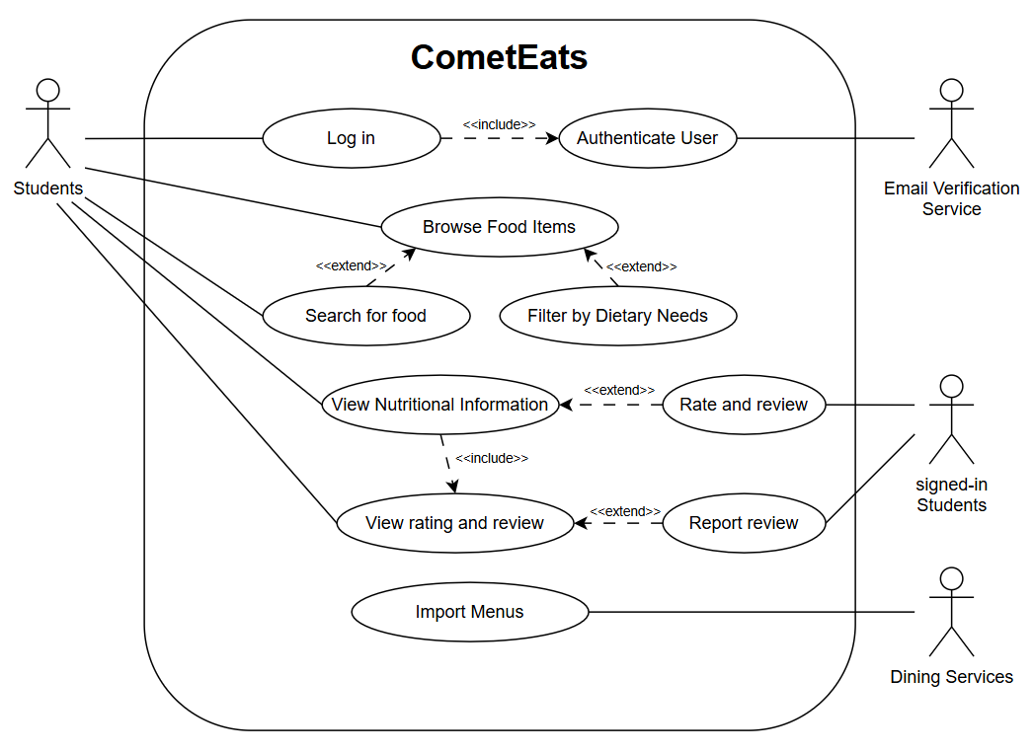
· UC –01: Log in
· UC –02: Authenticate User
· UC –03: Browse Food Items
· UC –04: Search for Food
· UC –05: Filter by Dietary Needs
· UC –06: View Nutritional Information
· UC –07: Rate and Review
· UC –08: View rating and review
· UC –09: Report review
· UC –10: Import Menus

Expanded use case — copy this block for each of your two
Field | Content
Identifier and name | UC-06: View Nutritional Information
Primary actor | Student
Supporting actors | Dining Services
Preconditions — what must be true before it starts | The nutritional information for the selected food by the student is in the university dining database.
Trigger — what starts it | Students select a food item in the system and taps "View Nutritional Information"
Main success scenario — numbered steps | 1.) Student opens CometEats. 2.) Students select food items. 3. ) Student clicks or taps "View Nutritional Information" drop down box.
Alternative and exception flows | Alternative: A student can filter food items based on a specific dietary need. Exception: The selected food item has no nutritional information included.
Postconditions — what is true when it succeeds | The selected food items with relevant information from calories, protein, sugars, fats, etc. are displayed to the student.
Requirements realized | FR-05

Field | Content
Identifier and name | UC-09: Report review
Primary actor | Signed-in Student
Supporting actors | None
Preconditions — what must be true before it starts | The student is signed-in, and the target review is currently visible.
Trigger — what starts it | A signed-in student chooses to report an inappropriate dish review.
Main success scenario — numbered steps | 1. Student submits a report for a specific dish review, flagging it as inappropriate.  2. System verifies the student's authentication token and checks whether the student has already reported this review.  3. System records the report linked to the student's account and the review.  4. System updates the count of distinct student reports for the review.  5. System displays a confirmation acknowledging that the report was successfully received.
Alternative and exception flows | Alternatives:  At step 2, the student has already reported this review. System notifies the student that duplicate reports for the same review are not allowed.  At step 4, total distinct student reports reach 3. System automatically hides the review from public display and acknowledges the report submission.
Postconditions — what is true when it succeeds | The system records the report under the student's identity; if total distinct student reports for the review reach 3, the review is hidden from public display.
Requirements realized | FR-09

3.5 Requirements to use case traceability
▸ WHAT GOES HERE
One row per requirement. The matrix is doing its job when it shows you something you did not already know.
Two shapes of trouble, and you must say what you did about each: a requirement that reaches no use case (either a use case is missing, or the requirement is not functional and belongs in 3.2), and a use case nothing traces to (either it is out of scope, or a requirement was never written down).

Requirement ID | Use case(s) that realize it | If blank — why, and what you will do
FR-01 | UC-03
FR-02 | UC-10
FR-03 | UC-03, UC-10
FR-04 | UC-06, UC-03, UC-10
FR-05 | UC-07
FR-06 | UC-05
FR-07 | UC-08
FR-08 | UC-01, UC-02
FR-09 | UC-09
FR-10 | UC-07
FR-11 | UC-09
FR-12 | UC-06
FR-13 | UC-04
FR-14 | UC-05

Add UC-10 to cover automatic menu imports.
Update UC-03 to show missing dietary information.
Add UC-07 so students can rate food items.

4 Use-Case Analysis
Chapter 7, first half. Here you take the use cases from section 3.4 and write the most important of them out turn by turn, still with the technology switched off.

4.1 Use cases selected for analysis
Use case | Name | Why it was selected | Non-trivial steps
UC-06 | View Nutritional Information | High value for students with dietary needs; handles missing external nutritional data. | Requesting item details, retrieving dietary tags, handling missing nutrition flow.
UC-07 | Rate and Review | High value for student interaction and enforces multiple rules (daily limits, character counts) requiring server validation. | Verifying previous daily ratings, validating character limits, storing the review, and computing the new average rating.
UC-09 | Report Review | Enforces automated community moderation without administrative staff | Validating previous reports, recording new reports, tracking distinct report counts, and auto-hiding reviews.

GUIDANCE: DELETE THIS BOX BEFORE SUBMITTING
Analyze at least three use cases, including the two you specified in full at P1. We recommend that one of them involves an external system or a failure that the actor can see.
Choose by risk and value, not by ease: the use case that carries most of the product, the one that touches most of your quality requirements, the one you are least sure you can build.
Budget: a quarter of a page.

4.2 Expanded use cases
Copy the block below once for each use case in 4.1.

UC-06 View Nutritional Information
Primary actor | Student
Supporting actors and external systems | Dining Services (External Data Source)
TUCBW (this use case begins when) | The student selects a food item from the daily menu.
TUCEW (this use case ends when) | The student sees the nutritional facts for the selected food item.
Preconditions | The system has displayed a menu containing food items.
Postconditions | The nutritional information for the selected food item is shown on screen.
Traces to requirements | FR-04, FR-05 , QR-01

Actor input / action | System response
 | (0) System displays the daily menu with food items, stations, meal periods, and dietary tags.
(1) Student selects a food item to view its details. | (2) System presents main item details (name, station, dietary tags) and provides an option to expand nutritional details.
(3) Student chooses to view the detailed nutritional information. | (4) System displays the full nutritional facts (calories, protein, carbohydrates, fats, and available serving details) for the selected item.
(5) Student reads the nutritional facts. | (6)

Alternate flow | At step | Condition | What happens | Ends or rejoins at
A1 | 4 | Selected food item has no nutritional data in the system. | System displays a message stating "Nutritional information is currently unavailable for this item" alongside a general dining disclaimer notice. | Ends
A2

UC-07 Rate and Review
Primary actor | Signed-in Student
Supporting actors and external systems | None
TUCBW (this use case begins when) | The student selects the option to rate a dish.
TUCEW (this use case ends when) | The student reads the success confirmation showing their published review.
Preconditions | The student is signed in and the dish menu page is open.
Postconditions | The system records the rating and review, and the dish's average rating is updated.
Traces to requirements | FR-05, FR-07, FR-10

Actor input / action | System response
 | (0) System displays the dish details and a prompt to leave a rating and review.
(1) Student enters a 1-5 star rating and optional review text (up to 280 characters), and submits it. | (2) System checks that the student has not rated this dish today, verifies the character count, saves the review, updates the average rating, and displays the published review with a success confirmation.
(3) Student reads the confirmation and their published review. | (4)
(5) | (6)

Alternate flow | At step | Condition | What happens | Ends or rejoins at
A1 | 2 | Student has already rated this dish today. | System rejects the submission and displays an error message stating only one review is allowed per day. | Ends
A2 | 2 | Review text exceeds 280 characters. | System rejects the submission and prompts the student to shorten the text. | Rejoins at 1

UC-09 Report review
Primary actor | Signed-in Student
Supporting actors and external systems | None
TUCBW (this use case begins when) | A signed-in student chooses to report an inappropriate dish review.
TUCEW (this use case ends when) | The student receives a confirmation message acknowledging their report.
Preconditions | The student is signed into their account, and the target review is visible on the food item page.
Postconditions | The report is recorded under the student's account; if total distinct student reports reach 3, the review is hidden from public display.
Traces to requirements | FR-09, QR-03, CON-01

Actor input / action | System response
 | (0) System displays a food item page with existing student reviews and a report option next to each review.
(1) Student submits a report for a specific dish review, flagging it as inappropriate. | (2) System checks that the student is signed in, verifies the student has not already reported this review, records the new report, updates the distinct report count, and displays a confirmation message.
(3) Student reads the confirmation message. | (4)
(5) | (6)

Alternate flow | At step | Condition | What happens | Ends or rejoins at
A1 | 2 | Student has already reported this review previously. | System displays an error message stating "You have already reported this review" and prevents submission. | Ends
A2 | 2 | Total distinct student reports for the review reach 3. | System updates the review status to hidden, removes it from public view on the menu page, and confirms report receipt to the student. | Ends

GUIDANCE: DELETE THIS BOX BEFORE SUBMITTING
The rules from Lesson 13, all of which are checked:
Step (0) is what the actor sees before touching anything. It is often skipped, and it is where many missing requirements are found.
One turn per row. An actor action on the left, the system response on the right. Two steps merged into one row become a missing message on your sequence diagram in section 5.
End with an acknowledgment the actor can perceive. No acknowledgment, no TUCEW, no use case.
No background processing. If the actor neither sees it nor waits for it, it belongs to another use case.
Precondition or alternate flow? If it can be false while the system works normally, it is a flow you must handle, not an assumption.
No technology yet. No screen widgets, no database, no framework names. "Taps the green button" and "queries the PostgreSQL table" both fail the analysis check.
Every item the actor column names should already be an attribute in your domain model (5.1). Where it is not, you have found one.
Budget: about one page per use case.

EXAMPLE (COMETPARK): DELETE BEFORE SUBMITTING
UC-02 Find an Open Space · Primary actor: Driver · External system: Lot Sensor Network · TUCBW the driver asks for parking near a destination building · TUCEW the driver sees the recommended lot with its number of open spaces.
(0) The system shows the campus lots with the time of the latest occupancy update. (1) The driver chooses a destination building and permit type. (2) The system shows the three nearest lots the permit allows, each with open spaces and walking time. (3) The driver selects a lot. (4) The system shows the lot entrance and confirms the count is no older than 60 seconds.
A1 at step (2): no permitted lot has an open space · the system shows the nearest lot with expected turnover and the visitor option · ends.

4.3 Self-review log
Use case | Check from the Lesson 13 review checklist | Defect found | How it was fixed
UC-06 | Ends with an acknowledgment the actor can perceive | The use case ended silently with a system response, leaving the actor without a clear finish. | Added Step (5) where the student reads the facts, and updated TUCEW.
UC-07 (Replaced UC-10) | No background processing | UC-10 was a background scheduler task with no human actor waiting or watching. | Replaced UC-10 entirely with UC-07 (Rate and Review) to analyze a valid, user-facing interaction.
UC-09 | One turn per row; No technology named; Ends with acknowledgment | System actions were placed in the Actor column. Step (2) used design jargon ("authentication token"). Missing actor acknowledgment. | Moved all system actions to the right column, grouped them into Step 2, changed jargon to "checks that the student is signed in", and added Step (3) acknowledgment.

GUIDANCE: DELETE THIS BOX BEFORE SUBMITTING
Run the review checklist from Lesson 13 on each expanded use case before anyone draws a diagram, and record what each check found, including any defects you fixed. Report honestly; a clean result is acceptable when it is true. Budget: a quarter of a page.

5 Analysis Models
Chapter 7, second half. What has to exist inside the system for the use cases in section 4 to happen, and how those parts talk to each other.

5.1 Domain model
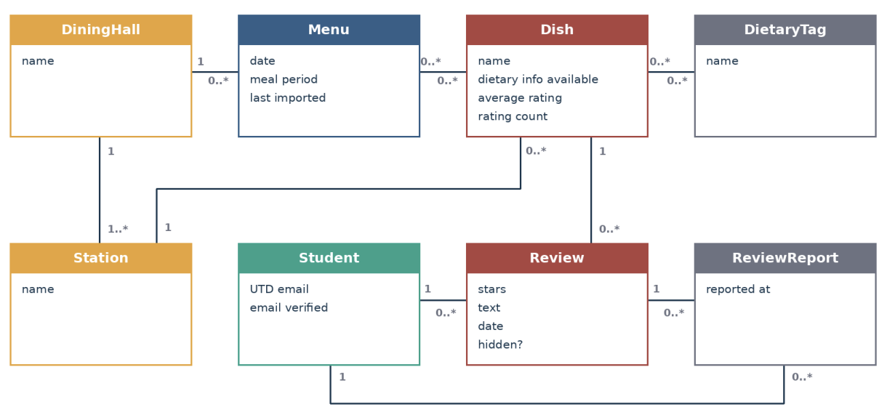
1 -> Exactly one
0..1 -> Zero or one
0..* -> Zero or more
1..* -> One or more

Figure 5.1 Domain model (conceptual classes, attributes, associations with multiplicities)
Class | What it represents (one line) | Key attributes | Associations (with multiplicity)
DiningHall | A campus dining location | name | - 1 hall offers 0..* menus  - 1 hall contains 1..* stations
Menu | Imported menu for one hall,  date and meal | date, meal period, last  imported | - each menu belongs to 1 hall  - 0..* menus  - 0..* dishes
Station | A serving counter within a  hall | name | - each station belongs to 1 hall and serves 0..* dishes  - each dish belongs to 1 station
Dish | A food item listed on menus | name, dietary info available,  average rating, rating count | - 0..* dishes  - 0..* dietary tags  - each dish receives 0..* reviews
DietaryTag | A source-provided dietary  label | name | - each tag labels 0..* dishes  - each dish has 0..*tags
Student | A student registered using a  UTD email | UTD email, email verified | - each student writes 0..* reviews and files 0..* reports
Review | A student rating and optional short review of a dish | stars, text, date, hidden? | - each review has 1 author and concerns 1 dish  - each review receives 0..* reports
ReviewReport | A student report about a  review | reported at | - each report has 1 reporting student and concerns 1 review

GUIDANCE: DELETE THIS BOX BEFORE SUBMITTING
Conceptual classes only: things and records from the problem domain, with attributes and associations. No operations, no data types, no database tables, no screen classes.
Every item the actor column of section 4.2 mentions is an attribute somewhere in this model. Every association has a multiplicity at both ends.
Budget: one page including the diagram.

EXAMPLE (COMETPARK): DELETE BEFORE SUBMITTING
Lot (name, zone, capacity) 1 ── 0..* Space (number, type) ; Space 1 ── 0..* OccupancyReading (time, state) ; Permit (type, valid until) * ── 1..* Lot "is valid in" ; Building (name) * ── * Lot "is near" (walking time).

5.2 Object interaction models
Copy the block below for at least two of the use cases in 4.1; preferably including your riskiest.

5.2.x UC-09 [Report Review]
(a) Non-trivial steps. List the steps from 4.2 that need objects inside the system, and say in one line why each of the others is trivial.
Step 1: Trivial because it is a frontend user action (Clicking a button) that does not initiate internal objects interactions until submitted.
Step 2: Non-trivial because the system must query existing ReviewReport objects to check if this Student has already submitted a report for specific Review.
Step 3: Non -trivial because the system must instantiate a new ReviewReport object, setting its report at attribute, and associate it with the Student and the Review
Step 4: Non-trivial because it queries the database to update the aggregate count of unique reports and evaluates conditional business logic to potentially hide the review.
Step 5: Trivial because rendering a standard confirmation message on screen is a basic user interface update that doesn’t process business data.
(b) Scenario table.
Step | Subject (who acts) | Subject action (what it does) | Other data / objects (what is used) | Object acted upon (who receives)
2 | ReviewController | Checks if a duplicate report exists for the student | UTD email | ReviewReport
3 | ReviewController | Instantiates new report and associates it with the student and review | UTD email(Student) | ReviewReport
4 | ReviewController | Updates aggregated count of unique reports and evaluates conditional logic to potentially hide reviews | Review | Review

(c) Analysis sequence diagram.
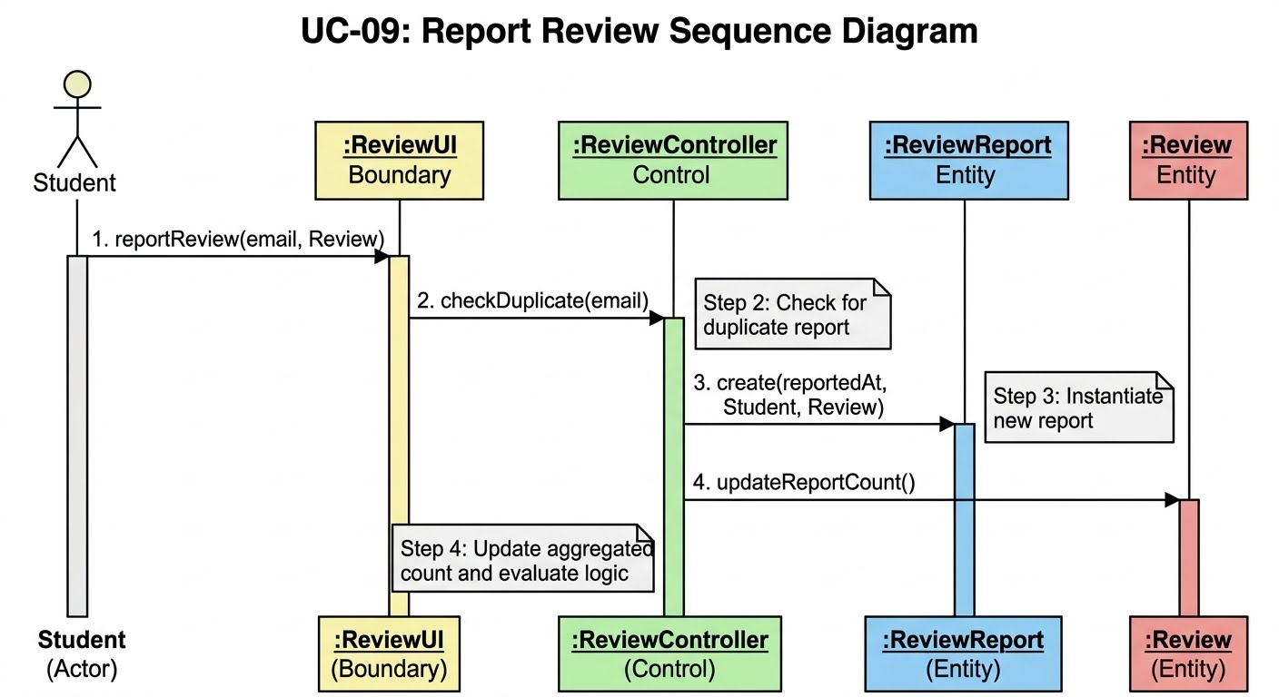
Figure 5.2.x Analysis sequence diagram for UC-xx; message numbers match the scenario table
GUIDANCE: DELETE THIS BOX BEFORE SUBMITTING
Write each step as a declarative sentence first, subject, verb, object, then fill the columns. Tables filled directly produce rows with no subject.
One message per table row, same numbers. Use the four translation cases from Lesson 14; the diagram is a conversion of the table, not a new drawing.
Messages are verb phrases, not operation signatures. "asks for the routes calling at the stop" is analysis; "getRoutes(stopId: int): List<Route>" is Chapter 9 and is not credited here.
Every object on the diagram is a class in 5.1 or an interaction object you name and explain in one line. One object is clearly in control of the interaction.
Budget: one to one and a half pages per use case.

EXAMPLE (COMETPARK): DELETE BEFORE SUBMITTING
Step 2 · Subject: LotFinder · Action: asks for the lots the permit allows · Data: permit type, destination · Object acted upon: PermitRules.

5.3 Consistency cross-check
Check | Result (pass, or what failed) | Fixed in
K1 Every item in an actor column (4.2) is an attribute in the domain model (5.1) | Pass | N/A
K2 Every object on a sequence diagram is a domain class or a declared interaction object | Pass | N/A
K3 Every message on a sequence diagram corresponds to exactly one scenario-table row
K4 Every non-trivial step in 5.2 (a) has at least one scenario-table row
K5 Every analyzed use case traces to at least one functional requirement
K6 The last messages of each diagram make the use case postcondition true

GUIDANCE: DELETE THIS BOX BEFORE SUBMITTING
Run the six checks across the work of different authors; they are designed to catch the seams between people. A failed check that you found and fixed is more convincing than a column of passes. Budget: a quarter of a page.

6 High-Level Design (Architecture)
Chapter 8. The rule now reverses: a high-level design that does not say where things run, what they are built from and what that choice cost has not been done.

6.1 Architectural drivers: quality-attribute scenarios
QAS | Quality attribute | Stimulus | Artifact | Response | Response measure | From
QAS-01 | Performance | 50 students at once open a menu or an item’s nutrition details during the lunch peak | Menu Service and Database | Server returns page from stored copy of the menu, no calls to Dine on Campus | 95% of requests complete in 2 seconds, measured by load tests | QR-01
QAS-02 | Availability | Dine on campus is unreachable or returns errors during import between 11PM and 6PM | Menu Import Job, Menu Service | Import fails and is logged. Users keep seeing the last imported menu with “last updated time” | 99% of studen requests will succeed between 11PM and 6PM over an extended period of time. The source is blocked in a test, 100% of menu pages will still show the correct timestamp | QR-02  FR-03
QAS-03 | Security | A user with no valid token or no valid email, sends a review or request directly to the server and skips the page | Authorization gateway, review and moderation service | The server rejects the request made with an error and stores nothing | 100% of 20 hardcoded responses that have no tokens, expired tokens, or invalid emails, or dupe reports, are rejects and none are stored | FR-08  FR-09  CON-01
QAS-04 | Modifiability | Dine on Campus changes page or data structure | Menu Import Job | Developer updaters parser and redeploys | Only C3 changes, fix is deployed in one working day | R3, A2

GUIDANCE: DELETE THIS BOX BEFORE SUBMITTING
At least three scenarios, preferably covering more than one quality attribute (for example performance, availability, security, modifiability, usability). Derive them from your P1 quality requirements and say which.
The response measure is the part teams leave out, and it is the only part that lets anyone tell whether the architecture worked. A scenario without a number is an opinion.
Below the table, list in two or three lines the constraints (CON IDs) that shape the architecture.
Budget: half a page.

EXAMPLE (COMETPARK): DELETE BEFORE SUBMITTING
QAS-01 · Performance · Stimulus: 400 drivers request lot status during the 7:45 to 8:15 AM peak · Artifact: the occupancy service · Response: returns current open-space counts · Measure: within 2 s for 95% of requests · From QR-02.

6.2 Architectural style and alternatives
Style considered | Drivers it serves | What it costs | Verdict
Layered (N-tier) client server | QAS-01, QAS-02, QAS-03, QAS-04, CON-04 | Single point of failure, import job shares server with student requests | Chosen
Microservices. | QAS-04 | Several deployments on $0 budget, network calls between services, operations work that is too demanding. | Rejected
Client plus backend as a service | CON-04 | No place to run scheduled import or enforce review and report rules since anyone can call the database directly | Rejected

GUIDANCE: DELETE THIS BOX BEFORE SUBMITTING
Name the style (or combination) you chose and at least two you rejected, using the vocabulary from Lessons 15 and 16: layered (N-tier), client-server, repository, model-view-controller, pipe-and-filter, event-driven, service-oriented or microservices.
One paragraph below the table explains the choice in terms of the scenarios in 6.1. "We are most comfortable with it" is not a driver. ADR-01 in section 7 records this decision formally.
Budget: half a page.

6.3 Component view
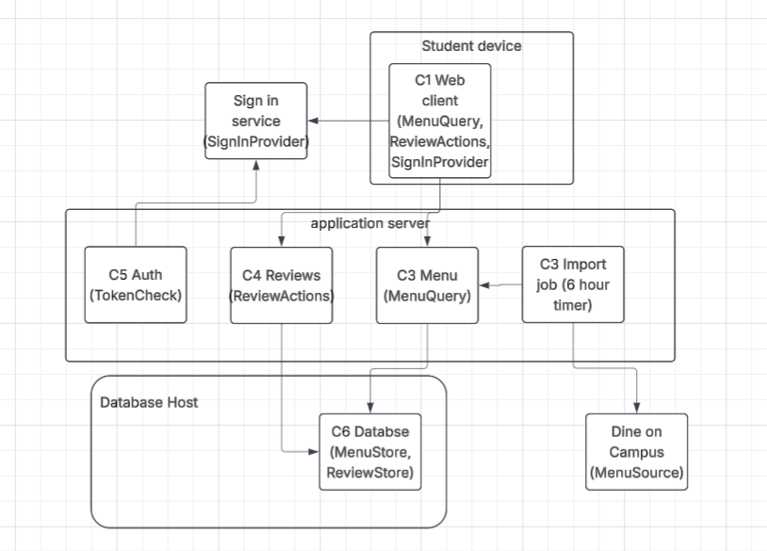
Figure 6.3 Component diagram: components, provided and required interfaces, external systems
Component | Responsibility (one sentence) | Provides | Requires | Answers to (UC / QAS / ADR)
C1 Web Client | Show menu, details, ratings, and reviews in phone/desktop browser and takes student input | None | MenuQuery, ReviewActions, SignIn Provider | UC-01, UC-03 to UC-09; CON-03; ADR-01
C2 MenuService | Owns all the menu data, serves brows, search, filter, and item detail requests, including last updated notice | MenuQuery, MeuUpdate | MenuStore, RatingSummary | UC-03 to UC-06; FR-01, FR-03, FR-04; QAS-01, QAS-02; ADR-02
C3 Menu Import Job | Every 6 hours, fetches menu from Dine on Campus and parses them with tags unchanged, passes them to C2 | None | MenuSource, MenuUpdate | UC-10; FR-02, FR-03; CON-02; QAS-02, QAS-04; ADR-02
C4 Review and Moderation Service | Store rates and reviews, applies once per day 280 char and one report rules, counts distinct reports, hides a review at 3 and computes averages | ReviewActions, Rating Summary | TokenCheck, ReviewStore | UC-07 to UC-09; FR-05, FR-07, FR-09; QAS-03; ADR-04
C5 Authorization Gateway | Checks sign in token on every protected requests and rejects unauthorized emails | TokenCheck | SignInProvider | UC-01, UC-02; FR-08; CON-01; QAS-03; ADR-03
C6 Database | Persists menu, student, and review data | MenuStore, ReviewStore | None | All stored data; QAS-01, QAS-02; ADR-01
External: Dine on Campus | Publishes menus | MenuSource | None | A1, R3; ADR-02
External: Third party sign in service | Stores passwords, sends verification emails, issues signed tokens | SignInProvider | None | CON-01; ADR-03

GUIDANCE: DELETE THIS BOX BEFORE SUBMITTING
Point at any box and say which use case, which quality scenario or which decision put it there. A box with no answer cannot be credited.
Show external systems outside the boundary. Name interfaces by what they offer ("OccupancyQuery"), not by operation signatures, which are Chapter 9.
Budget: one page including the diagram.

6.4 Deployment view
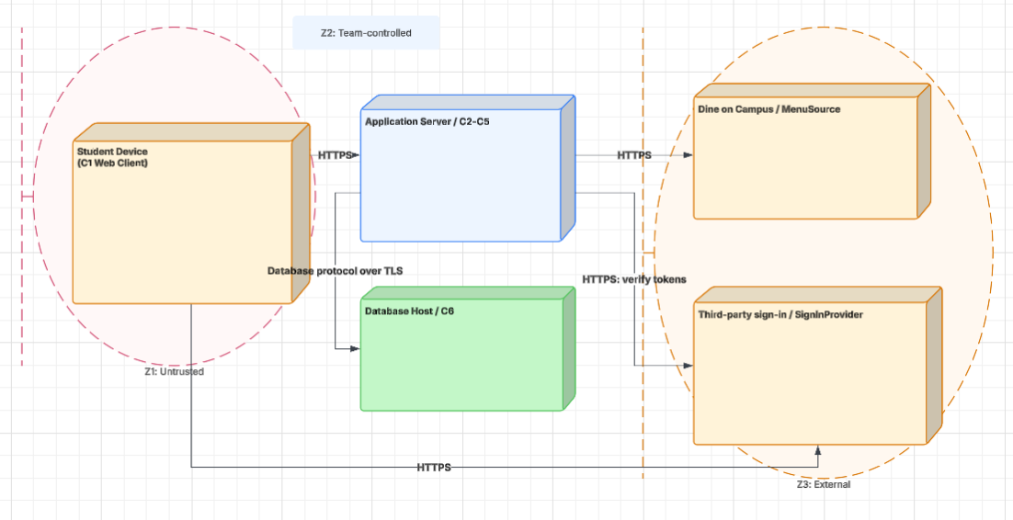
Figure 6.4 UML deployment diagram: nodes, execution environments, deployed artifacts, communication paths with protocols, trust boundaries
Node | What runs on it (artifacts, components) | Communicates with (protocol) | Trust zone
Student Device | C1 Web Client | Application Server HTTPS, sign in service HTTPS | Z1: untrusted. Input is never believed
Application Server | C2 C3 C4 C5 | Database Host (database protocol over TLS), Dine on Campus HTTPS, sign in service HTTPS | Z2: team-controlled
Database Host | C6 | Application Server only | Z2: team-controlled
Dine on Campus | Menu pages | Application Server HTTPS | Z3: external, outside our control
Third party sign in service | Accounts, verification emails | Student device and Application Server HTTPS | Z3: external, outside our control

GUIDANCE: DELETE THIS BOX BEFORE SUBMITTING
Every component in 6.3 is deployed somewhere in 6.4. Every communication path names its protocol. Mark the trust boundaries: where data crosses from a zone you control into one you do not.
If you use a cloud service, say which responsibilities stay with your team under the shared-responsibility model.
Budget: one page including the diagram.

6.5 From analysis to architecture
Analysis object (from 5.1 and 5.2) | Component that owns it (6.3) | Note (split, merged, external)
DiningHall, Station, Menu, Dish, DietaryTag | C2 Menu Service | C6 stores them, C3 supplies new records though MenuUpdate, C2 remains owner
Student | C5 Auth Gateway | Account and password live in external sign in service. C5 sees only the verified email token
Review, ReviewReport | C4 Review and Moderation Service | C6 stores these
Dish average rating and rating count | C4 | Derived from reviews, C2 displays them with RatingSummary
Last imported | C2 | Made by C3 on each successful import
Scheduler, menu parser | C3 Menu Import Job
Report handler | C4
Nutrition facts | C2

GUIDANCE: DELETE THIS BOX BEFORE SUBMITTING
Every class and interaction object from section 5 lands in exactly one component, or the note says why it was split, merged or left to an external system. This table is how the reader sees that the architecture realizes the analysis rather than replacing it. Budget: a quarter of a page.

6.6 Design principles applied
Principle | Where it shows in your design | Evidence (component, interface, ADR)
Separation of concerns | Presentation, logic, and date are separate layers, menu logic is split from review logic | C1-C6, ADR-01
Information hiding | Only C6 knows how data is stored. Only C3 knows Dine on Campus’s page format. Only the sign-in service holds passwords | MenuStore, ReviewStore, MenuSource, ADR-03
Low coupling | Components talk only through named interfaces, and C3 never calls C4 or C5 | Interfaces in 6.3
High cohesion | Every component only has one job | One-sentence responsibilities in 6.3
Design for change | A Dine on Campus change touches only C3. Switching sign-in provider touches only C5 | QAS-04, ADR-02, ADR-03
Keep it simple (KISS) | One server, one database, one deployable unit, with no queues or extra services | ADR-01, 6.4

GUIDANCE: DELETE THIS BOX BEFORE SUBMITTING
One line per principle, pointing at something concrete. A principle you cannot point at in your own design should be left blank and explained in one sentence, not filled with a definition from the slides. Budget: a third of a page.

7 Design Rationale

7.1 Architecture decision records

ADR-01 Layered client-server web application
Status | Accepted
Date and owner | 7 Nov 2026, Avneet Kaur
Context (drivers) | QAS-01 (menu page responds within 2 s), QAS-02 (99% availability during dining hours), CON-01 (no UTD SSO), and the zero-cost constraint in 2.4. Every use case runs in a phone or desktop browser (2.3), and menus must be imported on a schedule without a student present (FR-02).
Options considered | 1. Layered (N-tier) client-server: browser client, one application server with a scheduled import job, one database.  2. Microservices: separate import, menu, review, and account services,  each deployed on its own.  3. Client plus backend-as-a-service only: the browser talks straight to a hosted database with no server of our own.
Decision | Option 1, layered client-server. Presentation (browser), application logic (server), and data (database) are separate layers, and only the server talks to Dine On Campus and the database.
Consequences | Favors simplicity and modifiability: one deployable server that six students can build, test, and reason about in one semester. Costs: the single server is a single point of failure for QAS-02, and the import job shares the server with student requests, so a slow import can slow page loads. We accept both because the expected load is small (one campus) and FR-03 keeps the last menu on screen if something fails.
Evidence | None yet beyond team experience; QAS-01 will be checked against the deployed server in P3.
Related | QAS-01, QAS-02, ADR-02, ADR-04

ADR-02 Import menus on a schedule and serve them from our own database
Status | Accepted
Date and owner | 7 Nov 2026, Avneet Kaur
Context (drivers) | FR-02 (import at least every 6 hours), FR-03 (show the last imported menu when the source is down), QAS-01, QAS-02, and P1 risk R3 (Dine On Campus is an unofficial source that may change or block us). Out of scope 1.2: No menus entered by hand.
Options considered | 1. Scheduled import: a job copies each day's menus from Dine On Campus into our database every 6 hours; students only ever read our copy.  2. Live fetch: Every time a student opens a menu, the server fetches that page from Dine On Campus.  3. Hand-made sample data only, with no connection to Dine On Campus.
Decision | Option 1: scheduled import into our own database.
Consequences | Favors performance and availability: student requests never wait on Dine On Campus, and menus stay visible when it is down (FR-03). Costs: menus can be up to 6 hours out of date (A2), and the import parser breaks if Dine On Campus changes its page structure, so a team member must check the import and fix the parser. Option 2 was rejected because every page load would depend on an outside site we do not control; option 3 was rejected because it fails FR-01 and FR-02.
Evidence | Spike S-01 (section 8): whether Dine On Campus can be read automatically and how long an import takes.
Related | QAS-01, QAS-02, R3, Q1, S-01

ADR-03 Use a third-party sign-in service limited to UTD email addresses
Status | Accepted
Date and owner | 7 Nov 2026, Avneet Kaur
Context (drivers) | FR-09 (register only with a verified @utdallas.edu address), CON-01 (UTD SSO cannot be used by student projects), QAS-03 (only verified students can write reviews or reports), and the zero-cost constraint in 2.4.
Options considered | 1. Third-party sign-in service: it stores passwords, sends verification emails, and handles password resets; our server only accepts its signed tokens and checks the email domain.  2. Our own accounts: our server stores hashed passwords and sends its own verification emails.  3. UTD SSO.
Decision | Option 1, a third-party sign-in service, with our server rejecting any account whose email does not end in @utdallas.edu.
Consequences | Favors security: the team never stores passwords, and verification and resets are handled by a service built for it. Costs: a dependency on an outside provider and its free-tier limits on verification emails, and some lock-in if we later change providers. Option 2 was rejected because storing passwords safely is work and risk the team does not need; option 3 is ruled out by CON-01.
Evidence | CON-01 (P1). Free-tier email limits not yet confirmed; recorded as an open question in section 11.
Related | QAS-03, CON-01, FR-09

ADR-04 Enforce review and report rules on the server, not in the browser

Status | Accepted
Date and owner | 7 Nov 2026, Avneet Kaur
Context (drivers) | FR-10 (one review per student per dish per day, at most 280 characters), FR-11 (one report per student per review), FR-12 (hide a review after 3 reports from different students), QAS-03. There is no admin to fix abuse by hand (1.2).
Options considered | 1. Server-side: the application server checks every rule before saving a review or a report.  2. Browser-side: the page checks the rules before sending, and the server saves whatever arrives.
Decision | Option 1: Every rule is checked on the server; the browser repeats the checks only to give the student quick feedback.
Consequences | Favors security and data integrity: a student who bypasses the page still cannot post two reviews or report the same review twice, which matters because there is no admin. Costs: each review and report needs a round trip to the server, and the rules are coded twice (server and browser) and must be kept in step.
Evidence | None yet; FR-10 to FR-12 acceptance criteria will test this in P3.
Related | QAS-03, ADR-01, ADR-03

7.2 Trade-off summary
Quality favored | Architectural move | Cost accepted | Recorded in
Simplicity, modifiability | One layered client-server application instead of separate services | A single server is a single point of failure; import job shares the server with student requests | ADR-01
Performance, availability | Import menus every 6 hours into our own database and serve students from it | Menus up to 6 hours stale; parser must be maintained when Dine On Campus changes | ADR-02
Security | Third-party sign-in is limited to @utdallas.edu, so the team stores no passwords | Dependency on an outside provider and its free-tier email limits | ADR-03
Security, data integrity | All review and report rules are checked on the server | Extra round-trip; rules kept in step on server and browser | ADR-04

8 Prototype Evidence: Architecture Spike
Spike ID and title | S-01 Automated menu import from Dine on Campus
Risk or decision it addresses | R3, A1, Q1; FR-02, FR-04
Question (answerable yes or no) | Can the system automatically read a full day’s UTD menu (location, meal period, station, dish, dietary tags) from Dine on Campus, with at least 95% of requests succeeding, without anyone entering data by hand?
Set-up | Single-file Java 26 program (built-in HttpClient, no libraries, no API keys). Reads public Dine on Campus menu data for every UTD location for 7 days. Nothing was simulated. Folder: /spikes/S-01/
How it was measured | The program timed every request and logged its status code, time and size to results.log. It then counted the dishes, the dishes with dietary tags, and the distinct tag values. A request counted as a success if it returned HTTP 200 with readable data.
Result (numbers) | Every request completed successfully (14/14, 100.0% success rate), yielding a median latency of 206 ms and a 95th percentile response time of 549 ms. A total of 91 dishes were retrieved across 7 daily menus for 1 dining location; 0 items (0.0%) possessed dietary tags, with 0 distinct tag categories identified overall. The maximum recorded duration for a full single-day import was 1.9 s.
What it changed or confirmed | Confirmed (resolves Q1 and validates A1; mitigates R3 risk). The full data pull completes within seconds, demonstrating that the 6-hour execution cycle specified in FR-02 is fully feasible. Menu items lacking dietary markers (100.0%) trigger the missing-information notice per FR-05. The extracted tag set directly informs the R1 mapping structure.
Where to see it | Commit hash, /spikes/S-01/ (MenuImportSpike.java, README.md, results.log, RESULTS.md) https://github.com/NuQCLanh/3354.005-Team-6/commit/e363659bd9d5f2bf93be427d694a6fe3988e95c8

GUIDANCE: DELETE THIS BOX BEFORE SUBMITTING
Build the smallest thing that answers your riskiest architectural question, run it, and measure it. Time-box it to a few hours. It may be thrown away afterwards; it is not the product.
Good spikes answer questions such as: can we read the external data source, and is it fresh to within 60 seconds? Does the chosen hosting meet QAS-01 under a simulated peak? Does the authentication provider fit our trust boundary?
Never commit passwords, API keys or other credentials; keep them in local configuration excluded from the repository.
The code, the measurement and a short README are committed to /spikes before the deadline. A spike described but not in the repository is not evidence.
Budget: half a page.

9 Traceability

9.1 Extended traceability matrix
Requirement | Use case | Analysis classes | Component(s) | QAS / ADR | Evidence
FR-01 | UC-03, UC-10 | DiningHall, Menu, Station, Dish | C1, C2, C6 | QAS-01; ADR-01, ADR-02 | Spike S-01: 14/14 requests succeeded, 91 dishes retrieved (one location)
FR-02 | UC-10 | DiningHall, Menu, Station, Dish | C3, C2, C6 | QAS-02, QAS-04; ADR-02 | Spike S-01: median 206 ms, longest full-day import 1.9 s
FR-03 | UC-10, UC-03 | Menu (last updated) | C3, C2, C6 | QAS-02; ADR-02 | Design only. Source-blocked test planned for P3
FR-04 | UC-06, UC-03, UC-10 | Dish, DietaryTag | C2, C3, C6, C1 | QAS-04; CON-02; ADR-02 | Spike S-01 found tags on 0 of 91 dishes, so the tag path is not confirmed (gap G-E1)
FR-05 | UC-07 | Student, Review, Dish | C4, C5, C6, C1 | QAS-03; ADR-03, ADR-04 | P3 test
FR-06 | UC-03 | Dish (average rating) | C2, C4, C1 | none | P3 test
FR-07 | UC-08 | Dish, Review | C4, C2, C1 | ADR-04 | P3 test
FR-08 | UC-01, UC-02 | Student | C5, sign-in, C1 | QAS-03; ADR-03; CON-01 | P3 test. Free-tier email limits still open (section 11)
FR-09 | UC-09 | Student, Review, ReviewReport | C4, C5, C6 | QAS-03; ADR-04 | P3 test (2 reports visible, 3rd hides)
FR-10 | UC-07 | Student, Review, Dish | C4, C6 | QAS-03; ADR-04 | P3 test
FR-11 | UC-09 | Student, Review, ReviewReport | C4, C6 | QAS-03; ADR-04 | P3 test
FR-12 | UC-06 | Dish (nutrition facts) | C2, C3, C6, C1 | QAS-01; ADR-02 | Not yet confirmed. Spike S-01 did not read nutrition data (gap G-E2)
FR-13 | UC-04 | Dish | C2, C6, C1 | None | P3 test
FR-14 | UC-05 | Dish, DietaryTag | C2, C6, C1 | CON-02 | P3 test
QR-01 | UC-06 | Dish | C2, C6, C1 | QAS-01; ADR-01, ADR-02 | Spike S-01 read times were short. Load test in P3
QR-02 | UC-10, UC-03 | Menu | C3, C2, C6 | QAS-01; ADR-01, ADR-02 | Monitoring in P3
QR-03 | UC-03 | None | C1 | ADR-01; CON-03 | Focus group in P3
QR-04 | UC-04 | Dish | C2, C6 | None | P3 test
CON-01 | UC-01, UC-02, UC-09 | Student | C5, sign-in | QAS-03; ADR-03 | Carried through ADR-03
CON-02 | UC-06, UC-10 | DietaryTag, Dish | C3, C2, C6 | ADR-02 | Parser copies tags unchanged. P3 comparison test
CON-03 | all | none | C1 | ADR-01 | Design check (6.4)
CON-04 | all | none | All, hosting | ADR-01, ADR-03 | Hosting choice shown in 6.4

GUIDANCE: DELETE THIS BOX BEFORE SUBMITTING
Extend the P1 matrix one column at a time: from each requirement to the use case, to the analysis classes that realize it, to the component that will own it, to the decision or scenario that shaped it, and to whatever evidence exists (spike, measurement).
Requirements realized by the use cases you analyzed need the full chain. Every other MUST requirement needs at least its component. Withdrawn requirements stay in the matrix, marked as such.
Budget: one page.

9.2 Gap analysis
Gap | Items | What you did about it
Requirements with no component | None. Every MUST requirement reaches at least one component. | The first matrix draft showed two requirement gaps (nutrition display, search and filter). Both are fixed by FR-12 to FR-14.
Components with no requirement, QAS or ADR | FR-06, FR-13, QR-03 (ADR only), QR-04 | Acceptable. FR-06 is COULD, and the others are simple behaviour that does not drive the architecture. They are covered by P3 tests.
Use cases not analyzed (and why that is acceptable) | UC-01, UC-02, UC-03, UC-04, UC-05, UC-07, UC-08 | Acceptable. They reuse C1, C2, C4 and C5 and add no new components. UC-07 and UC-08 are the next candidates if time allows.
Components with no requirement, QAS or ADR | None. C1 and C6 trace through ADR-01, CON-03 and the FRs above. | No action.
Requirements with no evidence yet | FR-04, FR-12 (G-E1, G-E2). Most others rely on P3 tests. | Spike S-01 found 0 tags in 91 dishes from one location, and did not read nutrition data. FR-04, FR-12 and CON-02 are therefore unconfirmed. Add an open question in section 11 and a risk in 10.3. Re-run the spike for more halls, and read the nutrition field, before P3.
ADR references that did not match section 3 | ADR-02, ADR-03, ADR-04 | Corrected as listed above and recorded in 0.2.

GUIDANCE: DELETE THIS BOX BEFORE SUBMITTING
An empty gap table is believable only if the matrix above is complete. Say what each gap means and what you did. Budget: a quarter of a page.

10 Project Plan (updated; was P1 section 4)

10.1 Roles and working agreement
GUIDANCE: DELETE THIS BOX BEFORE SUBMITTING
Keep your P1 text and record only what changed. If roles moved between members, say so here and in 0.2.

10.2 Plan to P3
Milestone | Date | Owner | Done when

10.3 Risks (updated)
Risk | Status since P1 | Likelihood / impact | Mitigation and owner
R1
R2
R6 (new)

GUIDANCE: DELETE THIS BOX BEFORE SUBMITTING
Close or downgrade P1 risks with a reason. Add the architectural risks your design created, and point to the spike or ADR that addresses each.

10.4 Repository
GUIDANCE: DELETE THIS BOX BEFORE SUBMITTING
State the repository URL, the folder layout (/docs/p2, /docs/p2/diagrams, /spikes), your branch and pull-request rule, and confirm that the tag p2 points at the commit containing this PDF.
Access: the repository is public, or the instructor account announced on Canvas has read access before the deadline. A repository that cannot be opened at grading time cannot earn repository or contribution credit.

10.5 Use of AI tools in P2
Member | Tool | What it was used for | What you checked or changed
Makeda Ogunlana | Claude (Anthropic) | drafted the S-01 Java program and its README, and drafted the wording of the section 8 table | Ran the spike myself on Java 26 and checked the numbers in RESULTS.md against the raw results.log.
Kaetlyn Gonzalez | Chat GPT | Creating domain model visual | I checked that the information I provided about our project was correctly represented in the generated domain model
Thien An Mai | Gemini | Review P1 (section 1, 2, 3) and check section 4 with Lessons 15 and 16.  Rephrase input. | Check Section 1, 2, 3 with P1 response. Check section 4 with lesson 15-16 slides.  Some sentences were rephrased by gemini.

GUIDANCE: DELETE THIS BOX BEFORE SUBMITTING
Declare every use, including code assistants used in the spike. Commit messages carrying an AI co-author line must be matched by a row here. Using AI is permitted; using it without declaring it is not. Write "None" if no tool was used.

11 Open Questions (updated; was P1 section 5)
ID | Question | Raised by | Owner and due date | Status or answer | Assumption meanwhile
Q
Q

GUIDANCE: DELETE THIS BOX BEFORE SUBMITTING
Close the P1 questions you answered and say how. Add the questions analysis and design raised: a step whose triviality was unclear, a scenario with no agreed response measure. If no questions remain open, say how the earlier ones were resolved.

12 Baseline v1.0 Declaration (was P1 section 6)
We declare this document, version 1.0, the baseline for P2. Sections 1 to 9 describe what we will build in P3. Any later change to them is recorded in section 0.2 with its reason.
Team member | Signature or initials | Date
Nathan Nguyen | NN | 11/8/26
How P2 Is Marked
Delete this page and the next before submitting. 60 points: 48 for the shared team artifact (80%) and 12 for individual contribution evidence (20%).
Criterion | Points | What full marks look like
Baseline, change control, plan and repository (sections 0.2, 1 to 3, 10 to 12) | 6 | Every point of the P1 feedback is answered in 0.2. Requirement IDs are preserved and withdrawn items marked. The plan to P3, risks, AI-use declaration, open questions and signed v1.0 baseline are up to date. The repository is accessible and, before the deadline, holds this PDF, the diagram sources and the spike, with the tag p2 on that commit.
Use-case analysis (section 4) | 8 | At least three use cases expanded turn by turn with step (0), one turn per row, an acknowledgment at the end, real alternate flows, and no technology. Preconditions are true assumptions, not hidden alternate flows. The self-review log records what each check found, including any defects fixed.
Domain model and object interaction (section 5) | 10 | A conceptual domain model with attributes and multiplicities that contains every item the actor columns mention. At least two use cases carried through non-trivial steps, a five-column scenario table and an analysis sequence diagram whose messages match the table row for row. The six cross-checks are run honestly.
High-level design (section 6) | 10 | At least three quality-attribute scenarios with response measures. A named style chosen over at least two alternatives for reasons tied to those scenarios. A component view in which every component answers to a use case, scenario or decision; a UML deployment view with protocols and trust boundaries; every analysis object mapped to a component; design principles pointed out in the design itself.
Design rationale (section 7) | 6 | At least three decision records, each with real alternatives, a decision and a stated cost. The trade-off summary agrees with them.
Prototype evidence (section 8) | 4 | One spike that answers a real architectural question with a measured result, committed with its README before the deadline, and linked to the decision it changed or confirmed.
Traceability (section 9) | 4 | Every requirement realized by the analyzed use cases is traced through analysis classes to a component, and to the scenario or decision that shaped it where one exists. Every other MUST requirement reaches at least a component. Gaps are named, explained and acted on.
Document quality | up to −3 | Deducted from the team points, not awarded: guidance, example or warning boxes left in, placeholders, sections out of order or renumbered, unreadable diagrams, or a document far beyond its length budget.
Individual contribution evidence (section 0.1) | 12 each | 12: owns specific sections or artifacts, with own commits or pull requests before the deadline and at least one review of a teammate's pull request. 9: specific ownership and own commits, but thin or no review evidence. 6: specific claim with indirect evidence only (issues owned, or work uploaded explicitly on the member's behalf). 4: specific claim with no repository evidence. 2: vague or duplicated claim. 0: no credited work. A member with no credited work at all (absent from the contribution record and with no commits) may also lose the team portion, because the syllabus does not allow credit for work completed by others. This applies to individual non-participation only, never to a whole team.

WHERE P1 MARKS WERE LOST (DELETE THIS BOX BEFORE SUBMITTING)
Repositories that were empty, unreachable, or held a single upload from one account at the deadline. Repository and contribution credit could not be given, however good the document was.
Contribution records that cited commits, pull requests or files that were not in the repository. Everything cited is checked.
Guidance boxes, placeholders and unconfirmed draft text left in the submitted document.
Several members uploading different versions to Canvas. One member submits. If more than one file is uploaded, the latest upload is the one graded.
Quality requirements with no number in them, and requirements whose source was still "pending".
Work committed after the deadline. It is not counted, even a few minutes after.

