## **Samsung Innovation Campus**

## **Internet of Thing Course Information**

**▶ Course Module**

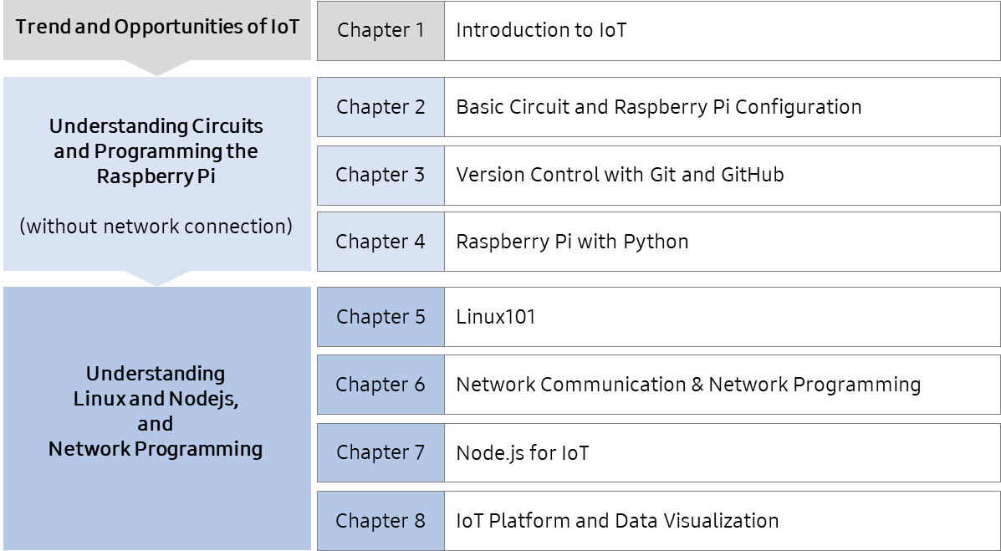

# **Course Details**

|  |  |  |
| --- | --- | --- |
| **Chapter** | **Details** | **Duration** |
| **1** | **Chapter 1. Introduction to IoT** | **20H (Total)** |
| [Objective] Understand the definition of IoT and market trends, especially about IoT components and features of IoT platform |
| Unit 1. IoT Overview   * Definition of IoT and background of IoT’s emergence | 3H |
| Unit 2. IoT Applications   * IoT technology and application in different industries | 4H |
| Unit 3. IoT Components   * Components of IoT and its features | 4H |
| Unit 4. IoT Platform   * Types of IoT platforms and their features | 4H |
| Unit 5. IoT Network   * Network environment for IoT | 4H |
| Quiz | 1H |
| **2** | **Chapter 2. Basic Circuit and Raspberry Pi Configuration** | **28H (Total)** |
| [Objective] Understand circuits and IoT devices and software; Learn how to connect and configure a development environment to run Raspberry Pi |
| Unit 1. How to Run Raspberry Pi   * Overview of Raspberry Pi * Getting Started with Raspberry Pi * Practice Environment Configuration | 3H |
| Unit 2. Understanding of Circuit   * Digital input and electric Circuits * LED and sensor: ultrasonic Sensor, 7-segment (4 Digit LED); and temperature-humidity sensor * Primary control programming * UART Communication * Making Process | 6H |
| Unit 3. Understanding of Sensor   * Definition and features of sensors * Classification and application of sensors | 6H |
| Unit 4. Basic Circuit & Components   * Basic electronics * Types of electronic parts * Interpretation of circuit diagram | 4H |
| Unit 5. Mini Project Using GPIO Zero   * GPIO Zero * Control LEDs, sensors, and buttons with GPIO Zero | 8H |
| Quiz | 1H |
| **3** | **Chapter 3. Version Control with Git and GitHub** | **14H (Total)** |
| [Objective] Understand version control of Git and GitHub and user interface and functions of GitHub; Distribute software with GitHub; Perform a collaborative mini-project |
| Unit 1. What is Version Control?   * Types and benefits of version control | 1H |
| Unit 2. Git: Overview & Installation   * Characteristics of Git * Installation of Git and GitHub | 3H |
| Unit 3. GitHub: Overview & Terminologies   * Overview and Terminologies of GitHub | 3H |
| Unit 4. How to Use GitHub   * Use GitHub when working along and through the GUI environment | 3H |
| Unit 5. Collaboration Using GitHub   * A collaborative project in Python programming using GitHub | 3H |
| Quiz | 1H |
| **4** | **Chapter 4. Raspberry Pi with Python** | **16H (Total)** |
| [Objective] Practice Python with a toy project using Raspberry Pi; Learn how to develop IoT devices using Python |
| Unit 1. CPU Usage Monitoring Project   * Control LED * Monitoring the Raspberry Pi board * Create text files * Carry out a toy project | 5H |
| Unit 2. Controlling Sensor’s Span Project   * Use a potentiometer and ultrasonic sensor * Create a toy project | 5H |
| Unit 3. Temperature Data Visualization Project   * Data visualization * Create a toy project | 5H |
| Quiz | 1H |
| **5** | **Chapter 5. Linux 101** | **16H (Total)** |
| [Objective] Understand Linux OS and Raspberry Pi OS; Learn the Editor and development environment used on the Raspberry Pi OS |
| Unit 1. Understanding Linux   * Understand Linux and its features * Raspberry Pi OS | 1H |
| Unit 2. Raspberry Pi OS Command Tutorial   * Understand and use Raspberry Pi commands * Learn how to do compiling, automated build, and debugging when programming in Linux, along with an understanding of gcc, make, makefile, and gdb | 6H |
| Unit 3. Shell Programming   * Understand Shell basics | 4H |
| Unit 4. Editors and IDEs   * Text editors * Nano * Integrated Development Environment (IDE) * Visual Studio Code (VSC) | 4H |
| Quiz | 1H |
| **6** | **Chapter 6. Network Communication and Network Programming** | **28H (Total)** |
| [Objective] Understand network and protocols; Understand socket programming and learn network programming using Raspberry Pi board; Be able to use the Raspberry Pi board as a DB server with practice |
| Unit 1. Understanding Network   * Network overview; devices and switching; transmission mode * Types of networks based on size and network topologies * Connect to network | 3H |
| Unit 2. Protocols   * Protocol overview * OSI Model, TCP/IP Protocol, HTTP, MQTT, CoAP, and Web Socket | 6H |
| Unit 3. Socket Programming   * TCP/IP Socket Programming * UDP Socket Programming * Multicast Programming | 6H |
| Unit 4. Socket Communication Tutorial with Raspberry Pi   * Serial Communication, SPI Communication, Bluetooth Communication, and Flask Web Server | 6H |
| Unit 5. Use Raspberry Pi as DB Server   * Use MariaDB and HeidiSQL * MariaDB application | 6H |
| Quiz | 1H |
| **7** | **Chapter 7. Node.js for IoT** | **15H (Total)** |
| [Objective] Understand basic Node.js concepts and the syntax and advanced programming techniques; Learn how to control various sensors of the Raspberry Pi based on Node.js. |
| Unit 1. Node.js Overview   * Concept of Node.js * Installation of development tools and create a node project * Sending log to the console * Using modules in Node and built-in modules | 2H |
| Unit 2. Basic Node.js Programming   * Understanding Events and Files * Remaining Log files | 4H |
| Unit 3. Raspberry Pi with Node-RED   * Control LED using Node-RED * Access Detection using Node-RED | 6H |
| Unit 4. Error Handling and Troubleshooting   * Most common errors and troubleshooting | 2H |
| Quiz | 1H |
| **8** | **Chapter 8. IoT Platform and Data Visualization** | **23H (Total)** |
| [Objective] Introduce IoT platforms as an example of representative standard oneM2M. Let’s get to know about the features and functions. Let’s use open-source platforms and applications and understand the importance of data visualization and learn about related open sources. |
| Unit 1. Using Platform   * oneM2M Platform Architecture * IoT Open Platform: OCEAN | 8H |
| Unit 2. IoT Open Platform Mobius Installation & Operation   * Mobius Platform Overview * Establishing a service environment | 6H |
| Unit 3. OpenHAB(Open Home Automation Bus)   * OpenHAB Overview * OpenHAB Installation and Demonstration * Configuring OpenHAB for MQTT Binding | 4H |
| Unit 4. Data Visualization   * Visualization concept & importance * Open source visualization tools: Grafana | 4H |
| Quiz | 1H |