**Sai Saketh Kosuri (002199401)**

**Program Structures & Algorithms Fall 2021**

**Assignment No. 05**

**Task:**

1. To implement a parallel sorting algorithm such that each partition of the array is sorted in parallel.
2. You should run with many different array sizes (they must be sufficiently large to make parallel sorting worthwhile, obviously) and different cut-off schemes.

**Relationship Conclusion:**

1. Considering large range of cut off values for the large array sizes , the time for execution of sorting the array is performing better when the cut off value is close to the half the array size.
2. Cut off should be N/2

**Findings:**

The experiment is performed considering large values for different array sizes {2000000, 2500000, 3000000, 3500000} and multiple cut off values ranging from 510000 to 1010000 with degrees of parallelisms 2 and 4. Below are the experiment values for each array size and parallelism.

Degree of parallelism: 2 Array Size – 2000000

cutoff：510000 10times Time:1459ms

cutoff：530000 10times Time:1295ms

cutoff：550000 10times Time:1312ms

cutoff：570000 10times Time:1313ms

cutoff：590000 10times Time:1306ms

cutoff：610000 10times Time:1306ms

cutoff：630000 10times Time:1316ms

cutoff：650000 10times Time:1316ms

cutoff：670000 10times Time:1312ms

cutoff：690000 10times Time:1262ms

cutoff：710000 10times Time:1243ms

cutoff：730000 10times Time:1267ms

cutoff：750000 10times Time:1252ms

cutoff：770000 10times Time:1282ms

cutoff：790000 10times Time:1312ms

cutoff：810000 10times Time:1311ms

cutoff：830000 10times Time:1331ms

cutoff：850000 10times Time:1318ms

cutoff：870000 10times Time:1289ms

cutoff：890000 10times Time:1261ms

cutoff：910000 10times Time:1254ms

cutoff：930000 10times Time:1250ms

cutoff：950000 10times Time:1251ms

cutoff：970000 10times Time:1500ms

cutoff：990000 10times Time:1335ms

cutoff：1010000 10times Time:977ms

Degree of parallelism: 2 Array Size – 2500000

cutoff：510000 10times Time:1631ms

cutoff：530000 10times Time:1342ms

cutoff：550000 10times Time:1393ms

cutoff：570000 10times Time:1330ms

cutoff：590000 10times Time:1371ms

cutoff：610000 10times Time:1408ms

cutoff：630000 10times Time:1312ms

cutoff：650000 10times Time:1324ms

cutoff：670000 10times Time:1327ms

cutoff：690000 10times Time:1326ms

cutoff：710000 10times Time:1292ms

cutoff：730000 10times Time:1323ms

cutoff：750000 10times Time:1300ms

cutoff：770000 10times Time:1312ms

cutoff：790000 10times Time:1502ms

cutoff：810000 10times Time:1289ms

cutoff：830000 10times Time:1347ms

cutoff：850000 10times Time:1340ms

cutoff：870000 10times Time:1356ms

cutoff：890000 10times Time:1330ms

cutoff：910000 10times Time:1358ms

cutoff：930000 10times Time:1363ms

cutoff：950000 10times Time:1308ms

cutoff：970000 10times Time:1339ms

cutoff：990000 10times Time:1284ms

cutoff：1010000 10times Time:1284ms

Degree of parallelism: 2 Array Size – 3000000

cutoff：510000 10times Time:1983ms

cutoff：530000 10times Time:1600ms

cutoff：550000 10times Time:1544ms

cutoff：570000 10times Time:1632ms

cutoff：590000 10times Time:1615ms

cutoff：610000 10times Time:1673ms

cutoff：630000 10times Time:1585ms

cutoff：650000 10times Time:1653ms

cutoff：670000 10times Time:1577ms

cutoff：690000 10times Time:1486ms

cutoff：710000 10times Time:1742ms

cutoff：730000 10times Time:1657ms

cutoff：750000 10times Time:1600ms

cutoff：770000 10times Time:1596ms

cutoff：790000 10times Time:1636ms

cutoff：810000 10times Time:1632ms

cutoff：830000 10times Time:1571ms

cutoff：850000 10times Time:1483ms

cutoff：870000 10times Time:1550ms

cutoff：890000 10times Time:1762ms

cutoff：910000 10times Time:1563ms

cutoff：930000 10times Time:1599ms

cutoff：950000 10times Time:1634ms

cutoff：970000 10times Time:1606ms

cutoff：990000 10times Time:1630ms

cutoff：1010000 10times Time:1617ms

Degree of parallelism: 2 Array Size – 3500000

cutoff：510000 10times Time:2235ms

cutoff：530000 10times Time:1902ms

cutoff：550000 10times Time:1874ms

cutoff：570000 10times Time:1911ms

cutoff：590000 10times Time:1954ms

cutoff：610000 10times Time:1883ms

cutoff：630000 10times Time:1878ms

cutoff：650000 10times Time:1914ms

cutoff：670000 10times Time:1807ms

cutoff：690000 10times Time:2036ms

cutoff：710000 10times Time:1926ms

cutoff：730000 10times Time:1908ms

cutoff：750000 10times Time:1868ms

cutoff：770000 10times Time:1923ms

cutoff：790000 10times Time:1891ms

cutoff：810000 10times Time:1815ms

cutoff：830000 10times Time:1795ms

cutoff：850000 10times Time:1891ms

cutoff：870000 10times Time:1854ms

cutoff：890000 10times Time:2167ms

cutoff：910000 10times Time:1963ms

cutoff：930000 10times Time:1936ms

cutoff：950000 10times Time:1892ms

cutoff：970000 10times Time:1894ms

cutoff：990000 10times Time:1905ms

cutoff：1010000 10times Time:1899ms

Degree of parallelism: 4 Array Size – 2000000

cutoff：510000 10times Time:1341ms

cutoff：530000 10times Time:1057ms

cutoff：550000 10times Time:1034ms

cutoff：570000 10times Time:1005ms

cutoff：590000 10times Time:1080ms

cutoff：610000 10times Time:1092ms

cutoff：630000 10times Time:1067ms

cutoff：650000 10times Time:1084ms

cutoff：670000 10times Time:1074ms

cutoff：690000 10times Time:1073ms

cutoff：710000 10times Time:1085ms

cutoff：730000 10times Time:1081ms

cutoff：750000 10times Time:1090ms

cutoff：770000 10times Time:1101ms

cutoff：790000 10times Time:1086ms

cutoff：810000 10times Time:1103ms

cutoff：830000 10times Time:1025ms

cutoff：850000 10times Time:1020ms

cutoff：870000 10times Time:1046ms

cutoff：890000 10times Time:1035ms

cutoff：910000 10times Time:1117ms

cutoff：930000 10times Time:1302ms

cutoff：950000 10times Time:1107ms

cutoff：970000 10times Time:1134ms

cutoff：990000 10times Time:1098ms

cutoff：1010000 10times Time:975ms

Degree of parallelism: 4 Array Size – 2500000

cutoff：510000 10times Time:1723ms

cutoff：530000 10times Time:1362ms

cutoff：550000 10times Time:1429ms

cutoff：570000 10times Time:1485ms

cutoff：590000 10times Time:1454ms

cutoff：610000 10times Time:1469ms

cutoff：630000 10times Time:948ms

cutoff：650000 10times Time:955ms

cutoff：670000 10times Time:947ms

cutoff：690000 10times Time:946ms

cutoff：710000 10times Time:934ms

cutoff：730000 10times Time:1072ms

cutoff：750000 10times Time:1007ms

cutoff：770000 10times Time:970ms

cutoff：790000 10times Time:960ms

cutoff：810000 10times Time:965ms

cutoff：830000 10times Time:987ms

cutoff：850000 10times Time:993ms

cutoff：870000 10times Time:984ms

cutoff：890000 10times Time:988ms

cutoff：910000 10times Time:931ms

cutoff：930000 10times Time:935ms

cutoff：950000 10times Time:937ms

cutoff：970000 10times Time:936ms

cutoff：990000 10times Time:954ms

cutoff：1010000 10times Time:950ms

Degree of parallelism: 4 Array Size – 3000000

cutoff：510000 10times Time:2065ms

cutoff：530000 10times Time:1730ms

cutoff：550000 10times Time:1730ms

cutoff：570000 10times Time:1770ms

cutoff：590000 10times Time:1791ms

cutoff：610000 10times Time:1829ms

cutoff：630000 10times Time:1812ms

cutoff：650000 10times Time:1757ms

cutoff：670000 10times Time:1720ms

cutoff：690000 10times Time:1863ms

cutoff：710000 10times Time:1833ms

cutoff：730000 10times Time:1833ms

cutoff：750000 10times Time:1843ms

cutoff：770000 10times Time:1239ms

cutoff：790000 10times Time:1205ms

cutoff：810000 10times Time:1217ms

cutoff：830000 10times Time:1193ms

cutoff：850000 10times Time:1171ms

cutoff：870000 10times Time:1177ms

cutoff：890000 10times Time:1429ms

cutoff：910000 10times Time:1231ms

cutoff：930000 10times Time:1190ms

cutoff：950000 10times Time:1209ms

cutoff：970000 10times Time:1235ms

cutoff：990000 10times Time:1237ms

cutoff：1010000 10times Time:1287ms

Degree of parallelism: 4 Array Size – 3500000

cutoff：510000 10times Time:2329ms

cutoff：530000 10times Time:2093ms

cutoff：550000 10times Time:2083ms

cutoff：570000 10times Time:2093ms

cutoff：590000 10times Time:2083ms

cutoff：610000 10times Time:2097ms

cutoff：630000 10times Time:2137ms

cutoff：650000 10times Time:2155ms

cutoff：670000 10times Time:2097ms

cutoff：690000 10times Time:1995ms

cutoff：710000 10times Time:2184ms

cutoff：730000 10times Time:2138ms

cutoff：750000 10times Time:2125ms

cutoff：770000 10times Time:2162ms

cutoff：790000 10times Time:2070ms

cutoff：810000 10times Time:1998ms

cutoff：830000 10times Time:1979ms

cutoff：850000 10times Time:2018ms

cutoff：870000 10times Time:2007ms

cutoff：890000 10times Time:1390ms

cutoff：910000 10times Time:1426ms

cutoff：930000 10times Time:1618ms

cutoff：950000 10times Time:1481ms

cutoff：970000 10times Time:1504ms

cutoff：990000 10times Time:1470ms

cutoff：1010000 10times Time:1472ms

**Output Screenshots:**

Array Size – 2000000

Degree of parallelism – 2

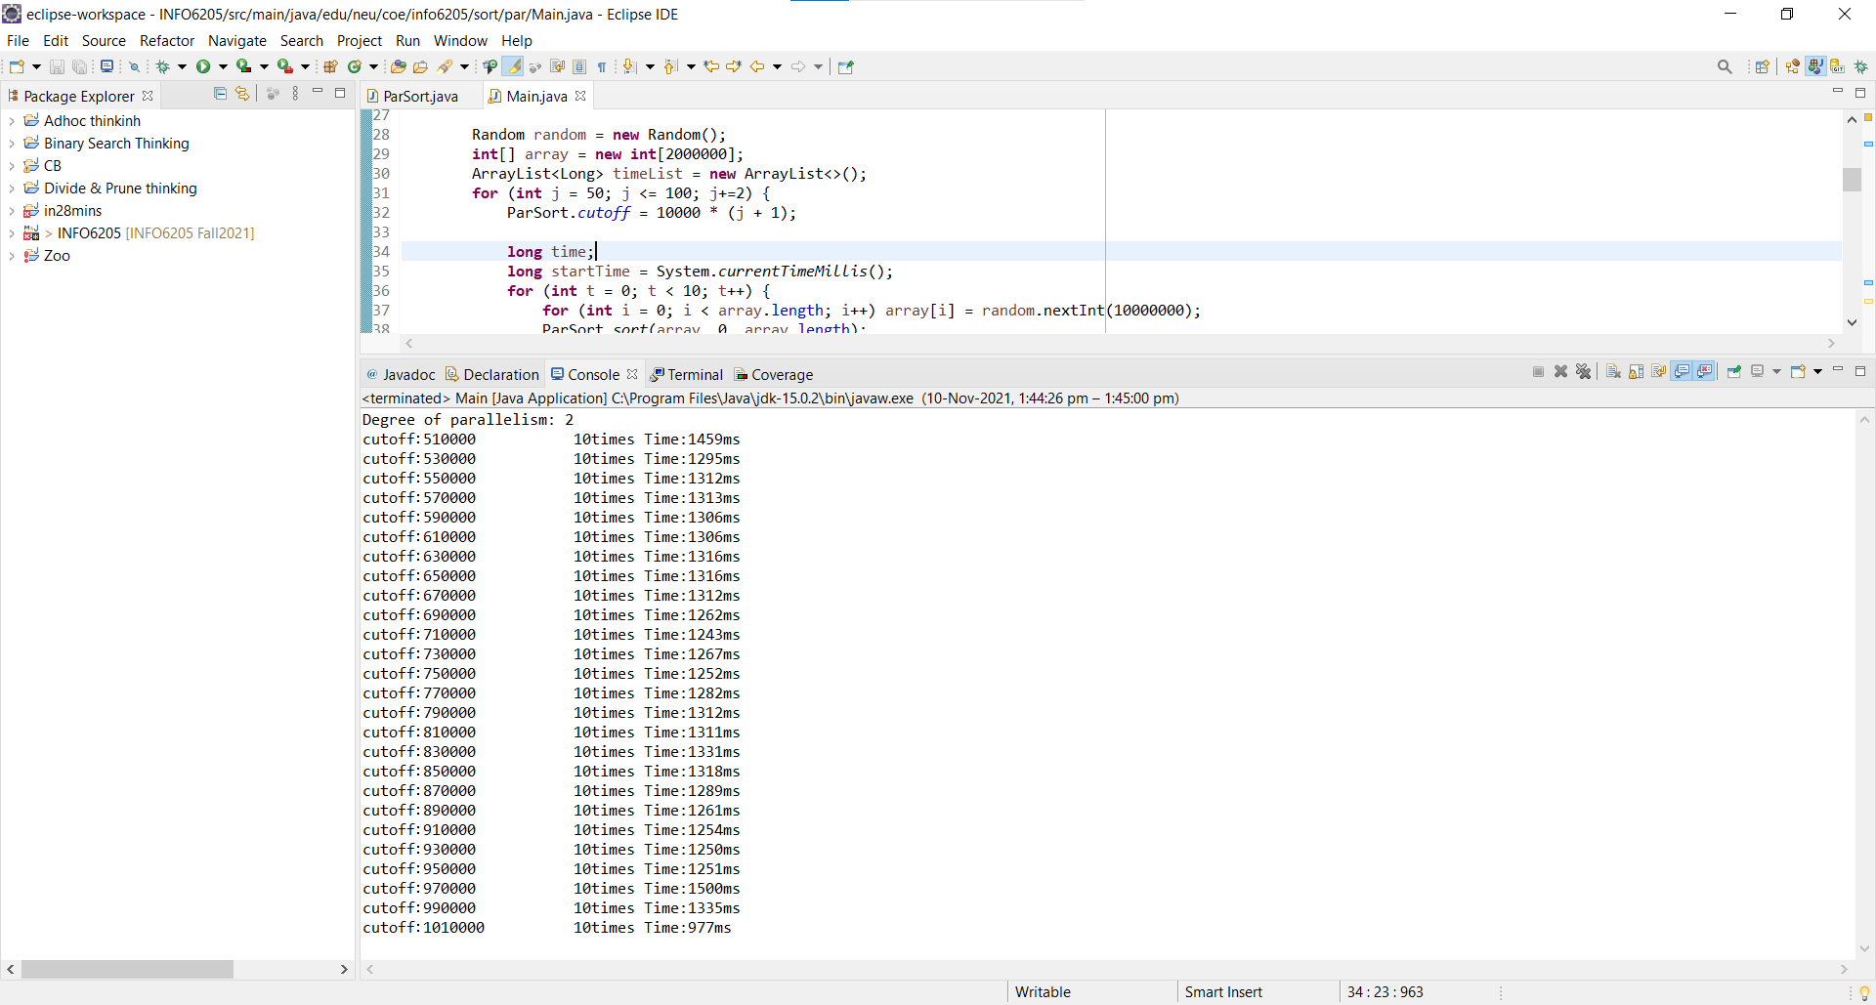

Array Size – 2500000

Degree of parallelism – 2

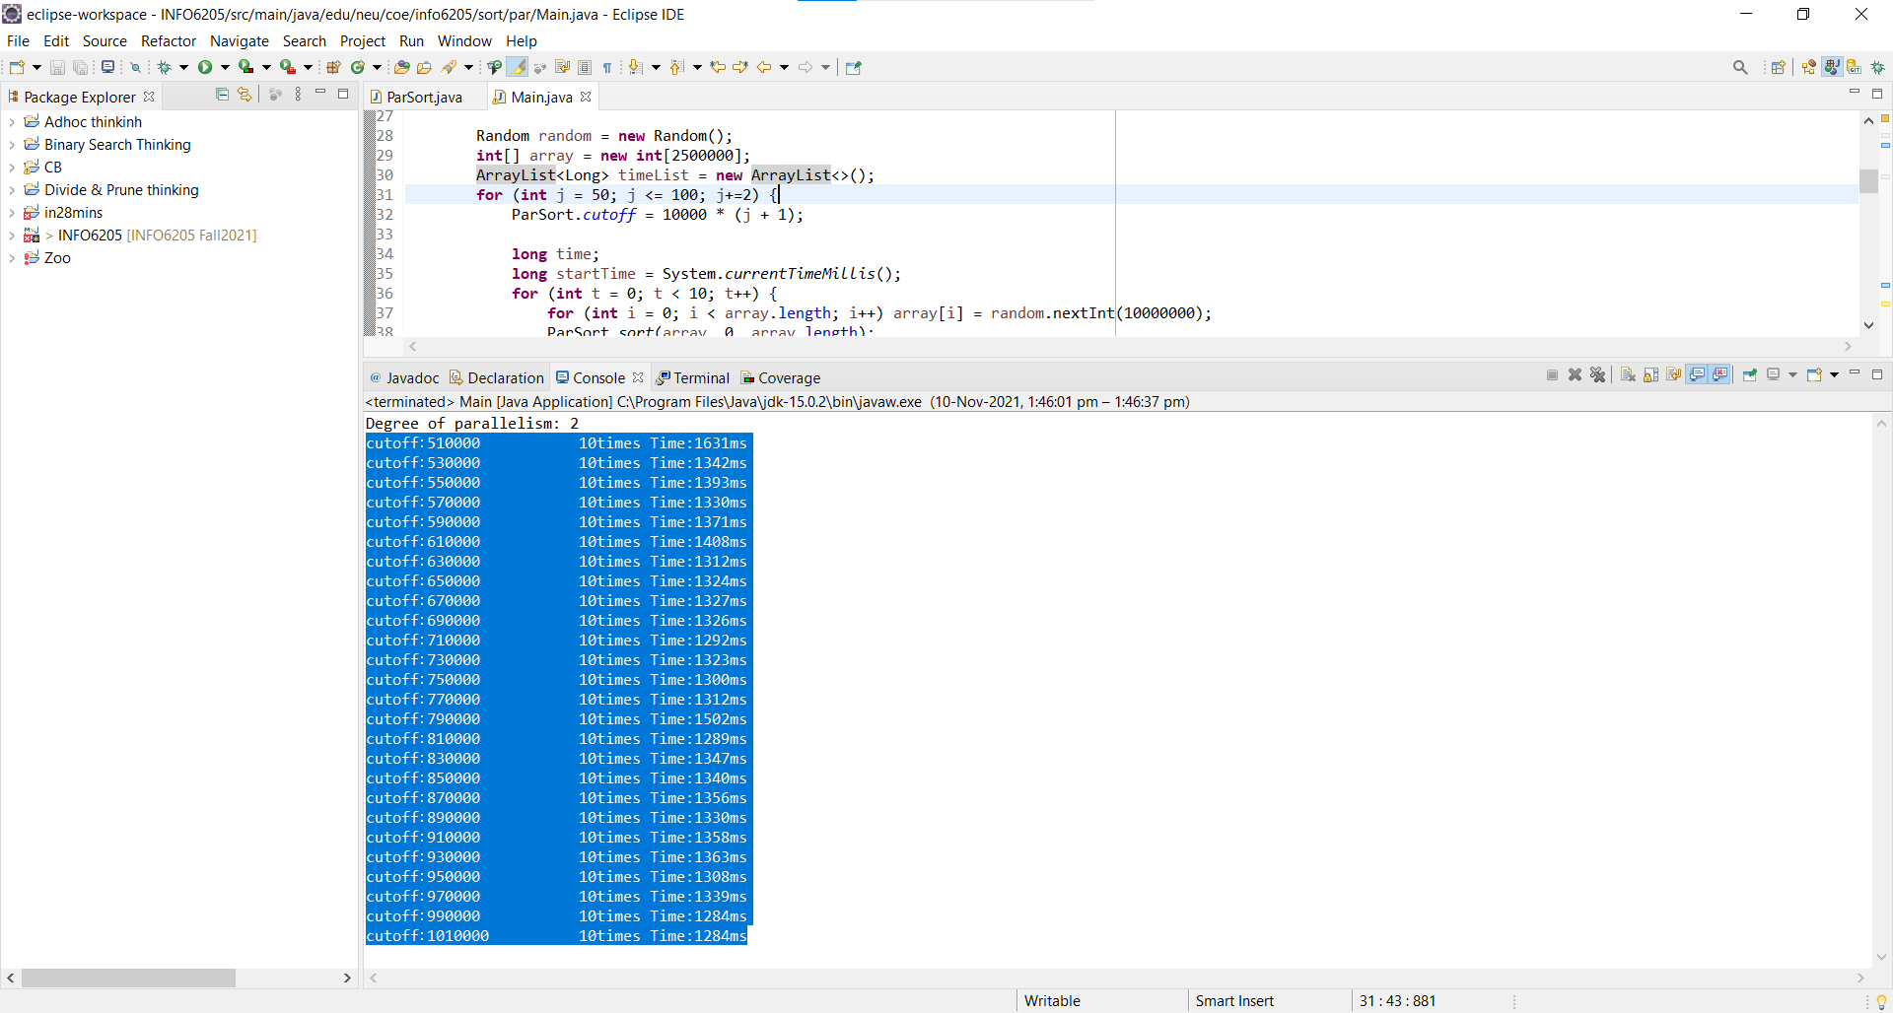

Array Size – 3000000

Degree of parallelism – 2

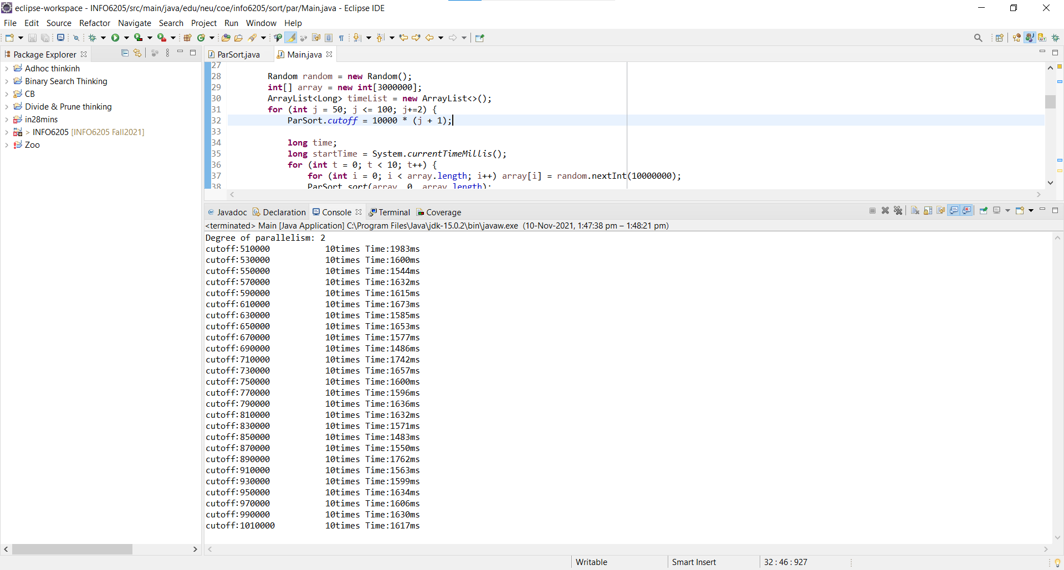

Array Size – 3500000

Degree of parallelism – 2

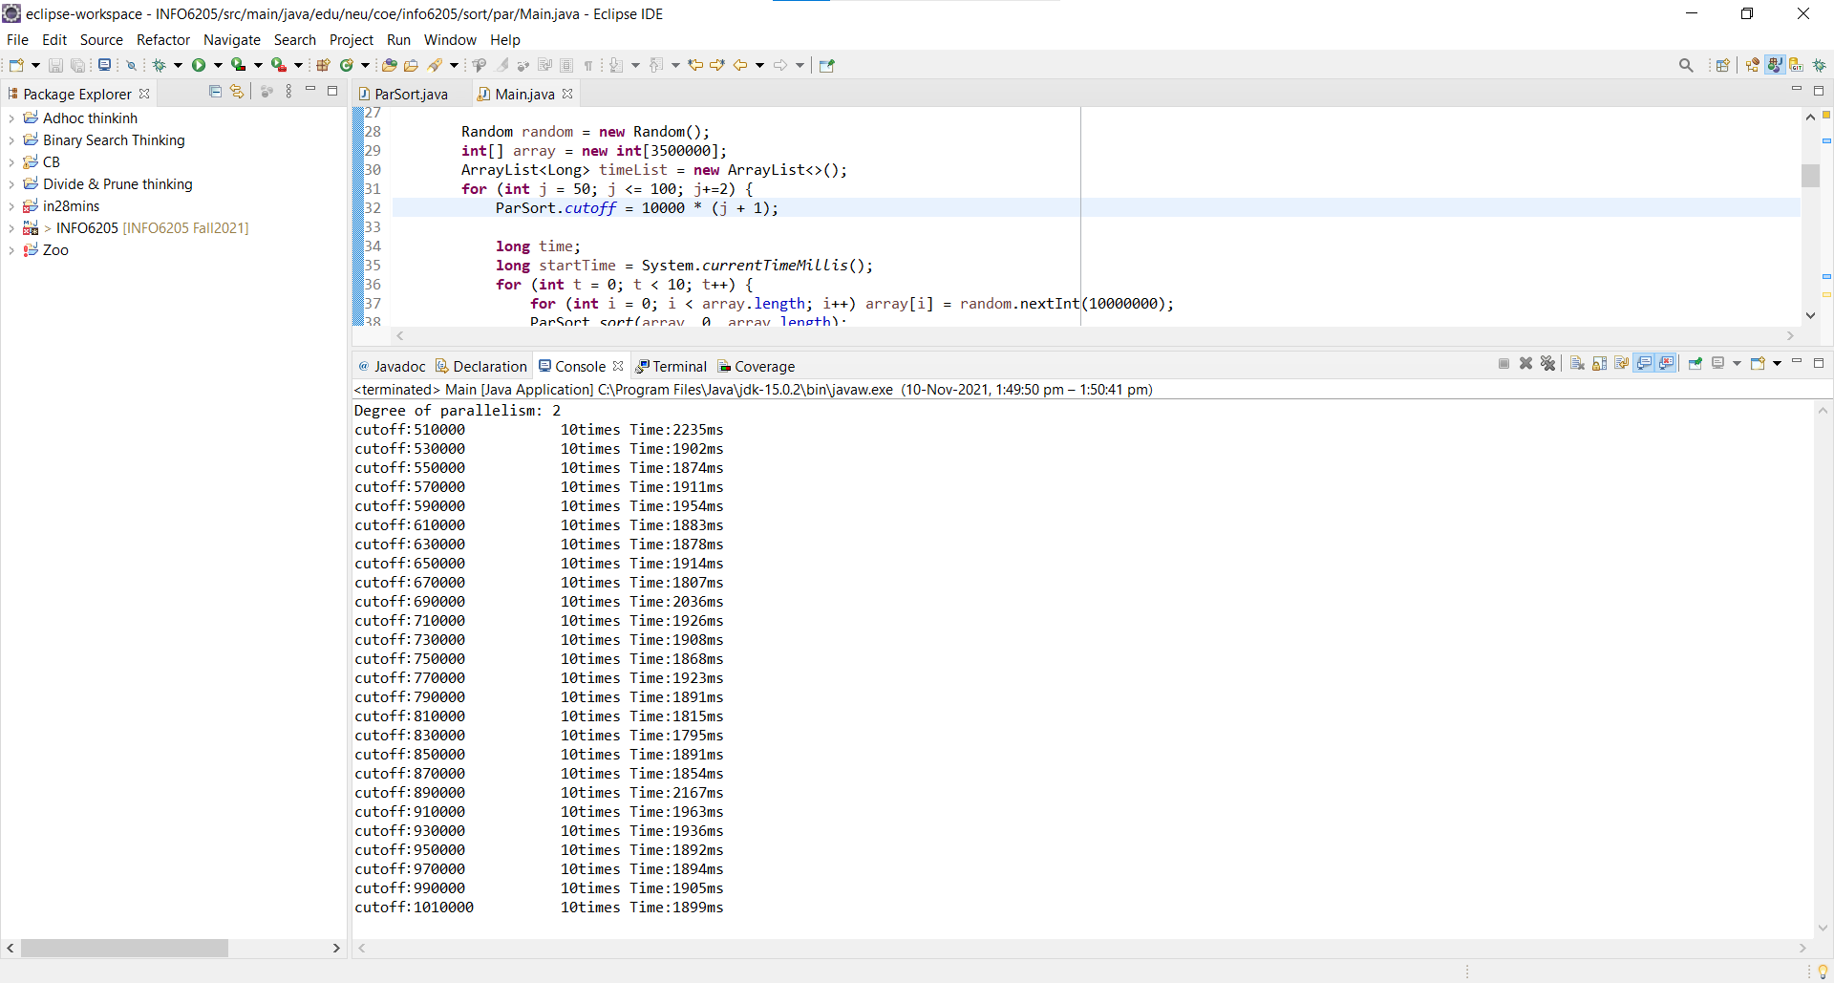

Array Size – 2000000

Degree of parallelism – 4

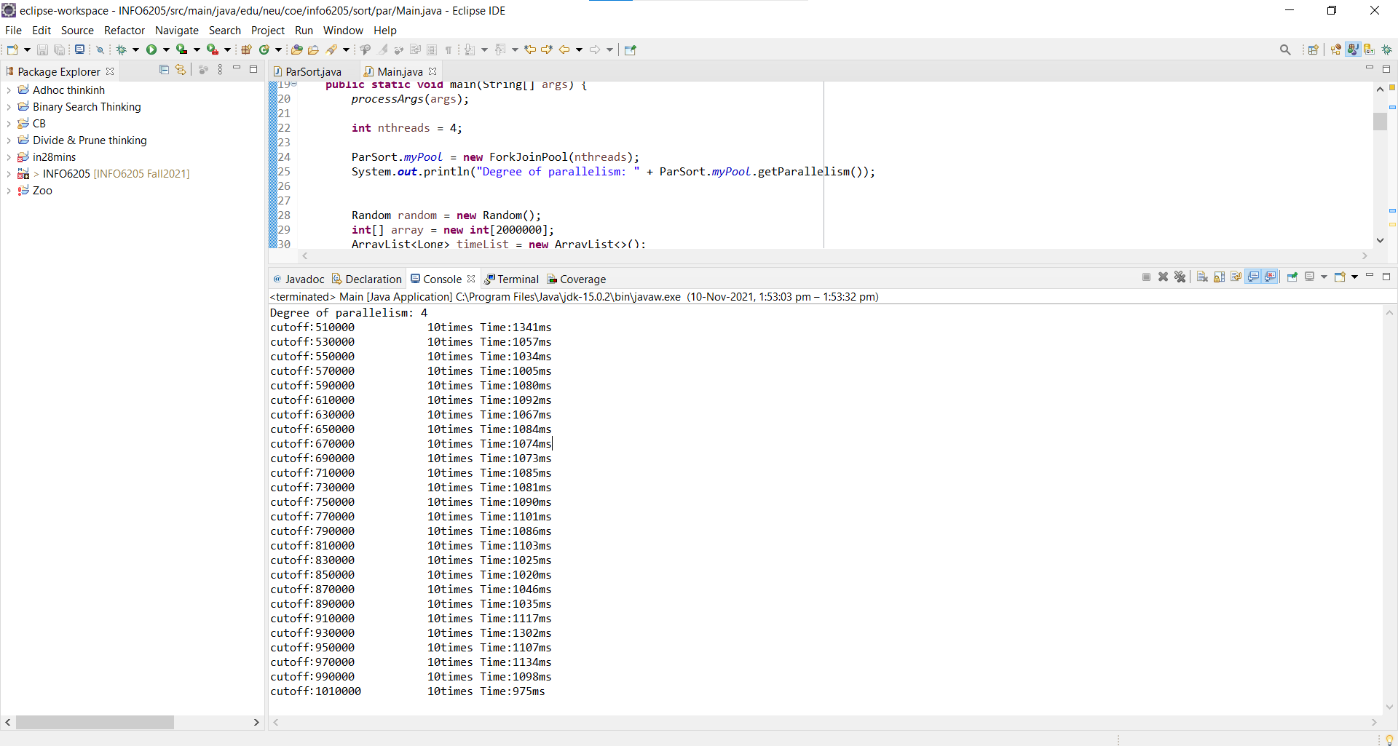

Array Size – 2500000

Degree of parallelism – 4

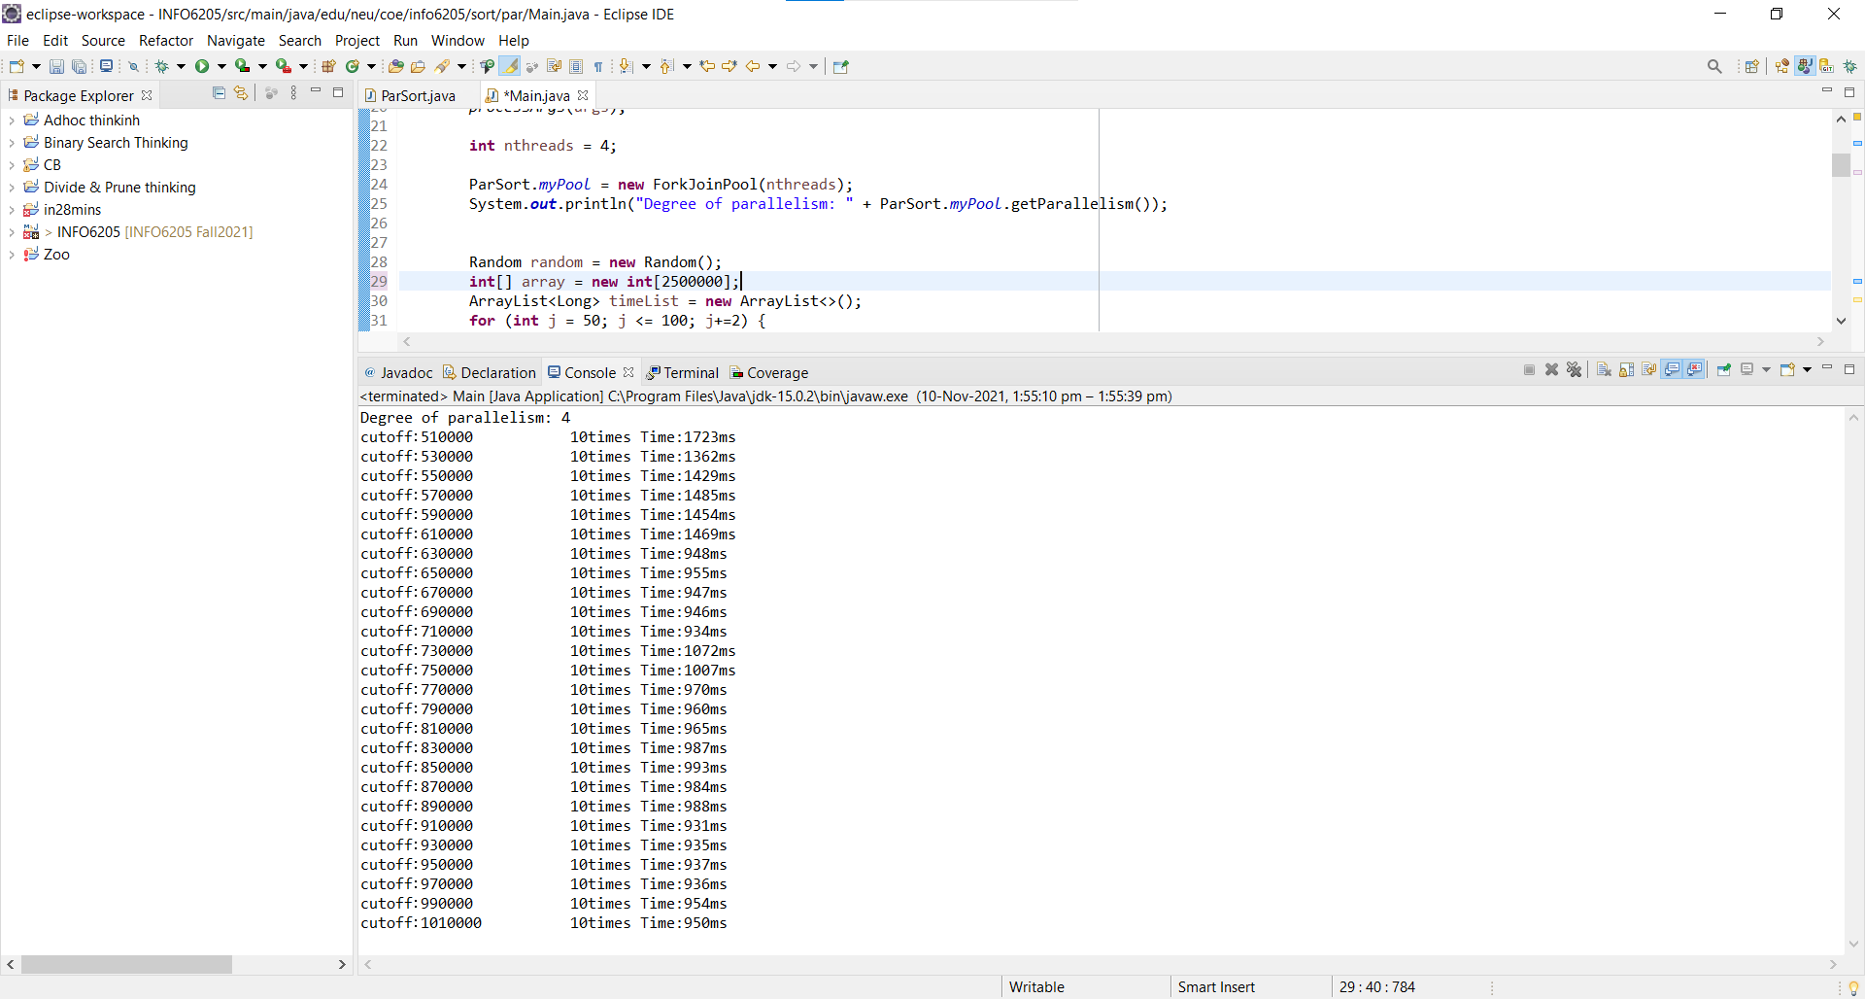

Array Size – 3000000

Degree of parallelism – 4

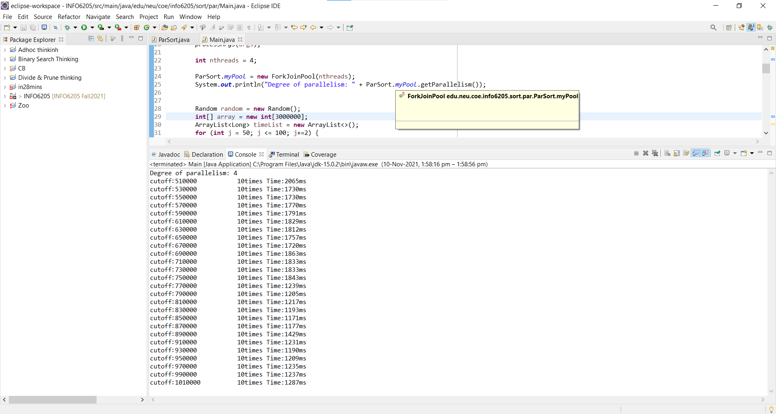

Array Size – 3500000

Degree of parallelism – 4

