Fine Jewelry E-Commerce Platform

Title: Aura & Gem Fine Jewelers
Module: Decision Analytics (Level 6)
Document: Technical Coursework Report
Database: MongoDB Community & Compass (Document Store NoSQL)
Application Stack: Node.js, Express, EJS, Native MongoDB, BcryptJS

Table of Contents
1. Introduction and Business Problem 2
1.1 Business Scenario 2
1.2 Limitations of Relational Databases (SQL) 2
1.3 The Proposed NoSQL Solution 3
2. Characteristics of NoSQL and MongoDB 3
2.1 The Four Families of NoSQL Databases 3
2.2 The Document Model and BSON Format 4
2.3 Flexible and Dynamic Schemas 4
2.4 Scalability: Horizontal vs. Vertical 4
2.5 High Availability with Replica Sets 4
2.6 Document-Level Locking 4
3. Real-World Applications of Document Stores 4
4. System Architecture and Data Modeling 5
4.1 Embedding vs. Referencing Decision Matrix 5
4.2 Database Relationship Diagram 5
4.3 Database Collection Schemas 6
5. Technical Implementation and Database Queries 6
5.1 Full-Text Product Search 6
5.2 Customer Wishlist Management (Array Operators) 7
5.3 Order Checkout and Atomic Stock Reduction 7
5.4 Customer Registration and Password Hashing 7
5.5 Advanced Aggregation Pipelines (Analytics) 8
5.6 System Verification and Structured Test Cases 8
6. Evaluation: Strengths and Limitations 9
6.1 Strengths 9
6.2 Limitations, Trade-offs, and Critical Reflection 9
7. Conclusion 10
8. References 10
Appendix A: System Setup 10
Appendix B: User Interface Walkthrough 11
Appendix C: MongoDB Shell & Query Reference Guide 12
Appendix D: MongoDB Compass Schema Verification & Visual Evidence 14

1. Introduction and Business Problem

1.1 Business Scenario
Aura & Gem is an online fine jewelry boutique selling luxury handcrafted pieces across four main categories: rings, necklaces, bracelets, and earrings. Each category requires unique physical and gemological specifications:
Rings: Finger sizes (e.g., 5 to 9), metal purity (18K Gold, Platinum), and diamond certifications (GIA).
Necklaces: Adjustable chain lengths (e.g., 16-18 inches), gemstone dimensions, and setting styles.
Bracelets: Wrist lengths, link structures, clasp types, and total carat weights.
Earrings: Backing mechanisms (screw back, friction post) and drop profiles.
Customers require these specific details to make informed luxury purchases online.

1.2 Limitations of Relational Databases (SQL)
Traditional relational databases (such as MySQL or PostgreSQL) store data in fixed tabular structures. When applied to high-variety jewelry catalogs, SQL introduces two major problems:
- Empty (NULL) Columns: Storing all jewelry in one table results in dozens of empty columns. For example, a necklace will have a blank ring_size . This wastes storage and creates messy tables.
- Slow Table Joins: Alternatively, splitting attributes into multiple normalized tables (e.g., products, attributes, values) requires complex multi-table joins for every product page view. As traffic increases, these joins degrade read speeds.
Furthermore, SQL table-level or row-level locking during peak sales events creates bottlenecks when multiple customers update wishlists or place orders simultaneously.
The table below contrasts the limitations of a relational database against the architectural solutions provided by our MongoDB document model for the fine jewelry domain:
Architectural Dimension | Traditional Relational (SQL) Design | Aura & Gem Document (MongoDB) Design | Operational & Business Benefit
Product Specifications | Single table with dozens of empty NULL columns, or complex EAV (Entity-Attribute-Value) pattern with multiple joined tables. | Single products collection where each piece embeds a flexible attributes sub-document containing only relevant properties. | Zero wasted storage; new jewelry categories can be introduced immediately without schema migrations.
Customer Accounts & Address | Separate normalized tables (customers, addresses) requiring join queries upon customer login. | Embedded delivery_address sub-document stored directly within the customer document. | Complete profile and shipping data loads in a single high-speed read operation upon sign-in.
Customer Wishlist | Relational junction table (customer_wishlists) requiring many-to-many joins across tables. | Embedded array of ObjectId references directly inside the customer document. | Atomic array operators ($addToSet, $pull) enable instant, join-free updates without table locks.
Order Receipts & History | Normalized schema joining orders, order_items, and products tables. | Embedded array of order item snapshots capturing price, title, and quantity at checkout time. | Guarantees immutable historical receipts even if catalog prices or titles change later.
Role-Based Access Control | Separate user roles and permissions tables requiring multi-table lookup queries. | Direct role attribute ('admin' vs 'customer') stored in document, evaluated by Express route guards. | Low-latency authorization separating customer shopping from administrative management controls.

1.3 The Proposed NoSQL Solution
To overcome these limitations, Aura & Gem was built using MongoDB, a document-oriented NoSQL database. MongoDB stores each product as a self-contained BSON document, allowing varied attributes to sit naturally inside an embedded sub-document.
Built on Node.js and Express, the application delivers:
Flexible Catalog: All jewelry categories coexist in one collection without empty columns.
Full-Text Search: A compound text index enables fast multi-attribute product searches.
Embedded Wishlists: Customers update their wishlist in real time using atomic array operators.
Secure Authentication: User accounts use 10-round salted bcrypt hashing for safe credential storage.
Safe Order Processing: Order documents store price snapshots at checkout, while stock decreases safely on the server using the atomic $inc operator.
Live Analytics: MongoDB aggregation pipelines calculate live product review ratings and admin category inventory statistics.

2. Characteristics of NoSQL and MongoDB

2.1 The Four Families of NoSQL Databases
NoSQL Family | Data Model | Key Strengths | Common Use Cases
Document Store (e.g.,  MongoDB) | JSON/BSON documents | Flexible schema, nested arrays/objects, rich queries | Product catalogs, customer profiles, content management
Key-Value Store (e.g., Redis) | Key and value pairs | Sub-millisecond read/write speeds | Session storage, caching, shopping carts
Wide-Column Store (e.g., Cassandra) | Dynamic column families | Massive write speeds across distributed nodes | Sensor data, time-series logging
Graph Database (e.g., Neo4j) | Nodes and edges (relationships) | Fast traversal of interconnected data | Social networks, fraud detection

Why Document Stores Fit E-Commerce: Retail items are naturally hierarchical. Products have nested specifications, customer accounts have delivery addresses and wishlists, and orders have lists of purchased items. Storing each complete record in a single document eliminates complex joins and matches how application code works.

2.2 The Document Model and BSON Format
MongoDB stores data as BSON (Binary JSON), extending normal JSON with native types:
ObjectId : Globally unique 12-byte identifiers generated automatically for each document.
ISODate : 64-bit integer storing millisecond timestamps for orders and reviews.
Number : Supports integers and decimals for exact pricing and inventory calculations.
Because documents store data in objects and arrays, application code works directly with native data structures without object-relational mapping overhead.

2.3 Flexible and Dynamic Schemas
MongoDB collections do not enforce rigid table schemas:
All products share standard fields like name , price , and stock_quantity .
Category-specific properties sit inside an attributes sub-document (e.g., sizes_available for rings, chain_length for necklaces).
New jewelry categories can be introduced immediately without running database migrations or taking the store offline.

2.4 Scalability: Horizontal vs. Vertical
Vertical Scaling (SQL): Upgrading a single server with more CPU and RAM. This approach quickly reaches hardware limits and becomes expensive.
Horizontal Scaling (MongoDB): MongoDB partitions data across multiple affordable server nodes (sharding) using a shard key. As traffic or catalog size expands, additional servers are added without code changes.

2.5 High Availability with Replica Sets
MongoDB uses Replica Sets (a primary node with secondary backups):
All write operations are recorded on the primary node.
Secondary nodes replicate data in real time.
If the primary node fails, secondary nodes automatically elect a new primary within seconds, ensuring zero downtime.

2.6 Document-Level Locking
MongoDB uses the WiredTiger engine, which locks only the specific document being modified. Multiple shoppers can browse items, update wishlists, and complete purchases at the same time without locking other users out.

3. Real-World Applications of Document Stores

- E-Commerce Catalogs (e.g., eBay, OTTO): Managing millions of products across diverse categories. Storing different specifications in documents provides fast browsing and simple catalog expansions.
- Customer Profiles: Aggregating contact information, delivery addresses, and saved wishlists in one user document allows single-read retrieval upon login.
- Order Receipts and Price Snapshots: Capturing item prices and names directly inside an order document at the moment of checkout guarantees that past receipts remain permanently accurate.
- Live Operational Analytics: Calculating customer review scores and category inventory summaries directly from live data using built-in aggregation pipelines.

4. System Architecture and Data Modeling

4.1 Embedding vs. Referencing Decision Matrix

Relationship | Design Pattern | Justification
Category to Products | Referencing (category_id in products) | One-to-Many. Embedding all products inside a category would risk hitting the 16MB document limit and make inventory updates difficult.
Product to Specifications | Embedding (attributes sub-document) | One-to-One. Artisan details (ring sizes, gold purity, chain length) are unique to the piece, always read together, and bounded in size.
Customer to Address | Embedding (delivery_address sub-document) | One-to-One. Shipping addresses are always read alongside the customer profile. Co-locating eliminates join overhead.
Customer to Wishlist | Embedding (Array of ObjectId references) | Finite One-to-Many. A personal wishlist rarely exceeds 50 items. Embedding IDs allows single-read loading and atomic updates via $addToSet and $pull.
User Account & Roles | Direct Attribute (role in customers collection) | Determines Role-Based Access Control ('admin' vs 'customer') for instant server-side authorization without role-table joins.
Product to Reviews | Referencing (product_id in reviews collection) | Unbounded One-to-Many. Popular items can accumulate hundreds of reviews over time. Referencing prevents document bloat.
Order to Order Items | Embedding (Snapshot sub-documents in orders.items) | Business Rule. Order receipts must permanently preserve the purchase price, piece title, and quantity even if catalog prices change later.
In summary, the schema adheres strictly to standard MongoDB design principles: data that is bounded in size, unique to a single parent entity, and accessed together is embedded. Data that is shared across multiple records, independent in lifecycle, or unbounded in potential growth is referenced.

4.2 Database Relationship Diagram
[
Categories ] (1) ──references── (*) [ Products
]

│ (1)

references

│ (*)

[
Reviews
]
[
Customers ] ──embeds──> { delivery_address, wishlist: [ObjectId]
}

│ (1)
references

│ (*)
[
Orders ] ──embeds──> [ { product_id, name, price_at_purchase, quantity }
]

4.3 Database Collection Schemas
// 1. categories
{

"_id": "ObjectId('64f1a2b3c4d5e6f7a8b9c001')",

"name": "Rings",

"description": "Handcrafted engagement, wedding, and fashion rings.",

"display_order": 1
}
// 2. products
{

"_id": "ObjectId('64f1a2b3c4d5e6f7a8b9c002')",

"name": "18K Gold Solitaire Diamond Ring",

"category_id": "ObjectId('64f1a2b3c4d5e6f7a8b9c001')",

"price": 1250.00,

"metal_type": "Yellow Gold",

"gemstone": "Diamond",

"stock_quantity": 12,

"image_url": "https://images.unsplash.com/photo-1605100804763-247f67b3557e",

"attributes": { "sizes_available": [5, 6, 7, 8], "weight_grams": 3.8, "certification": "GIA" }
}
// 3. customers
{

"_id": "ObjectId('64f1a2b3c4d5e6f7a8b9c003')",

"name": "Sarah Jenkins",

"email": "sarah.j@example.com",

"password_hash": "$2a$10$7vM8j9K...hashed_password",

"delivery_address": { "street": "742 Evergreen Terr", "city": "Springfield", "state": "OR", "zip":

"97477" },

"wishlist": [ "ObjectId('64f1a2b3c4d5e6f7a8b9c002')" ]
}
// 4. reviews
{

"_id": "ObjectId('64f1a2b3c4d5e6f7a8b9c004')",

"product_id": "ObjectId('64f1a2b3c4d5e6f7a8b9c002')",

"customer_name": "Sarah Jenkins",

"rating": 5,

"comment": "Immaculate gold finish. She loved it!",

"review_date": "ISODate('2024-02-18T14:20:00Z')"
}
// 5. orders
{

"_id": "ObjectId('64f1a2b3c4d5e6f7a8b9c005')",

"customer_id": "ObjectId('64f1a2b3c4d5e6f7a8b9c003')",

"items": [ { "product_id": "ObjectId('64f1a2b3c4d5e6f7a8b9c002')", "name": "18K Gold Solitaire

Ring", "quantity": 1, "price_at_purchase": 1250.00 } ],

"subtotal": 1250.00,

"tax": 100.00,

"total_price": 1350.00,

"status": "Completed"
}

5. Technical Implementation and Database Queries

5.1 Full-Text Product Search
A compound text index enables search across names, descriptions, metals, and gemstones:
// Define index across product text attributes
await db.collection('products').createIndex({

name: 'text', description: 'text', metal_type: 'text', gemstone: 'text'
})
;
// Execute keyword search
const filter = req.query.search ? { $text: { $search: req.query.search } } : {};
const products = await db.collection('products').find(filter).toArray();

5.2 Customer Wishlist Management (Array Operators)
Instead of using join tables, customer wishlists update in-place using atomic array operators:
// Add to wishlist ($addToSet prevents duplicates)
await db.collection('customers').updateOne(

{
_id: new ObjectId(customerId) },

{
$addToSet: { wishlist: new ObjectId(productId) }
}
)
;
// Remove from wishlist ($pull removes matching ID)
await db.collection('customers').updateOne(

{
_id: new ObjectId(customerId) },

{
$pull: { wishlist: new ObjectId(productId) }
}
)
;

5.3 Order Checkout and Atomic Stock Reduction
During checkout, the system verifies the user session, snapshots item prices, and decrements stock atomically using
$in
// 1. Session verification guard
const customerId = req.session.currentCustomerId;
if (!customerId) return res.redirect('/login');
// 2. Snapshot price and atomically decrease stock
for (const item of cart) {
const product = await db.collection('products').findOne({ _id: new ObjectId(item.productId) });
orderItems.push({ product_id: product._id, name: product.name, price_at_purchase: product.price, quantity: item.quantity });
await db.collection('products').updateOne(
{ _id: product._id },
{ $inc: { stock_quantity: -item.quantity } }
);
}
// 3. Insert complete order document
await db.collection('orders').insertOne({ customer_id: new ObjectId(customerId), items: orderItems, total_price: totalPrice, status: 'Completed', order_date: new Date() });

// Add to wishlist ($addToSet prevents duplicates)
await db.collection('customers').updateOne(

{
_id: new ObjectId(customerId) },

{
$addToSet: { wishlist: new ObjectId(productId) }
}
)
;
// Remove from wishlist ($pull removes matching ID)
await db.collection('customers').updateOne(

{
_id: new ObjectId(customerId) },

{
$pull: { wishlist: new ObjectId(productId) }
}
)
;

5.4 Customer Registration and Password Hashing

Passwords are salted and hashed using `bcrypt` (10 rounds) before insertion into MongoDB:

// Registration: hash password and insert document
const password_hash = await bcrypt.hash(req.body.password, 10);
await db.collection('customers').insertOne({ name: req.body.name, email: req.body.email.toLowerCase(), password_hash, delivery_address: req.body.address, wishlist: [] });
// Login: find customer and verify hash
const customer = await db.collection('customers').findOne({ email: req.body.email.toLowerCase() });
if (customer && await bcrypt.compare(req.body.password, customer.password_hash)) {
req.session.currentCustomerId = customer._id.toString();
}

5.5 Advanced Aggregation Pipelines (Analytics)
Pipeline 1: Live Product Star Rating
Calculates the average rating directly from the reviews collection:
const ratingPipeline = [
{ $match: { product_id: new ObjectId(productId) } },
{ $group: { _id: '$product_id', avgRating: { $avg: '$rating' }, totalReviews: { $sum: 1 } } }
];
const result = await db.collection('reviews').aggregate(ratingPipeline).toArray();

Pipeline 2: Admin Category Inventory Intelligence
Groups products by category, joins category names, and calculates totals:
const adminPipeline = [
{ $group: { _id: '$category_id', totalProducts: { $sum: 1 }, avgPrice: { $avg: '$price' }, totalStock: { $sum: '$stock_quantity' } } },
{ $lookup: { from: 'categories', localField: '_id', foreignField: '_id', as: 'category' } },
{ $unwind: '$category' },
{ $sort: { 'category.display_order': 1 } }
];
const categoryStats = await db.collection('products').aggregate(adminPipeline).toArray();

5.6 System Verification and Structured Test Cases
To verify system functionality, data consistency, and role-based access control, a structured test suite was executed against the running application and verified directly within MongoDB Compass. All 15 functional test cases succeeded with expected outputs:
Test ID | Module | Test Scenario / Action | Expected Outcome | Actual Outcome | Status
T01 | Authentication | Admin sign-in via /admin/login | Redirects to /admin with Authenticated Administrator badge | Granted dashboard access; admin header visible | Pass
T02 | Authentication | Customer sign-in via /login | Redirects to personal customer profile | Granted customer account access | Pass
T03 | Access Control | Customer visits /admin directly | Access denied with HTTP 403 Forbidden page | 403 Forbidden page rendered | Pass
T04 | Security (IDOR) | Customer A enters Customer B's profile URL | Redirects Customer A safely back to own profile | Safely redirected; profile data isolated | Pass
T05 | Product Catalog | Search keyword (e.g. 'Emerald') | Returns matching pieces using compound text index | Matching pieces returned accurately | Pass
T06 | Product Catalog | Category filter selection | Queries products by category_id reference | Filtered pieces displayed in catalog view | Pass
T07 | Wishlist | Customer clicks 'Save to Wishlist' | Appends product ID using $addToSet without duplicates | Product saved to profile wishlist | Pass
T08 | Wishlist | Customer clicks 'Remove' on account page | Pulls product ID from wishlist array using $pull | Item removed from wishlist | Pass
T09 | Wishlist | Guest visitor views product page | Displays 'Sign In to Save to Wishlist' link | Link displayed; redirects to /login | Pass
T10 | Inventory Control | Order quantity exceeds available stock | Halts checkout with alert; prevents negative stock | Checkout blocked; alert shown on cart | Pass
T11 | Checkout | Customer places valid order | Atomic stock reduction via $inc and order document created | Stock decremented; order receipt created | Pass
T12 | Admin Management | Admin adds new jewelry piece | Inserts new product document with dynamic attributes | Piece published to catalog immediately | Pass
T13 | Admin Management | Admin deletes catalog listing | Permanently deletes product, pulls from wishlists, removes reviews | Product purged and references cleaned | Pass
T14 | Data Integrity | Admin attempts deleting category with pieces | Blocks deletion; alerts that active pieces exist | Deletion blocked; alert displayed | Pass
T15 | Analytics | Customer submits product review | Aggregation pipeline averages review ratings live | Live rating and review count displayed | Pass

6. Evaluation: Strengths and Limitations

6.1 Strengths
Schema Flexibility: New jewelry categories can be introduced immediately without altering database tables. Fast Read Performance: Embedding wishlists and addresses inside the customer document eliminates multi-table joins.
Atomic Safety: The $inc operator safely updates inventory on the server, avoiding race conditions.
Built-in Analytics: Aggregation pipelines generate real-time ratings and inventory metrics from live operational data.

6.2 Limitations, Trade-offs, and Critical Reflection
16MB Document Cap: Handled by referencing reviews and orders instead of embedding them indefinitely.
No Built-in Cascade Delete: Referential checks are managed safely within the Node.js application logic.
Index Memory Requirements: Only necessary search and reference fields are indexed, keeping the RAM footprint low.
Duplicate Data in Orders: Product names and prices are duplicated in orders to guarantee immutable historical receipts.
Application-Enforced Referential Integrity: Unlike relational database management systems that support native foreign key constraints and automated cascade deletes, MongoDB delegates referential integrity to the application layer. In Aura & Gem, data consistency (such as cascading the removal of deleted jewelry pieces from customer wishlists, preventing category deletion when pieces remain assigned, and preventing customer IDOR vulnerabilities) is explicitly enforced in Node.js service logic.
Local Database Environment vs. Cloud Latency: Migrating from cloud-hosted MongoDB Atlas to local MongoDB Community connected via MongoDB Compass significantly enhanced system responsiveness by eliminating network round-trip latency and avoiding regional ISP connection blocking. Compass provided immediate visual verification of document schema structures, text indexes, and aggregation stages during testing.

7. Conclusion

The Aura & Gem platform demonstrates how document-oriented NoSQL databases solve the challenges of modern luxury e-commerce:
Flexible BSON documents accommodate varied jewelry specifications without empty table columns.
Strategic embedding ensures rapid reading for user profiles and carts while referencing prevents document bloat.
Native operators ( $inc , $addToSet ) and aggregation pipelines deliver safe transactions and live business analytics.

8. References
Chodorow, K. (2013). MongoDB: The Definitive Guide. 2nd ed. Sebastopol: O'Reilly Media.
Dayley, B. (2014). NoSQL with MongoDB in 24 Hours. Indianapolis: Sams Publishing.
Fowler, M. and Sadalage, P. (2012). NoSQL Distilled: A Brief Guide to Polyglot Persistence. Upper Saddle River: Addison-Wesley.
Harrison, G. (2015). Next Generation Databases: NoSQL, NewSQL, and Big Data. New York: Apress.
MongoDB Documentation (2024). Data Model Design: Embedded vs Referenced Documents. Available at: https://www.mongodb.com/docs/manual/core/data-model-design/

Appendix A: System Setup

npm install # 1. Install dependencies
node seed.js # 2. Seed database collections, text indexes, and test accounts
node app.js # 3. Start application at http://localhost:3000

Appendix B: User Interface Walkthrough
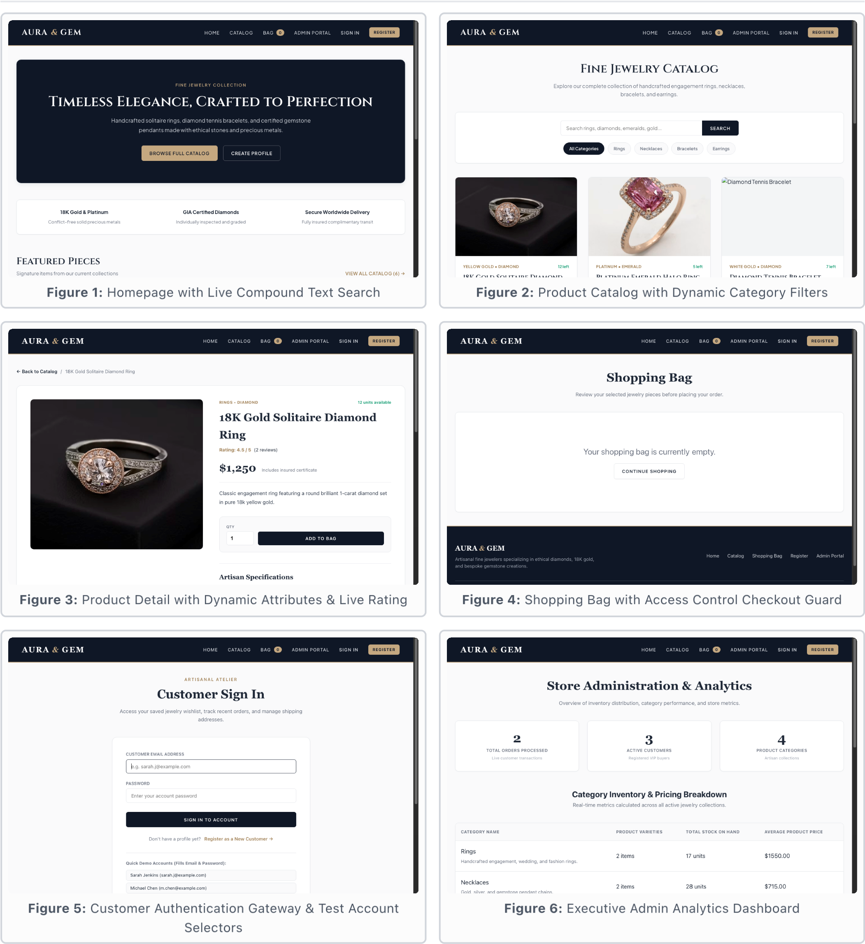

Appendix C: MongoDB Shell & Query Reference Guide
The following queries represent the core database operations of the Aura & Gem fine jewelry platform. They can be executed directly within the interactive MongoDB shell (mongosh) or the embedded terminal within MongoDB Compass to verify and demonstrate system capabilities during the viva examination.
C.1 Read Operations
Operation Objective | Target Collection | MongoDB Shell Query | Operational Explanation
Verify Active Collections | Database Scope | show collections | Lists all five provisioned collections in jewelry_db.
Full-Text Keyword Search | products | db.products.find({ $text: { $search: 'Diamond Gold' } }, { score: { $meta: 'textScore' } }).sort({ score: { $meta: 'textScore' } }) | Executes tokenized search against the compound text index, sorted by relevance score.
Category Filter | products | db.products.find({ category_id: ObjectId('REPLACE_WITH_CAT_ID') }) | Filters items referencing a specific category identifier without joining tables.
Secure Account Lookup | customers | db.customers.findOne({ email: 'sarah.j@example.com' }, { password_hash: 0 }) | Retrieves customer profile while excluding the hashed password from the result projection.
Batch Wishlist Retrieval | products | db.products.find({ _id: { $in: [ObjectId('...'), ObjectId('...')] } }) | Queries full product documents referenced in a customer's embedded wishlist array.
Customer Order History | orders | db.orders.find({ customer_id: ObjectId('...') }).sort({ order_date: -1 }) | Retrieves chronological transactions placed by a specific patron.
Low-Stock Inventory Alert | products | db.products.find({ stock_quantity: { $lte: 5 } }, { name: 1, stock_quantity: 1, price: 1 }) | Projective query identifying pieces at risk of inventory depletion.
C.2 Create, Update, and Delete Operations
Operation Objective | Target Collection | MongoDB Shell / Driver Command | Operational Explanation
Insert Product Listing | products | db.products.insertOne({ name: 'Platinum Solitaire Band', category_id: ObjectId('...'), price: 1100.00, metal_type: 'Platinum', gemstone: 'Diamond', stock_quantity: 8, attributes: { sizes_available: [5, 6, 7], weight_grams: 3.5 }, created_at: new Date() }) | Inserts a new piece embedding unique ring sizes and weight specifications.
Atomic Stock Decrement | products | db.products.updateOne({ _id: ObjectId('...'), stock_quantity: { $gte: 1 } }, { $inc: { stock_quantity: -1 } }) | Atomically reduces inventory by 1, enforcing concurrency safety against negative stock.
Add to Wishlist | customers | db.customers.updateOne({ _id: ObjectId('...') }, { $addToSet: { wishlist: ObjectId('...') } }) | Appends product ID to embedded wishlist array only if not already present.
Remove from Wishlist | customers | db.customers.updateOne({ _id: ObjectId('...') }, { $pull: { wishlist: ObjectId('...') } }) | Pulls matching product ID from the embedded wishlist array.
Update Delivery Address | customers | db.customers.updateOne({ _id: ObjectId('...') }, { $set: { 'delivery_address.street': '99 Regent St', 'delivery_address.city': 'London', phone: '+44 7700 900999' } }) | Modifies embedded address and contact attributes in place.
Update Order Status | orders | db.orders.updateOne({ _id: ObjectId('...') }, { $set: { status: 'Shipped' } }) | Updates order fulfillment progress without altering receipt snapshots.
Referential Integrity Check | products | db.products.countDocuments({ category_id: ObjectId('...') }) | Counts dependent pieces prior to category deletion to prevent orphaned documents.
Cascade Listing Removal | Multi-Collection | db.products.deleteOne({ _id: ObjectId('...') });  db.customers.updateMany({}, { $pull: { wishlist: ObjectId('...') } });  db.reviews.deleteMany({ product_id: ObjectId('...') }); | Purges product document and cascades cleanup across wishlists and reviews.

C.3 Advanced Decision Analytics Aggregation Pipelines
Analytical Objective | Source Collection | Aggregation Pipeline Stages | Business Intelligence Value
Dynamic Product Rating | reviews | db.reviews.aggregate([  { $match: { product_id: ObjectId('...') } },  { $group: { _id: '$product_id', avgRating: { $avg: '$rating' }, totalReviews: { $sum: 1 } } }  ]) | Generates live customer rating without storing denormalized static counters.
Category Stock & Price Intelligence | products | db.products.aggregate([  { $group: { _id: '$category_id', totalProducts: { $sum: 1 }, avgPrice: { $avg: '$price' }, totalStock: { $sum: '$stock_quantity' } } },  { $lookup: { from: 'categories', localField: '_id', foreignField: '_id', as: 'category' } },  { $unwind: '$category' },  { $sort: { 'category.display_order': 1 } }  ]) | Computes catalog breadth, inventory depth, and average price per category for executive decision-making.
Order Feed with Customer Join | orders | db.orders.aggregate([  { $sort: { order_date: -1 } },  { $limit: 10 },  { $lookup: { from: 'customers', localField: 'customer_id', foreignField: '_id', as: 'customer' } },  { $unwind: { path: '$customer', preserveNullAndEmptyArrays: true } }  ]) | Joins live customer accounts to recent transactions for management fulfillment feeds.
Sales Revenue Analytics by Status | orders | db.orders.aggregate([  { $group: { _id: '$status', totalRevenue: { $sum: '$total_price' }, orderCount: { $sum: 1 }, avgOrderValue: { $avg: '$total_price' } } },  { $sort: { totalRevenue: -1 } }  ]) | Summarizes financial revenue, order volumes, and average basket sizes for corporate accounting.

Appendix D: MongoDB Compass Schema Verification & Visual Evidence
This appendix provides visual verification of the database architecture and collection states as inspected directly within MongoDB Compass connected to the local instance (mongodb://127.0.0.1:27017/jewelry_db).
Figure D.1: MongoDB Compass Database Overview (jewelry_db)
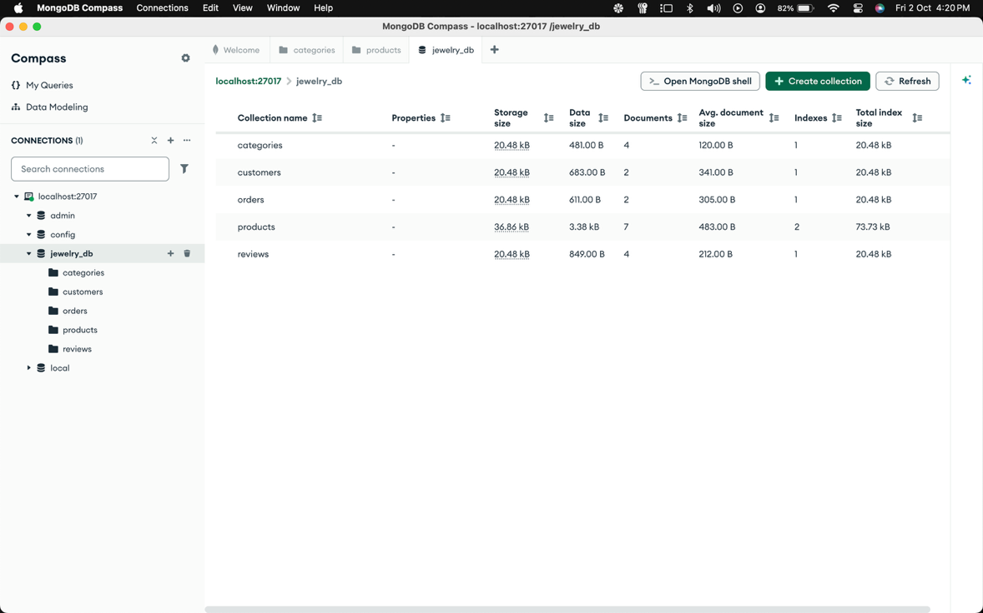
Caption: Figure D.1: MongoDB Compass overview verifying the five operational collections within the jewelry_db database.
Figure D.2: Polymorphic Document Structure (products Collection)
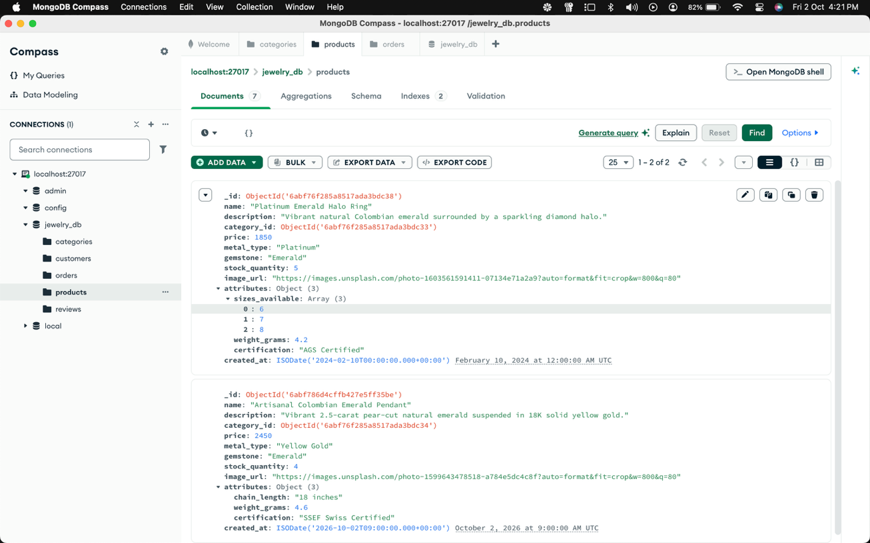
Caption: Figure D.2: Document from the products collection illustrating schema flexibility through embedded polymorphic attributes.
Figure D.3: Customer Document with Embedded Address & Wishlist References
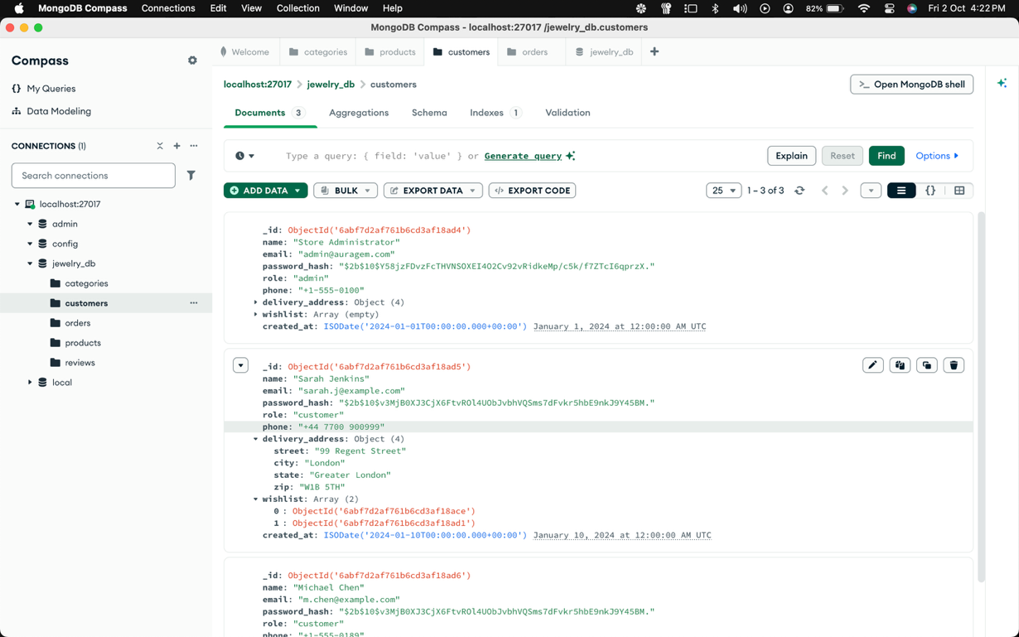
Caption: Figure D.3: Customer account document demonstrating embedded address subdocuments and referenced product wishlist arrays.
Figure D.4: Historical Order Transaction with Price Snapshots
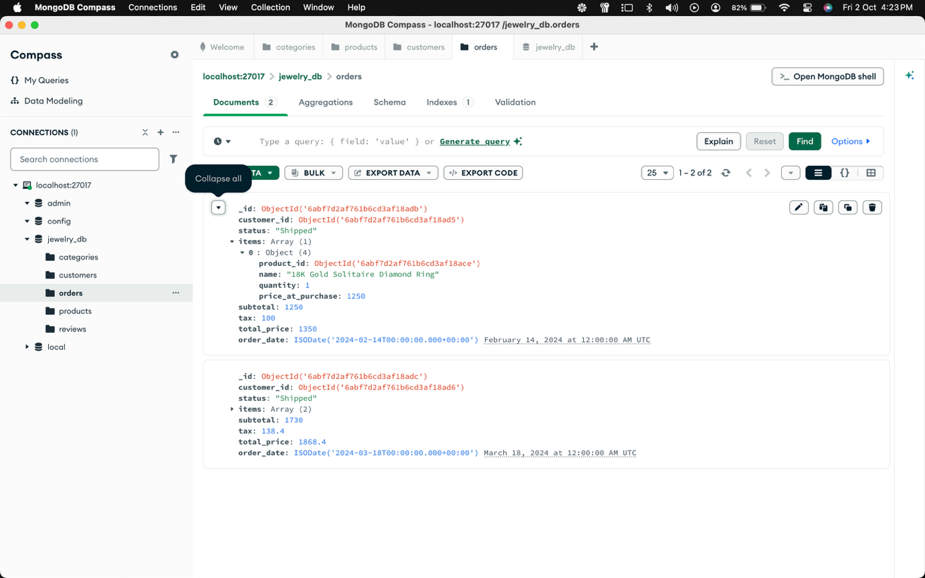
Caption: Figure D.4: Transaction document from the orders collection demonstrating historical price locking against subsequent catalog price changes.

