Governing privacy risk across repeated statistical releases:
probability models, programme tolerances and accountable decisions
Ronald Rethabile Malamule Mahomane
Department of Computing, Mathematical and Statistical Sciences, University of Namibia, Windhoek
School of Pathology, Faculty of Health Sciences, University of the Witwatersrand, Johannesburg
Basis Energy, Victoria, Australia
Author manuscript: September 2026
Abstract
Central banks publish monthly from confidential registers, and an adversary can combine the vintages. We ask when a release programme, not a single release, is safe enough to publish, and who decides. Risk depends on a declared adversary and carries estimation error, so a decision should compare an upper confidence bound with a tolerance that has an owner, an expiry date, a harm class, a horizon, an error probability, a legal basis and an access route. With a persistent pseudonym, no function of per-release risks bounds a pooling adversary. On a synthetic credit register with six monthly vintages and a tolerance of 0.12, we choose the minimum cell count by fixed-sequence testing and confirm it on fresh targets. Per-release review passes the file with no suppression, or a floor of 20 when every firm size class must pass. An adversary who pools the vintages and knows when the target’s loan is live needs 75 (200 for every size class). One who also holds an exposure reading per vintage needs 150, and no floor up to 200 protects every size class. No floor stops an insider who knows exposure closely. A floor of 150 keeps 20 per cent of loans, 4 per cent of exposure and no loan to a large firm. Against an adversary who knows loan histories, a loan-level release is the wrong product; aggregates or secure access are the realistic options. A neural network fitted to separate development attacks proposes the audit’s bets and starting floor; it cut the attacks needed by about a fifth without changing the floor, and a logistic model did as well. Floors depend on the tolerance and on the adversary’s reading precision. The results are synthetic.
Keywords: statistical disclosure control; record linkage; repeated releases; central bank statistics; risk tolerances; release governance.
Status. This is an author manuscript prepared for a central bank statistics audience and offered for consideration as an IFC Working Paper. It is not a BIS or IFC publication, and its views are the author’s own. The companion journal article, “Adaptive certification of attack-conditional disclosure risk across release programmes”, develops the sequential audit that Section 8 points to. An online appendix holds case studies from other data products and a neural procedure for proposing settings; neither enters the results.
Executive summary.
Situation. Central banks publish from confidential registers every month: aggregates, supervisory tables and, for accredited users, loan-level files. Each release is reviewed on its own, usually against a minimum cell count, and the review reports a point figure for the risk.
Complication. An adversary holds every vintage, not one. When records keep a pseudonym across releases, no function of the per-release risks bounds what that adversary can do (Proposition 11). The risk figure is also an estimate, and a point estimate at the tolerance passes about half the time (Proposition 5). Nobody owns the tolerance, and it has no expiry date.
Question. When is a release programme, rather than one release, safe enough to publish, who decides, and what does the answer cost in data?
Answer. Compare an exact upper bound on the programme’s risk with a written tolerance that has an owner, an expiry date, a harm class, a horizon, a legal basis and an access route, and choose the protection level by fixed-sequence testing confirmed on fresh targets. On a synthetic credit register at a tolerance of 0.12, per-release review passes the loan-level file with no suppression (a floor of 20 if every firm size class must pass). An adversary who pools six vintages and knows when the target’s loan is live needs a floor of 75 (200 for every size class); one who also reads exposure in each vintage needs 150, and no floor up to 200 protects every size class. No floor stops an insider who knows exposure closely. A floor of 150 keeps 20 per cent of loans, 4 per cent of exposure and no loan to a large firm (Table 9). Against an adversary who knows loan histories, a loan-level release is the wrong product: aggregates, or access in a secure setting under the Five Safes, are the realistic options. The loan-level file here stands in for securitisation loan-level disclosures and for research files as an accredited user sees them. The floors depend on the tolerance (Table 10) and on how precisely the adversary reads exposure (Table 11). A neural network fitted to development attacks proposes the audit plan, and only fresh audit outcomes certify the floor (Section 13.5).

1 Introduction
Central banks, statistical offices and health registries release granular data under a statutory duty of confidentiality. The technical means of protection are well developed. Cell suppression, minimum cell counts, global recoding, record swapping, the cell-key method, additive noise, synthetic data and formal privacy mechanisms are all documented, implemented and taught (Willenborg and de Waal, 1996, 2001; Duncan et al., 2011; Hundepool et al., 2012; Templ et al., 2015; Dwork and Roth, 2014). The object that remains underdeveloped is the decision rule that turns a measured risk into an admissible or inadmissible release.
Practice usually settles this by committee. A disclosure control officer presents a table of risk measures, a panel weighs them against the public value of the release, and a decision follows. The decision is often sound. It is rarely reproducible, and it is hard to audit after the fact, because the deciding quantity, how much residual risk the institution was willing to carry, was never written down. Improving the protection mechanism does not repair this. A mechanism with a formal guarantee can still be governed by an unstated tolerance, and an institution can adopt a carefully accounted $ε$ without being able to say what probability of harm it accepted.
This paper separates three objects that are routinely run together.
- A probability model for an adversary’s attempted linkage, conditional on a declared attack scenario.
- A statistical estimate of the resulting risk, with its uncertainty.
- A policy decision that states how much residual risk is acceptable, for which harm class, on whose authority, and until when.
The first is a modelling problem, the second an inference problem, the third a governance problem. Confusing them produces two familiar failures. A committee that releases whenever the point estimate falls below its tolerance will, for a release whose true risk equals the tolerance, release with probability near one half (Proposition 5). An institution that treats a protection parameter as a tolerance never states the probability it accepted.

1.1 Contribution
The paper makes four contributions.
First, we derive the prosecutor, journalist and marketer measures from a single linkage experiment (Section 3). The reciprocal-frequency formula $1/f_{k}$ follows from four stated assumptions, as Duncan and Lambert (1989) and Skinner and Elliot (2002) also show. Two of those assumptions, exchangeability of the records sharing a key and error-free observation of the key, fail whenever the adversary holds informative side information, and then the posterior linkage probability exceeds $1/f_{k}$. The same derivation gives $k$-anonymity its scope (Proposition 2): on a declared key it does not deliver $1/k$ when the intruder also knows a released continuous variable. In the simulation of Section 10, a 10-anonymous release contains a record whose own re-identification probability is 0.74, with a one-sided 95 per cent lower bound of 0.64.
Second, we treat the risk figure as an estimate that enters a written decision rule (Sections 4 and 5). A release is admissible only when an upper confidence bound, not a point estimate, lies below a tolerance that has a named owner, an expiry date, a harm class, a declared adversary, a stated error probability, a legal basis with the parties it protects, an access route and, for a programme, a horizon. The rule has a price (Proposition 3): certifying $τ={10}^{−3}$ at the 5 per cent level needs 2,995 independent attacks without a success, and $τ={10}^{−5}$ needs 299,572. Supporting results sign the bias of plug-in frequency measures (Proposition 4), give the relative harm weight a tolerance implies (Proposition 7, after Abowd and Schmutte (2019)), and relate scenario risk to differential privacy (Proposition 14).
Third, we state what marginal risks can and cannot say about a release programme. The sharp bounds from the marginals are maxiRi≤R∪≤min1,i​Ri (Proposition 10). When records carry a pseudonym that is the same in every release, no bound on a pooling adversary in terms of the marginals exists (Proposition 11). The construction is the classic intersection attack (Sweeney, 2002; Ganta et al., 2008), and with a persistent pseudonym the programme is one release keyed on the union of the keys, so the result says that a finer key can carry far more risk than any of its projections (Remark 2). What we add is its statement in the terms a certifying body uses.
Fourth, we evaluate the rule on a synthetic credit register built to share the structure of a supervisory collection (Section 13). Loans enter and leave the register over six monthly vintages, and the same adversary faces five loan-level protection policies. The minimum cell count is chosen by fixed-sequence testing on the upper bound and confirmed on a second draw of targets (Table 9). At a tolerance of 0.12, per-release review passes the file with no suppression, or with a floor of 20 when every firm size class must meet the tolerance. An adversary who pools the vintages and knows in which of them the target’s loan is live needs a floor of 75, or 200 for every size class. Without that knowledge pooling adds nothing on this register (Proposition 15). An adversary who also holds one exposure reading per vintage needs 150, and no floor up to 200 protects every size class. No floor up to 300 stops an insider who reads exposure with small error. The cost falls on credit volume more than on loan counts: the floor of 150 keeps 20 per cent of loans but 4 per cent of exposure, and no loan to a large firm. Against an adversary who knows loan histories, then, a loan-level release is the wrong product, and aggregates or access in a secure setting are the realistic options. The floors are conditional on the tolerance (Table 10) and on how precisely the adversary reads exposure (Table 11). Rotating the pseudonym does not help while exposure is published exactly, because the published key and exposure relink every loan; with exposure rounded to one significant figure they relink about one loan in ten.

1.2 Reader’s guide
A reader at a central bank who wants to apply the paper to its own releases should start with Section 16. It sets out seven steps, the roles they need, starting declarations for six release types common in central banks (Table 15), the remedies to use when a release fails and a small pilot, and Appendix H holds blank worksheets for each step. A reader who wants the recommendation and its evidence can read three parts. Section 5 states the governance rule. Section 12 describes the synthetic credit register and its five harms, and Section 13 runs the attack evaluation on it. Section 15 gives the protocol and a filled decision record for the register (Table 14). The other sections supply the derivations (Sections 2 to 7), certification under monitoring (Section 8), the relation to formal privacy (Section 9), a simulation on a synthetic population (Section 10), two public microdata files (Section 11) and six falsification tests (Section 14). Section 17 states, in the terms of a security evaluation, what the method adds to a release system and what it does not, and Section 19 concludes. The appendices hold the proofs, expanded derivations, simulation details and the worksheets. Case studies from other data products, and the earlier neural procedure SENTRY-R with its proofs, are in a separate online appendix. The neural release pipeline that proposes bets and a start floor for the audit is part of the main results (Section 13.5).

1.3 Relation to existing work
The measurement literature is long and we do not restate it. Disclosure risk as a probability conditional on an intruder scenario goes back to Duncan and Lambert (1989) and Elliot and Dale (1999); per-record and uniqueness measures and their estimation under a population-frequency model are developed in Skinner and Holmes (1998), Skinner and Elliot (2002), Reiter (2005) and Skinner and Shlomo (2008), with smoothing models by Rinott and Shlomo (2006) and earlier by Bethlehem et al. (1990). Elamir (2004) and Franconi and Polettini (2004) estimate per-record risk from log-linear and superpopulation models, and Shlomo and Skinner (2010) extend the estimation to files perturbed by misclassification. The prosecutor, journalist and marketer scenarios are named in El Emam and Dankar (2008). Skinner (2012) separates the potential for disclosure from the harm it causes, the distinction this paper keeps through the harm class of Section 5. Record linkage under error is Fellegi and Sunter (1969). The risk–utility trade-off was formalised as a map by Duncan et al. (2001), with utility measures developed by Karr et al. (2006), Woo et al. (2009) and Snoke et al. (2018). Trottini and Fienberg (2002) model the user’s uncertainty on both axes of the map, and Gomatam et al. (2005) apply it to remote analysis servers that release query answers instead of microdata. Stadler et al. (2022) tested synthetic data, which Drechsler (2011) sets out as a release strategy, against inference attacks and found that it either left the attacks open or lost utility, and that the outcome varied from one dataset to the next. Formal privacy begins with Dinur and Nissim (2003) and Dwork (2006); Dwork et al. (2006), and McSherry and Talwar (2007) extend it from numeric answers to general outputs, with the composition and accounting machinery in Dwork et al. (2010), Kairouz et al. (2017), Dwork and Roth (2014), Bun and Steinke (2016), Mironov (2017) and Dong et al. (2022), and the statistical reading in Wasserman and Zhou (2010) and Duchi et al. (2018). The economic reading of the trade-off as a social choice is Abowd and Schmutte (2019), with the census application in Abowd et al. (2022) and the counterargument in Hotz et al. (2022). The governance literature, in particular the Five Safes (Desai et al., 2016) and the anonymisation decision-making framework (Elliot et al., 2020), is where tolerances and accountability are discussed, and it is largely disjoint from the measurement literature.
Three of this paper’s components have close antecedents, and we state what is taken from them. The result that a tolerance is pinned by the relative harm weight assigned to disclosure risk and public value is a restatement, in a per-release governance setting, of the social-choice argument of Abowd and Schmutte (2019); the economics is theirs and the contribution here is only to carry it into a decision rule that a release committee can operate. The threshold at which an adversary acts follows from its payoffs rather than from the convention of one half, which is the premise of the game-theoretic analyses of re-identification risk (Wan et al., 2015); what is added is the requirement that an evaluation report the precision and coverage curve over that threshold rather than one point on it. And the anytime-valid machinery of Section 8 is standard: the martingale bound is Ville (1939), the modern confidence sequences are Howard et al. (2021), and the framework is set out in Ramdas et al. (2023), with the adaptive-analysis problem in its statistical form in Dwork et al. (2015). The contribution is the application, which is to certify a disclosure risk while the simulation is being monitored, and the measurement of what monitoring costs.
The two bodies of work are not joined. The measurement literature produces numbers without saying which decision they license; the governance literature produces accountability structures without saying which number triggers them. Two specific gaps motivate this paper. The first is not the variance of a risk estimate: Skinner and Shlomo (2008) and Rinott and Shlomo (2006) give variance and interval estimates for per-record and file-level risk under population-frequency models, and Brown et al. (2001) and the exact binomial interval of Clopper and Pearson (1934) give the tools for simulated risk. What is missing is a decision rule that uses an upper bound rather than a point estimate, names an owner and an expiry date, and states whether it covers one release or a programme. The second is that neither literature states what a programme of releases may claim, as opposed to a single release, once the adversary is allowed to combine them, though the reconstruction attacks of Dinur and Nissim (2003), Garfinkel et al. (2019) and Dick et al. (2023) and the de-anonymisation work of Narayanan and Shmatikov (2008) and Rocher et al. (2019) show that combination is the operative threat. The evidence that a few attributes single people out is older. Sweeney (2000) and Golle (2006) found that date of birth, sex and postcode identify most of the US population, and de Montjoye et al. (2013, 2015) found that four points in space and time identify nine in ten people in mobile phone and card payment records. A review of published attacks on health data (El Emam et al., 2011) found that most were small and targeted data that had not been de-identified to any standard, which is a reason to report the adversary with the risk figure.

2 Population, sample, keys and mechanisms
Let the finite population be $P=\{1,…,N\}$. A confidential sample is indexed by the random set $I⊆P$ with $\left|I\right|=n$. Its inclusion indicators and first-order inclusion probabilities are
$$S_{i}=1\{i∈I\}, π_{i}=P\left(S_{i}=1\right), i∈P. \left(1\right)$$
Under simple random sampling without replacement, $π_{i}=n/N$ for every $i$; under Bernoulli sampling the $S_{i}$ are independent with common $π$. A census is the limiting case $I=P$ and $π_{i}=1$.
Let $X_{i}∈X$ be the confidential record of unit $i$. An adversary does not necessarily observe all of $X_{i}$. It uses a declared key map
$$K_{a}:X→K_{a}, \left(2\right)$$
where the subscript $a$ records the assumed attack scenario. For $k∈K_{a}$, define the population and sample key frequencies
Fk=i∈P​1{KaXi=k}, fk=i∈P​Si1{KaXi=k}. 3
Thus $0≤f_{k}≤F_{k}$. The statements “sample unique” and “population unique” mean $f_{k}=1$ and $F_{k}=1$.
A protection mechanism is a Markov kernel $M_{θ}\left(dy∣x\right)$ indexed by $θ∈Θ$. The notation covers deterministic transformations as the degenerate case. Applied to the confidential sample $X_{I}=\left(X_{i}:i∈I\right)$, it generates a release
$$Y_{θ}∼M_{θ}\left( ⋅∣X_{I}\right). \left(4\right)$$
The randomness in (4) matters for everything that follows. Risk is a probability over four sources at once: the sampling design, the mechanism, the noisy or incomplete auxiliary information held by the adversary, and any randomisation in the adversary’s own decision rule. An assessment that integrates over some of these and conditions on others must say which.
Remark 1. Nothing in this section requires $θ$ to carry a formal guarantee. A minimum cell count of five, a coarser age classification and a Laplace mechanism with $ε=1$ are all points in $Θ$. Section 9 explains why the last of these supports a claim the others do not, and why that claim is not a linkage probability.

3 A unified linkage experiment
Fix a target $t∈P$. The adversary observes auxiliary information $Z_{t}$ and the release $Y_{θ}$, then applies a measurable linkage rule
$$δ_{a}:Z×Y→I∪\{∅\}. \left(5\right)$$
The value $δ_{a}\left(Z_{t},Y_{θ}\right)=j$ asserts that released record $j$ belongs to $t$, and $∅$ denotes abstention. Correct identification is the event
$$C_{t}\left(θ,a\right)=\{S_{t}=1, δ_{a}\left(Z_{t},Y_{θ}\right)=t\}. \left(6\right)$$
Definition 1 (Scenario-conditional target risk). Given background information $B_{a}$ declared by scenario $a$, the unconditional and file-membership-conditional risks are
$$R_{a}^{unc}\left(t,θ\right)=P\{C_{t}\left(θ,a\right)∣B_{a}\}, R_{a}^{in}\left(t,θ\right)=P\{δ_{a}\left(Z_{t},Y_{θ}\right)=t∣S_{t}=1,B_{a}\}. \left(7\right)$$
The distinction in (7) prevents a common error. If membership in the file is not known to the adversary, the unconditional risk carries an inclusion-probability factor,
$$R_{a}^{unc}\left(t,θ\right)=π_{t} R_{a}^{in}\left(t,θ\right), \left(8\right)$$
provided a correct association is impossible when $S_{t}=0$. Equation (8) is the multiplication rule $P\left(A∩B\right)=P\left(A∣B\right)P\left(B\right)$ and not an independence assumption. Reporting the two quantities under one label, which happens whenever a sampling fraction is quietly applied or quietly omitted, changes the reported risk by an order of magnitude in the simulation of Section 10.

3.1 Exact matching as a special case
Consider four assumptions.
Assumption 1. The released key is unperturbed: $K_{a}$ applied to the release agrees with $K_{a}$ applied to the confidential sample.
Assumption 2. The adversary observes the target’s key without error.
Assumption 3. All records sharing the target’s key are exchangeable in the adversary’s information.
Assumption 4. The adversary selects uniformly among the compatible records.
Proposition 1 (Reciprocal frequency). Under Assumptions 1 to 4, conditional on $S_{t}=1$ and $K_{a}\left(X_{t}\right)=k$,
$$P\{δ_{a}=t∣S_{t}=1,K_{a}\left(X_{t}\right)=k,f_{k}\}=\frac{1}{f_{k}}. \left(9\right)$$
Proof. See Appendix B. $▫$
Proposition 1 states the assumptions behind a familiar formula (Duncan and Lambert, 1989; Skinner and Elliot, 2002). Once they are stated, they can fail, and two of them fail often. Assumption 3 fails whenever the adversary holds a covariate correlated with the confidential variable, which is the normal case in financial and health data. Assumption 2 fails whenever the adversary’s auxiliary source has reporting error, which is also the normal case.

3.2 Imperfect matching and posterior linkage probability
For perturbed keys or measurement error, let $L_{tj}$ denote the likelihood of the observed auxiliary information and released record $j$ under the hypothesis $H_{tj}$ that $j$ belongs to $t$, in the sense of Fellegi and Sunter (1969). With prior match weights $q_{tj}$ and a no-match hypothesis $H_{t0}$, Bayes’ rule gives
ptj:=PHtj∣Zt,Yθ,Ba=qtjLtjqt0Lt0+ℓ∈I​qtℓLtℓ. 10
If the adversary chooses the maximum-posterior candidate, its conditional success probability is
$$R_{a}^{in}\left(t,θ\right)=E[\max_{j∈I}p_{tj} \left| S_{t}=1,B_{a}\right]. \left(11\right)$$
When the only compatible records have equal likelihood and the no-match prior is zero, (10) and (11) reduce to (9). Measurement error therefore cannot be declared to reduce risk. It changes the likelihood ratios, and it may either spread posterior mass across candidates or concentrate it on one. Section 10 exhibits a case where key reporting error lowers success from 0.4663 to 0.3812 while one noisy continuous covariate returns it to 0.4642, so that the reciprocal-frequency figure was right by cancellation rather than by argument.

3.3 The three conventional scenarios
Prosecutor. The prosecutor knows $S_{t}=1$. Under exact exchangeable matching,
$$R_{pros}\left(t,θ\right)=\frac{1}{f_{K_{a}\left(X_{t}\right)}}, \left(12\right)$$
and a file-level conservative summary is the maximum target risk
$$R_{max}\left(θ\right)=\max_{i∈I}R_{pros}\left(i,θ\right), \left(13\right)$$
or the whole empirical risk distribution, which is more informative and no harder to publish. Calling (12) an upper bound over all conceivable scenarios requires Assumptions 2 to 4. An adversary with identifying side information breaks exchangeability and can achieve a posterior above $1/f_{k}$.
Journalist. The journalist does not know that the target is in the file. For a sample-unique released record with key $k$, the classical object is $ρ_{k}=P\left(F_{k}=1∣f_{k}=1\right)$, the probability that a sample unique is population unique (Skinner and Holmes, 1998; Skinner and Elliot, 2002). It is not the journalist’s linkage success, which for a sample unique is $E\left[1/F_{k}∣f_{k}=1\right]≥ρ_{k}$, and it differs again from the journalist risk $1/\min_{k}F_{k}$ of El Emam and Dankar (2008). We keep the name $ρ_{k}$ for the uniqueness probability throughout. Bayes’ theorem gives
ρk=Pfk=1∣Fk=1PFk=1v≥1​Pfk=1∣Fk=vPFk=v. 14
Under Bernoulli sampling with common inclusion probability $π=n/N$,
$$P\left(f_{k}=1∣F_{k}=v\right)=\left({v \atop 1}\right)π{\left(1−π\right)}^{v−1}, \left(15\right)$$
and substitution into (14) yields
ρk=πPFk=1v≥1​vπ1−πv−1PFk=v. 16
Equation (16) shows why the sampling fraction matters, and it shows that $π$ alone is not enough: the calculation needs a model or external evidence for the population frequency distribution (Skinner and Elliot, 2002; Reiter, 2005; Rinott and Shlomo, 2006). Section 10 reports what that model costs. Using $π$ itself in place of $ρ$ overstates the truth by a factor of about two at $π=0.05$, while a fitted negative binomial frequency model, which is closed under binomial thinning and therefore identified from the sample, is accurate to within 8 to 25 per cent.
Marketer. The marketer attacks many targets and values the expected fraction correctly linked. If the attacked unit $J$ is drawn uniformly from the population,
Rmarkpopθ=1Ni∈P​Raunci,θ. 17
If instead one conditions on attacking the released records, and exact exchangeable matching holds, the sample mean is
Rmarksampleθ=1ni∈I​1fKaXi=1nk:fk>0​1=DIn, 18
where $D_{I}$ is the number of distinct released keys, because each occupied class contributes $f_{k}⋅\left(1/f_{k}\right)=1$. Formula (18) is not n−1i​1/FKi. The former models choice among released candidates; the latter presumes population frequencies are known and describes a different experiment. The attack population and the conditioning event belong beside any marketer figure. In the simulation the sample-frequency measure is 7.3 times the population-frequency version, and the unconditional measure (17) is smaller than both, at 0.023 against 0.466 and 0.064.

3.4 $k$-anonymity is a threshold statement
Proposition 2 ($k$-anonymity as a decision rule). Under Assumptions 1 to 4, for $τ∈(0,1]$,
$$\sup_{t∈I}R_{pros}\left(t,θ\right)≤τ ⇔ \min_{k:f_{k}>0}f_{k}≥⌈1/τ⌉, \left(19\right)$$
so the release satisfies $k$-anonymity with $k=⌈1/τ⌉$ in the sense of Sweeney (2002). If Assumption 3 fails, for instance because the release publishes a continuous variable of which the adversary holds a noisy reading, the implication from right to left fails: there are releases that are $k$-anonymous on the declared key for which $\sup_{t}R_{a}^{in}\left(t,θ\right)>1/k$.
Proof. See Appendix B. The failure claim is constructive and is shown numerically in Section 10.4. $▫$
Proposition 2 gives $k$-anonymity its scope. The failure it describes is one of key selection: a release that is $k$-anonymous on a key that leaves out a variable the intruder knows is not $k$-anonymous in the sense of Sweeney (2002) (Hundepool et al., 2012, ch. 3). Read this way, $k$-anonymity is the special case of the decision rule (27) below in which the risk model is exact exchangeable matching, the estimate carries no uncertainty, and the tolerance is the reciprocal of an integer. Each of those three simplifications is a place where an institution can be wrong, and the third is the only one that is a policy choice. The same reading applies to the syntactic strengthenings of $k$-anonymity, such as $ℓ$-diversity (Machanavajjhala et al., 2007) and $t$-closeness (Li et al., 2007): they restrict the attribute distribution within a key class rather than the tolerance, and so they change the risk model, not the decision rule.

4 Estimation and statistical uncertainty
The risk in Definition 1 is unknown. It is a functional of the sampling design, the mechanism, the population frequency structure and the adversary’s information, and in any realistic scenario it has no closed form. It must be estimated, and the estimate must carry its uncertainty into the decision.

4.1 Simulation estimator
Let $D^{\left(1\right)},…,D^{\left(B\right)}$ be attack simulations generated under the declared scenario, and set $C_{t}^{\left(b\right)}=1$ if replicate $b$ identifies $t$ correctly. The Monte Carlo estimator is
$${\hat{R}}_{a}\left(t,θ\right)=\frac{1}{B}\sum_{b=1}^{B}{C_{t}^{\left(b\right)}}, E\left[{\hat{R}}_{a}\right]=R_{a}, Var\left({\hat{R}}_{a}\right)=\frac{R_{a}\left(1−R_{a}\right)}{B}, \left(20\right)$$
the variance holding because the $C_{t}^{\left(b\right)}$ are independent Bernoulli variables under independent simulation. If replicates share auxiliary data, records or fitted parameters, independence fails and (20) understates the variance. The remedy is a clustered bootstrap over the shared unit, a posterior interval, or a repeated-sample calculation that preserves the dependence. The clustered version resamples whole units of sharing, the auxiliary file or the fitted parameter draw, rather than individual attacks, and recomputes the risk within each resampled cluster (Efron and Tibshirani, 1993; van der Vaart, 1998); the between-cluster spread then carries the dependence that (20) assumes away. The nested design of Section E.3 is the same accounting written as an analysis of variance, and either device answers the same question: how much of the reported precision comes from the number of simulated attacks alone. Institutions that reuse one auxiliary file across all replicates are in this case and should not quote (20).

4.2 Small risks and the zero-success problem
For small risks a normal interval is unreliable (Brown et al., 2001). An exact or score-based one-sided bound ${\overline{R}}_{1−α}$ should be reported. With zero successes in $B$ independent simulations, the one-sided Clopper–Pearson bound (Clopper and Pearson, 1934) solves ${\left(1−U\right)}^{B}=α$, so
$${\overline{R}}_{1−α}=1−α^{1/B}≈−\frac{logα}{B}. \left(21\right)$$
At 95 per cent confidence this is approximately $3/B$, the rule of three of Hanley and Lippman-Hand (1983). Observing no successful attack does not establish zero risk, and the strength of the statement is set entirely by $B$.
Proposition 3 (Certification cost). Suppose $B$ independent simulated attacks produce no success. The one-sided $\left(1−α\right)$ bound satisfies ${\overline{R}}_{1−α}≤τ$ if and only if
$$B≥\frac{logα}{log\left(1−τ\right)}≈\frac{−logα}{τ} \text{as }τ↓0. \left(22\right)$$
Proof. See Appendix B. $▫$
The practical content of (22) is a budget. Certifying $τ=0.01$ at $α=0.05$ needs 299 independent attacks; $τ={10}^{−3}$ needs 2,995; $τ={10}^{−5}$ needs 299,572, and at $α=0.01$ the last figure becomes 460,515. Table 18 collects these. An institution that adopts a very small tolerance has thereby committed to a large simulation programme, or to a model-based argument in place of simulation. Choosing the tolerance and choosing the evidence standard are the same decision, and it is better made openly.

4.3 Plug-in frequency measures
Two reciprocal-frequency measures circulate, one built on sample frequencies and one on population frequencies. They are not two estimates of one quantity.
Proposition 4 (Ordering and plug-in bias). For every key $k$ with $f_{k}>0$ we have $1/f_{k}≥1/F_{k}$ pathwise, hence
$$E\left[\frac{1}{f_{K\left(i\right)}}\right]≥E\left[\frac{1}{F_{K\left(i\right)}}\right], \left(23\right)$$
with equality only if the sample contains every population member of every occupied key class. Moreover, for any random $f_{k}$ that is positive with probability one and has finite mean,
$$E\left[\frac{1}{f_{k}}\right]≥\frac{1}{E\left[f_{k}\right]}, \left(24\right)$$
by Jensen’s inequality, strictly unless $f_{k}$ is degenerate. The reciprocal of an average frequency is therefore not an unbiased summary of average reciprocal-frequency risk, and the direction of the error is known.
Proof. See Appendix B. $▫$
The gap is not a technicality. In the simulation of Section 10 the sample-frequency measure is 0.466, the population-frequency measure is 0.064, and the reciprocal of the mean sample frequency is 0.191. All three have been published as “the” re-identification risk of a microdata file. Only the first answers the question “if the adversary picks among the released candidates, how often does it win”.

4.4 Model uncertainty
Simulation error is not the only uncertainty, and it is the only one the binomial expression describes. Let $η$ index uncertain assumptions about population frequencies, measurement error and adversary capability, and define the robust risk
$$R_{a}^{rob}\left(t,θ\right)=\sup_{η∈H_{a}}R_{a}\left(t,θ;η\right), \left(25\right)$$
where the uncertainty set $H_{a}$ is declared before evaluation. The order of operations decides whether this is a rule at all. Declaring $H_{a}$ first and taking the supremum is a decision rule. Varying $η$ after seeing the result and reporting the variant one prefers is sensitivity analysis presented as a decision rule, and it inherits none of the error control in Section 5.
Simulation error, sampling variability and the uncertainty of fitted inputs are three layers hidden inside one error bar, and the binomial expression (20) describes only the first. Appendix C separates them by the law of total variance and a nested design, and Section E.3 measures them on the simulated register.

5 Governance thresholds as decision rules
Definition 2 (Governance threshold). A governance threshold is the tuple
$$G=\left(τ,o,d,a,h,α,ℓ,s\right), \left(26\right)$$
where $τ∈\left(0,1\right)$ is the risk tolerance, $o$ is the named accountable owner, $d$ is the expiry date, $a$ is the adversary specification, $h$ identifies the harm class to which the tolerance applies, $α$ is the accepted statistical error probability, $ℓ$ is the legal basis for the release together with the parties it protects, and $s$ is the access route. When $τ$ is a programme tolerance, $G$ also carries a declared programme horizon $m$, the number of vintages or months over which the pooled risk is assessed.
Each element prevents a named failure. Without $o$ the tolerance belongs to nobody and cannot be revised on authority. Without $d$ an assessment made against a 2019 register governs a 2026 release. Without $a$ the number has no referent, since risk is only defined given an adversary. Without $h$ a tolerance calibrated for commercial nuisance is applied to a harm class where the consequence is physical. Without $α$ the institution has not said how much evidence it requires. Without $m$ a programme tolerance has no fixed meaning, because pooled risk rises with the number of vintages (Proposition 11) and a monthly series has no natural end.
The last two elements tie the number to the law. Without $ℓ$ the tolerance has no source of duty and no list of whom it protects. For a credit register there are three protected parties, and they need not share one tolerance: the borrowers, the reporting agents whose positions the register holds, and any natural persons behind a borrower, such as sole traders. In the European System of Central Banks the duty comes from Council Regulation (EC) No 2533/98, Article 8, as amended by Council Regulation (EC) No 951/2009 (Council of the European Union, 1998, 2009), and for European statistics from Regulation (EC) No 223/2009 (European Parliament and Council, 2009). Where natural persons are concerned, data protection law asks whether identification is “reasonably likely” by the means an adversary could use (Recital 26 of Regulation (EU) 2016/679, European Parliament and Council, 2016). The law does not give a number. A tolerance is the institution’s written reading of that phrase for a declared adversary and harm, and the record should say so. Without $s$ the same tolerance is applied to products that face different adversaries. A public file, a scientific-use file released under contract to accredited researchers, and access in a secure environment are three routes with three threat models, and the Five Safes (Desai et al., 2016) treat the route as a control in its own right. A loan-level file that fails as a public or scientific-use release may pass in a secure environment, where the declared adversary no longer holds the file.
The roles map onto the three lines of defence that central banks use for operational risk. The analyst who declares the scenarios and runs the attacks, and the data owner, sit in the first line. The reviewer who checks the scenarios and the falsification tests, in a risk or methodology function, is the second line. Internal audit, which checks that the record was filed, that the tolerance was signed before the first outcome and that the controls of Section 17 were in place, is the third. The owner $o$ is the senior officer who accepts the residual risk on the institution’s behalf.
Let ${\overline{R}}_{1−α}\left(t,θ\right)$ be an upper confidence or credible bound whose interpretation is recorded. A release is statistically admissible only if
$$\sup_{t∈T}{\overline{R}}_{1−α}\left(t,θ\right)≤τ, \left(27\right)$$
the assessment date precedes $d$, and the release and adversary fall within the scope of $a$ and $h$. The target set $T$ must be explicit. A maximum over sample records, a maximum over a protected subgroup, and an average over a declared population are three different controls, and a release can pass one while failing another.
When $T$ is a finite set of subgroups, rule (27) releases only if every subgroup’s bound meets $τ$. That is an intersection–union test (Berger, 1982): the null hypothesis is that some subgroup exceeds $τ$, and the release is wrongly made only if a subgroup above $τ$ has its own bound at or below $τ$, which has probability at most $α$ for that subgroup. Each subgroup’s bound may therefore be taken at level $α$, with no correction for the number of subgroups. A Bonferroni correction is needed only to report the worst subgroup’s bound as a simultaneous statement, or to claim that the worst subgroup lies above some value, as Section 10.4 does.
Proposition 5 (Why a point estimate is insufficient). If a rule releases whenever ${\hat{R}}_{a}≤τ$, then at the boundary $R_{a}=τ$ a consistent and asymptotically symmetric estimator releases with probability tending to $1/2$. Replacing the point estimate by the one-sided rule (27) controls erroneous release at approximately $α$, subject to the interval model.
Proof. See Appendix B. $▫$
Proposition 5 holds for one setting $θ$ fixed in advance. An institution that scans a grid of settings and takes the least protective one whose bound meets $τ$ has chosen $θ$ with the same bounds that certify it, and the chance that the chosen setting is unsafe can then reach the number of unsafe settings times $α$. Ordering the grid in advance removes the problem, and it loses power only when the true risks are out of order.
Proposition 6 (Choosing a level by fixed-sequence testing). Let $θ_{1},θ_{2},…,θ_{L}$ be settings ordered before any outcome is seen, from the most protective to the least. Test them in that order with the level-$α$ rule (27), stop at the first setting whose bound exceeds $τ$, and choose the last setting that passed. Then the probability that a setting is chosen whose true risk exceeds $τ$ is at most $α$, whatever the true risks, and whether or not they are monotone in the ordering.
Proof. See Appendix B; the argument is that of Maurer et al. (1995). $▫$
When the bounds are monotone along the ordering the rule picks the same setting as the scan; it loses power only when the true risks are out of order, because it then stops early at a setting that happens to fail. The error guarantee comes from the selection step alone. We also audit the chosen setting on a second, independent draw of targets, so that the certificate a committee reads does not rest on the draw that chose it (Section 13.4). Because that draw is independent of the selection, a failed confirmation can be followed by moving to the next stricter setting and reading its confirmation from the same independent draw. That stays valid. Every setting stricter than the chosen one also passed in the selection sequence, and the proof of Proposition 6 bounds by $α$ the chance that any passed setting is unsafe, since it needs the first unsafe setting in the order to pass. None of this holds unless the adversary set, the grid, its order, the tolerance and the sample sizes are declared before any table is read.
The two error rates are not symmetric in consequence, and an institution should state both. As in the testing framework of Neyman and Pearson (1933), the rule fixes the error that matters more at a stated level and leaves the other to the sample size. Rule (27) controls the probability of releasing when the true risk exceeds the tolerance at $α$. The cost is erroneous suppression: a release whose true risk is comfortably below $τ$ can still fail (27) when $B$ is small, because ${\overline{R}}_{1−α}$ is then far above $\hat{R}$. In the simulation of Section 10, one setting on the frontier has a point estimate of 0.1058 from $B=1,200$ replicates and a bound of 0.1216, so a tolerance of 0.12 rejects a release that its own point estimate accepts. The remedy is a larger $B$. Proposition 3 gives the sample size needed when no attack succeeds; when some succeed, a larger $B$ is needed, and inverting (51) gives it.

5.1 The tolerance is not free
Definition 2 treats $τ$ as a policy input. That is right in the sense that no statistical calculation can supply it, and wrong in the sense that once an institution has stated how it values public benefit against harm, the tolerance is implied. Let $U\left(θ\right)$ be the utility of the release, defined in Section 6, and let the institution value utility at $λ>0$ and expected harm at $c_{h}>0$ per unit of identification probability, for the declared harm class $h$. Here $λ$ converts one unit of measured release utility into the decision-value scale, while $c_{h}$ assigns decision-value to one unit of attack success probability. No monetary valuation is assumed. Their ratio $κ=c_{h}/λ$ is the relative harm weight, measured in units of release utility per unit of attack probability: it is the marginal utility increase required to justify a unit increase in risk along the frontier. Social value is
$$V\left(θ\right)=λU\left(θ\right)−c_{h}R_{a}^{rob}\left(θ\right). \left(28\right)$$
Proposition 7 (Implied tolerance). Suppose the risk–utility frontier of Section 6 is the graph of a differentiable, increasing, strictly concave function $u=φ\left(r\right)$ on an interval $\left[\underline{r},\overline{r}\right]$. Then the maximiser of (28) over the frontier is interior and unique whenever $φ′\left(\underline{r}\right)>κ>φ′\left(\overline{r}\right)$, where $κ=c_{h}/λ$, and it satisfies
$$φ′\left(τ^{⋆}\right)=κ, τ^{⋆}:=R_{a}^{rob}\left(θ^{⋆}\right). \left(29\right)$$
The implied tolerance $τ^{⋆}$ is decreasing in $κ$.
Proof. See Appendix B. $▫$
Equation (28) is written with the robust risk. An institution that governs with the bound (27), as we recommend, should read (29) with ${\overline{R}}_{1−α}$ in place of $R_{a}^{rob}$, and that is how the tolerance is computed in Section 10. The bound is a monotone transformation of the estimate at fixed $B$, so the ranking of settings and the frontier set are unchanged; $κ$ then describes the marginal utility required per unit of upper-bound risk rather than per unit of point-estimated risk. This distinction must be recorded when a bound is the decision coordinate.
Proposition 7 is the disclosure-control counterpart of the social choice framing in Abowd and Schmutte (2019), and it has the form of a Bayes decision under a linear loss (Berger, 1985); Hsu et al. (2014) choose $ε$ by a related argument from the cost a data subject would bear. Its practical use is not to compute $τ$, since $κ$ is no easier to elicit than $τ$, but to expose the marginal trade-off a stated tolerance implies. An institution that adopts $τ=0.05$ on one release and $τ=0.20$ on another has assigned different relative weights to harm in the two cases, and should be able to say why. In the simulation, moving $κ$ from 0.25 to 10 moves $τ^{⋆}$ from 0.464 to 0.081 and changes the selected mechanism from an unsuppressed release to a 20-anonymous one that keeps 58 per cent of the records.
Corollary 8 (Uniform tolerances are usually inefficient). Let releases $i=1,…,m$ have frontiers $φ_{i}$ and a common relative harm weight $κ$. A common tolerance $τ$ across the $m$ releases is optimal only if $φ_{i}′\left(τ\right)=κ$ for every $i$. Otherwise total value strictly increases by tightening the tolerance where the frontier is flat and loosening it where the frontier is steep.
Proof. Immediate from (29) applied release by release. $▫$
Two cautions belong with this result. The relative harm weight $κ$ is not discovered in the data. Choosing it is a governance and ethical decision: it expresses how strongly the institution weights the specified disclosure harm against the declared statistical utility, and no estimation procedure will supply that number. What the proposition does is force the choice into the open, because a tolerance already implies a $κ$ whether or not anyone has said so. The second caution follows. The accountable owner $o$ of Definition 2 has to be senior enough to make that statement on the institution’s behalf and be answerable for it, which in a central bank or a statistical office means the release committee or the executive member who chairs it, not the analyst who runs the simulation. An owner who cannot defend $κ$ in public is not the right owner.

6 Utility and mechanism choice
Let $Q\left(P\right)$ be the estimand of interest and $\hat{Q}\left(Y_{θ}\right)$ its released-data estimator. A loss-based utility measure is
$$U\left(θ\right)=−E\left[L\{\hat{Q}\left(Y_{θ}\right),Q\left(P\right)\}\right], \left(30\right)$$
with expectation over sampling and mechanism randomness and $L$ declared in advance. Squared error, absolute error, confidence-interval distortion and a weighted loss across authorised analyses are all admissible choices; the general and specific utility measures of Snoke et al. (2018) and the framework of Karr et al. (2006) fit here. Declaring $L$ in advance matters for the same reason that declaring $H_{a}$ in advance matters: a mechanism chosen after inspecting which loss it happens to minimise carries no guarantee.
The attainable set is
$$A=\{\left(R_{a}^{rob}\left(θ\right),U\left(θ\right)\right):θ∈Θ\}. \left(31\right)$$
A point $\left(r,u\right)∈A$ is dominated if another attainable point $\left(r′,u′\right)$ satisfies $r′≤r$ and $u′≥u$ with at least one strict inequality. The risk–utility frontier is the nondominated subset
$$F=\{\left(r,u\right)∈A:∄\left(r′,u′\right)∈A\text{ dominating }\left(r,u\right)\}, \left(32\right)$$
which is the confidentiality map of Duncan et al. (2001) with a robust risk coordinate. Given the governed tolerance, mechanism selection is the constrained problem
$$θ^{⋆}∈\underset{θ∈Θ}{arg max}U\left(θ\right) \text{subject to} \sup_{t∈T}{\overline{R}}_{1−α}\left(t,θ\right)≤τ. \left(33\right)$$
Proposition 9 (Existence). If $Θ$ is compact, $U$ is upper semicontinuous, $θ↦\sup_{t∈T}{\overline{R}}_{1−α}\left(t,θ\right)$ is lower semicontinuous and the feasible set is nonempty, then (33) has a solution.
Proof. See Appendix B. $▫$
The conditions in Proposition 9 fail for the discrete mechanism families used in practice, where $Θ$ is a finite grid of suppression thresholds and recoding levels. Then the maximum over the grid exists trivially and the report should give an approximate optimiser with the search resolution stated, not an implied global optimum. Section 10 reports a grid of 45 settings whose frontier contains 11 points.
One further caution belongs here. The frontier in (32) is itself estimated, and using the upper bound ${\overline{R}}_{1−α}$ as the risk coordinate shifts every point rightward by an amount that depends on $B$. A frontier drawn with point estimates and a decision rule applied with bounds are not the same object, and an institution that mixes them will choose mechanisms that its own rule rejects.

7 Release programmes and composition
Single-release assessment is not the operative problem. Institutions publish programmes: a quarterly series, a research file and a public extract from the same underlying register.
For releases $Y_{1},…,Y_{m}$, let $C_{i}$ be the event that release $i$, used alone, permits a correct identification under its declared attack, and let $R_{i}=P\left(C_{i}\right)$. Write $C_{∪}=⋃_{i=1}^{m}C_{i}$ and $R_{∪}=P\left(C_{∪}\right)$.
Proposition 10 (Sharp bounds from marginal risks). Without assumptions on the dependence among the $C_{i}$,
$$\max_{i}R_{i} ≤ R_{∪} ≤ min\left(1,\sum_{i=1}^{m}{R_{i}}\right), \left(34\right)$$
and both bounds are attained for suitable joint distributions, so the marginals alone cannot identify a narrower universal interval.
Proof. See Appendix B. $▫$
If the success events were independent one could write R∪=1−i​1−Ri, but repeated releases from the same underlying data are ordinarily dependent, and the expression must not be used without evidence for independence. In the simulation the independence value is 0.2313 against a Boole interval of $\left[0.0884,0.2530\right]$, so it looks reassuringly close to the upper bound; that agreement is a coincidence of the design and carries no information.

7.1 Marginal risks do not bound a pooled attack
Figure 1 shows the set operation behind a pooled attack. The small example uses two key classes of size three: each release alone leaves three candidates, while their intersection leaves one.
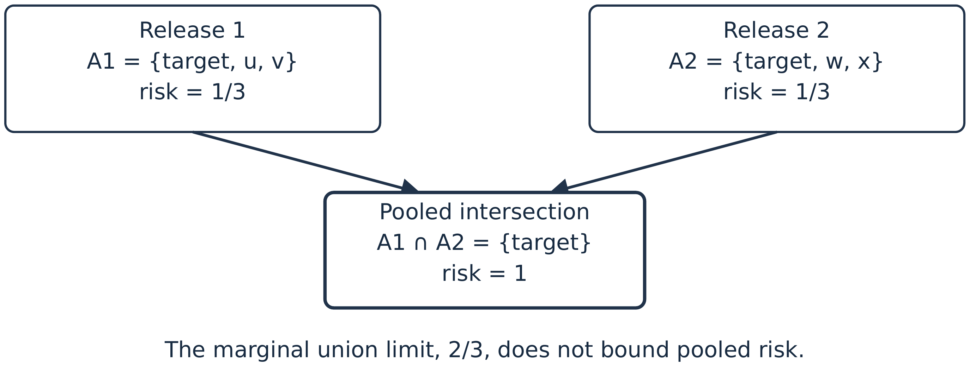
Figure 1. Pooling intersects candidate sets. This illustrative construction assumes uniform selection within each displayed set; it is distinct from the measured four-release simulation.
The larger difficulty is that $C_{∪}$ is the wrong event. An adversary who holds all $m$ releases is not restricted to using them one at a time. It applies a joint linkage rule
$$δ_{a}^{\left(m\right)}:Z×Y_{1}×⋯×Y_{m}→I∪\{∅\}, \left(35\right)$$
and the programme-level risk is $R_{pool}=P\{δ_{a}^{\left(m\right)}=t\}$, which is not contained in the union $C_{∪}$.
Proposition 11 (Marginal risks do not bound pooled risk). Let $m≥2$. Suppose each released record carries a pseudonym that is the same in every release, so that records can be matched across releases, and the adversary knows the target’s full quasi-identifier vector, from which it forms the target’s key in every release. For every $ν>0$ there exist a population, a sample and $m$ releases such that $R_{i}≤ν$ for every $i$ while $R_{pool}=1$. Consequently no upper bound on $R_{pool}$ can be written as a function of $\left(R_{1},…,R_{m}\right)$ alone. If each release publishes the candidate set implied by its key and the adversary selects uniformly from the intersection of those sets, then $R_{pool}$ is nondecreasing in $m$ and satisfies $R_{pool}≥\max_{i}R_{i}$.
Proof. See Appendix B. The construction takes $n=k^{m}$ units labelled by vectors in $\{1,…,k\}^{m}$ and lets release $i$ key on all coordinates except the $i$th, so that every release is $k$-anonymous while the intersection of the $m$ candidate sets is a singleton. $▫$
Remark 2 (A persistent pseudonym makes the programme one release). If every release carries the same pseudonym, the adversary can join the releases into one table keyed on the union of their key projections. The pooled attack is then an attack on one finer release, and Proposition 11 says that the finer key can carry far more risk than any of its projections. That is true, but it is not a composition theorem, and it points to a remedy beside a higher floor: rotate the pseudonym between releases, so that linkage has to run through the published fields. Rotation is a control on linkability. It is not pseudonymisation in the sense of Article 4(5) of Regulation (EU) 2016/679 (European Parliament and Council, 2016), which concerns whether data can be attributed to a person without separately held information; a rotated pseudonym leaves the published fields as they were. The pseudonym itself should be keyed, for example a keyed hash (HMAC) of the record identifier under a key held apart from the release team, so that nobody can recompute it from the identifier. Whether rotation helps depends on the published fields. On the credit register of Section 13 it does not while exposure is published exactly, because the published key and exposure relink every loan; with exposure rounded to one significant figure they relink about one loan in ten (Section 13.4). Many release types, such as aggregates, payment statistics and supervisory tables, carry no record pseudonym at all, and for them the proposition applies only through whatever else links the releases.
The proposition is an existence result, and it says nothing about how large the gap is in any given programme. Section 10.6 measures it on four releases built from ordinary demographic keys, each carrying a minimum cell count of three and containing no unique record at all, under the assumption that the four share a record identifier. The pooled attack identifies the target with probability 0.4581 against a Boole upper bound of 0.2530. Two releases are already enough: the pooled risk at $m=2$ is 0.4114, against a Boole bound of 0.148 for those two releases, and it is 1.6 times the bound of all four.
Neither the phenomenon nor its direction is new. Complementary releases that are each $k$-anonymous can be joined to re-identify (Sweeney, 2002), linked tables and differencing are an old problem in disclosure control (Hundepool et al., 2012, ch. 4), and Ganta et al. (2008) showed that independent releases of overlapping populations, each protected by a syntactic rule, can be combined into a successful attack, and the failure of syntactic criteria under composition is the standard argument for a formal accountant (Dwork, 2006; Dwork and Roth, 2014). The problem of releases that follow one another has its own literature: Wang and Fung (2006) anonymise sequential releases of one table that publish different attributes, Byun et al. (2006) treat a table that grows by insertion, and Xiao and Tao (2007) define $m$-invariance for a table republished as records enter and leave: each record keeps the same set of sensitive values in every version, so intersecting the versions reveals nothing new about it. Cohen and Nissim (2020) prove the same failure for a formal version of the legal notion of singling out: more than logarithmically many exact counts, each safe alone, let an adversary single out a record. What Proposition 11 adds is a statement in the terms institutions use to certify releases. The composition-attack literature shows that combining releases can break a syntactic rule; the proposition says that no function of the published marginal risks can bound the combined risk, so the quantity a release programme is certified against is not the quantity that governs it. Section 13 then measures that gap on a synthetic release system with an operational lever.
Three consequences follow for practice. Marginal risk figures may be published, but they license no programme-level claim. A programme tolerance must be assessed by direct joint simulation under (35), with shared targets and shared auxiliary information; separate simulations of each release cannot recover cross-release dependence by construction, because they never form the intersection. And a formal accountant, discussed in Section 9, is the one device that does compose without a dependence assumption.
A programme tolerance can also be split among releases as a risk budget on the union event. Appendix A gives the optimal split (Proposition 16) and shows that it differs from the equal split an institution applies by default. By Proposition 11 such a budget governs the union event only, not the pooled attack, so it allocates attention across releases and does not replace joint simulation.

8 Adaptive attacks and anytime-valid certification
The preceding analysis fixes the number of releases and attacks. An operational adversary does neither: it observes a new vintage, decides whether to acquire more auxiliary information, and stops when the posterior is sufficiently favourable. An institution also monitors its simulation and may be tempted to stop when the bound first passes. Fixed-sample intervals do not generally survive either form of optional stopping. Wald (1945) built tests for data that arrive one observation at a time, Darling and Robbins (1967) and Lai (1976) gave confidence sequences that hold at every sample size, and Johari et al. (2022) show how repeated looks at an online experiment inflate the error of a fixed-sample test.
Let $F_{s}=σ\left(Y_{1},…,Y_{s},Z^{\left(s\right)}\right)$ be the information available after release $s$, including auxiliary information acquired adaptively, and let $H_{t}$ be the hypothesis that candidate record $j$ belongs to target $t$. The posterior odds process is
$$O_{s}\left(H_{t}\right)=O_{0}\left(H_{t}\right)\prod_{v=1}^{s}{\frac{p\left(Y_{v},Z^{\left(v\right)}∣H_{t},F_{v−1}\right)}{p\left(Y_{v},Z^{\left(v\right)}∣H_{t}^{c},F_{v−1}\right)}}. \left(36\right)$$
The conditional densities in (36) prevent the common error of multiplying marginal likelihoods from dependent vintages. Revisions, common records and mechanism randomness shared across releases must remain in the conditioning history.
An adversary need not use the arbitrary posterior threshold one half. Suppose a correct allegation produces benefit $h>0$, a false allegation costs $c_{f}≥0$, and making the allegation costs $c_{a}≥0$. At posterior match probability $p$, the expected payoff is $ph−\left(1−p\right)c_{f}−c_{a}$.
Proposition 12 (Economically rational attack threshold). Suppose an expected-payoff-maximising adversary acts when acting has nonnegative expected payoff, and abstains when acting cannot gain at any posterior. If $c_{a}≥h$ it never acts, and we write $p^{⋆}=+∞$. If $c_{a}<h$ it acts if and only if
$$p≥p^{⋆}:=\frac{c_{f}+c_{a}}{h+c_{f}}, \left(37\right)$$
and then $p^{⋆}<1$. The threshold equals one half exactly when $h=c_{f}+2c_{a}$.
The attack evaluation must therefore report the precision–coverage curve over $p^{⋆}$, or state the payoff assumptions that select one point. A low average success rate can coexist with a high-payoff attack that makes few, accurate allegations.
For institutional monitoring, let $X_{b}∈\{0,1\}$ be success in simulated attack $b$, SB=b≤B​Xb, and consider a candidate risk $r∈\left(0,1\right)$. Mixing the Bernoulli likelihood ratio against a $Beta\left(a,b\right)$ alternative gives the e-process
$$E_{B}\left(r\right)=\frac{B\left(a+S_{B},b+B−S_{B}\right)}{B\left(a,b\right)r^{S_{B}}{\left(1−r\right)}^{B−S_{B}}}. \left(38\right)$$
Proposition 13 (Anytime-valid risk sequence). If the simulated attacks are conditionally Bernoulli with risk $r_{0}$, then $\{E_{B}\left(r_{0}\right),F_{B}\}_{B≥0}$ is a nonnegative martingale with initial value one. Consequently
$$P_{r_{0}}​\left\{\sup_{B≥1}E_{B}\left(r_{0}\right)≥α^{−1}\right\}≤α. \left(39\right)$$
The confidence sequence
$$C_{B}=\{r∈\left(0,1\right):E_{B}\left(r\right)<α^{−1}\} \left(40\right)$$
therefore contains $r_{0}$ simultaneously for every monitoring time with probability at least $1−α$ (Ville, 1939; Howard et al., 2020, 2021). The betting construction of Waudby-Smith and Ramdas (2024) gives narrower sequences for bounded means, and (38) is an instance of the e-values studied by Vovk and Wang (2021) and Grünwald et al. (2024).
For a family of $q$ targets, mechanisms or subgroups fixed before any outcome is seen, replacing $α$ by $α/q$ in (40) gives simultaneous anytime coverage without independence, through the union bound. That is what a report of every coordinate’s bound needs. A release that must pass every coordinate of a fixed family is an intersection–union test, and each coordinate may keep level $α$ (Section 5). The correction is not valid when $q$ or the choice of family depends on the outcomes. If hypotheses are added after inspection, $α$ must be allocated by a spending sequence registered in advance (Foster and Stine, 2008; Tian and Ramdas, 2021), which is the construction of the companion article. A hierarchical or max-e-process can recover power only if its dependence model is declared before the results are observed. Control of the false discovery rate (Benjamini and Hochberg, 1995) is a weaker guarantee and does not suit a certificate, which must hold for every release it covers.
Finally, calibration on one attack distribution $P$ does not transport without a condition on the deployment distribution $Q$. The success indicator $C$ is a function of the attack experiment, so by the data-processing inequality a declared neighbourhood $D_{KL}\left(Q∥P\right)≤ρ$ gives $kl\left(R_{Q}∥R_{P}\right)≤ρ$, where $kl\left(q∥p\right)=qlog\left(q/p\right)+\left(1−q\right)log\{\left(1−q\right)/\left(1−p\right)\}$ is the divergence between two Bernoulli laws. Hence
$$R_{Q}≤max\{r∈\left[0,1\right]:kl\left(r∥R_{P}\right)≤ρ\}. \left(41\right)$$
The right side increases with $R_{P}$, so on the event that the upper bound ${\overline{R}}_{P}$ covers $R_{P}$ the bound stays valid with ${\overline{R}}_{P}$ in place of $R_{P}$, and that is how the pipeline applies it. Pinsker’s inequality gives the looser special case $R_{Q}≤min\{1,R_{P}+\sqrt{ρ/2}\}$, which is far weaker near zero. The bound is a sensitivity statement over the law of the data and the auxiliary information, with the attack algorithm held fixed. It does not describe every change an institution should fear. A new attack algorithm run on the same data leaves the law unchanged, so it sits at divergence zero, while its success can move a long way. And the changes that matter most are large on this scale: halving the standard deviation of the adversary’s exposure reading, from 0.6 to 0.3, is a divergence of about 0.32 per reading. The pipeline implements (38)–(41), so optional stopping is measured here and a declared $ρ$ is turned into a bound, but the main evidence on shift in this paper is the direct rerun at other reading precisions in Table 11.
Appendix F.1 reports what these devices give on the credit release system of Section 13. Twenty looks at a fixed-sample bound put it below the true risk in 21 per cent of 500 runs, against 0 per cent for the confidence sequence, at the cost of an interval wider by a ratio of 1.05. An adversary’s threshold set by its payoffs changes what it collects from the same attack. And the programme floor of Section 13.4 can absorb a divergence of well under ${10}^{−3}$ before its bound reaches the tolerance.

9 Formal privacy is a different regime
A randomised mechanism $M$ is $\left(ε,δ_{dp}\right)$-differentially private if, for all neighbouring datasets $x∼x′$ and all measurable output sets $E$,
$$P\{M\left(x\right)∈E\}≤e^{ε} P\{M\left(x′\right)∈E\}+δ_{dp}. \left(42\right)$$
For mechanisms $M_{i}$ with parameters $\left(ε_{i},δ_{dp,i}\right)$, basic adaptive composition gives εtot=i​εi and δdp,tot=i​δdp,i, and tighter accountants are available (Dwork et al., 2010; Kairouz et al., 2017; Bun and Steinke, 2016; Mironov, 2017; Dong et al., 2022). Even the basic form shows the structural difference from Section 7: the composition holds without any assumption about the adversary or about dependence between releases.
The parameter $ε$ bounds the change in output distributions for neighbouring databases. It is not itself the probability that a person is correctly linked, but it does bound that probability. Read the guarantee as a limit on hypothesis tests (Wasserman and Zhou, 2010; Kairouz et al., 2017; Dong et al., 2022). Let an attack’s success be any event that depends on the release and on the target’s record, and let $κ$ be its success probability when the target’s record is replaced by another. For an $\left(ε,δ_{dp}\right)$-differentially private release, (42) applied to that event gives a success of at most $e^{ε}κ+δ_{dp}$, for every attack at once. A tolerance $τ$ is therefore met by all attacks together whenever $e^{ε}κ+δ_{dp}≤τ$, with $κ$ the largest baseline success the institution admits. The gate of this paper is for releases that carry no privacy parameter, which is most of what central banks publish. A second relation is Bayesian and depends on the prior.
Proposition 14 (What $ε$ permits). Let $M$ satisfy (42) with $δ_{dp}=0$, and let $H$ be a hypothesis about a single individual such that the databases $x$ and $x′$ under $H$ and its negation differ only in that individual’s record (the replace-one neighbouring relation), the rest of the database having the same distribution under both. For a Bayesian adversary with prior $P\left(H\right)=p$, the posterior after observing that the release falls in a measurable set $E$ of positive probability satisfies
$$P\left(H∣M∈E\right) ≤ \frac{e^{ε}p}{e^{ε}p+\left(1−p\right)}. \left(43\right)$$
Proof. See Appendix B; the argument is the Bayesian reading of differential privacy in Kasiviswanathan and Smith (2014). $▫$
Inequality (43) shows why $ε$ alone is not a tolerance. Take an adversary whose prior that a given record is the target’s is $0.1$, because side information outside the release has narrowed the target to ten candidates. Against a release that is $ε$-differentially private, $ε=0.5$ permits a posterior of 0.155, $ε=1$ permits 0.232 and $ε=2$ permits 0.451. With a prior of $1/3$ the same $ε=1$ permits 0.576. An institution that adopts $ε=1$ has not chosen a tolerance of 1; it has chosen a multiplier on whatever prior the adversary brings, and the tolerance it has implicitly accepted depends on what the adversary knows before it sees the release.
The two regimes therefore answer different questions and both belong in the record. Scenario-conditional risk answers what a named adversary would achieve against this release, which is the question a governance committee, a data protection authority and an affected person all ask. Formal privacy bounds how far any adversary’s beliefs can differ between the release computed with a record and the release computed without it. That comparison of two posteriors (Kasiviswanathan and Smith, 2014) needs no assumption about how records depend on one another; only the prior-to-posterior form of Proposition 14 needs one, because correlated records carry information about each other (Kifer and Machanavajjhala, 2011). The guarantee composes across a programme, which scenario analysis cannot do because Proposition 11 denies it a composition theorem. Kifer and Machanavajjhala (2011) show that neither can be made assumption-free, and the Pufferfish framework of Kifer and Machanavajjhala (2014) makes the adversary’s prior an explicit input, which is the formal counterpart of a declared scenario. Kairouz et al. (2017) and Balle et al. (2020) read the guarantee as a limit on the power of any test between neighbouring datasets, in the sense of Neyman and Pearson (1933). The practical arrangement is to run a formal accountant for the programme budget and a scenario assessment for the release decision, and to report them separately with their assumptions attached.
The distinction decides which tool an institution should use. The framework of this paper is adversary-specific: it answers what happens if someone with these resources attacks this release, and the answer is a probability that can be compared with a tolerance and audited against a stated attacker. Differential privacy is adversary-agnostic: it answers how much any observer’s beliefs can move because one person’s record was included, whoever that observer is and whatever it knows, and the answer is not a linkage probability. The first is what a release committee needs, because a committee must justify a decision about a particular publication to a particular public. The second is what a programme needs, because it is the only device that composes without an assumption about how releases relate to one another. An institution that wants both should hold both. The two meet at the bound $e^{ε}κ+δ_{dp}$: for a differentially private release it turns the privacy parameter into a ceiling on every declared attack, and the scenario assessment is then needed only to argue for $κ$.

10 Simulation study
The results above are statements about any release. This section applies them to a synthetic register where the population is known, so that every estimate can be compared with a truth. All quantities come from one program with fixed seeds; Appendix D gives the details.

10.1 Design
The population has $N=200,000$ units. Each unit carries a district (40 categories with a skewed size distribution), sex, age in single years from 18 to 87, and an occupation group (12 categories, also skewed). The adversary’s key is the cross-classification of district, sex, five-year age band and occupation group, giving 13,440 possible cells of which 12,596 are occupied. 1,305 cells are population unique, so 0.65 per cent of the population would be identifiable from the key alone in a census.
The confidential variable is
$$y_{i}=8+ψ_{d\left(i\right)}+ω_{o\left(i\right)}+0.018 \left({age}_{i}−50\right)+0.10 {sex}_{i}+ϵ_{i}, ϵ_{i}∼N\left(0,{0.6}^{2}\right), \left(44\right)$$
with district and occupation effects drawn once from $N\left(0,{0.45}^{2}\right)$ and $N\left(0,{0.35}^{2}\right)$. A Bernoulli sample with $π=0.05$ gives $n=10,035$ records containing 4,679 distinct keys, of which 2,729 are unique, so 27.2 per cent of the released records are sample unique.
The release supports three declared analyses: the mean of $y$ by district, by five-year age band, and by occupation. Utility (30) is the negative of the average of the three root mean squared errors, each computed at the finest classification its analysis needs and normalised by the standard deviation of $y$, plus a penalty of $0.5$ times the share of target categories the release leaves unreportable. Coarsening the key therefore costs accuracy on the analysis it coarsens, and suppression costs coverage, so both levers reduce measured utility. The two interact: once a minimum cell count binds, coarsening also buys back records, so the levers are substitutes as well as costs, which is why the frontier has to be traced rather than reasoned out.
The declared adversary observes district and sex without error, the released age band with probability 0.15 of a one-band error, the occupation group with probability 0.10 of a wrong group, and a noisy reading $z_{t}=y_{t}+N\left(0,{0.75}^{2}\right)$ of the confidential variable. It links by maximum posterior under the same error model that generates the error, which is (10) with a flat prior over the records in the target’s district and sex. The uncertainty set $H_{a}$ in (25) contains two adversaries, the declared one and one whose covariate is twice as precise, each modelling its own information correctly. The robust risk is the larger, and across all 45 settings of the grid it is attained by the more capable adversary, whose risk runs from 1 to 76 per cent above the declared one, with a median gap of 40 per cent.
Two target sets are reported, because as Section 5 insists they are different controls. The first is a target drawn uniformly from the released records, whose risk is an average; this is the coordinate used for the frontier and the mechanism grid. The second is the set of records sitting in the smallest released cells, whose risk is estimated target by target and summarised by its maximum; this is the supremum control of (27) and it is the stricter of the two.
The mechanism family is a grid of 45 settings: age band width in $\{5,10,20\}$ years, occupation groups in $\{12,6,3\}$, and minimum cell count $k_{min}∈\{1,3,5,10,20\}$ with records in smaller cells suppressed. A district record swapping lever (Dalenius and Reiss, 1982; Fienberg and McIntyre, 2004) was built and then removed. Swapping reduced the simulated risk, but only against an adversary that takes the released district at face value, and the declared scenario gives no reason to assume that. Its apparent protection was a property of the assumed adversary rather than of the release, which is the failure that Section 4 warns about, so we dropped the lever rather than report a risk figure that depends on it.

10.2 The conventional measures disagree by orders of magnitude
Table 1 reports the standard summaries for the unprotected release. The identity (18) holds exactly: the mean sample-frequency risk and $D_{I}/n$ are the same number, 0.4663. The population-frequency version is 0.0636, and the unconditional measure (17), which carries the inclusion probability of (8), is 0.0233. The sample-frequency measure is 7.3 times the population-frequency version and 20 times the unconditional one, and all three have been published under the same label.
Table 1. Conventional risk summaries for the unprotected release ($N=200,000$, $π=0.05$, $n=10,035$).
Measure | Experiment described | Value
Prosecutor, mean $1/f_{k}$ | uniform choice among released candidates | 0.4663
Prosecutor, $max1/f_{k}$ | worst released record | 1.0000
Share of records with $f_{k}=1$ | sample uniqueness | 0.2719
Marketer, $D_{I}/n$ | identity (18), same experiment | 0.4663
Plug-in n−1i​1/FKi | population frequencies assumed known | 0.0636
Marketer, unconditional (17) | membership unknown, $π$ applied | 0.0233
$π$ times the plug-in measure | neither experiment; reported anyway | 0.0032
Uniqueness probability $ρ$, truth | $P\left(F_{k}=1∣f_{k}=1\right)$, computed | 0.0227
Uniqueness probability $ρ$, model-based | fitted negative binomial for $F_{k}$ | 0.0274
Journalist, naive $π$ | sampling fraction used as the risk | 0.0500
The uniqueness probability $ρ$, reported in the rows of the table headed uniqueness probability, is the one measure that needs a model for an unobservable. If the population frequency law is negative binomial, binomial thinning leaves it negative binomial with the same dispersion, so the law is identified from the sample cell counts, and the fit recovers a mean population cell size of 14.83 against a truth of 14.88, within 1 per cent. The closure property fails its own check, however: the fitted dispersion rises from 0.33 at $π=0.02$ to 0.51 at $π=0.2$, where the model says it should not move. That drift is evidence of misfit, and it belongs in falsification test 2 of Section 14. Figure 2 compares the resulting $ρ$ with the truth across sampling fractions. The model-based estimate is conservative at every sampling fraction and its relative error lies between 8 and 25 per cent. Using $π$ itself in place of $ρ$ overstates the truth at every sampling fraction, by a factor of 2.20 at $π=0.05$ and 1.64 at $π=0.5$.
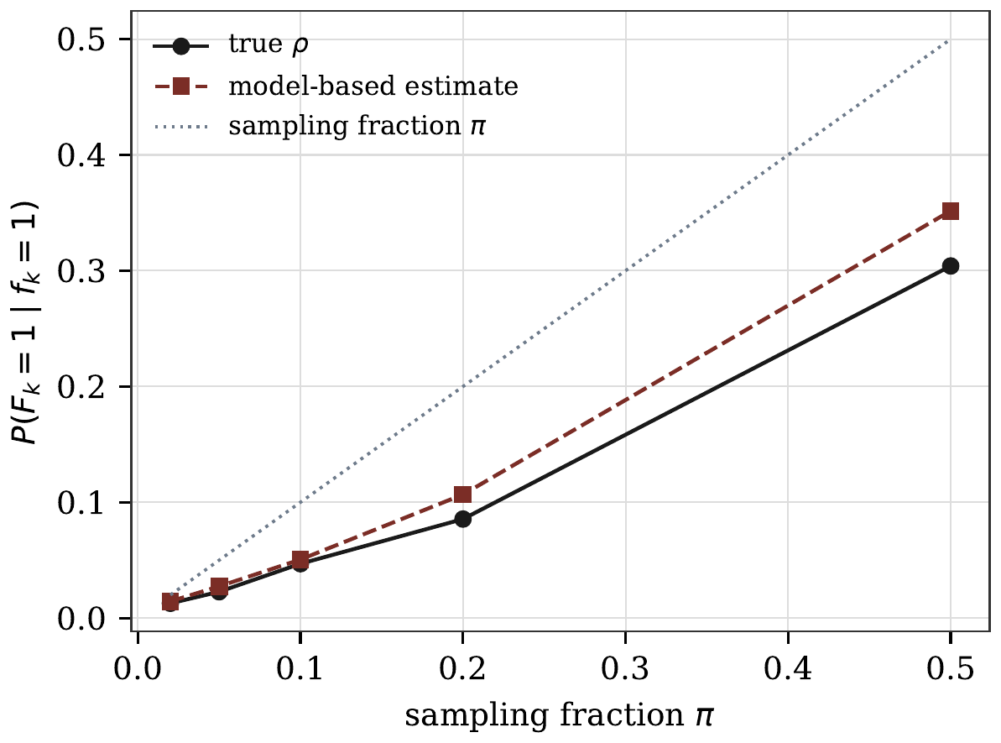
Figure 2. The uniqueness probability $ρ=P\left(F_{k}=1∣f_{k}=1\right)$, the chance that a sample unique is population unique, against the sampling fraction. The model-based estimate uses a negative binomial population frequency law fitted to the sample cell counts. The sampling fraction itself is not an approximation to $ρ$.

10.3 Measurement error does not simply reduce risk
Under exact exchangeable matching the predicted success rate for a uniformly drawn released target is 0.4663. Simulating the declared adversary with key reporting error but no covariate gives 0.3812 over 5,000 replicates, which is the reduction practitioners expect. Adding the single noisy covariate returns the success rate to 0.4642 over 20,000 replicates, with a one-sided 95 per cent bound of 0.4701. The reciprocal-frequency figure is therefore accurate for this release, but by cancellation between an error that spreads posterior mass and a covariate that concentrates it. An assessment that modelled only the reporting error would have understated the risk by 18 per cent.
Figure 3 tests the posterior itself, which is the first falsification requirement of Section 14. When the adversary’s declared model matches the process that generates its information, the mean gap between the binned maximum posterior and the empirical success rate is 0.007. When the adversary assumes a covariate 2.5 times noisier than the truth, the mean gap rises to 0.049 and the miscalibration is one-sided: the posterior understates the success rate in the lower bins. The overall success rate barely moves, from 0.4642 to 0.4571. This is the practical lesson of the figure. A single risk number cannot reveal that the linkage model is wrong, and a calibration check on held-out matches can.
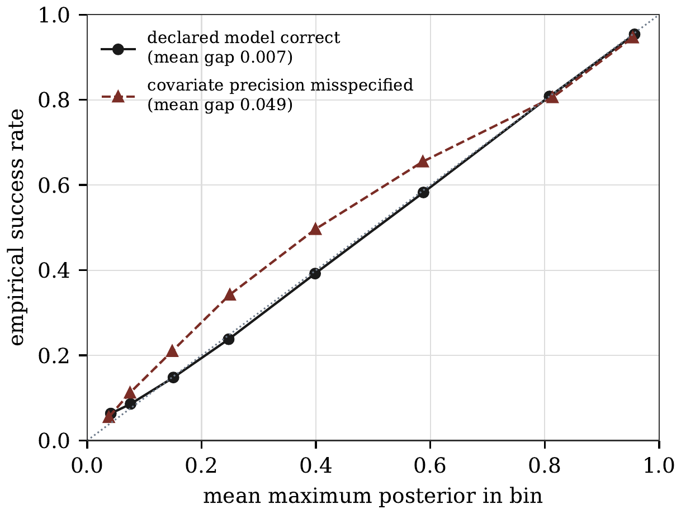
Figure 3. Calibration of the adversary’s maximum posterior against the empirical success rate, 20,000 replicates per curve. The two models produce risk estimates that differ by 0.007, while their calibration gaps differ by a factor of seven.

10.4 $k$-anonymity does not deliver $1/k$
Table 2 applies minimum cell counts and compares the nominal bound $1/k$ with two simulated quantities: the average risk over a uniformly drawn released target, and the risk of the worst target among those in the smallest released cells, each of the latter estimated from 250 replicates.
The average risk stays below $1/k$ at $k=3$ and $k=5$ and exceeds it at $k=10$ and $k=20$. The worst target’s risk exceeds $1/k$ at every $k$, and so does its one-sided 95 per cent lower confidence bound, which is 0.82, 0.78, 0.64 and 0.68 as $k$ runs from 3 to 20. Those bounds carry a Bonferroni correction for the number of targets examined, since the worst target is selected on its own estimate. Between 27 and 75 per cent of the targets in minimum-size cells have an individual lower bound above $1/k$. Both comparisons show that $k$-anonymity on the declared key does not deliver $1/k$ when the intruder also holds a reading of the released continuous variable, and the second shows it in the form that matters for rule (27), which is stated as a supremum. This is a failure of key selection, not of the criterion: the covariate separates members of a key class, and raising $k$ on a key that leaves it out shrinks the share of the adversary’s information that the criterion controls while leaving the covariate untouched.
Figure 4 shows what the suppression does to the whole risk distribution rather than to its maximum, and the utility loss is large. Reaching $k=10$ retains 15.5 per cent of the released records and reaching $k=20$ retains 4.8 per cent, so a release governed by its maximum prosecutor risk alone is pushed towards discarding most of its own content.
Table 2. Minimum cell counts against the simulated risk of the declared adversary. The average uses 12,000 uniformly drawn targets with ${\overline{R}}_{0.95}$ its one-sided Clopper–Pearson bound. The worst target is taken over the listed number of targets in minimum-size cells, each estimated from 250 replicates, and is reported with a one-sided 95 per cent lower bound carrying a Bonferroni correction for the number of targets examined. The last column is the share of those targets whose individual lower bound exceeds $1/k$.
$k_{min}$ | Kept | Share | $1/k$ | Average | ${\overline{R}}_{0.95}$ | Targets | Worst (bound) | Share above $1/k$
3 | 5,426 | 0.541 | 0.3333 | 0.2573 | 0.2640 | 250 | 0.900 (0.817) | 0.748
5 | 3,361 | 0.335 | 0.2000 | 0.1852 | 0.1911 | 250 | 0.868 (0.778) | 0.492
10 | 1,555 | 0.155 | 0.1000 | 0.1129 | 0.1178 | 230 | 0.744 (0.638) | 0.326
20 | 484 | 0.048 | 0.0500 | 0.0787 | 0.0828 | 60 | 0.768 (0.675) | 0.267
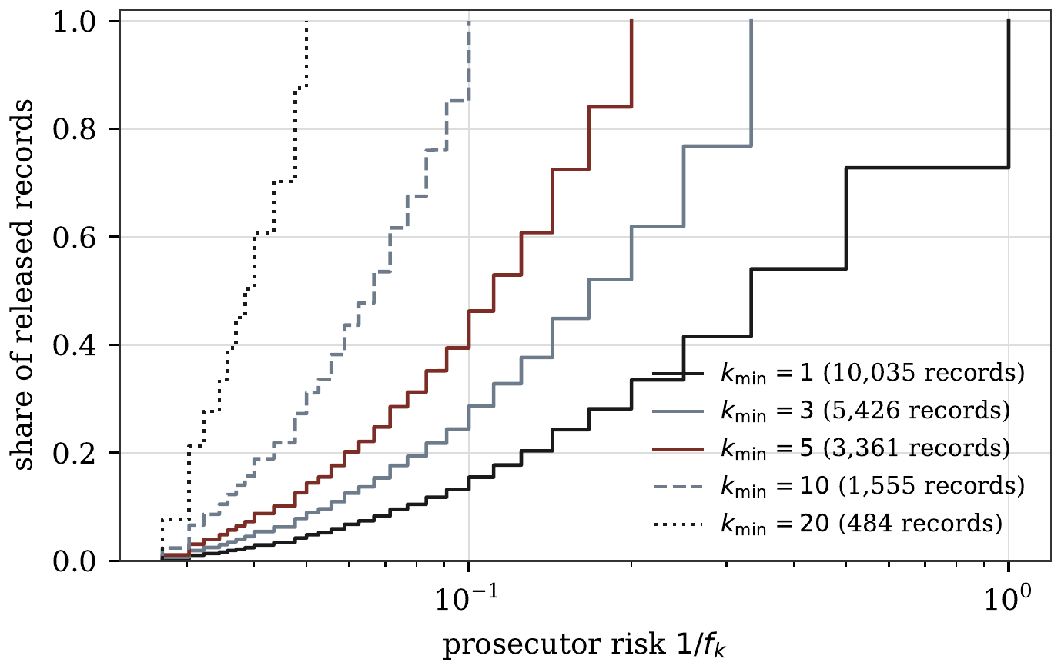
Figure 4. Distribution of prosecutor risk $1/f_{k}$ across released records under minimum cell counts. Governing the maximum alone forces most of the file out of the release.

10.5 Frontier, tolerance and the relative weight assigned to harm
Figure 5 plots all 45 mechanism settings in the plane of the one-sided risk bound and the utility of Section 6. Eleven settings are nondominated, and the frontier spans risk from 0.081 to 0.564. It is steep at the low-risk end: halving the bound from 0.1715 to 0.0806 costs 0.17 of utility, half the range the frontier spans, and cuts the records retained from 100 to 58 per cent.
The attainable frontier is not concave. Successive slopes of the eleven nondominated points run from 6.0 down to 0.006 and not monotonically, which is what a discrete mechanism family produces and what Proposition 9 anticipates. A three-parameter power curve fits it with $R^{2}=0.964$ and is concave over the fitted range; it is used only for the allocation in Section 10.6, which is therefore a stylised illustration on a fitted curve, not an optimum over the discrete settings. Table 3 reports the implied tolerance of Proposition 7, computed as the value-maximising choice over the eleven nondominated settings rather than on the fitted curve, and with the one-sided bound as the risk coordinate as (27) requires.
Two features matter for practice. The implied tolerance is flat over wide ranges, since one setting is optimal from $κ=5$ to $κ=10$, and it jumps between ranges: doubling the relative weight assigned to harm from $κ=0.5$ to $κ=1$ cuts the tolerance from 0.345 to 0.145 and moves the release from an unsuppressed file with twelve occupation groups to one with three groups and a minimum cell count of five. The jump is a property of the discrete mechanism family, not of the argument, and it has a practical reading: over most of the range an institution cannot fine-tune its tolerance, and near a breakpoint a small revision of the relative weight assigned to harm changes the release.
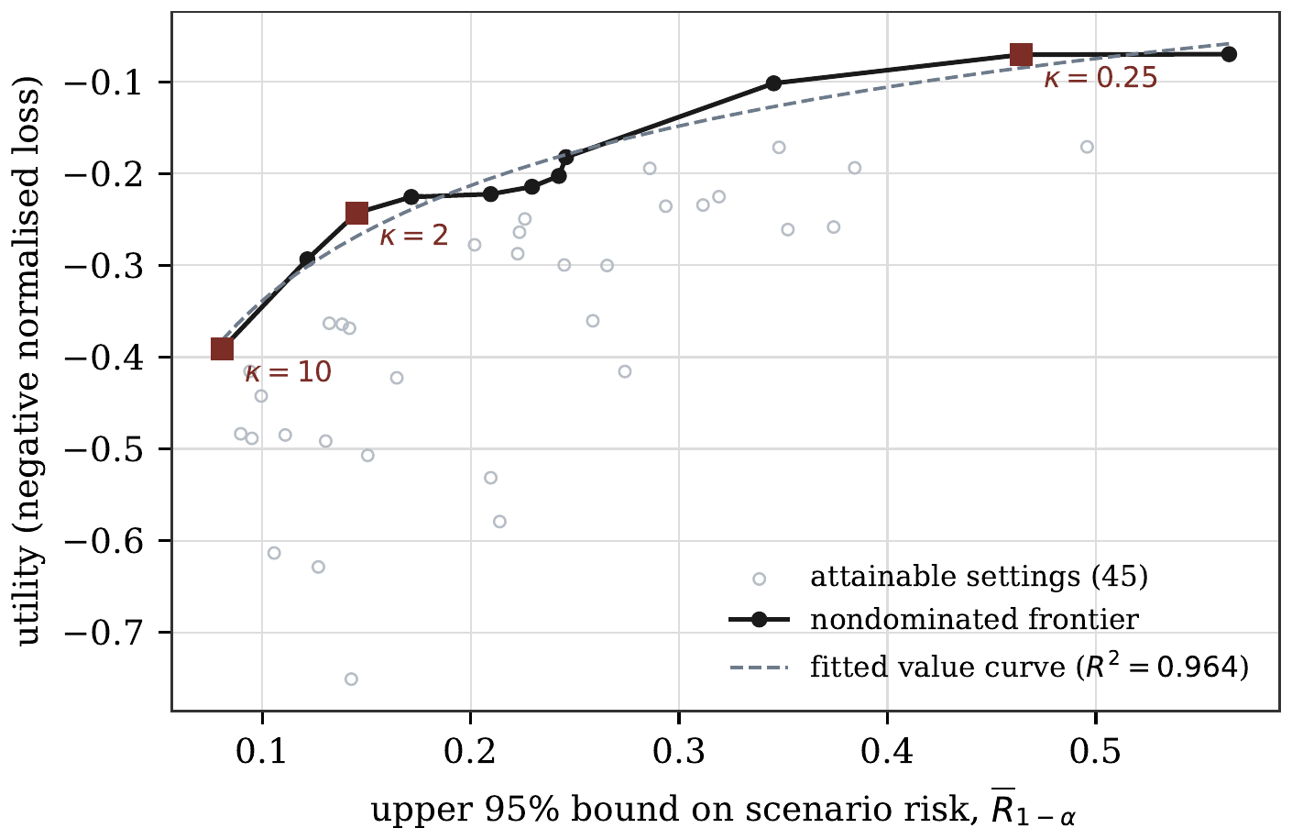
Figure 5. Risk–utility plane for 45 mechanism settings. The risk coordinate is the one-sided 95 per cent bound for a uniformly drawn target, not the point estimate. Squares mark the value-maximising setting for three values of the relative harm weight $κ$; the associated risk is the implied tolerance $τ^{⋆}$ of Proposition 7.
Table 3. Tolerance implied by the relative harm weight, computed by maximising $U−κ{\overline{R}}_{0.95}$ over the nondominated settings. The selected setting reports age band width in years, occupation groups and minimum cell count.
$κ=c_{h}/λ$ | Implied $τ^{⋆}$ | Selected setting | Records kept
0.25 | 0.464 | 10-year bands, 12 groups, $k_{min}=1$ | 1.00
0.50 | 0.345 | 20-year bands, 12 groups, $k_{min}=1$ | 1.00
1.00 | 0.145 | 20-year bands, 3 groups, $k_{min}=5$ | 0.94
2.00 | 0.145 | 20-year bands, 3 groups, $k_{min}=5$ | 0.94
5.00 | 0.081 | 20-year bands, 3 groups, $k_{min}=20$ | 0.58
10.00 | 0.081 | 20-year bands, 3 groups, $k_{min}=20$ | 0.58

10.6 A programme of four releases
Four releases are built from the same sample. Release A keys on district, sex and five-year age band; release B on district, sex and occupation; release C on district, ten-year age band and six occupation groups; release D on sex, ten-year age band and occupation. Each applies a minimum cell count of three, so each is 3-anonymous and, by construction, no release contains a single unique record. Their marginal risks, computed unconditionally so that a target suppressed from a release contributes zero, are 0.0768, 0.0711, 0.0884 and 0.0168.
The pooled adversary below assumes that the four releases carry a common record identifier, so that it can intersect the target’s candidate sets across them. Four releases cut from one sample need not carry one, and without it the adversary would have to link records through the published keys; we did not measure that case here. With a common identifier the four releases are one release keyed on the union of their keys (Remark 2), and the figures below measure how much finer that union is than any of its parts.
Table 4 and Figure 6 report what the programme permits. The bounds implied by the marginals are $\left[0.0884,0.2530\right]$ and the independence value is 0.2313. An adversary that intersects the candidate sets of the first two releases succeeds with probability 0.4114, which is 2.8 times the bound of 0.148 implied by those two marginals and 1.6 times the upper bound implied by all four. With all four releases the pooled risk is 0.4581, which is 1.8 times that bound, and 26.0 per cent of targets are uniquely identified by the intersection although none was unique in any single release.
Table 4. Four 3-anonymous releases from one sample, 20,000 target replicates. No single release contains a unique record. Marginal risks are unconditional; a target suppressed from a release contributes zero to that release and does not narrow the intersection. The pooled adversary intersects the candidate sets of releases 1 to $m$ and selects uniformly from the intersection.
 | Records released | Marginal risk | Unique share
Release A (district, sex, fine age) | 9,648 | 0.0768 | 0.000
Release B (district, sex, occupation) | 9,709 | 0.0711 | 0.000
Release C (district, ten-year age, six groups) | 9,257 | 0.0884 | 0.000
Release D (sex, ten-year age, occupation) | 10,035 | 0.0168 | 0.000
Programme-level quantities
Lower bound $\max_{i}R_{i}$ |  | 0.0884
Upper bound min1,i​Ri |  | 0.2530
Value under independence |  | 0.2313
Pooled attack, $m=2$ |  | 0.4114 | 0.208
Pooled attack, $m=3$ |  | 0.4279 | 0.222
Pooled attack, $m=4$ |  | 0.4581 | 0.260
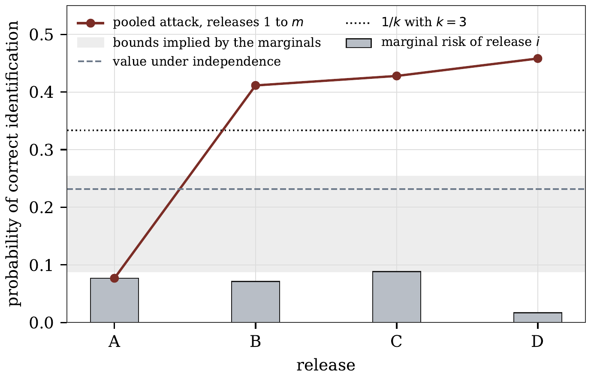
Figure 6. Marginal risks of four 3-anonymous releases and the risk of an adversary that pools them. The shaded band is the interval implied by the marginals under Proposition 10. The pooled attack leaves the band at $m=2$.
Two remarks. First, the effect is not driven by a large number of releases. Two are enough, and the third and fourth add little because the first two already carry most of the separating information. Second, on this draw, ranking releases by their own risk figures does not rank their contribution to the programme: release D has the smallest marginal risk, 0.0168, yet adding it to the pool raises the risk by 0.030, while release C, whose marginal risk is the largest at 0.0884, adds 0.017. The contributions depend on the order in which releases are added and rest on one sample, so we read this as an example that the two rankings can differ, not as a finding about releases C and D. Neither observation is visible in a marginal assessment.
Applying Proposition 16 to the union event, with value weights $1,0.7,0.5,0.3$ and $τ_{prog}=0.50$, the optimal allocation is $\left(0.186,0.139,0.106,0.070\right)$ against the equal split of $0.125$ each, and cuts the total loss by 4.5 per cent on the fitted curve. A constrained numerical optimum agrees with the closed form (46) to five decimal places, which is one check on both. With the fitted $γ=−0.23$ the exponent in (46) is 0.81, so the allocation is flatter than the value weights. This is a stylised illustration on a fitted curve, not an optimum over the discrete settings, whose frontier is not concave; the gain is small, and it is available only for the union event.

10.7 Further checks
Appendix E reports three further checks on the synthetic population: whether the gap between pooled and marginal risk survives at other register sizes (it widens, Table 17), what certifying a small tolerance costs in simulated attacks (Table 18), and how much of the variance of a risk estimate the binomial interval misses (Section E.3).

10.8 Reproducing the study
Everything above comes from one program with a single seed, packaged as Mahomane (2026). The package keeps four kinds of work apart and labels them: proof checks that verify algebraic consequences of the declared assumptions, simulation checks that estimate attack success and its Monte Carlo error, falsification tests that can reject the model, and the governance gate that applies the tolerance. A run writes the configuration it used, every result, the validation status, the five figures, the LaTeX fragments for the tables in this section, a decision record naming the tolerance, owner, expiry date and adversary, and a SHA-256 hash of each of those files. A failed falsification test produces a non-zero exit status, so a rejected model cannot be presented as governed evidence.
Two details of that arrangement matter for a reader checking this paper. The tables in this section are generated by the run rather than typed, so a table cannot disagree with the experiment that produced it. And the figures quoted in the prose are checked against the run by a script that fails when one of them drifts. The script checks every value the run writes to its number file and every quoted decimal with three or more places; integers and two-place figures are checked by hand. The run reported here selects the 20-anonymous setting under a tolerance of 0.12. Its single-release upper bound meets the tolerance, so the release check passes, but the upper bound on the pooled risk of the declared four-release programme, 0.464, exceeds the release tolerance, and the gate therefore returns a fail. The programme check compares the upper bound, not the point estimate of 0.4581, with the tolerance, for the reason of Proposition 5. The programme validation check uses its own tolerance of 0.50, which is recorded separately and plays no part in that decision. A failed decision is the intended outcome here: the gate fails closed when the programme is riskier than the tolerance the release was set. The credit evaluation of Section 13 was also rerun over 20 independent register draws by a separate script, scripts/programme_robustness.py (Table 11).

11 Real data
Everything above is measured on data we generated, which is the only way to check an estimator against a truth. It is not a substitute for running the framework on a file someone actually published. This section does that, on two real public microdata files that ship with the wooldridge package: an extract of the US Census 2000 public use sample, 29,501 records with state, public use microdata area, years of schooling, potential experience and log weekly income; and the Boston Fed mortgage application study, 1,986 real applications with area, income, marital status, dependants, occupancy, the lending decision and a record of late payments. Both files are already public and already protected. Nothing confidential is read here, and the question asked is the one an agency asks before publishing a file of that shape: what would a declared adversary achieve against it.
Three things change when the data are real, and each of them is a claim the earlier sections make. The population behind the file is not observed, so the population-frequency measure cannot be computed at all and the uniqueness probability $ρ$ has no truth to be checked against: a fitted model is the only route to it, which is why Section 14 asks for a frequency-transport test rather than a comparison. The analyses that define utility are given by what the file is used for, not chosen by us. And the risk levels are much higher than in the simulation, so the choice of tolerance matters more.

11.1 The census sample
The figures in this subsection are a demonstration that the pipeline runs on a real published file. They are prosecutor risks computed inside the file, for an adversary who knows that its target is in the extract. They are not an estimate of the risk the file posed to the population, which a statistical office would assess with the sampling fraction, the population frequencies and the access conditions that we do not have.
On the full key, state, area, schooling and experience, the 29,501 records occupy 27,390 classes. Of those classes 92.9 per cent are unique, and they hold 86.3 per cent of the records. The mean reciprocal frequency is 0.928. This is a published file, so the finding is not that someone blundered: it is that the key an outsider can reconstruct almost determines the record, and that any protection claim about it has to come from something other than the key. The key space, counting the areas actually observed inside each state, holds 665,896 cells. The uniqueness probability $ρ$ needs the file’s sampling fraction, which is not known, and the pipeline assumes $π=0.05$. Under that assumption a negative binomial law fitted to the observed counts puts the mean population cell at 0.886 people once empty cells are counted, and a record unique in the file is unique in the population with probability 0.225. The figure is a consequence of the assumed $π$, not a finding about the file. With the dispersion held at its fitted value, $ρ$ is 0.035 at $π=0.01$ and falls further at smaller fractions, and the file, a small subsample of the 2000 public use sample, covers a fraction of the US population far below 0.05. There is no truth here to compare these with, which is the position an agency is in when it does not know its own sampling fraction.
Table 5 reports the releases on the frontier of 25 settings that vary the area, schooling and experience bands and the minimum cell count. The declared adversary observes the key exactly but models a misreading probability of 0.10, and holds a noisy reading of income. The column headed Simulated is the robust risk, the larger of the risks of this adversary and one whose income reading is twice as precise. The simulated attack beats exact matching at every setting, by a factor between 1.05 and 4.19: at the widest bands with a minimum cell count of ten, exact matching gives 0.062 and the simulated attack gives 0.239.
Utility charges for coarsening as well as for suppression. Each of the three analyses is estimated at the fine level of its variable, and a release that publishes a band supplies the band mean for every fine level inside it, as in Section 10; so a release with four-year schooling bands loses accuracy on income by schooling even when it suppresses nothing. The frontier then holds eight of the 25 settings, and it runs from 0.276 to 0.942 under simultaneous one-sided bounds over the 72 planned setting–adversary comparisons. These are conditional attack success rates against the tested public file, not population re-identification rates or certificates against untested attacks. The pipeline also reads implied tolerances off this frontier, as in Section 10; we do not report them, because a tolerance for a file of this kind is a policy choice for the office that publishes it, and in-file prosecutor risks are not the quantity it would govern. The settings with the finest bands sit at the high-risk end of the frontier, where they buy the last units of utility.
Table 5. US Census 2000 public use sample: the nondominated releases. The file holds 29,501 records, and the columns report the width of the area, schooling and experience bands, the minimum cell count, the share of records kept, the risk under exact matching, the simulated risk with its simultaneous one-sided bound over the 72 planned setting–adversary comparisons, and the utility across the three income analyses. The simulated risk is the larger of two adversaries, the declared one and one with a covariate reading twice as precise. Both read the key exactly but model a misreading probability of 0.10, and both hold a noisy reading of log weekly income.
Area | Schooling | Experience | $k_{min}$ | Kept | Exact matching | Simulated | ${\overline{R}}_{0.95}$ | Utility
100 | 4 | 10 | 10 | 0.284 | 0.0615 | 0.2393 | 0.2761 | -0.330
10 | 4 | 10 | 10 | 0.253 | 0.0680 | 0.2713 | 0.3094 | -0.327
100 | 4 | 10 | 5 | 0.566 | 0.1093 | 0.3407 | 0.3808 | -0.161
10 | 4 | 10 | 5 | 0.554 | 0.1165 | 0.3567 | 0.3972 | -0.155
100 | 4 | 10 | 1 | 1.000 | 0.2965 | 0.5060 | 0.5475 | -0.097
100 | 1 | 10 | 1 | 1.000 | 0.4282 | 0.6567 | 0.6954 | -0.071
100 | 4 | 1 | 1 | 1.000 | 0.7418 | 0.8827 | 0.9077 | -0.026
100 | 1 | 1 | 1 | 1.000 | 0.8348 | 0.9213 | 0.9419 | -0.000
Selection and uncertainty. Figure 7 lays out the public-file evaluation in the order it runs: the public files, the declared releases, the attack simulation on fresh targets, the 72 exact bounds that share one familywise error of 0.05, the frontier chosen from them, and the sensitivity checks, which sit outside that family. The frontier is chosen after the bounds are computed, and the familywise bound is what keeps that choice valid. The grid plans $3×2×2×3=36$ settings and two attacker precisions, although only 25 settings retain at least 500 records. For planned pair $j∈\{1,…,72\}$ let $K_{j}$ be its number of successful attacks in $n_{j}=1500$ independently sampled targets, with fresh auxiliary noise, conditional on the released file and fixed attack rule. If $U_{j}=B_{1−α/72}^{−1}\left(K_{j}+1,n_{j}−K_{j}\right)$ for $K_{j}<n_{j}$, and $U_{j}=1$ otherwise, where $B_{q}^{−1}\left(a,b\right)$ is a beta quantile, then
$$Pr\{∀j: p_{j}≤U_{j}∣\text{these public files}\}≥1−α, α=0.05.$$
This follows from the exact one-sided binomial bound and a union bound; it does not assume independence between settings. Each setting’s reported upper risk is the maximum of its two $U_{j}$ values. Hence selecting a frontier setting after viewing all simulated attacks does not undo this familywise Monte Carlo coverage. The result does not cover a new attacker, a new file, uncertainty in the source population, or adaptive additional grid searches. The utility is measured against analyses of the public extract itself, rather than population ground truth.
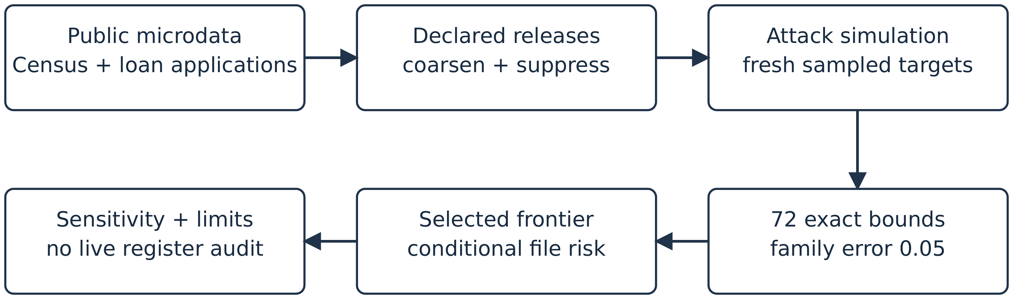
Figure 7. Public-file evaluation. The familywise bound covers the planned 36 release settings and two attacker precisions on the census file, conditional on the released file and independent sampled targets. Sensitivity checks are exploratory; a separate audit is needed for a live register.
The attacker assumption matters: on one setting of the grid, a separate exploratory run with 3,000 targets, archived in artifacts-real/replication.json, gives success rates 0.371, 0.271 and 0.186 as the standard deviation of its log-income reading changes from 0.25 to 0.5 to 1.0. On the loan file the corresponding rates are 0.179, 0.137 and 0.093 for loan-amount standard deviations 20, 40 and 80. These additional rates have individual 95 per cent intervals only and do not extend the 72-comparison family. They make the assumed quality of auxiliary information visible rather than treating one risk value as intrinsic to the file.
The supremum control needs a setting to act on, and the run takes the middle setting of the frontier, which has four-year schooling bands and no minimum cell count. The 80 records it examines sit in classes of 1. The attack names them with mean probability 1.000, and the worst of them is identified with probability 1.00, with a Bonferroni-corrected lower bound of 0.964. On this setting the key alone separates them, so the check shows how exposed an unsuppressed release of this file is; it does not test a $k$-anonymity promise, because the setting makes none, and we do not compare it with the simulated register of Section 10.4.
Composition was run on this file under the same condition as Section 10.6: the four releases are taken to share a record identifier, so that a record can be matched across them. Four public-use files cut from one census sample would not carry common record identifiers, and an adversary would then have to link them through the published fields; we did not measure that case on the census file. With the shared identifier, four releases were built by dropping one key component at a time, each with a minimum cell count of three. Their marginal risks are 0.138, 0.030, 0.118 and 0.096, so the union bound is 0.381. The pooled adversary reaches 0.709, which is 1.86 times that bound, and 60.7 per cent of targets are uniquely identified by the intersection although none of the four releases contains a unique record. On the synthetic register the same comparison gave 1.8 times the bound. Each figure comes from one draw, so the two do not show that the effect is larger on either kind of data.

11.2 The mortgage applications
The second file, the Boston Fed mortgage applications, is small and shows the other risks of Section 12: identification against a noisy reading of the loan amount, attribute disclosure of the lending decision and of late payments, and residual disclosure from published totals. Appendix F.4 reports the figures. Unlike the synthetic credit register, both harmful directions of attribute disclosure occur in it.

11.3 What the real files settle and what they do not
Two findings from the generated data reappear on the two public files: the covariate beats exact matching at every setting, and, when the releases share a record identifier, the pooled attack exceeds the marginal bound.
Four limits should be read with the numbers. The files are samples whose populations are not observed, so the uniqueness probability $ρ$ rests on an assumed sampling fraction and a fitted law that this exercise cannot check, and the utility analyses are computed against the file rather than against the population it came from. The adversary is declared, not observed: the reporting error rate and the precision of the income reading are assumptions, and Section 14 is how an institution would test them. And these are public files, so the exercise measures what a release of this shape discloses, not whether a wrong was done in publishing them. And only the demographic path of the pipeline ran on these files: the credit evaluation of Section 13 has run only on the synthetic register.

12 A granular credit register
Many central banks collect loan-level credit data under statute. In the euro area, AnaCredit collects, mostly monthly, data on loans by credit institutions to legal entities, not households, whenever the debtor’s commitment amount with the reporting institution is at least EUR 25,000, and each record ties a borrower to a lender (ECB, 2016). The Irving Fisher Committee has discussed the use of such micro data across jurisdictions (IFC, 2016), and Israël et al. (2017) describe the content and uses of AnaCredit. Loan-level registers also support research on credit supply: Khwaja and Mian (2008) use a credit register to separate supply from demand, and Jiménez et al. (2012) use loan applications in the Spanish register to identify the bank balance-sheet channel. Loan-level data of this kind are not released for general use; research access is restricted. The releases studied here are therefore a stylised set of three kinds: a loan-level file of the sort a secure research environment might give access to, aggregates by region, sector and lender, and a monthly series with revisions. The borrowers are firms. That combination is what makes a credit register a different problem from a demographic file, and it is the problem this section measures on a synthetic register built to share the structure of a supervisory collection.
Five harms have to be told apart, because a single risk figure covers only one of them. A borrower may be identified. A borrower–lender relationship may be alleged, whether or not the borrower is identified. Arrears, default or forbearance status may be inferred for a class of borrowers without identifying anyone. One lender’s contribution may be reconstructed from published totals by another participant. And two consecutive vintages may be differenced. Table 6 reports all five against one lever, a minimum cell count on the borrower key.
The simulated register has 20,000 borrowers, 60 lenders, 18 sectors, 12 regions and 4 size classes, so the borrower key has 864 cells. It runs for six monthly vintages. Most loans are outstanding when the panel opens and the rest are originated in a later month; every loan then leaves with a monthly hazard of 0.04 and does not come back. The stock stays near 27,000 loans, about 4 per cent of it turns over each month, and 81 per cent of the loans in the first release are live in all six. Over the six months 32,581 loans are observed, and the first release holds 27,167 of them. Exposure is lognormal within size class and arrears occur at 7 per cent. Appendix D gives the details. The lenders hold unequal shares, the largest 23 per cent. One simplification matters for everything that follows: a loan’s exposure is the same in every vintage in which it is live. A real register reports outstanding amounts that change as loans are drawn and repaid, and we have not modelled that.
Table 6. Credit register: five risks and one utility under a minimum cell count on the borrower key. The register holds 32,581 relationships between 20,000 borrowers and 60 lenders. Identification is the average over released relationships with its one-sided bound, and again for the largest size class alone. The predictive value is that of an alleged borrower-lender relationship, and the homogeneity share is the proportion of large borrowers whose key class discloses their arrears status. Utility is the negative weighted loss across credit growth, concentration, the arrears ratio and lender-level supervision.
$k_{min}$ | Kept | Identification | ${\overline{R}}_{0.95}$ | Large firms | Relationship PPV | Status disclosed | Utility
1 | 1.000 | 0.0855 | 0.0931 | 0.247 | 0.328 | 0.444 | -0.000
5 | 0.990 | 0.0770 | 0.0843 | 0.273 | 0.324 | 0.381 | -0.050
10 | 0.958 | 0.0705 | 0.0775 | 0.119 | 0.320 | 0.262 | -0.139
20 | 0.851 | 0.0563 | 0.0626 | 0.155 | 0.313 | 0.119 | -0.254
Identification is a subgroup problem. Success can be scored two ways, and the difference matters. Recovering the exact relationship succeeds for 0.0855 of released rows, with a one-sided bound of 0.0931; recovering the right borrower, which is the harm the register creates, succeeds for 0.1095, because a borrower with several lenders can be found through any of them. Both look comfortable as averages. Split by size class the relationship figure is 0.050, 0.091, 0.128 and 0.247, so a large borrower faces about five times the risk of a micro borrower. This is the target-set point of Section 5: the same file meets any tolerance its average figure meets and breaches that tolerance on the largest size class. Raising the minimum cell count to 20 brings the large-borrower figure to 0.155 and keeps 85 per cent of the relationships. That subgroup rests on few targets, so it is reported with its interval: [0.192, 0.309] at $k_{min}=1$ and [0.085, 0.250] at $k_{min}=20$. The two overlap, and the risk is not monotone across the grid: it is 0.273 at $k_{min}=5$ and 0.119 at $k_{min}=10$. The large-firm figure at no suppression agrees across draws: it is 0.248 in Table 7, which scores the same event on its own draw, and about 0.24 on a stratified draw of 4,000 large-firm targets (Section 13.4). A uniform draw holds only a few hundred large-firm targets, which is why the subgroup floor of Section 13.4 uses the stratified draw.
An alleged relationship is a base-rate statement. Suppose the adversary names, for every borrower in the release, the lender holding the largest share of that borrower’s key class. Equation (58) gives the quantity that matters, the probability that an allegation is true. On the simulated register the prevalence of any given borrower–lender pair is 0.0243, the sensitivity of this rule is 0.225 and its specificity is 0.989, and (58) returns 0.328, which is the realised share of correct allegations. The four cells are reported so that a reader can check the identity rather than take the predictive value on trust; their agreement is arithmetic, not evidence. Two readings follow. A specificity of 0.989 sounds protective and is not, because the prevalence is low. And an allegation that is right a third of the time is 1.4 times the success rate of always naming the largest lender in the market (share 0.23), and wrong about two borrowers in three. The minimum cell count barely moves it: 0.328 at $k_{min}=1$ and 0.313 at $k_{min}=20$. The lever that governs identification does not govern relationship disclosure, and an institution that reports only the first has not addressed the second.
Status can be disclosed without identification. A key class whose members all share an arrears status discloses that status for every member, whatever the class size. For large borrowers 44.4 per cent of released relationships sit in such a class at $k_{min}=1$, falling to 11.9 per cent at $k_{min}=20$. In this register every homogeneous class is homogeneous in the benign direction, because arrears are rare, so what is disclosed is the absence of arrears. Large borrowers carry the highest homogeneity share because their key classes are the smallest. That is a property of the base rate and the class sizes rather than a guarantee, and it is exactly the quantity an agency should measure on its own register, where a small sector–region cell in distress is the case that matters. A minimum cell count does not address the harm; the attribute-level criteria of Machanavajjhala et al. (2007) and Li et al. (2007) do, and they change the risk model rather than the tolerance.
Published totals give contributions away by subtraction. Published totals by region, sector and size class give a linear system, and Appendix C states when a contribution is determined by it. In the first vintage 2.0 per cent of the 814 published cells have a single contributor, so that lender’s position is the published total, and a further 3.9 per cent have two, so either participant recovers the other’s amount by subtraction. Together that is 5.9 per cent of cells, holding 2.8 per cent of total exposure; the single-contributor cells alone hold 0.65 per cent. The remedy is a rule on the aggregates, not on the microdata: requiring five contributors rather than three suppresses 14.4 per cent of cells instead of 5.9 per cent. A threshold rule is not enough on its own. With lender shares up to 23 per cent, one contributor can estimate another’s amount closely even when three or more contribute, which is what the dominance $\left(n,k\right)$ rule and the $p\%$ rule for magnitude tables are designed to catch (Hundepool et al., 2012, ch. 4). We do not evaluate them here. The loan-level minimum cell count leaves this risk untouched, which is the third place in this case where one lever fails to govern another risk.
Monthly vintages can be differenced. When a published count moves by one between vintages, the change in the published total is the arriving or departing amount, provided one loan moved. The lever here is not the loan-level minimum cell count but a minimum on the published count, written $c_{min}$ to keep the two apart. Across consecutive months 36.1 per cent of comparable cell pairs show a unit change at $c_{min}=1$, and 39.0 per cent at $c_{min}=10$, because a higher minimum keeps only the busier cells, where counts move more. The adversary does not observe the number of moves, and (59) gives the posterior that a unit change was a single move. Which rate goes into it decides the answer. Pooled over all cells, arrivals and departures together average 2.7 per cell per transition, and (59) returns 0.45. The cells that show a unit change are a little quieter, averaging 2.4 moves, and at the rate of the cell in question the model returns 0.65. The realised share of unit changes that were in fact a single move is also 0.65, so the per-cell Poisson model passes the calibration test of Section 14 (test 1) on this register, and the pooled rate understates the exposure. The institution holds the register and can count realised single moves directly, and that count is what the record should carry. At $c_{min}=10$ a unit change still reveals one loan’s exposure in 56 per cent of cases, so a count floor alone does not govern this harm.
The utility side is not one number either. A credit register is collected for credit growth measurement, concentration analysis, financial stability monitoring and supervision, and a minimum cell count damages them unequally. At $k_{min}=20$ the weighted loss is 0.254, of which almost all comes from the sectoral exposure and lender-level supervision terms, at 0.531 and 0.435, while the concentration and arrears-ratio terms lose 0.015 and 0.016. Both level estimates are grossed up by the retained share of records, which is the rule an analyst applies who is told how many records were suppressed and not how much exposure they carried; suppression removes the thin large-borrower cells, so that rule understates the totals and the loss reflects both effects together. Suppression removes whole thin cells, which is where a supervisor looks and where an aggregate ratio does not change. An institution that reports one utility score for the release hides which analysis paid for the protection.
What the record should say. The five risks have different target sets, different harm classes and different owners, so they need five entries of the form (26) rather than one. Section 13 adopts $τ=0.12$ for illustration; no institution has set a tolerance for this register, and without one neither pass nor fail means anything under Definition 2. On this register a defensible record would set a subgroup tolerance for identification of large borrowers. At $τ=0.10$ no setting in Table 6 passes (27), and none passes even on its point estimate, the lowest being 0.119 at $k_{min}=10$. The record would also set a separate tolerance on the predictive value of an alleged relationship, an attribute rule rather than a cell-count rule for status, a contributor rule on the aggregates, a count rule with a stated tolerance for differencing, and a programme tolerance for the monthly series over a declared horizon, assessed by the joint simulation of Section 7, since consecutive vintages whose loans carry a persistent pseudonym are exactly the pooled adversary of Proposition 11. No single minimum cell count delivers all five, and Table 6 shows why: as $k_{min}$ rises from 1 to 20 the large-borrower identification risk falls by about two fifths, the relationship predictive value by about 5 per cent, and the reconstruction risk does not move at all.

13 An adversarial evaluation of a credit-release system
Section 12 measured five risks on a synthetic credit register against one protection lever. This section fixes an adversary and a set of attacks, and runs them against stylised versions of protection policies described in the disclosure control literature, on the same register and with one body of auxiliary information. The results report how often an attack succeeds, how often it is right when it chooses to act, what it must know before it can act at all, and how it degrades when its own model of the data is wrong. The same reporting is used for attacks on trained models. Shokri et al. (2017) introduced membership inference against such models, Carlini et al. (2022) argue that an attack should be judged by its true positive rate at a low false positive rate rather than by average accuracy, and Jagielski et al. (2020) and Steinke et al. (2023) turn simulated attacks into an empirical lower bound on a privacy parameter.
The evaluation asks whether the quantity these policies are calibrated against, the risk of one release, governs the risk of the programme they are part of. Proposition 11 says that, when loans carry a persistent pseudonym, no bound in terms of the marginals exists. The evaluation measures the size of that gap on a synthetic register built to share the structure of a supervisory collection, and what closing it costs in loans and in exposure released.

13.1 Threat model
The adversary targets one borrower and holds up to five pieces of auxiliary information about it: sector, region and size class, which it holds exactly; one reading of log exposure, or one per published vintage in which the loan is live, each corrupted by independent Gaussian noise; and, in some attacks, the loan’s history, that is, the vintages in which the target’s loan is live. Holding the key fields exactly is the pessimistic case for the institution and the natural one for a credit register, where a firm’s sector, region and size class are matters of public record.
The history needs an argument, because it is what lets pooling help. Some adversaries know it. The borrower knows its own loan, and so does the lender and any counterparty to it, such as a guarantor or a buyer of the loan. Public records can reveal it too: where a register of security interests or of charges over company assets is public, or where a firm reports the start and repayment of its borrowing in its accounts or in a bond or equity filing, an outsider can date the loan’s start and end. Others do not. A journalist or researcher who knows a firm’s sector, region and size, and has an estimate of what it borrows, will not in general know in which months a particular loan was drawn or repaid. We therefore report every pooled attack with and without the history (Table 9), and the institution declares which adversary it guards against. We also report an insider, such as the lender or the borrower itself, who knows the history and reads exposure with a standard deviation of 0.01 on the log scale.
Each released loan carries a pseudonym that is the same in every vintage, so the pooled adversary can match a loan across vintages. If the pseudonym rotated each month, the adversary would have to link vintages through the published key and exposure; Section 13.4 measures how often those fields relink a loan.
The attack blocks on region, restricts to loans in the first release whose key agrees with the target’s, scores each candidate by the log density of the exposure readings under the adversary’s own error model, and names the candidate with the highest score. The pipeline attack behind Tables 6 and 7 takes the first of tied candidates, which is rare with continuous readings; the attack behind the floors of Table 9 breaks ties at random. For the precision and coverage figures it acts only when the normalised posterior passes one half, so the adversary may abstain and precision is measured over real choices. The per-release attack uses one vintage and one exposure reading. The pooled attack uses every vintage and adds the evidence across them. It can gain in two ways. With the history, it uses the full likelihood of the target’s pattern of appearances: a candidate whose pattern differs from the target’s in any vintage, whether it is absent where the target is live or live where the target is absent, is excluded. And with one reading per vintage, it gains from the extra readings, which together amount to one more precise reading of the same exposure. Figure 8 shows the history test on four loans in one key cell: only the candidate whose pattern of appearances matches the target’s in all six vintages survives, and the exposure readings then rank the survivors. Algorithm 1 states the whole attack, and the per-release attack is the special case of one release, one reading and no history. The algorithm is the attack behind the floors of Table 9; the pipeline attack behind Tables 6 and 7 runs the same steps and also returns the normalised posterior of the named loan, which the precision and coverage figures use. The exclusion is implemented as a penalty of 30 on the log score for each mismatched vintage; because the target itself always matches, a mismatched candidate is in effect removed.
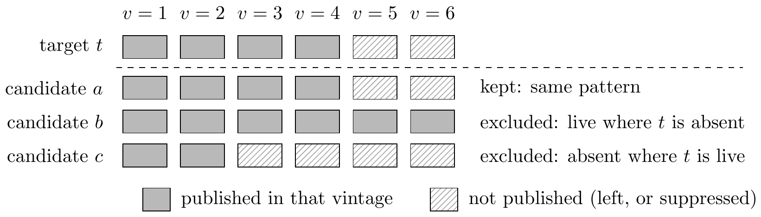
Figure 8. How the pooled adversary uses a loan’s history. All four loans share the target’s key cell. An adversary who knows the vintages in which the target is live keeps only candidates whose pattern of appearances matches the target’s in every vintage, and then ranks the survivors by its exposure readings (Algorithm 1). Shade and hatching both mark the two states, so the figure reads in black and white.
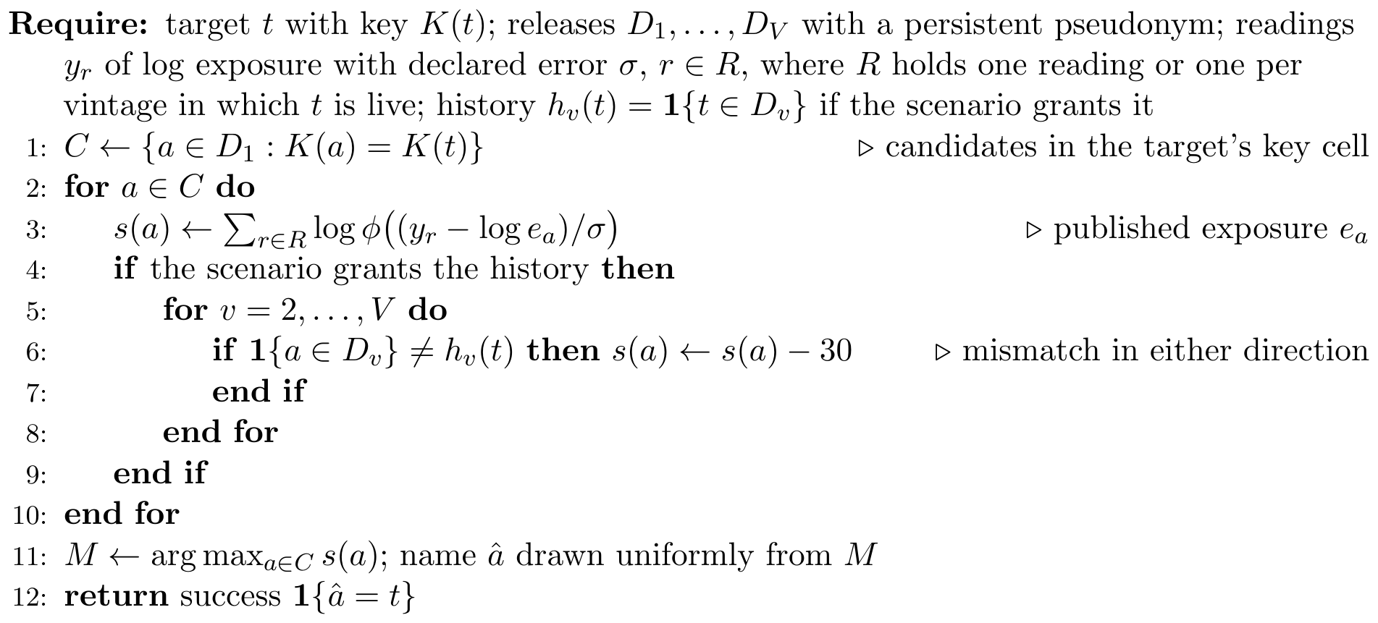
Algorithm 1. Full-likelihood linkage attack on a programme of releases
Table 8 separates the two for the adversary with history, and Table 9 adds the adversary without it. Each entry in Table 7 rests on 4,000 simulated attacks against independently drawn targets. Tables 6 and 7 compute the per-release identification rate with two separate functions of the pipeline, and a check at 20,000 targets (scripts/estimand_check.py) shows that they estimate the same quantity: 0.076 against 0.081 at $k_{min}=5$, 0.070 against 0.069 at $k_{min}=10$, and 0.056 against 0.054 at $k_{min}=20$, each difference within two standard errors.
Three further attacks run against the same releases. The relationship attack names, for each released borrower, the lender holding the largest share of that borrower’s key class, and is scored by the share of allegations that are true. The attribute attack reads arrears status off a key class whose members agree, and is scored by accuracy on the classes it is confident about. The differencing attack compares two vintages of the same cell and claims a single arrival or departure whenever the count moves by one, and is scored by how often exactly one loan moved.

13.2 The policies compared
Five loan-level policies enter the comparison. They are stylised versions of rules described by Hundepool et al. (2012), not copies of any institution’s practice:
- no suppression, the isolated-release baseline;
- a threshold rule, which withholds a cell unless at least three lenders contribute to it; for magnitude tables such a rule is usually applied beside a dominance $\left(n,k\right)$ or $p\%$ rule (Hundepool et al., 2012, ch. 4), which we leave out;
- the same rule with a heuristic secondary suppression (the row labelled complementary suppression), which also withholds the smallest surviving cell in each region so that a suppressed cell cannot be recovered from a published row total; it is not audited against the other margins, sector and size, and is not secondary suppression in the sense of Cox (1980) and Fischetti and Salazar-González (2001);
- $k$-anonymity on the borrower key at $k=5$ and $k=10$.
The pipeline also runs two releases of noisy counts; we do not compare them with the loan-level policies, because their targets are key classes rather than loans and so their success event differs. Utility is the same weighted loss across credit growth, concentration, the arrears ratio and lender-level supervision that Section 12 used, computed on what each policy actually publishes.
Table 7. Attack outcomes by protection policy, on the same credit register and the same adversary. The release and pooled columns give the share of targets the maximum-posterior linkage names correctly, for one release and pooled over the 6 vintages. Precision is measured over the attempts the adversary acts on, those whose posterior passes 0.5, and the column headed acts is how often it acts at all. The last two columns use the same success event as the release column for the size class with the highest rate, with that class’s exact 95 per cent upper bound; a release passes the subgroup control when every class’s bound meets the tolerance, which needs no correction for the number of classes. Utility is the negative weighted loss on the four analyses the register is collected for. Noisy-count releases are not compared: their targets are key classes, not loans.
Policy | Kept | Utility | Release | Pooled | Precision | Acts | Worst class | Upper
no suppression | 27,167 | -0.000 | 0.089 | 0.260 | 0.716 | 0.020 | 0.248 | 0.297
three contributors | 27,068 | -0.019 | 0.084 | 0.255 | 0.822 | 0.018 | 0.180 | 0.228
complementary suppression | 27,027 | -0.028 | 0.080 | 0.259 | 0.746 | 0.015 | 0.156 | 0.203
$k$-anonymity, $k=5$ | 26,885 | -0.050 | 0.074 | 0.269 | 0.771 | 0.012 | 0.183 | 0.234
$k$-anonymity, $k=10$ | 26,019 | -0.139 | 0.070 | 0.244 | 0.800 | 0.009 | 0.141 | 0.193

13.3 What the attacks achieve
Table 7 gives four results.
First, every suppression policy reduces the per-release risk and none of them removes it. With no suppression the adversary names the right loan for 0.089 of targets. The threshold rule brings that to 0.084, $k$-anonymity at $k=5$ to 0.074, and at $k=10$ to 0.070. The reduction within a release is modest, because the exposure reading separates candidates inside a cell however large the cell is. Every policy meets the tolerance of 0.12 on one release.
Second, the same policies do far less against the pooled attack. Pooled over the programme, the five policies lie between 0.244 and 0.269, and no suppression is at 0.260. Under $k=5$ the per-release figure of 0.074 becomes 0.269 once the adversary combines the vintages, and under $k=10$ it becomes 0.244. The largest gap in the table, 0.195, belongs to $k$-anonymity, $k=5$. Table 8 shows where the gap comes from. Under no suppression, six readings of exposure against one release raise the rate from 0.089 to 0.158, and pooling the six vintages with a single reading raises it to 0.191, with an upper bound of 0.201, above the tolerance of 0.12. With both the rate is 0.260, so on this register the two effects add with almost no interaction. The pooled attacks in this table know the loan’s history. For that adversary the programme finding does not rest on the extra readings: with the same exposure reading as the per-release attack, pooling alone takes the release above the tolerance. Without the history pooling adds nothing (Section 13.4).
Table 8. Where the pooled excess comes from. Share of targets named correctly, with the exact 95 per cent upper bound in brackets. The adversary attacks one release or all 6 vintages, holding one exposure reading or one per vintage (6). The first and last columns are the release and pooled columns of Table 7; the middle two change one factor at a time on the same targets.
Policy | One release, one reading | One release, 6 readings | All releases, one reading | All releases, 6 readings
no suppression | 0.089 (0.097) | 0.158 (0.168) | 0.191 (0.201) | 0.260 (0.272)
$k$-anonymity, $k=5$ | 0.074 (0.081) | 0.141 (0.150) | 0.183 (0.194) | 0.269 (0.281)
$k$-anonymity, $k=10$ | 0.070 (0.076) | 0.130 (0.139) | 0.179 (0.190) | 0.244 (0.256)
Third, the adversary is often right when it acts, but it seldom acts on one release. Under $k=5$ it passes the decision threshold on 0.012 of its attempts and is right on 0.771 of those: 48 of 4,000 attempts pass, and 37 of them are right. That is about 108 attempts per correct identification, and the precision rests on 48 decisions, so it is loosely measured. An evaluation that reports only the average success rate hides the precision, and one that reports only the precision hides how few attempts it rests on.
Fourth, the average conceals a subgroup. The last two columns of Table 7 use the same success event as the release column, that the highest-scoring candidate is the target, for the size class with the highest rate, with that class’s own exact upper bound. The release passes the subgroup control only if every class’s bound meets the tolerance, an intersection–union test that needs no correction for the number of classes (Section 5). With no suppression the largest-firm class reaches 0.248, with an upper bound of 0.297; under $k=5$ it reaches 0.183 (0.234), and under $k=10$ 0.141 (0.193). No row of the table passes the subgroup control at 0.12 even on a single release. Large borrowers are few, so their key classes are small and their exposures are far apart, and both effects push the same way.
The other three attacks are largely indifferent to the lever. Under $k=5$ an alleged borrower-lender relationship is true 0.324 of the time, and a unit change between vintages is a single loan movement 0.623 of the time. A confident reading of arrears status is right 0.946 of the time, but guessing no arrears for every loan is right 0.929 of the time, so the gain over the base-rate guess is 0.017 and the attack discloses little. Every homogeneous class on this register is homogeneous in the benign direction (Section 12), so in the harmful direction it discloses nothing here. Suppression on the borrower key is aimed at identification, and it does not touch the disclosures that do not require it.

13.4 Per-release calibration against programme calibration
Fix the tolerance at 0.12 and choose the minimum cell count by the exact upper bound, as rule (27) requires, not by the point estimate. The level is chosen from a grid by the same bounds that certify it, so we use fixed-sequence testing (Proposition 6): the levels are tested from $k_{min}=300$ down, the procedure stops at the first level whose bound exceeds 0.12, and the floor is the last level that passed. The choice uses one draw of 4,000 targets at each level. The chosen level is then audited on a second, independent draw, and that confirmation is the figure a decision record should carry; where it fails, the next stricter level is confirmed on the same fresh draw, which stays valid for the reason given after Proposition 6. Table 9 gives the result for six adversaries, which differ in the vintages, the readings, the history and the precision they hold, and it reports the cost of each floor in loans and in exposure. Algorithm 2 sets out the selection and confirmation steps as they were run; the error bound rests on the selection step, and the confirmation draw only guards against reporting a floor that passed by chance near the tolerance.
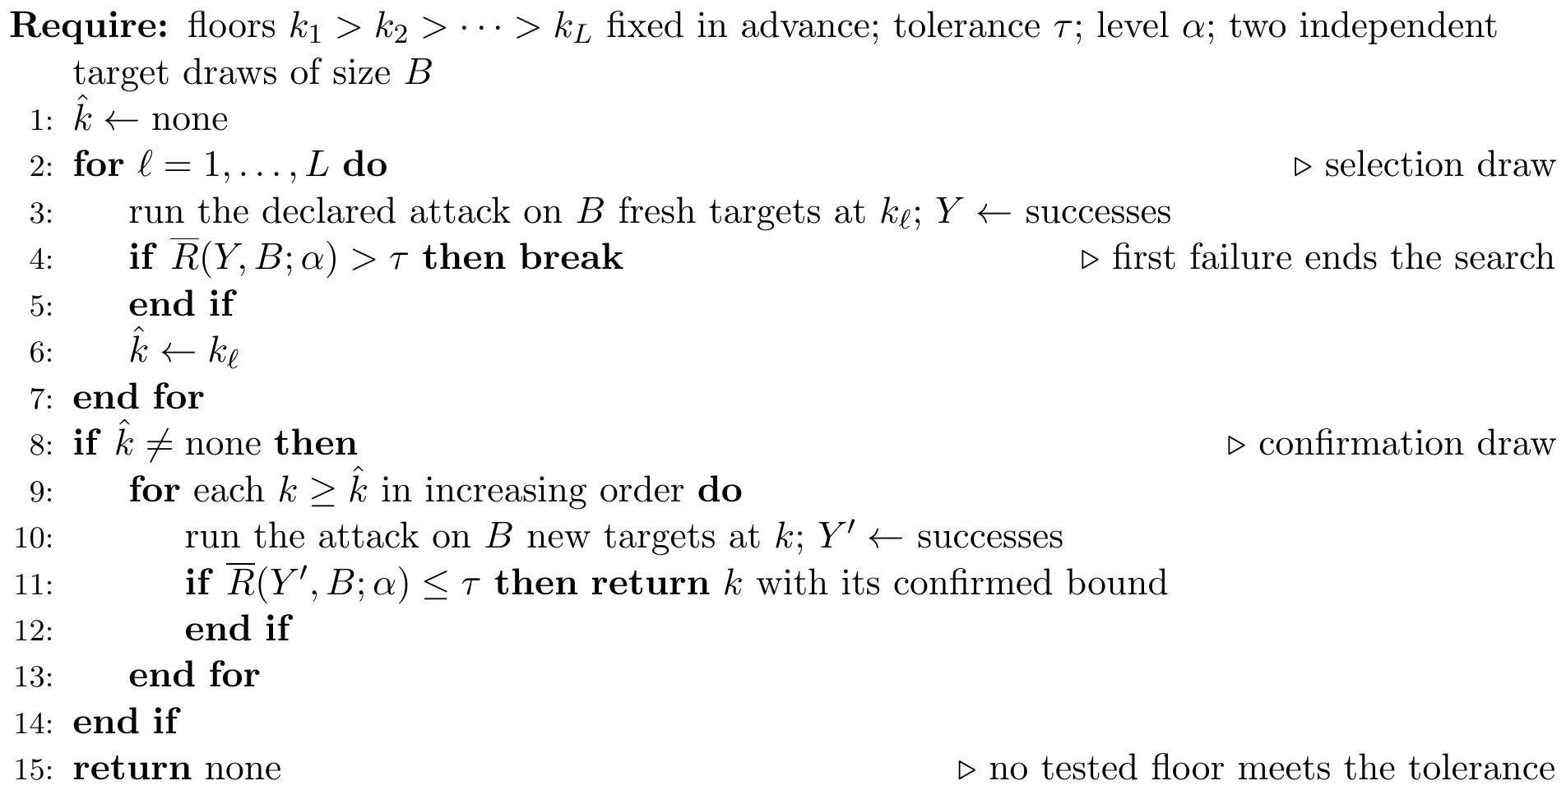
Algorithm 2. Fixed-sequence choice of a floor, with confirmation
Table 9. What sets the programme floor on the synthetic credit register, tolerance 0.12. History: the adversary knows in which vintages the target’s loan is live. The floor is chosen by fixed-sequence testing from $k=300$ down on one draw of 4,000 targets and confirmed on a second, independent draw (rate, with exact 95 per cent upper bound); where confirmation fails the next stricter level that passes is shown. Loans and exposure are the percentages of the first release kept at that floor. The subgroup floor requires every size class to meet the tolerance, with the largest firms on a stratified draw, from $k=200$ down. The insider reads exposure with error 0.01 on the log scale. In the Floor column “none” means no level up to 300 passes, and in the Subgroup column no level up to 200.
Adversary | Floor | Confirmation | Loans (%) | Exposure (%) | Subgroup
One release, one reading | 1 | 0.084 (0.092) | 100 | 100 | 20
Six releases, one reading, no history | 1 | 0.083 (0.091) | 100 | 100 | –
Six releases, one reading, history | 75 | 0.096 (0.104) | 45 | 11 | 200
Six releases, reading per vintage, no history | 20 | 0.105 (0.114) | 85 | 52 | –
Six releases, reading per vintage, history | 150 | 0.101 (0.109) | 20 | 4 | none
Insider: exact exposure, history | none | – | – | – | –
Exposure published to one significant figure
One release, one reading | 1 | 0.079 (0.086) | 100 | 100 | –
Six releases, one reading, history | 50 | 0.111 (0.119) | 58 | 20 | –
Six releases, reading per vintage, history | 150 | 0.085 (0.092) | 20 | 4 | –
Insider: exact exposure, history | none | – | – | – | –
Against one release with one exposure reading, the floor is 1: no suppression, all 27,167 loans of the first release kept, and a confirmation rate of 0.084 with an upper bound of 0.092. Pooling the six releases with the same single reading, for an adversary that does not know in which vintages the target’s loan is live, adds nothing: the floor stays at 1 and the confirmation is 0.083 (0.091). The reason is structural, and it is stated in Proposition 15 below.
The adversary that knows the history needs more. Selection passes at 50, but confirmation there fails, at 0.115 with an upper bound of 0.123, so the floor is the next stricter level, 75, confirmed at 0.096 (0.104). This is the floor that pooling alone requires, with the auxiliary data of the per-release attack plus the history. An adversary that holds one reading per live vintage but not the history needs 20 (confirmation 0.105, bound 0.114). The full attack, the pooled attack of Table 7, with a reading per live vintage and the history, needs 150, confirmed at 0.101 (0.109). The insider fails at every level: its success is 0.772 at $k_{min}=1$ and still 0.416 at $k_{min}=300$, because a precise reading of exposure separates candidates in any cell.
When several adversaries are declared for one release, the floor must meet the tolerance for all of them at once. The companion article does this with a release chain, shown in Figure 9 and stated in Algorithm 3: the floors are audited from the strictest down, each declared attack at each floor is a coordinate of the registered betting gate at the full error level, and the chain stops at the first floor at which any attack fails. Because a floor that fails ends the search, no split of $α$ over floors or attacks is needed. Figure 9 shows the pattern most streams followed on this register: the three attacks certify down to $k_{min}=150$, and at 100 the full pooled attack, whose risk there is 0.116, does not certify within the cap of 3,000 draws, so the chain chooses 150.
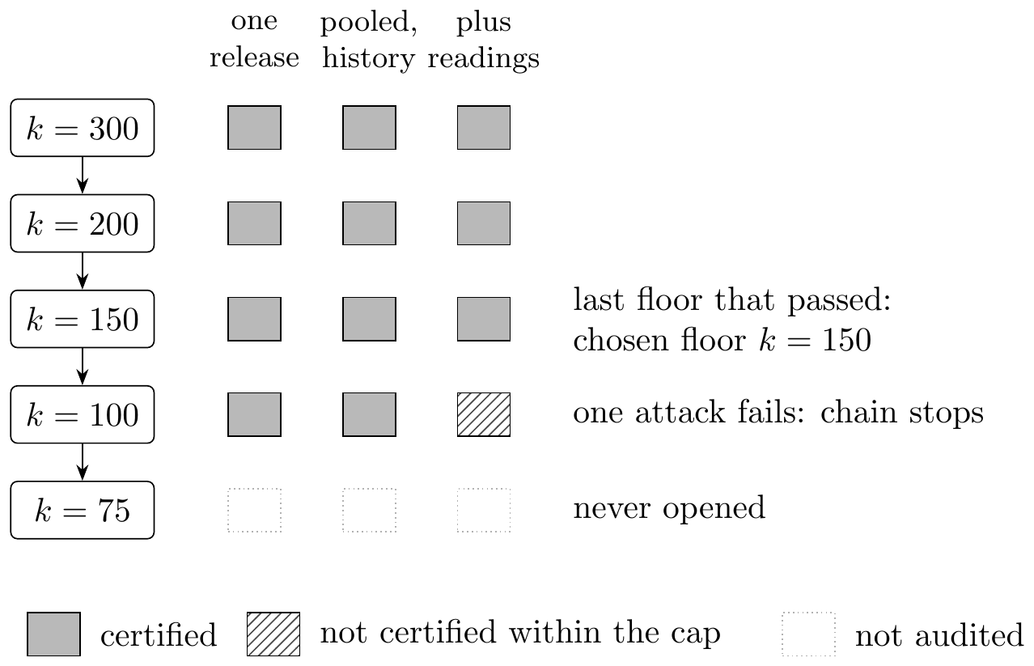
Figure 9. A release chain chooses the cell-count floor. Floors are audited from the strictest down; at each floor every declared attack is a coordinate audited on fresh targets at the full error level, and the floor passes only if all of them certify. The chain stops at the first floor that fails and chooses the last one that passed (Algorithm 3). The pattern shown is the one most streams followed in the credit-register audit of the companion article.
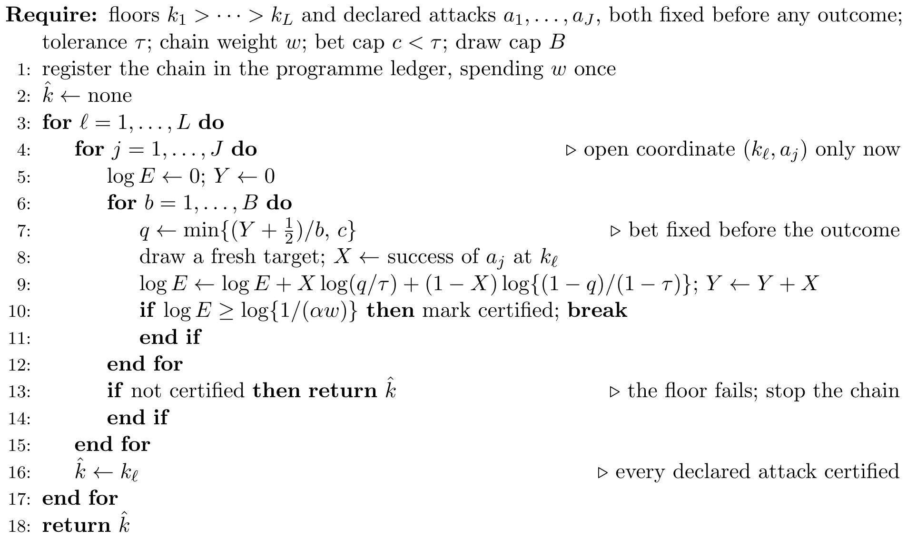
Algorithm 3. Release chain with the registered betting gate
The cost of these floors falls on credit volume more than on loan counts. Large firms carry the largest exposures and sit in the thinnest cells, so they are the first to go. The floor of 75 keeps 45 per cent of loans but 11 per cent of exposure, and the floor of 150 keeps 20 per cent of loans, 4 per cent of exposure and no loan to a large firm; no large-firm loan survives any floor from 75 up. Even the floor of 50 that selection first picked for the history adversary keeps 58 per cent of loans and 20 per cent of exposure. A file that meets the tolerance against a history-aware adversary is therefore not the file its users asked for: it has lost the borrowers that concentration and supervisory analysis are about. Against such an adversary a loan-level release is the wrong product. Aggregates with a contributor rule (Section 12), or access to the loan-level file in a secure setting under the Five Safes (Desai et al., 2016), where the declared adversary no longer holds the file, are the realistic options. The loan-level file of this section stands in for two real products: the loan-level disclosures that accompany securitisations, and research files as an accredited user sees them.
The subgroup control asks more. When every size class must meet the tolerance, with the largest-firm class audited on its own stratified draw of 4,000 targets because a uniform draw gives it too few, the per-release floor is 20, pooling with the history needs 200, and for the full attack no level up to 200 passes. The grid for this control starts at 200, because at 300 the classes that remain are too thin to audit. From $k_{min}=75$ no loan of the largest class is released, and that class then has no target to protect, so the subgroup floors above 75 are set by the other classes. These subgroup floors were chosen by the same fixed-sequence rule but not confirmed on a second draw. Under the supremum control the per-release answer is therefore 20, not 1, and a programme needs far more.
Two further rows of Table 9 publish exposure rounded to one significant figure. The outside adversaries barely notice: their floors are 1, 50 and 150. The insider still fails at every level, but its success at $k_{min}=1$ halves, to 0.388, because rounding creates ties among candidates that a precise reading can no longer break.
The floor depends on the tolerance. Table 10 repeats the selection at three other tolerances, from the same draw. At 0.05 the per-release floor is 40, pooling with the history needs 300 and the full attack has no floor up to 300; at 0.20 the three floors are 1, 5 and 30. The column for pooling with the history shows the selection result, 50 at a tolerance of 0.12, before the confirmation that moved it to 75. A committee that is unsure of its tolerance should read the whole table, since the floor moves by an order of magnitude across this range.
Table 10. The floor chosen at four tolerances by the selection draw of Table 9, before confirmation; at 0.12 pooling with the history therefore shows 50, where Table 9 shows the confirmed 75. “None” means no level up to 300 passes.
Tolerance | One release | Pooling, history | Full pooled | Insider
0.05 | 40 | 300 | none | none
0.09 | 5 | 100 | 200 | none
0.12 | 1 | 50 | 150 | none
0.20 | 1 | 5 | 30 | none
A chain of audits. The companion article runs the same choice as one release chain: a fixed sequence of intersection–union tests, each at the full level $α$, with all three outside attacks declared as coordinates. Over 20 independent target streams it chose 150 in 19 and 100 once, against an estimated true floor of 100, and no stream chose a floor that was unsafe. The floor of 150 is thus what an honest audit of this register returns. The gap to 100 comes from the full attack’s risk at that floor, 0.116, which lies so close to the tolerance that the audit’s capped bet certifies it only by chance.
Proposition 15 (Without the history, the other vintages are uninformative). Suppose that each loan’s published key and exposure are the same in every vintage in which it is released, that whether a loan is live in a vintage is drawn independently of its key, its exposure and the adversary’s auxiliary information, and that the adversary knows only that the target is live in the first release. Then, for any fixed auxiliary information, the posterior over candidates computed from all $m$ releases equals the posterior computed from the first release, and the pooled attack succeeds exactly when the single-release attack does.
Proof. The candidates are the loans live in the first release whose key agrees with the target’s. Let $Z$ be the auxiliary information and write $L_{j}$ for the vector of live indicators of candidate $j$ over vintages $2,…,m$. Under the hypothesis $H_{j}$ that $j$ is the target, the other vintages add to the likelihood only the published key and exposure of each candidate, which repeat those of the first release, and the factor ℓ​PLℓ. By assumption the law of $L_{ℓ}$ does not depend on which candidate is the target, and the adversary holds nothing that ties $Z$ to any $L_{ℓ}$, so the factor is the same under every $H_{j}$ and cancels from the posterior (10). What remains is the first-release likelihood of $Z$, so the two posteriors, and their maximisers, coincide. $▫$
The proposition explains the second row of Table 9, and it holds on this register by construction of the generator: published values do not change between vintages, and whether a loan is live is drawn independently of them. It shows where the gain from pooling lives here: in the history, not in the releases. On a register where published fields change from month to month, for example where outstanding exposure is published and amortises, the other vintages would carry information of their own, and the proposition would not apply.
Replication over register draws. Every figure so far comes from one register draw with one reading noise. Table 11 repeats the choice over 20 independent register draws and three values of the standard deviation of the adversary’s log-exposure reading, with 2,000 targets per level. At the value of the main study, 0.6, the per-release floor is 1 in every draw, pooling with the history gives a median of 75 (range 40 to 75) and the full attack 150 (range 100 to 150). With a reading twice as precise, at 0.3, the medians are 20, 150 and 300, and for the full attack no level up to 300 passes in 3 of the 20 draws. At 1.0 they are 1, 40 and 75. The adversary’s reading precision moves the floor more than anything else we varied, and it is the input an institution most needs to argue for. For the full attack at $k_{min}=150$ the rate has a between-register standard deviation of 0.0073 over the 20 draws. We computed a 95 per cent interval for it from the chi-square law with 19 degrees of freedom, which runs from 0.006 to 0.011. The binomial standard error of one draw of 2,000 targets at the mean rate is 0.0064, inside that interval, so the register draw may add nothing or may add a design standard deviation of up to about 0.009. Twenty draws do not estimate the design term well. What they do show is that at fixed precision the floor stays in a narrow band across register draws, from 40 to 75 for pooling with the history and from 100 to 150 for the full attack.
Table 11. The floor over 20 independent register draws and three levels of reading noise (the standard deviation of the adversary’s log-exposure reading), 2,000 targets per level. Median floor, with the smallest and largest in brackets; “none” means no level up to 300 passed, and a superscript counts the register draws in which that happened.
Reading SD | One release, one reading | Six releases, one reading, history | Six releases, reading per vintage, history
0.3 | 20 [10, 20] | 150 [150, 200] | 300 [300, none]$​^{3}$
0.6 | 1 [1, 1] | 75 [40, 75] | 150 [100, 150]
1 | 1 [1, 1] | 40 [30, 40] | 75 [50, 100]
Rotating the pseudonym. The attacks match loans across vintages through a pseudonym that persists. If the pseudonym rotated each month, the adversary would have to relink vintages through the published fields. With exposure published exactly, the pair of key and exposure is unique for every first-release loan at every floor tested (a share of 1.000), so the published fields alone relink every loan and rotation gives no protection. With exposure rounded to one significant figure the pair relinks 0.104 of loans at $k_{min}=1$, so rotation would then remove most of the relinkage that the persistent pseudonym gives. Rotation is a control on linkability, not pseudonymisation in the sense of the data protection law (Remark 2), and the pseudonym should be a keyed hash under a key held apart from the release team. We did not rerun the attacks with rotation; the relink share is a count of loans that could be joined, not an attack.
This is the practical content of Proposition 11. The proposition denies that any function of the marginals can bound the pooled risk, and the evaluation shows what that denial costs on a synthetic monthly collection with a lever supervisors recognise. Among the policies in Table 7, none calibrated on one release meets the tolerance against the pooled attack with history, while each passes its own test at vintage 1. A floor chosen by fixed-sequence testing on the declared pooled adversary does meet it (Table 9). Which floor that is depends on what the institution declares the adversary to know: 1 without the history, 75 with it, 150 with a reading in every vintage as well, none for an insider, and more again if every size class must be protected.

13.5 The neural release pipeline
The release chain needs a bet for every draw and a floor at which to start. The neural release pipeline supplies both from a network, and it is the package’s main entry point (python -m privacy_risk.neural_pipeline). Figure 10 shows its four stages and Algorithm 4 states them. The declared attacks are first run on a dense grid of 25 floors with 400 development targets each, on seeds the final audit never uses. A network with two hidden layers of 16 units is fitted to these counts by the binomial likelihood, one output per declared attack, with a third of the floors held out for early stopping; a logistic model is fitted to the same counts as a baseline. The features are those an agency can compute from the register without running an attack: the floor, the share of loans kept, the mean size of the released cells and the share of released loans not live in every vintage. Before any final outcome exists, the fitted model predicts every attack’s success at every floor of the release grid, and the plan (the bets, and a start floor one step stricter than the floor the model predicts to be safe) is frozen with its digest. The release chain then audits the plan on fresh targets. If it fails at its first floor, a reserve of a fifth of the error budget runs a second chain from $k_{min}=300$.
Because every bet is fixed before its outcome and the chain’s order is fixed at registration, the network’s accuracy does not enter the error bound: a poor model costs attacks and cannot raise the chance of certifying an unsafe floor. Table 12 compares five designs on the same final draws. Every design chose the same floor as the release chain with running-rate bets in almost every stream, 150, and none chose an unsafe floor. The difference is cost. With bets from the network the chain used a median of 5,620 attacks against 6,422 with running-rate bets, and with the network’s start floor as well it used 5,044, about a fifth fewer, and never needed the reserve. Depth does not explain the saving. The logistic model’s predictions were closer to the estimated true risks (mean absolute error 0.004 against 0.008 for the network), and its plan saved as many attacks; the gain comes from basing bets and the start on development evidence rather than on the network’s hidden layers. The network is kept as the pipeline’s default because its architecture extends to many more features and declared attacks than this register has, and the logistic model is reported beside it so that a reader can see when depth has not paid.
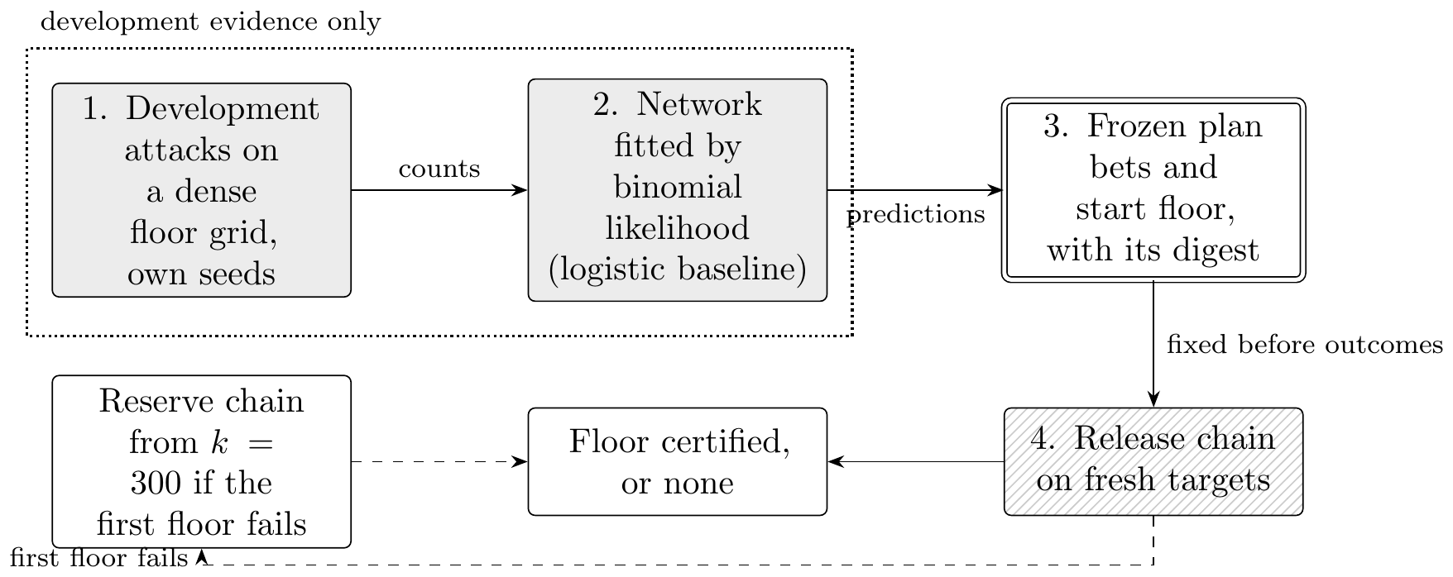
Figure 10. The neural release pipeline. Grey boxes use development attacks only; the double box is the plan, frozen with its digest before any final outcome exists; the hatched box is the only stage whose outcomes can certify a floor. The network’s predictions choose the bets and the floor at which the release chain starts, so a poor network costs attacks but cannot raise the chance of certifying an unsafe floor.
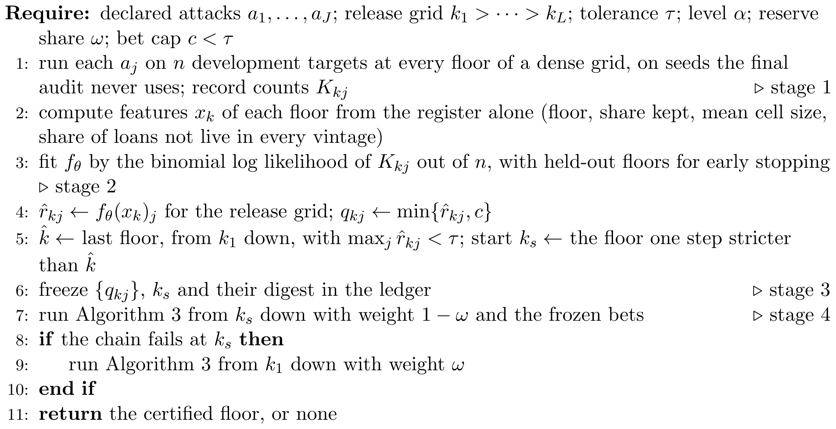
Algorithm 4. The neural release pipeline
Table 12. The neural release pipeline on the synthetic credit register, 20 attack streams, tolerance 0.12, $α=0.05$. Every design is a release chain over the three declared attacks on the same final draws; they differ only in where the bets and the start floor come from. The network and the logistic model are fitted to development attacks on separate seeds and fixed before the final audit. Entries give each floor chosen with the number of streams in brackets, and the median number of attacks.
Source of bets and start | Floor chosen | Attacks
Running-rate bets, chain from 300 | 100 (1), 150 (19) | 6,422
Logistic bets, chain from 300 | 100 (2), 150 (18) | 5,572
Network bets, chain from 300 | 100 (2), 150 (18) | 5,620
Logistic bets and start floor | 100 (1), 150 (19) | 5,019
Network bets and start floor | 100 (1), 150 (19) | 5,044
Figure 11 shows what the network learned. In each panel the solid line is the network’s prediction at the 13 floors of the release grid, fixed before the final audit, and the dotted line is the true risk estimated from 100,000 separate targets per floor. The crosses are the development rates, each from only 400 attacks, which is all the network saw. It recovers the shape of all three curves: flat and low for a single release, and falling steeply with the floor for the two pooled attacks, crossing the tolerance near $k_{min}=100$ for the full pooled attack, which is where the true floor lies. Its largest errors are in the middle of panel (c), where it follows the scatter of the development rates more closely than the logistic model does. Table 13 puts numbers on this. The two models reach almost the same held-out log loss, 0.3482 for the network and 0.3480 for the logistic model, and both predict a floor of 100 and start the chain at 150; the network’s mean error against the true risks is 0.008 and the logistic model’s 0.004. The network therefore fits the development data as well as the simpler model and no better, and on this register its extra capacity goes into following noise.
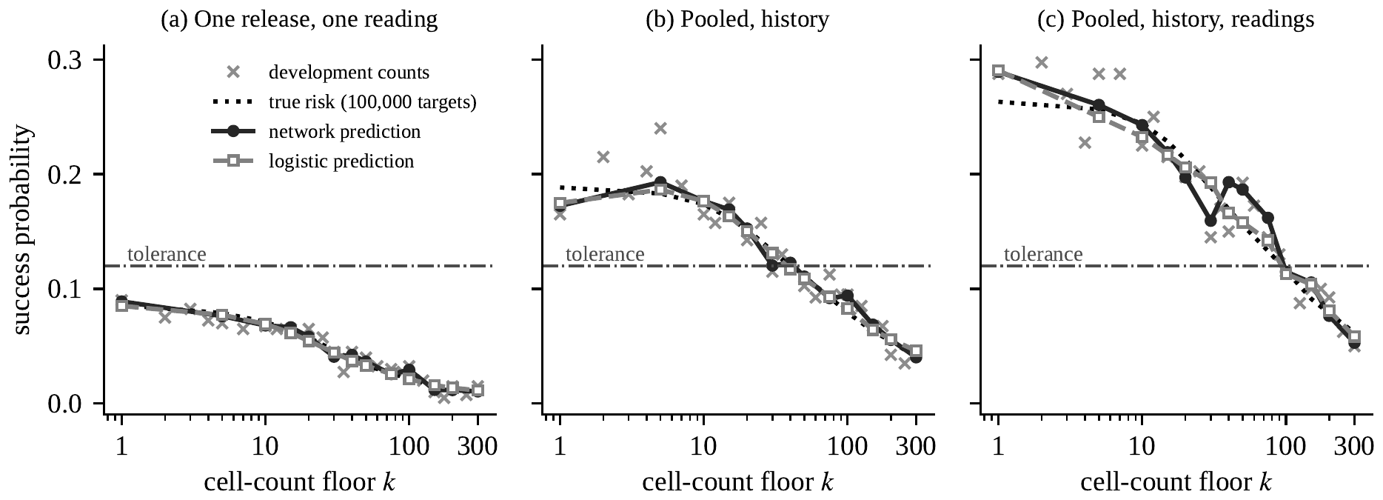
Figure 11. What the neural network predicted. For each declared attack, the frozen predictions of the network (solid line, filled circles) and of the logistic model (dashed line, open squares) against the true risk estimated from 100,000 separate targets (dotted line), with the development success rates the models were fitted to (crosses, 400 targets each) and the tolerance (dash-dot line). The network was fitted to the crosses alone and never saw the final audit.
Table 13. What the two models learned from the development attacks. Log losses are the binomial log loss per development attack on the training and held-out floors; the epoch is where held-out loss was lowest. Errors compare each model’s frozen prediction with the true risk, estimated from 100,000 separate targets, over the 39 coordinates of the release grid. The predicted floor is the last floor, from $k=300$ down, at which every predicted risk lies below the tolerance; the start floor is one step stricter.
 | Log loss |  |  | Error against truth |  | Floor
2-3(lr)5-6(lr)7-8 Model | Training | Held out | Epoch | Mean | Largest | Predicted | Start
Network, two hidden layers | 0.3240 | 0.3482 | 1146 | 0.008 | 0.031 | 100 | 150
Logistic model | 0.3245 | 0.3480 | 2067 | 0.004 | 0.027 | 100 | 150

13.6 What the attack needs, and a wrong model
Appendix F.2 withdraws the adversary’s auxiliary information one field at a time (Table 21). Without the exposure reading the adversary never passes the decision threshold under $k$-anonymity at $k=5$; the key narrows the candidates to a cell and the reading separates the members of that cell, while neither does much alone. When the adversary misstates the dispersion of its own reading, its success barely moves but its calibration gap grows from 0.003 to as much as 0.073, which is what the falsification tests of Section 14 are for.

13.7 What this evaluation does not settle
The register is synthetic, and every result in this section holds on the synthetic register only. Its structure follows a supervisory collection, with skewed lender shares, several relationships per large borrower and monthly entry and exit, but the parameters are chosen, not estimated from a real credit register, which cannot be released. Two simplifications bear on the floors. Exposure is constant across vintages, so the other vintages carry no information without the history (Proposition 15); with amortising balances they would. And whether a loan is live is independent of its key and exposure, where in a real register large loans may run longer. The results are therefore claims about a class of release systems with these structural features, and the way to refute them is to run the same evaluation inside an institution that holds the real file. The pipeline’s credit module would take the real register in place of the simulated one, but it has not been run on a real register, and Section 11 ran only the demographic path on real files.
The adversary is one adversary, strong in some respects and weak in others. It holds the key exactly, uses a persistent pseudonym, knows the true error model of its exposure reading and, in the pooled attacks with history, the loan’s live vintages. It does not use the arrears status, the lender identity or a longer history. The evaluation is therefore neither a lower nor an upper bound on what an adversary can achieve. Its value is comparative, since every policy faces the same attacker, and conditional, since every floor holds for the adversary declared.
Finally, the evaluation compares policies as they are usually configured, not as they could be. A minimum-contributor rule applied to the pooled programme rather than to each vintage would do better than the row for it here: the same lever, calibrated on the programme, changes the outcome.

14 Falsification and validation
Reproducing the equations of Sections 2 to 9 in software is an implementation check, not empirical validation. Evidence for the scenario model must be capable of contradiction. We propose six tests, each with a stated failure consequence, and report how the simulation of Section 10 performs against them.
- Linkage calibration. Posterior probabilities from (10) must agree with held-out match frequencies within prespecified bands. Figure 3 shows the test passing for the correct model with a mean gap of 0.007 and failing for a misspecified covariate precision with a gap of 0.049, while the two risk estimates differ by 0.007. Failure means the risk figure is not supported, whatever its value.
- Population-frequency validation. The model behind (16) must predict held-out or externally benchmarked key frequencies. In Section 10 the fitted law recovers the mean population cell size to within 1 per cent and the uniqueness probability $ρ$ to between 8 and 25 per cent, and the direction of the error is conservative. The test also shows misfit: the fitted dispersion drifts with the sampling fraction, from 0.33 to 0.51, where a negative binomial law closed under thinning would hold it fixed. Failure means the model-based $ρ$ should be replaced by a bound. We act on that here: the model-based figure enters no decision in this paper and is reported only beside the truth, and on the census file, where there is no truth, Section 11 reports $ρ$ across a range of sampling fractions rather than as one value.
- Adversary stress test. A materially stronger plausible feature set must not push the upper risk bound above $τ$. In the simulation, an adversary whose covariate is twice as precise raises the simulated risk by between 1 and 76 per cent across the 45 settings of the grid, with a median of 40 per cent. This is why the robust risk (25), and not the nominal risk, is the coordinate in Figure 5. Capability and modelling are separate things, and a second check records the difference: an adversary that keeps its information but assumes the covariate is noisier than it is loses only 0.007 of its success rate while its calibration gap grows sevenfold, so a risk figure alone will not reveal the mistake. The record swapping lever described in Section 10 was removed on the same principle. Failure of the test means the release fails or the scenario is revised in writing.
- Mechanism monotonicity. Where stronger protection is claimed to reduce risk, violations must be investigated rather than smoothed. Every row of Table 2 violates the nominal bound on the supremum control, and the investigation of that violation is Proposition 2. Three breaks in order also appear. The worst target in Table 2 rises from 0.744 at $k=10$ to 0.768 at $k=20$, a difference within one standard error of estimates that rest on 250 replicates each. The pooled rate in Table 7 rises from 0.260 with no suppression to 0.269 at $k=5$, a difference of about one standard error at 4,000 attacks each, and the large-firm rate in Table 6 rises from 0.247 to 0.273 between the same two levels, on a few hundred targets. Beyond this check we did not look for a mechanism, and we treat all three as consistent with sampling noise. The choice of floor does not rely on monotonicity, because fixed-sequence testing stops at the first failure whatever the order of the true risks (Proposition 6).
- Composition test. Simulated joint attacks under (35) must be compared with the marginal bound (34) and evaluated against a programme tolerance. In Section 10.6 the comparison fails at two releases by a factor of 2.8 against the bound of those two releases, 0.148, and by a factor of 1.8 at four releases against the bound of all four. Failure means the programme, not the release, is the object that needs governing.
- Temporal transport. An assessment must fail or be re-estimated when new registers, linkage methods or data vintages move observed attack performance outside its prespecified range. This is the test that the expiry date $d$ in Definition 2 enforces, and it is the only one of the six that cannot be run at assessment time.

15 Operational protocol
The governance record should follow six stages, in this order, with the output of each written down before the next begins.
- Declare the legal basis and protected parties $ℓ$, the access route $s$, the attack scenario $a$, the target set $T$, the harm class $h$, the uncertainty set $H_{a}$ and the loss $L$.
- Compute the point estimate ${\hat{R}}_{a}$, the bound ${\overline{R}}_{1−α}$ and the number of replicates $B$, with the dependence structure of the replicates stated.
- Review whether the declared scenario is plausibly conservative, using the tests of Section 14.
- Apply the tolerance $τ$ through the named owner $o$, using rule (27).
- File the complete record with the expiry date $d$ and evidence sufficient to reproduce the computation.
- Re-assess when a new vintage would take the programme past its declared horizon $m$: re-run the joint simulation over the longer programme before the vintage is released, and file a new record.
Exposure and harm remain distinct throughout. The risk $R_{a}$ measures the probability of successful exposure; the tolerance $τ\left(h\right)$ reflects the consequence class, the legal duties and the public value of the release. The owner owns the residual risk. The analyst owns the correctness of the calculation. These are separate responsibilities and should sit with separate people.
For a programme, two further items belong in the record: the joint attack simulation under (35) with its own tolerance, and, where a formal mechanism is used, the accountant’s running total with the accounting method named. Neither can be inferred from the single-release records.
Table 14 fills the record for the synthetic credit register, for the first vintage and for the programme of six, using only figures reported in Sections 12 and 13. The tolerance of 0.12 is the illustrative value of Section 13; the owner, dates and legal basis are illustrative. The record declares a scientific-use file for accredited researchers and the full outside adversary, with a reading per vintage and the loan’s history, and so sets the floor at 150; a committee that declares a weaker adversary would file the rows for the floor of 75, or of 1, in its place (Table 9). The record shows what that floor costs, because the owner has to weigh it: 20 per cent of loans, 4 per cent of exposure and no loan to a large firm. One row fails at every floor tested, the insider row would fail at every floor once a tolerance is set for it, and three more cannot reach a decision because no tolerance has been set for their harm. The owner’s decision on the file as a whole follows from those rows rather than from the one that passes. A record that shows these gaps is more useful to a committee than a single pass.
Table 14. Decision record for the synthetic credit register, assessed on the first vintage as released and on the programme of six vintages. Common to every row: legal basis, Council Regulation (EC) No 2533/98, Article 8, as amended by Council Regulation (EC) No 951/2009 (illustrative); protected parties, borrowers, reporting agents and natural persons behind borrowers; access route, a scientific-use file for accredited researchers; $α=0.05$; owner, the Chair, Statistics Release Committee (illustrative); expiry one year after the assessment date (illustrative); re-assessment on a vintage beyond the horizon $m=6$, a new auxiliary source available to the adversary, a change of mechanism or a change of access route. The bound is the exact one-sided upper bound with the number of simulated attacks $B$; where the figure is a census of released units rather than a simulation, the measure is named instead. The level $k_{min}=150$ was chosen by fixed-sequence testing from $k_{min}=300$ down (Proposition 6) and confirmed on a second, independent draw of targets.
Harm $h$ | Target set $T$ | Adversary $a$ | $τ$ | Evidence | Setting | Decision
Identification, one release | Released loans, first vintage | Linkage attack of Section 13.1, one exposure reading |  | At $k_{min}=150$, confirmation 0.0135, ${\overline{R}}_{0.95}=0.017$, $B=4,000$; the floor for this row alone would be 1 | $k_{min}=150$ | Pass
Identification, programme | Loans over the six vintages, horizon $m=6$ | Pooled attack, one reading per live vintage, knows the loan’s history |  | Floor 150 by fixed sequence; confirmation 0.101, ${\overline{R}}_{0.95}=0.109$, $B=4,000$ fresh targets; keeps 20% of loans, 4% of exposure | $k_{min}=150$ | Pass on risk; the owner decides whether the file is still worth releasing; re-assess before vintage 7
Identification, every size class | Each size class, largest firms on a stratified draw | As in the second row |  | At $k_{min}=150$ the worst class bound is 0.184; no floor up to 200 passes | None found | Fail; offer aggregates or secure access instead
Identification by an insider | Released loans | A party to the loan, exposure read with log error 0.01, knows the history | Not set | Success 0.772 at $k_{min}=1$ and 0.416 at $k_{min}=300$ | Not governed by $k_{min}$ | Fail at every floor if a tolerance is set; restrict access
Relationship allegation | Released borrowers | Names the largest lender in the key class | Not set | Predictive value 0.328 at $k_{min}=1$, 0.313 at $k_{min}=20$ | Not governed by $k_{min}$ | No decision until $τ$ is set
Arrears status | Large borrowers | Reads status off a homogeneous key class | Not set | Homogeneity share 0.119 at $k_{min}=20$ | Attribute rule needed | No decision until $τ$ is set
Contribution from totals | published cells | A participating lender, by subtraction | – | per cent of cells recoverable | Three-contributor threshold rule; dominance rule not assessed | Rule-based; not a probability
Differencing | Consecutive cell pairs | Claims a single move on a unit change | Not set | A unit change is a single move in 65 per cent of cases at $c_{min}=1$, 56 per cent at $c_{min}=10$ | $c_{min}=10$ | No decision until $τ$ is set

16 Applying the framework to a central bank release programme
This section sets out how a central bank can apply the framework to its own releases. It assumes no reading of the derivations. Each step names what the institution must decide, who decides it, what evidence the step produces, and where in the paper the method is justified. Appendix H holds blank worksheets for each step, and Table 14 shows them filled for the synthetic credit register.

16.1 Roles
Four roles are needed, and the first and third should not be held by the same person.
Release owner.
A named senior officer, for example the chair of a statistics release committee, who sets the tolerance, signs the decision and owns the residual risk.
Data owner.
The business area that collects the source register and knows which products are drawn from it, how often, and under what legal basis.
Disclosure analyst.
The statistician who declares the scenarios, runs the attack simulation and computes the bounds. The analyst owns the correctness of the calculation, not the decision.
Reviewer.
A person outside the production line, in the risk, audit or methodology function, who checks that the scenarios are plausible and that the falsification tests of Section 14 were run.
The analyst and the data owner sit in the first of the three lines of defence, the reviewer in the second, and internal audit, which checks the filed record and the audit controls of Section 17, in the third (Section 5).

16.2 Seven steps
Figure 12 shows the seven steps as a decision process, and Algorithm 5 states them compactly. Two loops matter. The dotted loop is the re-assessment at each new vintage or at the expiry of the decision, which starts again at the planning step and draws on what remains of the programme’s error budget. The dashed loop is a change of product: when no setting meets the tolerance, as for loan-level files against an adversary who knows loan histories (Section 13.4), the institution moves to another product, such as aggregate tables or access in a secure setting, and assesses it from the start.
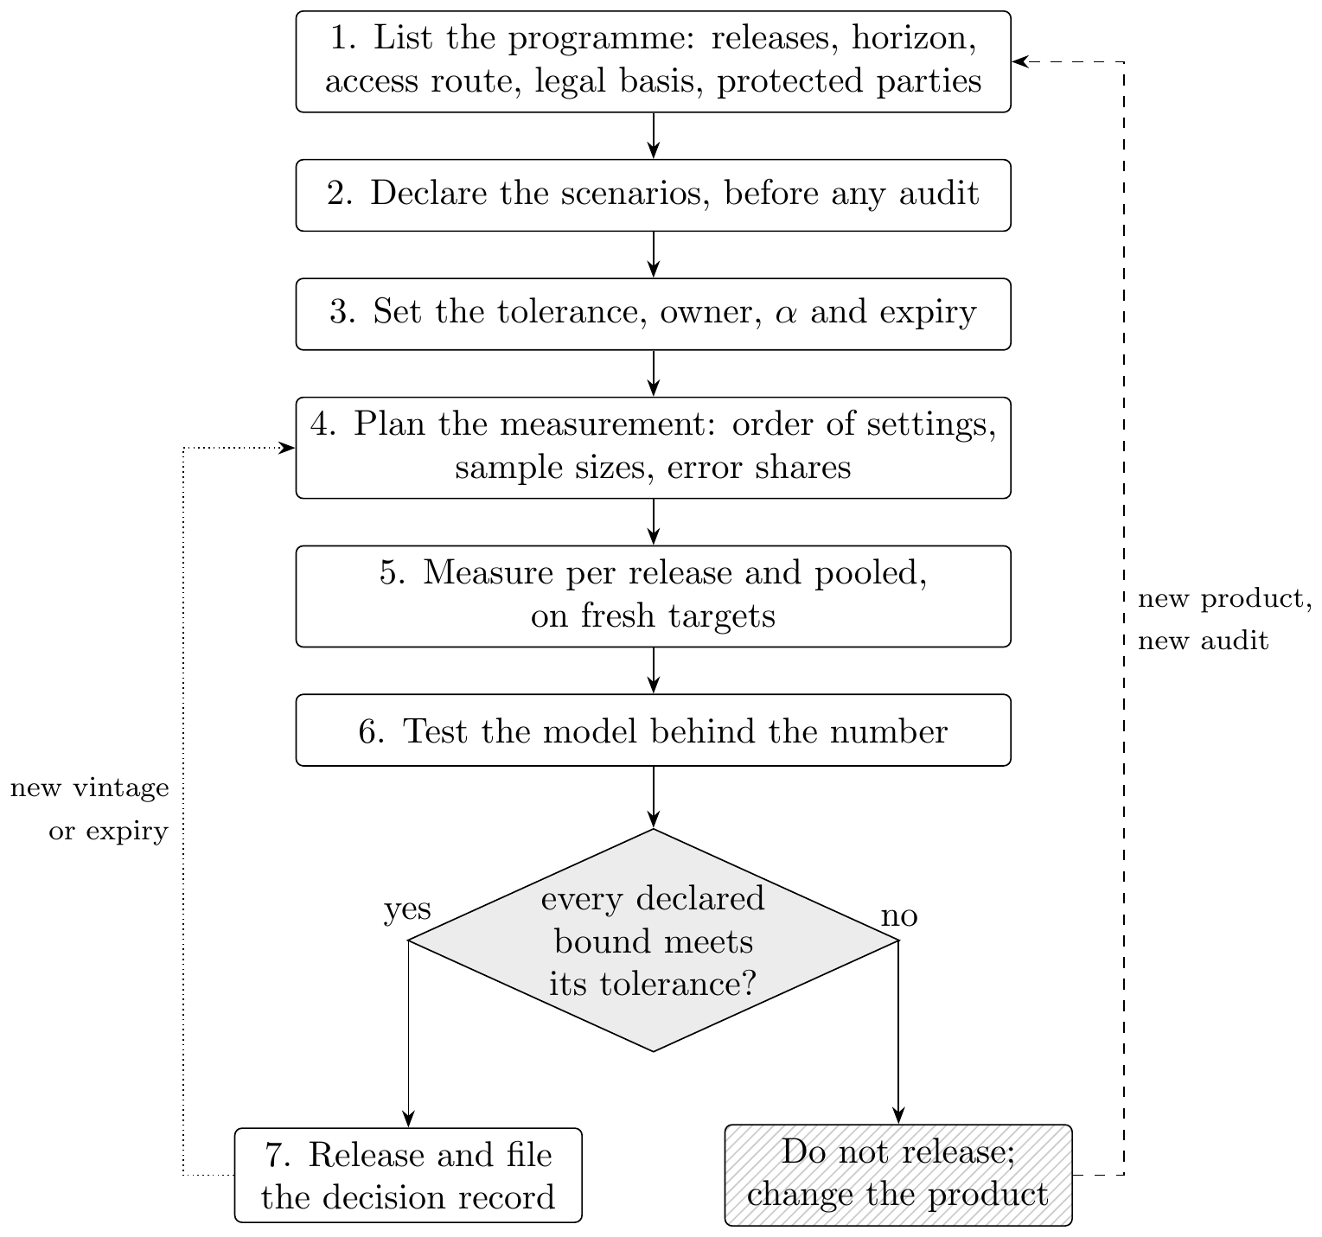
Figure 12. The assessment of a release programme as a decision process. Solid arrows follow the seven steps of Section 16 and Algorithm 5; the dotted arrow is the re-assessment at each new vintage or at expiry, which draws on the programme’s remaining error budget; the dashed arrow is a change of product, such as moving from loan-level files to aggregates or to secure access, which needs a new audit.
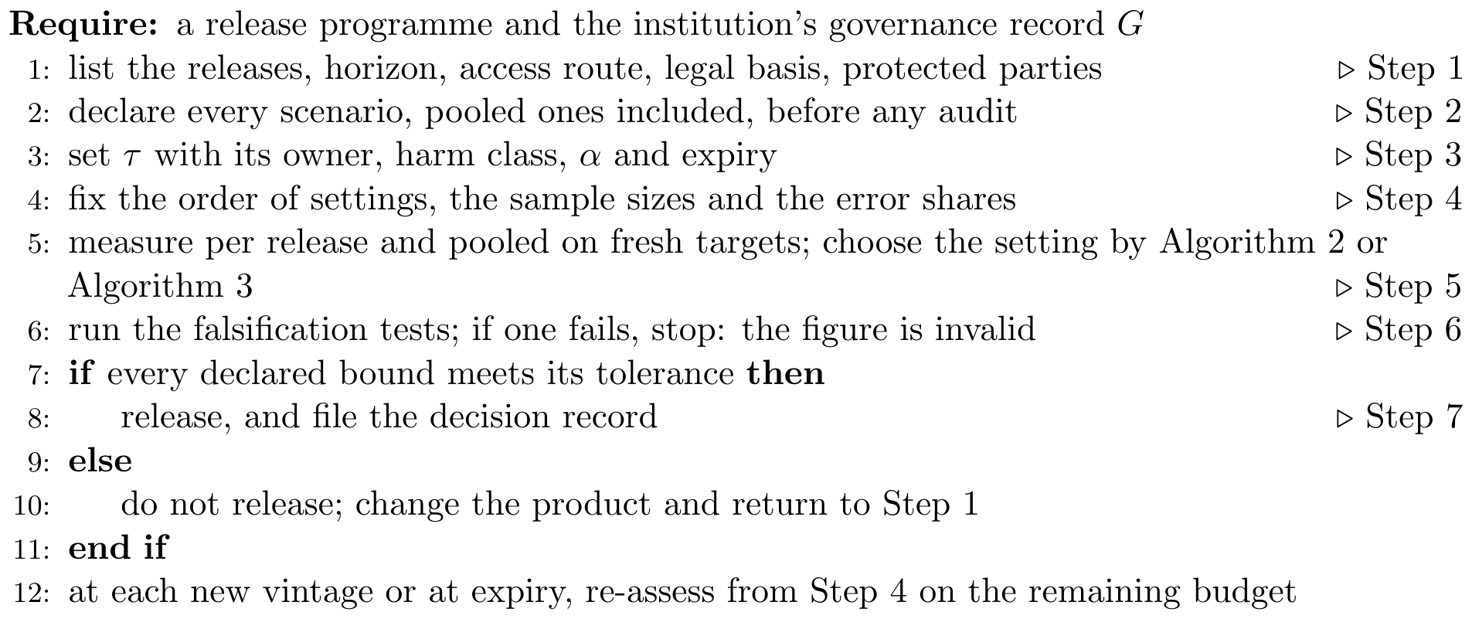
Algorithm 5. Assessing a release programme
Step 1. List the programme, not the release. Start from the source register, not from the product about to be published. List every product drawn from it over the planning horizon: monthly or quarterly aggregates, supervisory publications, research extracts, data shared with other authorities, and answers to ad hoc requests. For each product record its frequency, the population it covers, the variables it publishes, and whether any identifier or stable ordering persists from one vintage to the next. A persistent pseudonym, a stable row order or a unique combination of rarely changing attributes lets an adversary match records across vintages, which is the condition that Proposition 11 requires. With a persistent pseudonym the products are, for the adversary, one release on the union of their keys (Remark 2). Declare a horizon $m$, the number of vintages the assessment covers. Worksheet 1 records the inventory.
Step 2. Declare the scenarios. For each product, and for each combination of products an outsider could hold together, write down who the adversary is, what it knows, which records it targets and what harm follows if it succeeds (Section 3). For a pooled scenario, say whether the adversary knows when the target’s record is present in each vintage, and why (Section 13.1). The declaration should be specific enough that someone can disagree with it. Table 15 gives starting declarations for release types common in central banks. They are illustrations to be adapted, not a statement of what any institution does. Worksheet 2 records each scenario.
Step 3. Set the tolerance. For each harm class the release owner sets a tolerance $τ$, an error level $α$, an expiry date and the horizon $m$ of Step 1, and records the legal basis, the parties the tolerance protects and the access route of the product (Definition 2). The tolerance is the institution’s written reading of when identification is reasonably likely for that adversary and route. Two routes lead to a number. The direct route states the largest probability of successful exposure the institution will accept for that harm, taking account of its confidentiality duty and the public value of the release. The indirect route states the relative weight the institution places on harm against lost utility and reads the implied tolerance off the risk–utility frontier (Proposition 7, Table 3). Either way, the tolerance is written down before the risk is measured, and a programme tolerance is set alongside the per-release one. Where the institution has not yet agreed a tolerance for a harm, the record says so and no decision is made on that harm, as in the last rows of Table 14.
Step 4. Plan the measurement. Decide how many simulated attacks each scenario needs before running any. With no observed success, certifying a tolerance $τ$ at error level $α$ needs about $log\left(1/α\right)/τ$ independent attacks, roughly $3/τ$ at $α=0.05$ (Hanley and Lippman-Hand, 1983); Table 18 gives exact counts. A tolerance of ${10}^{−3}$ needs 2,995 attacks, and one of ${10}^{−5}$ needs 299,572, so a very small tolerance can be expensive to certify by simulation. If the release must pass every one of a fixed set of scenarios or subgroups, each may be assessed at level $α$, because that is an intersection–union test (Section 5); divide $α$ among them only when their bounds are to be reported as one simultaneous statement. If a level such as a minimum cell count is to be chosen from a grid, fix the order in which the levels are tested before any result is seen (Proposition 6). If scenarios may be added after results are seen, for example because a reviewer proposes a stronger adversary, use a registered spending sequence rather than a fixed split (Section 8 and the companion article).
Step 5. Measure, per release and pooled. Run the declared attacks on the release as it would be published, on fresh targets, and compute the exact upper bound ${\overline{R}}_{1−α}$ for each scenario (Section 4). Then run the pooled attack over the programme of Step 1, holding the same auxiliary information, and compute its bound in the same way (Section 7). Report separately any pooled attack that adds knowledge, such as more readings or the target’s history across vintages. The attacks must be reported side by side. Tables 8 and 9 show why: on the synthetic register, pooling with one reading adds nothing unless the adversary knows the loan’s history, and part of the remaining excess comes from the adversary holding more readings, and a committee needs to know which it is protecting against. Where a level is chosen from a grid, audit the chosen level again on fresh targets. Report what the chosen level keeps in volume, such as the share of exposure and of large borrowers, as well as the share of records.
Step 6. Test the model behind the number. Before the bound is used, run the falsification tests of Section 14: calibration of the linkage posterior, the population-frequency model, a stronger adversary, monotonicity of the mechanism, the composition test and temporal transport. A failed test makes the assessment invalid, not failed: the institution cannot release on it and must repair the model first.
Step 7. Decide, record and re-assess. Apply rule (27): the release passes a scenario only if the upper bound, not the point estimate, is at or below the tolerance, and it passes overall only if it passes every declared scenario, pooled ones included. Where the programme fails, the release fails, even if it passes on its own. File the decision record (Worksheet 3). Re-assess when the programme is about to pass its horizon, when a new product is drawn from the same register, when a new public source could serve as auxiliary information, when the mechanism changes, and at expiry.

16.3 Release types common in central banks
Table 15 maps six release types to the objects of Steps 2 to 5. The first column of the table is the product; the others say whom the adversary targets, what it plausibly holds, which harm is at stake, which measure of this paper applies, and where a pooled scenario arises.
Table 15. Starting declarations for release types common in central banks. The entries are illustrations to be adapted to each institution’s products, legal basis and users; they do not describe the practice of any institution.
Release type | Targets | Adversary holds | Harm | Measure in this paper | Pooled scenario
Aggregates from a credit register (by sector, region, size) | Borrowers in small cells; lenders in concentrated cells | A firm’s sector, region and size from public filings; a lender’s own book | Identification of a borrower; a lender’s position revealed | Prosecutor risk by cell (Section 3.3); residual disclosure from totals (Appendix C) | Monthly vintages; differencing of consecutive months
Loan-level research extract | Every borrower in the extract | Key fields and a noisy reading of exposure from other sources | Identification; attribute disclosure of arrears | Linkage attack of Section 13.1; attribute rule | Successive extracts for the same project; extracts for different projects
Supervisory statistics by bank group | Individual banks | Each bank’s own figures; published annual reports | A bank’s confidential figure recovered | Contribution from totals; dominance and $p\%$ rules (Hundepool et al., 2012) | Quarterly series; tables that share a margin
Payment and transaction statistics | Merchants or payers in thin cells | Merchant category and location; own transactions | Identification; commercial information revealed | Prosecutor risk by cell; minimum contributor count | Daily or weekly series of the same cells
Household or firm survey microdata | Respondents | Demographic or firm characteristics from registers or social media | Identification; attribute disclosure of wealth or debt | Journalist and marketer measures (Section 3.3); frequency model (Section 4) | Survey waves; the public file and a scientific-use file
Answers to ad hoc data requests | Units in the requested breakdown | Everything already published from the same register | Identification by differencing | Differencing posterior (Appendix C) | Each answer pooled with every earlier publication

16.4 When a release fails
A failed scenario does not end the matter. It tells the committee what to change, and the record should state which remedy was chosen and why. The remedies fall into five groups.
- Change the key. Coarsen the published breakdown, or withdraw the field that the adversary uses most (Table 21 shows how far each field moves the risk on the synthetic register).
- Raise the floor. Increase the minimum cell count or add a dominance rule, choosing the level by fixed-sequence testing on the upper bound of the pooled scenario and confirming it on fresh targets (Table 9).
- Break the link between vintages. Rotate pseudonyms, change the row order, or publish some products less often, so that the pooled adversary cannot match records across vintages. Rotation is a control on linkability, not pseudonymisation in the legal sense, and the pseudonym should be a keyed hash under a key held apart from the release team. It helps only if the published fields cannot relink the records; on the synthetic credit register the key and the exact exposure relink every loan, and with exposure rounded to one significant figure about one loan in ten (Section 13.4).
- Add noise. Use a formal mechanism and account for its budget over the horizon, remembering that its guarantee bounds posterior odds rather than naming a linkage probability (Section 9).
- Change the access route or the product. Move the product from public or scientific-use release to a secure research environment, where the risk is governed by access controls and output checking rather than by the release alone (Desai et al., 2016), or publish aggregates in place of loan-level records. On the synthetic credit register this is the realistic remedy against an adversary who knows loan histories, because the floors that meet the tolerance keep a small share of the exposure (Section 13.4).
Shortening the horizon $m$ is also a remedy, but only if the institution is prepared to stop the series or re-assess it at the new horizon.

16.5 Starting small
An institution does not need to apply the framework to every product at once. A workable start is one register and one product family over one quarter:
- choose the register whose products are published most often;
- complete Worksheet 1 for it and agree a horizon;
- agree one tolerance, for identification, with a named owner;
- run one per-release and one pooled attack, with the sample sizes of Step 4;
- file one decision record and present it to the release committee beside the current method, so the committee can see where the two disagree.
The pipeline that produces this paper (Mahomane, 2026) runs the attacks and writes the record. It needs, for each product, the published file or its specification, the key fields, the auxiliary variables the adversary is declared to hold and the tolerance. Section 11 shows the demographic path of the code applied to two public files, which is the pattern for adapting it to an institution’s own data; the credit path has so far run only on the synthetic register.

16.6 What the framework does not decide
The framework makes a decision reproducible; it does not make it for the institution. It cannot say whether a declared adversary is realistic, whether a tolerance is legally or ethically right, or whether a release is worth its risk. Those remain judgements for the release owner. What it adds is that each judgement is written down, owned and dated, and that the number it is compared with carries its uncertainty and covers the whole programme.

17 What the method adds to the security of a release system
A statistical release system can be assessed in the terms used for any other information system. This section restates the method in those terms, for readers in information security, operational risk and internal audit, and follows the fuller treatment in the companion article. It does not claim that the method meets, or is certified under, any security standard.
Two adversaries. The asset is the confidential register: its units (loans, borrowers and lenders) and their attributes. Disclosure review faces two adversaries. The first, $A_{data}$, holds the releases and the declared auxiliary information and tries to identify a unit. On the credit register the record declares three outside classes of it: a single-release adversary, a pooling adversary with the history, and a pooling adversary with the history and a reading per vintage (Section 13.1), with the insider reported beside them. The second, $A_{op}$, is whoever runs the audit and wants a release to pass, through carelessness, deadline pressure or intent. Per-release review has a model of neither. The method gives a claim about the first that holds only if the second is contained, so both belong in the record.
The security claim and what it trusts. For each declared adversary and harm class, with probability at least $1−α$, no release is certified whose declared attack succeeds at a rate at or above the tolerance $τ$. The probability is over the simulated attacks, given the register and the declared attack. It holds for a floor chosen from a grid (Proposition 6), for every subgroup at once (Section 5), and while the evidence is being watched (Proposition 13). It holds against $A_{op}$ only if five things are trusted: (T1) the registry that stores the audits and the error budget, one per programme and kept across re-assessments; (T2) the randomness from which targets are drawn, which the operator cannot predict when it registers an audit; (T3) the attack code, fixed by a digest when it is registered; (T4) the list of attacks declared for each release, fixed before its first outcome; and (T5) a time source the operator does not control. An operator who chooses the seed knows every outcome in advance, and then no error statement holds. Figure 13 draws these boundaries: the outside adversary reads only the released files, the operator reaches the register only through the registry, and the five trusted parts sit inside the dashed box. Algorithm 6 gives one audit draw under these controls. The bet is written to the ledger before the target exists, the target is derived from a secret committed at registration and a beacon value the operator cannot choose, and the outcome is written after the attack runs, so a later reviewer can recompute every target and check the order of every entry.
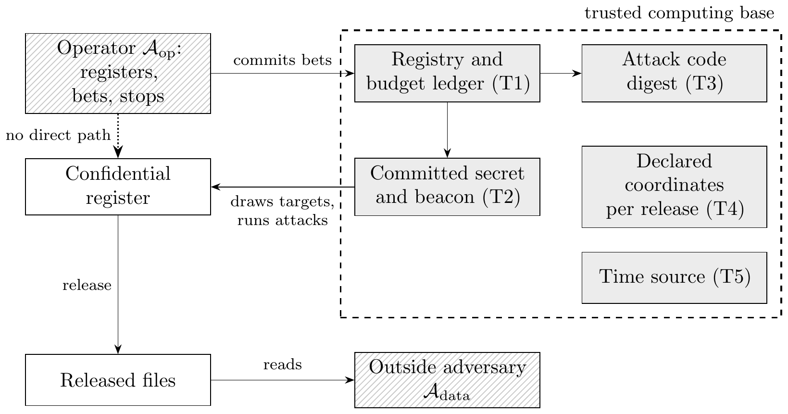
Figure 13. Trust boundaries of the audit. The outside adversary sees only the released files. The operator reaches the confidential register only through the registry, which draws targets from committed randomness, records each bet before the attack runs, runs attack code fixed by its digest and keeps one budget per programme (Algorithm 6). Everything inside the dashed box must be trusted for the error bound to hold against the operator; the dotted arrow is the path that complete mediation forbids. Hatching marks the two adversaries and grey fill the trusted parts.
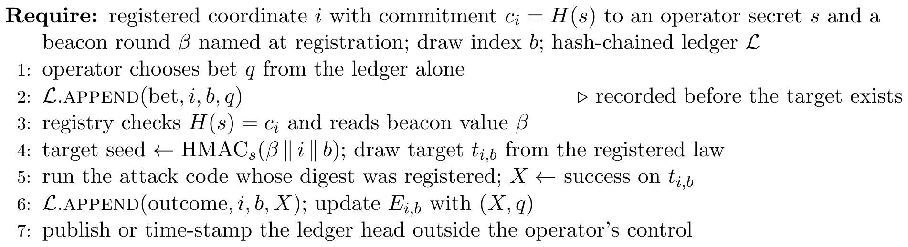
Algorithm 6. One committed audit draw
What breaking the trusted parts costs. Table 16 measures three ways an operator can break them. An operator who can pick among seeds, or who runs shadow audits outside the registry and registers only the one that passed, turns a false-certification rate of 0.038 at the tolerance into 0.322 with ten tries and 0.979 with a hundred, rates computed from the measured single-try rate with the tries treated as independent. An operator who chooses each bet of the sequential audit after seeing the outcome certifies an unsafe attack in every run. The repository implements the matching controls in privacy_risk.adaptive_audit: targets are derived from a committed secret and a later round of a public randomness beacon, so that neither the operator nor the beacon alone chooses them; each bet is recorded in a hash-chained ledger before the attack runs and its outcome is recorded after; and the ledger’s entries cannot be changed, dropped or reordered without breaking the chain or changing its head. With the controls in place, and the registry trusted, the rates return to the honest ones.
Table 16. Attacks on the audit process. Share of runs in which an unsafe or boundary coordinate is certified, with one coordinate at the full level $α=0.05$ and tolerance 0.12. Seed grinding rows use at most 3,000 draws and the capped plug-in bet; post-hoc rows use at most 300 draws and the operator’s bet without the control, and the capped plug-in bet with it. Tries is the number of seeds or shadow audits the operator can choose among. Without the control, the rate for several tries is $1−{\left(1−f\right)}^{tries}$ for the single-try rate $f$; with it, the operator has one stream. Script: scripts/audit_process_attacks.py.
Attack on the audit | True risk | Tries | Without control | With control
Seed grinding or shadow audits | 0.12 | 1 | 0.038 | 0.038
Seed grinding or shadow audits | 0.12 | 10 | 0.322 | 0.038
Seed grinding or shadow audits | 0.12 | 100 | 0.979 | 0.038
Seed grinding or shadow audits | 0.14 | 1 | 0.007 | 0.007
Seed grinding or shadow audits | 0.14 | 10 | 0.066 | 0.007
Seed grinding or shadow audits | 0.14 | 100 | 0.495 | 0.007
Bet chosen after the outcome | 0.14 | 1 | 1.000 | 0.007
Bet chosen after the outcome | 0.20 | 1 | 1.000 | 0.000
What it adds over per-release review. Against $A_{data}$ the method adds four properties.
- Programme coverage. It assesses the pooled, or intersection, attack over the declared horizon, which Proposition 11 shows cannot be read off per-release figures.
- Assurance with a stated error. The decision compares an upper bound with the tolerance, so the chance of false assurance is at most $α$, where a point estimate passes a release at the boundary about half the time (Proposition 5). Monitoring uses an anytime-valid sequence, so watching the evidence does not raise the error: in Section F.1, 20 looks at a fixed-sample bound put it below the true risk in 21 per cent of runs, against 0 per cent for the anytime sequence.
- Fail-closed defaults. These are properties of the pipeline. An attack that has not been audited is given a risk bound of one and fails, rather than being treated as zero risk, and the pipeline returns a fail when the upper bound on the pooled risk of the declared programme exceeds the release tolerance, even when each release passes on its own (Section 10.8).
- Red-team findings. A new attack proposed by a red team enters as a new coordinate with its own share of the error budget, without voiding the certificates already issued for earlier coordinates, if budget was reserved for it, as the companion article shows.
Against $A_{op}$ it makes audit shopping, repeating an audit or scanning settings until one passes, either impossible or paid for out of the error budget. That holds only under complete mediation (Saltzer and Schroeder, 1975): every attack run on the confidential register must pass through the registry, and development work must use a separate extract. Registering settings, targets, tolerances and sample sizes before any outcome is seen, and choosing a level by fixed-sequence testing, are the procedural half of the same condition.
What it does not give. The implementation is a library, not a security boundary. Read-only fields in Python are not a security control: code in the same process can change private state. The SHA-256 hashes a run writes are the pipeline’s manifest of its outputs; they show that a file has changed since the run, but they carry no key or trusted time stamp, and the ledger’s hash chain detects changes only if its head is published or time-stamped outside the operator’s control. A deployment that must hold against the operator needs the registry as a separate service with its own storage, signing keys and time stamps; separation of duties, in which an independent team writes and signs the attack code, a data custodian holds the register and the randomness commitment, and the owner signs the tolerance before the first outcome; and verification by internal audit inside the secure environment, since the log of which targets were identified is itself confidential. The method gives no guarantee against attacks that were not registered, and no differential privacy guarantee (Section 9). The evidence in this paper is synthetic, and the floor depends most on how precisely the adversary can read exposure (Table 11), which an institution has to argue for from what it knows of the sources outsiders hold.
Relation to security-assessment practice. The declared scenario is a threat model in the usual sense (Shostack, 2014): asset, adversary, capability and harm are written down before testing. The attack simulation is red-team testing with a statistical stopping rule. The decision record is an assurance case: a claim (the release meets $τ$ against the declared adversaries), the evidence (bounds, sample sizes and falsification tests) and the argument that links them (the propositions of this paper), with a named owner and an expiry date. The mapping is offered to help an institution place the method within its existing risk and audit processes, not as a claim of conformity with any standard.

18 Discussion
The argument of this paper is that a release decision has three parts that should be separately visible, and that most of the difficulty in practice comes from collapsing them. Section 3 shows that the standard risk measures are theorems about one linkage experiment, so that changing the experiment changes the measure; Section 4 shows that the resulting figure is an estimate whose uncertainty belongs in the decision rule; Section 5 shows that the tolerance is a policy quantity that a stated relative harm weight already pins down. Two negative results follow. The first holds by construction: a $k$-anonymous release does not guarantee a risk of $1/k$ once the adversary holds a variable the key leaves out (Table 2), and its use is to show how large the gap can be, not to reveal a flaw in the criterion. The second has more consequence for institutions: when records carry a persistent pseudonym, a programme of low-risk releases can be attacked far above the bound its marginals imply (Table 4). Section 13 shows what the second costs on a release system rather than in a construction, and what it depends on. On the synthetic register, with the floor chosen by fixed-sequence testing and confirmed on fresh targets, per-release review passes the file with no suppression, or with a floor of 20 when every size class must pass. An adversary who pools the vintages and knows when the target’s loan is live needs 75 (200 for every size class); without that knowledge pooling adds nothing there. An adversary that also holds a reading per vintage needs 150, and no floor up to 200 protects every size class. An insider who reads exposure closely is stopped by no floor. The answers are all correct, for different adversaries, and the choice among them is the institution’s declaration, not a result of the analysis (Table 9).
The cost is the finding a committee should weigh most. The floor of 150 keeps 20 per cent of loans and 4 per cent of exposure, and no loan to a large firm, so the file that survives is not the file that concentration and supervisory analysis need. We draw a plain conclusion from this for the synthetic register: against an adversary who knows loan histories, a loan-level release is the wrong product. The realistic options are aggregates with contributor and count rules, or access to the loan-level file in a secure setting, where the Five Safes govern who sees it and what leaves. The loan-level file here stands in for securitisation loan-level disclosures and for research files as an accredited user sees them; it is not a claim that any central bank publishes loan-level credit data.
Four limitations apply. First, the simulation is synthetic. It establishes that the phenomena occur under a transparent data generating process and that the estimators behave as the propositions say, and it cannot establish the magnitudes an agency would see on its own register; those depend on the auxiliary data actually available, which is exactly the quantity a declared scenario has to guess. Second, the framework represents harm through a scalar $c_{h}$ within a declared class $h$. Harms that fall on groups rather than individuals, and harms that arise from correct inference about a population rather than identification of a person, are outside it, and the second of these is precisely what Dwork and Roth (2014) argue is not a privacy violation at all. Third, the joint attacks are one pooling rule among many, and they assume a record identifier shared across releases. They measure what pooling achieves for that adversary’s information, so they support the negative result of Proposition 11, but no simulation can deliver the supremum over rules that a formal guarantee delivers by construction. Fourth, the credit floors are conditional. They depend on the tolerance (Table 10), on the precision of the adversary’s exposure reading (Table 11), which an institution can argue for but not measure, and on a register whose exposures do not change between vintages.
Four extensions look tractable. The frontier estimation in Section 6 could be given a proper inferential treatment, since the frontier is a functional of an estimated set and its selected point is biased in the same way as any quantity chosen by maximising an estimate. The risk budget of Proposition 16 could be extended from the union event to a joint accountant that admits dependence, which would need a composition theorem for scenario-conditional risk under a stated dependence class. The implied tolerance of Proposition 7 could be estimated from revealed institutional behaviour, since agencies have been making these decisions for decades and their past choices identify $κ$ under the framework. And the calibration test of Section 14 could be developed into a formal specification test with a distribution under the null.
The recommendation is to publish, alongside each release decision, the risk estimate, the uncertainty bound and the number of replicates behind it, the tolerance, the adversary specification, the legal basis and access route, the mechanism setting with what it keeps in records and in volume, the named owner and the expiry date. For a programme, publish the joint simulation and its horizon as well. The record does not remove judgement from the decision. It places the judgement in the tolerance and leaves the probability calculation reproducible and open to being proved wrong.

18.1 What a release committee should take from this
Three decisions follow from the argument, and each needs a committee. The first is the tolerance, its accountable owner and its expiry date, which Definition 2 makes a record rather than a habit. Section 16 sets out how to reach it. The second is whether that tolerance is asserted of each release or of the programme, which Section 13 shows is not a matter of wording: on the synthetic register, at a tolerance of 0.12, the per-release reading of the rule releases all 27,167 loans of the first vintage, while the programme reading against the full adversary releases 5,553, with 4 per cent of the exposure. The third is the adversary specification, written down, so that the assumption can be disagreed with explicitly instead of inherited silently. On the credit register it decides the floor: whether the adversary knows the history of the target’s loan moves the programme floor from 1 to 75, and whether it holds a reading in every vintage moves it from 75 to 150.
A fourth choice is easy to miss because the arithmetic hides it. The measures of Section 3.3 protect different people. The marketer measure is an average over the released records, and a release can meet a tolerance on that average while a particular record in it is identified with near certainty. The prosecutor measure in its supremum form protects the most exposed record instead, and the subgroup bounds of Section 13 are the operational form of the same idea. Which one an institution reports is an ethical choice about whose protection the threshold is for, not a technical preference, and the framework supports either as long as the committee says which it has chosen.

19 Conclusion
A release programme, not a release, is the object a central bank should govern. When records keep a pseudonym across vintages, per-release risk figures cannot bound what an adversary who holds every vintage can do, and a point estimate at the tolerance passes about half the time. The rule we propose compares an exact upper bound on the programme’s risk with a written tolerance that has an owner, an expiry date, a harm class, a horizon, a legal basis and an access route, and it chooses the protection level by fixed-sequence testing, confirmed on fresh targets, with the adversary set declared before any table is read.
On a synthetic credit register at a tolerance of 0.12, that rule passes the loan-level file with no suppression on one release, needs a floor of 75 against an adversary who knows loan histories and 150 against one who also reads exposure in each vintage, and finds no floor against an insider. The floor of 150 keeps a fifth of the loans and 4 per cent of the exposure, and no large firm. The floors move with the tolerance and with the adversary’s reading precision, so both belong in the record. For a register like this one, and an adversary who knows loan histories, the loan-level file is the wrong product: aggregates, or access in a secure setting, are the options a committee can defend. The results are synthetic, and the pipeline that produced them can be run on a real register inside the institution that holds it.

Data and code availability
The pipeline (Mahomane, 2026) generates every table, figure and quoted study result, and writes the configuration and recorded outputs to artifacts-paper/. The script scripts/check_paper_numbers.py checks the figures quoted in the prose against the run. The script scripts/programme_robustness.py writes artifacts-robustness/robustness.json, the source of Tables 9, 10 and 11, and scripts/estimand_check.py writes artifacts-robustness/estimand_check.json. The module privacy_risk.adaptive_audit implements the audit-process controls of Section 17, and scripts/audit_process_attacks.py produces Table 16. The neural release pipeline of Section 13.5 is privacy_risk.neural_pipeline, which writes artifacts-neural/neural_pipeline.json and Table 12. The earlier procedure of the online appendix is privacy_risk.neural_trust and supplies no inputs to the tables or figures here. The two public microdata files of Section 11 are loaded through the wooldridge package.

Acknowledgements
An earlier version was prepared for the Workshop on Data Security and Privacy of the Banco de Portugal and the Irving Fisher Committee, Lisbon, September 2026. The views are the author’s own.

A Allocating a programme tolerance
Suppose an institution governs the union event, so that the programme constraint is i​Ri≤τprog by (34). This is not a conservative route: by Proposition 11 the pooled risk can exceed the union bound. Each release has value weight $w_{i}>0$ and frontier $φ$ shared across releases for simplicity.
Proposition 16 (Risk budget). The problem maxi​wiφri subject to i​ri≤τprog and $r_{i}≥0$, with $φ$ increasing, differentiable and strictly concave, and with $φ′\left(0^{+}\right)=∞$, so that no release is allocated zero risk, has a unique solution characterised by
wiφ′ri⋆=μ for all i, i​ri⋆=τprog, 45
for a multiplier $μ>0$. If $φ\left(r\right)=logr$ then ri⋆=τprogwi/j​wj, so the budget is allocated in proportion to value.
Proof. See Appendix B. $▫$
The equal split $r_{i}=τ_{prog}/m$, which is what an institution does by default when it applies one tolerance to every release, satisfies (45) only if all $w_{i}$ are equal. The proportional rule is equally particular: it holds for the logarithmic value curve and for no other. For the power family $φ\left(r\right)=a+br^{γ}$ with $b<0$ and $γ<0$, which is the family that fits the simulated frontier, condition (45) gives
$$r_{i}^{⋆} ∝ w_{i}^{1/\left(1−γ\right)}, \left(46\right)$$
so the allocation is flatter than value whenever $γ<0$, and it approaches an equal split as $γ→−∞$. In the simulation the fitted $γ=−0.23$ gives an exponent of 0.81, and on the fitted curve the resulting allocation cuts the total loss by 4.5 per cent relative to the equal split. That figure is a stylised illustration: the attainable frontier is not concave, and the curve smooths it (Section 10).
We stress the scope. Proposition 16 governs the union event. It does not govern the pooled attack, and by Proposition 11 nothing stated in terms of the marginals can. A risk budget is a device for allocating attention across releases, not a substitute for joint simulation.

B Proofs
Proof of Proposition 1. Condition on $S_{t}=1$ and $K_{a}\left(X_{t}\right)=k$. By Assumption 1 the released key of every record equals its confidential key, and by Assumption 2 the adversary observes $k$. The compatible set is therefore $\{j∈I:K_{a}\left(X_{j}\right)=k\}$, which has cardinality $f_{k}$ by (3) and contains $t$. By Assumption 3 the adversary’s information is invariant to permutations of that set, and by Assumption 4 it selects each member with probability $1/f_{k}$. Exactly one member is correct, so
$$P\{δ_{a}=t∣S_{t}=1,K_{a}\left(X_{t}\right)=k,f_{k}\}=\sum_{j=1}^{f_{k}}{\frac{1}{f_{k}}}1\{j=t\}=\frac{1}{f_{k}}.$$
$▫$
Proof of Proposition 2. By (12) and Proposition 1, $\sup_{t∈I}R_{pros}\left(t,θ\right)=1/\min_{k:f_{k}>0}f_{k}$. Hence $\sup_{t}R_{pros}≤τ$ if and only if $\min_{k}f_{k}≥1/τ$, and since $f_{k}$ is an integer this is $\min_{k}f_{k}≥⌈1/τ⌉$, which is the definition of $k$-anonymity with $k=⌈1/τ⌉$.
For the failure claim, drop Assumption 3. Let the release publish a confidential variable $y$ alongside the key, let a key class have $f_{k}=k$ members with distinct values of $y$, and let the adversary observe $z_{t}=y_{t}+σξ$ with $ξ$ standard normal and $σ$ small relative to the within-class spacing of $y$. The posterior (10) concentrates on the member whose $y$ is nearest $z_{t}$, and as $σ↓0$ the success probability of the maximum-posterior rule tends to one, while $k$-anonymity holds for every $σ$. Therefore $\sup_{t}R_{a}^{in}>1/k$ for all sufficiently small $σ$. $▫$
Proof of Proposition 3. With zero successes the one-sided Clopper–Pearson upper limit solves ${\left(1−U\right)}^{B}=α$, giving ${\overline{R}}_{1−α}=1−α^{1/B}$ as in (21). Then ${\overline{R}}_{1−α}≤τ$ if and only if $α^{1/B}≥1−τ$. Taking logarithms, and noting $logα<0$ and $log\left(1−τ\right)<0$, this is $B^{−1}logα≥log\left(1−τ\right)$, that is $B≥logα/log\left(1−τ\right)$. Since $log\left(1−τ\right)=−τ+O\left(τ^{2}\right)$, the right side is $−logα/τ+O\left(1\right)$ as $τ↓0$. $▫$
Proof of Proposition 4. For any occupied key class, $f_{k}≤F_{k}$ by (3), hence $1/f_{k}≥1/F_{k}$ pointwise, and monotonicity of expectation gives the first claim, with equality if and only if $f_{k}=F_{k}$ almost surely for every class the average touches. The second claim is Jensen’s inequality applied to the convex function $x↦1/x$ on $\left(0,∞\right)$, which is strict unless $f_{k}$ is degenerate. $▫$
Proof of Proposition 5. At $R_{a}=τ$, asymptotic symmetry of the estimator gives $P\left({\hat{R}}_{a}≤R_{a}\right)→1/2$, so the point-estimate rule releases with probability tending to $1/2$. A valid one-sided $\left(1−α\right)$ upper bound satisfies $P\{R_{a}≤{\overline{R}}_{1−α}\}≥1−α$, hence $P\{{\overline{R}}_{1−α}<R_{a}\}≤α$. At the boundary, release under (27) implies ${\overline{R}}_{1−α}≤τ=R_{a}$, an event of probability at most $α$ up to equality conventions. $▫$
Proof of Proposition 6. Write $H_{i}$ for the hypothesis that $R\left(θ_{i}\right)>τ$, and say that setting $i$ passes when its bound is at or below $τ$. If every $H_{i}$ is false there is nothing to prove. Otherwise let $i^{*}$ be the first index in the fixed order for which $H_{i^{*}}$ is true. The procedure chooses a setting $j$ only if settings $1,…,j$ all pass, so it chooses a setting with true risk above $τ$ only if it chooses some $j≥i^{*}$, which requires that setting $i^{*}$ pass. Setting $i^{*}$ is fixed before the data are seen, so by the one-sided bound at level $α$ the probability that it passes while $R\left(θ_{i^{*}}\right)>τ$ is at most $α$. Hence the probability of choosing an unsafe setting is at most $α$. No step uses the order of the true risks, so the result holds whether or not they are monotone (Maurer et al., 1995). $▫$
Proof of Proposition 7. On the frontier the problem is $\max_{r}\{λφ\left(r\right)−c_{h}r\}$ over $\left[\underline{r},\overline{r}\right]$. The objective is strictly concave because $φ$ is, so a maximiser exists and is unique. Its derivative is $λφ′\left(r\right)−c_{h}$, which is strictly decreasing; under $φ′\left(\underline{r}\right)>κ>φ′\left(\overline{r}\right)$ with $κ=c_{h}/λ$ it is positive at $\underline{r}$ and negative at $\overline{r}$, so the maximiser is interior and solves $φ′\left(r\right)=κ$. Monotonicity of $τ^{⋆}$ in $κ$ follows because $φ′$ is strictly decreasing, so $τ^{⋆}={\left(φ′\right)}^{−1}\left(κ\right)$ is decreasing in $κ$. $▫$
Proof of Proposition 9. The feasible set $Θ_{τ}=\{θ:\sup_{t}{\overline{R}}_{1−α}\left(t,θ\right)≤τ\}$ is closed by lower semicontinuity of the constraint function, hence compact as a closed subset of the compact $Θ$, and nonempty by assumption. An upper semicontinuous function attains its maximum on a nonempty compact set. $▫$
Proof of Proposition 10. Monotonicity gives $C_{i}⊆⋃_{j}C_{j}$ and hence $R_{i}≤R_{∪}$ for every $i$, so $\max_{i}R_{i}≤R_{∪}$. Boole’s inequality gives R∪≤i​Ri, and $R_{∪}≤1$ always, which is the upper bound. Attainment: if the events are nested, $C_{1}⊇C_{2}⊇⋯$, then $R_{∪}=R_{1}=\max_{i}R_{i}$. If they are disjoint and i​Ri≤1, then R∪=i​Ri; if i​Ri>1, a standard overlapping construction on $\left[0,1\right]$ with Lebesgue measure, placing $C_{i}$ as intervals that cover $\left[0,1\right]$, gives $R_{∪}=1$. $▫$
Proof of Proposition 11. Fix $m≥2$ and an integer $k≥1/ν$. Let the sample consist of $n=k^{m}$ units labelled by the vectors $x=\left(x_{1},…,x_{m}\right)∈\{1,…,k\}^{m}$, all present with certainty. Let release $i$ publish the key $K_{i}\left(x\right)=\left(x_{1},…,x_{i−1},x_{i+1},…,x_{m}\right)$, that is all coordinates except the $i$th. Each key class of release $i$ contains exactly $k$ units, so the release is $k$-anonymous and, under Assumptions 1 to 4, $R_{i}=1/k≤ν$.
Now let the adversary hold all $m$ releases and know the target’s full label. The candidate set from release $i$ is $\{x:K_{i}\left(x\right)=K_{i}\left(t\right)\}$, which is the set of units agreeing with $t$ in all coordinates except possibly the $i$th. The intersection over $i=1,…,m$ of these sets is $\{t\}$, because a unit in the intersection agrees with $t$ in every coordinate: for coordinate $j$, membership in the candidate set of any release $i≠j$ forces $x_{j}=t_{j}$, and $m≥2$ guarantees such an $i$ exists. Hence $δ_{a}^{\left(m\right)}$ that selects the unique element of the intersection satisfies $R_{pool}=1$. Since $ν$ was arbitrary and $\left(R_{1},…,R_{m}\right)=\left(1/k,…,1/k\right)$ can be made arbitrarily small while $R_{pool}=1$, no function of the marginals can bound $R_{pool}$ from above.
For the final claim, let $A_{i}\left(t\right)$ be the candidate set of release $i$ and $G_{m}\left(t\right)=⋂_{i≤m}A_{i}\left(t\right)$, and suppose the adversary selects uniformly from $G_{m}\left(t\right)$. Then $G_{m+1}\left(t\right)⊆G_{m}\left(t\right)$ and $t∈G_{m}\left(t\right)$ for every $m$, so $1/\left|G_{m+1}\left(t\right)\right|≥1/\left|G_{m}\left(t\right)\right|$ pathwise and taking expectations gives monotonicity. Since $G_{m}\left(t\right)⊆A_{i}\left(t\right)$ for each $i≤m$, the same argument gives $R_{pool}≥\max_{i≤m}E\left[1/\left|A_{i}\left(t\right)\right|\right]=\max_{i}R_{i}$. $▫$
Proof of Proposition 16. The objective is strictly concave and the constraint set is compact and convex, so a unique maximiser exists. Since $φ$ is increasing, the constraint binds. The Lagrangian is i​wiφri−μi​ri−τprog and the first-order conditions are $w_{i}φ′\left(r_{i}\right)=μ$ for every $i$, which is (45); concavity makes them sufficient. For $φ=log$ the conditions read $w_{i}/r_{i}=μ$, so $r_{i}∝w_{i}$, and the constraint fixes the constant at τprog/j​wj. For $φ\left(r\right)=a+br^{γ}$ with $b<0$ and $γ<0$, which is increasing and strictly concave on $\left(0,∞\right)$, we have $φ′\left(r\right)=bγr^{γ−1}$, so (45) reads $w_{i}r_{i}^{γ−1}=μ/\left(bγ\right)$ and hence $r_{i}∝w_{i}^{1/\left(1−γ\right)}$, which is (46). $▫$
Proof of Proposition 12. At posterior probability $p$, acting has expected payoff $V\left(p\right)=ph−\left(1−p\right)c_{f}−c_{a}=p\left(h+c_{f}\right)−\left(c_{f}+c_{a}\right)$, which is increasing in $p$ because $h+c_{f}>0$. Its largest value is $V\left(1\right)=h−c_{a}$. If $c_{a}>h$ then $V\left(p\right)<0$ for every $p≤1$, and if $c_{a}=h$ then $V\left(p\right)≤0$ with equality only at certainty, where acting gains nothing; in both cases the adversary does not act, which we record as $p^{⋆}=+∞$. If $c_{a}<h$, then $V\left(p\right)≥0$ if and only if $p≥\left(c_{f}+c_{a}\right)/\left(h+c_{f}\right)$, and this ratio is below one because $c_{f}+c_{a}<h+c_{f}$. Finally $\left(c_{f}+c_{a}\right)/\left(h+c_{f}\right)=1/2$ if and only if $2c_{f}+2c_{a}=h+c_{f}$, that is $h=c_{f}+2c_{a}$. $▫$
Proof of Proposition 13. For fixed $u∈\left(0,1\right)$, the Bernoulli likelihood ratio through time $B$ between risk $u$ and risk $r_{0}$ is a nonnegative $r_{0}$-martingale with initial value one. Integrating these likelihood-ratio martingales against the $Beta\left(a,b\right)$ density preserves the martingale property by Tonelli’s theorem and gives exactly (38). Ville’s inequality for a nonnegative martingale yields (39). The event that $r_{0}$ exits $C_{B}$ at some time is the event that $E_{B}\left(r_{0}\right)≥1/α$ at some time, so its probability is at most $α$. $▫$
Proof of Proposition 14. Let $x$ and $x′$ be the databases in which $H$ is true and false respectively; they differ in one individual’s record, so they are neighbouring, and by hypothesis the remaining records have the same distribution under both. For any observed output set $E$ of positive probability, (42) with $δ_{dp}=0$ gives the likelihood ratio bound $P\{M\left(x\right)∈E\}/P\{M\left(x′\right)∈E\}≤e^{ε}$. Bayes’ rule in odds form gives
$$\frac{P\left(H∣M∈E\right)}{1−P\left(H∣M∈E\right)}=\frac{p}{1−p}⋅\frac{P\{M\left(x\right)∈E\}}{P\{M\left(x′\right)∈E\}}≤\frac{p}{1−p}e^{ε},$$
and solving for $P\left(H∣M∈E\right)$ gives (43). With $δ_{dp}>0$ the same steps give the exact bound
$$\frac{P\left(H∣M∈E\right)}{1−P\left(H∣M∈E\right)}≤\frac{p}{1−p}\left(e^{ε}+\frac{δ_{dp}}{P\{M\left(x′\right)∈E\}}\right),$$
which is unbounded for rare $E$, so no uniform posterior bound holds when $δ_{dp}>0$. With probability at least $1−O\left(δ_{dp}/\left(1−e^{−ε}\right)\right)$ over outputs, a bound of the form (43) holds with $ε$ inflated by a constant factor (Kasiviswanathan and Smith, 2014). $▫$

C Expanded derivations
This appendix expands the calculations used in the text, so that each reported quantity can be reconstructed without treating an intermediate identity as given.

C.1 From joint success to membership-conditional risk
Let $A_{t}=\{δ_{a}\left(Z_{t},Y_{θ}\right)=t\}$ and $B_{t}=\{S_{t}=1\}$. Since a released record cannot equal an unsampled target, $A_{t}⊆B_{t}$, and
$$R_{a}^{unc}\left(t,θ\right)=P\left(A_{t}∩B_{t}∣B_{a}\right)=P\left(A_{t}∣B_{t},B_{a}\right)P\left(B_{t}∣B_{a}\right)=π_{t}R_{a}^{in}\left(t,θ\right), \left(47\right)$$
which is (8). If the auxiliary information changes the adversary’s belief about membership, the last factor is $P\left(B_{t}∣B_{a}\right)$ and not the design probability $π_{t}$; using $π_{t}$ requires that $B_{a}$ carry no information about who was sampled.

C.2 Bayesian linkage from comparison vectors
Let $γ_{tj}=γ\left(Z_{t},Y_{j}\right)$ be a comparison vector, and write $m\left(γ\right)=p\left(γ∣H_{tj}=1\right)$ and $u\left(γ\right)=p\left(γ∣H_{tj}=0\right)$ for its density under a match and a non-match, with likelihood ratio $Λ_{tj}=m\left(γ_{tj}\right)/u\left(γ_{tj}\right)$. Under the usual assumptions that the fields of a comparison vector are conditionally independent given the match status (Fellegi and Sunter, 1969), and that the comparison vectors of distinct candidates are conditionally independent of one another, Bayes’ theorem and division by ℓ​uγtℓ give
ptj=qtjΛtjqt0Λt0+ℓ∈I​qtℓΛtℓ, 48
where $Λ_{t0}=1$, because under the no-match hypothesis every candidate is scored by its non-match density and the division leaves one. This is (10) with $L=Λ$. Exact exchangeable matching is the case of equal likelihood and prior weight on each of the $f_{k}$ compatible records and zero weight elsewhere, giving $1/f_{k}$ for each. For two candidates,
$$\frac{p_{tj}}{p_{tℓ}}=\frac{q_{tj}}{q_{tℓ}}⋅\frac{L_{tj}}{L_{tℓ}}, \left(49\right)$$
so the reciprocal-frequency figure is valid only when both ratios equal one inside the key class. Equation (49) is where informative side information enters.

C.3 The uniqueness probability under binomial thinning
Conditional on $F_{k}=v$, Bernoulli sampling gives $f_{k}∣F_{k}=v∼Binomial\left(v,π\right)$, so $P\left(F_{k}=1,f_{k}=1\right)=πP\left(F_{k}=1\right)$ and Pfk=1=v≥1​vπ1−πv−1PFk=v. Dividing the first by the second gives (16). For a parametric frequency law $g\left(v;η\right)$ the plug-in estimator is
ρk=πg1;ηv≥1​vπ1−πv−1gv;η, 50
and the analyst must carry the uncertainty in $\hat{η}$ through (54), or refit $g$ inside each replicate.

C.4 Exact binomial bounds and simultaneous control
If X=b​Ctb=x, the one-sided Clopper–Pearson upper endpoint is
$${\overline{R}}_{1−α}\left(x,B\right)={Beta}_{1−α}^{−1}\left(x+1,B−x\right), x<B, \left(51\right)$$
and one when $x=B$, where ${Beta}_{q}^{−1}\left(a,b\right)$ is the $q$th quantile of a beta distribution. At $x=0$ the beta distribution function is $F\left(u\right)=1−{\left(1−u\right)}^{B}$, so $F\left(\overline{R}\right)=1−α$ recovers (21).
If $T$ holds $q$ targets and the decision uses their maximum, separately valid $\left(1−α\right)$ intervals do not give a $\left(1−α\right)$ file-level statement. Bonferroni control uses targetwise error $α/q$. Section 10.4 needs the lower form, since it reports the worst target, so writing ${\underline{R}}_{α/q,t}$ for a one-sided lower limit,
PRt≥Rα/q,t for every t∈T≥1−t∈T​αq=1−α, 52
and the same argument gives the upper form when every target’s bound is to be reported at once. This is conservative but valid without independence, and it is what Section 10.4 uses for the worst target. A release decision that requires every target’s bound to meet $τ$ does not need it: that is an intersection–union test, and per-target bounds at level $α$ already control false release at $α$ (Berger, 1982). A max-statistic bootstrap can replace it when the resampling scheme preserves dependence across targets (Efron and Tibshirani, 1993).

C.5 Three layers of uncertainty
It is useful to separate three layers of uncertainty that are otherwise hidden inside one error bar. Write $\hat{η}$ for parameters estimated from an auxiliary source and $D$ for the realised confidential sample. The law of total variance gives
$$Var\left({\hat{R}}_{a}\right)=E_{D,\hat{η}}\{Var\left({\hat{R}}_{a}∣D,\hat{η}\right)\}+{Var}_{D,\hat{η}}\{E\left({\hat{R}}_{a}∣D,\hat{η}\right)\}=V_{MC}+V_{input}, \left(53\right)$$
where the second term collects everything that varies with the sample and the fitted inputs rather than with the simulation. A nested design that redraws the sample estimates the part of it that the sampling design contributes. Separating that from the contribution of a refitted auxiliary model needs a second level of nesting, and the two parts do not in general add, because the risk is not separable in the two inputs. The binomial expression in (20) estimates only $V_{MC}$. Increasing $B$ drives that term to zero and does nothing to the others.
For a smooth risk functional $R\left(η\right)$ with $\sqrt{m}\left(\hat{η}−η_{0}\right)⇒N\left(0,Σ_{η}\right)$, the delta method supplies the first-order approximation (van der Vaart, 1998)
$${Var}_{aux}\{R\left(\hat{η}\right)\}≈\frac{1}{m}∇_{η}R{\left(η_{0}\right)}^{⊤}Σ_{η}∇_{η}R\left(η_{0}\right). \left(54\right)$$
Non-smooth operations such as a maximum over targets invalidate this calculation at ties, and a nested bootstrap or a simultaneous bound is then the safer object. Appendix C constructs both, and Section E.3 measures the two terms of (53) on the simulated register.

C.6 Nested estimator for simulation and input uncertainty
Draw outer replicates $s=1,…,S$. In each, redraw the confidential sample according to its design, refit any auxiliary model, apply the mechanism, and run $B_{s}$ conditional attacks. With Rs=Bs−1b​Csb and R=S−1s​Rs, an analysis-of-variance decomposition is
$${\hat{V}}_{within}=\frac{1}{S}\sum_{s=1}^{S}{\frac{{\hat{R}}_{s}\left(1−{\hat{R}}_{s}\right)}{B_{s}}}, {\hat{V}}_{between}=\frac{1}{S−1}\sum_{s=1}^{S}{{\left({\hat{R}}_{s}−\overline{R}\right)}^{2}}−{\hat{V}}_{within}, \left(55\right)$$
the second truncated at zero when the finite estimate falls slightly negative. The variance of $\overline{R}$ is then approximately $\left({\hat{V}}_{between}+{\hat{V}}_{within}\right)/S$ for independent outer replicates. Percentile or studentised outer bootstrap bounds avoid relying on normality near zero. Section E.3 reports both terms.

C.7 Tangency and boundary cases
On a differentiable frontier $u=φ\left(r\right)$, maximise $J\left(r\right)=λφ\left(r\right)−c_{h}r$. Then
$$J′\left(r\right)=λφ′\left(r\right)−c_{h}, J″\left(r\right)=λφ″\left(r\right)<0, \left(56\right)$$
so the first-order condition is sufficient and gives $φ′\left(r\right)=c_{h}/λ$. If $c_{h}/λ≥φ′\left(\underline{r}\right)$ the optimum is the safest boundary $\underline{r}$; if $c_{h}/λ≤φ′\left(\overline{r}\right)$ it is the highest-risk boundary $\overline{r}$. These cases complete Proposition 7 when its interiority condition fails.
For the programme allocation, allow $r_{i}=0$ and attach multipliers $ξ_{i}$ to the non-negativity constraints. The Karush–Kuhn–Tucker conditions are
wiφi′ri−μ+ξi=0, ξiri=0, μτprog−i​ri=0, μ,ξi≥0, 57
so active releases equalise weighted marginal value, and a release receives zero budget only when its marginal value at zero is no greater than the constraint multiplier (Boyd and Vandenberghe, 2004). This is the general form behind (45).

C.8 Predictive value of an alleged relationship
Let $D$ be the event that a stated relationship holds and $A$ the event that the adversary alleges it. Bayes’ theorem gives
$$P\left(D∣A\right)=\frac{ps}{ps+\left(1−p\right)\left(1−q\right)}, p=P\left(D\right), s=P\left(A∣D\right), q=P\left(A^{c}∣D^{c}\right), \left(58\right)$$
the sensitivity $s$ and specificity $q$ of the allegation. The quantity that matters for harm is the left side, not $s$. When $p$ is small, as it is for borrower–lender pairs, a specificity close to one still leaves a modest predictive value, and Section 12 reports the four cells of the table so that (58) can be checked as an identity rather than believed.

C.9 Residual disclosure from published totals
Let cells $c$ carry published totals Tc=b​xbc, where $x_{bc}$ is contributor $b$’s amount. Stacking the published totals gives a linear system $Ax=T$. A contribution $x_{bc}$ is determined by the release if and only if it is constant on the feasible set $\{x:Ax=T, x≥0\}$ intersected with whatever else the adversary knows, which for a participating institution includes its own row. The non-negativity constraint matters: it is what makes a zero total disclosive, and it is what linear-programming attacks on suppressed tables exploit. Two familiar cases follow at once. A cell with one contributor gives $x_{bc}=T_{c}$. A cell with two contributors gives the other’s amount to either of them by subtraction. Requiring three contributors per published cell removes both cases, and threshold rules of this kind are described by Hundepool et al. (2012, ch. 4), usually beside a dominance or $p\%$ rule, since with three or more contributors one of them can still estimate another’s amount closely. Counting the two cases gives a lower bound on what the release determines, not the whole of it, and it does not address the differencing attack below.

C.10 Differencing across consecutive releases
Let $n_{c,m}$ and $T_{c,m}$ be the count and total published for cell $c$ in month $m$. If $n_{c,m+1}−n_{c,m}=1$ and exactly one relationship moved, the arriving amount is $T_{c,m+1}−T_{c,m}$. The adversary does not observe the number of moves. Under a model in which arrivals $A$ and departures $D$ are independent Poisson counts, each with mean $λ$, the posterior that an observed unit change came from a single move, one arrival and no departure or one departure and no arrival, is
P{A=1,D=0}∪{A=0,D=1}∣A−D=1=2 PA=1PD=0a−d=1​PA=aPD=d, 59
where the factor 2 counts the two single moves, which have equal probability when $A$ and $D$ share a mean. The total movement rate of a cell is $2λ$, and Section 12 quotes that total; $λ$ is half of it. The inference is therefore probabilistic, and its strength falls as the cell becomes busier. Section 12 evaluates (59) on the simulated register.

D Simulation details
Generation. District and occupation categories are drawn from distributions with probabilities proportional to $j^{−0.9}$ and $j^{−0.8}$ respectively, which produces the skewed cell sizes and the population uniques reported in Section 10. Ages are drawn uniformly on $[18,88)$ and then thinned towards younger ages, so that the oldest bands are the sparse ones. All draws use a single seeded generator.
Attack. Targets are drawn uniformly with replacement from the released records, except in the per-target experiment of Section 10.4, where each named target is attacked 250 times. The reported lower bound for the worst target is the one-sided Clopper–Pearson limit from those 250 replicates, taken at $0.05$ divided by the number of targets examined, because that target is selected on its own estimate. The adversary blocks on the target’s district and sex, which it observes without error. Within the block it evaluates the likelihood of the observed age band and occupation group under the error model that generated them, with the neighbour count of each candidate band handled so that the declared model and the generating model agree at the boundary bands, and multiplies by the normal density of the noisy covariate. It selects the maximum-posterior candidate and abstains only when the total likelihood vanishes. Replicates within a setting are independent draws of the target and of the adversary’s information, so (20) and the Clopper–Pearson bound apply to that draw, conditional on the realised sample and mechanism output. They do not cover sampling variability, and an institution reusing one auxiliary file across replicates would not have even this much independence.
Grid and frontier. The 45 mechanism settings are evaluated with 1,200 replicates each for both members of the uncertainty set, and the robust risk is the larger point estimate with its own bound. Utility is the negative of the average of three root mean squared errors, for the mean of $y$ by district, by five-year age band and by occupation, each computed against the population truth over target categories that the release can report with at least three records and normalised by the standard deviation of $y$, plus a penalty of 0.5 times the average share of target categories left unreportable. Age and occupation estimates are formed from the released classification, so a release with 20-year bands or three occupation groups can only supply a piecewise constant answer to an analysis stated at five-year bands or twelve occupations. The frontier is the nondominated subset in the plane of the risk bound and this utility. In the allocation of Section 10.6 the fitted curve is evaluated on $(0,τ_{prog}]$ with a numerical lower bound of ${10}^{−3}$ on each share, which is inactive at the reported optimum.
Credit register. The register of Section 12 draws borrowers with a sector, region and size class, gives each between one and four lending relationships with larger firms holding more, and draws exposures lognormally within size class and arrears at rates that vary by sector and size. Six monthly vintages are generated as a panel with a stable stock. A share of the loans, set so that the stock stays level, is originated in a month drawn uniformly from the second to the sixth; the rest are outstanding when the panel opens. Each loan then survives a geometric number of months with exit hazard 0.04 and does not return once it has left. A loan’s key and exposure are the same in every vintage in which it is live. The linkage attack blocks on region, requires an exact match on the sector and size class, and adds the log density of each reading of log exposure, with standard deviation 0.6; with the history it also excludes any candidate whose pattern of live vintages differs from the target’s. The attack behind the floors of Section 13.4 breaks ties at random; the pipeline attack behind Tables 6 and 7 takes the first of tied candidates. Success is scored at the relationship, so recovering a different relationship of the correct borrower counts as a failure; the borrower-level figure is reported beside it. The published aggregates are totals by region, sector and size class, and the differencing comparison uses the counts of those cells across consecutive vintages, which is a separate lever from the minimum cell count applied to the loan-level file.
Composition. The four releases share one sample, so all dependence between them is the dependence an agency would face when publishing several products from one collection. Candidate sets are the key classes of each release after suppression. A target suppressed from a release contributes zero to that release’s marginal risk and does not narrow the intersection, so the pooled figure is what an adversary achieves using the releases that contain the target. Reported marginal and pooled risks are means of $1/\left|A_{i}\left(t\right)\right|$ and $1/\left|G_{m}\left(t\right)\right|$ over the same 20,000 targets rather than Bernoulli draws, which removes selection noise without changing the estimand.

E Further simulation results
This appendix holds three checks on the synthetic population of Section 10 that the main text summarises in one paragraph.

E.1 Does the gap survive at other register sizes?
A synthetic study invites the question whether its findings are an artefact of the size chosen. National registers hold millions of records, not the 200,000 of the main study. Table 17 rebuilds the same four releases, with the same keys and the same minimum cell count, on registers of 4 sizes with the sampling fraction held fixed.
Table 17. Does the pooling gap survive at other register sizes? The same four releases, the same keys and the same minimum cell count, rebuilt on registers of four sizes with the sampling fraction held fixed. Larger registers are safer release by release, because the key classes grow. The pooled attack falls more slowly, so the ratio of the pooled risk to the bound the marginals imply rises with size rather than falling. The gap the paper is about is not an artefact of the size chosen for the main study.
Population | Sample | Largest marginal | Pooled, 2 releases | Pooled, 4 | Boole bound | Ratio
50,000 | 2,362 | 0.113 | 0.454 | 0.623 | 0.398 | 1.57
100,000 | 5,056 | 0.102 | 0.458 | 0.561 | 0.328 | 1.71
200,000 | 10,035 | 0.088 | 0.411 | 0.458 | 0.253 | 1.81
400,000 | 20,079 | 0.062 | 0.320 | 0.332 | 0.162 | 2.05
Two things move in opposite directions, and the second is the one that matters. Release by release, larger registers are safer: the largest marginal risk falls from 0.113 at 50,000 units to 0.062 at 400,000, because the key classes grow with the population. The pooled attack also weakens, but more slowly, so the ratio of the pooled risk to the bound the marginals imply rises from 1.57 to 2.05 across the same range. Size does not dissolve the problem. It makes the marginals a worse guide to the programme, which is the opposite of the reassurance a large register is usually taken to provide. One reading of this, which we have not tested, is that growth adds records to every key class, which protects each release, while the intersection of four candidate sets can still close on a single record. The pooled figures assume, as above, a common record identifier across the four releases.
Each size rests on one draw, and the samples are Bernoulli draws at $π=0.05$ from one seed, with the same sampling rule at every size. At 50,000 units the draw gave 2,362 records against an expected 2,500 with a standard deviation of about 49, so it is about 2.8 standard deviations low. That is chance in a single draw, not a different rule, and that row should be read with it in mind.
The extrapolation beyond the largest size tested is not established here, and a register of several million would need its own run, which the pipeline supports by changing one number in the configuration.

E.2 The cost of certifying a small tolerance
Table 18 applies Proposition 3. The table answers a question that arises whenever an institution proposes a very small tolerance: what evidence would establish it. At $τ={10}^{−5}$ and $α=0.01$ the answer is 460,515 independent attack simulations with no success. If the institution cannot run them, and if its replicates share an auxiliary file so that they are not independent, then the tolerance is not supported by simulation and the record should say so.
Table 18. Independent simulated attacks required to certify ${\overline{R}}_{1−α}≤τ$ with no observed success, from (22).
$τ$ | $B$ at $α=0.05$ | $B$ at $α=0.01$
$0.05$ | 59 | 90
$0.01$ | 299 | 459
${10}^{−3}$ | 2,995 | 4,603
${10}^{−4}$ | 29,956 | 46,050
${10}^{−5}$ | 299,572 | 460,515

E.3 How much the binomial interval misses
Section 4 separates simulation error from the variance carried by the sample and the fitted inputs. The separation is testable, and the nested design of Appendix C measures it. 120 outer replicates redraw the 5 per cent sample from the same population, apply the same mechanism, and run 500 attacks each.
The within-replicate standard deviation is 0.0112, and the between-replicate standard deviation comes out at 0.0000 after the correction of Appendix C: on this design the sampling term is not detectable, and the standard error of the mean is 0.0010 whether it is included or not. The figure a decision needs is not that point estimate but its interval, and the interval for the share of variance the design contributes runs from 0 to 0.19. So the binomial expression is adequate here, and the data would not have distinguished a design contribution of up to a fifth from none at all. Reporting 0 without the interval would overstate what the design shows.
Three features of this design keep the term small: the population is fixed and large, the sampling fraction is modest, and the adversary’s model is not refitted between replicates. None is guaranteed in practice. The point is the accounting rather than this particular split, and the accounting has a practical edge: increasing $B$ shrinks only the term the binomial expression describes, so an institution that reports a very tight interval from a very large $B$ should say which of the two terms it drove down.

F Further results on the credit register and the public files
This appendix holds the monitoring study of Section 8, two further analyses of the credit attack of Section 13, and the mortgage file of Section 11.

F.1 What the pipeline measures
The three devices of Section 8 are implemented in the packaged pipeline, and this subsection reports what they give on the release system of Section 13. The reference attack throughout is the pooled one, with a reading per vintage and the loan’s history, against the $5$-anonymous release, whose success rate is 0.269.
Monitoring changes the error rate. Take an institution that simulates 4,000 attacks and looks at its bound 20 times along the way. The study records whether the bound falls below the true risk at any of the 20 looks, which is the event that an institution free to stop at any look could release on a bound that is wrong. Over 500 such runs the fixed-sample bound at the 5 per cent level falls below the true risk at some look in 21 per cent of them. The confidence sequence (40) does so in 0 per cent. The stated level of a fixed-sample interval is a statement about one prearranged sample size, and an institution that watches its own simulation is not making that statement.
The inferential cost of optional stopping is a wider interval, and it is small. On the same counts the fixed-sample upper bound is 0.281 and the anytime bound is 0.296, a ratio of 1.05 over the runs of the study.
Table 19. The cost of watching the run. The fixed-sample column is the number of successless attacks that certifies the tolerance at one prearranged sample size. The anytime column is the number that certifies it while the institution monitors and may stop whenever it likes, using the confidence sequence of Proposition 13 with a uniform prior. The last column is the ratio. It is the price of that mixture, which stays able to certify after a success is seen, and not of monitoring itself: a predeclared point alternative at zero risk is also anytime-valid and certifies after the fixed-sample count, but can never certify once a success occurs.
Tolerance $τ$ | $α$ | Fixed sample | Anytime | Ratio
0.01 | 0.05 | 299 | 984 | 3.3
0.001 | 0.05 | 2,995 | 12,417 | 4.1
Table 19 gives the certification counts of Proposition 3 beside those of the confidence sequence. With the uniform mixture used here, anytime certification of a tolerance of ${10}^{−3}$ at the 5 per cent level needs 12,417 successless attacks, against 2,995 at a sample size fixed in advance. A predeclared point alternative at zero risk gives an anytime-valid test that certifies after 2,995, the fixed-sample count, but it can never certify once a success is seen. The larger figure is therefore the price of staying able to certify after successes, not of monitoring itself, and the ratio column of Table 19 should be read in that sense.
The adversary’s threshold is a payoff, not a convention. Table 20 reads the same attack at the thresholds three payoff structures imply. An adversary that gains and loses equally and pays nothing to allege acts at one half, and collects a yield of 0.146 successful allegations per target. An adversary that gains ten times what a false allegation costs it acts at 0.136 instead: it acts on 0.395 of targets, is right 0.556 of the time, and its yield is 0.220, half as much again as the first. An adversary facing reputational or legal cost for a false allegation acts at 0.917, on 0.083 of targets, and is right 0.994 of the time.
Table 20. Where a paid adversary acts. The payoff of a correct allegation, the cost of a false one and the cost of making any allegation fix the posterior threshold of Proposition 12. Coverage is the share of targets the adversary acts on at that threshold, precision the share of those allegations that are true, and yield the product, which is what the adversary collects. The attack is the pooled one against k anonymity 5. One half, the threshold usually assumed, is the middle case of equal stakes and free allegations.
Benefit $h$ | False cost $c_{f}$ | Action cost $c_{a}$ | $p^{⋆}$ | Coverage | Precision | Yield
1 | 1 | 0 | 0.500 | 0.179 | 0.814 | 0.146
10 | 1 | 0.5 | 0.136 | 0.395 | 0.556 | 0.220
1 | 5 | 0.5 | 0.917 | 0.083 | 0.994 | 0.082
The three rows are the same attack on the same release. An evaluation that reports one threshold reports one row of a curve the adversary chooses from, and an institution that assumes one half is assuming a payoff structure it has not stated. The precision–coverage curve belongs in the release record with the risk estimate.
How much shift a certificate can absorb. The transport bound (41) turns a declared neighbourhood into a number. It starts from the upper bound of the reference attack, 0.281. At $ρ=0.005$ the deployed risk is bounded by 0.326, at $ρ=0.02$ by 0.373, and at a divergence of 0.05 by 0.429; Pinsker’s inequality would give 0.331, 0.381 and 0.439. Read the other way, the bound says how much shift a release can absorb before it breaks its tolerance. The reference release can absorb none: its pooled risk already exceeds the tolerance of 0.12. The programme floor of Section 13.4 for the same adversary, $k_{min}=150$, has a confirmed upper bound of 0.109, and it can absorb $kl\left(0.12∥0.109\right)$, about $6×{10}^{−4}$, before that bound reaches the tolerance; Pinsker’s inequality would allow about $2.5×{10}^{−4}$. Both are three orders of magnitude below the divergence of a reading twice as precise, which moves the floor from 150 to a median of 300 (Table 11). The certificate holds for the declared reading precision and for little else, and that is why the record must state it.

F.2 What the credit attack needs
Table 21. What the attack needs, and what happens when the adversary’s model is wrong. The upper block withdraws auxiliary information from the adversary one field at a time; the lower block keeps all four fields and misstates the dispersion of its exposure reading. Calibration error is the gap between the average posterior the adversary reports and the share of its guesses that are right. Both blocks use $k$-anonymity at $k=5$.
Adversary holds | Fields | Risk | Precision | Calibration error
all four fields | 4 | 0.081 | 0.672 | 0.000
no exposure reading | 3 | 0.025 | – | 0.002
no size class | 3 | 0.042 | 0.500 | 0.002
region and exposure only | 2 | 0.004 | – | 0.001
assumed $σ$ $×$ 0.5 | 4 | 0.079 | 0.384 | 0.073
assumed $σ$ $×$ 1 | 4 | 0.079 | 0.667 | 0.003
assumed $σ$ $×$ 2 | 4 | 0.079 | 1.000 | 0.039
Table 21 withdraws the adversary’s auxiliary information one field at a time, under $k$-anonymity at $k=5$. The full adversary reaches 0.081. Without the exposure reading it reaches 0.025, and it never passes the decision threshold at all, because a released cell has at least five members and nothing separates them. Without the size class it reaches 0.042, and holding only region and the exposure reading it reaches 0.004.
The key without the exposure reading does about six times better than the exposure reading with only region, and the two together do better than either. The effect is an interaction: the key narrows the candidates to a cell, and the reading separates the members of that cell, while neither does much alone. We tested one perturbation of the published exposure, rounding to one significant figure (Table 9); it stops the insider from breaking ties but leaves the outside floors almost where they were. The table also gives a cost measure: the pooled attack requires one noisy reading per target per vintage, which for a credit register means a data source that tracks firm borrowing, and Table 11 shows how much the floor depends on that source’s accuracy.
The first row of the upper block and the middle row of the lower block describe the same adversary, yet read 0.081 and 0.079, with precision 0.672 and 0.667. The two blocks draw their targets from separate random streams, so these are two draws of the same quantity, and they agree within sampling error.

F.3 When the adversary’s model is wrong
The lower block of Table 21 keeps all four fields and misstates the dispersion of the exposure reading in the adversary’s own likelihood. The success rate barely moves, because the highest-scoring choice is invariant to a rescaling of the same density over the same candidates. What moves is calibration. With the dispersion stated correctly the gap between the posterior the adversary reports and the share of its guesses that are right is 0.003; misstated, it reaches 0.073.
This matters for the institution, not for the attacker. An attacker who is overconfident still identifies the same records. An institution that estimates risk under a misspecified adversary model reports a number whose stated confidence is wrong, and the falsification tests of Section 14 are the check that catches it.

F.4 The mortgage applications
The loan file is small and shows the other three risks of Section 12. On the key of area, income band, marital status, dependants and occupancy, the 1,986 applications occupy 150 classes. Of those classes 63, or 42 per cent, are unique; they hold 3.2 per cent of the applications, and the worst class holds one record. The declared adversary, holding a noisy reading of the loan amount, identifies 0.134 of applications with a one-sided bound of 0.149.
Attribute disclosure is the risk this file makes concrete. 12.2 per cent of applications sit in a class where every application received the same decision, and 0.65 per cent sit in a class where every application was denied, so for those applicants the decision is disclosed by the class rather than by the record. For the record of late payments the shares are 29.6 per cent and 0.35 per cent. Both harmful directions are non-zero here, where the synthetic credit register had none, which is the difference between a base rate chosen for a simulation and one that occurred.
Published totals leak by subtraction as Appendix C describes. Aggregating by area, occupancy and income band gives 48 cells, of which 16, a third of them, contain a single application, so that application’s amount is the published total. Those cells hold 2.2 per cent of the total lending in the file. A three-record rule would suppress 42 per cent of the cells.

G Material in the online appendix
Two blocks of material that earlier drafts carried as appendices are now in a separate online appendix, “Online appendix: case studies and a neural procedure for proposing settings”. The first maps four cases from other data products, the Netflix Prize, the 2020 US Census, Census 2021 in England and Wales and US health-data de-identification, onto the decision record of Section 5, with a common protocol for studying them. The second sets out an audited margin vector with an earlier neural model that proposes candidate settings, its variant SENTRY-R, and their proofs. The network used in the main results is the neural release pipeline of Section 13.5; in both, the network’s score never decides a release. A third block gives a multiscale feature dictionary for such proposal models, explicit sensitivities of the fitted network, and a fixed-family audit with a declared total-variation shift radius; it is mathematics for future proposal models and plays no part in the results either.

H Worksheets for applying the framework
The three worksheets below follow the steps of Section 16. They are meant to be copied into an institution’s own templates. Table 14 shows Worksheet 3 filled for the synthetic credit register, with the legal basis and access route, which are common to its rows, given in the caption.

Worksheet 1. Programme inventory (Step 1)
Product drawn from the register | Frequency | Population covered | Variables published | Link across vintages (pseudonym, row order, stable attributes) | Access route
Source register: Horizon $m$ (vintages): Data owner:

Worksheet 2. Scenario declaration (Step 2), one per scenario
Item | Entry
Scenario name and products it holds
Adversary (who, and why it would attack)
Auxiliary information held, with its error
Target set $T$ (prosecutor, journalist or marketer)
Success event (what counts as a correct attack)
Harm class $h$
Single release or pooled over the horizon
For a pooled scenario: does the adversary know in which vintages the target is present, and why
Stronger adversary for the stress test
Declared by, and date

Worksheet 3. Decision record (Steps 3 to 7), one row per scenario
Scenario | Legal basis and protected parties | Access route | $τ$ | $α$ | Attacks $B$ | Upper bound ${\overline{R}}_{1−α}$ | Falsification tests passed | Decision (pass, fail, invalid, not set) | Remedy if failed
Release owner: Signed on: Expiry:
Re-assess when: the horizon is reached; a new product is drawn from the register; a new public source could serve as auxiliary information; the mechanism changes; the record expires.

Checklist before release
- Every product drawn from the register over the horizon is listed.
- Every scenario names its adversary, auxiliary information, target set and harm.
- A tolerance, error level, owner and expiry are recorded for every harm, or the record says that none has been set.
- The legal basis, the protected parties and the access route are recorded for every product.
- The number of attacks, the error level of each scenario and the order in which any grid of levels is tested were fixed before any result was seen.
- Pooled scenarios were run with the same auxiliary information as the single-release ones, any pooled scenario that adds knowledge (more readings, or the target’s history across vintages) is reported separately, and all are reported.
- The decision uses upper bounds, not point estimates.
- All six falsification tests were run and their results are filed.
- The reviewer is not the analyst, and the release owner signed the record.

References
Abowd, J. M. and Schmutte, I. M. (2019) An economic analysis of privacy protection and statistical accuracy as social choices. American Economic Review, 109(1), 171–202.
Abowd, J. M., Ashmead, R., Cumings-Menon, R., Garfinkel, S., Heineck, M., Heiss, C., Johns, R., Kifer, D., Leclerc, P., Machanavajjhala, A., Moran, B., Sexton, W., Spence, M. and Zhuravlev, P. (2022) The 2020 Census Disclosure Avoidance System TopDown Algorithm. Harvard Data Science Review, Special Issue 2.
Balle, B., Barthe, G., Gaboardi, M., Hsu, J. and Sato, T. (2020) Hypothesis testing interpretations and Rényi differential privacy. In Proceedings of the 23rd International Conference on Artificial Intelligence and Statistics, Proceedings of Machine Learning Research 108, 2496–2506.
Benjamini, Y. and Hochberg, Y. (1995) Controlling the false discovery rate: a practical and powerful approach to multiple testing. Journal of the Royal Statistical Society, Series B, 57(1), 289–300.
Berger, R. L. (1982) Multiple parameter hypothesis testing and acceptance sampling. Technometrics, 24(4), 295–300.
Berger, J. O. (1985) Statistical Decision Theory and Bayesian Analysis, 2nd edn. Springer, New York.
Bethlehem, J. G., Keller, W. J. and Pannekoek, J. (1990) Disclosure control of microdata. Journal of the American Statistical Association, 85(409), 38–45.
Boyd, S. and Vandenberghe, L. (2004) Convex Optimization. Cambridge University Press, Cambridge.
Brown, L. D., Cai, T. T. and DasGupta, A. (2001) Interval estimation for a binomial proportion. Statistical Science, 16(2), 101–133.
Bun, M. and Steinke, T. (2016) Concentrated differential privacy: simplifications, extensions, and lower bounds. In Theory of Cryptography Conference, 635–658.
Byun, J.-W., Sohn, Y., Bertino, E. and Li, N. (2006) Secure anonymization for incremental datasets. In Secure Data Management, Lecture Notes in Computer Science 4165, 48–63. Springer, Berlin.
Carlini, N., Chien, S., Nasr, M., Song, S., Terzis, A. and Tramèr, F. (2022) Membership inference attacks from first principles. In Proceedings of the 2022 IEEE Symposium on Security and Privacy, 1897–1914.
Clopper, C. J. and Pearson, E. S. (1934) The use of confidence or fiducial limits illustrated in the case of the binomial. Biometrika, 26(4), 404–413.
Cohen, A. and Nissim, K. (2020) Towards formalizing the GDPR’s notion of singling out. Proceedings of the National Academy of Sciences, 117(15), 8344–8352.
Cox, L. H. (1980) Suppression methodology and statistical disclosure control. Journal of the American Statistical Association, 75(370), 377–385.
Dalenius, T. and Reiss, S. P. (1982) Data-swapping: a technique for disclosure control. Journal of Statistical Planning and Inference, 6(1), 73–85.
Darling, D. A. and Robbins, H. (1967) Confidence sequences for mean, variance, and median. Proceedings of the National Academy of Sciences, 58(1), 66–68.
de Montjoye, Y.-A., Hidalgo, C. A., Verleysen, M. and Blondel, V. D. (2013) Unique in the crowd: the privacy bounds of human mobility. Scientific Reports, 3, 1376.
de Montjoye, Y.-A., Radaelli, L., Singh, V. K. and Pentland, A. S. (2015) Unique in the shopping mall: on the reidentifiability of credit card metadata. Science, 347(6221), 536–539.
Desai, T., Ritchie, F. and Welpton, R. (2016) Five Safes: designing data access for research. University of the West of England.
Dick, T., Dwork, C., Kearns, M., Liu, T., Roth, A., Vietri, G. and Wu, Z. S. (2023) Confidence-ranked reconstruction of census microdata from published statistics. Proceedings of the National Academy of Sciences, 120(8), e2218605120.
Dinur, I. and Nissim, K. (2003) Revealing information while preserving privacy. In Proceedings of the 22nd ACM Symposium on Principles of Database Systems, 202–210.
Dong, J., Roth, A. and Su, W. J. (2022) Gaussian differential privacy. Journal of the Royal Statistical Society, Series B, 84(1), 3–37.
Drechsler, J. (2011) Synthetic Datasets for Statistical Disclosure Control: Theory and Implementation. Springer, New York.
Duchi, J. C., Jordan, M. I. and Wainwright, M. J. (2018) Minimax optimal procedures for locally private estimation. Journal of the American Statistical Association, 113(521), 182–201.
Duncan, G. T. and Lambert, D. (1989) The risk of disclosure for microdata. Journal of Business and Economic Statistics, 7(2), 207–217.
Duncan, G. T., Keller-McNulty, S. A. and Stokes, S. L. (2001) Disclosure risk vs. data utility: the R–U confidentiality map. Technical Report 121, National Institute of Statistical Sciences, Research Triangle Park, NC.
Duncan, G. T., Elliot, M. and Salazar-González, J.-J. (2011) Statistical Confidentiality: Principles and Practice. Springer, New York.
Dwork, C. (2006) Differential privacy. In Automata, Languages and Programming (ICALP), 1–12.
Dwork, C. and Roth, A. (2014) The algorithmic foundations of differential privacy. Foundations and Trends in Theoretical Computer Science, 9(3–4), 211–407.
Dwork, C., Feldman, V., Hardt, M., Pitassi, T., Reingold, O. and Roth, A. (2015) The reusable holdout: preserving validity in adaptive data analysis. Science, 349(6248), 636–638.
Dwork, C., McSherry, F., Nissim, K. and Smith, A. (2006) Calibrating noise to sensitivity in private data analysis. In Theory of Cryptography Conference, 265–284.
Dwork, C., Rothblum, G. N. and Vadhan, S. (2010) Boosting and differential privacy. In Proceedings of the 51st IEEE Symposium on Foundations of Computer Science, 51–60.
Efron, B. and Tibshirani, R. J. (1993) An Introduction to the Bootstrap. Chapman and Hall, New York.
Elamir, E. A. H. (2004) Analysis of re-identification risk based on log-linear models. In Privacy in Statistical Databases, Lecture Notes in Computer Science 3050, 273–281. Springer, Berlin.
El Emam, K. and Dankar, F. K. (2008) Protecting privacy using $k$-anonymity. Journal of the American Medical Informatics Association, 15(5), 627–637.
El Emam, K., Jonker, E., Arbuckle, L. and Malin, B. (2011) A systematic review of re-identification attacks on health data. PLOS ONE, 6(12), e28071.
Elliot, M. and Dale, A. (1999) Scenarios of attack: the data intruder’s perspective on statistical disclosure risk. Netherlands Official Statistics, 14, 6–10.
Elliot, M., Mackey, E. and O’Hara, K. (2020) The Anonymisation Decision-Making Framework, 2nd edn. UK Anonymisation Network, Manchester.
European Central Bank (2016) Regulation (EU) 2016/867 of the European Central Bank of 18 May 2016 on the collection of granular credit and credit risk data (ECB/2016/13). Official Journal of the European Union, L 144, 1 June 2016, 44.
Fellegi, I. P. and Sunter, A. B. (1969) A theory for record linkage. Journal of the American Statistical Association, 64(328), 1183–1210.
European Parliament and Council (2009) Regulation (EC) No 223/2009 of 11 March 2009 on European statistics. Official Journal of the European Union L 87, 164–173.
European Parliament and Council (2016) Regulation (EU) 2016/679 (General Data Protection Regulation), Recital 26 and Article 4(5). Official Journal of the European Union L 119, 1–88.
Council of the European Union (1998) Council Regulation (EC) No 2533/98 of 23 November 1998 concerning the collection of statistical information by the European Central Bank, Article 8. Official Journal of the European Communities L 318, 8–19.
Council of the European Union (2009) Council Regulation (EC) No 951/2009 of 9 October 2009 amending Regulation (EC) No 2533/98 concerning the collection of statistical information by the European Central Bank. Official Journal of the European Union L 269, 1–6.
Fienberg, S. E. and McIntyre, J. (2004) Data swapping: variations on a theme by Dalenius and Reiss. In Privacy in Statistical Databases, Lecture Notes in Computer Science 3050, 14–29. Springer, Berlin.
Fischetti, M. and Salazar-González, J.-J. (2001) Solving the cell suppression problem on tabular data with linear constraints. Management Science, 47(7), 1008–1027.
Foster, D. P. and Stine, R. A. (2008) $α$-investing: a procedure for sequential control of expected false discoveries. Journal of the Royal Statistical Society, Series B, 70(2), 429–444.
Franconi, L. and Polettini, S. (2004) Individual risk estimation in $μ$-Argus: a review. In Privacy in Statistical Databases, Lecture Notes in Computer Science 3050, 262–272. Springer, Berlin.
Ganta, S. R., Kasiviswanathan, S. P. and Smith, A. (2008) Composition attacks and auxiliary information in data privacy. In Proceedings of the 14th ACM SIGKDD International Conference on Knowledge Discovery and Data Mining, 265–273. ACM, New York.
Garfinkel, S., Abowd, J. M. and Martindale, C. (2019) Understanding database reconstruction attacks on public data. Communications of the ACM, 62(3), 46–53.
Golle, P. (2006) Revisiting the uniqueness of simple demographics in the US population. In Proceedings of the 5th ACM Workshop on Privacy in Electronic Society, 77–80.
Gomatam, S., Karr, A. F., Reiter, J. P. and Sanil, A. P. (2005) Data dissemination and disclosure limitation in a world without microdata: a risk–utility framework for remote access analysis servers. Statistical Science, 20(2).
Grünwald, P., de Heide, R. and Koolen, W. M. (2024) Safe testing. Journal of the Royal Statistical Society, Series B, 86(5), 1091–1128.
Hanley, J. A. and Lippman-Hand, A. (1983) If nothing goes wrong, is everything all right? Interpreting zero numerators. Journal of the American Medical Association, 249(13), 1743–1745.
Hotz, V. J., Bollinger, C. R., Komarova, T., Manski, C. F., Moffitt, R. A., Nekipelov, D., Sojourner, A. and Spencer, B. D. (2022) Balancing data privacy and usability in the federal statistical system. Proceedings of the National Academy of Sciences, 119(31).
Howard, S. R., Ramdas, A., McAuliffe, J. and Sekhon, J. (2020) Time-uniform Chernoff bounds via nonnegative supermartingales. Probability Surveys, 17, 257–317.
Howard, S. R., Ramdas, A., McAuliffe, J. and Sekhon, J. (2021) Time-uniform, nonparametric, nonasymptotic confidence sequences. Annals of Statistics, 49(2), 1055–1080.
Hsu, J., Gaboardi, M., Haeberlen, A., Khanna, S., Narayan, A., Pierce, B. C. and Roth, A. (2014) Differential privacy: an economic method for choosing epsilon. In Proceedings of the 27th IEEE Computer Security Foundations Symposium, 398–410.
Hundepool, A., Domingo-Ferrer, J., Franconi, L., Giessing, S., Nordholt, E. S., Spicer, K. and de Wolf, P.-P. (2012) Statistical Disclosure Control. Wiley, Chichester.
Irving Fisher Committee on Central Bank Statistics (2016) Combining micro and macro statistical data for financial stability analysis. IFC Bulletin 41, Bank for International Settlements, Basel.
Israël, J.-M., Damia, V., Bonci, R. and Watfe, G. (2017) The Analytical Credit Dataset: a magnifying glass for analysing credit in the euro area. Occasional Paper 187, European Central Bank, Frankfurt am Main.
Jagielski, M., Ullman, J. and Oprea, A. (2020) Auditing differentially private machine learning: how private is private SGD? In Advances in Neural Information Processing Systems 33, 22205–22216.
Jiménez, G., Ongena, S., Peydró, J.-L. and Saurina, J. (2012) Credit supply and monetary policy: identifying the bank balance-sheet channel with loan applications. American Economic Review, 102(5), 2301–2326.
Johari, R., Koomen, P., Pekelis, L. and Walsh, D. (2022) Always valid inference: continuous monitoring of A/B tests. Operations Research, 70(3), 1806–1821.
Kairouz, P., Oh, S. and Viswanath, P. (2017) The composition theorem for differential privacy. IEEE Transactions on Information Theory, 63(6), 4037–4049.
Karr, A. F., Kohnen, C. N., Oganian, A., Reiter, J. P. and Sanil, A. P. (2006) A framework for evaluating the utility of data altered to protect confidentiality. The American Statistician, 60(3), 224–232.
Kasiviswanathan, S. P. and Smith, A. (2014) On the ‘semantics’ of differential privacy: a Bayesian formulation. Journal of Privacy and Confidentiality, 6(1).
Khwaja, A. I. and Mian, A. (2008) Tracing the impact of bank liquidity shocks: evidence from an emerging market. American Economic Review, 98(4), 1413–1442.
Kifer, D. and Machanavajjhala, A. (2011) No free lunch in data privacy. In Proceedings of the 2011 ACM SIGMOD International Conference on Management of Data, 193–204.
Kifer, D. and Machanavajjhala, A. (2014) Pufferfish: a framework for mathematical privacy definitions. ACM Transactions on Database Systems, 39(1), 1–36.
Lai, T. L. (1976) On confidence sequences. Annals of Statistics, 4(2).
Li, N., Li, T. and Venkatasubramanian, S. (2007) $t$-closeness: privacy beyond $k$-anonymity and $ℓ$-diversity. In Proceedings of the 23rd IEEE International Conference on Data Engineering, 106–115.
Machanavajjhala, A., Kifer, D., Gehrke, J. and Venkitasubramaniam, M. (2007) $ℓ$-diversity: privacy beyond $k$-anonymity. ACM Transactions on Knowledge Discovery from Data, 1(1), 3.
Mahomane, R. R. M. (2026) Privacy Risk Thresholds: Reproducible Research Pipeline, version 0.7.0. Software. https://github.com/Nube1/privacy-risk-thresholds.
Maurer, W., Hothorn, L. A. and Lehmacher, W. (1995) Multiple comparisons in drug clinical trials and preclinical assays: a-priori ordered hypotheses. In Vollmar, J. (ed.) Biometrie in der chemisch-pharmazeutischen Industrie, Vol. 6, 3–18. Fischer, Stuttgart.
McSherry, F. and Talwar, K. (2007) Mechanism design via differential privacy. In Proceedings of the 48th IEEE Symposium on Foundations of Computer Science, 94–103.
Mironov, I. (2017) Rényi differential privacy. In Proceedings of the 30th IEEE Computer Security Foundations Symposium, 263–275.
Narayanan, A. and Shmatikov, V. (2008) Robust de-anonymization of large sparse datasets. In Proceedings of the 2008 IEEE Symposium on Security and Privacy, 111–125.
Neyman, J. and Pearson, E. S. (1933) On the problem of the most efficient tests of statistical hypotheses. Philosophical Transactions of the Royal Society of London, Series A, 231, 289–337.
Ramdas, A., Grünwald, P., Vovk, V. and Shafer, G. (2023) Game-theoretic statistics and safe anytime-valid inference. Statistical Science, 38(4), 576–601.
Reiter, J. P. (2005) Estimating risks of identification disclosure in microdata. Journal of the American Statistical Association, 100(472), 1103–1112.
Rinott, Y. and Shlomo, N. (2006) A generalized negative binomial smoothing model for sample disclosure risk estimation. In Privacy in Statistical Databases, Lecture Notes in Computer Science 4302, 82–93. Springer, Berlin.
Rocher, L., Hendrickx, J. M. and de Montjoye, Y.-A. (2019) Estimating the success of re-identifications in incomplete datasets using generative models. Nature Communications, 10, 3069.
Saltzer, J. H. and Schroeder, M. D. (1975) The protection of information in computer systems. Proceedings of the IEEE, 63(9), 1278–1308.
Shlomo, N. and Skinner, C. (2010) Assessing the protection provided by misclassification-based disclosure limitation methods for survey microdata. Annals of Applied Statistics, 4(3).
Shokri, R., Stronati, M., Song, C. and Shmatikov, V. (2017) Membership inference attacks against machine learning models. In Proceedings of the 2017 IEEE Symposium on Security and Privacy, 3–18.
Shostack, A. (2014) Threat Modeling: Designing for Security. Wiley, Indianapolis.
Skinner, C. (2012) Statistical disclosure risk: separating potential and harm. International Statistical Review, 80(3), 349–368.
Skinner, C. J. and Elliot, M. J. (2002) A measure of disclosure risk for microdata. Journal of the Royal Statistical Society, Series B, 64(4), 855–867.
Skinner, C. J. and Holmes, D. J. (1998) Estimating the re-identification risk per record in microdata. Journal of Official Statistics, 14(4), 361–372.
Skinner, C. J. and Shlomo, N. (2008) Assessing identification risk in survey microdata using log-linear models. Journal of the American Statistical Association, 103(483), 989–1001.
Snoke, J., Raab, G. M., Nowok, B., Dibben, C. and Slavkovic, A. (2018) General and specific utility measures for synthetic data. Journal of the Royal Statistical Society, Series A, 181(3), 663–688.
Stadler, T., Oprisanu, B. and Troncoso, C. (2022) Synthetic data: anonymisation groundhog day. In Proceedings of the 31st USENIX Security Symposium, 1451–1468.
Steinke, T., Nasr, M. and Jagielski, M. (2023) Privacy auditing with one (1) training run. In Advances in Neural Information Processing Systems 36, 49268–49280.
Sweeney, L. (2000) Simple demographics often identify people uniquely. Data Privacy Working Paper 3, Carnegie Mellon University, Pittsburgh.
Sweeney, L. (2002) $k$-anonymity: a model for protecting privacy. International Journal of Uncertainty, Fuzziness and Knowledge-Based Systems, 10(5), 557–570.
Templ, M., Kowarik, A. and Meindl, B. (2015) Statistical disclosure control for micro-data using the R package sdcMicro. Journal of Statistical Software, 67(4), 1–36.
Tian, J. and Ramdas, A. (2021) Online control of the familywise error rate. Statistical Methods in Medical Research, 30(4), 976–993.
Trottini, M. and Fienberg, S. E. (2002) Modelling user uncertainty for disclosure risk and data utility. International Journal of Uncertainty, Fuzziness and Knowledge-Based Systems, 10(5), 511–527.
van der Vaart, A. W. (1998) Asymptotic Statistics. Cambridge University Press, Cambridge.
Ville, J. (1939) Étude critique de la notion de collectif. Gauthier–Villars, Paris.
Vovk, V. and Wang, R. (2021) E-values: calibration, combination and applications. Annals of Statistics, 49(3), 1736–1754.
Wald, A. (1945) Sequential tests of statistical hypotheses. Annals of Mathematical Statistics, 16(2), 117–186.
Wan, Z., Vorobeychik, Y., Xia, W., Clayton, E. W., Kantarcioglu, M., Ganta, R., Heatherly, R. and Malin, B. A. (2015) A game theoretic framework for analyzing re-identification risk. PLOS ONE, 10(3), e0120592.
Wang, K. and Fung, B. C. M. (2006) Anonymizing sequential releases. In Proceedings of the 12th ACM SIGKDD International Conference on Knowledge Discovery and Data Mining, 414–423. ACM, New York.
Wasserman, L. and Zhou, S. (2010) A statistical framework for differential privacy. Journal of the American Statistical Association, 105(489), 375–389.
Waudby-Smith, I. and Ramdas, A. (2024) Estimating means of bounded random variables by betting. Journal of the Royal Statistical Society, Series B, 86(1), 1–27.
Willenborg, L. and de Waal, T. (1996) Statistical Disclosure Control in Practice. Lecture Notes in Statistics 111. Springer, New York.
Willenborg, L. and de Waal, T. (2001) Elements of Statistical Disclosure Control. Springer, New York.
Woo, M.-J., Reiter, J. P., Oganian, A. and Karr, A. F. (2009) Global measures of data utility for microdata masked for disclosure limitation. Journal of Privacy and Confidentiality, 1(1), 111–124.
Xiao, X. and Tao, Y. (2007) $m$-invariance: towards privacy preserving re-publication of dynamic datasets. In Proceedings of the 2007 ACM SIGMOD International Conference on Management of Data, 689–700. ACM, New York.

Corresponding author: ron@basisenergygroup.com. An earlier and shorter version was prepared for Session 5 of the Workshop on Data Security and Privacy, Banco de Portugal and Irving Fisher Committee, Lisbon, 14 and 15 September 2026. This is an author manuscript, not a BIS or IFC publication. Every empirical table and quoted study result in this paper is produced by the packaged pipeline Mahomane (2026); Section 10.8 describes what a run writes.

