Table of Contents

Per-Device Key - Test Guideline (QA / QC)
Who this is for: a tester following the steps to give a LoRa device its own AES key and confirm it works. Read top to bottom, do each step, tick each box.
What "done" looks like: the device's key matches the key in Rubix CE, and the Rubix CE log shows decrypt ok (CMAC valid) for that device.
For the background - how AES protects a frame, why any of this works - see Per-Key-Loraraw.md. This file is the hands-on procedure.

The job is two halves
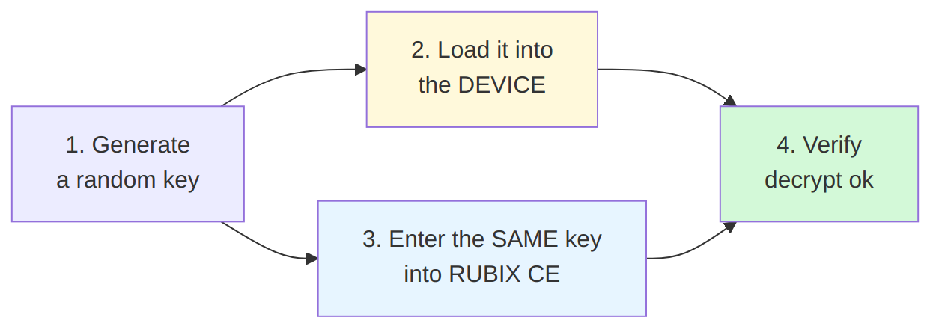
Both halves must use the same key. If they differ, the device goes silent.
Which device you have decides how you load the key:
Device | Chip | How to load the key | Key format
Optical Power Meter | STM32 | AT commands over UART (needs 3.3 V) | plain, no dashes
Droplet V2 | STM32 | AT commands over UART (needs 3.3 V) | plain, no dashes
FGA Gen2 (UART) | ESP32 | console over USB | dashed

0. What you need
Hardware
Device | What to connect
Optical Power Meter / Droplet V2 (STM32) | ST-LINK V3MINIE + UART, both through a 2-in-1 ST-Link + UART module, plus a 3.3 V wire to enter AT mode
FGA Gen2 (ESP32) | a single USB Type-C cable
Software
- A serial terminal at 115200 baud, 8N1 (any: screen, minicom, PuTTY, pyserial).
- STM32_Programmer_CLI - only if you want to verify the STM32 key over SWD.
- Rubix CE - download the binary from the releases page: https://github.com/NubeIO/rubix-ce-builds/releases

1. Generate a key
python3 -c "import secrets; print(secrets.token_bytes(16).hex().upper())"
Example output: A3F91C77E2B4085D6619CC30FA47D2E8
Write it down against the device address (its 8-character ID) before going on.
address | key | tester | date
5CC0D947 | A3F91C77E2B4085D6619CC30FA47D2E8 | |
- ☐ Key generated and recorded

2A. Load the key: Optical Power Meter and Droplet V2 (STM32)
These two boards are the same procedure. Optical Power Meter is shown; Droplet V2 is identical.

2A.1 Wire it up
Connect the ST-LINK and the UART through the 2-in-1 module, and feed 3.3 V into the board - that is what lets it enter AT mode.
Optical Power Meter:
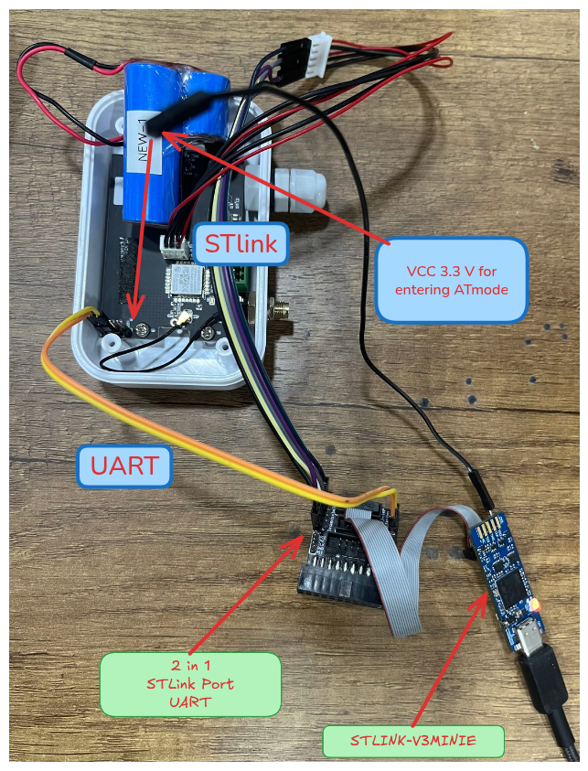
Droplet V2 (same connections):
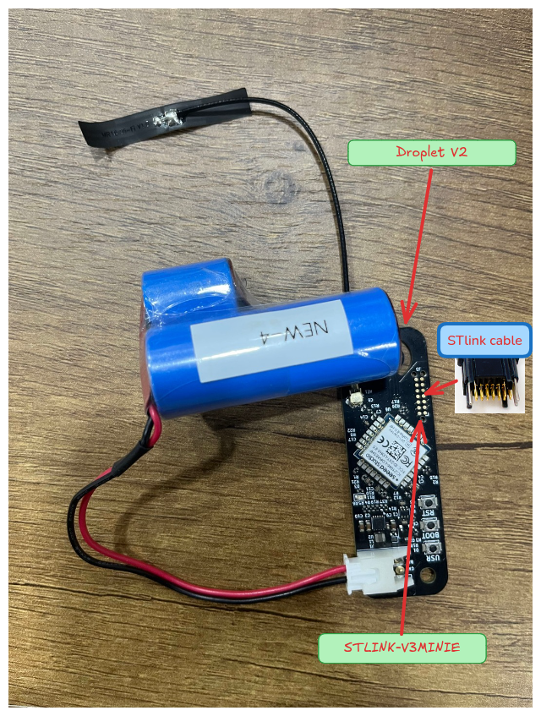
Key points from the photos:
- VCC 3.3 V wire into the board - required to enter AT mode.
- ST-Link to the SWD pads.
- UART to the 2-in-1 ST-Link + UART module.
- The module goes to the STLINK-V3MINIE on USB.
Without the 3.3 V wire the board reads about 1.9 V and will ignore all AT commands. This is the number-one reason "AT does nothing".
- ☐ Wired, 3.3 V applied

2A.2 Enter AT mode and confirm
Open the serial terminal at 115200, reset the board, then:
AT+VER?
+VER: 0.0.1
A reply means you are in AT mode. No reply - check the 3.3 V wire and reset again.
- ☐ AT+VER? replies

2A.3 Read the current key (optional, for the record)
AT+AES?
+AES: 0301021604050F07E6095A0B0C12630F
That value is the shared default key - the device has not been personalised yet.

2A.4 Write the new key, then SAVE
Use the key from step 1, plain hex, no dashes:
AT+AES=A3F91C77E2B4085D6619CC30FA47D2E8
+AES: OK
AT+SAVE
+SAVE: OK
Actual output from a real run (note the flash-write lines around the save):
>>> AT+AES=02F0BC331A1A4348C09D2B71A2E4E564
+AES: OK
+AT: OK
>>> AT+SAVE
[FLASH] Writing config to addr 0x0803C800
[FLASH] Config saved successfully with CRC 0x8C1E7C4F
+SAVE: OK
+AT: OK
Two rules, or the key will not stick:
- AT+SAVE is mandatory. AT+AES= only writes RAM. Skip the save and the key is gone at the next reset.
- Type/send slowly - the parser reads one character at a time. Pasting the whole key too fast drops characters (you see +AE OK instead of +AES: OK). Typing by hand is always slow enough.
The port may drop for a moment during AT+SAVE while flash is written - normal.
- ☐ +AES: OK and +SAVE: OK

2A.5 Read it back
AT+AES?
+AES: A3F91C77E2B4085D6619CC30FA47D2E8
Must match step 1 exactly.
- ☐ Read-back matches

2A.6 (Optional) verify in flash over SWD
The surest check - reads the chip directly, bypassing the console:
STM32_Programmer_CLI -c port=SWD mode=UR -r 0x0803C000 0x2000 /tmp/cfg.bin
python3 - <<'EOF'
d = open('/tmp/cfg.bin','rb').read()
for i, base in enumerate([0, 0x800, 0x1000, 0x1800]):
if int.from_bytes(d[base:base+4],'little') == 0xDEADBEEF:
print("page%d key = %s" % (i, d[base+0x5C:base+0x5C+16].hex().upper()))
EOF
Actual output (this board had been re-keyed twice, so two pages hold records):
page0 key = EBAF6AD648D78403E458F0FE8A91E063
page1 key = 02F0BC331A1A4348C09D2B71A2E4E564
The last page that prints a key is the one in use - here page1, 02F0BC33...E564. It must match step 1.
Skip to section 3.

2B. Load the key: FGA Gen2 (ESP32)

2B.1 Wire it up
Just a USB Type-C cable. No ST-Link, no separate 3.3 V, no AT mode - the console is always available.
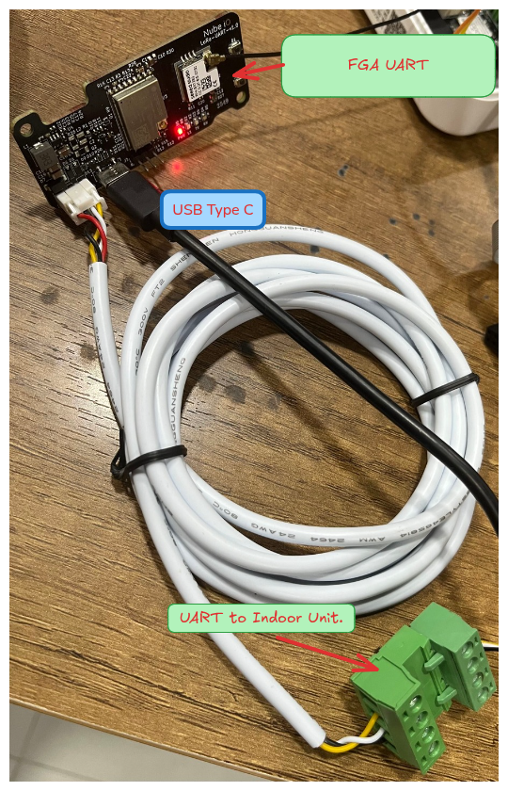
- The USB-C goes to the bench PC.
- The other cable is the UART to the indoor HVAC unit - leave it as-is.
- ☐ USB connected, console reachable at 115200

2B.2 Read the current key
FGA-UART> param_get 0x0220
+ Value : 03-01-02-16-04-05-0F-07-E6-09-5A-0B-0C-12-63-0F
Notice the console prints the key with dashes. That is also how you must enter it.

2B.3 Write the new key - DASHED
Take the key from step 1 and add dashes between every byte:
echo "A3F91C77E2B4085D6619CC30FA47D2E8" | sed 's/../&-/g;s/-$//'
# A3-F9-1C-77-E2-B4-08-5D-66-19-CC-30-FA-47-D2-E8
Then:
FGA-UART> param_set 0x0220 A3-F9-1C-77-E2-B4-08-5D-66-19-CC-30-FA-47-D2-E8
The real error, if you forget the dashes, looks exactly like this (from an actual console session):
FGA-UART> param_set 0x0220 726DCC1E692E6D287704BEEE3CC41095
E (99302) Srvc_Param: Data length of param 0x0220 (11 bytes) is NOT within the allowed range
+ PUC : 0x0220
+ Data type : blob (16 bytes)
+ Old value : 03-01-02-16-04-05-0F-07-E6-09-5A-0B-0C-12-63-0F
11 bytes is the giveaway - the console misread 32 plain characters as 11 bytes. Add the dashes and it accepts them. There is no separate save step.
- ☐ param_set accepted (no length error)

2B.4 Read it back
FGA-UART> param_get 0x0220
+ Value : A3-F9-1C-77-E2-B4-08-5D-66-19-CC-30-FA-47-D2-E8
Must match step 1 (ignoring dashes).
- ☐ Read-back matches

3. Run Rubix CE and enter the key

3.1 Get and run Rubix CE
Download the binary from https://github.com/NubeIO/rubix-ce-builds/releases, then run it:
./Rubix\ CE

3.2 Go to the LoRaRAW device manager
Navigate: Supervisor -> Location -> Group -> Host -> Drivers (Networks) -> Loraraw (Network). The device list opens on the right.
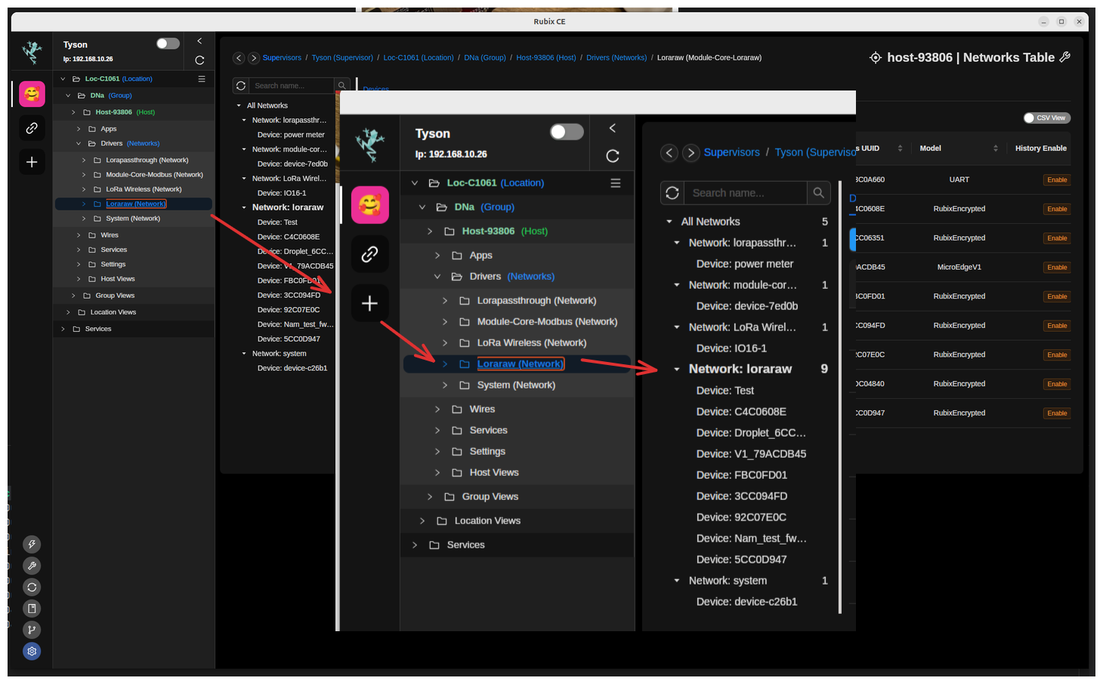
- ☐ LoRaRAW device list open

3.3 Read the Device Key column - shared vs per-device
The Device Key column tells you each device's state at a glance:
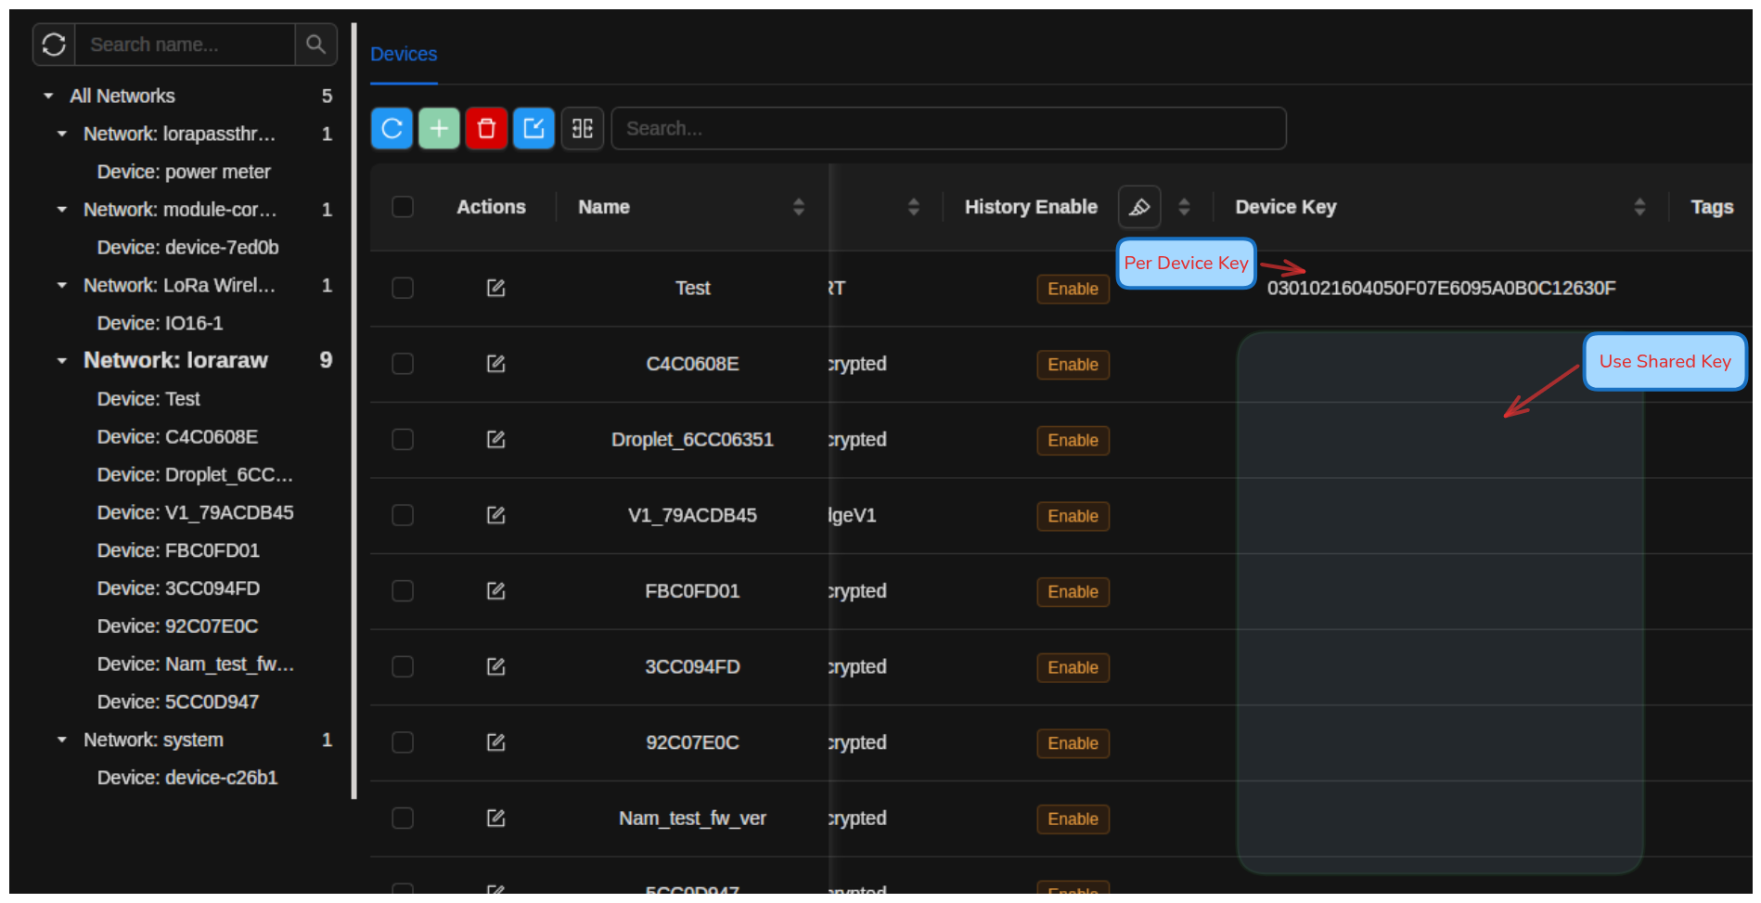
- A key is shown -> that device uses its own per-device key.
- The cell is empty -> that device uses the shared default key.
You can set the key when you add a device, or edit an existing one. Both are below.

3.4 Enter the key when ADDING a device
Click the green + to add a device.
Step 1 - pick the device type. For anything other than the listed Droplets, choose More Options -> View More:
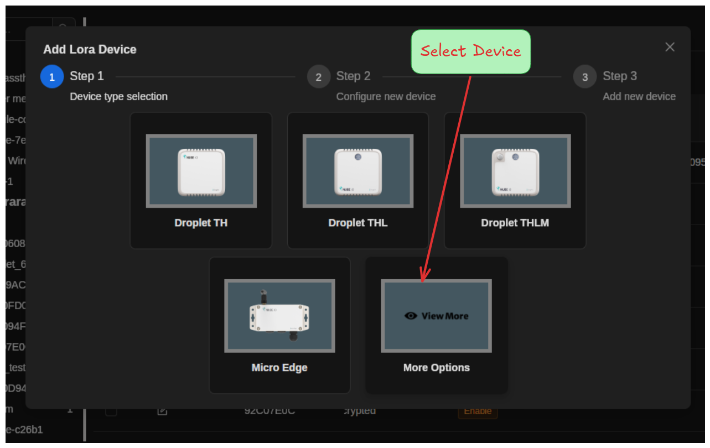
Step 3 - fill the form:
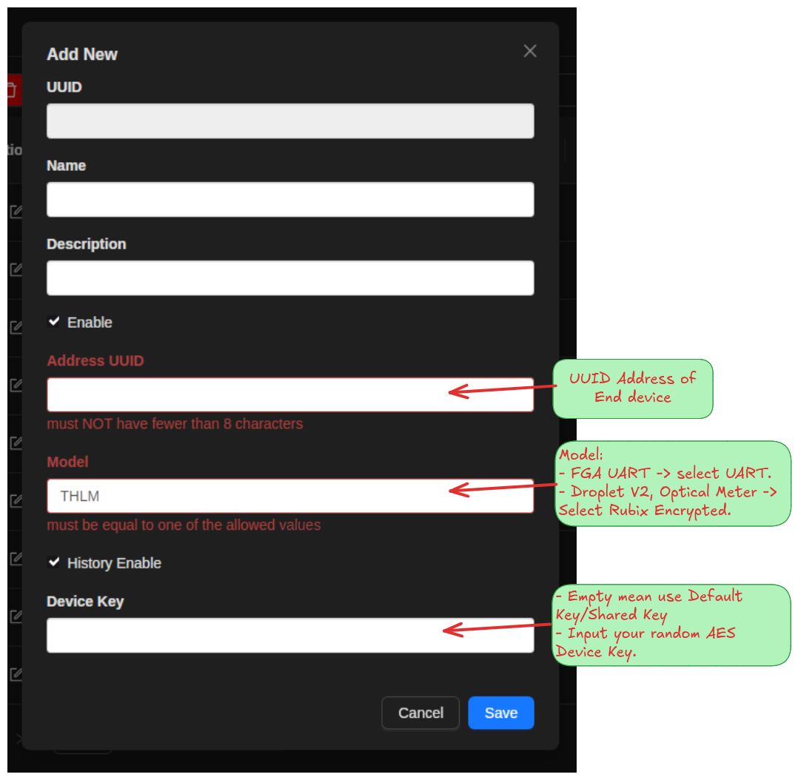
Field | What to enter
Name | any label you like
Address UUID | the device's 8-character address (for example 5CC0D947) - at least 8 characters
Model | FGA Gen2 -> UART. Droplet V2 / Optical Power Meter -> RubixEncrypted
Device Key | paste the key from step 1, plain hex, no dashes. Leave empty to keep using the shared key
Click Save.
- ☐ Device added with the correct Model and Device Key

3.5 Enter the key when EDITING a device
Click the edit (pencil) icon on the device row. Set Device Key, then Save:
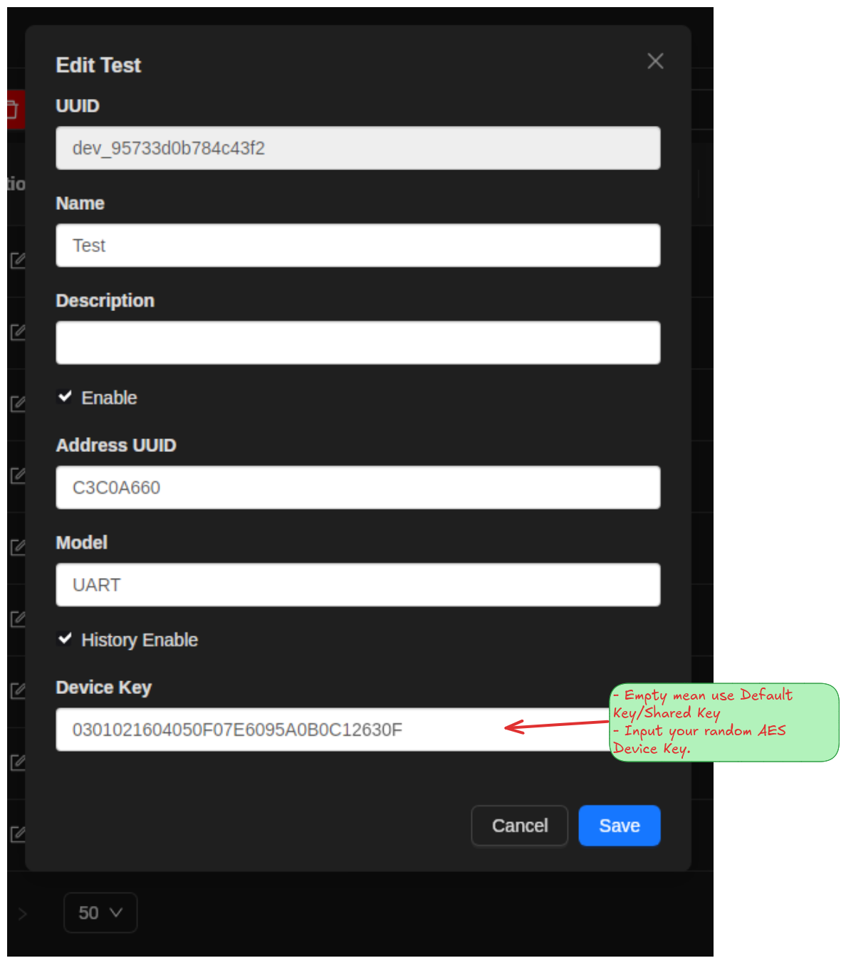
- Device Key field: paste the key (plain hex, no dashes), or clear it to fall back to the shared key.
Reminder: even for an FGA Gen2, the Rubix CE field takes the plain key (no dashes). The dashes are only for the ESP32 console in step 2B.
- ☐ Device Key set and saved

3.6 Confirm the key landed
Back in the list, check the Device Key column for that device:
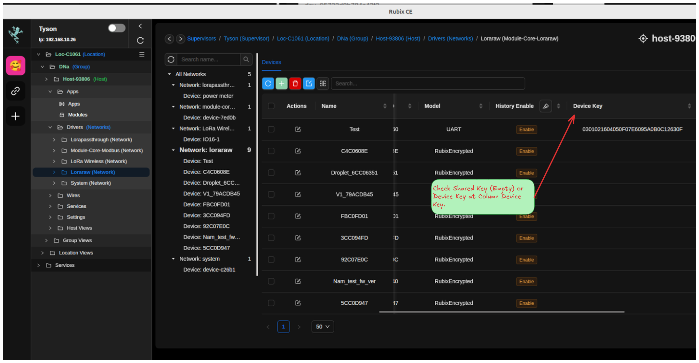
The key you entered should now show in the row (empty means shared key).
- ☐ Device Key column shows the expected value

4. Verify end to end
The real test: does Rubix CE decrypt the device's traffic with the key you set?
Wait for the device to transmit (an Optical Power Meter sends about every 60 seconds by default), then check the log:
ssh <board> 'journalctl -u nubeio-rubix-os.service -f -g "5CC0D947"'
Replace 5CC0D947 with your device address.
Log line | Meaning
LoRaRAW decrypt ok (CMAC valid) address=... | PASS - both ends agree on the key
frame not decryptable and not accepted as plaintext ... incorrect CMAC or Key | FAIL - keys differ, see troubleshooting
nothing for that address | device is not transmitting - check power, antenna, range
A real PASS looks like this - one Optical Power Meter frame from 5CC0D947, copied from an actual run:
handleSerialPayload: enter, networkUUID=net_ad16a71b33f24360,
dataHex=5CC0D947FC524A515FD4227327F6588AA1416DB7F061131F4EC1DE66F6E59AADE0382D4FAD19352F6F05
uplink: 5CC0D947FC524A51...E0382D4FAD19352F6F05
dispatchFrame: decoded address=5CC0D947
dispatchFrame: address=5CC0D947 rssi=-111 snr=1.25 legacyDevice=false
dispatchFrame: LoRaRAW decrypt ok (CMAC valid) address=5CC0D947 decodedLen=40
handleSerialPayload: done for address=5CC0D947 model=RubixEncrypted
mqtt: publishing decoded values ... address=5CC0D947 device=5CC0D947 points=6
payload={"device_address_uuid":"5CC0D947","device_name":"5CC0D947",
"payload":{"UVP-1":60,"UVP-2":3.700000047683716,"UVP-3":0,
"UVP-6":0,"rssi":-111,"snr":1.25}}
Reading it: the address 5CC0D947 is read first, the frame decrypts and passes the CMAC check (decrypt ok), and the four sensor values come out (UVP-1..UVP-6) plus signal quality. That is a fully working device.
The lines failed to find point with address_uuid ... io_number: UVP-1 that may appear are not an encryption problem - decryption already succeeded. The module is just creating points that did not exist yet on first contact. They stop after the first frame.
A real FAIL looks like this - the same device with a mismatched key:
dispatchFrame: decoded address=5CC0D947
dispatchFrame: address=5CC0D947 rssi=-108 snr=4.25 legacyDevice=false
dispatchFrame: matched device model=RubixEncrypted uuid=dev_e69a2c... isLoRaRAW=true
dispatchFrame: LoRaRAW frame not decryptable and not accepted as plaintext
(address=5CC0D947, allowUnencrypted=false, encShaped=true): incorrect CMAC or Key
The address is still read (it is in the clear), but the frame does not decrypt - the key in Rubix CE does not match the key in the device. Go to troubleshooting.
- ☐ Log shows decrypt ok (CMAC valid)

5. Troubleshooting
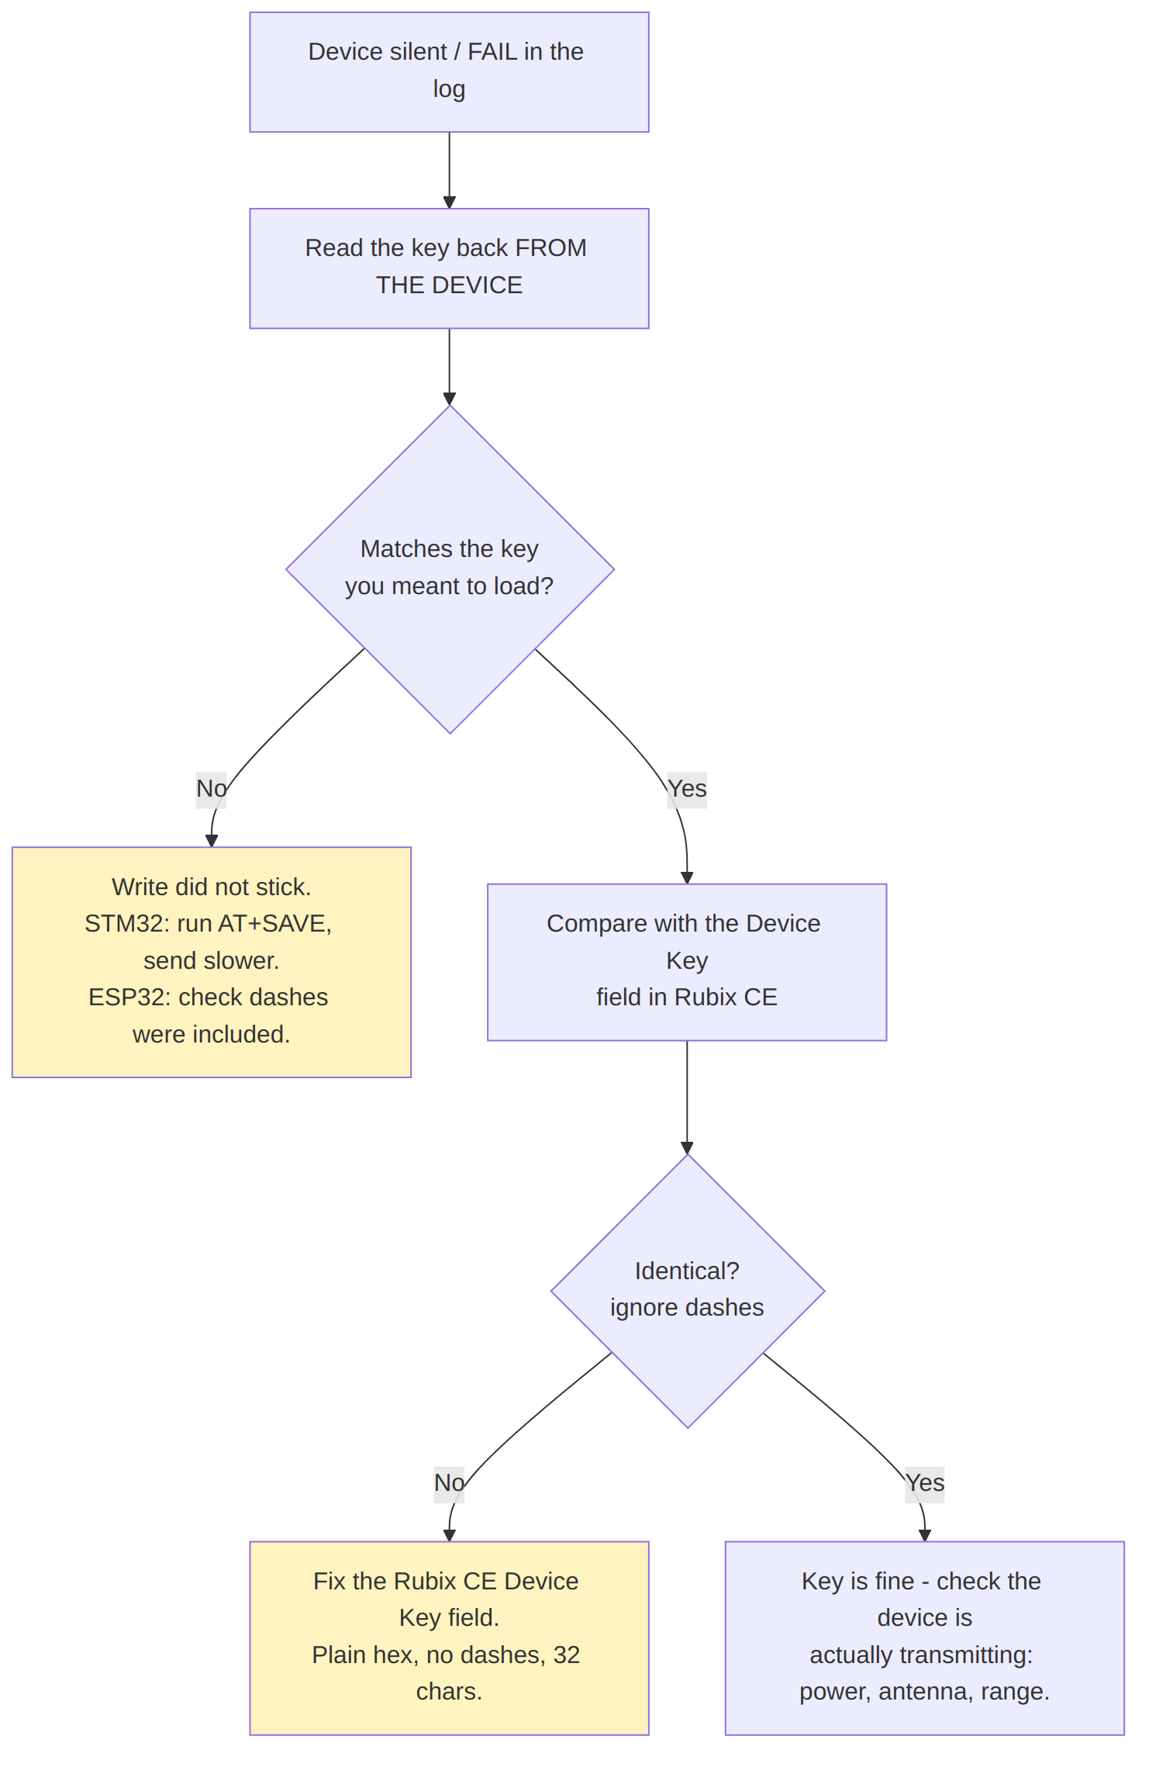
Symptom | Cause | Fix
AT+VER? no reply (STM32) | not in AT mode | apply 3.3 V, reset
+AE OK / truncated reply (STM32) | characters dropped | send slower, ~20-25 ms per char
key reverts after power-cycle (STM32) | forgot AT+SAVE | write again, then AT+SAVE, then read back
Data length ... 11 bytes ... NOT within range (ESP32) | plain hex sent | add dashes: AA-BB-CC-...
Rubix CE shows incorrect CMAC or Key | keys differ | compare device read-back vs the Device Key field
device still shows the shared key 030102...630F | key never changed | redo the load step

6. QA sign-off checklist
Per device:
[ ] 1. Random key generated and recorded against the address
[ ] 2. Key loaded into the device
STM32: AT+AES= then AT+SAVE, plain hex
ESP32: param_set 0x0220 with dashes
[ ] 3. Key read back FROM THE DEVICE and it matches
[ ] 4. Power-cycle the device, read back again (proves it persisted)
[ ] 5. Device added/edited in Rubix CE with correct Model + Device Key
[ ] 6. Rubix CE log shows decrypt ok (CMAC valid)
[ ] 7. Row ticked off in the key register
Rules that always apply:
- One key per device. Never reuse a key across devices.
- Never enter the shared default key as a Device Key - it protects nothing.
- Always read back from the device. A write that silently failed looks exactly like one that worked, until the device goes quiet later.
- Keep the key register. Lose it and the device must be re-keyed by hand.

