Table of Contents

Per-Device Encryption Keys - LoRaRAW
Audience: production and commissioning engineers. Purpose: give every LoRa device its own AES key instead of the one key shared by the whole fleet, and know how to verify it actually took.
Everything here works with module-core-loraraw as shipped. No firmware or module change is required.

Table of contents
- Why this matters
- How AES protects a LoRa packet
  - 2.4 Worked example: one real frame, end to end
- How Rubix CE picks the key
- Key format - the one thing people get wrong
- Generating a key
  - 5.1 The whole procedure at a glance
- Loading a key: Optical Power Meter
- Loading a key: Droplet V2
- Loading a key: FGA Gen2
- Entering the key in Rubix CE
- Verifying it worked
- Troubleshooting
- Production checklist
- Known limitations

1. Why this matters
Every device that has never been re-keyed ships with the same AES key. That key is a compile-time constant in the firmware source, so anyone who reads the source, or who extracts the key from a single device, can decrypt and forge traffic for every device in the field.
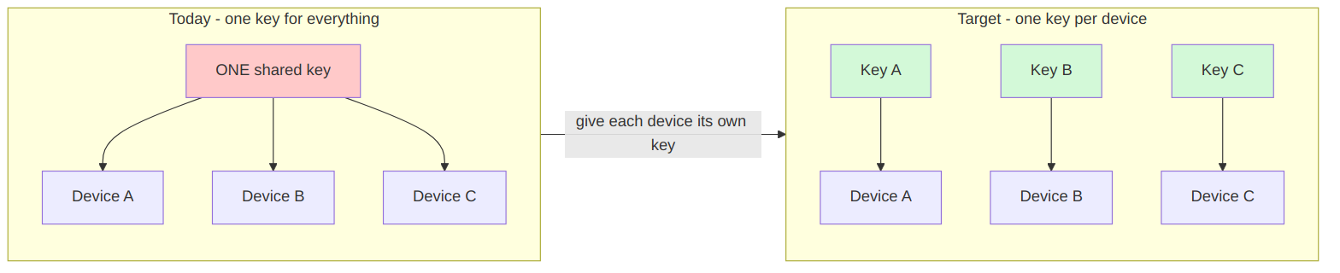
With per-device keys, extracting one device's key exposes that device only.
The job is two steps, and both must be done:
- Load a unique key into the device.
- Enter the same key into Rubix CE, in that device's Device Key field.
Miss either step and the device goes silent, because the two ends no longer agree on the key.

What you need at the bench
Device | Hardware | Power
Optical Power Meter (STM32) | ST-LINK V3 + UART adapter, both broken out by an ICQMCU module | 3.3 V supply - required to enter AT mode
Droplet V2 (STM32) | same as above | 3.3 V supply - required to enter AT mode
FGA Gen2 (ESP32) | plain USB cable | battery or USB, either works
Plus a terminal at 115200 baud, 8N1 on the UART/USB serial port.
The ICQMCU module matters on the STM32 boards because you need SWD and UART at the same time: flash or verify over SWD, talk AT over UART, without unplugging anything in between.

2. How AES protects a LoRa packet

2.1 What a frame looks like on air
The outer frame - what the gateway hands to Rubix CE:
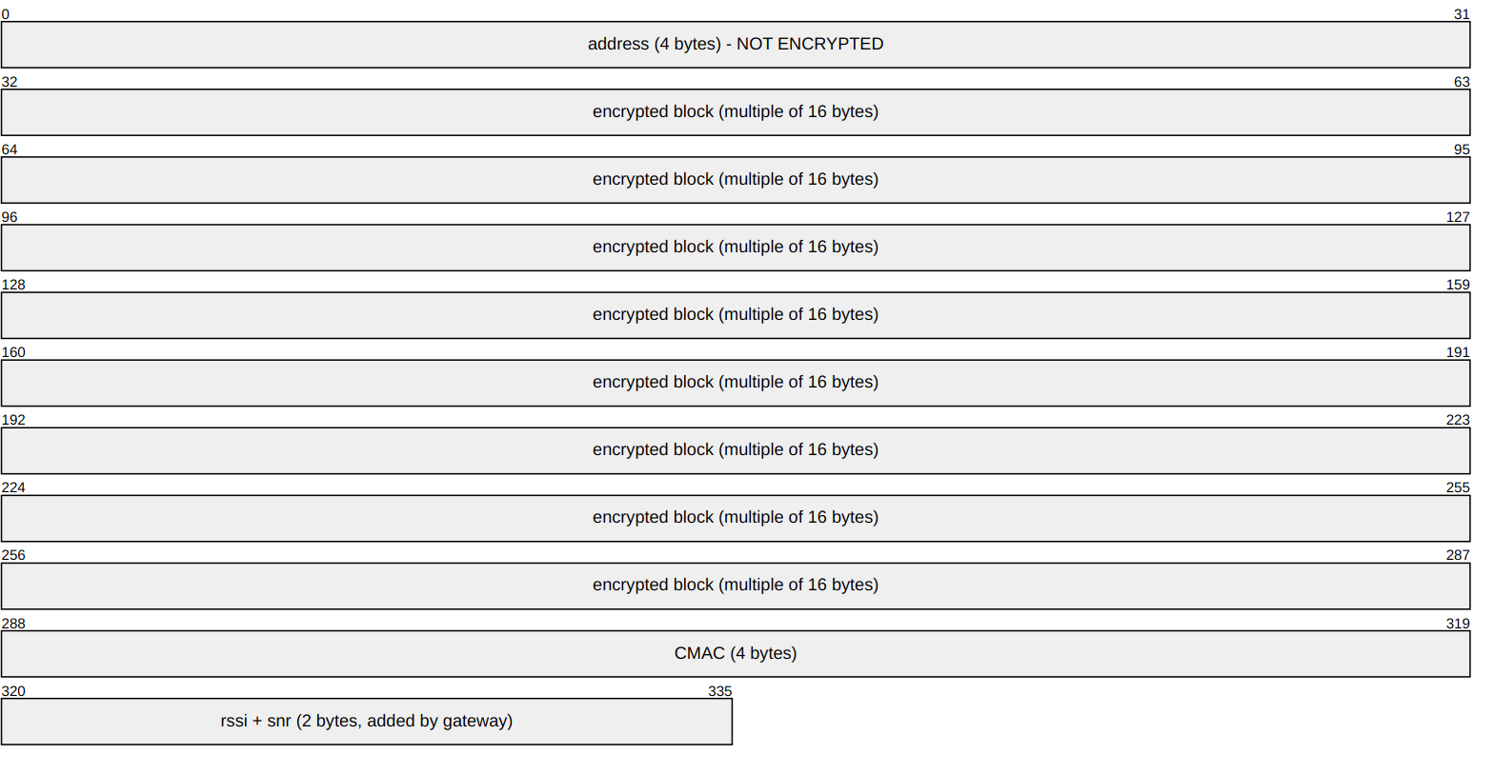
Inside the encrypted block, once decrypted:
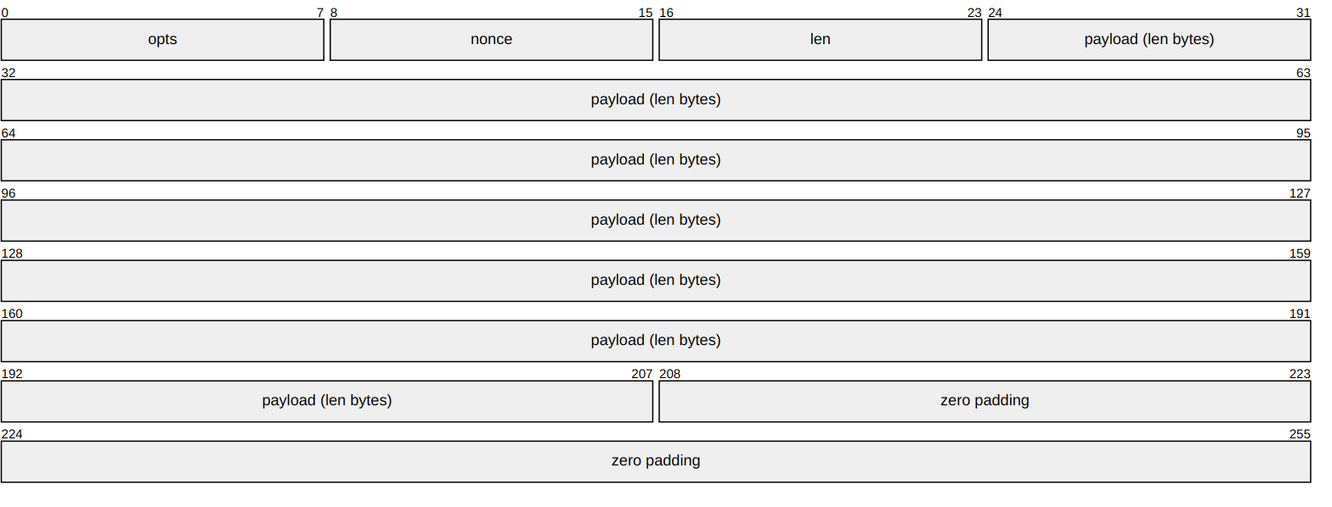
Part | Size | What it is
address | 4 bytes | Device identity. On LoRaRAW devices the second byte is always C0 - see 2.1.1. The other three come from the chip's unique ID or MAC
opts | 1 byte | Frame type: 0 uplink, 1 confirmed uplink, 2 ack, 3 request, 4 response
nonce | 1 byte | Message counter, used to match a reply to a request
len | 1 byte | Length of the real payload, so padding can be removed
payload | len bytes | The sensor data
padding | 0-15 bytes | Zeros, to reach a whole 16-byte AES block
CMAC | 4 bytes | Tamper check computed over address + encrypted part
rssi, snr | 2 bytes | Signal quality, added by the gateway radio board

2.1.1 Why every address has C0 in it
Take the address from the worked example below:
5C C0 D9 47
| | | |
| | | +-- from the chip's unique ID
| | +------- from the chip's unique ID
| +------------ ALWAYS C0 - the protocol version marker
+----------------- from the chip's unique ID
The second byte is not part of the device identity. It is a fixed protocol version marker that every firmware writes into the same position:
- module-core-loraraw: LORARAW_VERSION = 0xC0, LORARAW_VERSION_POSITION = 1 (positions counted from 0, so position 1 is the second byte)
- Optical Power Meter and Droplet V2: (VERSION << 16) in GenerateMAC4()
- FGA Gen2: addr[1] = 0xC0 in generateAddressUnique()
Two practical consequences:
- Every LoRaRAW device has C0 as its second byte - Optical Power Meter, Droplet V2 and FGA Gen2 all do. If one of those does not, suspect a typo.
- Only 3 bytes carry identity, not 4. That is 16.7 million combinations rather than 4.3 billion. Still far more than any single site needs, but worth knowing when you assign or audit addresses.
One exception you will meet in the field. Older MicroEdge units predate this convention and use a different address scheme, so their addresses do not carry C0. A real example from a live site:
5CC0D947 Optical Power Meter second byte C0 - LoRaRAW
C3C0A660 FGA Gen2 second byte C0 - LoRaRAW
79ACDB45 MicroEdge V1 second byte AC - legacy, not LoRaRAW
Legacy MicroEdge devices are outside the scope of this guide: they encrypt the whole frame including the address, so Rubix CE cannot read the address before decrypting and cannot give them a per-device key at all. They stay on the shared key until the hardware is replaced.
Careful with the wording "byte 1": the Go module counts from 0, the STM32 firmware comments count from 1, and they mean the same byte. This document says "the second byte" to avoid the ambiguity.

2.2 The important detail
The address is not encrypted. It has to stay readable, because the receiver must know which device sent the frame before it can choose which key to try.
That is exactly what makes per-device keys possible without changing the radio protocol at all.
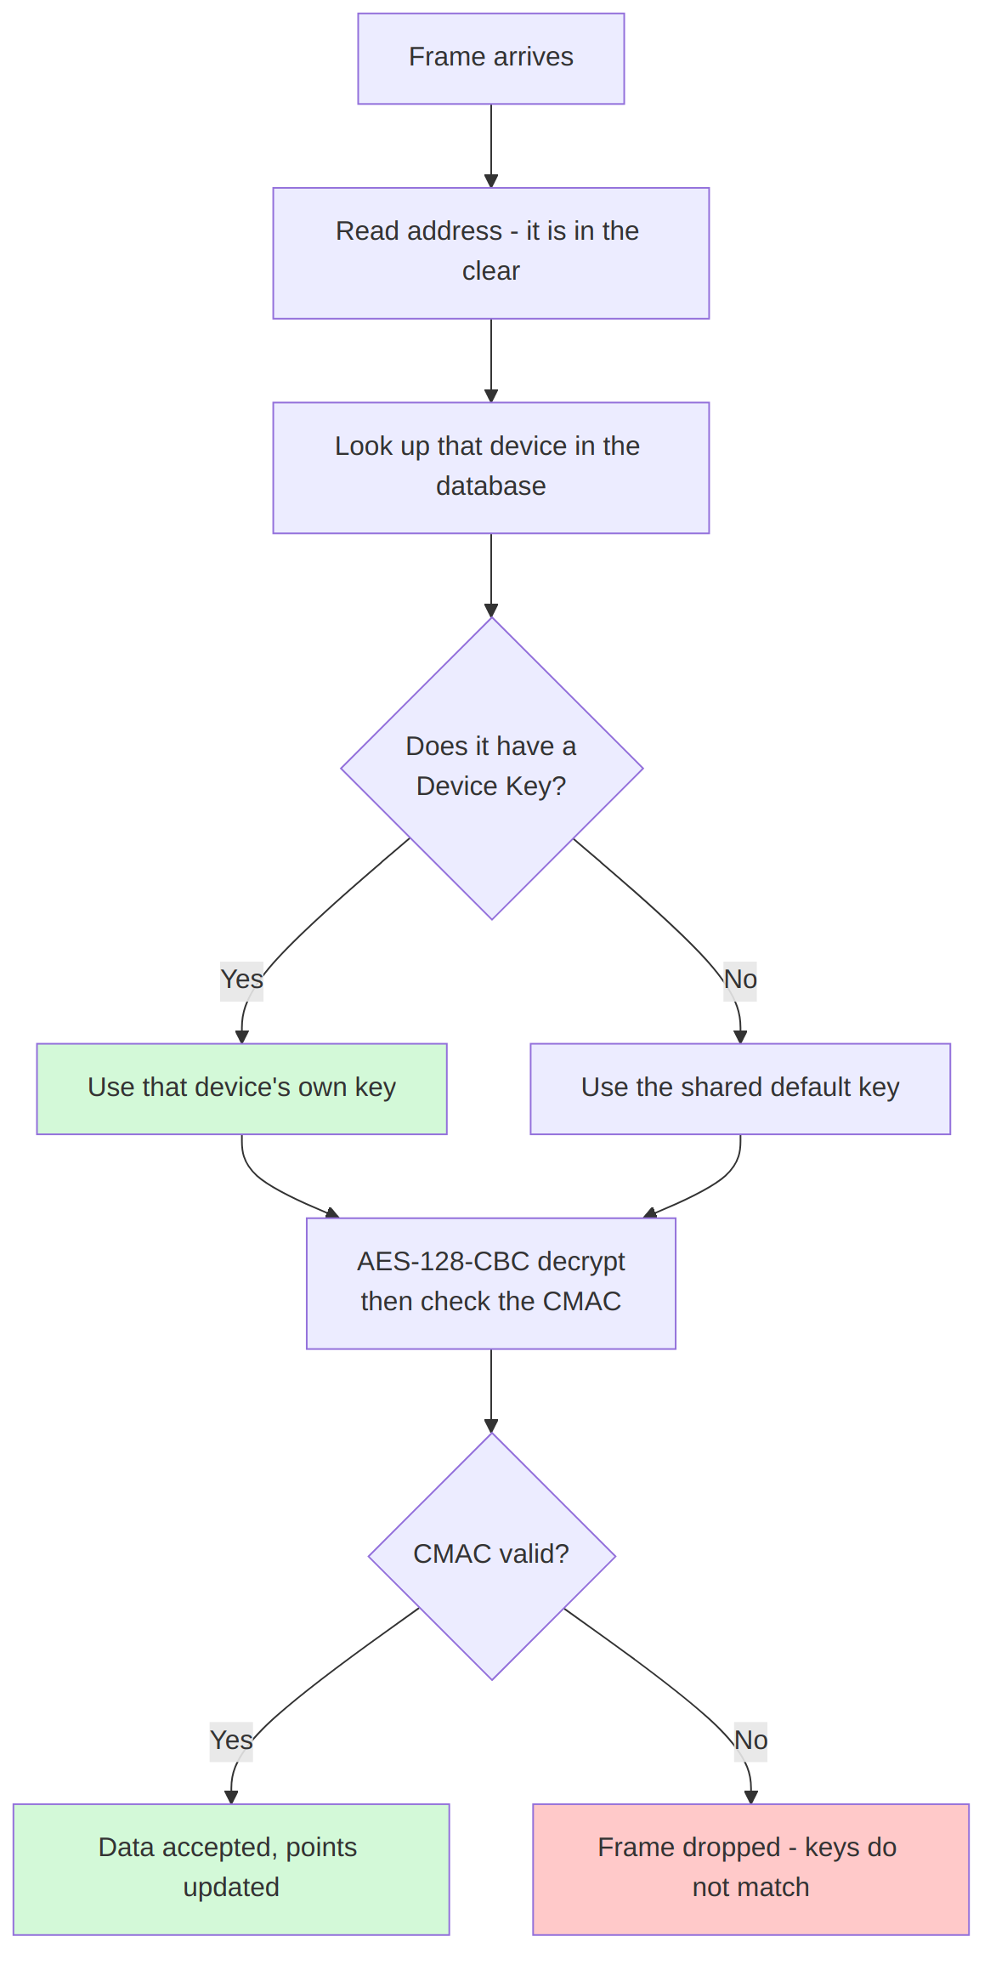

2.3 Encrypting and decrypting, step by step
Device sending:
- Build the inner block: opts | nonce | len | payload
- Pad with zeros up to a multiple of 16 bytes
- Encrypt that block with AES-128-CBC using the device's key
- Compute a CMAC over address + encrypted block, keep the first 4 bytes
- Transmit address + encrypted block + CMAC
Rubix CE receiving:
- Strip the 2 trailing rssi/snr bytes added by the gateway
- Read the 4-byte address, look up the device, fetch its key
- Recompute the CMAC and compare with the received 4 bytes
- If it matches, decrypt and use len to strip the padding
- If it does not match, drop the frame
The CMAC is what tells CE "this key is correct". A wrong key fails the CMAC check, so a bad key never produces garbage data - it produces no data at all.

2.4 Worked example: one real frame, end to end
This section follows a single genuine frame from device 5CC0D947 all the way through: how the device builds it, what goes on air, and how Rubix CE takes it apart again. Every value below is copied from a real bench run.

Part A - the device builds and sends the frame
A1. Collect the readings. The Optical Power Meter firmware packs four datapoints, each at a fixed position:
Position | Value | What it is | Source
UVP-1 | 60 | transmit interval, seconds | RAM_Config.tdc_s
UVP-2 | 3.7 | battery voltage | ADC reading
UVP-3 | 0 | packet counter | packet_id_counter
UVP-6 | 0 | optical pulse count | LPTIM counter
A2. Bit-pack them into a payload. The Rubix encoder writes a one-byte position header before each value, then the value itself in a fixed-point or raw form. The result here is 23 bytes:
01A08000F284C968A200000000A5900000000000000000
A3. Add the inner header. Three bytes go in front: frame type, message counter, payload length.
01 opts = confirmed uplink
21 nonce = 33 (this device's 33rd message since boot)
17 len = 23 (the payload above)
A4. Pad to a whole AES block. 3 + 23 = 26 bytes, which is not a multiple of 16, so 6 bytes of padding bring it to 32. The padding content does not matter - len is what tells the receiver where the real data ends.
A5. Encrypt with the device's key, then sign. AES-128-CBC over those 32 bytes, then a CMAC over address + ciphertext, truncated to 4 bytes.
A6. Transmit address + ciphertext + CMAC. The gateway appends rssi and snr on arrival, and Rubix CE sees the result as one hex line.
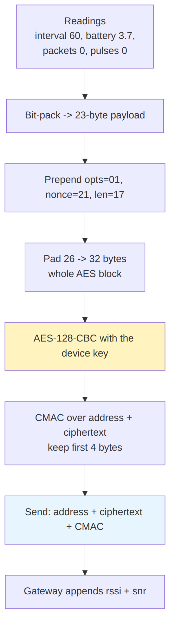

Part B - Rubix CE receives and takes it apart
B1. The frame arrives. From the log:
msg="handleSerialPayload: enter, networkUUID=net_ad16a71b33f24360,
dataHex=5CC0D947FC524A515FD4227327F6588AA1416DB7F061131F4EC1DE66F6E59AADE0382D4FAD19352F6F05"
84 hex characters = 42 bytes.
B2. Split it, working from both ends inwards. The address is always the first 4 bytes; the last 6 are always CMAC (4) plus rssi/snr (2).
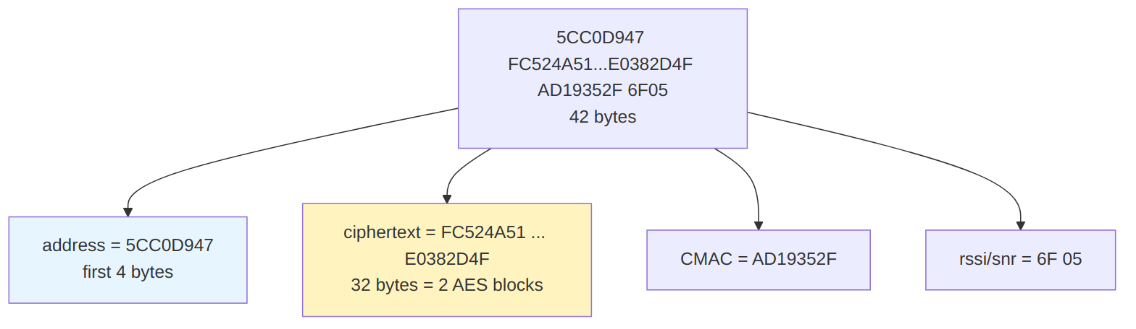
Field | Value
address | 5CC0D947
ciphertext | FC524A515FD4227327F6588AA1416DB7F061131F4EC1DE66F6E59AADE0382D4F
CMAC | AD19352F
rssi, snr | 6F, 05
Sanity check: 32 bytes of ciphertext is a multiple of 16. Good.
B3. Read the address and signal quality - no key needed. The log line confirms both:
msg="dispatchFrame: decoded address=5CC0D947"
msg="dispatchFrame: address=5CC0D947 rssi=-111 snr=1.25 legacyDevice=false"
- address 5CC0D947 - second byte C0 as always, so 5C, D9, 47 are the identity bits
- rssi 0x6F = 111, negated = -111 dBm
- snr 0x05 = 5, divided by 4 = 1.25 dB
This is the step that makes per-device keys work: CE knows which device sent the frame before it needs any key at all.
B4. Look up the device, fetch its key, decrypt.
python3 - <<'PYEOF'
from cryptography.hazmat.primitives.ciphers import Cipher, algorithms, modes
FRAME = "5CC0D947FC524A515FD4227327F6588AA1416DB7F061131F4EC1DE66F6E59AADE0382D4FAD19352F6F05"
KEY = "0301021604050F07E6095A0B0C12630F" # this device's key, plain (no dashes)
f = bytes.fromhex(FRAME)
ct = f[4:-6] # drop address (4) and cmac+rssi+snr (6)
d = Cipher(algorithms.AES(bytes.fromhex(KEY)), modes.CBC(b"\x00" * 16)).decryptor()
pt = d.update(ct) + d.finalize()
print("plaintext:", pt.hex().upper())
print("opts =", pt[0], " nonce =", pt[1], " len =", pt[2])
print("payload :", pt[3:3 + pt[2]].hex().upper())
PYEOF
plaintext: 01211701A08000F284C968A200000000A5900000000000000000324D468C5AEB
opts = 1 nonce = 33 len = 23
payload : 01A08000F284C968A200000000A5900000000000000000
Compare with Part A: opts=01, nonce=21 hex = 33, len=17 hex = 23, and the same 23-byte payload the device packed. The frame has been recovered exactly.
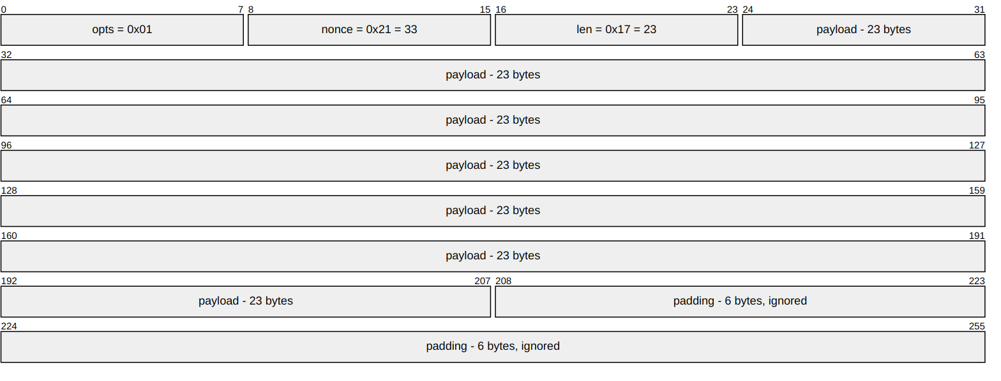
The 6 padding bytes here are 324D468C5AEB, not zeros. That is fine and expected - whatever happened to be in the buffer gets encrypted along with the data, and len is what marks where the real payload ends.
The module logs the same conclusion:
msg="dispatchFrame: LoRaRAW decrypt ok (CMAC valid) address=5CC0D947 decodedLen=40"
B5. Decode the payload into datapoints. The codec unpacks the 23 bytes back into the four values the device measured, and publishes them:
msg="mqtt: publishing decoded values ... address=5CC0D947 points=6"
payload={"device_address_uuid":"5CC0D947","device_name":"5CC0D947",
"payload":{"UVP-1":60,"UVP-2":3.700000047683716,"UVP-3":0,
"UVP-6":0,"rssi":-111,"snr":1.25}}
Round trip complete - these are the same readings from step A1:
Point | Value received | Value sent (A1)
UVP-1 | 60 | transmit interval, 60 s
UVP-2 | 3.7000000476837 | battery, 3.7 V (float rounding)
UVP-3 | 0 | packet counter
UVP-6 | 0 | optical pulses
rssi | -111 | added by the gateway
snr | 1.25 | added by the gateway
B6. Cross-check against the republished frame. The module also publishes the decrypted frame on MQTT, which is a free way to confirm your own decryption:
msg="mqtt: publishing topic=module-core-loraraw/raw bytes=64
payload=5CC0D94701211701A08000F284C968A200000000A59000000000000000006F05"
Line that up against what we decrypted:
5CC0D947 01 21 17 01A08000F284C968A200000000A5900000000000000000 6F05
address opts payload (23 bytes) rssi
nonce snr
len
Identical. If your manual decryption produces this, the key is right.

What a wrong key looks like
Run the same script with a different key and you get:
plaintext: 3B95412ED51B8D9C30253231FF16EF63CB0246200F065D17A5A3CC96FD242618
opts = 59 nonce = 149 len = 65 -> nonsense
opts must be 0-4 and len cannot exceed the block, so both are out of range. In the real module the CMAC check rejects the frame before it ever gets this far, and the log shows the frame being dropped instead of decoded.
This is the practical technique for finding out which key a silent device is really using: capture one frame, try the key you expect and the shared default key, and see which one yields a sane opts and len.
Note on the log lines failed to find point with address_uuid ... io_number: UVP-1: those are unrelated to encryption. Decryption already succeeded - the module is simply creating points that did not exist yet on first contact.

3. How Rubix CE picks the key
One field decides everything: Device Key in the device form.
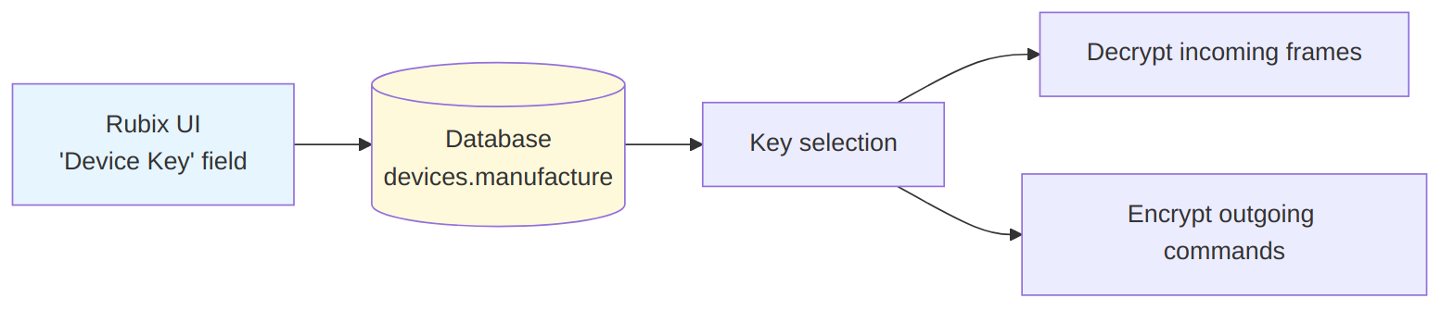
The rule, in plain terms:
- Device Key filled in - that key is used for this device, both directions.
- Device Key empty - the shared default key is used.
Filling the field is the only thing needed on the CE side. There is no separate "enable encryption" switch, and no restart required.

4. Key format - the one thing people get wrong
A key is 16 bytes, written as 32 hex characters. The two device families want that written differently, and one will reject the other's format.
Where | Format | Example
Optical Power Meter (STM32) | plain AES key (without dashes) | A3F91C77E2B4085D6619CC30FA47D2E8
Droplet V2 (STM32) | plain AES key (without dashes) | A3F91C77E2B4085D6619CC30FA47D2E8
FGA Gen2 (ESP32) | dashed AES key | A3-F9-1C-77-E2-B4-08-5D-66-19-CC-30-FA-47-D2-E8
Rubix CE "Device Key" field | plain AES key (without dashes) | A3F91C77E2B4085D6619CC30FA47D2E8
It is the same key in every row - only the way it is typed differs.
If you send a plain AES key (without dashes) to an FGA Gen2 you get:
E Srvc_Param: Data length of param 0x0220 (11 bytes) is NOT within the allowed range
The console counts bytes assuming dashes are present, so 32 plain characters are misread as 11 bytes and rejected.
Converting between the two:
KEY=A3F91C77E2B4085D6619CC30FA47D2E8
# plain AES key (without dashes) -> dashed AES key, for FGA Gen2
echo "$KEY" | sed 's/../&-/g;s/-$//'
# A3-F9-1C-77-E2-B4-08-5D-66-19-CC-30-FA-47-D2-E8
# dashed AES key -> plain AES key (without dashes), for STM32 and the Rubix UI
echo "A3-F9-1C-77-E2-B4-08-5D-66-19-CC-30-FA-47-D2-E8" | tr -d '-'
# A3F91C77E2B4085D6619CC30FA47D2E8

5. Generating a key
Use a random generator. Do not invent keys by hand, do not use a pattern, and do not reuse one key across devices.
python3 -c "import secrets; print(secrets.token_bytes(16).hex().upper())"
Record the key against the device's address (its 8-character ID) before moving on. You will need it again when entering it in Rubix CE, and if the record is lost the device must be re-keyed from scratch.
Suggested record format:
address | key | date | operator
5CC0D947 | A3F91C77E2B4085D6619CC30FA47D2E8 | 2026-08-26 | <name>

5.1 The whole procedure at a glance
Before the per-device detail in sections 6 to 9, here is the entire flow in one picture. The branch in the middle is the only part that differs between device families.
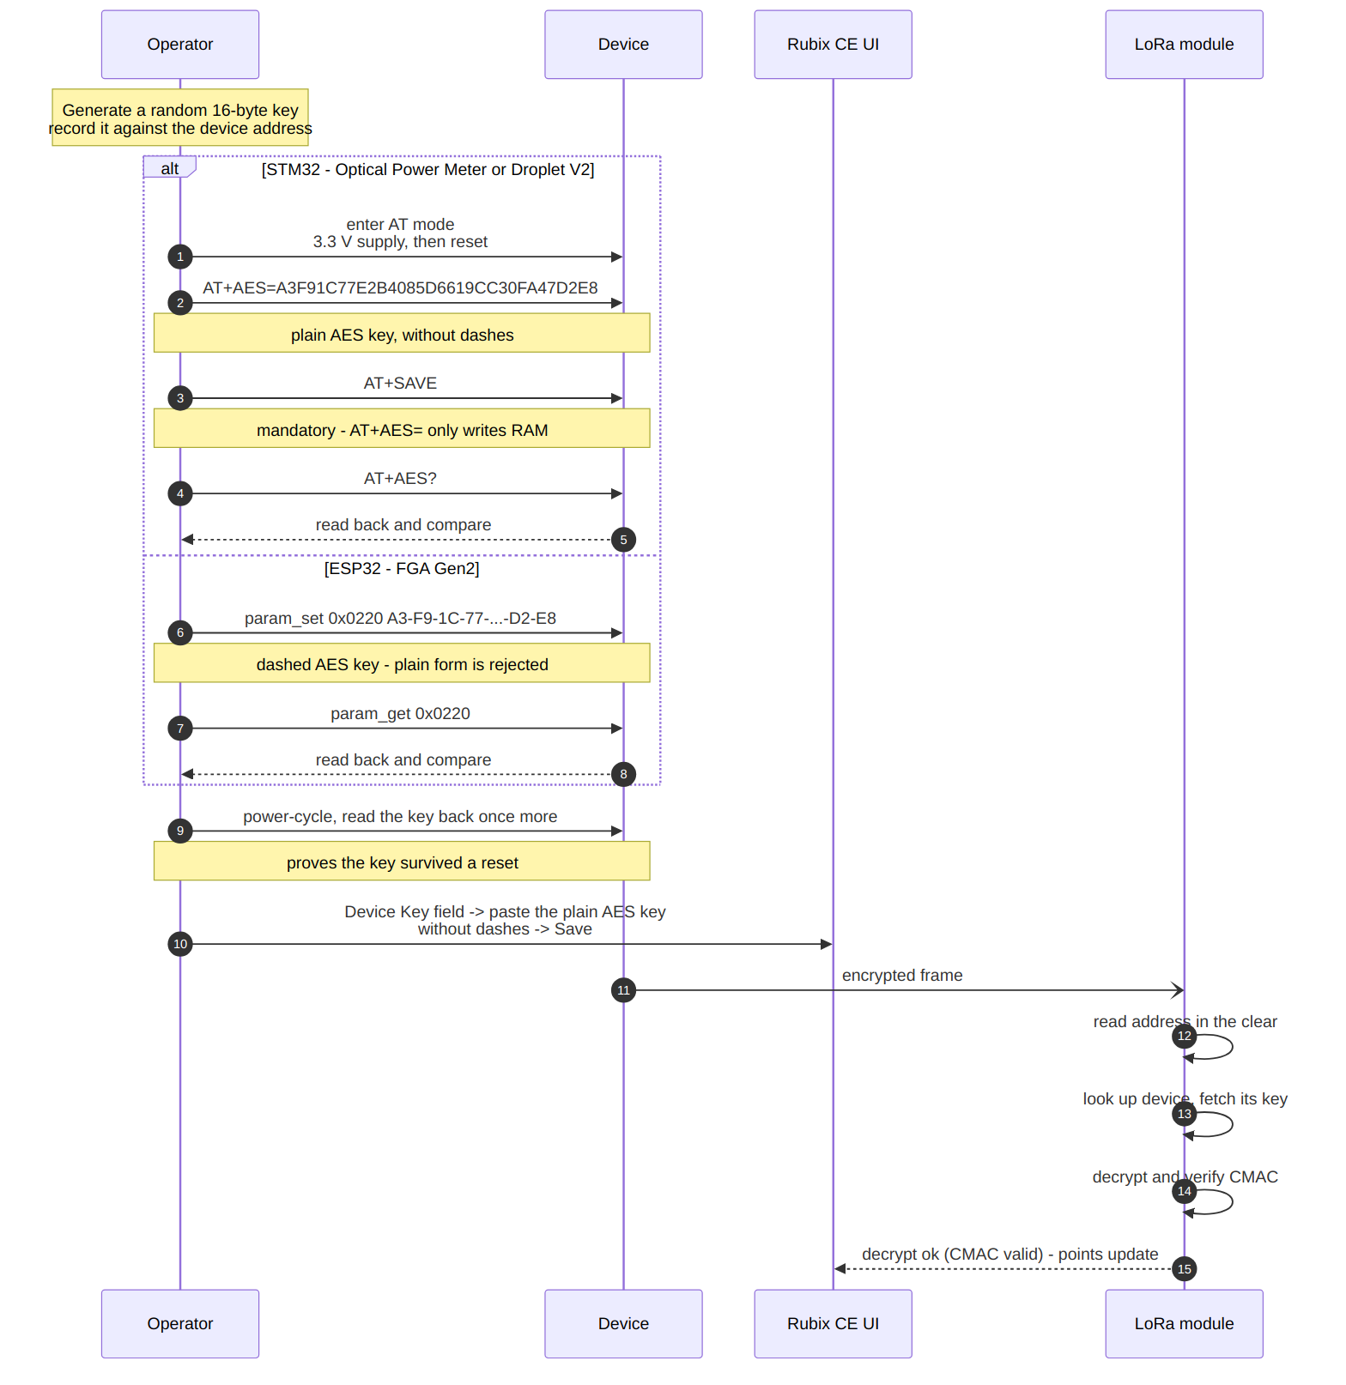
Two things to take from this diagram:
- The device and Rubix CE are updated separately. Between the AT commands and saving the Device Key field, the device is unreachable. That gap is expected - close it promptly rather than leaving a unit half-configured.
- The read-back steps are not optional. They are the only way to tell a write that took from one that silently did not.

6. Loading a key: Optical Power Meter (STM32)

6.1 Bench setup and wiring
You need two links to the board at the same time:
Link | Used for | Hardware
SWD | flashing firmware, reading flash to verify | ST-LINK V3
UART | AT commands, boot log | UART adapter, 115200 baud, 8N1
An ICQMCU adapter module exposes both the ST-LINK port and the UART port at once, so you do not have to unplug one to use the other. That matters here because the normal sequence is: flash over SWD, then immediately talk AT over UART, then read flash back over SWD to confirm.
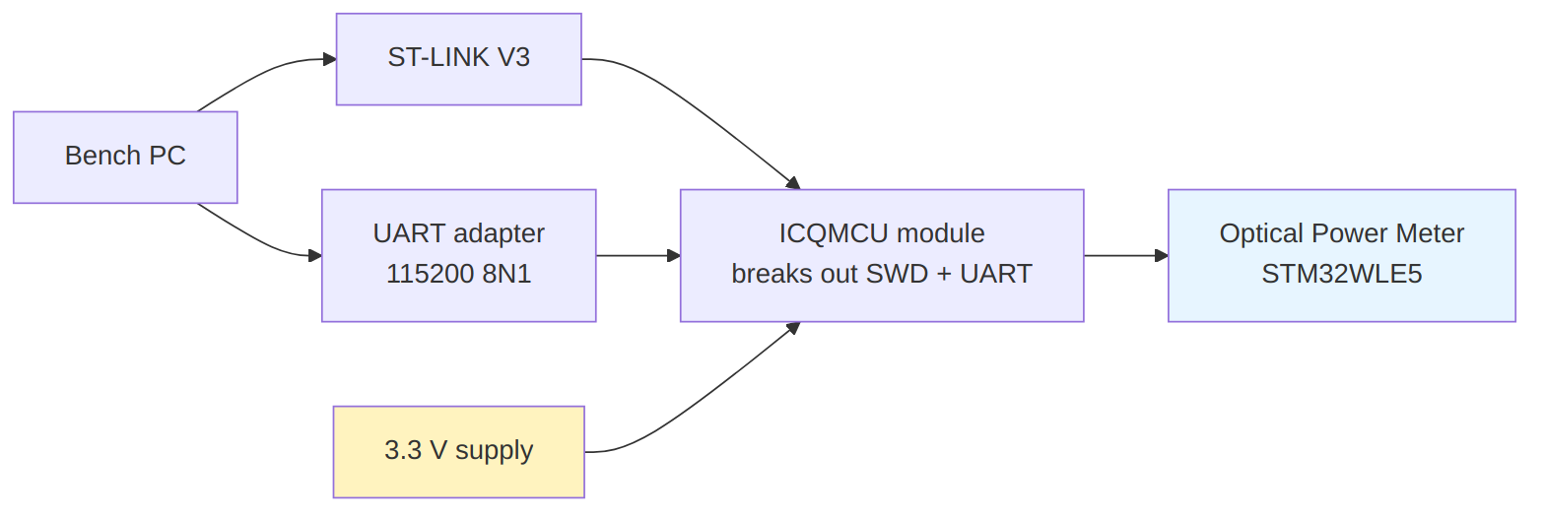
Power the board from a 3.3 V supply, not from its battery. The reason is in 6.2 - on battery the board will refuse to enter AT mode.

6.2 Enter AT command mode
The firmware only checks for AT mode once, at startup, and only enters it when the supply rail reads above 2900 mV (if (vref > 2900 && !vout_sel) in Core/Src/main.cpp).
A battery-powered board reads around 1930 mV, which is below that threshold, so AT commands are ignored no matter what you type. This is the single most common reason "the AT commands do nothing".
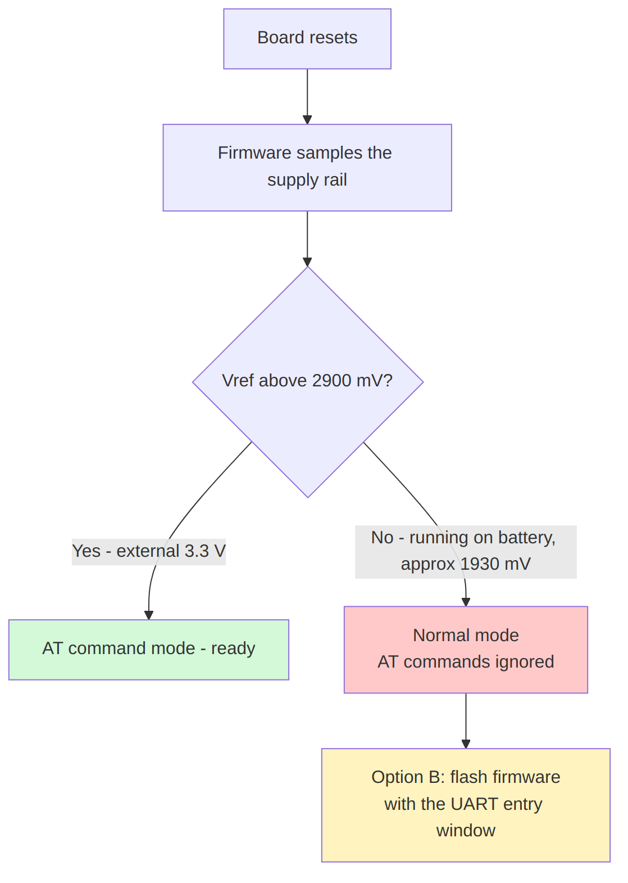
There are two ways to get in. Pick one.

Option A - power the board at 3.3 V (recommended for production)
Feed the board from a 3.3 V bench supply through the ICQMCU module instead of the battery, then reset it. Nothing needs to be flashed, and the shipping firmware is used unchanged. This is the intended production path.

Option B - flash firmware that can enter AT mode on battery
If the board must stay on battery - for example a unit already assembled that you do not want to open up - flash the firmware from the feat/debug-print-aes-key branch of the optical-power-meter repository (commit aeb725a, "allow entering AT mode over UART on battery power").
That build adds a 3-second window after reset during which any character on UART enters AT mode, whatever the supply voltage reads. The 3.3 V check is still tried first, so the production path in Option A is unaffected.
To use it: reset the board, then send characters continuously for a few seconds. A single keypress is easily missed, because the firmware reads one character at a time. Holding Enter down, or letting a script send \r every 50 ms, both work.
Option B is bench tooling. Ship devices with the standard firmware.

6.3 Confirm you are in AT mode
AT+VER?
+VER: 0.0.1
No reply means you are not in AT mode:
- On Option A - check the board is on 3.3 V, not battery, and reset again.
- On Option B - reset and send characters faster, or for longer.

6.4 Read the current key (optional, useful for records)
AT+AES?
+AES: 0301021604050F07E6095A0B0C12630F
That value is the shared default key. Anything else means the device already has its own key.

6.5 Write the new key
AT+AES=A3F91C77E2B4085D6619CC30FA47D2E8
+AES: OK
AT+SAVE
+SAVE: OK
Two rules that cause most failures:
AT+SAVE is mandatory. AT+AES= only writes RAM. Without AT+SAVE the key is lost at the next reset and the device silently returns to its old key.
Type or send the command slowly. The firmware reads one character at a time. If a script sends the 32-character key as one burst, characters are lost and you see a truncated reply such as +AE OK. Around 20-25 ms per character is reliable. Typing by hand is always slow enough.
The serial port may briefly disconnect during AT+SAVE while the chip writes flash. That is normal.

6.6 Read it back
AT+AES?
+AES: A3F91C77E2B4085D6619CC30FA47D2E8
Must match exactly what you intended to load. If it does not, repeat 6.5 more slowly.

7. Loading a key: Droplet V2 (STM32)
Droplet V2 uses the same chip family (STM32WLE5) and the same AT command set as the Optical Power Meter. Follow section 6 exactly - same wiring (ST-LINK V3 + UART through an ICQMCU module), same 3.3 V supply requirement to reach AT mode, same commands, same plain AES key (without dashes), same mandatory AT+SAVE.
Quick reference:
AT+VER? confirm AT mode
AT+AES? read current key
AT+AES=A3F91C77E2B4085D6619CC30FA47D2E8 write new key (plain, no dashes)
AT+SAVE persist to flash - REQUIRED
AT+AES? read back and compare

8. Loading a key: FGA Gen2 (ESP32)
Wiring: a single USB cable, 115200 baud. The ESP32-C3 exposes a USB serial port directly, so no ST-LINK, no UART adapter and no ICQMCU module are needed.
Easier than the STM32 boards in one way: the console is always available. There is no AT mode to enter, and no 3.3 V supply requirement - it works on battery.
Harder in another: the key must be the dashed form.

8.1 Read the current key
FGA-UART> param_get 0x0220
+ Data type : blob (16 bytes)
+ Value : 03-01-02-16-04-05-0F-07-E6-09-5A-0B-0C-12-63-0F
Note the console prints the dashed AES key. That is also how it must be entered here.

8.2 Write the new key
FGA-UART> param_set 0x0220 A3-F9-1C-77-E2-B4-08-5D-66-19-CC-30-FA-47-D2-E8
The parameter is stored immediately - there is no separate save command.

8.3 Read it back
FGA-UART> param_get 0x0220
+ Value : A3-F9-1C-77-E2-B4-08-5D-66-19-CC-30-FA-47-D2-E8
Remember: when you type this same key into Rubix CE later, remove the dashes.

9. Entering the key in Rubix CE
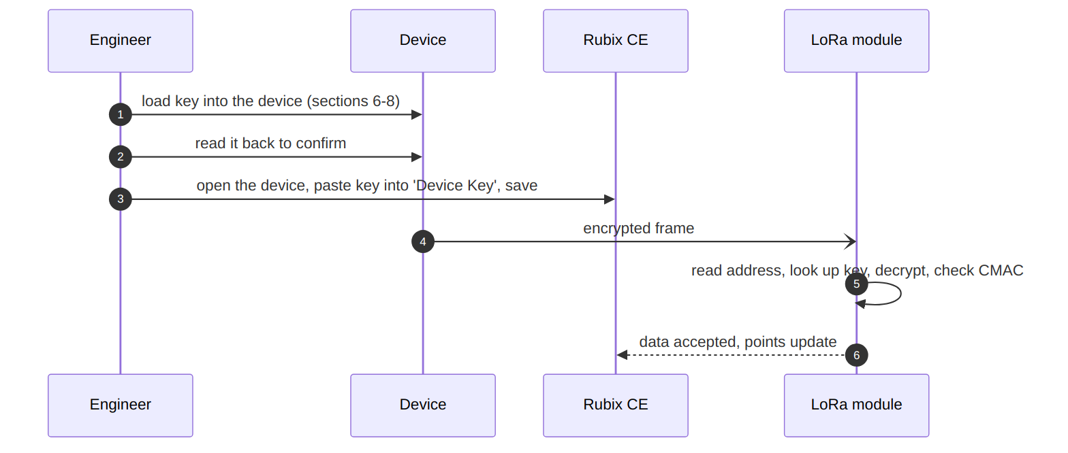
Steps:
- Open Rubix CE, find the device by its address (for example 5CC0D947).
- Edit the device. The form has a Device Key field.
- Paste the plain AES key (without dashes) - 32 characters.
- Save.
The change takes effect on the next frame the device sends. No restart needed.
If the device is an FGA Gen2 and you copied the key from param_get, strip the dashes first - see section 4.

10. Verifying it worked
Do not assume it worked because no error appeared. Wait for the device to send its next frame, then check the log:
ssh <board> 'journalctl -u nubeio-rubix-os.service -f -g "5CC0D947"'
Replace 5CC0D947 with the device's address.
What you see | What it means
dispatchFrame: LoRaRAW decrypt ok (CMAC valid) address=... | Success. Both ends agree on the key
frame not decryptable and not accepted as plaintext ... incorrect CMAC or Key | Keys differ. See troubleshooting
Nothing at all for that address | The device is not transmitting - check power, antenna, range
Devices send on their own schedule. An Optical Power Meter typically transmits every 60 seconds by default; allow a couple of minutes before concluding anything.

11. Troubleshooting

Device went silent right after re-keying
Almost always the two ends do not match. Check in this order:
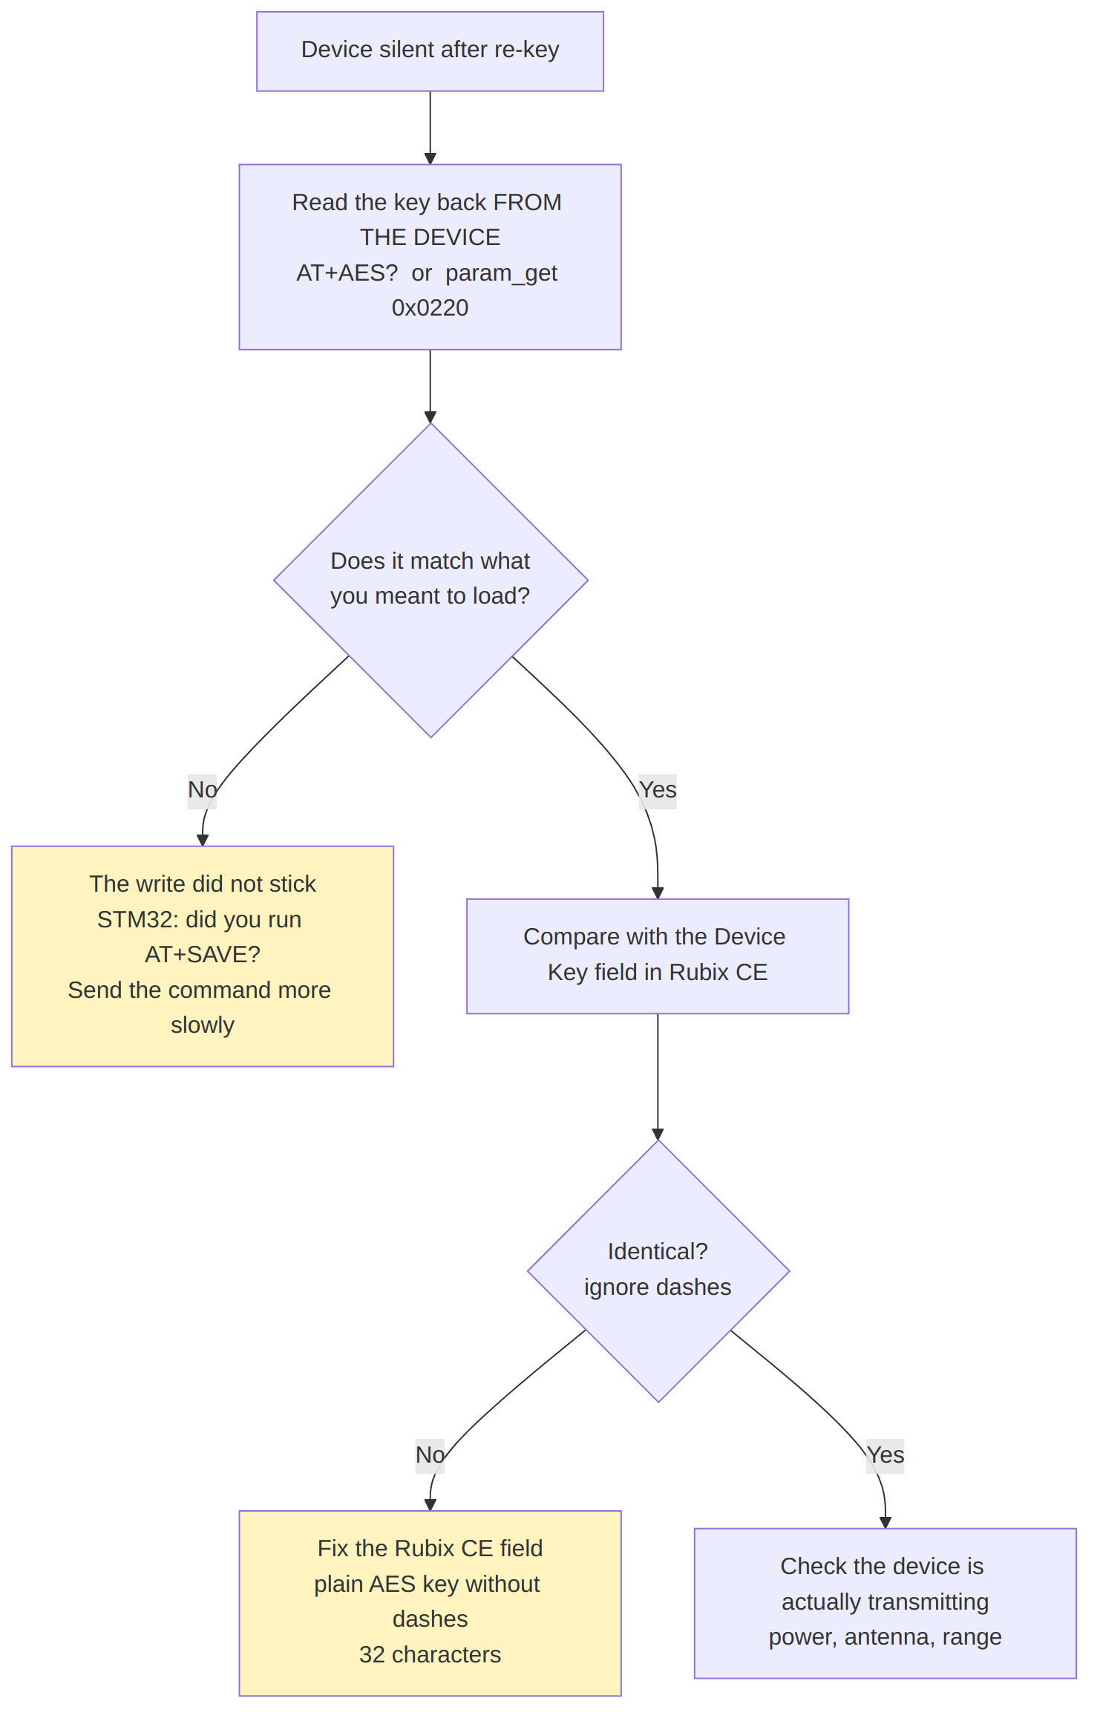

+AE OK or a truncated reply on STM32
Characters were lost on the serial line. Send the command more slowly, around 20-25 ms per character. Then read back with AT+AES?.

Data length of param 0x0220 (11 bytes) is NOT within the allowed range
You sent a plain AES key (without dashes) to an FGA Gen2. It needs the dashed form - see section 4.

Key reverts after a power cycle (STM32)
AT+SAVE was not run, or it failed. AT+AES= alone only writes RAM. Repeat the write and the save, then power-cycle and read back to confirm it persisted.

The device works but you are not sure the key really changed
Read it back from the device itself rather than trusting the write:
AT+AES? STM32
param_get 0x0220 ESP32
If it still shows 03-01-02-16-04-05-0F-07-E6-09-5A-0B-0C-12-63-0F, that is the shared default key and nothing changed.

12. Production checklist
Per device:
[ ] 1. Generate a random key (section 5)
[ ] 2. Record address + key in the key register (section 5)
[ ] 3. Load the key into the device (section 6, 7 or 8)
- STM32: AT+AES= then AT+SAVE
- ESP32: param_set 0x0220 with the dashed form
[ ] 4. Read the key back from the device and compare
[ ] 5. Power-cycle the device, read back again (proves it persisted)
[ ] 6. Enter the key in Rubix CE Device Key (plain, without dashes)
[ ] 7. Wait for a frame, confirm "decrypt ok (CMAC valid)"
[ ] 8. Tick the device off in the register
Rules that apply to every device:
- Never reuse a key across devices. One key per device, always.
- Never use the shared default key as a device key. It protects nothing.
- Never skip the read-back. A write that did not stick looks exactly like a write that did, until the device goes silent hours later.
- Keep the key register safe. Lose it and the affected devices must be re-keyed by hand.

13. Known limitations
Worth knowing before this is rolled out at scale.
Limitation | What it means in practice
Keys are stored unprotected on the device. STM32 readout protection is not enabled, and the ESP32 has flash encryption and secure boot turned off | Someone with physical access and a debugger can read a device's key out of flash. Per-device keys still contain the damage to that one device
Changing a key breaks the link until both ends are updated | Plan the two steps together. A device is unreachable between step 3 and step 6 of the checklist
STM32 boards cannot enter AT mode on battery | Re-keying a deployed STM32 device means bringing it back to a jig, or opening the enclosure to power it externally
A device that is factory-reset silently returns to the shared key | Its address does not change, so Rubix CE keeps expecting the per-device key and the device goes quiet. Re-key it
Nothing stops the same key being entered on two devices | The system will not warn you. The key register and the checklist are the safeguard
Legacy MicroEdge devices cannot have a per-device key | They encrypt the whole frame including the address, so CE cannot tell which device sent it before decrypting. Recognisable by the second byte not being C0 (for example 79ACDB45). They stay on the shared key until replaced
Two further notes for whoever owns the security posture, rather than for the production line:
- The encryption uses a fixed all-zero initialisation vector, so identical payloads from the same device produce identical ciphertext. Per-device keys remove this pattern between devices but not within one device.
- There is no replay protection. A captured frame can be replayed and will be accepted as genuine.
Neither affects the procedure in this document, and neither is made worse by per-device keys - they are pre-existing properties of the protocol.

