**Data Exploration and Cleaning:**

Expected database structure:

1. Orders: Contains details of customer orders.
   * order_id, customer_id, order_date, total_amount, status
2. Customers: Contains details about customers.
   * customer_id, name, email, location, signup_date, birthdate
3. Products: Details of the products in the store.
   * product_id, product_name, category, price
4. Order_Items: Details of products in each order.
   * order_id, product_id, quantity
5. Customer Reviews: Customer feedback on purchased products.
   * review_id, order_id, product_id, rating, review_text, review_date

Schema creation:

|  |  |
| --- | --- |
|  |  |
|  |  |
|  | |

Database structure:

ER diagram:

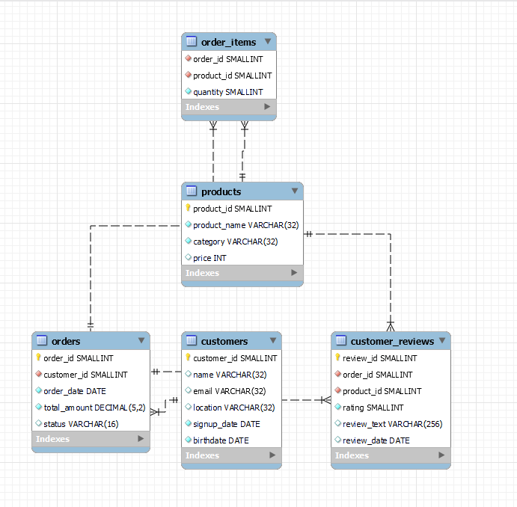

Data load:

Python with SQL connect Engine using sql alchemy.

