**Customer segmentation: is categorization of customers based upon various factors and behavior.**

This helps to target potential customers and put valuable resources into them.

For example, apply discount coupons to customers who place frequent orders. This will motivate customers to place more orders. This increases customer engagement.

Potential customer is one which has probability of making more revenue, most of ecommerce websites plays very strategic games to spot potential customers and make them to engage with company more.

**Behaviors:**

**Top spenders:** the person who spends more money from pocket is one who contributes more for revenue generation. It is a significant step to attract more such customers, and not only attracting them to make them engaged with the company is second most important step.

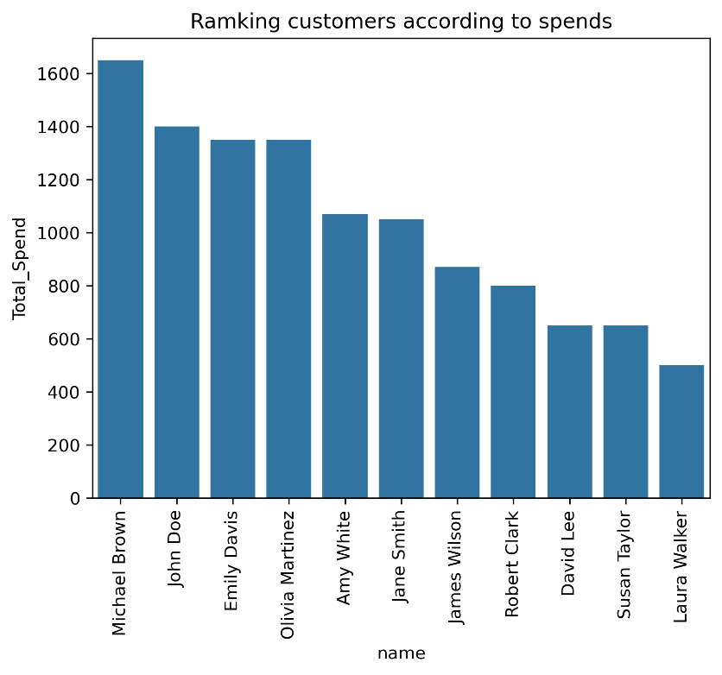

This graph shows the total spend amount by each customers. This highlights certain types of customers such as

* + A customer who spends most
  + A customer who spends less
  + And in between them the group has potential; those can be converted into top spenders.

**Average total spends:**

This analysis is necessary because, when we say top spenders it may be one time or just a couple of orders which worth more, average total spend shows the consistency in spendings.

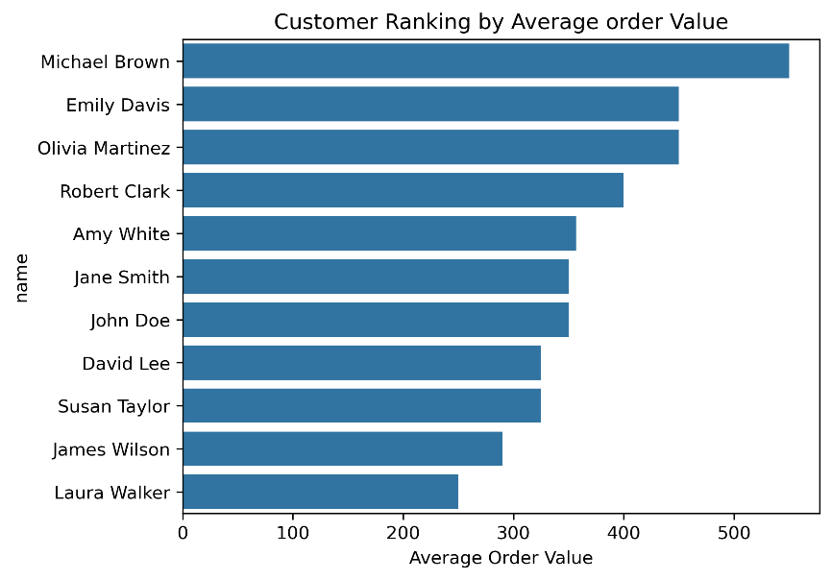

**Take here the customer Jhon and Michel and Emily,**

In the first analysis Michel and Jhon were highlighted as top spenders, but in second analysis Michel highlighted as top as average spender along with Emily, but Jhon moved below. This shows though Jhon seems to be one of the top spenders at first glance, he can not be targeted as he might be one-time big buyer.

Emily was not one of the top buyers, but she listed top during ranking by average order price. This indicates that she is spending money on range mid to high.

**Order frequency:**

Order frequency indicates consistency in buying stuff. The more order frequency more consistence is customer and the more chances that he will have more customer life with the company.

These customers further converted into long-term runners. The graph shows the ranking of customers by frequency orders.

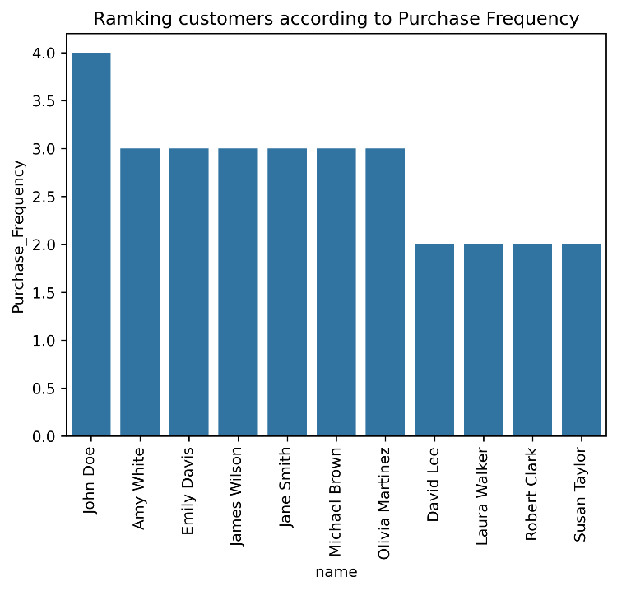

**Customer distribution:**

This distribution shows distribution of customers clustered around the specific ranges

Order frequency – 1 to 3

Spent – 100 to 700

Indicating that customers laying in this group are key contributors.

On the other hand, focusing on outliers,

Customers with the highest buying value are less likely to place second order,

Also, the most frequent buyers are not the ones who pay more.

**Segmentations:**

Segment 1: High-value customers → Spend the most and buy frequently.

Segment 2: Mid-tier customers → Moderate spending and occasional purchases.

Segment 3: Low-spending customers → Infrequent buyers with low total spend.

After studying above graphs, one can easily find out customers with 3 major labels.

Segment 1: High-value customers → Michel, john, Amily

Segment 2: Mid-tier customers → all other customers lying between them

Segment 3: Low-spending customers → Laura, James, Susan