**Sales Trend:**

This is all about how a product performed in market, over year.

Checking sales by product, by category etc.

**Monthly sales pattern:**

Extreme variation in sales over the months, there is no fixed pattern to follow. This shows less effect of season on market.

**Category vise sales:**

This revels the top performing category vs least performing category, also the other categories those needs some investment for sales improvement.

**Top performing category: electronics worth INR 6000+**

**Least performing category: clothing, accessories worth INR < 1000**

**Category-wise order count:**

This revels that if top performing categories are the one who most likely to be purchased frequently by customers.

**Customer segmentation on purchase frequency:**

Category 1: frequent buyers

Category 2: occasional buyers

Category 3: inactive buyers

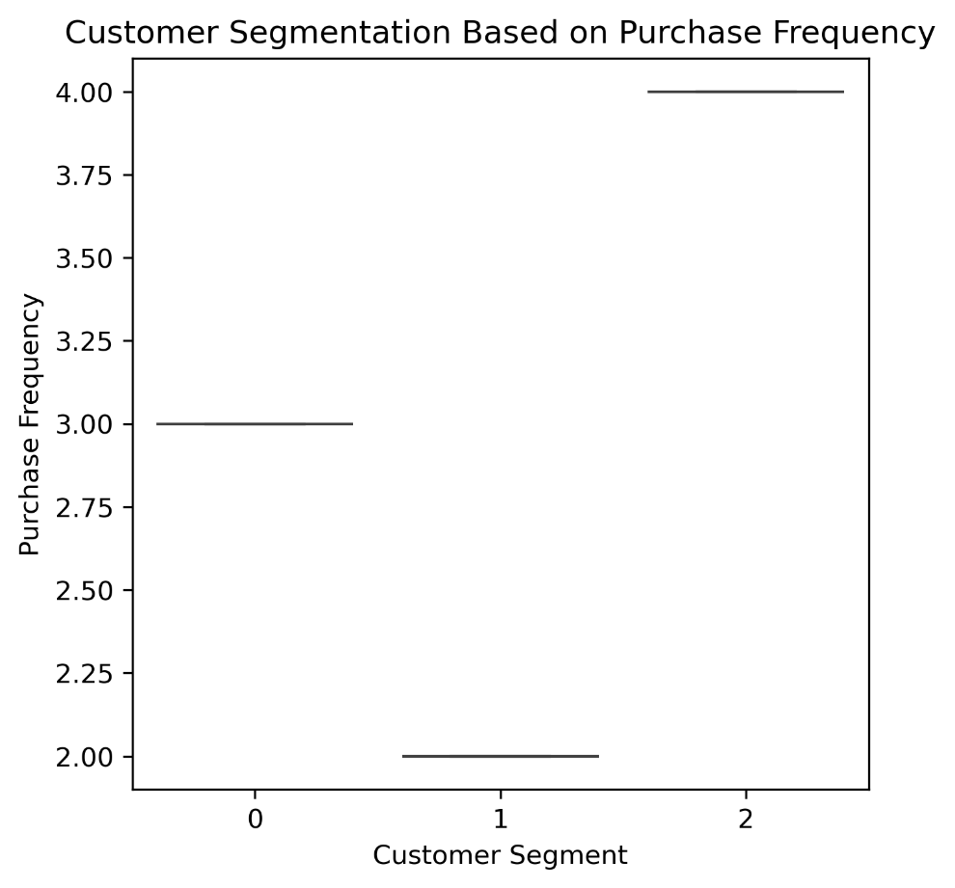

Group 1: has average order count is 3 -> occasional buyers

Group 2: has average order count around 2 -> inactive buyers

group 2: has average order count 4 -> frequent buyers

**Final Sales Dashboard:**

