🚀 Dynamics 365 Finance (D365 F&O) Finance Functional
Ultimate Guide

🧱 MODULE 1 — Foundations of Finance in ERP
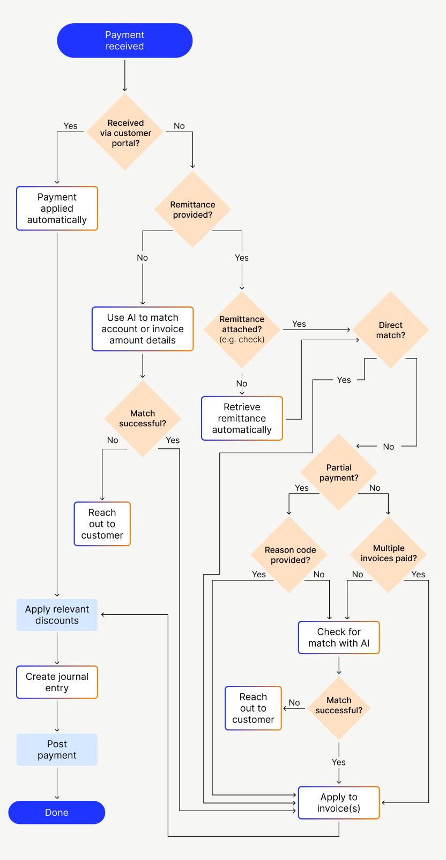
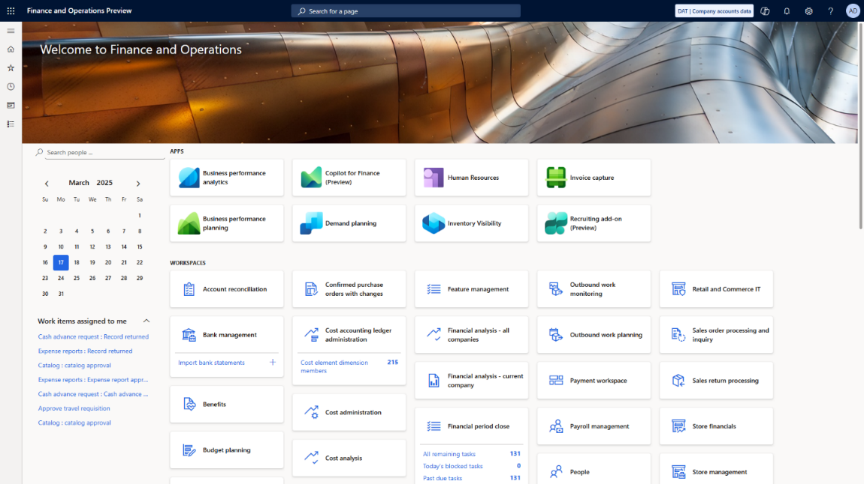
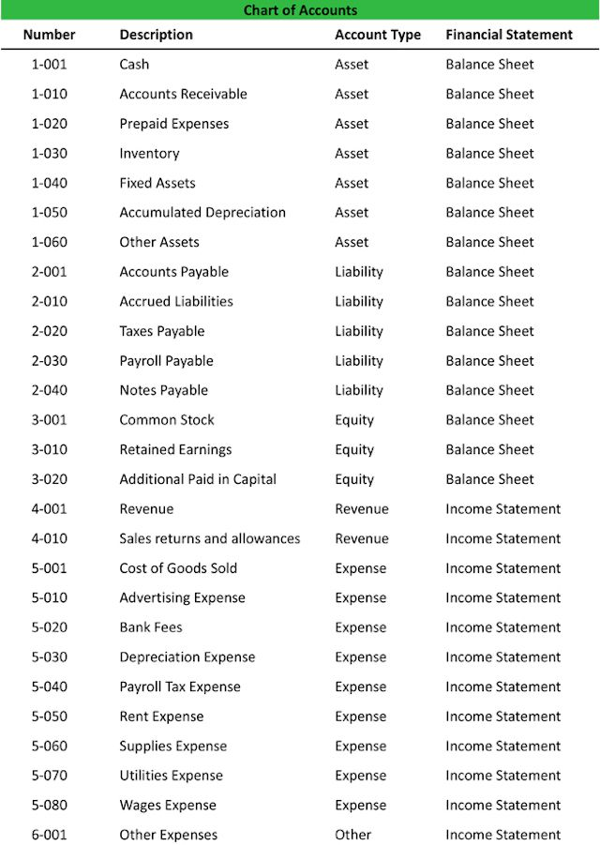
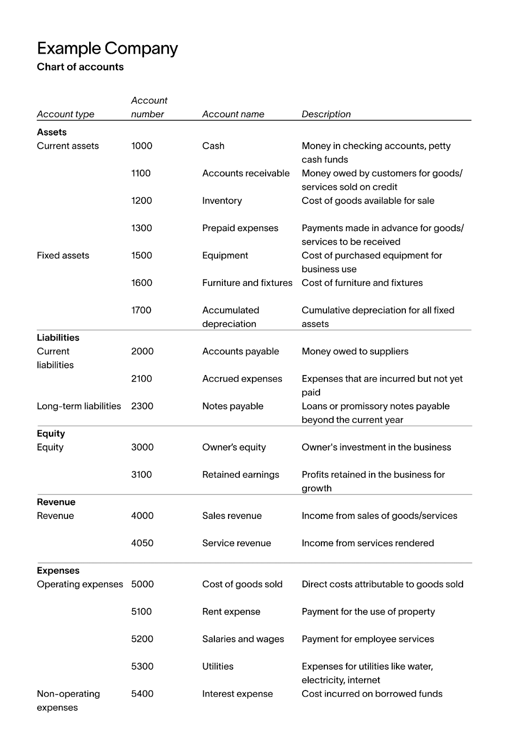
📘 Topics
- What is Financial Management in ERP
- Overview of Finance modules
- Legal entities & organizational structure
- Chart of Accounts & Financial Dimensions
🛠️ Hands-on Exercises
- Explore Chart of Accounts
- Create a Financial Dimension
- Identify Legal Entity structure

💰 MODULE 2 — General Ledger (GL)
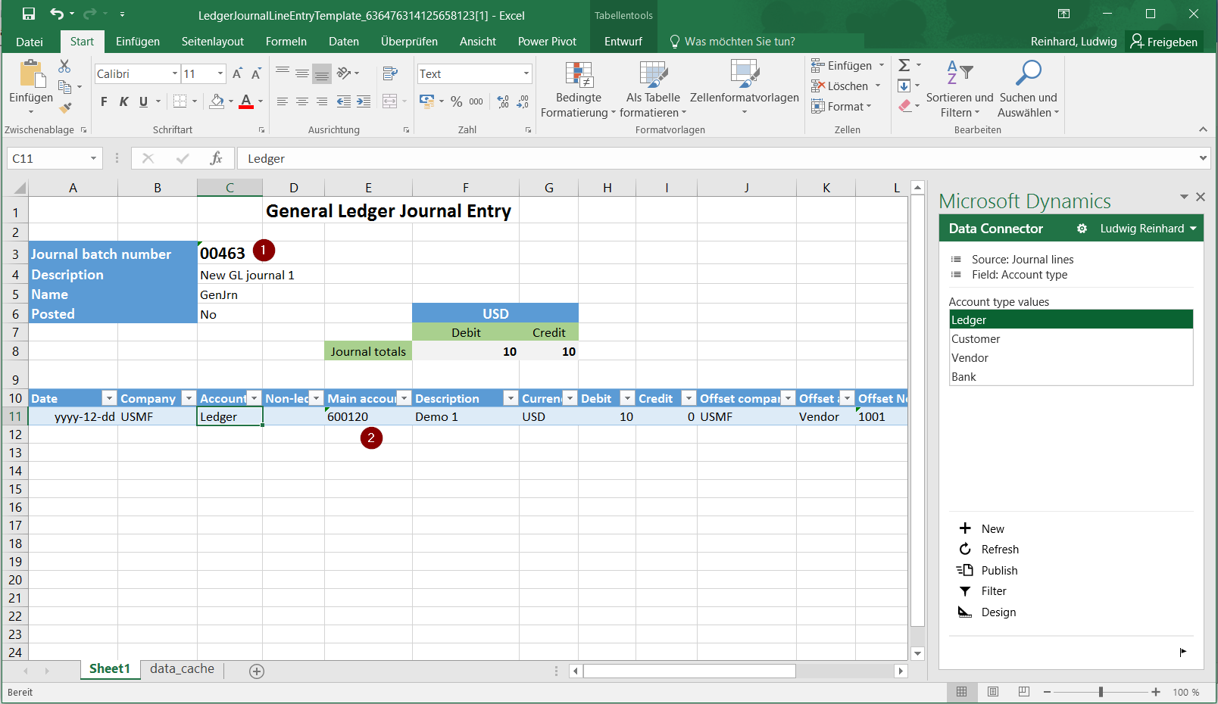
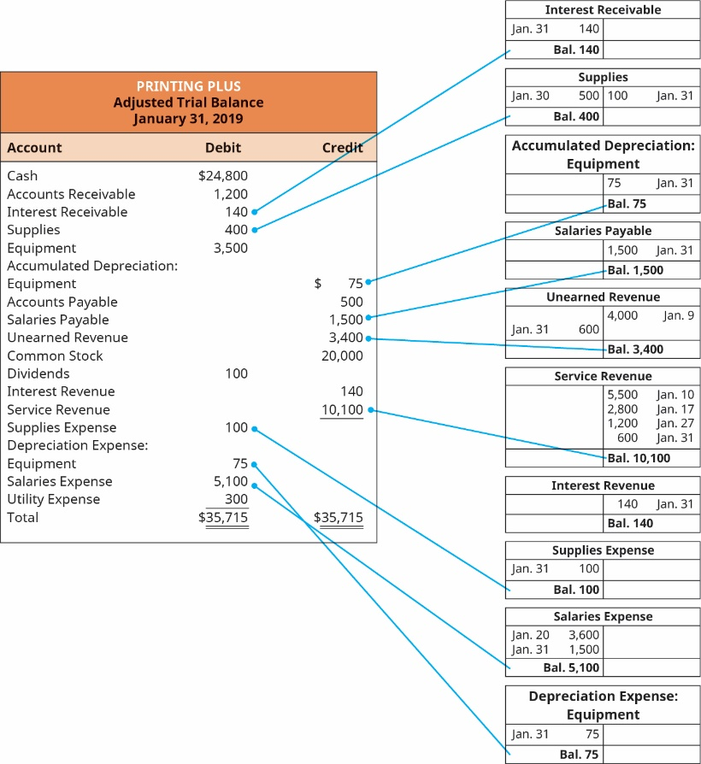
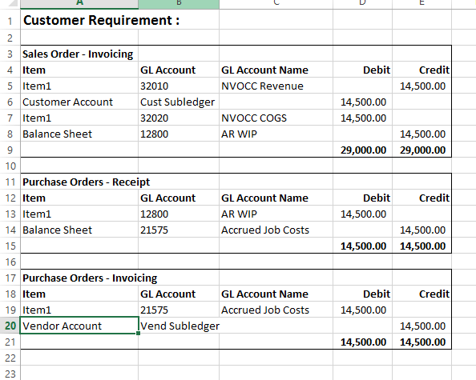
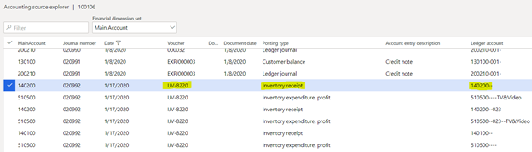
📘 Topics
- Ledger setup
- Journals (General, Daily)
- Posting profiles
- Financial reporting basics
🛠️ Hands-on Exercises
- Create and post a journal entry
- Configure ledger parameters
- Generate trial balance

🧾 MODULE 3 — Accounts Payable (AP)
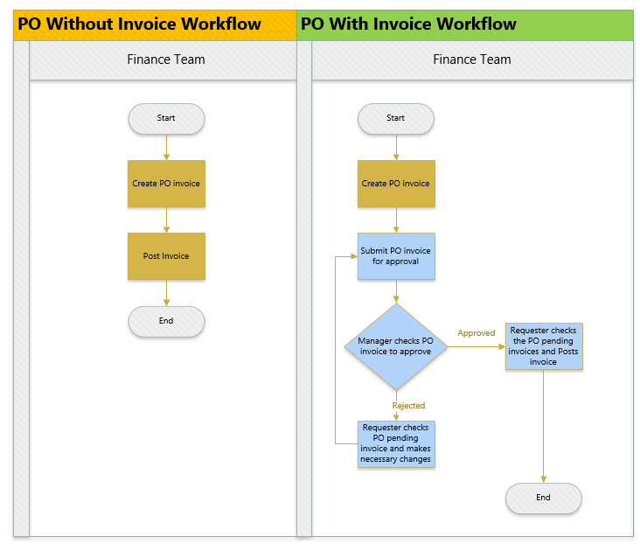
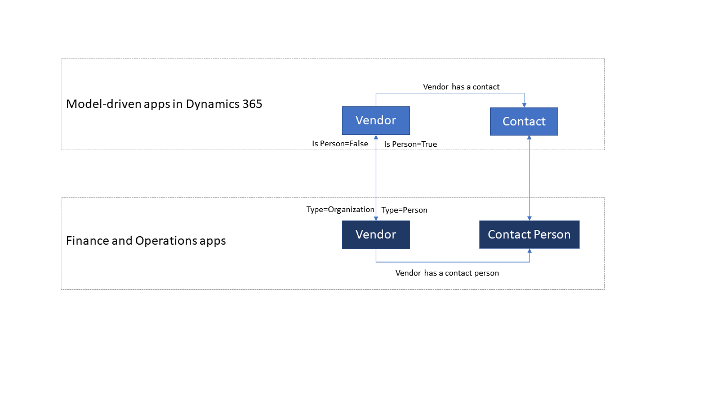
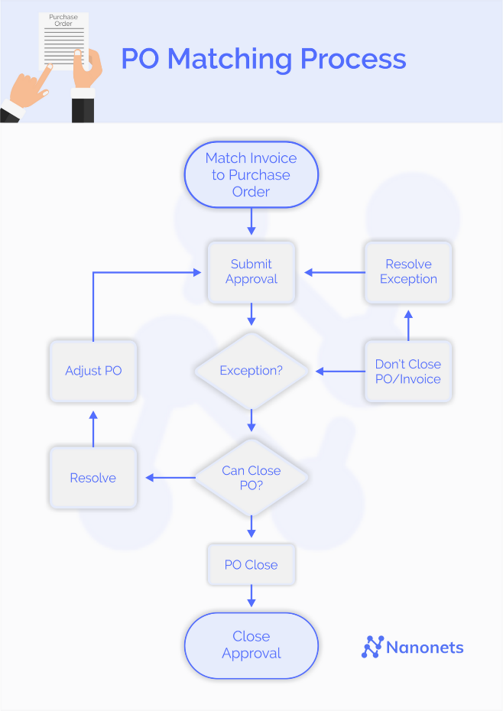
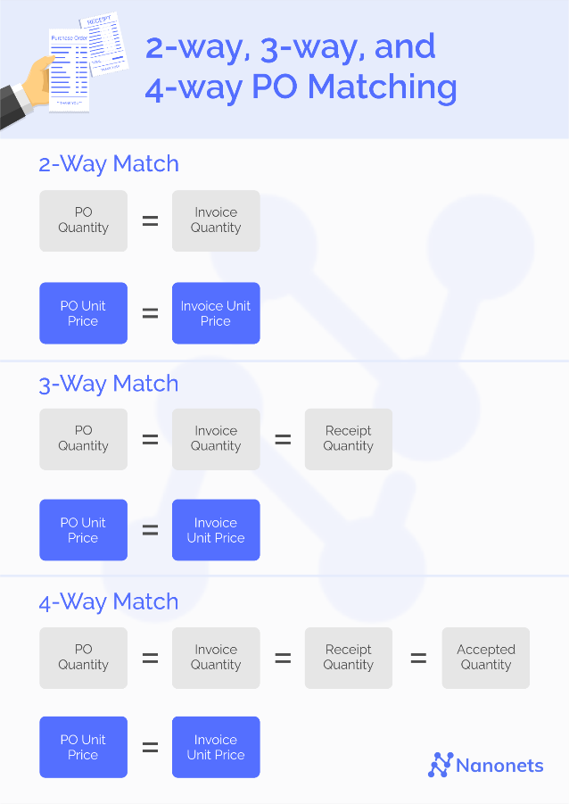
📘 Topics
- Vendor master
- Invoice processing
- 2-way / 3-way matching
- Payments
🛠️ Hands-on Exercises
- Create vendor
- Post vendor invoice
- Process payment journal

💵 MODULE 4 — Accounts Receivable (AR)
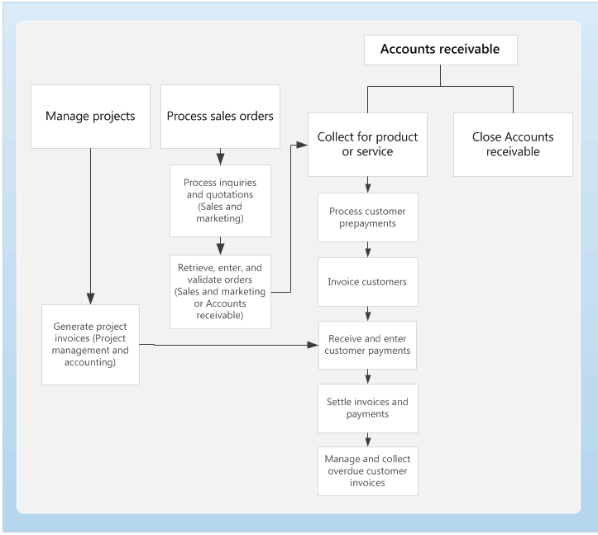
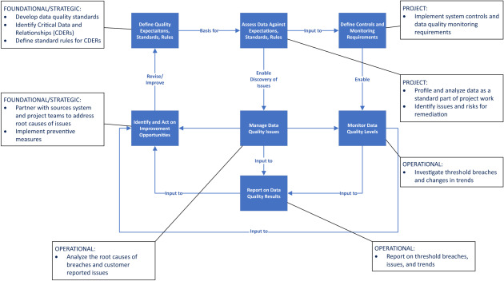
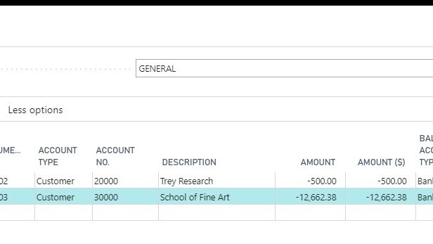
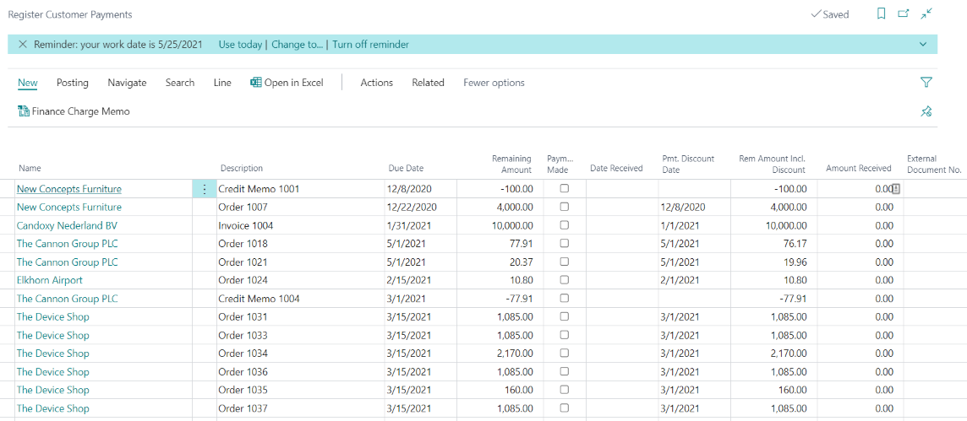
📘 Topics
- Customer master
- Sales invoice process
- Cash receipts
- Credit management
🛠️ Hands-on Exercises
- Create customer
- Generate sales invoice
- Record customer payment

📦 MODULE 5 — Fixed Assets
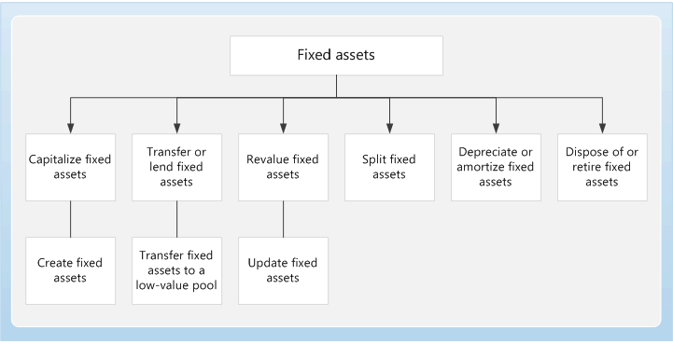
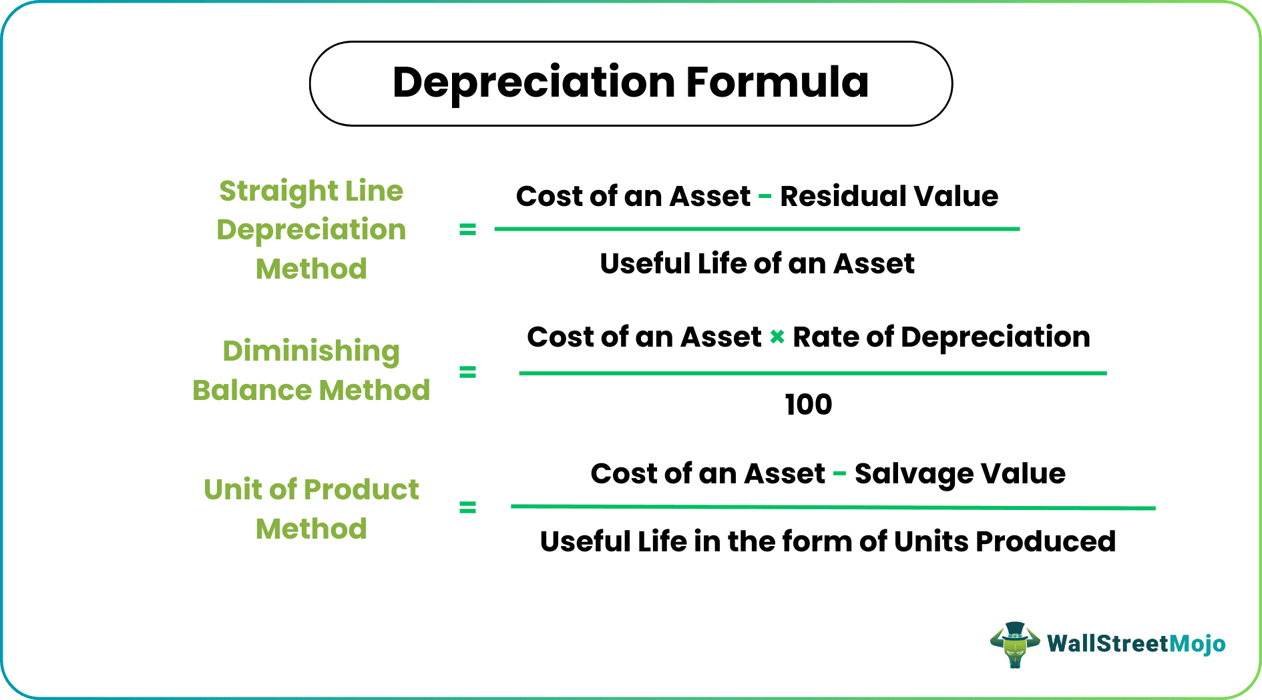
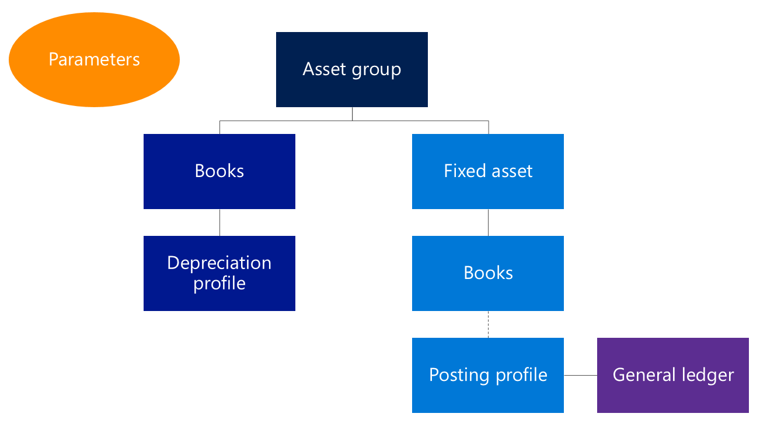
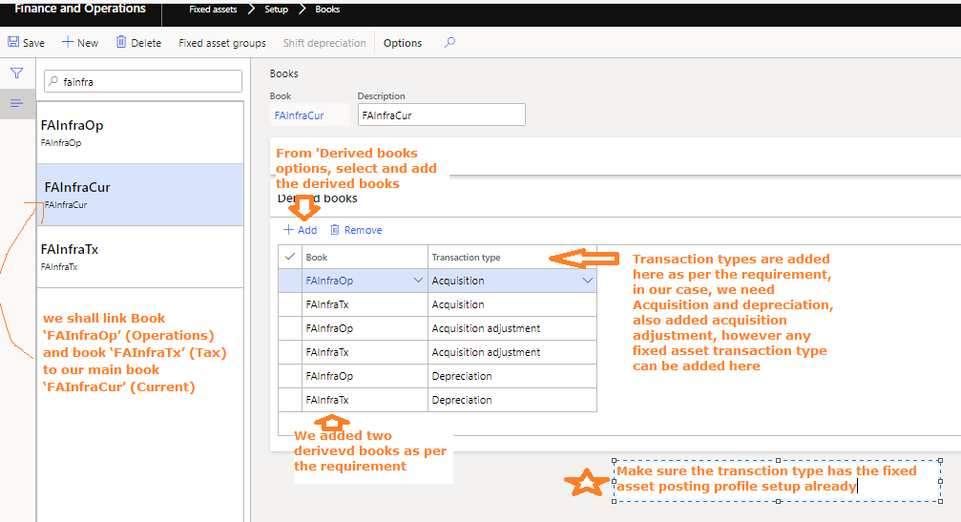
📘 Topics
- Asset lifecycle
- Depreciation methods
- Asset books
🛠️ Hands-on Exercises
- Create asset
- Run depreciation
- Dispose asset

🧾 MODULE 6 — Budgeting & Forecasting
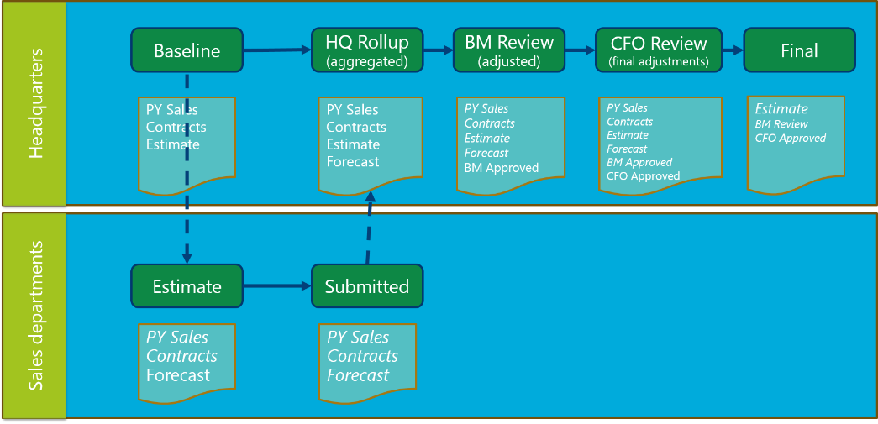

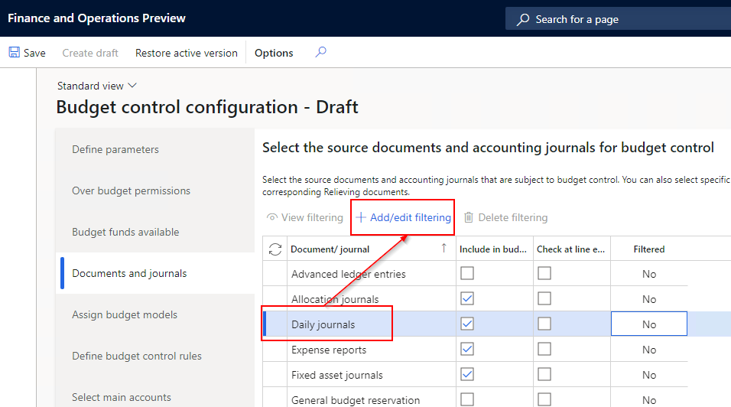
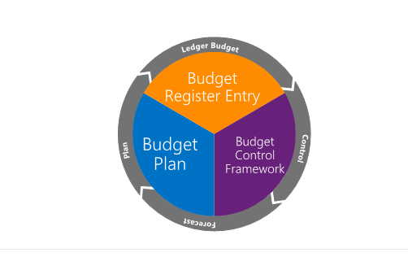
📘 Topics
- Budget planning
- Budget control
- Forecasting
🛠️ Hands-on Exercises
- Create budget plan
- Configure budget control
- Compare budget vs actual

🏦 MODULE 7 — Cash & Bank Management
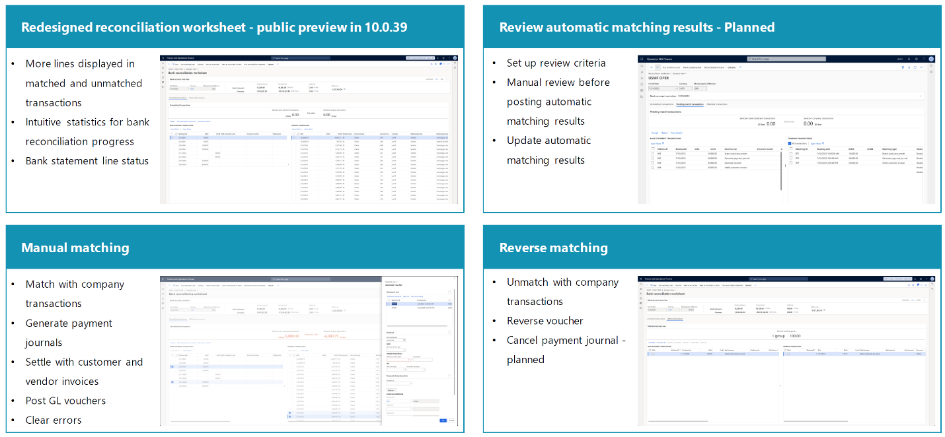

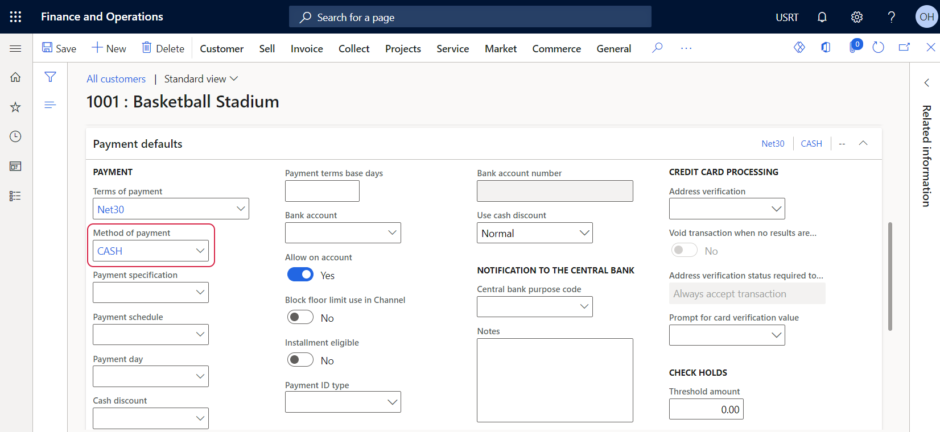
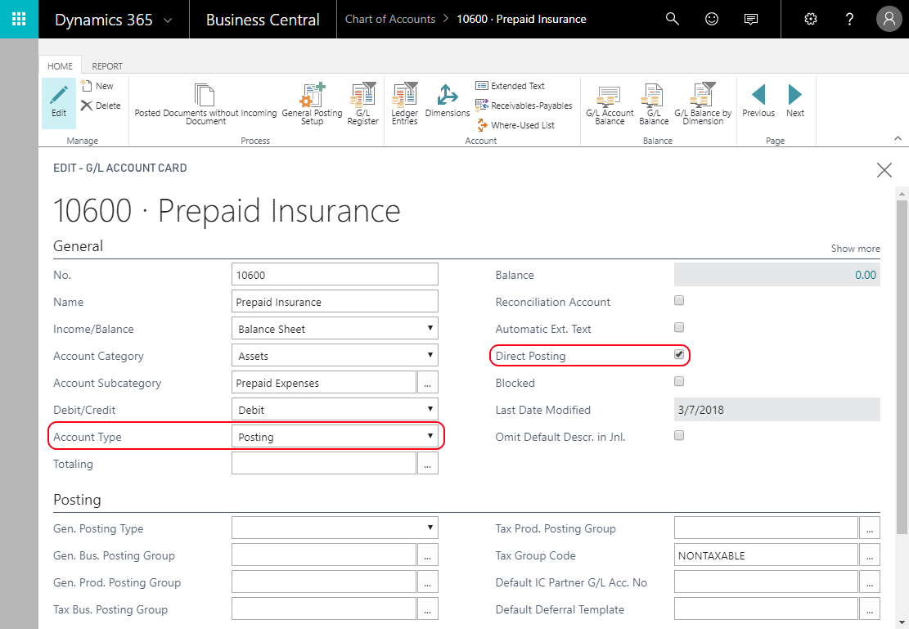
📘 Topics
- Bank setup
- Bank reconciliation
- Cash flow
🛠️ Hands-on Exercises
- Create bank account
- Perform reconciliation
- Process payments

🌍 MODULE 8 — Tax Configuration
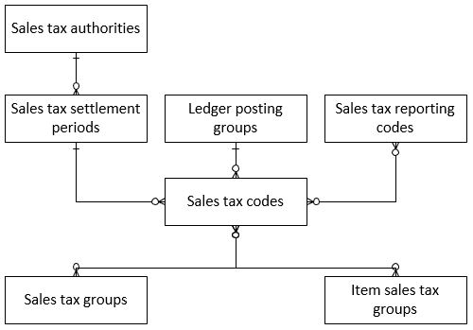
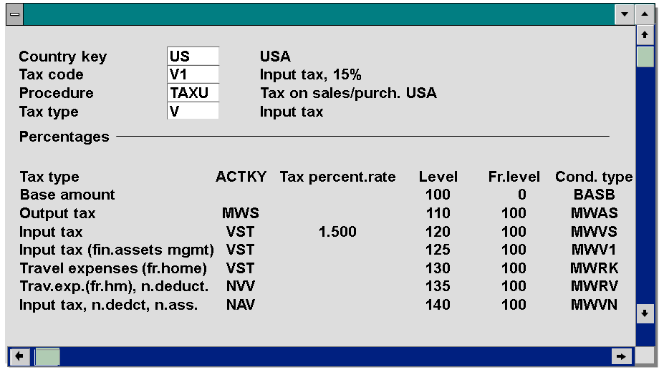
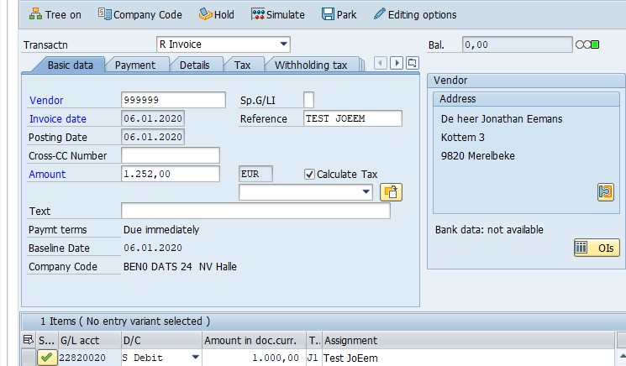
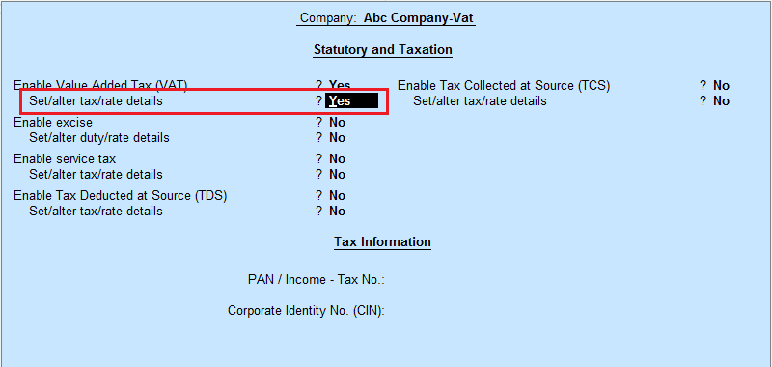
📘 Topics
- Tax codes & groups
- Sales tax setup
- Tax reporting
🛠️ Hands-on Exercises
- Configure tax codes
- Apply tax on transactions
- Validate tax calculation

📊 MODULE 9 — Financial Reporting
📘 Topics
- Trial balance
- Financial statements
- Reporting tools
🛠️ Hands-on Exercises
- Generate financial report
- Analyze profit & loss
- Customize report

🔐 MODULE 10 — Finance Security & Controls
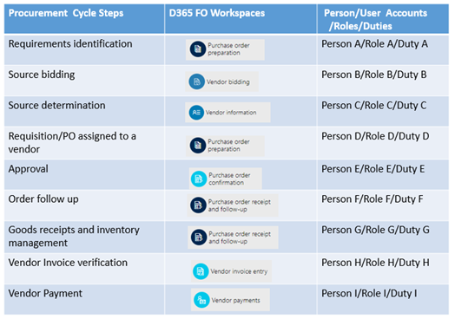
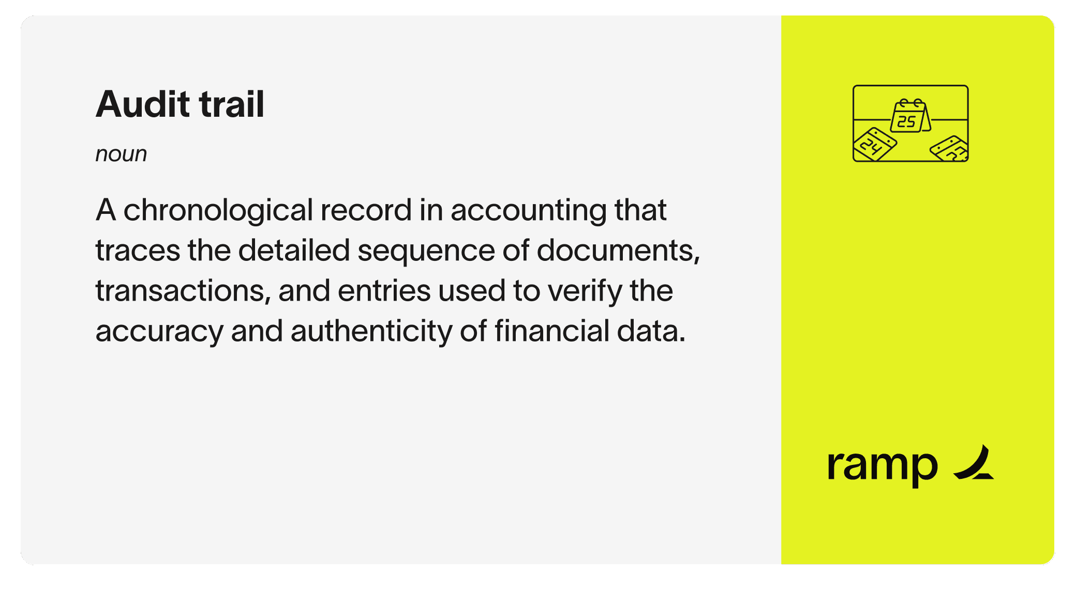
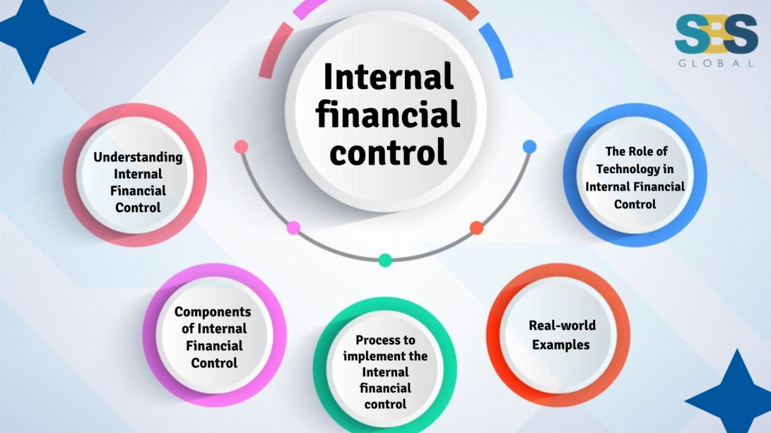
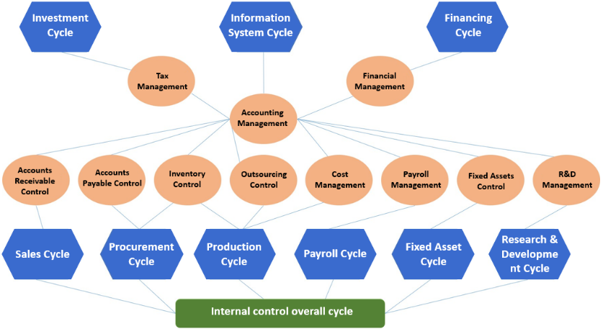
📘 Topics
- Segregation of duties
- Security roles
- Audit trail
🛠️ Hands-on Exercises
- Assign finance roles
- Test access restrictions
- Review audit logs

⚙️ MODULE 11 — Period Close & Financial Operations
📘 Topics
- Month-end close
- Year-end close
- Reconciliation
🛠️ Hands-on Exercises
- Perform month-end close
- Reconcile accounts
- Validate balances

🧠 MODULE 12 — Real-World Finance Processes
📘 Topics
- Procure-to-Pay (P2P)
- Order-to-Cash (O2C)
- Record-to-Report (R2R)
🛠️ Hands-on Exercises
- Execute full P2P cycle
- Execute full O2C cycle
- Trace transaction end-to-end

🚀 MINI PROJECT (CAPSTONE — FINANCE SYSTEM)
🎯 Project: “End-to-End Financial Management System”
Scope:
- Configure Chart of Accounts
- Create vendors & customers
- Process AP & AR transactions
- Perform bank reconciliation
- Apply taxes
- Run financial reports
- Perform month-end close
Expected Outcome:
✔ Complete finance lifecycle
✔ Real-world readiness
✔ Functional mastery foundation

🔥 20 REAL-WORLD FINANCE INSIGHTS
- Business understanding > system navigation
- Posting profiles drive everything
- Financial dimensions are critical
- Data accuracy is non-negotiable
- Reconciliation is key to trust
- Month-end close is high-pressure
- Audit trail must be clean
- Tax setup must be precise
- Small setup mistakes cause big issues
- Always validate postings
- Reports depend on correct setup
- Understand end-to-end flow
- Communication with technical team is important
- Documentation is critical
- Test scenarios thoroughly
- Edge cases matter
- Finance users rely on system accuracy
- Timing of transactions matters
- Compliance is mandatory
- Continuous learning is required

🎯 INTERVIEW PREPARATION CHECKLIST
🔹 Functional Knowledge
- GL, AP, AR concepts
- Fixed assets
- Budgeting
- Tax
🔹 Scenario-Based
- How to handle invoice mismatch?
- How to troubleshoot posting issue?
- How to perform reconciliation?
🔹 Practical
- Walk through P2P cycle
- Walk through O2C cycle
- Explain financial setup
🔹 Behavioral
- Business understanding
- Problem-solving
- Communication skills

🏁 FINAL TRANSFORMATION GOAL
A person completing this should be able to:
✔ Handle finance processes end-to-end
✔ Configure system correctly
✔ Support business operations
✔ Work in real D365 Finance projects

💡 FINAL MESSAGE
“Finance is not just configuration.
It is understanding how a business runs.
If you master this,
you don’t just use the system —
you drive business decisions.”

