🚀 Dynamics 365 Supply Chain Management (D365 SCM) SCM Functional
Ultimate Guide

🧱 MODULE 1 — Foundations of Supply Chain in ERP
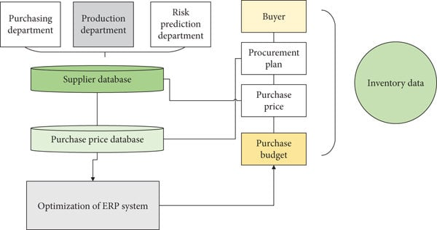
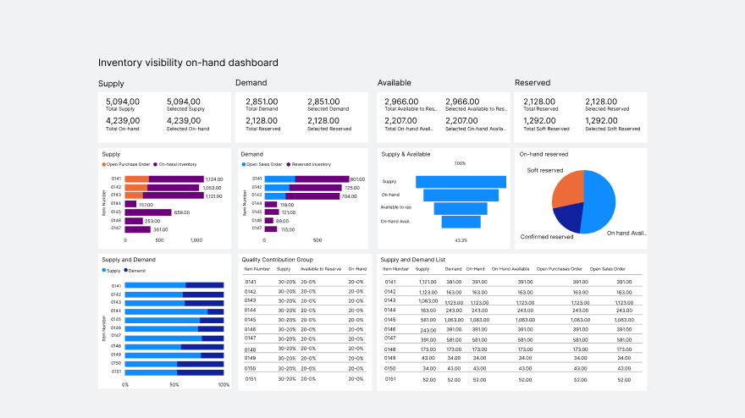

📘 Topics
- What is Supply Chain Management in ERP
- Overview of SCM modules
- Organizational structure (Site, Warehouse, Location)
- Item master basics
🛠️ Hands-on Exercises
- Explore inventory structure (Site/Warehouse)
- Create a new released product
- Identify item model group settings

📦 MODULE 2 — Product Information Management (PIM)
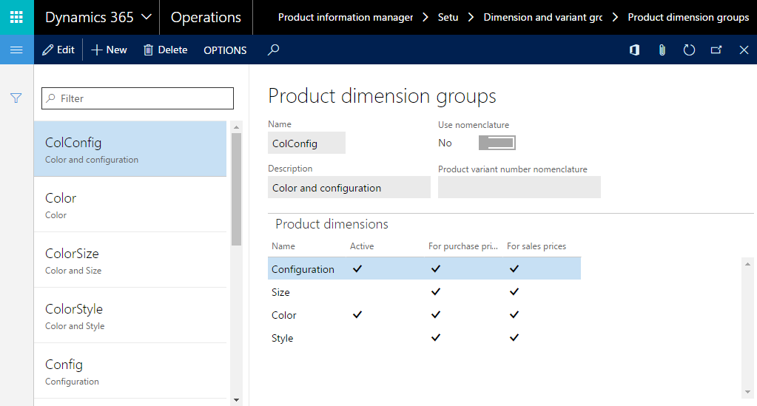
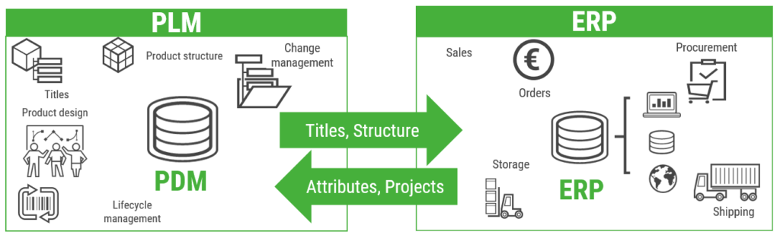
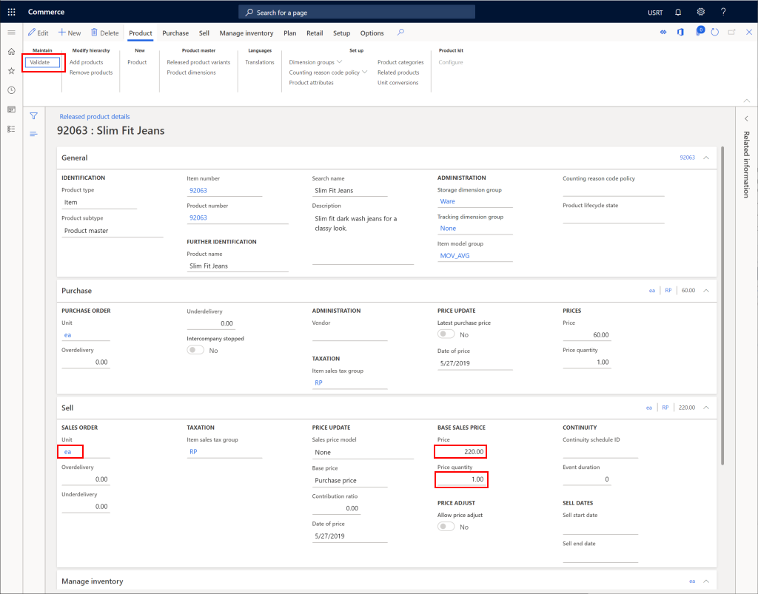
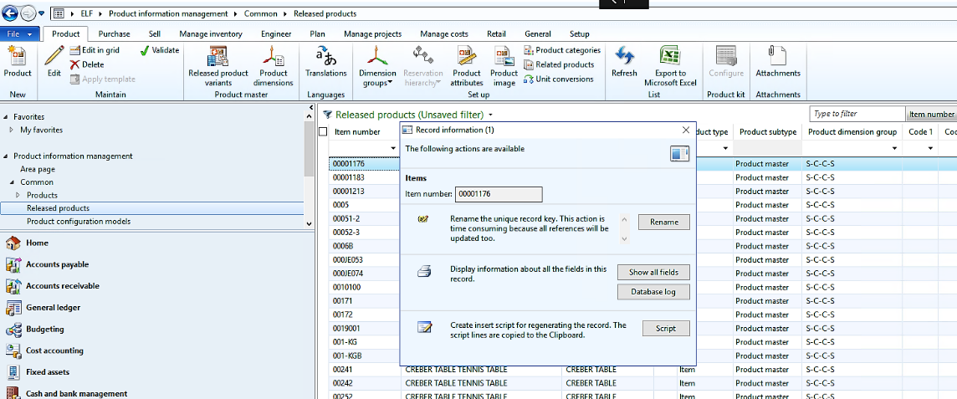
📘 Topics
- Product master vs released product
- Product variants (size, color, config)
- Product lifecycle
🛠️ Hands-on Exercises
- Create product master
- Define product variants
- Release product to legal entity

🏭 MODULE 3 — Inventory Management
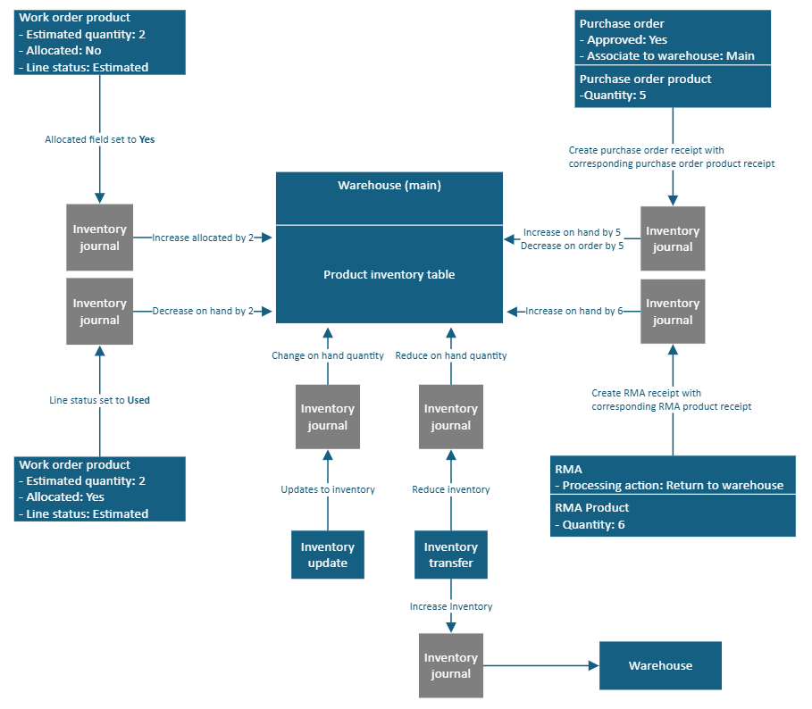
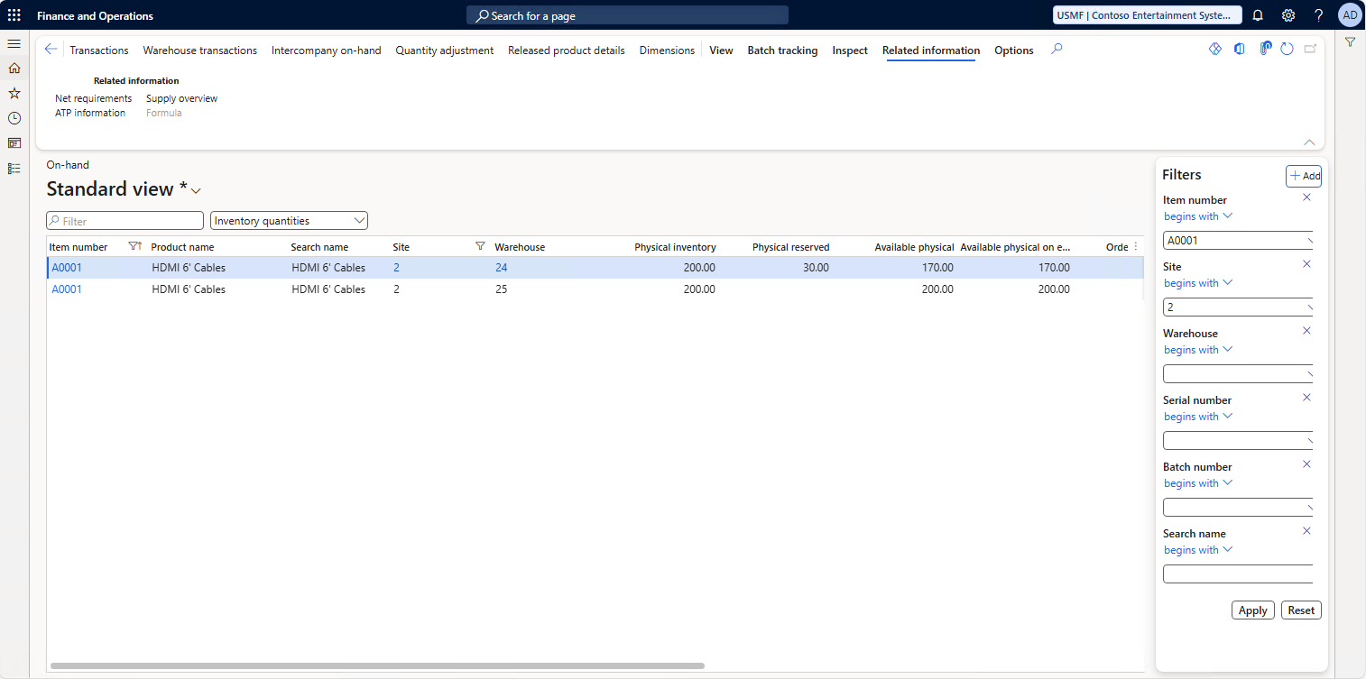
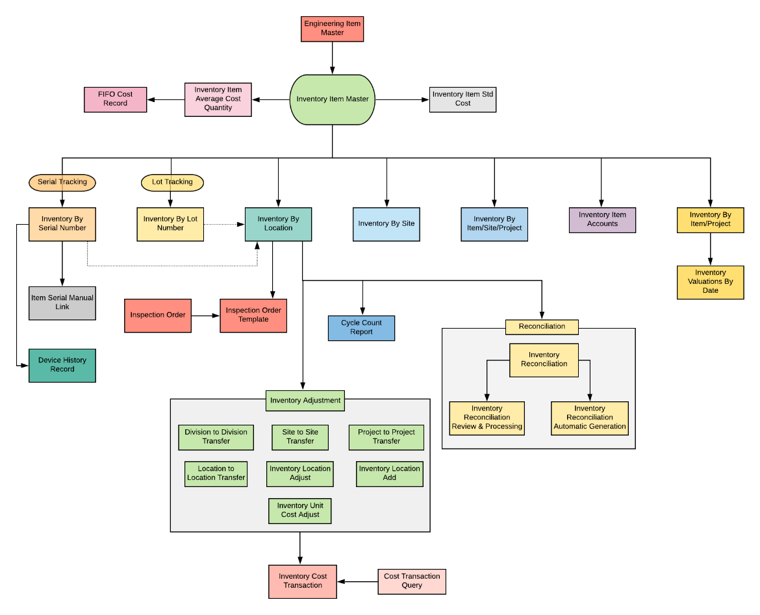
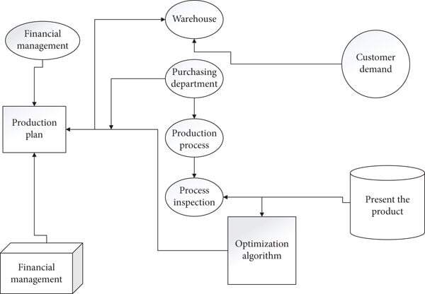
📘 Topics
- Inventory transactions
- Inventory dimensions
- On-hand inventory
🛠️ Hands-on Exercises
- Perform inventory adjustment
- Transfer inventory between warehouses
- Check on-hand inventory

🛒 MODULE 4 — Procurement & Sourcing (P2P)
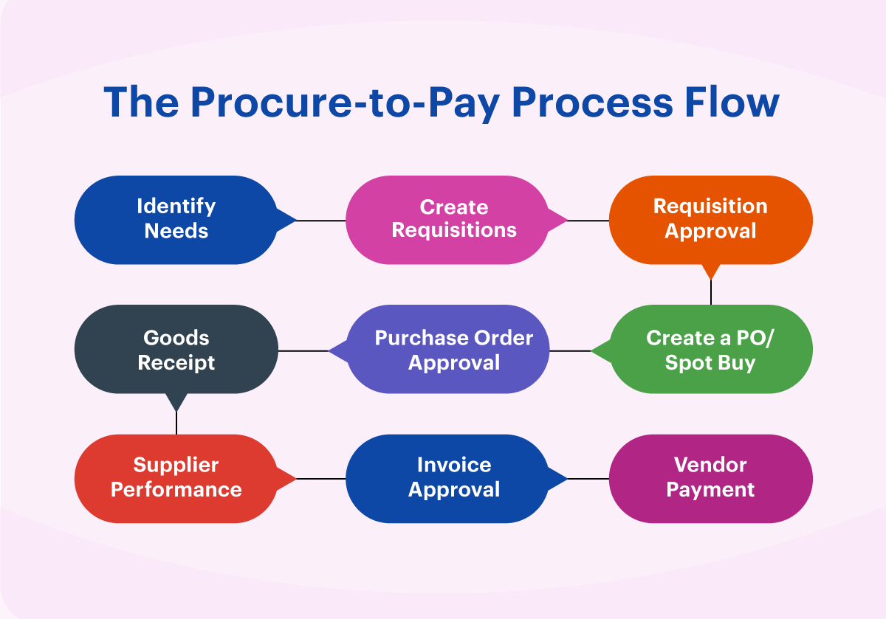
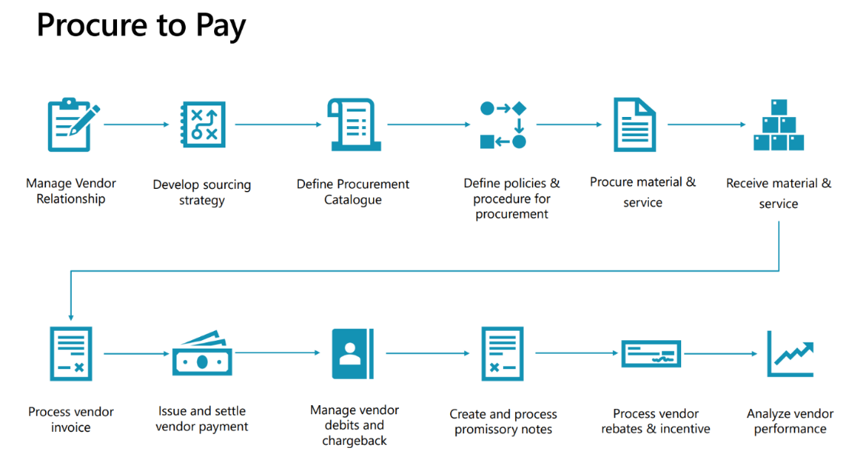

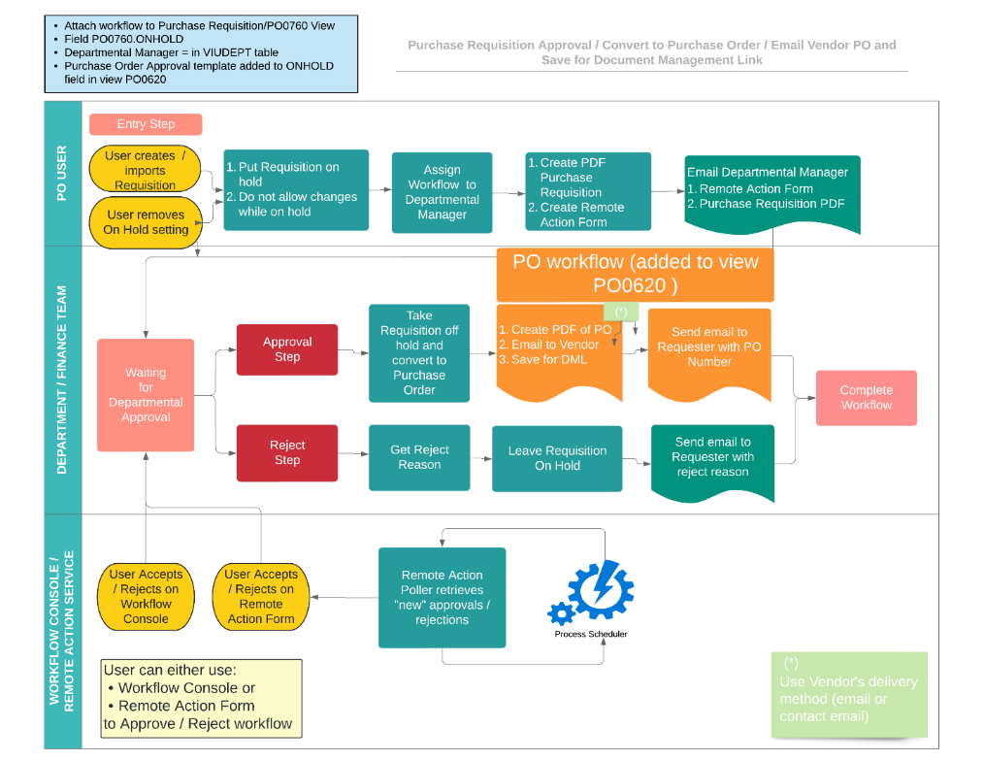
📘 Topics
- Vendor management
- Purchase requisition
- Purchase order lifecycle
- Product receipt & invoicing
🛠️ Hands-on Exercises
- Create vendor
- Create and confirm purchase order
- Post product receipt and invoice

🚚 MODULE 5 — Sales & Distribution (O2C)
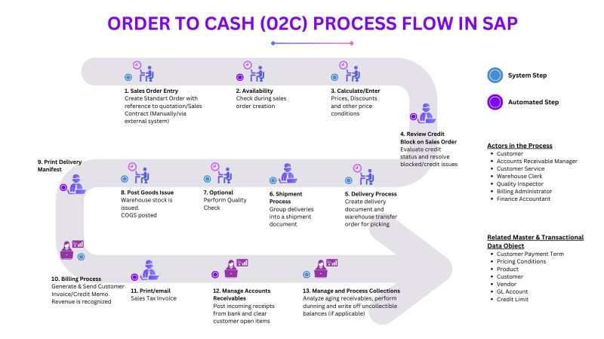
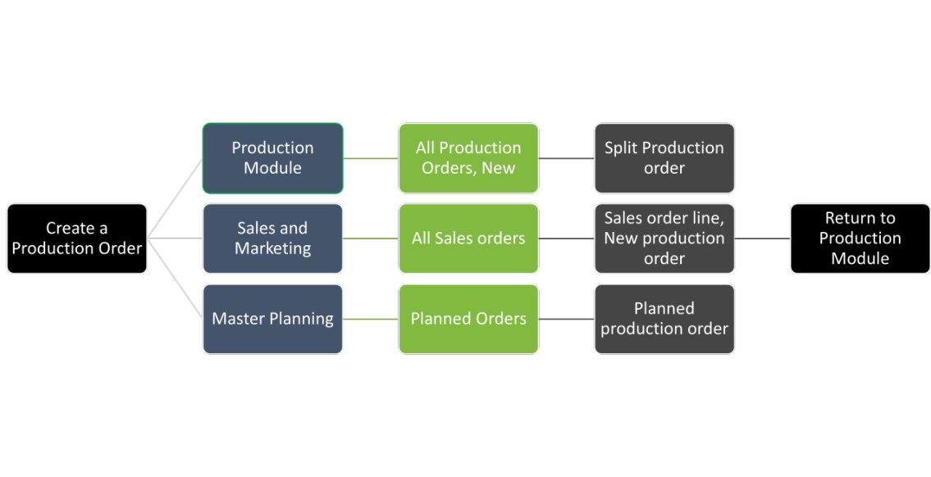

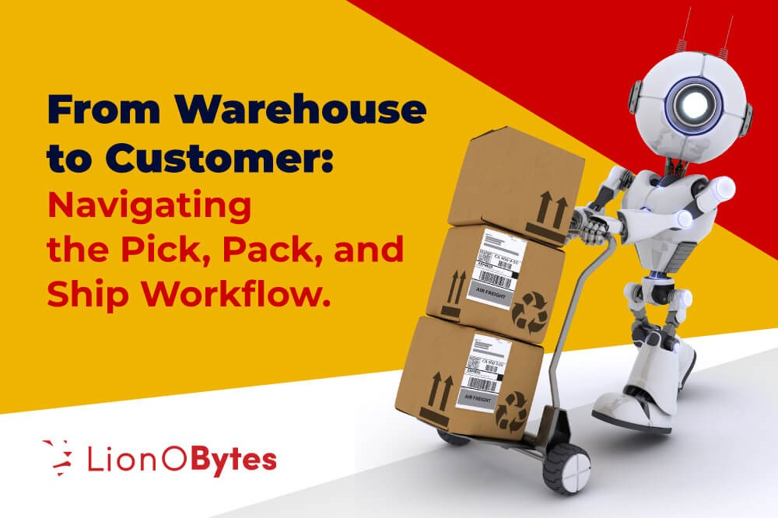
📘 Topics
- Sales order lifecycle
- Delivery & shipment
- Invoicing
🛠️ Hands-on Exercises
- Create sales order
- Perform picking & packing
- Generate invoice

🏬 MODULE 6 — Warehouse Management (WMS)
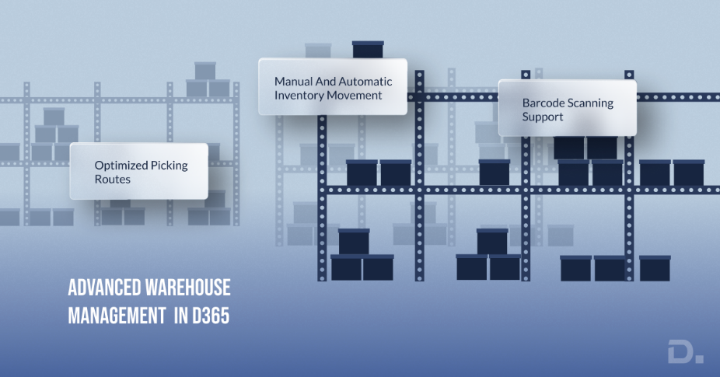
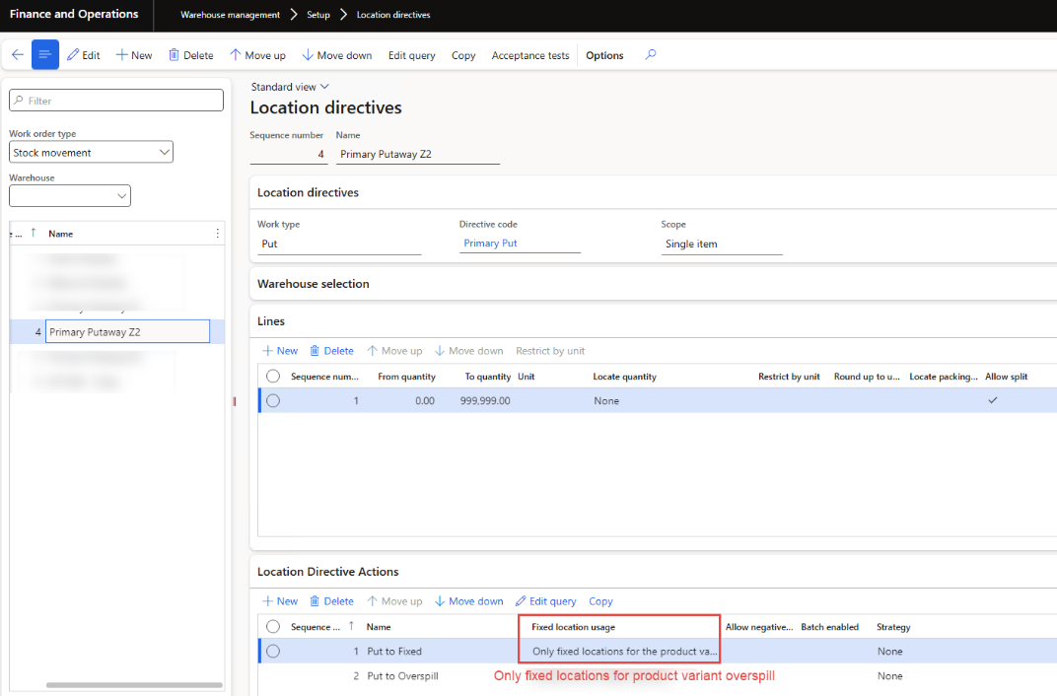
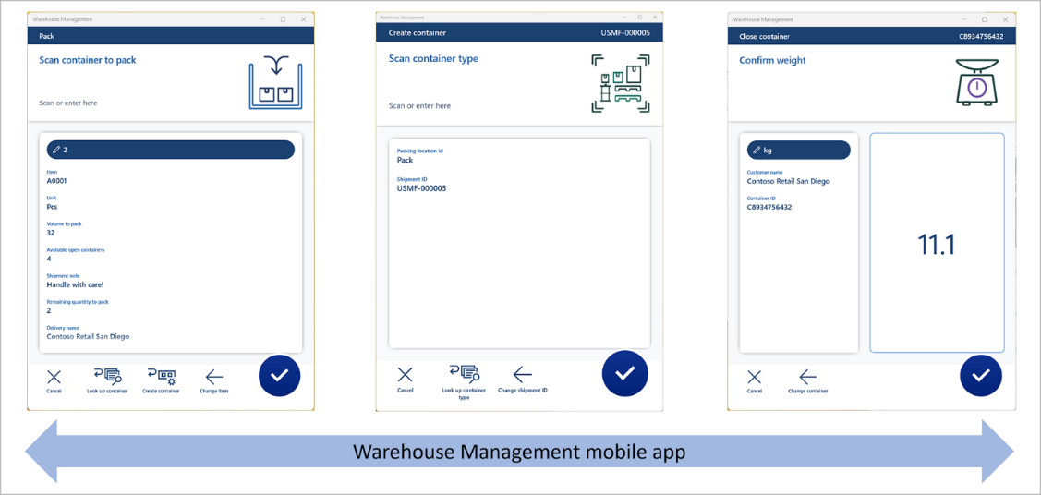
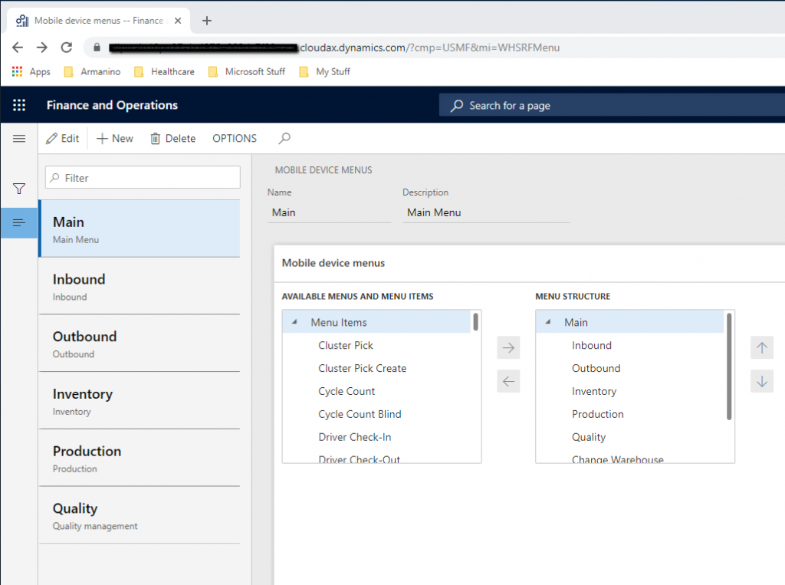
📘 Topics
- Warehouse setup
- Work creation
- Mobile device workflows
🛠️ Hands-on Exercises
- Configure warehouse
- Create location directives
- Execute picking via mobile simulation

🔄 MODULE 7 — Inventory Valuation & Costing

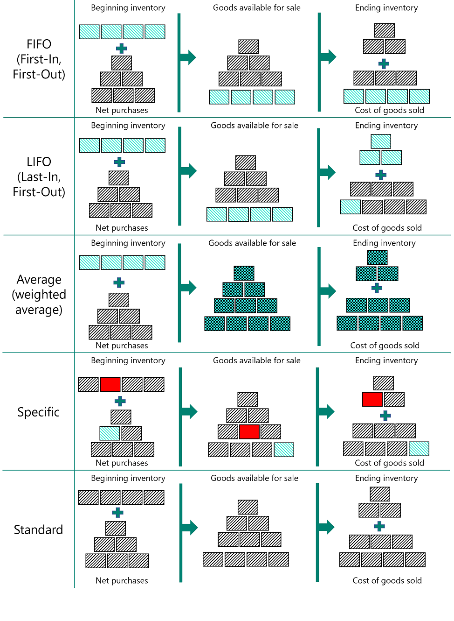
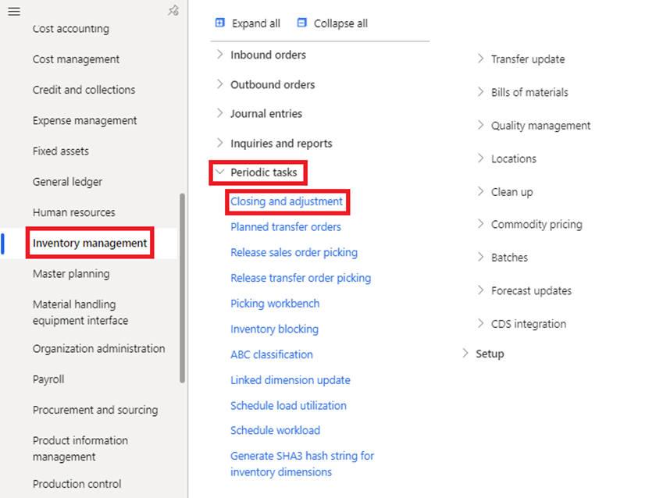
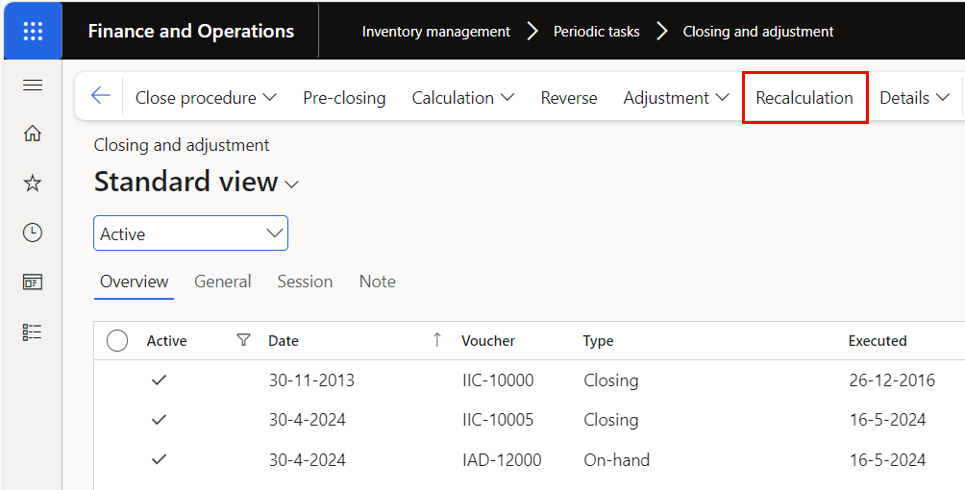
📘 Topics
- Costing methods (FIFO, Weighted Avg)
- Inventory close
- Cost adjustments
🛠️ Hands-on Exercises
- Assign costing method
- Run inventory close
- Analyze cost impact

🏭 MODULE 8 — Production Control (Manufacturing Basics)
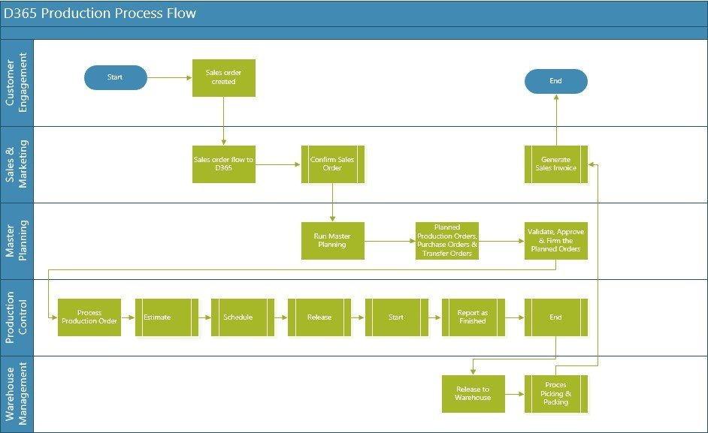
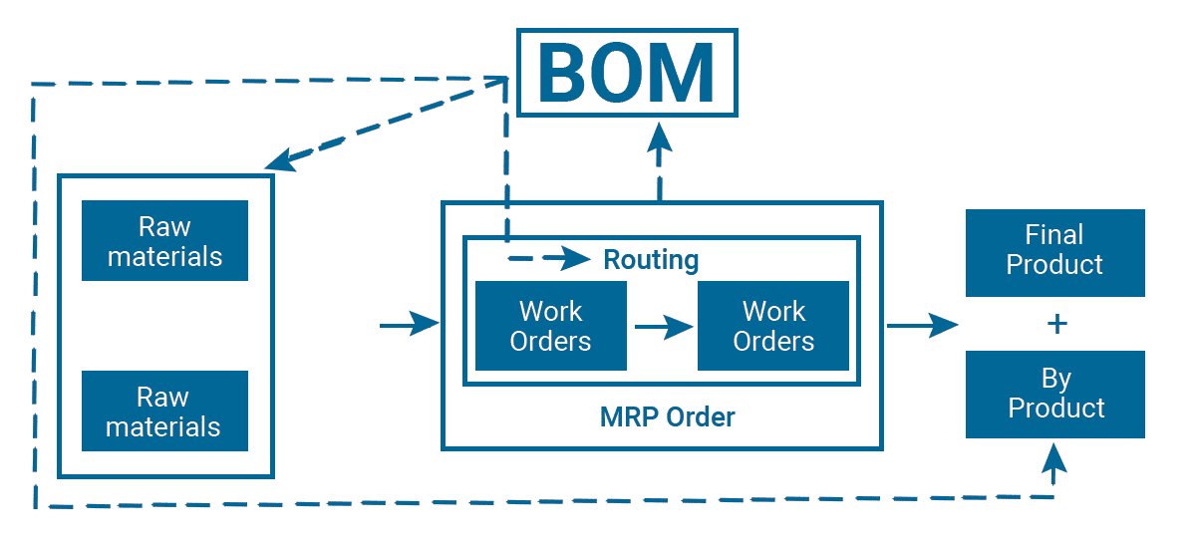

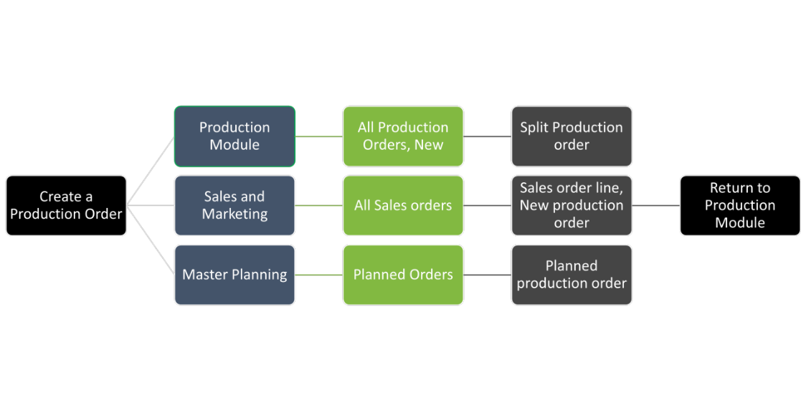
📘 Topics
- Production orders
- BOM & routing
- Scheduling
🛠️ Hands-on Exercises
- Create BOM
- Create production order
- Report production as finished

📊 MODULE 9 — Master Planning
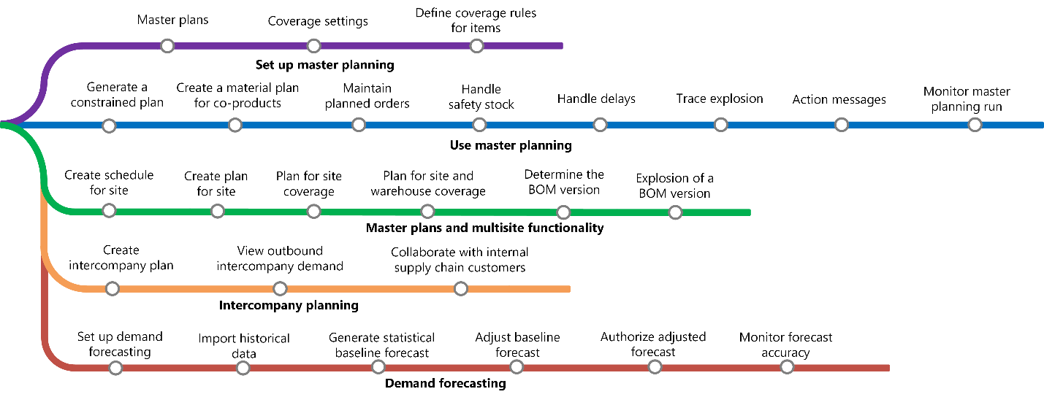
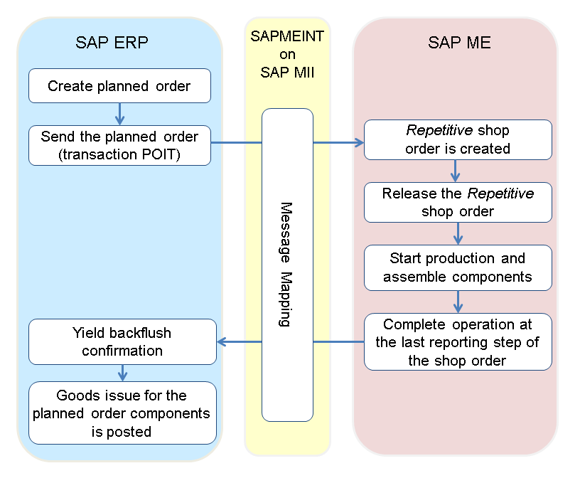

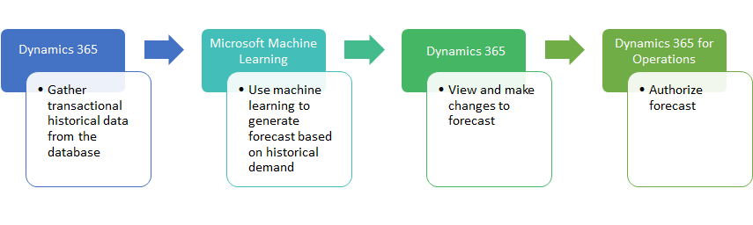
📘 Topics
- MRP concepts
- Master planning setup
- Planned orders
🛠️ Hands-on Exercises
- Run master planning
- Review planned orders
- Firm planned orders

🔐 MODULE 10 — SCM Security & Controls
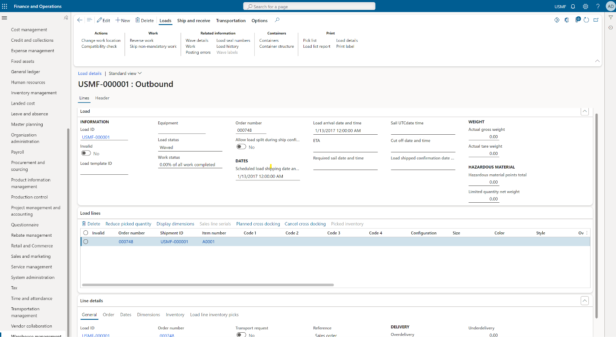
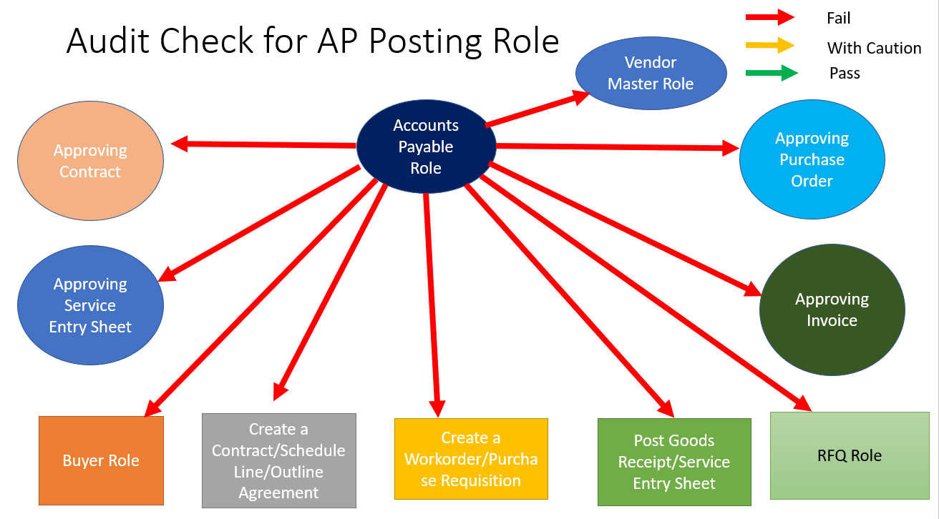
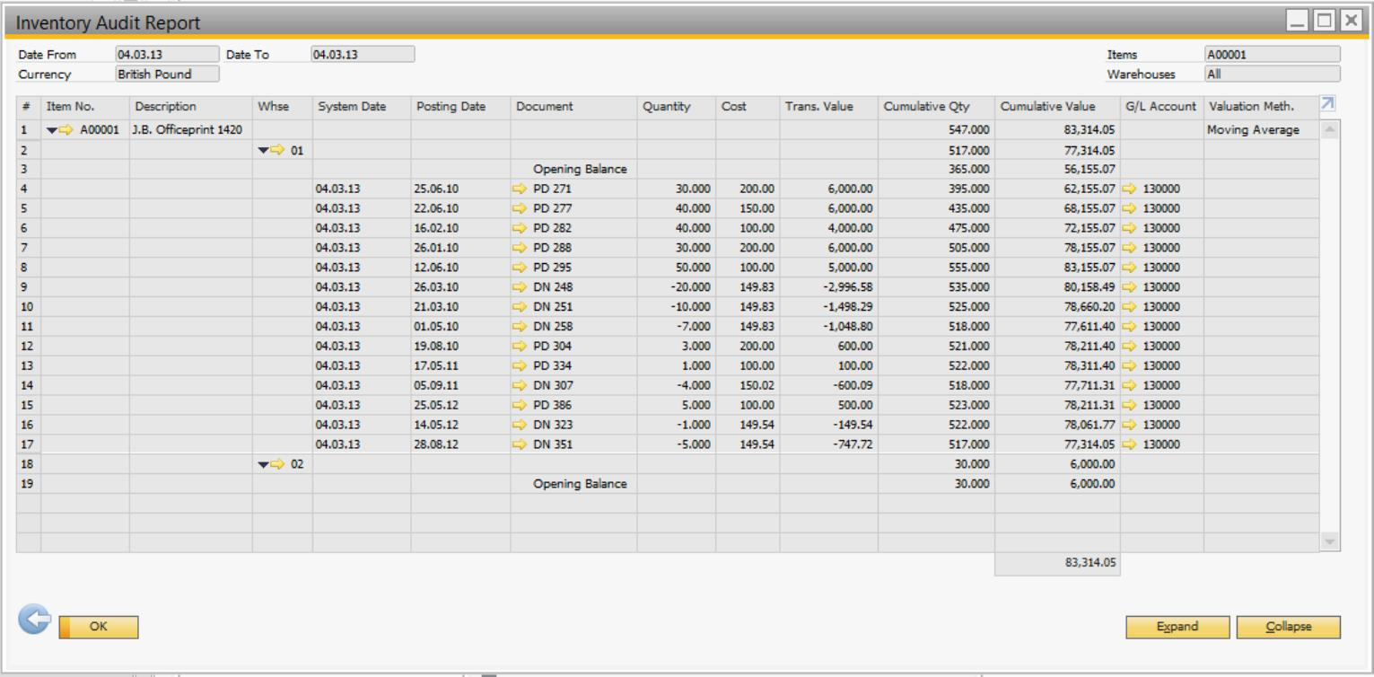
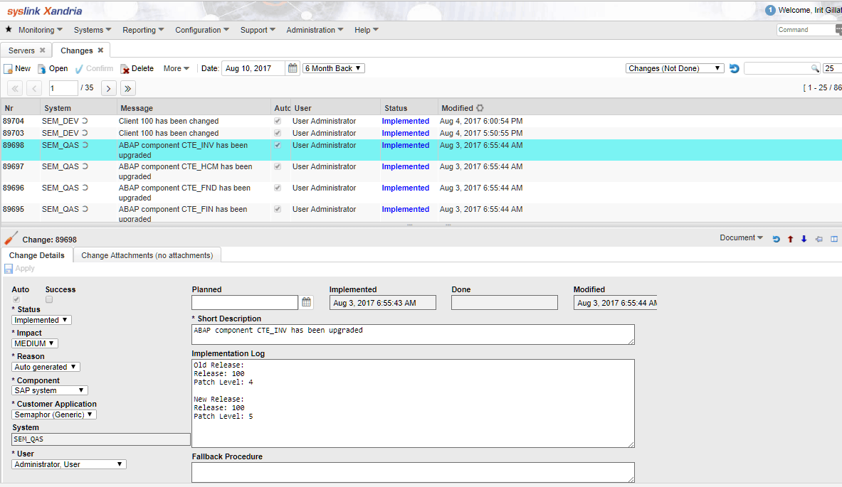
📘 Topics
- Roles & permissions
- Inventory control
- Audit tracking
🛠️ Hands-on Exercises
- Assign SCM role
- Restrict warehouse access
- Review audit logs

⚙️ MODULE 11 — Period Close (Inventory & Operations)
📘 Topics
- Inventory close
- Reconciliation
- Operational validations
🛠️ Hands-on Exercises
- Perform inventory close
- Reconcile stock vs ledger
- Validate discrepancies

🧠 MODULE 12 — Real-World SCM Processes
📘 Topics
- Procure-to-Pay (P2P)
- Order-to-Cash (O2C)
- Plan-to-Produce
🛠️ Hands-on Exercises
- Execute full P2P cycle
- Execute full O2C cycle
- Execute production flow

🚀 MINI PROJECT (CAPSTONE — SCM SYSTEM)
🎯 Project: “End-to-End Supply Chain System”
Scope:
- Create products & variants
- Setup inventory structure
- Procure goods (PO → Receipt → Invoice)
- Sell goods (SO → Delivery → Invoice)
- Manage warehouse (picking/packing)
- Run master planning
- Perform inventory costing & close
Expected Outcome:
✔ Full SCM lifecycle
✔ Covers all modules
✔ Real-world readiness

🔥 20 REAL-WORLD SCM INSIGHTS
- Inventory accuracy is everything
- Item setup drives system behavior
- Warehouse design impacts performance
- Master planning requires clean data
- Procurement errors affect entire chain
- Sales flow must align with inventory
- Costing errors impact finance
- Always validate item dimensions
- Warehouse processes must be efficient
- Automation reduces manual errors
- Batch jobs impact planning
- Understand physical vs financial updates
- Reconciliation is critical
- Data consistency across modules is key
- Integration impacts supply chain
- Timing of transactions matters
- Always test end-to-end scenarios
- Edge cases happen frequently
- Communication across teams is vital
- Continuous improvement mindset

🎯 INTERVIEW PREPARATION CHECKLIST
🔹 Functional Knowledge
- Inventory management
- Procurement
- Sales process
- Warehouse management
- Master planning
🔹 Scenario-Based
- How to handle stock mismatch?
- How to optimize warehouse process?
- How to handle delayed procurement?
🔹 Practical
- Walk through P2P
- Walk through O2C
- Explain inventory flow
🔹 Behavioral
- Problem-solving
- Process understanding
- Communication

🏁 FINAL TRANSFORMATION GOAL
A person completing this should be able to:
✔ Manage supply chain processes end-to-end
✔ Configure SCM modules
✔ Handle real-world operations
✔ Work in D365 SCM projects

💡 FINAL MESSAGE
“Supply Chain is not just movement of goods.
It is the heartbeat of operations.
If you master this,
you control how business flows.”

