🚀 Dynamics 365 Finance & Operations (D365 F&O) Technical
Ultimate Guide

🧱 MODULE 1 — Foundations
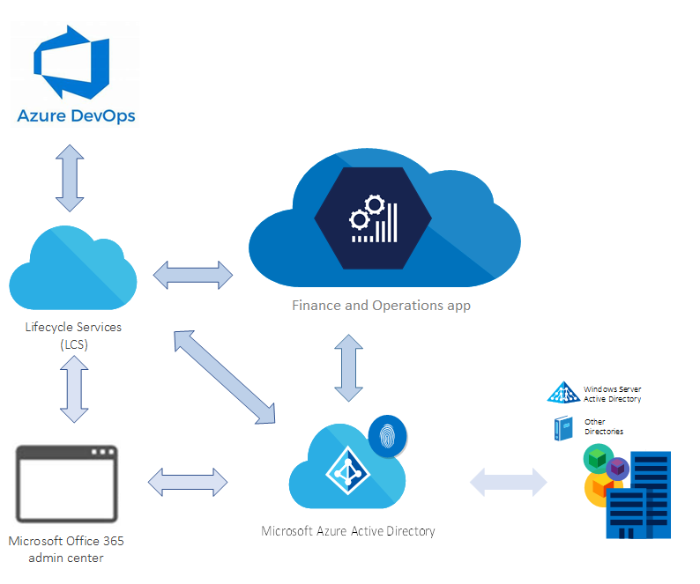
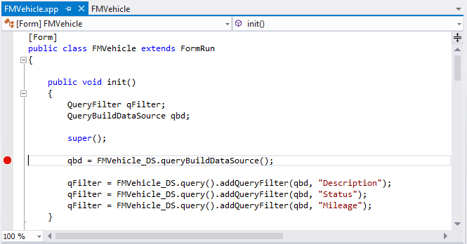
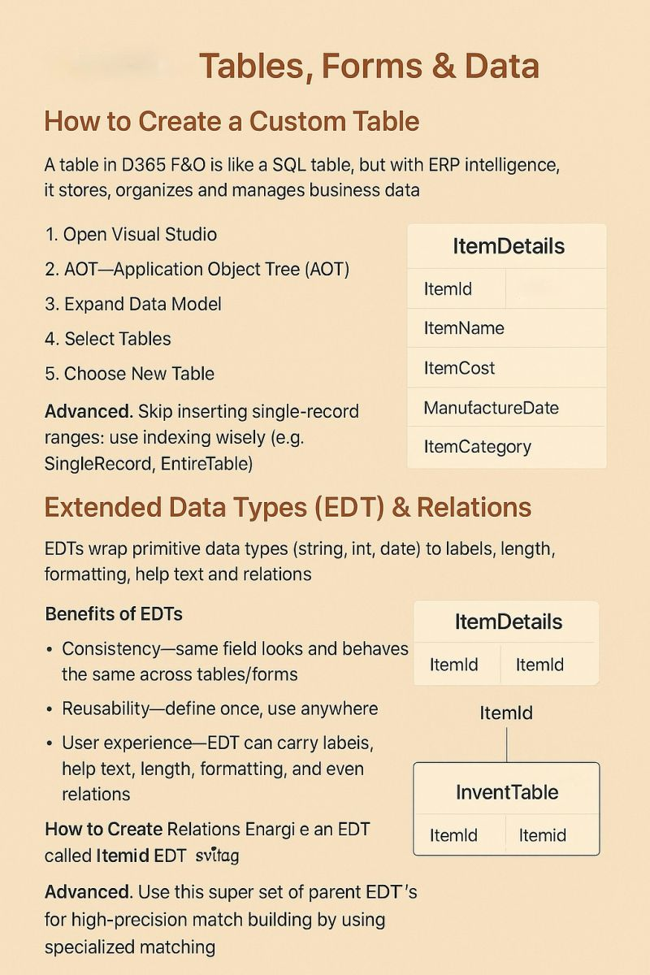
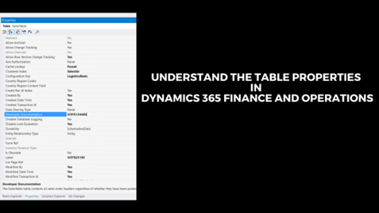
📘 Topics
- ERP fundamentals
- D365 F&O overview
- LCS & environments
- AOT structure
🛠️ Hands-on Exercises
- Explore AOT: identify Tables, Forms, Classes
- Login to environment and navigate modules
- Identify 3 standard tables and their purpose

⚙️ MODULE 2 — X++ Programming
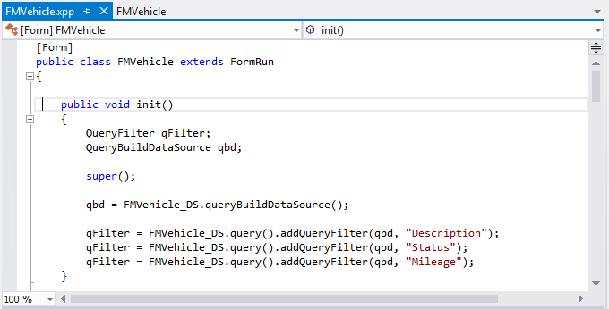
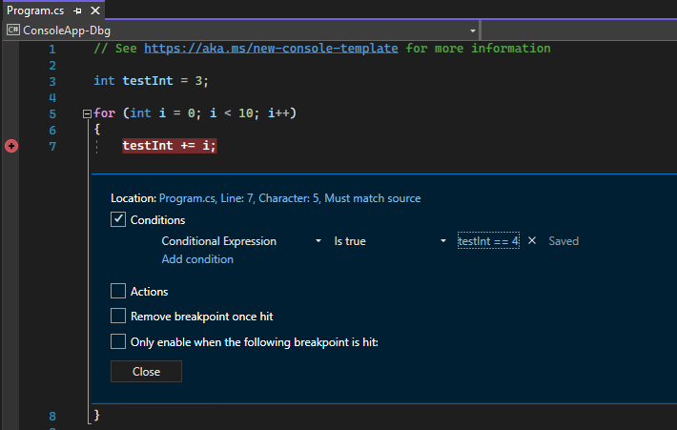

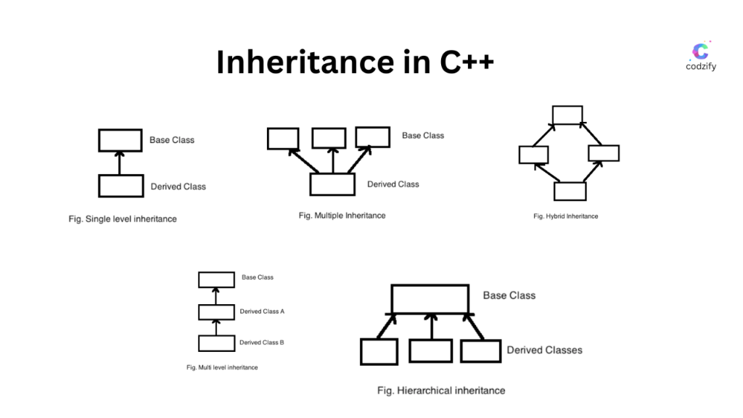
📘 Topics
- Data types, control flow
- OOP concepts
- Collections & queries
- Debugging
🛠️ Hands-on Exercises
- Write a class with method returning customer info
- Loop through records using while select
- Debug a class using breakpoints

🗄️ MODULE 3 — Data Model & Tables
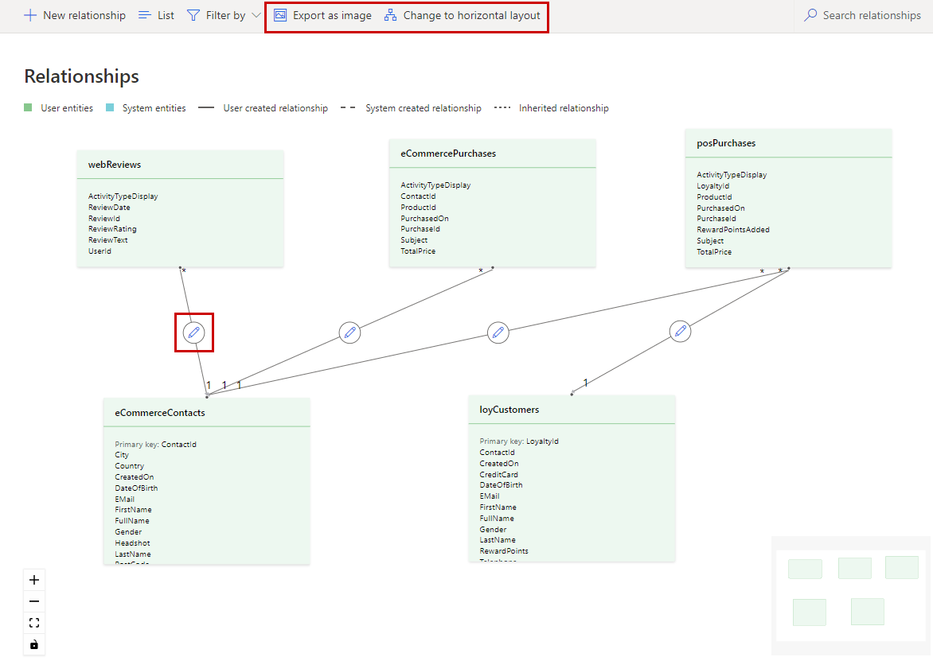
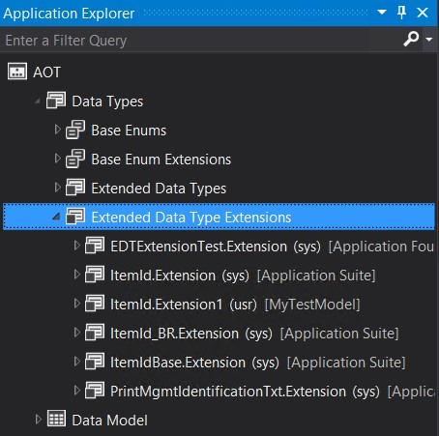

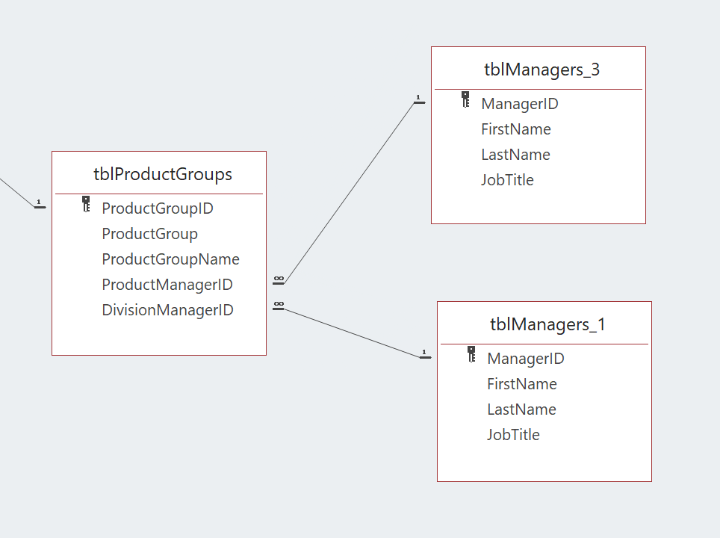
📘 Topics
- Tables, EDTs
- Relations
- Indexes
- Table methods
🛠️ Hands-on Exercises
- Create custom table with fields
- Add relations to another table
- Override insert() method

🖥️ MODULE 4 — Forms (UI Development)
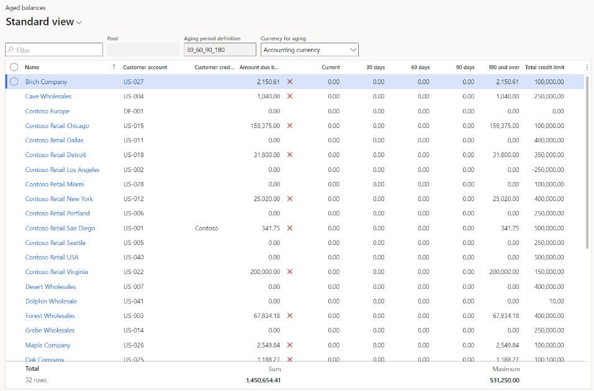
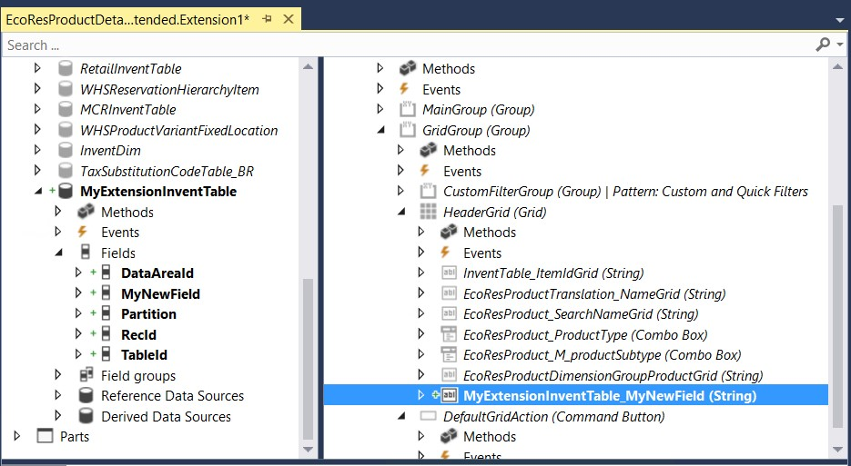
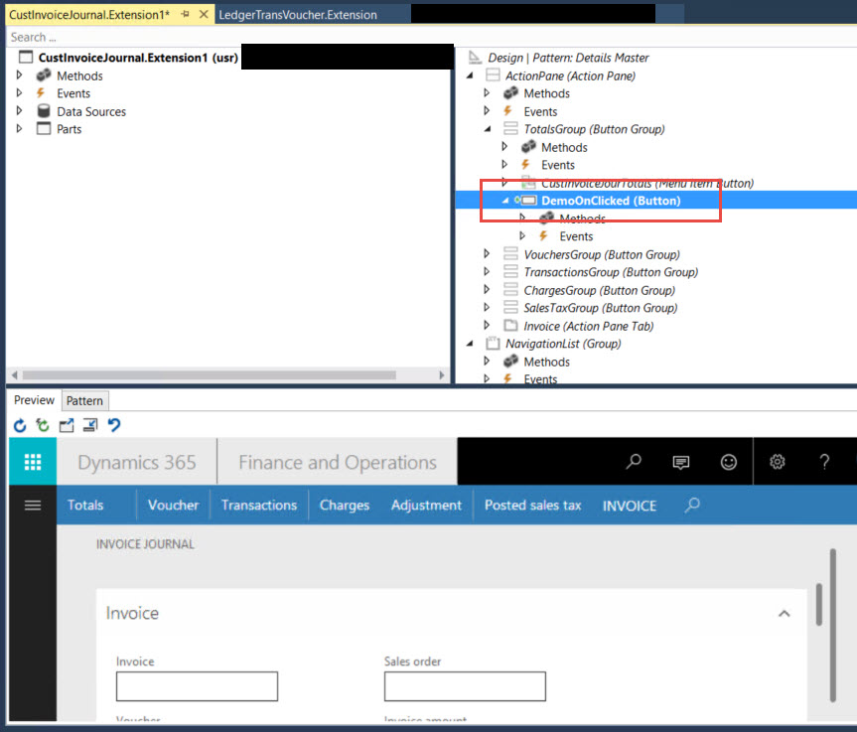
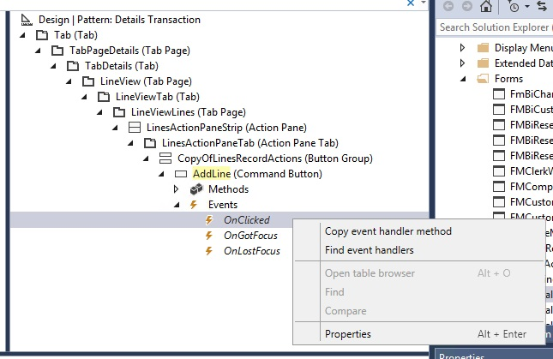
📘 Topics
- Form structure
- Controls
- Patterns
- Events
🛠️ Hands-on Exercises
- Create a form for your custom table
- Add grid + data source
- Add button with action logic

🧩 MODULE 5 — Extensions & Customization
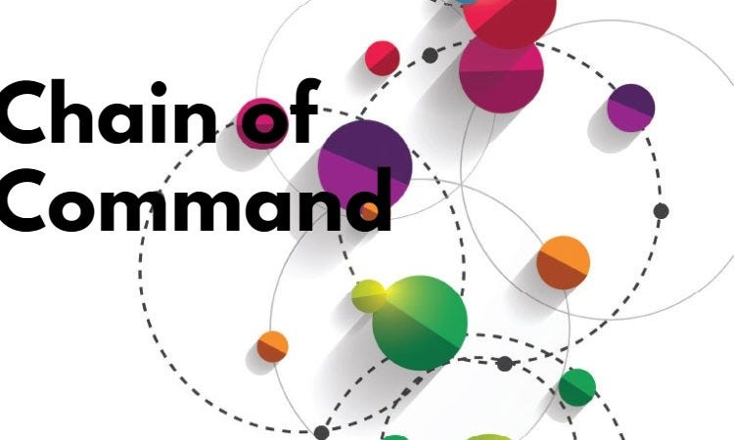
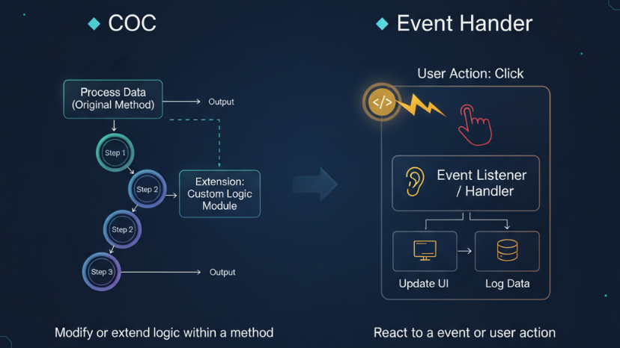
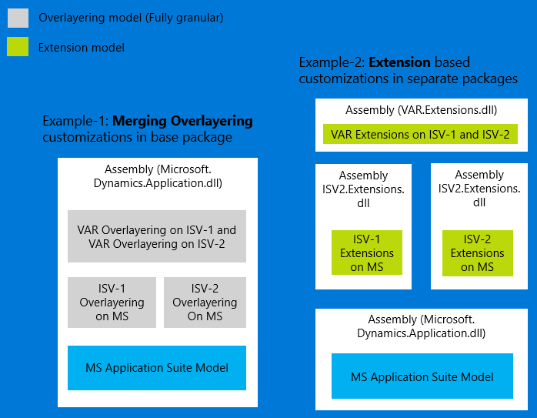
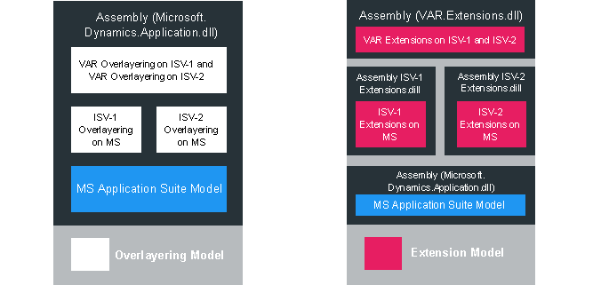
📘 Topics
- Extensions
- Chain of Command
- Event handlers
🛠️ Hands-on Exercises
- Extend standard table (add field)
- Use CoC to modify method
- Create event handler for form

🔄 MODULE 6 — Data Management & Integration
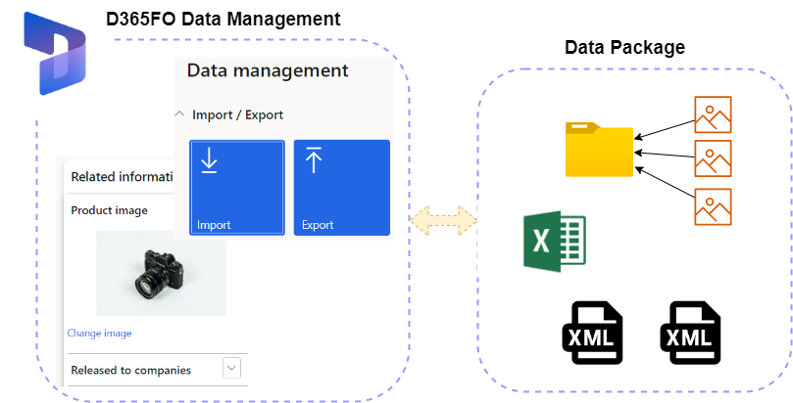
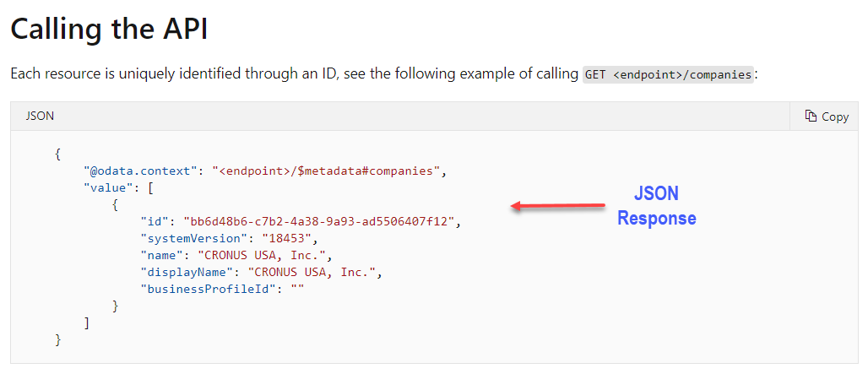
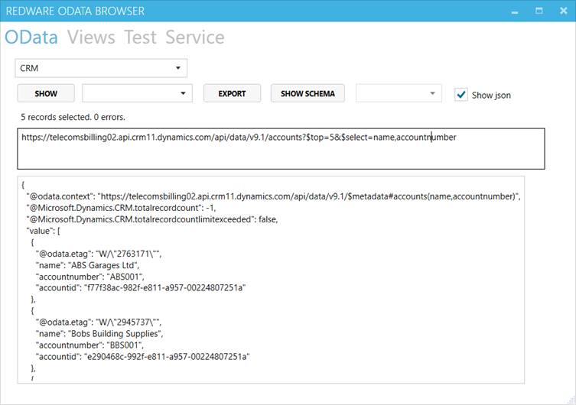
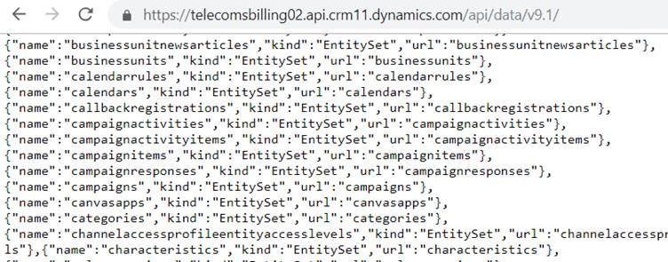
📘 Topics
- Data entities
- DMF
- OData & APIs
- Integration patterns
🛠️ Hands-on Exercises
- Create custom data entity
- Import data via Excel
- Expose entity via OData

⏱️ MODULE 7 — Batch Jobs
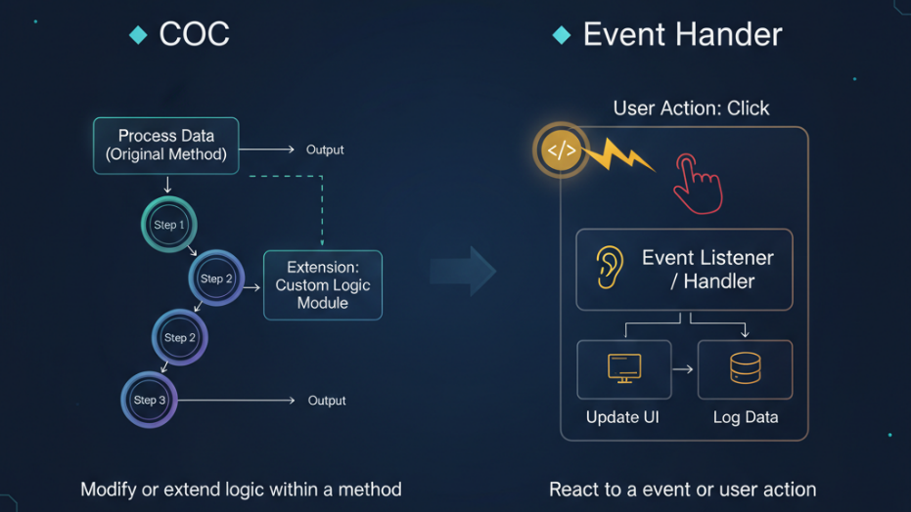
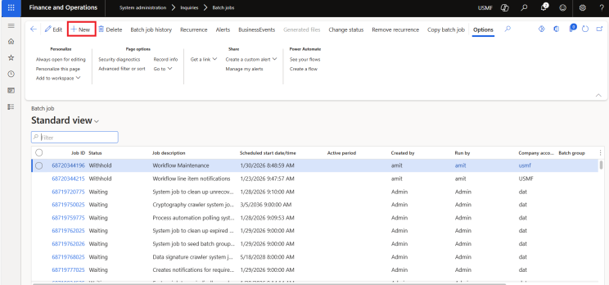
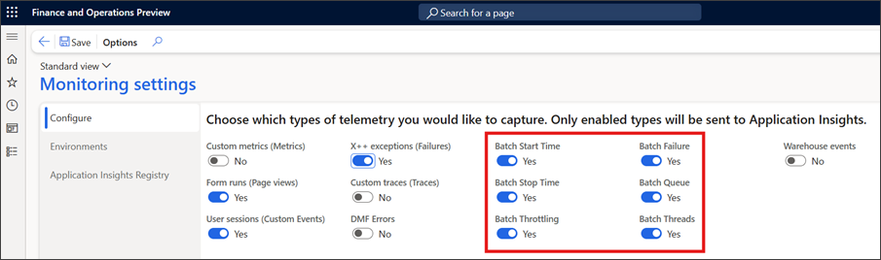
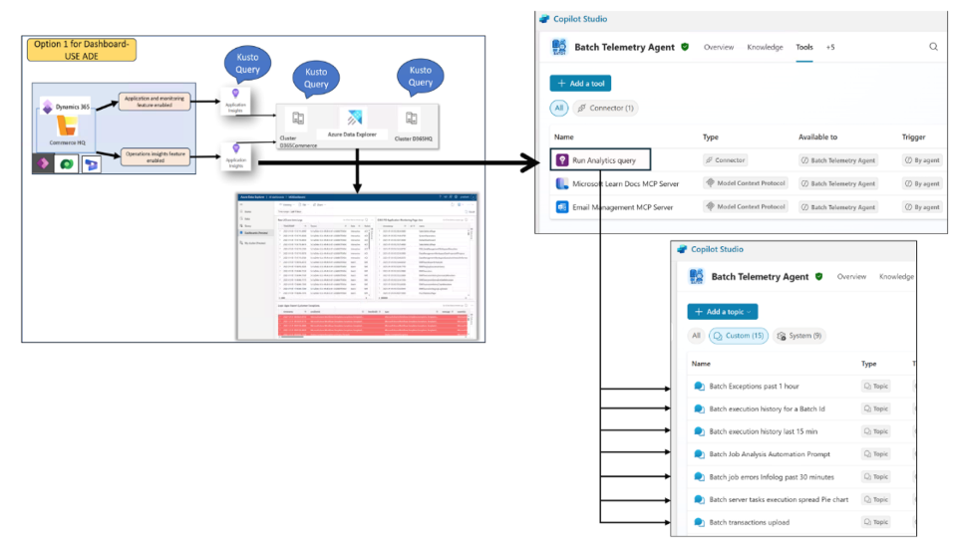
📘 Topics
- SysOperation framework
- Batch scheduling
- Monitoring
🛠️ Hands-on Exercises
- Create batch job using SysOperation
- Schedule job
- Log execution results

🔐 MODULE 8 — Security
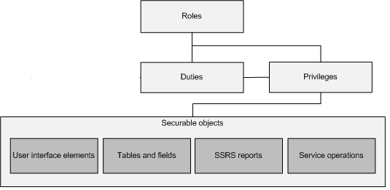
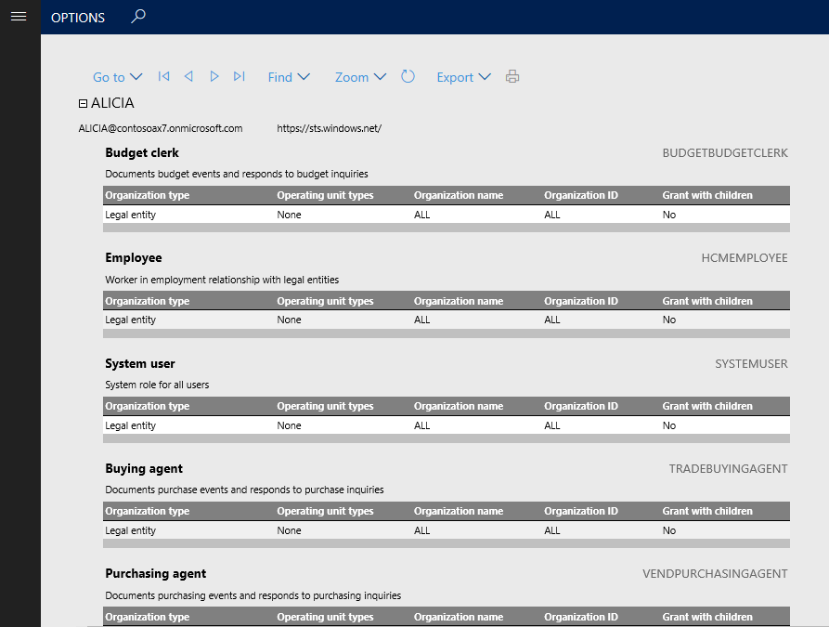

📘 Topics
- Roles, duties, privileges
- Security setup
- Data policies
🛠️ Hands-on Exercises
- Create new role
- Assign access to form
- Restrict data using policy

🧪 MODULE 9 — Testing & Debugging
📘 Topics
- Debugging techniques
- Data validation
- Logs
🛠️ Hands-on Exercises
- Debug failed transaction
- Trace data from table to form
- Validate business logic

🚀 MODULE 10 — Deployment & Lifecycle
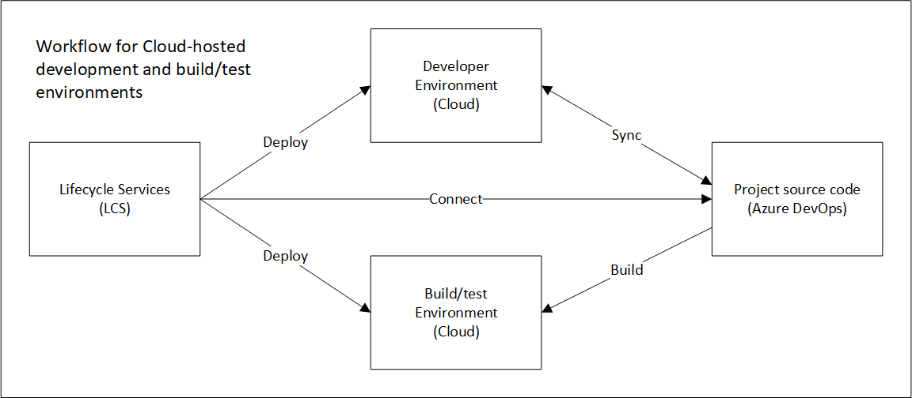
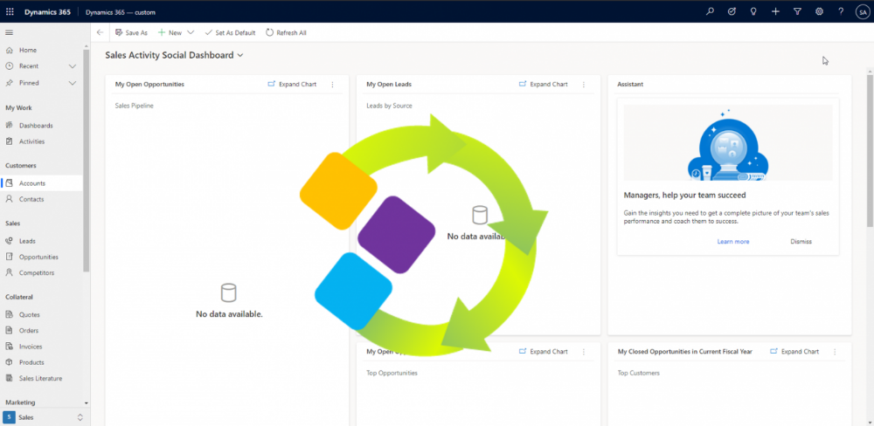
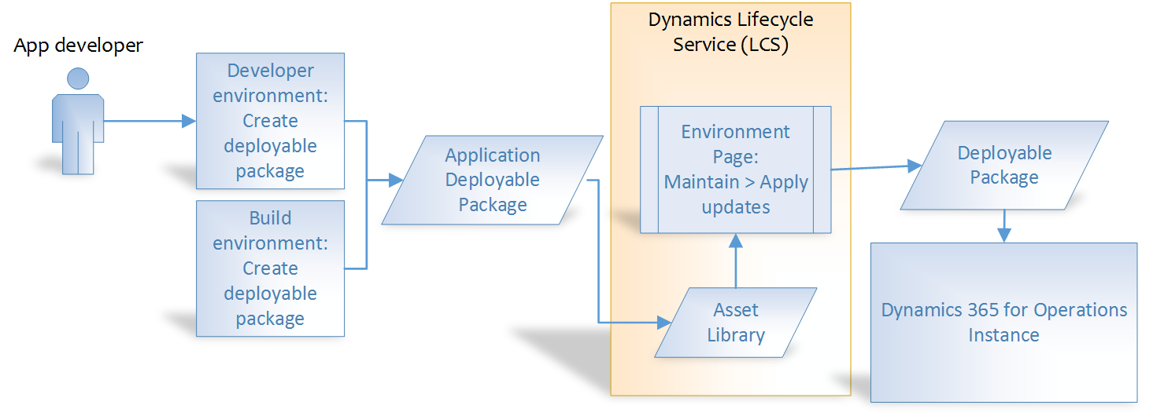
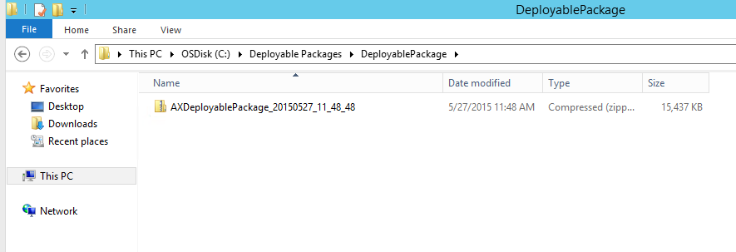
📘 Topics
- Build & deploy
- LCS
- DevOps
🛠️ Hands-on Exercises
- Create deployable package
- Deploy to another environment
- Track build pipeline

⚡ MODULE 11 — Performance
📘 Topics
- Query optimization
- Indexing
- Batch tuning
🛠️ Hands-on Exercises
- Analyze slow query
- Add index and test performance
- Optimize batch job

🧠 MODULE 12 — Real-World Application
📘 Topics
- End-to-end development
- Troubleshooting
- System flow understanding
🛠️ Hands-on Exercises
- Build feature from scratch
- Simulate error and fix
- Trace full data flow

🚀 MINI PROJECT (CAPSTONE — USES ALL MODULES)
🎯 Project: “Custom Order Processing System”
Scope:
Build a mini system including:
- Custom tables (Orders, Lines)
- Form UI for entry
- Business logic (validation, posting)
- Batch job for processing orders
- Data entity for import/export
- Security role
- Integration endpoint (OData/API)
Expected Outcome:
✔ Full end-to-end solution
✔ Covers 100% technical learning
✔ Real-world readiness

🔥 20 REAL-WORLD INSIGHTS (5+ Years Experience)
- Debugging skill > coding skill
- Always validate data before logic
- Never assume integration data is correct
- Understand business flow first
- Extensions over overlayering always
- Performance matters early
- Batch jobs can break systems silently
- Logs are your best friend
- Security issues are often overlooked
- Naming conventions matter
- Reuse standard framework wherever possible
- Avoid hardcoding
- Data consistency is critical
- Always test edge cases
- Small mistakes can impact large data
- Understand staging vs final tables
- Monitor jobs regularly
- Communication with functional team is key
- Learn how to read existing code
- Continuous learning is mandatory

🎯 INTERVIEW PREPARATION CHECKLIST
🔹 Technical
- X++ basics & OOP
- Tables, forms, extensions
- CoC vs Event handlers
- Data entities & DMF
- Batch framework
🔹 Scenario-Based
- How to debug issue?
- How to design feature?
- How to handle integration failure?
🔹 Practical
- Build small feature live
- Explain architecture
- Walk through code
🔹 Behavioral
- Problem-solving approach
- Learning attitude
- Real-world thinking

🏁 FINAL TRANSFORMATION GOAL
A person completing this should be able to:
✔ Build solutions end-to-end
✔ Debug real-world issues
✔ Understand system architecture
✔ Work in professional D365 projects

💡 FINAL MESSAGE (to Learner)
“This is not a course.
This is a journey.
If you follow this with discipline,
you won’t just learn D365 —
you’ll become valuable in the industry.”

