# Version History

* 06/03/2018
  + Game design document started;
* 13/04/2018
  + Added simple texture rendering;
  + Begun creation of physics system;
* 20/04/2018
  + Updated physics system and added player controls;
  + Added bricks and player-paddle textures;
  + Begun creation of the main-menu;
  + Begun creation of level editor;
* 27/04/2018
  + Completed physics system;
  + Updated level editor (placeholder button textures, can now drag blocks to position);
  + Created main-menu (placeholder button textures);
  + Added a basic “bump” ability;
* 03/04/2018
  + Begun creation of the map file saving system;
  + Bumping the ball now increases its’ speed;
  + Added smooth color animation to main-menu background;
* 10/04/2018
  + Added main-menu buttons;
  + Added button textures to level editor;
* 24/04/2018
  + Finished basic bump functionality (ball speed now resets, 3 different ball speeds)
  + Updated level editor (scalable blocks);
* 07/05/2018
  + Completed the map saving/load file system;
  + Updated player-paddle color-scheme;
  + Added lives system: game over on 3 balls lost
  + Added a “life counter” graphic to the player-paddle;
  + Added ball textures for the different bump stages;
  + Added third bump, the “Breakthrough” effect;
* 10/05/2018
  + Begun work on a map randomize function for the level editor;
* 28/06/2018
  + Completed map randomizer.

# Game Overview

Breakthrough is an arcade “Breakout” clone in which the player controls a special paddle to bounce a ball and break objects for points and to eventually clear the level.

The intent of this game is to give a more modern feel to the classic brick-breaker game with smoother, faster paced gameplay, many available abilities and even physics. The player will have to do more than just reflect the ball to effectively beat the levels, giving it a higher skill-ceiling.

# Game Details

### Description

Breakthrough is a single-player 2D arcade game in which the player (represented by the paddle) must shoot balls into the level and use special abilities to break objects to clear the stage, all while making sure the balls do not get past his paddle (leading to a game-over if the player has no more balls).

### World

The game takes place in each level, all of which are represented by an arena with 3 unpassable edges (above, left and right) and a passable edge on the bottom where the player (paddle) moves in. Inside this set arena each level will have a different setup of objects and obstacles.

### Length

Since new levels can be made relatively easily, the game is easily expandable - making it hard to guess how long the completed game will take to finish.

Due to the small scale of the game and the main objective being the destruction of the current level’s objects, each level should only last 1 to 4 minutes (on average) depending on the difficulty.

### Comparison

***Breakout (1976)*** - the original brick-breaker, this was the game started the genre - it is fairly simple: you ricochet the ball with the paddle and break as many blocks as possible before losing your three lives. As you get deeper in the level the blocks have different colors and become tougher. The ball also gets faster and the paddle smaller as you play.

Main difference: there’s only one level. The blocks are tightly packed left to right, forming an array every time you play the game.

***Arkanoid (1986)*** - an upgraded version of Breakout: Arkanoid adds levels, power-ups and even a storyline with a boss.

Main difference: While Arkanoid had the same idea as us - it took Breakout and “modernized it” - it did so over 30 years ago. The game was a big improvement over Breakout, but the improvements it had made are once again behind the currently available game making tools and playing machines, which means our Breakthrough can offer a much smoother, higher-resolution and more dynamic game.

Is it unique?

Due to the fact that brick-breaker games have a simple, basic ruleset and aren’t too complex programming wise, and due to the lengthy legacy of the genre there’s probably been thousands of different takes on brick-breaker games created before today, either by triple-A game companies or by flash-game-making solo students - so adding something truly new and unique to a brickbreaker is probably very hard.

Why make this game then?

Making a complex brickbreaker game is a great way of learning game programming, and allows us to have a playable game very early on - we can setup a basic brickbreaker game and optimize it before moving onto the more complex planned mechanics, and then we can safely work on each mechanic one by one, always being near the next “fully working version”.

This means we can go as far as we can, while not being scared of deadlines and without having to fix lots of bugs at once.

Audience and Marketing

### Target Audience

The target audience are teenagers and adults.

It’s a retro-genre arcade game which is easy to understand, but it requires precise, fast inputs and some prediction abilities to play effectively, so our target audience is comprised of skillful gamers who can enjoy some challenge, and retro-game enthusiasts who’d appreciate our modern take on the old genre.

### Top Performers

There have been a number of unique takes on the brickbreaker genre which got a relatively small but dedicated following: [Wizorb](https://en.wikipedia.org/wiki/Wizorb) (an RPG), [Shatter](https://en.wikipedia.org/wiki/Shatter_(video_game)) (heavily physics-based with a storyline) and [Strikey Sisters](http://store.steampowered.com/app/643880/Strikey_Sisters/) (combat and action, with emphasis on co-op).

While not a very mainstream genre, reviews on these games clearly show that there is a albeit small, loving playerbase awaiting for the next good take on the brickbreaker genre.

### Feature comparison

Our game follows a path like Shatter’s: it doesn’t stray far from the original breakout, keeping gameplay on a simple levels system and having the simple objective of clearing the level without losing all your lives/balls.

Feature Set

### General features

The victory and loss rules are the basic Brickbreaker rules: you must break all the blocks to proceed and lose a ball if it gets past the paddle. You lose when you run out of balls.

Player abilities:

* Bump: the player can perform a “bump”, which if timed properly will give the ball faster speed and higher damage, eventually giving it the Breakthrough effect.
* Successive bumps: the player can stack up to three successive bumps to make the ball more powerful but also harder to control:

0 bumps -> The ball moves slowly and deals 1 damage per hit;

1 bump -> The ball moves slightly faster and deals 2 damage per hit;

2 bumps -> The ball moves much faster and deals 3 damage per hit;

3 bumps -> The ball moves extremely fast and gains the Breakthrough effect.

* Breakthrough effect: If the ball deals enough damage to destroy a brick, instead of being reflected away it keeps moving forward. This effect remains until the ball leaves the stage or bounces off the player-paddle without being bumped.

Blocks:

* Normal blocks: damaged by any ball, can take 1 to 3 damage before breaking
* Invincible blocks: invulnerable, unmoving wall block;
* ~~Hard block: this block can only be damaged with Bumped balls;~~
* ~~Shield block: this block is completely invulnerable in one direction, but Bumped balls can punch through the shielded side (and then destroy the shield block by hitting it from behind);~~
* ~~TNT block: explodes, damaging nearby blocks once.~~

### Level Editor

The level editor allows the developers and the players to easily create the game’s levels. The user can create a level freely by drag-and-dropping bricks from the toolbox to the map, which can then be moved again, scaled up and down, or deleted.

At any time the user may quit without saving, or save the map, which adds the current map to the end of the levels list, stored permanently in a save file.

User Interface

# Main-menu

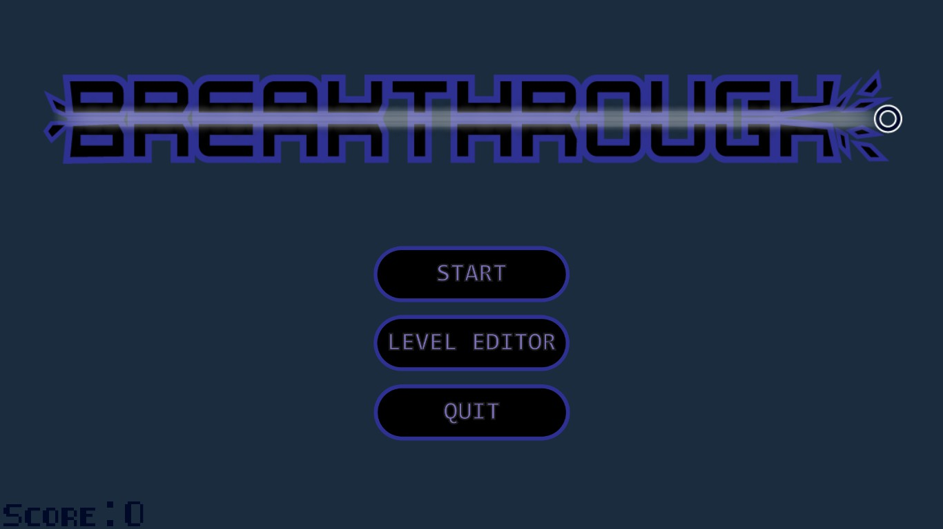

### Features:

* Game title sprite;
* Smooth color-animation background;
* Functions:
  + Start
  + Level Editor
  + ~~Options~~
  + Quit

# Level Editor

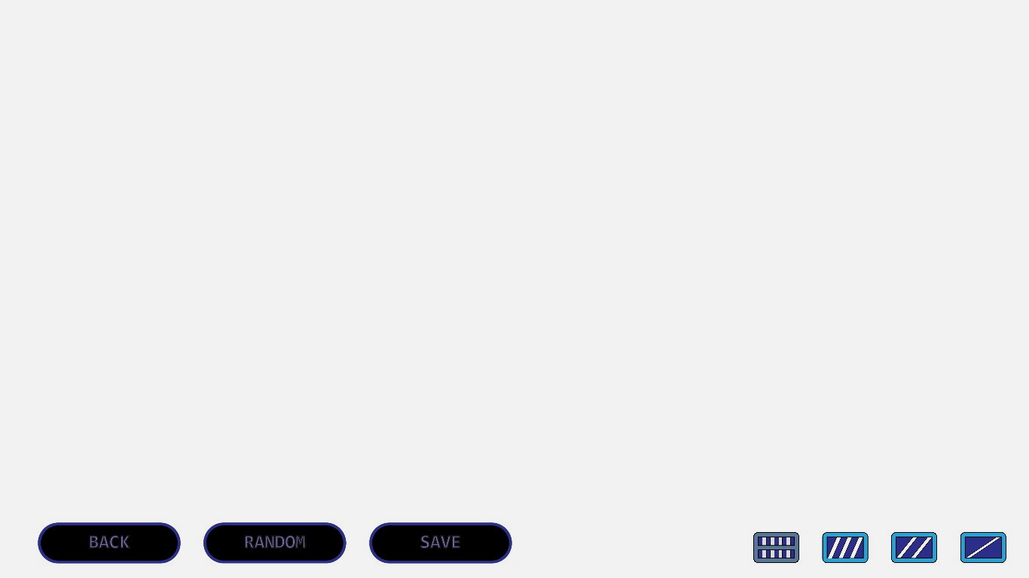

### Features:

* Clean, white background for easier level design;
* Functions:
  + Back button
  + Randomize map menu
  + Save button
  + Drag-and-drop bricks

# Level Editor



### Features:

* Clean, white background for easier level design;
* Functions:
  + Back button
  + Randomize map menu
  + Save button
  + Drag-and-drop bricks

# Random Map Generator

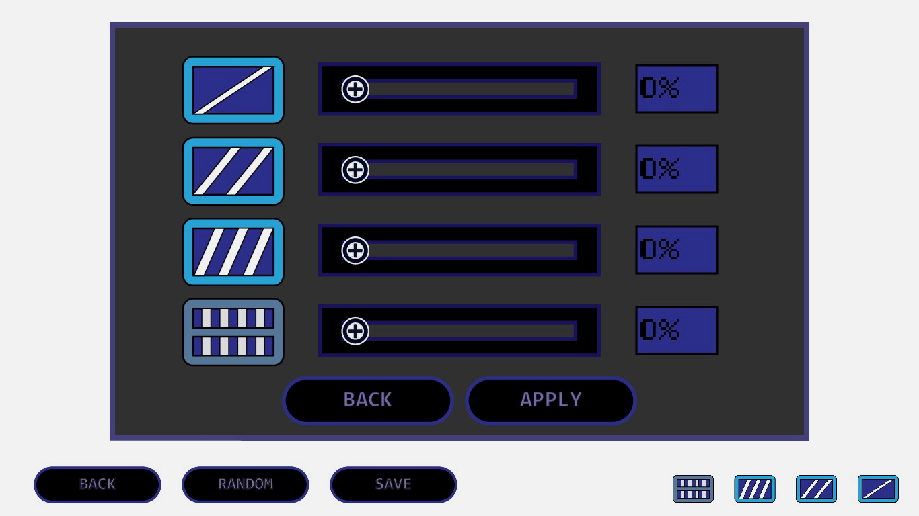

### Features:

* 4 bars which control percentage of each type of block, with a maximum total sum of 100%
* Percentage indicators
* Apply button which generates the map;
* Back button which cancels the operation;

Ingame

### 

### Features:

* Static blue background;
* The current map’s blocks;
* Ball;
* Balls-left counter displayed as white bars in the player-paddle.
* Current score;