Video Classification

Did you know?
- The very first YouTube video was uploaded on 23 April 2005.
- The total number of people who use YouTube – 1,300,000,000.
- 300 hours of video are uploaded to YouTube every minute!
- Almost 5 billion videos are watched on Youtube every single day.
- YouTube gets over 30 million visitors per day
- In an average month, 8 out of 10 18-49 year-olds watch YouTube.
- By 2025, half of the viewers under 32 will not subscribe to a pay-TV service.
- 6 out of 10 people prefer online video platforms to live TV
- The total number of hours of video watched on YouTube each month – 3.25 billion.
- 10,113 Youtube videos generated over 1 billion views.
- 80% of YouTube’s views are from outside of the U.S.
- The average number of mobile YouTube video views per day is 1,000,000,000
- The average mobile viewing session lasts more than 40 minutes. This is up with more than 50% year-over-year.
- Female users are 38% and male users are 62%.
- User Percentage by Age 18-24 – 11%, 25-34 – 23%, 35-44 – 26%, 45-54 – 16%, 50-64 – 8%, 65+ – 3%, unknown age – 14%.
- More than half of YouTube views come from mobile devices.
- YouTube’s mobile revenue is up to 2x y/y.
- YouTube overall and even YouTube on mobile alone reaches more 18-34 and 18-49 year-olds than any cable network in the U.S.
- The number of hours people spend watching videos (aka watch time) on YouTube is up 60% year-over-year, the fastest growth we’ve seen in 2 years.
- You can navigate YouTube in a total of 76 different languages (covering 95% of the Internet population).
- YouTube has launched local versions in more than 88 countries.
- 9% of U.S small businesses use Youtube
- Approximately 20% of the people who start your video will leave after the first 10 seconds.

Motivatie
Traim in era informatiilor. Datele circula pe internet cu o viteza si debit pe care nici nu ni-l imaginam. Cu atat de multe date in jurul nostru, este greu sa deosebim continutul util, interesant de spam-uri si reclame. Din fericire, odata cu extinderea ariei informatiilor se dezvolta si noi tehnologii care ne ajuta sa alegem ceea ce ne intereseaza, astfel incat sa nu pierdem timp sa alegem ceea ce ne dorim sa accesam.

Un astfel de tool poate fi clasificatorul de videoclipuri. El analizeaza continutul videoclipului pe care il urmaresti la un moment dat pentru a-ti sugera ce videoclip ti-ar placea sa urmaresti in continuare.

Setul de date
Pentru antrenare, am folosit videoclipurile din setul de date de la Center of Research in Computer Vision, UCF11. Acesta contine 11 clase de videoclipuri din aria activitatilor umane (basketball shooting, biking/cycling, diving, golf swinging, horse back riding, soccer juggling, swinging, tennis swinging, trampoline jumping, volleyball spiking, and walking with a dog). Modelul poate fi, insa, extins, antrenand un set de 101 clase de videoclipuri (UCF101), set de date pus la dispozitie tot de cei de la Center of Research in Computer Vision.

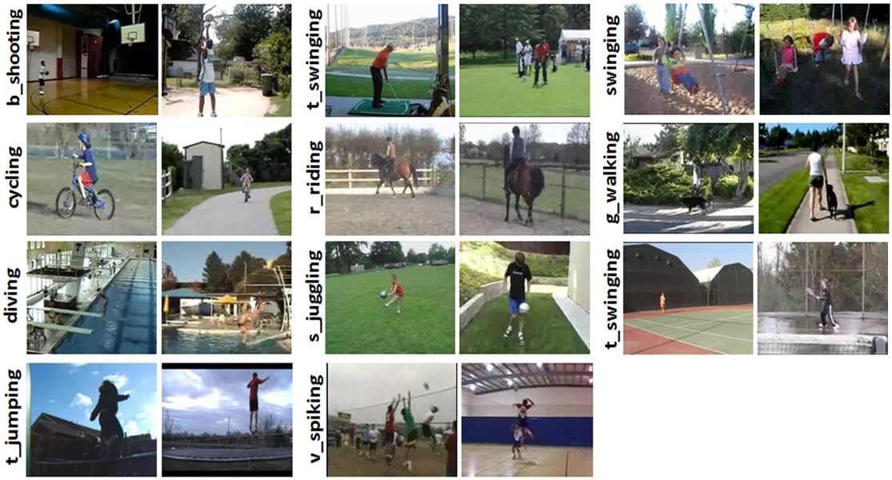
Tehnologii folosite
Keras este un framework open source scris în Python pentru crearea unor retele neurale complexe. Este capabil să ruleze pe TensorFlow, Microsoft Cognitive Toolkit, Theano sau MXNet. Proiectat pentru a permite experimentarea rapidă cu Deep Neural Networks, este ușor de utilizat, modular și extensibil.
OpenCV este o biblioteca de funcții open source proiectata astfel icat sa ofere eficiența computationala pentru aplicații de computer vision în timp real. Scopul librariei este de a pune la dispoziție potentialilor utilizatori o infrastructura de procesare a imaginilor ușor de folosit ce poate fi utilizata ușor în dezvoltarea aplicatiilor complexe.

Referinte
http://crcv.ucf.edu/data/UCF_YouTube_Action.php
https://keras.io/
https://github.com/sagarvegad/Video-Classification-CNN-and-LSTM-
http://opencv-python-tutroals.readthedocs.io/en/latest/py_tutorials/py_gui/py_image_display/py_image_display.html

