**The title of your paper**

**Your name**

**Your institution**

Content

Introducti

on

**How does Kazakhstan educational system compete in the world?**

**Shymkent, history teacher at Nazarbayev Intellectual School of Physics and Mathematics in Shymkent Daniyar Baytreyeev Sharipbekovich**

**Summary**

It is obvious that Kazakhstan's educational standards are one of the most pressing social issues today. Authors of the article have presented the stages and difficulties of the national education system as well as means to solve them.The article considers features of the world

educational system and the opportunities available today to support and achieve high results.

In any society, national competition is determined by its level of education. Education systems in rapidly evolving processes become the driving force of economic growth and global competition. This is a factor that affects the national security and welfare of the state. The education and upbringing of young people in accordance with the current standard of living is one of the main tasks facing society in Kazakhstan. Education is a continuous process of teaching and learning, aimed at ensuring a high level of professional and ethical culture of moral, intellectual and cultural development of our future members of society.

The process of teaching the young in this country is based on national traditions, culture, economics and political life.

It is no secret that in recent decades the education system of Kazakhstan has undergone radical changes. The newly introduced changes are based on global experiences. The amendments were approved on December 7, 2010 as the State Program for the Development of Education in the Republic of Kazakhstan for 2011–2020 [4].

The topic of my studies is closely related to the major transnational changes in the current education system, according to which “education standards in the Republic of Kazakhstan are as competitive as all international standarts ”. Many students have adapted to the learning process for this changing program, and since this is our share, the issue of the education system is very motivational.

To this effect, we are setting a goal to continue our research:

Objective: To compare the new knowledge-based education standards with other countries with advanced education, analyzing the impact and benefits of changes in the education system in Kazakhstan and evaluating the country's methods in a study of the public education system.

**Questions:**

**-** What fundamental changes were made to the education system of Kazakhstan?

What are the opportunities and advantages of the State Program for the Development of Education for 2010-2020?

- What do the results indicate with regard to the new knowledge system?

- What are the differences in the quality of education in Kazakhstan?

The formation of the education system of Independent Kazakhstan began in 1991-1994. At the same time the state developed its own system concept which led to the creation of an education system at an acceptable level. At the next stage of development, the task was to reorganize the state education system. As a result, two sub-programmes were developed for 2001-2010: 2001-2004 and 2005-2010 [5] It has been implemented since 2003. In Kazakhstan the transition to a market economy in recent years and the policy of the education system is aimed at finding ways of matching the market economy [1]. In this regard, the main document was raised for 2011-2020. Within the project, several new changes were made to the state:

The beginning of the transition to a 12-year education system which consisted of three stages was in the Address of the Head of State to the people of Kazakhstan: “... they start learning in school - that is why we must switch to a 12-year general secondary education ”[4].

- transfer of secondary schools’ skills to the e-learning system;

- increase the number of Nazarbayev Intellectual Schools, covering all regions - 20;

- determine the quality of training for students in secondary schools through international research and forecasts: the assessment of the literacy of mathematics and science - PISA2 and TIMSS3;

Recent changes in the long-term program “Kazakhstan-2030” should correspond to the educational system of the OECD in order to be included in the list of 30 developed countries based on the requirements of the global education system. The main source of experience in a market economy and the standards of modern world education is OECD1 [2]. The main requirements of the quality education system of the OECD are the availability of qualifications and flexibility for any new changes. For example, the availability and quality of the knowledge gained and the effective use of resources in the learning process and its transparency. OECD experts reviewed and analyzed the education system of Kazakhstan for two years, analyzing its shortcomings and development. [13] The experience of this organization is in the formulation of the education system in Kazakhstan, the state of the investment climate and the future of this sector. The results of studies conducted in 2015 show that the conditions of the educational environment in Kazakhstan are lower than those of OECD countries. At the same time, the comparison of the financial part of the education sector of Kazakhstan is inadequate. [2] However, as a result of international testing of the OECD PISA, pupils of secondary schools in Kazakhstan are among the top ten countries.

Speaking of developing a world-class competitive education system, the Harvard University Press book written by Goldin and Katz, "Race between technology and education" gives a clear distinction and harmony. At the same time, we interviewed experts at the Center for Pedagogical Skills in Shymkent.

During the interview, the following questions were asked:

- How was the education system formed over the last three years?

- How close is the education system to world standards?

- What is the harmony of world standards of education and public awareness?

- What additions would you add to educational programs in the education system?

The head of the Center for the Improvement of Pedagogical Skills in Shymkent Zhamira Saparbayeva noted that today work with school teachers is improving intensively, and the quality of education is increasing. And new changes in this global education system are consistent with the consciousness of society: the problem of textbooks in the new educational system is becoming ever more relevant. At the same time, all changes were directly related to the teachers. At present, the average salary of teachers in developed countries, particularly in Finland or Japan, is higher than in our country, and the requirements and obligations put forward by these teachers are quite high. Zamira Saparbayeva gave the following argument in favor of this idea: for example, a graduate undergraduate in Finland can provide only primary or secondary education, and senior teachers can only be obtained in the magistracy. In the last question, the interlocutor repeatedly compared his education with the Finnish education system. In particular, the need to supplement the programs developed in Kazakhstan - the introduction of a new system of programs in general education schools and some obstacles by integrating the updated education system for 2 years. For example, there were cases when some teachers could not attend refresher courses. As a result, these teachers taught the 5th grade class, without being fully experienced. This, of course, lowers the quality of education and reduces competitiveness. Similar programs were also conducted in the state of Finland, and the Department of Education developed and implemented this project for 10 years.

The aim of the study is to identify the potential of Kazakhstan's educational work and its competitiveness. As a result of the work done questions were answered at the beginning of work.

According to the study, experts estimated the average level of education in Kazakhstan. When discussing the answers of experts, Kazakhstan pays great attention to education and increases its competitiveness. Equipping schools with the best technologies (eCommissioning 2016-2019), conducts various courses and sends them to neighboring countries to develop the experience of teachers [7]. If we discuss the mathematical performance of Kazakh students, PISA 2015 is a good indicator with 460 points. This means that a breakthrough occurred in the previous PISA 2012 [12]. In addition, the Republic of Kazakhstan became a member of the OECD in May 2017, and the international organization is engaged in determining a key indicator of world educational standards, thereby creating new opportunities for the education system of Kazakhstan [13].

The Kazakhstan education system faces some barriers to increase its global competitiveness. According to the OECD analysis, if the average government spending on education is 5-6% of GDP, in Kazakhstan this figure is 3-4% [3].

|  |  |  |
| --- | --- | --- |
| Funds allocated to education | Kazakhstan (2013) | OECD (2013) |
| Total,% | 3,8% | 5,6% |

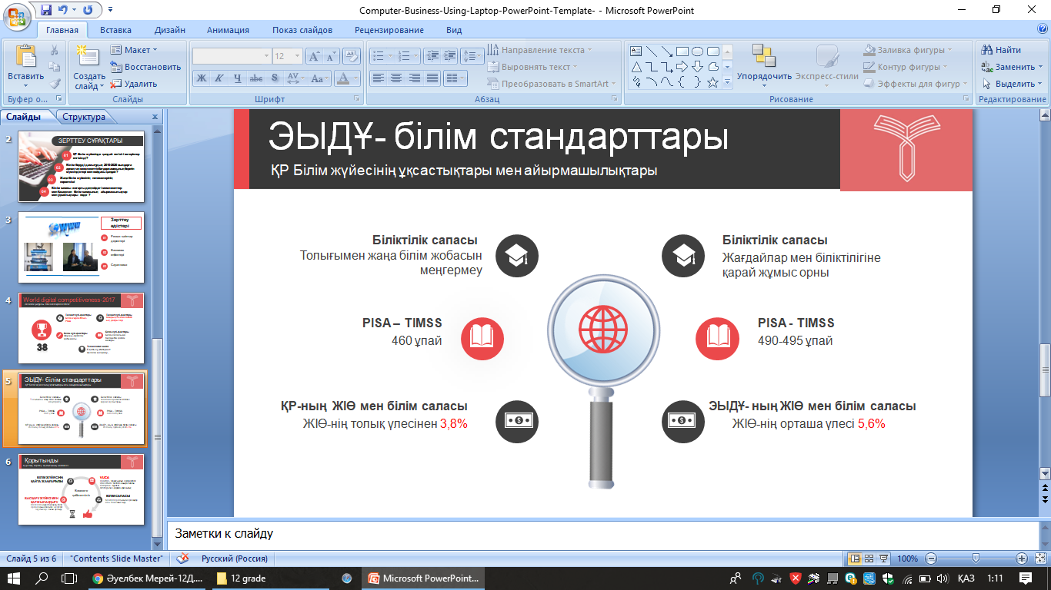

Picture-1-

According to the above diagram, it is clear that Kazakhstan has a higher level of education by the OECD than the average national income. However, according to international experts in 2015, the education system of Kazakhstan continues to use the inefficient use of educational resources and does not correspond to the indicators of urban and rural education.

The interviewer and respondents concluded that the main goal is aimed at increasing the competitiveness of Kazakhstan's education on the world stage and increasing our ability to build a school of education. There are six factors:

- correspondence of educational institutions with Halyk paralysis;

- the status of teachers and the professional qualifications of the staff;

- the correctness of the completion of training;

- the effectiveness of the education of younger generations;

- scientific essays in educational literature;

- The effectiveness of the education management system. [14]

Currently, the programs are aimed at improving the competitiveness of the Kazakh education sector. To meet the requirements of the current efforts of the OECRA have borne fruit. There are still deficiencies in the field of education. OECD is one of the main requirements for teacher qualifications necessary for this in our education system, the slow development of educational institutions, direction and goal: pragmatism and flexible learning in the VUCA world (volatility, vulnerability, uncertainty, complexity, ambiguity - inconsistency), which leads to world competitiveness class source of increase. [eight]

|  |  |  |
| --- | --- | --- |
| **The level of educational the system in Kazakhstan** | **Future goals for the educational system of Kazakhstan** | **Strategies to achieve these goals** |
| **Training methods and resources**  On average, there are 16 children in a class, which is lower than the OECD index of 24 students. Until now, 189 schools were in poor condition due to lack of repairs, and 92 schools attended 3 shifts. 99.3% of schools have access to the Internet. 1 computer for 11.2 children. 527 schools are connected to the e-learning system. 34.2% of secondary schools have created Boards of Trustees [9].  However, according to the global competitiveness index for 2015-2016, Kazakhstan ranks 42nd, which, as has been proven in full compliance with 8 out of 12 indicators of education (quality of the education system, internet access of research institutes and secondary schools) [4 ] | All educational centers will have full electronic equipment and internet access; There are now three central educational centers and textbooks in a foreign language are included in the programs and will be translated into the Kazakh language in a new edition; | Higher education institutions to improve the quality of education, i.e. approve universities as a teaching and research institution; Provision of electronic equipment and resources: the introduction of elements of a fiber-optic education system through autonomous guardianship bodies in educational institutions; |
| **Current teacher qualifications** The current teacher remuneration system is fragmented and difficult to administer. The level of the teacher is connected with the load on the teacher, which prevents the use of creative and innovative teaching methods. Low system performance (the ratio of students and teachers is 8: 1). The average salary of teachers is 80.386 tenge, which is lower than the average monthly salary in Kazakhstan, which is about 110 thousand tenge. The initial wage of a teacher is 42,000 tenge, which is 30% of GDP per capita, and in OECD countries wages per capita is 95% of GDP per capita [9]. | The number of qualified teachers will increase; they can improve their language skills through independent certification, such as IELTS, TOEFL and teacher career development. The access of teachers to higher educational institutions will increase from secondary education to further educational institutions. | This situation may require careful analysis and rationalization of the school network and review of staff standards. In Kazakhstan, there are serious problems in attracting, selecting and training highly qualified candidates for the teaching profession. It is necessary to correct the urgent need for pedagogical education, and the system of career growth should correspond to the goals of improving the system of vocational training and professional development. Also teacher | It is necessary to have clear standards that meet the goals of formal education and vocational training and use these standards in teacher, student and teacher training programs. |
| **Student indicator**  PISA 2015 shows a good result with 460 points [10]. This shows that students of Kazakhstan participating in international testing compared with the previous PISA 2012 have a breakthrough in all aspects of the study. Mathematical growth was 28 points and 31 points in physical terms. | During the PISA 2018 survey among Kazakhstani students, the average score was 450, an average of 440 in science and more than 410 in educational literacy; | For the development of indicators it is necessary to develop the first two conditions. |

Education is a continuous process of learning and training aimed at ensuring a high level of professional and ethical development of the moral, intellectual and cultural development of members of society.

Education is a key factor in the development of each country. The education system influences the trend of direct economic growth and the human development index. For example, the system of secondary education for a period of 1 year (12 years) increases GDP by 0.44% or improves 50% PISA, Gross domestic product increases by 1% [4].

At present, the stereotypes of basic education are determined by the OECD indicators in the field of education of an independent organization. In this regard, the sources of the organization were obtained as a working post.

During the study, there is a difficulty in determining statistics of Kazakhstani international standards, since Kazakhstan has recently become a member of the OECD, and the results of the examination are now published more than in the other 34 countries. In addition, a quick review of the current reforms and a drastic change in the education system are comparable to the results of other countries. However, we are convinced that the initiative is in the right direction, and we are convinced of its success.

**Reference**

1. *http//www.*[*e-history.kz/ru*](http://e-history.kz/ru/contents/view/1541)
2. *http//www.*[*articlekz.com*](https://articlekz.com/article/10928)
3. *http//ww*[*w.oecd.org*](https://www.oecd.org/edu/school/ECECDCN-Kazakhstan.pdf)
4. *http//www.iac.kz*
5. *http//www.edu.gov.kz*
6. *http//www.*[*unesdoc.unesco.org*](http://unesdoc.unesco.org/images/0024/002457/245752R.pdf)
7. *State program for the development of education and science of the Republic of Kazakhstan for 2016-2019*
8. *Scientific research journal "Kғ &am & Dәir" №4 (52) 2016*
9. *1-RК the concept of 12-year education Astana, 2005. 2014. Development of strategic directions for reforming the education system of the Republic of Kazakhstan for 2015-2020. Diagnostic Report - Astana: Innprint, 2014*
10. *State Program for the Development of Education and Science of the Republic of Kazakhstan for 2005-2010*
11. *Education at Glance- 2016 World Education Monitoring System - UNESCO Edition 2016*
12. *Askarbek Kusainov, “The quality of education in the world and in Kazakhstan*
13. *Pr. Goldin & Katz The race between technology and education*