AIVCtrl

Contenu

Description 3

Installation 4

Home page 5

Content folder page 6

Queue page 7

Current playing page 8

Settings menu 9

Settings dailog 10

Language 10

About 11

Home page contextual menu 11

Folder, playlist, queue contextual menu 13

Add to playlist 14

Miscellaneous 14

# Description

AIVCtrl (audio image video control) is an application to link your **UPnP** media servers and media renderers.  
The main functionality is to browse your media servers and to play your audio files or to show your video files and photos on your renderer.

A great number of devices are UPnP compatible.

Media servers we will quote:

* Most of NAS.
* StriimServer (Awox).
* Windows Media Player (Microsoft).
* Foobar 2000 (Peter Pawłowski).
* MediaTomb (Open source)
* Connected speakers.
* Internet boxes.
* …

Media renderers we will quote:

* Windows Media Player (Microsoft).
* Foobar 2000 (Peter Pawłowski).
* Many connected speakers.
* Many Android players (e.g. BubbleUPnP).
* Many televisions.
* Soundbar4.
* Internet boxes.
* Connected digital to analog converter.
* Connected audio amplifier.
* …

Its use is close to the phone audio players or an advanced remote control.

Try it, it is very simple to use.

# Installation

You can download the installers from: **https://drive.google.com/drive/folders/1buJLY6XTpp-wZo90_Iixgs8oof-Ij1yu?usp=sharing**

* Windows 7 to 10 (32 or 64 bits): Download **install-AIVCtrl-32-<version>.exe** and double click on it to install. Tested with Windows 10. For Vista, AIVCtrl must be built with QT 5.6.  
  Because AIVCtrl must access the networks, you may need to create an exception in your firewall. For the Windows, the firewall launchs a dialog for this. Just click on accept to create the exception.  
  For Windows 64 bits, you can use **install-AIVCtrl-64--<version>.exe.**
* Kubuntu and Ubuntu (64 bits): Download **aivctrl-<version>.deb** click or double click on it to install.  
  Tested with Kubuntu 17.10 and Ubuntu 16.04 LTS (for this, use preferably **/user/share/aivctrl/aivctrl.run.desktop** to launch AIVCtrl).  
  In a terminal you can also launch **sudo dpkg -i aivctrl-<version>.deb** to install the package**.**
* All Linux (64 bits): Download **aivctrl-<version>.zip** for a manual installation.  
  For this, use preferably **/user/share/aivctrl/aivctrl.run.desktop** to launch AIVCtrl.
* Raspberry PI3.  
  Normally QT5.7 is installed by default. If not, you can install it by:   
  **sudo apt-get install qt5-default**to install the package, with the explorer, double click on the file  
   **aivctrl-pi3-<version>.deb** or with a terminal **sudo dpkg -i aivctrl-pi3-<version>.deb.**an entry is created in the sub-menu Multimedia.
* Documentation in English and in French.

# Uninstall

* Windows: Use the standard uninstallation of Windows applications.
* Linux: For all Linux base Debian, in a terminal **sudo apt-get remove aivctr.**

# Home page

Queue or current playing

Home

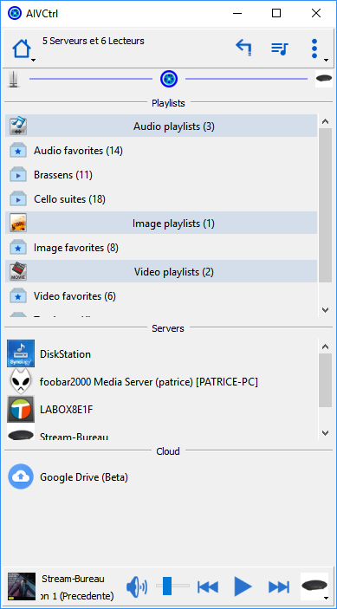

Remote servers

Local servers

Contextual actions

Collapse or expand

Server **c**ommunications

List of renderers

Video playli**s**ts

Audio playli**s**ts

Image playli**s**ts

Mute

Double click creates a new playlist

Renderer communications

Volume

Previous

Next

Play  
Pause  
Stop

Current playing  
 title

Current playing  
 thumbnail

Current Renderer  
 name

# Content folder page

Click or double click on one server, and double click on the different folder provide by the server.

Servers is selected or search

Folders with direct access (click on “Musique” goto this folder)

Previous folder  
(genre)

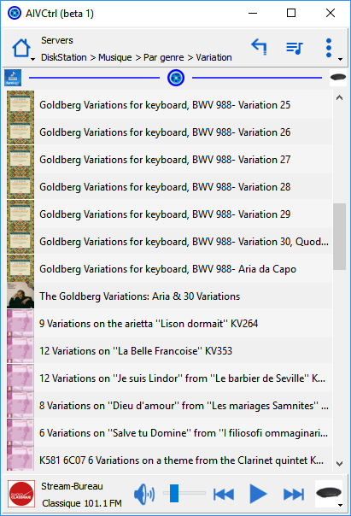

Music track of “Variation“ folder

# Queue page

Double click on one item, replace the current queue by the folder content and start the streaming with the selected item.

Current playing

Return last displayed folder

Current queue

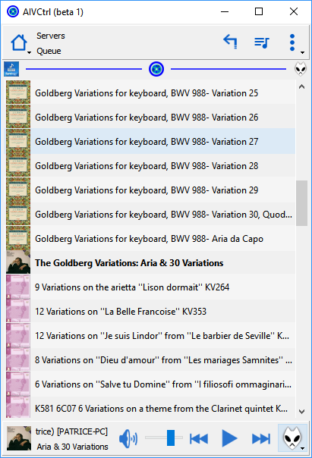

Current playing

Content of the folder

Current playing thumbnail

# Current playing page

Return last displayed folder

Queue

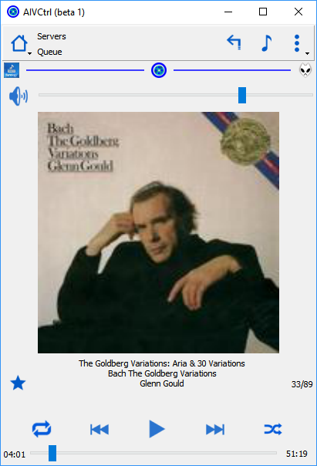

Enable or disable shuffle

Title  
Album  
Artist

Add or remove favorites

Track duration or remaining time

Change position (seek)

Next

Previous

Play, Pause, Stop

Repeat all, repeat one or stop repeat

Rank in the queue

Mute

Volume

Time from beginning of the track

# Settings menu

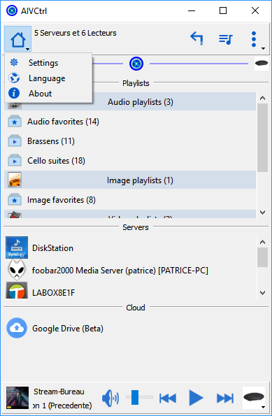

## Settings dailog

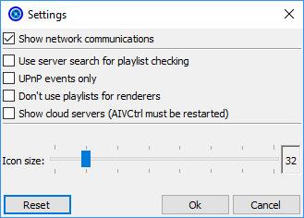

6

5

4

3

2

1

1. Use servers search capabilities for playlist checking.   
   With a set of servers, Check playlist command may be very slow. On certain server, check this option to speed up the searching of titles.
2. UPnP events only  
   AIVCtrl uses UPnP event principally when you change the renderer. This may accelerate the change of renderers.
3. Don’t use playlists for renderers.  
   Some renderers can handle playlists. For example, Windows Media Player accepts playlist of images. With this, it starts automatically a slideshow. But in this case the slideshow starts always by the first image. Check this option invalids the playlists and use only base functions of UPnP. Of course the slideshow of WMP is lost.
4. Hide or show the cloud servers.
5. Change the icon size.
6. Restores the default settings.

## Language

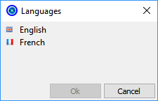

The language is detected automatically at startup. It is possible to choose another language.

## About

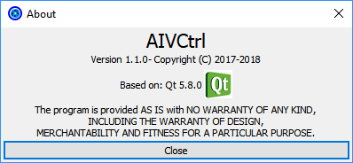

# Home page contextual menu

This menu depends of the current selection.

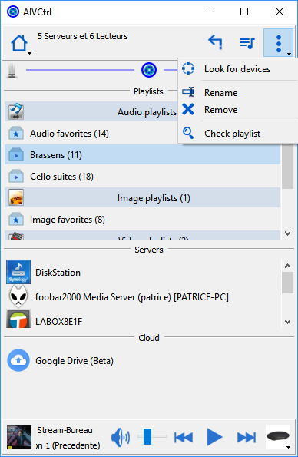

**Look for devices**: Search for devices that seem to be missing.

**Rename**: Rename the selected playlist.

**Remove**: Remove the selected playlist.

**Check playlist:** It is the problem of most UPnP media servers. The address is stored in each playlist item. Sadly, the server can change this address (e.g. rebuild the server database). This depends on the implementation of the server. This command tries to update the address from the title.

# Folder, playlist, queue contextual menu

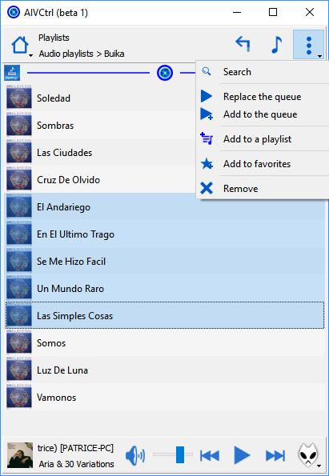

**Search**: Can be also activated by CTRL+F keys. Search a text in the current page. The provider field is cleared. You can enter now a part of title. Corresponding titles are moved on the top of the list. Stop the search with the same menu or CTRL+F keys.

**Replace the queue**: Replace all items of the queue by the selected items.

**Add to the queue:** Add the selected items at the queue.

**Add to a playlist:** Add the selected items at a playlist.

**Add to favorites:** Add the selected items at favorites.

**Remove**: Remove the selected items (available for playlist, queue and favorite)

# Add to playlist

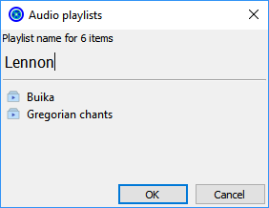

Enter a new name to create a new playlist or select an existing playlist.

# Miscellaneous

* The playlists can be renamed directly in the home page by click on a selected playlist.   
  For playlist, queue and favorite it is possible to change the order of the items by drag and drop.
* Multiple items selection is possible.
* Some shortcut are defined
  + **Suppr**: To remove items.
  + **Esc**: To remove the selection
  + **Return**: To start streaming
  + **Ctrl+F**: To enable or disable the search.
  + **Right arrow**: Stream the next item.
  + **Left arrow**: Stream the previous item.

Do not hesitate to report me the malfunctions and your comments on: <https://github.com/ptstream/QtUPnP/issues>

The sources are published at: <https://github.com/ptstream/QtUPnP> (GNU GENERAL PUBLIC LICENSE Version 3, 29 June 2007).