**ASSIGNMENT 1 FRONT SHEET**

|  |  |  |  |
| --- | --- | --- | --- |
| **Qualification** | **BTEC Level 5 HND Diploma in Business** | | |
| **Unit number and title** | **Unit 30: Application Development** | | |
| **Submission date** |  | **Date Received 1st submission** |  |
| **Re-submission Date** |  | **Date Received 2nd submission** |  |
| **Student Name** | Mai Dinh Phong | **Student ID** | GCD201883 |
| **Class** | GCD1001 | **Assessor name** | Nguyen Van Loi |
| **Student declaration**  I certify that the assignment submission is entirely my own work and I fully understand the consequences of plagiarism. I understand that making a false declaration is a form of malpractice. | | | |
|  |  | **Student’s signature** | Phong |

**Grading grid**

|  |  |  |  |  |  |
| --- | --- | --- | --- | --- | --- |
| **P1** | **P2** | **P3** | **M1** | **M2** | **D1** |
|  |  |  |  |  |  |

|  |  |  |
| --- | --- | --- |
| **❒ Summative Feedback: ❒ Resubmission Feedback:** | | |
| **Grade:** | **Assessor Signature:** | **Date:** |
| **Internal Verifier’s Comments:** | | |
| **Signature & Date:** | | |

**TABLE OF CONTENTS**

INTRODUCTION (P1) 6

1. Document purpose 6

2. Product scope 6

3. Intended audience and document overall 6

4. Definition Acronyms and Abbreviations 7

5. References and acknowledgments 7

OVERALL DESCRIPTION (P1) 7

1. Product overview 7

2. Product functionality 8

SPECIFIC REQUIREMENTS (P1 & M1) 9

1. Function requirements (P1) 9

2. Use Case Model (P1) 9

3. WireFlow (P1) 10

TECHNICAL DESIGN (M1) 11

1. Entity Relationship diagram (ERD) 11

2. Class Diagram 12

3. Activity Diagram 13

4. Gantt Chart 14

RISK ASSESSMENT (P2) 14

1. Risk Assessment 14

EVALUATION REPORT (P3-M2) 15

1. Design tools 15

1.1. Tools to design UML 15

1.2. Tools to design User Interface 15

1.3. Conclude which tools will be used for the design of the application 16

2. Front end Technology stack 17

HTML/CSS/SCSS/SASS/LESS etc. 17

What are the benefits when using SCSS? 19

JavaScript Library / Framework 21

CSS Framework 22

Conclude which Front End technologies will be used for the development 23

Chapter 3 - Back End technology stack 24

Back End Programming Language 24

Operation System 26

3. Web Server 28

4. Database 29

5. Hosting 29

6. Framework 30

7. Conclude which Back End technologies will be used for the development 30

TOOLS FOR SOURCE CONTROL MANAGEMENT 33

1. Tools 33

1.1 Git 33

2. Conclude which tools will be used for the development 35

3. Software Development Models 35

SDLC Models 35

References 39

**TABLE OF FIGURE**

Figure 1 System work flow 8

Figure 2 Usecase diagram 10

Figure 3 ERD 11

Figure 4 Class Diagram 12

Figure 5 Activity diagram 13

Figure 6 Front-end 17

Figure 7 HTML 18

Figure 8 CSS 18

Figure 9 Scss 19

Figure 10 Sass 20

Figure 11 LESS 21

Figure 12 CSS Frameworks 23

Figure 13 Back-end 24

Figure 14 C# 25

Figure 15 Python 25

Figure 16 Java 26

Figure 17 Windows 27

Figure 18 Linux 27

Figure 19 Mac OS 28

Figure 20 Microsoft IIS (IIS) 28

Figure 21 Apache 29

Figure 22 GitFlow 34

Figure 23 GitHub 34

Figure 24 Waterfall Model 36

Figure 25 V Models 37

Figure 26 Agile model 38

CONTENTS

REVISIONS

# INTRODUCTION (P1)

## Document purpose

The document's aim is to describe in depth the functional and non-functional criteria for developing the FPT Books Website System, including details about the change and the author. The document's targeted readership includes the system administrator, shop proprietors, and end-users. Another group we can address in this paper is our development staff.

## Product scope

The FPTBook will be a web-based software system that will assist book store owners in managing book sales and purchases by making it simpler and faster for customers to choose, order, and buy books online and by providing information about their customers and goods to book store owners. The initiative will be implemented in shops, and both store owners and customers will be able to access the website. This website aims to enhance the user experience and make doing business simpler for customers and shop owners. It also wishes to make it simpler for shop owners to operate their businesses.

## Intended audience and document overall

The object that needs to be discussed in this document is the system administrator, end-point users, and store owners. We highly recommend that you study the paper from top to bottom, section by section, to get a clear and thorough comprehension of it.

**This document's contents** will include the heading description for each section. It is beneficial to describe the structure of the document so that readers can gain an understanding of what the document is about.

## Definition Acronyms and Abbreviations

|  |  |  |
| --- | --- | --- |
| No. | Abbreviations/Acronyms | Explanation |
| 1 | SRS | Software Requirement Specification |
| 2 | MVC | Model-View-Controller |
| 3 | DFD | Data Flow Diagram |
| 4 | UCD | Use Case Diagram |
| 5 | FBS | FPT Book Store |
| 6 | CRUD | Create, Read, Update, Delete |
| 7 | ERD | Entity Relationship Diagram |
| 8 | Wins | Window-ISS-.Net-Sql Server |

## References and acknowledgments

# OVERALL DESCRIPTION (P1)

## Product overview

FPTBook is a web-based software application. It functions similarly to a standard website and includes all of the features that a website requires. This product was created because FPT Bookstores required an online web system to facilitate and speed up business operations between stores and consumers. The product will be used in all FPT Book store chains and will ensure that all system users can conduct online financial operations as well as view and store user data in a secure and simple manner.

Figure System work flow

## Product functionality

+ The FPT Book web-based system enables **Administrators** to:

* Manage customer accounts and change customer passwords as required
* Manage store owner accounts and reset store owner passwords as needed
* Approve or reject the Store Owner's proposal for a new book genre.

+ The FPT Book web-based system enables **store owners** to:

* Manage books with particular categories
* Manage records purchased by customers
* Request that the Admin add a new book category if it does not already exist

**+ Customers** can use the FPT Book web-based system to:

* Register a new account if they do not already have one
* View the list of books the customer can buy
* View Book Detail about Specific Book
* Search books by name or category
* View a list of solutions to website issues if there are any
* View their profile - View a list of their order information, including previous orders
* View the transaction information in detail and make a payment

# SPECIFIC REQUIREMENTS (P1 & M1)

## Function requirements (P1)

The table below displays the complete details of the quantity, content, and outcomes of each job in the FPT Book Web-based System based on the function of each item.

|  |  |  |  |
| --- | --- | --- | --- |
| ID | AS A (TYPE OF USER) | I WANT TO (PERFORM SOME TASK) | SO THAT I CAN (ACHIEVE SOME GOAL) |
| 1 | Customer | Register a new account | Have an account to log in the website |
| 2 | Customer | View Detail of book | Get more information about a specific book |
| 3 | Customer | View the Profile | Check her/his Profile |
| 4 | Customer | View all past orders | Check information book ordered |
| 5 | Customer | Search Book By Name, Category | Find the book that I want to find |
| 6 | Customer | Displaying a list of help topics | See the feedback of books |
| 7 | Customer | Log out the system of Website | Finish the process of purchased book |

## Use Case Model (P1)

Below is the use case diagram the describe the whole system of role customer

Figure Usecase diagram

## WireFlow (P1)

The image below depicts the wireflow of whohe system based on the function of the client. To begin, if consumers already have an account, they simply check in to the website. If a client does not already have an account, they must register to make one. After successfully logging in, customers can examine the list and details of the books they want to buy, as well as pay the books they want to buy. In addition, customers can handle their previous orders and view order details. Additionally, customers can control their identity and get help selecting a book subject via the Help Screen.

# TECHNICAL DESIGN (M1)

## Entity Relationship diagram (ERD)

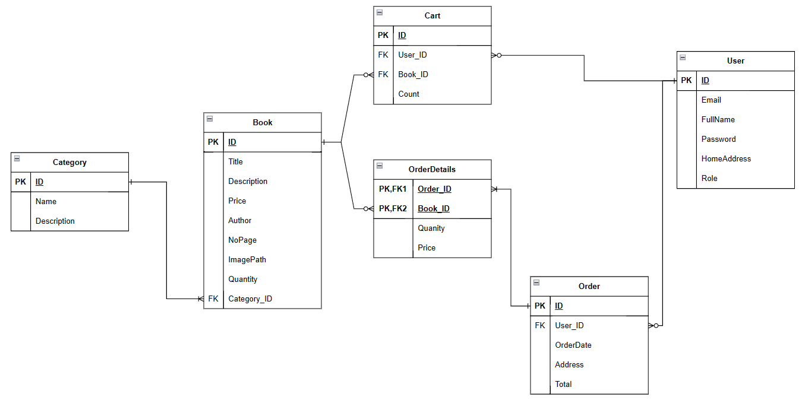

Figure ERD

## Class Diagram

Figure Class Diagram

## Activity Diagram

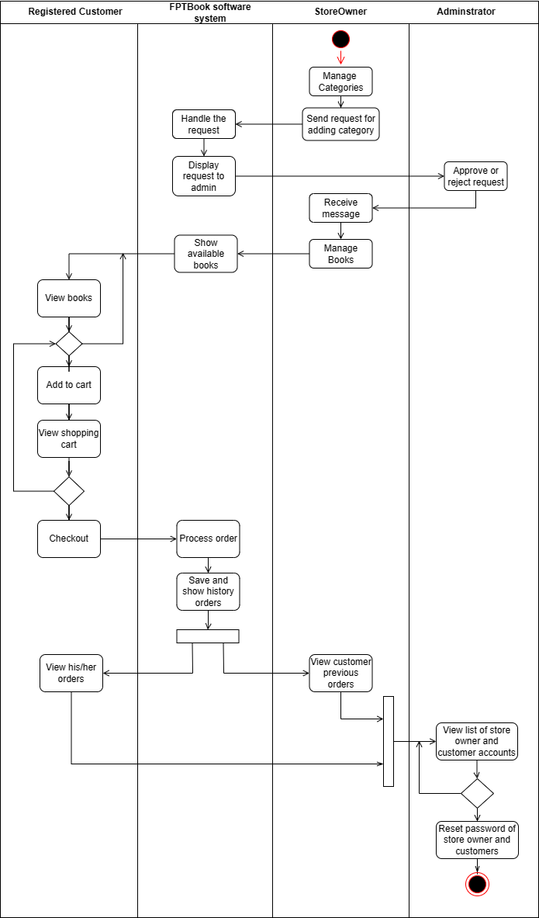

Figure Activity diagram

## Gantt Chart

This picture below shows the Gantt chart of our project

# RISK ASSESSMENT (P2)

## Risk Assessment

The table below depicts the challenges and risks encountered while planning, executing, and finishing the project to construct the FPT Book Web-based System.

|  |  |  |  |  |
| --- | --- | --- | --- | --- |
|  | Identity and list Hazards | List current risk controls | Risk level | List additional controls |
| 1 | The project schedule is not well specified or known. | Create a Gantt Chart of the schedule for each task step using Microsoft Project. | High | Ask team members if necessary |
| 2 | Team members not complete tasks on time | Set strict restrictions for each job and divide the workload. The squad meets every day to weigh in on each member's development. | Medium | If required, fines |
| 3 | Failure to comprehend the structure (ASP .NET core) | Each team member will spend two to three hours per day conducting study on various websites and networks. If an error occurs, you can search for a remedy on sites such as Stack Overflow. | Medium | Learn deeply the frameworks and practice with project |
| 4 | Programming errors and insufficient software quality testing. | Fix the problem and possibly expand the working hours. | High | Adopt an iterative or agile project management approach to ensure that software quality is evaluated and enhanced on a regular basis. |
| 5 | lack of early instruction and assistance | Fix the problem and perhaps extend the workday. | High | Find a tutor to help with the endeavor. |
| 5 | Member of the team abandons the endeavor | Maintain positive interpersonal interactions and a positive workplace culture to keep employees inspired. | Low | Add new team members with the necessary credentials to satisfy the project's requirements. |

# EVALUATION REPORT (P3-M2)

## Design tools

### Tools to design UML

1. **Draw.io:** Draw.io, created by Seibert Media, is private software for creating diagrams and infographics. You can use the software's automatic layout feature or build a custom structure. They have a wide range of forms and hundreds of graphic components to help you create a one-of-a-kind diagram or chart. The drag-and-drop function makes it easy to build a visually appealing diagram or graphic (Anon., 2020).
2. **Lucidchart:** Lucidchart is a web-based diagramming application that allows you to create layouts quickly and easily. Easily create flowcharts, org charts, wireframes, UML, mind maps, and other diagrams. It is an intelligent diagramming tool that brings together teams to make better choices and create the future (Anon., n.d.).

### Tools to design User Interface

**MockFlow** is a cloud-based wireframe and prototype tool for Web/software engineers, UI/UX designers, Marketers, and others. The approach makes it much simpler to create multipage UI mockups for websites and mobile applications in a project-like environment. Even MockFlow is a popular and dependable UI design tool because it has a broad variety of UI tools and template objects with an easy-to-use User Interface that can help a lot in the UI design process, despite the fact that its open-source version does not have many choices. Users can also purchase a complete edition, which includes even more tools and themes.

**Wireframe:** Wireframing is a method of designing an online service on a fundamental level. A wireframe is frequently used to layout information and features on a website while taking user requirements and user journeys into consideration. Before visual design and content are added, wireframes are used to define the fundamental structure of a website early in the development process (Anon., 2023).

**WireFlow:** A wireflow is a graphical depiction of the displays and interactions that a user goes through in order to accomplish particular tasks. It incorporates elements of a basic wireframe, task flow, and flowchart, as well as sophisticated screen flows that show numerous travel routes in a single image (Trigo, 2022).

### Conclude which tools will be used for the design of the application

As previously stated, I use tools to sketch UML and build interface. In this part, I will choose and explain the benefits and drawbacks of the UML sketching tool and interface design that I use in this project.

In terms of tool selection for UML design, I chose draw io as the instrument for this assignment.

**Benefits:**

* Draw.io offers a large number of models based on the user's search criteria, as well as a high degree of freedom in designing the arrangement of the diagram.
* Draw.io makes it possible for you to apply drawing models according to your intuitive method of thinking about forms and connecting shapes together
* Draw.io is quick and easy to use.

That is why I used sketch io.

Based on the above benefits and drawbacks, draw.io is the best tool for my requirements, particularly when it comes to using diagrams such as use case, ERD, system architecture, and others. The primary reason is that draw.io is free to use, which saves me and others money and allows me to quickly create basic diagrams for my project.

In terms of tool selection for interface design, I chose WireFlow as the instrument for this assignment.

**Benefits:**

* Improved teamwork
* Prevents project mistakes and expensive redesign
* Excellent for brainstorming

Reason why I used WireFlow

Based on the benefits and cons listed above, WireFlow is the best tool for my interface design requirements, particularly when it comes to concretizing design ideas with WireFlow, etc. With wireflows, collaboration is significantly improved by providing a clearer and more comprehensive picture of the project. Team members can see what occurs when a user hits a CTA using a per-page and live procedure. Depending on whether the user or our system is enabled, we may decide the visual feedback given to the user.

## Front end Technology stack

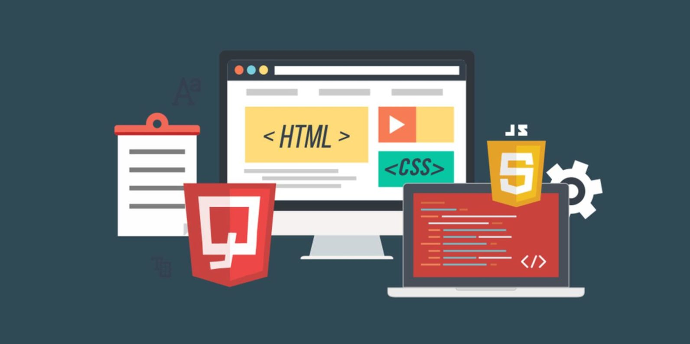

Figure Front-end

1. **Definition**

Everything that users visibly see first in their browser or program is managed by front end development. The appearance and feel of a website are the responsibility of front end coders.

1. **What are Front-end languages?**

HTML, CSS, and JavaScript are examples of front end languages. Although jQuery is out of date (modern browsers can perform the same tasks much more rapidly than jQuery), JS library is still used in many old projects, so it shouldn't come as a surprise to see it on a bootcamp's syllabus (Stewart, 2021).

1. **Why we need front-end languages?**

The majority of front end development is devoted to what some may refer to as the "client side" of development. In addition to ensuring a seamless user experience, front end engineers will be involved in examining code, designing, and debugging apps. You control what a user's computer displays initially. You are in charge of the site's appearance, feel, and final design as a front end engineer.

### HTML/CSS/SCSS/SASS/LESS etc.

1. **HTML**

**What is HTML language?**

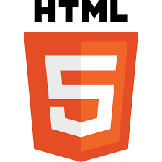

Figure HTML

HyperText Markup Language, or HTML. It is a common scripting language used to create online pages. Using HTML components, such as tags and attributes, it enables the construction and organization of sections, paragraphs, and links (S., 2023).

**There are numerous uses for HTML, including:**

* Developing a website. Developers use HTML code to create how a computer shows web page components, such as text, hyperlinks, and media files.
* Using the internet. Since HTML is widely used to incorporate hyperlinks, users can browse and place links between relevant pages and websites with ease.
* Web-based instruction. Similar to Microsoft Office, HTML allows for document organization and formatting.

1. **CSS**

**What is CSS programming language?**

Figure CSS

CSS (Cascading Style Sheets) enables you to design beautiful online sites, but how does it function internally? This essay discusses some important CSS terms as well as defining CSS with a straightforward syntax sample.

**Benefits of CSS for Online Sites:**

* A website that uses CSS has a significant and unmistakable advantage over one that doesn't.
* You may have come across a website that partially loads, has a white backdrop, and the majority of its writing is blue and black. This indicates that the HTML component of the website either didn't render properly or doesn't exist at all.
* You'd probably concur that it's not very appealing to have web sites made entirely of HTML.
* All stylization had to be incorporated into the HTML code prior to using CSS. This implies that backdrop color, text size, alignments, etc., had to be described individually by site writers.
* With CSS, you can stylize everything in a separate file, where you can also create the style, and then add the CSS files on top of the HTML code. The real HTML code is much cleaner and simpler to manage as a result.
* In other words, CSS features eliminate the need to constantly define the appearance of individual elements. This shortens the code, saves time, and reduces the likelihood of mistakes.
* Because CSS enables numerous styles on a single HTML website, the customization options are practically limitless. Nowadays, this is becoming more a requirement than a product (Anon., 2023).

1. **SCSS**

**What is SCSS?**

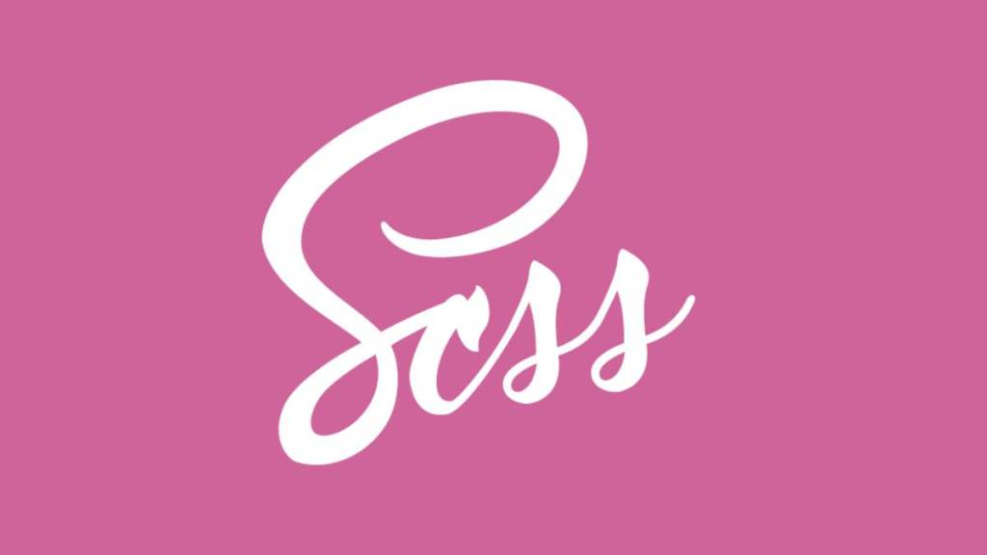

Figure Scss

Sharp Cascading Style Sheets is referred to as SCSS. It is essentially a more sophisticated and developed form of CSS. It was developed by Chris Eppstein and Natalie Weizenbaum, and made by Hampton Catlin. It is frequently known as Sassy CSS because it has more sophisticated features. This language is a preprocessor, so we must stop or convert it into the CSS language. The.scss file suffix is associated with the SCSS programming language (Anon., 2023).

### What are the benefits when using SCSS?

SCSS (Sassy CSS) is a preprocessor scripting language that is converted into CSS, which means that SCSS code is changed into CSS before it's delivered to the viewer. The following are some advantages of using SCSS:

* Variables: SCSS enables the use of variables, making it simple to reuse code and uphold uniformity across your stylesheets. You can assign a number once and use it repeatedly throughout your code by defining a variable.
* Nesting: SCSS enables nesting of selectors, making CSS simpler to write and comprehend. You can reduce duplication in your code by nesting filters.
* Mixins are reusable code elements that can be used throughout your stylesheets, and SCSS enables you to make them. Mixins can comprise properties, filters, and even other mixins.
* Functions: SCSS comes with built-in tools for manipulating hues, performing arithmetic operations, and more. Additionally, you can design your own unique features.
* It is possible to use inheritance in SCSS, which enables one selection to take characteristics from another selector. This makes it possible to modify a design without having to duplicate the code.
* Modularity: By dividing your stylesheets into smaller, easier-to-manage files using SCSS, you can more easily arrange and keep your codebase.

Ultimately, SCSS can help you write CSS more quickly and effectively, which will save you time and enhance the standard of your code.

1. **SASS**

**What is SASS?**

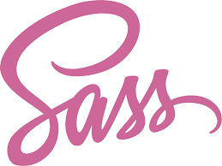

Figure Sass

Sass (which stands for 'Syntactically awesome style sheets) is an extension of CSS that enables you to use things like variables, nested rules, inline imports and more. It also helps to keep things organized and allows you to create style sheets faster (Coron, 2020).

**What are the benefits using SASS?**

* Saving time by writing less code is one way that Sass can help you save time. Variables, mixins, and functions are elements of Sass that make composing CSS easier and more automated.
* Maintainability: Sass makes it possible to create CSS that is more well-organized and flexible, which makes it simpler to keep and update. You can reuse styles throughout your coding and divide your styles up into smaller folders by using Sass.
* Consistency: By using variables for colors, typefaces, and other design components, Sass enables you to create a uniform style throughout your codebase. This makes it simpler to keep your website or application's appearance and feel uniform.
* Reusability: Sass offers a variety of mixings, or reused code fragments, that can be used throughout your project. By doing so, you can reduce duplication and improve the effectiveness of your code.
* Sass is interoperable with all CSS versions, so you can use any CSS code that you are accustomed to using.
* Community Support: Sass has a big and active community of writers who add to the growth of the language and share their knowledge through lessons, forums, and code libraries.

1. **LESS**

**What is LESS Programming?**

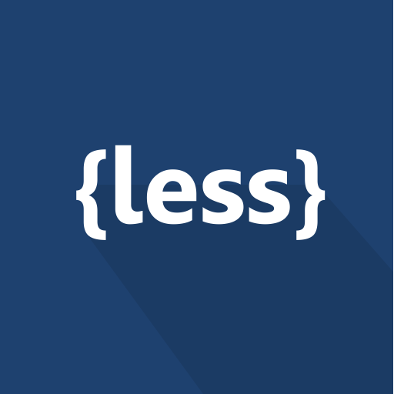

Figure LESS

Less is a backwards-compatible language expansion for CSS, short for Leaner Style Sheets. This is the original documentation for both Less.js, the JavaScript utility that transforms your Less styles to CSS styles, and Less, the programming language.

Less is simple to learn because it resembles HTML in appearance. One of the reasons Less is so easy to learn is that it only adds a few useful features to the HTML language (Anon., 2023).

**What are the benefits using LESS?**

* You can use any CSS code you're accustomed to because LESS is consistent with all versions of CSS.
* Reusability: LESS offers a variety of mixins, or reused code fragments, that can be used throughout your project. By doing so, you can reduce duplication and improve the effectiveness of your code.
* Simpleness: Even for coders who are new to CSS shorthand languages, LESS is made to be simple to learn and use.
* Client-side processing: LESS can be handled using JavaScript on the client-side, which can make it simpler to incorporate into your workflow than Sass, which needs server-side processing to create CSS.
* Saving time: By lowering the quantity of code you must create, LESS can save time. Similar to Sass, LESS offers tools like variables, mixins, and functions to help with and streamline CSS coding.
* Maintainability: LESS makes it possible to create CSS that is more well-structured and flexible, which makes it simpler to keep and update. By using LESS, you can share styles throughout your script and divide your styles into smaller files.

### JavaScript Library / Framework

**What is JavaScript Library?**

A bit of reusable code with just one main use case is known as a JavaScript library. Depending on the language, a JavaScript library can contain a variety of functions, classes, and procedures. Your application will link to a library in order to utilize that feature. JavaScript frameworks eliminate the need to write some code from scratch. Development is therefore more effective and error-free.

**What is JavaScript Framework?**

One of the finest JavaScript frameworks accessible is without a doubt AngularJS. It is a Google-developed, open-source JS system that was first made available in 2010. It is a front-end JavaScript platform used to create websites. It was created for client-side MVC and MVVM architectures to make online application creation and testing easier. Angular is primarily used to build interactive web sites for real-time data apps like weather predictions and e-commerce applications. This is due to the fact that it allows 2-way data binding and makes use of directives to add HTML code and enhance the usefulness of the app.

**What are the different between JavaScript Library and Framework?**

Both JS frameworks and JS libraries are collections of code written by others to address common issues. Nevertheless, they are different.

JS libraries provide preset classes and methods to writers to facilitate quicker and more effective work. The JS framework, on the other hand, serves as a foundation for developers to build applications for particular platforms.

The word "responsible" refers to a person who is responsible for the actions of another person. When you use a library, you have total influence over the direction the program takes. You are free to choose where and when to contact the library. While when using a framework, the framework itself manages the movement. You can insert your code in a number of places, but it won't be called until it is necessary (Camus, 2022).

**What are the benefits when using JavaScript Library?**

* Community help: Many JavaScript libraries have busy groups of coders who add to the library, provide support, and share code snippets and best practices.
* Added features: JavaScript frameworks can give your website or program extra features like data visualization, user UI elements, and data processing.
* Improved performance: JS frameworks are frequently performance-optimized, which can help your website or application load faster and respond more quickly.
* Simple integration: You can rapidly add new features or capabilities to your application without having to start from zero by integrating JavaScript libraries into current codebases.
* Time-saving: By providing pre-written code for popular features, JavaScript libraries can speed up development.
* Consistency: A quality JavaScript framework offers a uniform code structure and grammar, assisting in the organization and readability of your code.
* Cross-browser compatibility: JavaScript tools make it possible for your code to function reliably in a variety of web platforms.

### CSS Framework

1. **What is CSS Framework?**

Figure CSS Frameworks

A CSS framework is a ready-to-use CSS code that has been prepared (Cascading Style Sheets). A UI developer's work is made simpler by the stylesheets library .

A CSS template gives them the tools to rapidly build a user interface that they can reuse and modify throughout a project rather than having to start each one from beginning. They also make it possible to build more webpages that follow guidelines.

**What Is the Purpose of a CSS Framework?**

CSS frames are intended for use in common situations such as creating navigation bars, footers, sliders, hamburger menus, 3-column layouts, and other elements.

The platforms also allow for the extension of JavaScript, SASS, and other technologies. If designers are short on time, frameworks enable them to create web sites - not just homepages - without delving into CSS.

**CSS Framework Use Cases:**

CSS frameworks provide standards that help teams of multiple coders in addition to saving time. Instead of each worker on a project adding their own name style, frameworks control patterns, make it easier to understand others' code, and ease the development cycle with fewer errors and better team collaboration.

Bootstrap and Foundation are two popular CSS template samples.

### Conclude which Front End technologies will be used for the development

**Why did I select HTML, CSS, and JavaScript, and Bootstrap?**

**HTML** is extensively used by people because it is open source. HTML is also compatible with browsers such as Google Chrome, Mozilla Firefox, Opera, and others. HTML is straightforward to learn and has a fundamental design that novices can use.

**CSS** can help us save time. We can create CSS once and then reuse it across numerous HTML pages. Furthermore, it is simple to keep; simply alter the style and all components in all web sites will be automatically updated.

**Bootstrap** is a famous framework for creating mobile-first, responsive webpages. Here are some reasons why you should use Bootstrap:

Saves time and effort: Bootstrap includes CSS, JavaScript, and HTML templates that can be used to rapidly create a website or online application. When compared to creating everything from start, this can save you time and effort.

Bootstrap offers a uniform collection of styles and components that can be used across your website or application. This can assist in ensuring that your website appears and acts consistently across browsers and devices.

Bootstrap is mobile-first and responsive, which means that your website or application will adjust to various screen resolutions and platforms.

Customizable: While Bootstrap provides a set of pre-built components and styles, it is also highly customizable. You can change the CSS and JavaScript to meet your particular demands and design specifications.

help from the community: Bootstrap has a sizable developer community that contributes to the project, provides help, and creates extra tools such as themes and plugins.

## Chapter 3 - Back End technology stack

### Back End Programming Language

1. **Definition**

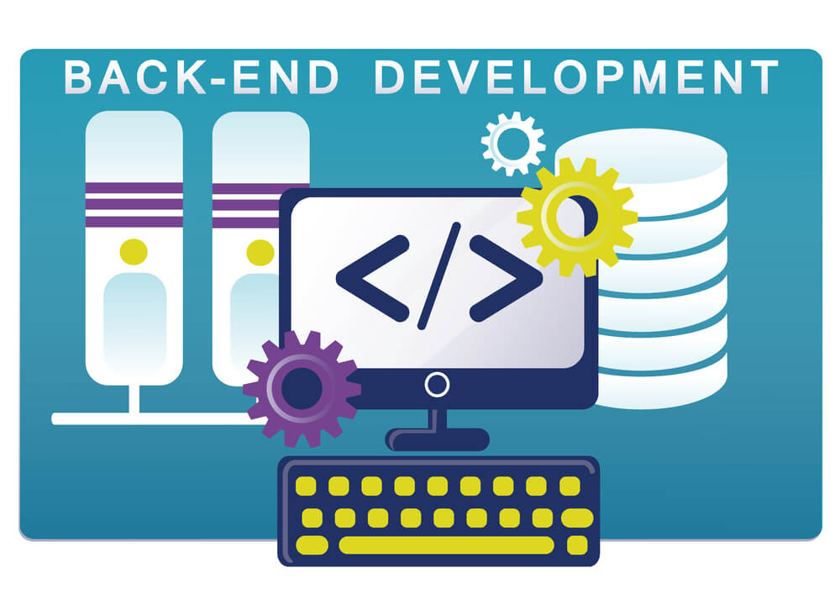

Figure Back-end

Back end development is the term used to describe the server portion of a program and everything that takes place during database and browser communication (Stewart, 2021).

1. **What are Back-end languages?**

**C#:** Microsoft's C# computer language is contemporary, object-oriented, and type-safe. C# allows developers to create a broad variety of secure and dependable applications that operate in the.NET ecosystem. C# is a computer language built on objects and components. C# includes language characteristics that directly support these concepts, making it a natural language for creating and deploying software components. C# has evolved over time to support new jobs and methods of developing software. C# is a programming language that can be used to create Web, mobile, and desktop apps.

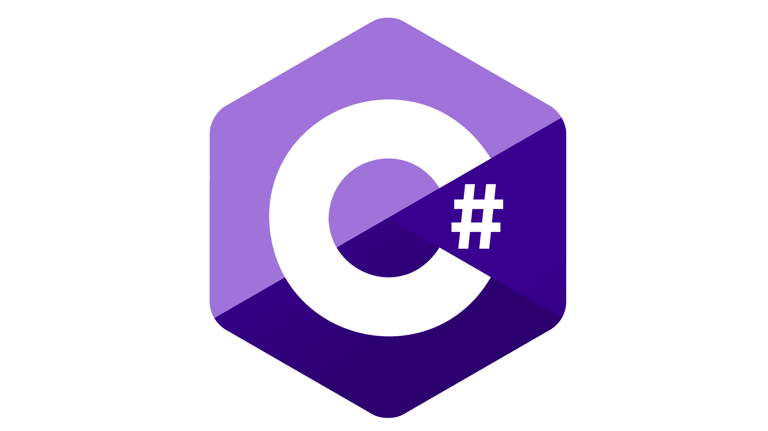

Figure C#

**Python** is a high-level, general-purpose, object-oriented programming language that a machine can understand and execute. Python is well-known for being strong, quick, and enjoyable to use. Python programmers can write variables on the move without having to specify what the variable should be. Users can download Python for free and begin learning to write right away. The source code is open to modify and reuse in other locations. Python is widely used because its grammar is simple to comprehend and read. Python generates code that is simple to view, comprehend, and learn. It is frequently employed in data analytics, machine learning (ML), and online development.

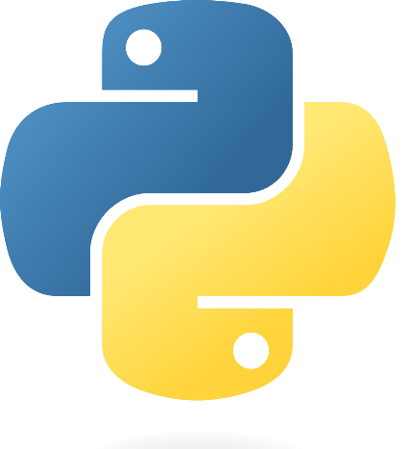

Figure Python

**Java** is a general-purpose, class-based, object-oriented programming language designed to be less dependent on how it is implemented. Java also includes a robust framework with a set of programs, such as an execution engine, a compiler, and a set of tools, that can be used to create applications for various devices. Many businesses use Java to create their projects because they believe it is quick, secure, and dependable. It is frequently used in the development of Java applications for laptops, data centers, game systems, scientific supercomputers, mobile phones, and other devices.

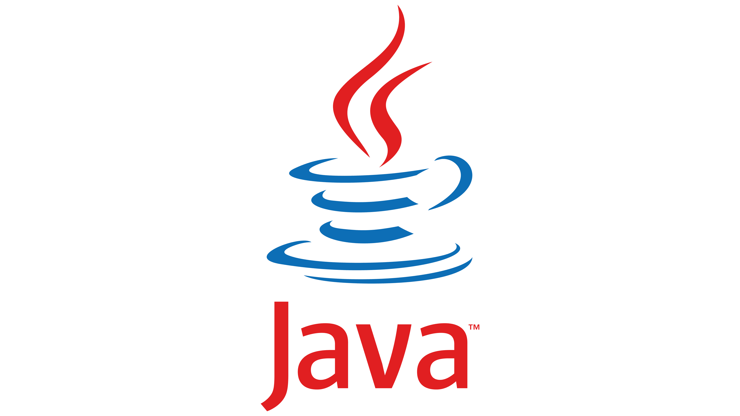

Figure Java

Even though they need to use languages like Java, PHP, Ruby on Rails, Python, and more, many back end workers are familiar with front end languages like HTML and CSS. Net to complete the back-end work. The responsiveness and performance of a site are the main concerns of back end engineers. These programming languages are used to build dynamic websites, which vary from static websites in that they hold database data. The website's content is updated and changed frequently. Facebook, Twitter, and Google Maps are a few examples of changing websites.

1. **Why we need Back-end?**

Back end development is the server part of development, where you are mainly concerned with the functionality of the website. Making upgrades and adjustments in addition to watching operation of the site will be your main duty. Three components are typically included in this kind of online development: a server, a program, and a database. The information from the database is communicated to the computer through code created by back end coders. A back end engineer is responsible for anything that is difficult to see with the naked eye, like computers and databases. Positions in back end development are frequently referred to as coders or web developers.

## Operation System

**Window:** Microsoft Windows, also known as Windows, is a family of computer operating systems (OS) developed by Microsoft Corporation for use on desktop computers. (PCs). Windows has a graphical user interface (GUI) that allows users to see and interact with the operating system through the use of cursors, drop-down menus, graphical symbols, and movable windows that symbolize files and drives (a command line interface is also available). Windows has been the most common operating system for decades because it is simple to use and has a user-friendly UI. It also has a large number of apps that are simple to setup. However, the Windows operating system is costly and requires a lot of computer resources. It also has average protection, which many coders are concerned about.

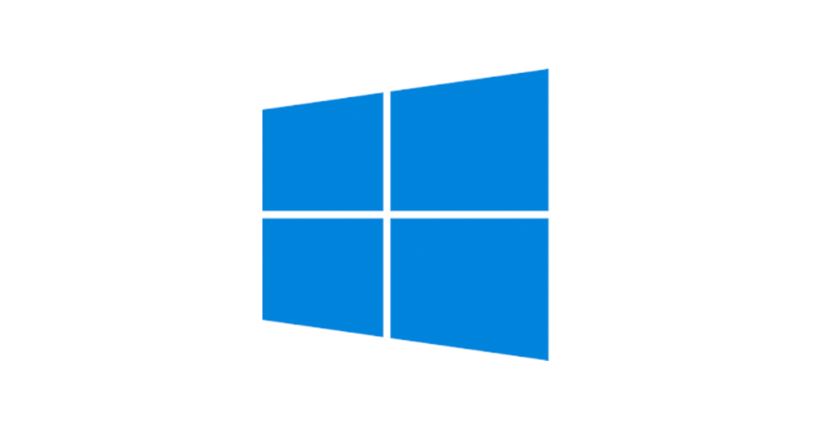

Figure Windows

**Linux** is an operating system, similar to Windows. Linux is the most famous and well-known open source operating system. Linux is the software that rests on top of all other programs on a computer and transmits queries from those programs to the computer's hardware. Linux is unique in that, while the basic components of the Linux operating system are typically the same, there are numerous versions of Linux available, each with its own set of software. This means that Linux is very simple to modify because you can alter more than just applications such as word processors and web browsers. Linux users can also select essential components such as GUI display systems and other user interface components.

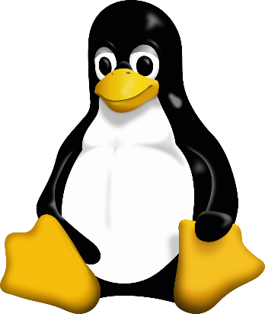

Figure Linux

**MacOS:** The Mac OS, also known as the Macintosh Operating System, was created by Apple Inc. It was released in 1984 and is an operating system with a graphical user interface. (graphical user interface). The program that operated the Mac was known as System program. macOS is the operating system that runs on every Mac. It allows you to do things that other systems cannot because it was built with distinct hardware. This operating system includes a number of attractive applications and works with iCloud to keep papers and pictures on your iPhone and other Apple devices up to date. This operating system includes private and security controls.

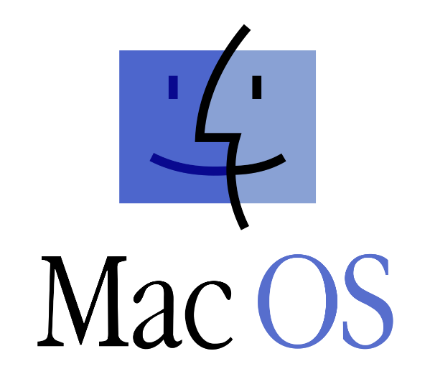

Figure Mac OS

## Web Server

**IIS:** The Internet Information Services (IIS) server, formerly known as Internet Information Server, is a versatile computer server. It was created by Microsoft and runs on Windows. It delivers the requested HTML files or websites. The web server accepts requests from distant clients and returns a legitimate and accurate response. This is a critical component of a web server's capacity to exchange and send data. This data is accessible via LANs (Local Area Networks) and WANs (Wide Area Networks), which include the internet.



Figure Microsoft IIS (IIS)

**Apache:** The Apache Software Foundation maintains and develops Apache, an open, cross-platform web server software. Apache is very simple to modify due to its open-source architecture. As a result, web writers and consumers can modify the source code to suit the type of website they are creating. Furthermore, Apache includes a plethora of plugins that allow server admins to enable and disable additional features. The Apache web server includes components for security, caching, URL rewriting, password verification, and other functions.

Figure Apache

## Database

**SQL Server:** SQL Server: Microsoft SQL Server is a relational database management system developed by Microsoft. In corporate IT settings, Microsoft SQL Server is used to operate a variety of transaction processing, business intelligence, and analytics apps. SQL is a standard programming language used by database administrators (DBAs) and other IT workers to perform queries and handle databases, and Microsoft SQL Server is constructed on top of it. T-SQL is a Microsoft SQL implementation that provides a collection of proprietary computing enhancements to the standard language. It is linked to SQL Server. Its most essential component is a relational engine, which processes commands and searches as well as saves files, bb.dd., tables, and data buffers.

**PostgreSQL:** SQL Server: Microsoft SQL Server is a relational database management system that was created by the company Microsoft. Microsoft SQL Server is used in corporate IT environments to run a range of transaction processing, business intelligence, and analytics applications. SQL is a standard programming language that database managers (DBAs) and other IT professionals use to conduct queries and manage databases, and Microsoft SQL Server is built on it. T-SQL is a Microsoft SQL version that adds private computing features to the standard language. It's connected to SQL Server. A relational engine, which handles instructions and finds and stores files, bb.dd., tables, and data buffers, is its most important component.

**MySQL:** SQL means for Structured Query Language. MySQL is a database management system that assists you in the administration of relational datasets. It is a database administration solution. Oracle supports unrestricted, opensource software. It is relatively simple to master when compared to Microsoft SQL Server. MySQL is compatible with UNIX, Linux, Windows, and other systems. It can be installed on a laptop or a computer.

MySQL is also reliable, flexible, and fast. A database administration system is available on the MySQL server and can be queried and linked to. It also has a decent data structure and can operate with a variety of platforms. It can manage large databases swiftly and consistently in high-demand production settings.

## Hosting

**Heroku** is a Cloud Platform that provides Container-as-a-Service. (PaaS). It is a well-known platform as a service that allows developers to launch, administer, and expand modern apps. Heroku provides a collection of development tools as well as application-specific services on a singular platform that can be used to create, test, launch, and administer apps from beginning to end. Heroku is made up of various components that work together to create a complete cloud programming framework.

**Heroku** is a Cloud Platform offering Container-as-a-Service. (PaaS). It is a well-known platform as a service that enables developers to build, manage, and scale modern applications. Heroku offers a set of development tools as well as application-specific services on a single platform that can be used to build, test, deploy, and manage applications from start to finish. Heroku is composed of various components that work together to form a comprehensive cloud computing platform.

**Azure** is a cloud computing tool that can provide companies with everything they need to operate the majority or all of their computing operations, including servers, storage, databases, networks, and more. Users can select which of these services to use to create and grow new apps or operate existing apps in the public cloud. Companies can now use a public cloud computing tool like Azure, which purchases and manages all processing gear. This implies that businesses can "rent" hardware tools as required.

## Framework

**ASP.NET Core** is the name of Microsoft's latest web framework. It has been completely rebuilt from the bottom up to be fast, adaptable, modern, and compatible with multiple devices. ASP.NET Core will be the web programming platform that can be used with.NET in the future. If you've dealt with MVC or Web API in the last few years, you'll notice some similarities. By the conclusion of this tutorial, you will have learned everything you need to know to get started with ASP.NET Core and build an application that can generate, edit, and examine data from a database.

**Django:** Django is a free and open source Python-based web application platform. A framework is simply a collection of components that facilitate development. They are grouped together, and you can use them instead of beginning from zero to create applications or websites. Django includes a large number of components that you can use in your own applications. Frameworks like Django exist primarily to save coders time and effort, and Django is no exception.

**Laravel:** Laravel is a free and open source PHP platform. It provides you with a collection of tools and materials for developing modern PHP applications. You can use its built-in features as well as the numerous packages and add-ons that function with it if you have a full environment. Laravel includes sophisticated database engines such as Eloquent, an Object Relational Mapper (ORM), and built-in utilities for database migrations and seeders. Developers can use the Artisan command-line utility to test new models, controllers, and other application components. This accelerates the overall creation of apps.

## Conclude which Back End technologies will be used for the development

As previously stated, I will be presenting languages, tools, and technologies to help with project implementation. In this part, I will select and emphasize the benefits of the languages, tools, and technologies that I will use in this endeavor.

**Front-end Programming language:**

In this part I will use HTML for building the skeleton of project and CSS for styling some of my custom style

A website's basis is HTML: HTML (Hypertext Markup Language) is the most commonly used markup language for creating online sites. It defines the material and its meaning and gives the fundamental structure of a web page. A web website would be nothing more than a plain text record with no organization or formatting if it did not contain HTML.

CSS (Cascading format Sheets) provides visual attractiveness and design: CSS (Cascading Style Sheets) is used to format HTML components and add visual design to a web page. It gives web creators authority over a website's structure, typography, color, and other visual elements. CSS separates a website's presentation from its information, making it simpler to manage and change.

User experience: HTML and CSS are critical components of a website's user experience. A well-structured HTML document and well-designed CSS can aid in making a website simple to browse, load rapidly, and appear appealing. This can boost user interest and motivate people to return to the site.

**Framework for CSS (Bootstrap):**

Assessing a statistical model's reliability: Bootstrap can be used to assess a statistical model's reliability by comparing the model's performance on the original dataset to its performance on numerous bootstrap examples.

Bootstrap can be used to determine a statistic's confidence intervals, which can provide crucial information about the range of values in which the actual population parameter is likely to reside.

Overall, the use of bootstrap can help to improve statistical inference precision and dependability by giving more robust approximations of population parameters and model performance.

**Back-end Programming language**

In this section, as I mentioned some Back-end languages above, I will choose C# language as Back-end

development language for my project and here are the reasons why I choose it

* C# is an object-oriented programming language. This implies that working on big tasks with long codes is simpler than working on procedures-focused languages.
* C# programs can be divided into smaller sections that operate together as a whole by using functions. This improves people's understanding of the procedure.
* C# is simple to use because it has a wide range of features and purposes. Furthermore, it provides structure to the software, making it simpler to comprehend.
* C# is a program that can be scaled up and changed automatically. The outdated files are frequently updated, and new ones assume their position.

**OS (Operating System)**

* In this part, as I stated some of the operating systems above, I will choose Window OS to be the Backend development operating system for my project, and here's why: I primarily use Windows because it is accessible on our devices, is simple to use, is familiar, requires less time, and meets the requirements of our project.
* When compared to other platforms, Windows apps tend to have more functionality. This is not to say that all of the finest software is created for Windows. There are some excellent apps available for other devices. When we compare Windows-based applications to their competitors, we discover that they appear to be the finest.
* Statistics on how frequently Windows is used demonstrate its popularity. Almost all computer users have used Windows at some time. It also makes it simpler for groups to collaborate and collaborate well.
* with each other. - Windows is the most widely used operating system on the market. Cost is a critical consideration when selecting an operating system. But you can't find it out by comparing prices. The expense of retraining customers, using comparable devices, and having the same amount of functions all add up.

**Web Server**

* In this part, as I stated some of the Web Servers above, I will choose IIS as the back-end development Web Server for my project, and this is why I chose it.
* Pools of Applications: Application groups are required for the IIS server architecture to function. There could be 0 or many IIS worker tasks operating in a single application pool. These worker programs are required to maintain application instances operating.
* security: You can choose between Windows login, Basic, and ASP.NET security on the IIS server. Windows auth is particularly useful if you use Windows Active Directory because it allows you to check in to online applications using your domain account.
* Security features include TLS certificate administration tools, SFTP and HTTPS binding, and the ability to limit queries to successfully block and ban traffic. You can configure access and authentication criteria, record queries, and use other FTP security features.

**Database**

* As I stated in the previous part, I will use MS SQL Server as my database for back-end development for my project, and this is why I chose it.
* Simple to set up: All you have to do is follow Microsoft's directions to install it. In contrast to other database systems that require lengthy command line configuration, MS SQL Server is simple to use and has a highly user-friendly setup interface.
* Performance: MS SQL server has excellent compression and security features that make data storage and retrieval simpler.
* Security: MS SQL server is regarded as one of the most secure database servers due to the use of complex encryption algorithms that make it nearly impossible to breach the security levels established by the user. Because MS SQL server is not an opensource database server, the danger of database server attacks is reduced.
* Multiple editions and price variations: One advantage of MS SQL server is that it is available in a variety of editions to suit the requirements of both big companies and residential users. There are also various price ranges, so anyone can find something to suit their income. It is divided into three categories: Enterprise, Standard, and Developer.

**Hosting**

* As I stated in the previous part, I will use Azure as the hosting provider for my project, and this is why I chose it.
* Distinctive storage system: Azure is the only cloud service with the most distribution sites and data centers. This enables Azure to provide the best potential user experience and send information more quickly. With Azure, we can keep data in a fast and dependable location. Content can also be shared between virtual computers.
* Improve scalability: Microsoft Azure is a pay-as-you-go tool that can be rapidly changed to suit your requirements and the capabilities of your environment. As a result, it's a viable option for us.
* Greater adaptability: Azure is extremely adaptable, and we can use it at any degree of capability that we require. It's convenient that it functions with tools that many developers and IT professionals are already familiar with. We can rapidly modify and move web applications to Azure with almost no downtime.

**Framework**

As I stated in the previous part, I will use ASP.NET as the back-end development framework for my project, and this is why I chose it.

* Because Windows has built-in authentication and configuration for each program, your applications are safe and private. It is quicker because it includes early binding, just-in-time assembly, native optimization, and caching services.
* The Visual Studio integrated programming environment includes numerous tools and a designer that are compatible with the ASP.NET platform. This powerful utility includes "what you see is what you get" editing, drag-and-drop server settings, and automated distribution.
* The ASP.NET infrastructure monitors and manages all actions. If one process fails, another can be made to take its place, ensuring that your application is always ready to handle queries.
* ASP.NET code is performed on the server before being sent to the browser because it only works on the server.

# TOOLS FOR SOURCE CONTROL MANAGEMENT

## Tools

### 1.1 Git

Git is the name of one of the most common Distributed Version Control Systems (DVCS) currently. When someone makes a change to the source code on their computer, they commit the change and transmit it to the server that houses the primary source code repository. This is known as a DVCS. If they have access to the repository, they can also re-clone the source code from it or a collection of the most recent modifications on another machine. This term is used in the Git: Working Tree program. This term is used in the Git: Working Tree program.

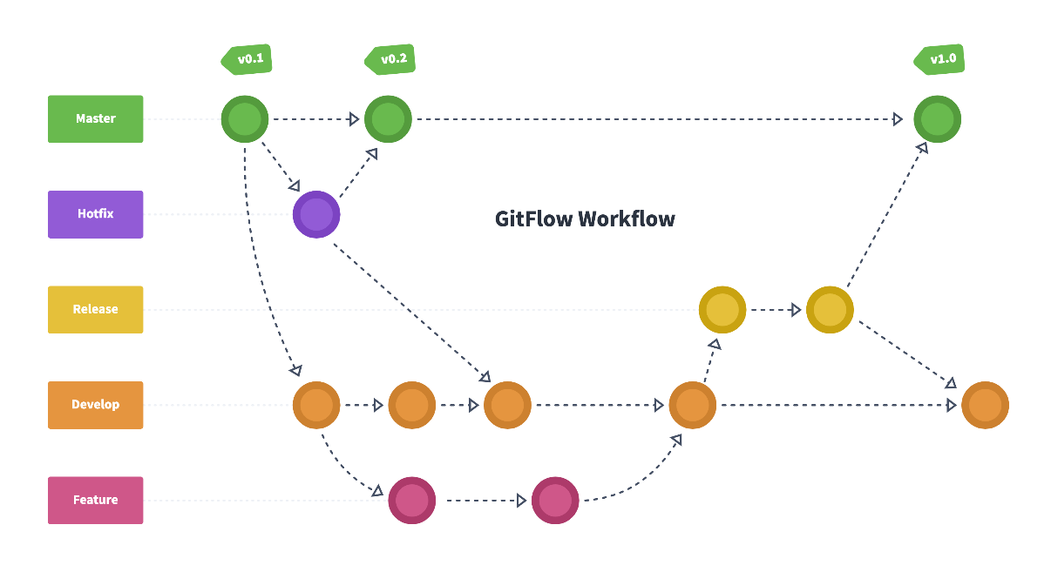

Figure GitFlow

**GitHub**

GitHub is an online software development tool that allows users to store, monitor, and collaborate on projects.

Source code can be cloned from a repository, and GitHub is a public repository server service where anyone can establish an account and work with their own files. GitHub is also a social networking site for coders, where they can connect, collaborate, and showcase their work.

GitHub is one of the most common sites for developers to exchange code and collaborate on projects. It's free, simple to use, and has played an important role in the transition to open source software.

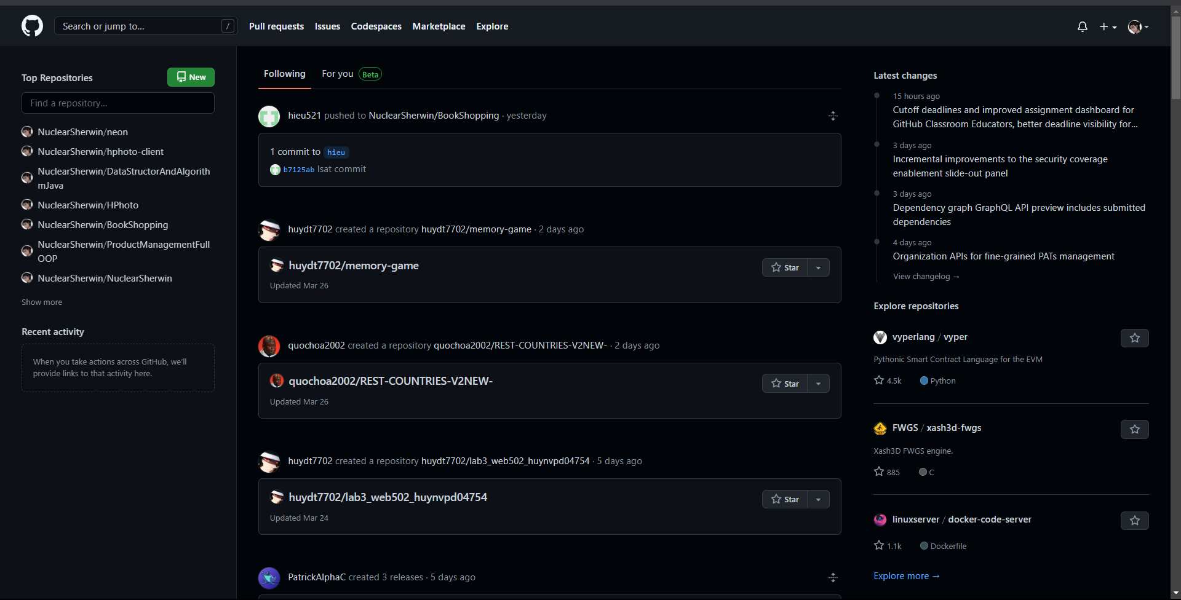

Figure GitHub

## Conclude which tools will be used for the development

Git and GitHub are two tools for source control that I mentioned earlier. As a result, I will be using these two tools in the project to handle our team's source code. Here are some of the reasons I selected these two instruments.

Why I chose the **Git application** for source control administration

**Efficiency:** When compared to many other tools, Git's raw speed is very powerful. New modifications, branching, combining, and comparing previous versions are all performed in a time-efficient manner. Git's algorithms make extensive use of knowledge about how actual source code file trees are constructed, how they evolve over time, and how users access them.

**Security:** Git was designed with the security of the source code it maintains in mind. The substance of the files and how they are connected to each other, as well as the real connections between files and folders, versions, tags, and commits, are all protected by cryptographically secure hashing methods known as SHA1. This safeguards both the code and the change in history against both unintentional and malevolent modifications. It also ensures that the past is completely traceable. Customers can be confident that they have a complete timeline of source code thanks to Git.

**Git** is versatile in that it can be used for a wide range of nonlinear development processes, for speed in both small and large tasks, and for compatibility with a wide range of other systems. Git, like SVN, treats branching and labeling as first-class residents. Merging and reverting operations are also recorded in the change log for these branches and identifiers. Some revision control systems do not retain this much information on file.

The reason I chose GitHub for source control administration is that we can use it for free if our project is open source. It includes a wiki and a problem database.

* It is simple to add comprehensive notes and receive comments on our initiatives.
* When we use GitHub, we find it simpler to obtain excellent documentation. Their assistance and tutorials page has pieces on almost every git-related subject we can think of.
* When it comes to hiring new people for their initiatives, most businesses now glance at GitHub profiles. We have a higher chance of getting employed if our profile is public.
* The source is GitHub. This implies that the general public can see our efforts. Also, because GitHub is one of the most popular sites to learn how to code, our project receives a lot of interest there.
* Observe how our programming has evolved over time. When a large group of people collaborate on a project, it can be difficult to keep track of who modified what, when, and where data are stored. This is taken care of by GitHub, which maintains account of all modifications made to the repository.

## Software Development Models

### SDLC Models

**Waterfall Model**

The waterfall model is a software development method that is split into stages and performed consecutively, with the output of one phase being the input of the next with no overlap. The waterfall model is called after the top-to-bottom sequential method, which mimics the flow of a cascade.

(Lewis, 2022). This software development approach is most commonly used in small tasks. At the conclusion of each step, an evaluation will be performed to determine whether the project is on track and on plan, as well as to settle the problem of project continuation or termination.

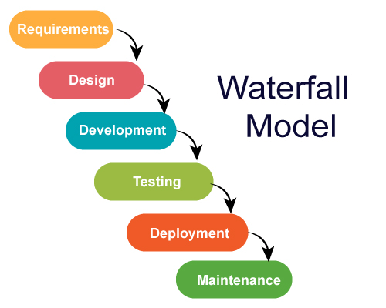

Figure Waterfall Model

**Description The V-Model**

The cascade model is extended by the V model. This is not the case with the cascade approach. The software development phase corresponds to a testing phase in the V model, and testing is done in tandem with the software development cycle. (Javatpoint, 2022).

The V model's test implementation starts with the questioning step. Model V is also known as a proof or validation model. To grasp the V model, first understand what software verification and validation are.

Verification: A form of static analysis is verification. This method is used to evaluate code without running it.

It necessitates several duties, including review, inspection, and teaching.

Validation is a sort of dynamic analysis in which testing is carried out by executing code. Functional and non-functional testing techniques are instances.

In the V model, development and quality testing tasks are carried out concurrently. There is no distinct testing process; instead, testing starts with the requirements gathering phase. Authentication and authentication are inextricably linked. To understand more about the Model V, see the illustration below.

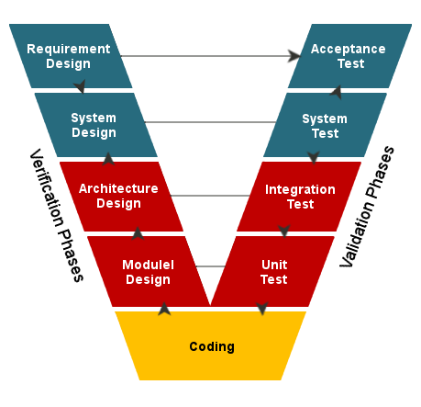

Figure V Models

**The Agile Model**

Agile is a collection of rules for agile software development with the goal of putting products into the hands of customers.

Customers should be contacted as quickly as feasible. Adaptive planning, incremental growth, on-time delivery, and constant improvement is one of the factors on which the Agile methodology emphasizes. Projects in software engineering are handled in a highly flexible and practical way. It predicts risks and encompasses occurrences to prevent them and encourages cross-functional cooperation, prerequisite comprehension, ongoing and iterative development, and re-testing

"Agile" aspires to provide the best solutions to satisfy the requirements of consumers at the lowest possible cost, while averting risks and spending as little time as possible. It is diametrically opposed to the conventional "Water Fall" method, making the workflow more linear, sequential, and continuously battling to promote positive change. There are numerous Agile Frameworks. Dynamic Systems Modeling (DSDM) and Extreme Programming (XP), for example, are software development models. The Scrum framework's increasing appeal is well-suited to today's software development and project management.

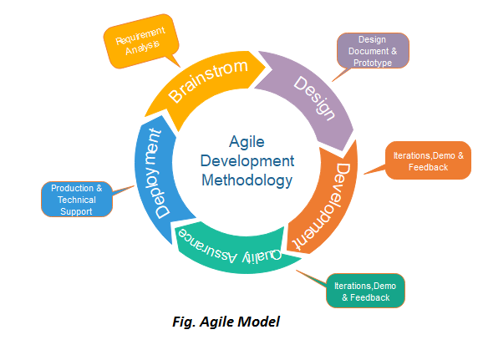

Figure Agile model

1. **Conclude which SDLC model will be used for the development**

As previously stated, I will be presenting Software Development Models for project administration. In this part, I will choose the Agile approach as a project management approach, and here are the reasons why I used it in this project.

Simply put, the Agile development method is an incremental development process. Each project is divided into tiny stages that can be changed when the client requests a change.

In each phase, with each sub-phase given to the customer, the customer can make a new request or alter the product update without having to redo it all. To adjust to change, agile values flexibility and creativity.

The Agile method is split into the following major phases:

* Strategy
* Examine
* Design and programming
* Product testing
* Product handover

The Agile approach is not only confined to the software development process; it is also the best alternative to the conventional work management models that we strive for.

The Agile project management technique that we have used helps to improve work productivity, finish work easily and on time, and produce more quality goods and services that satisfy the needs of consumers.

Changes can be made rapidly because each project is divided into several distinct work and information processing stages.

* Timely updates: Agile is appropriate for initiatives that are still in the planning phases and do not have all of the long-term objectives.
* Quicker project handover: As each step is finished, a portion of the project is delivered.
* Customer and consumer feedback is an important source of information: Listening to customer feedback helps to enhance product quality.
* Continuous Improvement: As you learn more about the Agile model, you will discover that it promotes fast change and changes at every level.

**ILLUSTRATE ALL YOUR FINDINGS ON HOW TO USE THESE BY DRAW THE OVERVIEW**

# References

Anon., 2020. *computerhope.* [Online]   
Available at: https://www.computerhope.com/jargon/d/drawio.htm  
[Accessed 28 03 2023].

Anon., 2023. *byjus.* [Online]   
Available at: https://byjus.com/gate/difference-between-css-and-scss/#:~:text=What%20is%20SCSS%3F,thus%20often%20called%20Sassy%20CSS.

Anon., 2023. *experienceux.* [Online]   
Available at: https://www.experienceux.co.uk/faqs/what-is-wireframing/  
[Accessed 28 03 2023].

Anon., 2023. *hostinger.* [Online]   
Available at: https://www.hostinger.com/tutorials/what-is-css

Anon., 2023. *lesscss.* [Online]   
Available at: https://lesscss.org/

Anon., n.d. [Online]   
Available at: https://www.definitions.net/definition/lucidchart

Camus, A., 2022. *microverse.* [Online]   
Available at: https://www.microverse.org/blog/javascript-library-vs-javascript-frameworks-the-differences  
[Accessed 15 03 2023].

Coron, T., 2020. *creativebloq.* [Online]   
Available at: https://www.creativebloq.com/web-design/what-is-sass-111517618

S., A., 2023. *hostinger.* [Online]   
Available at: https://www.hostinger.com/tutorials/what-is-html

Stewart, L., 2021. *coursereport.* [Online]   
Available at: https://www.coursereport.com/blog/front-end-development-vs-back-end-development-where-to-start#:~:text=Front%20end%20languages%20include%20HTML,it%20on%20a%20bootcamp's%20curriculum.

Trigo, A., 2022. *alvarotrigo.* [Online]   
Available at: https://alvarotrigo.com/blog/wireflows/  
[Accessed 28 03 2023].