**SE426 - Web Services**

**Week 9 Lab - Consuming your own Web Service**

Michael Lopez & Saimer Nieves

Teammates :

**Recommended**

Reviewers :

1. An application that allows you to consume and interact properly/fully with your Web API / Service. You may choose the development environment of choice, but you are responsible for its functionality and all research involved in making it work properly. You can choose JS, Blazor, PHP, Python, or another platform of choice. I recommend JS or Blazor, especially if you hit major brick walls and time is limited. Make sure both Good and Bad responses are handled in the App.

We went the PHP Route

1. Create a list of the functions and object classes the App has and make sure there are links in the App.

* API_Functions.php
* GetAllAgents.php
* GetAllBookings.php
* GetAllProperties.php
* PostAgentForm.php
* PostBookingForm.php
* PostClientForm.php
* PostPropertyListingForm.php

1. As you connect to each functionality built into the App, test both good and bad situations. As you build functionality share:  
   a) Text describing the function & show snapshot of the code

API_Functions.php:

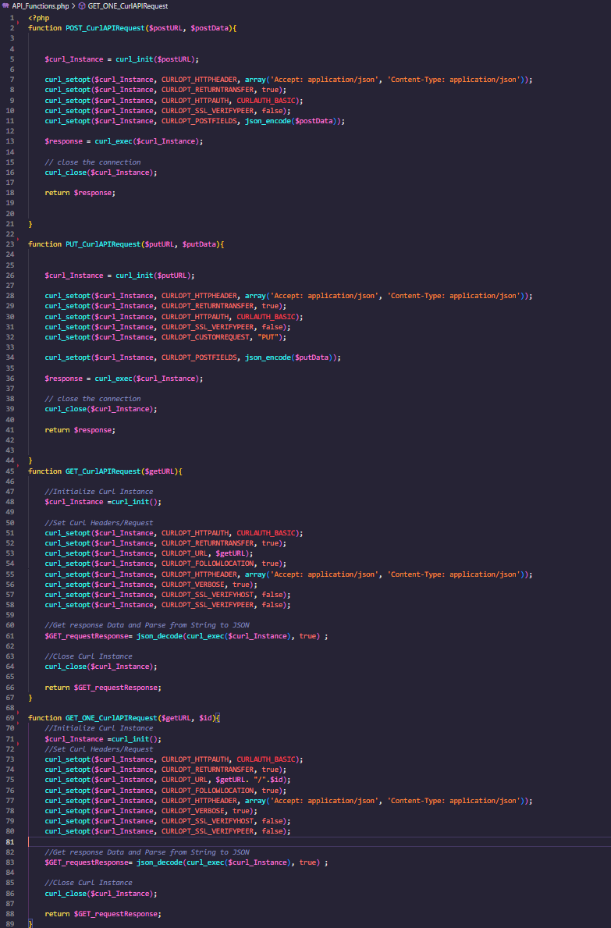

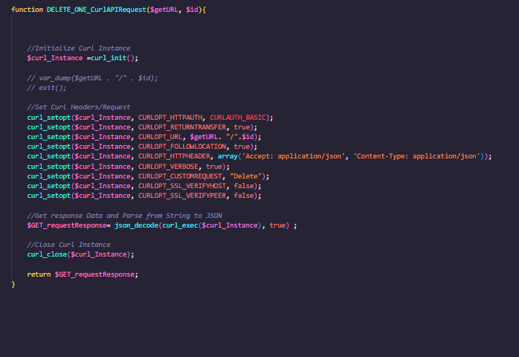

GetAllAgents:

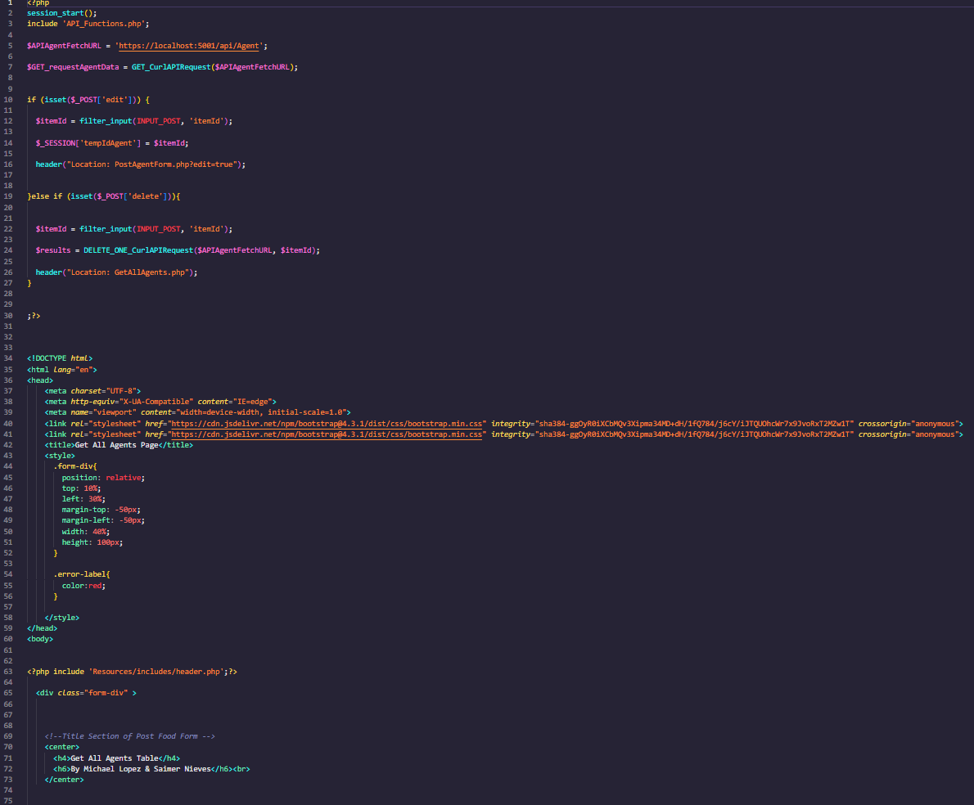

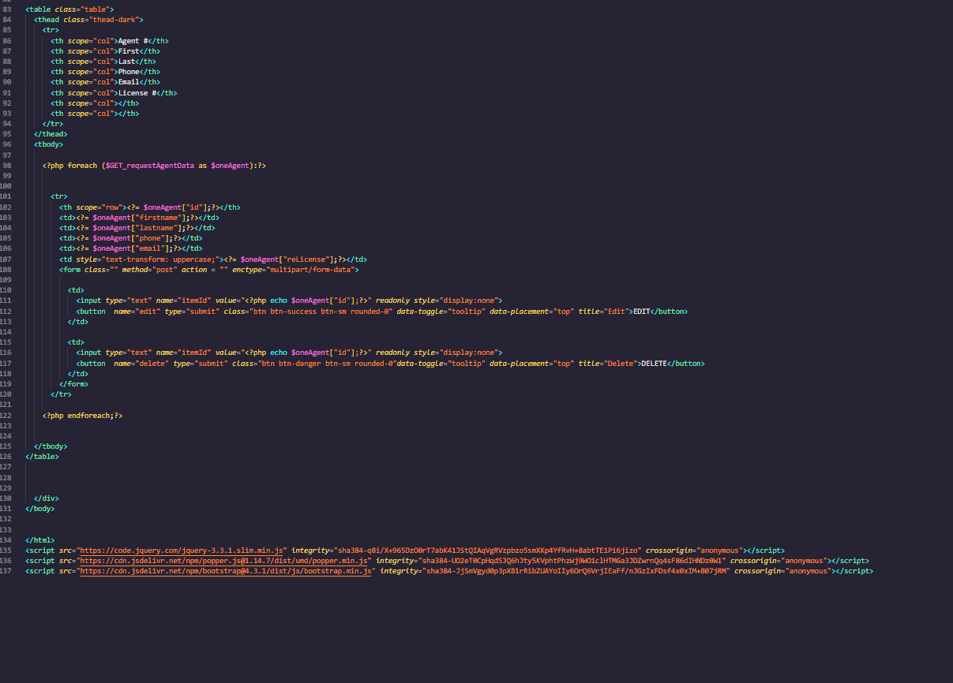

**GetAllBookings:**

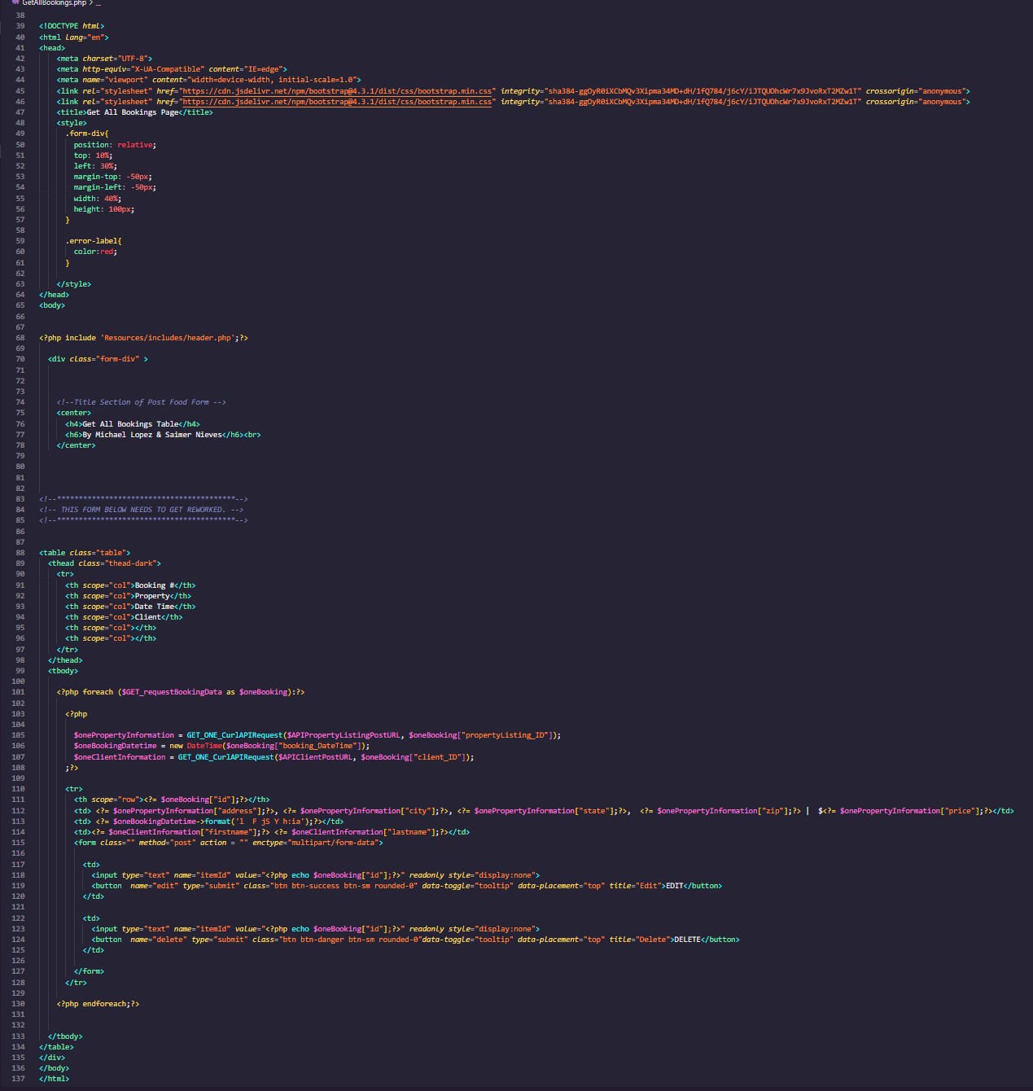

**GetAllClients:**

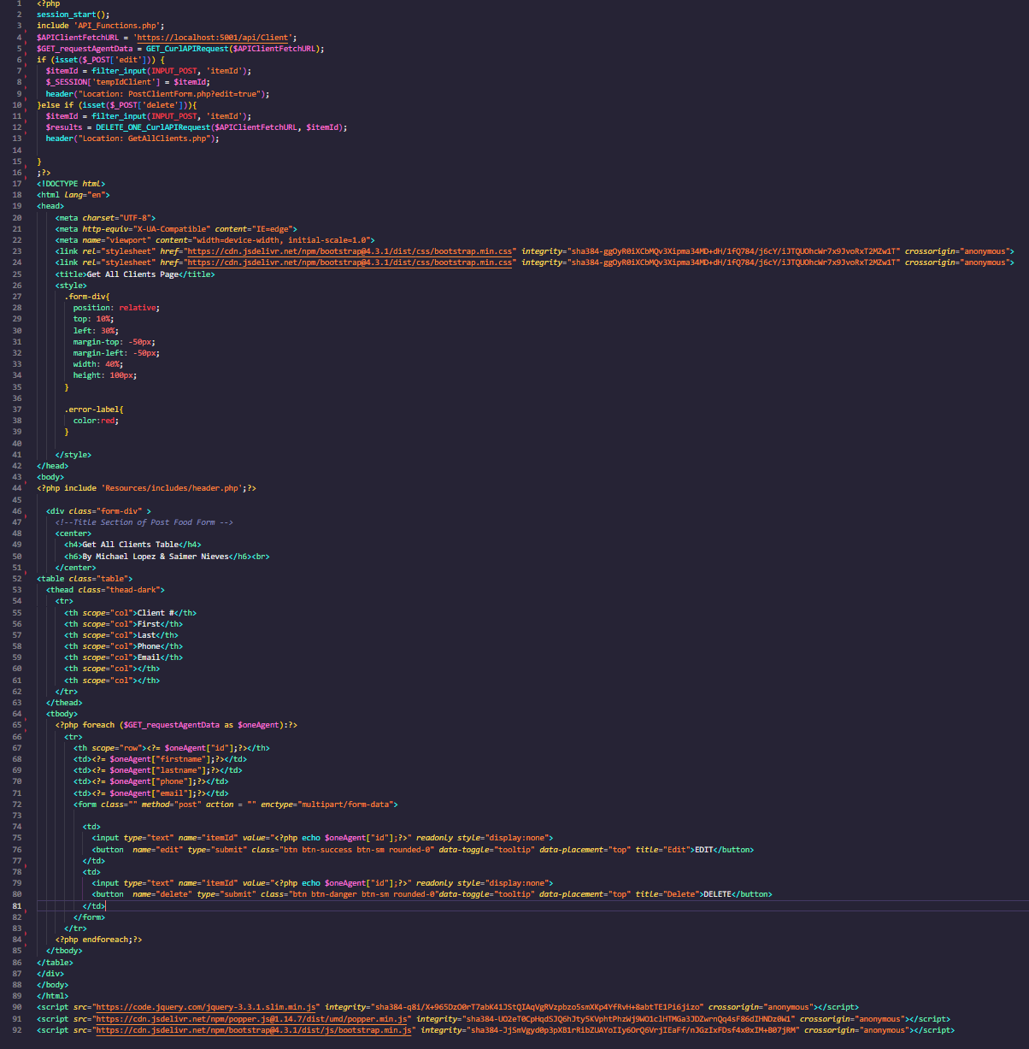

**GetAllProperties:**

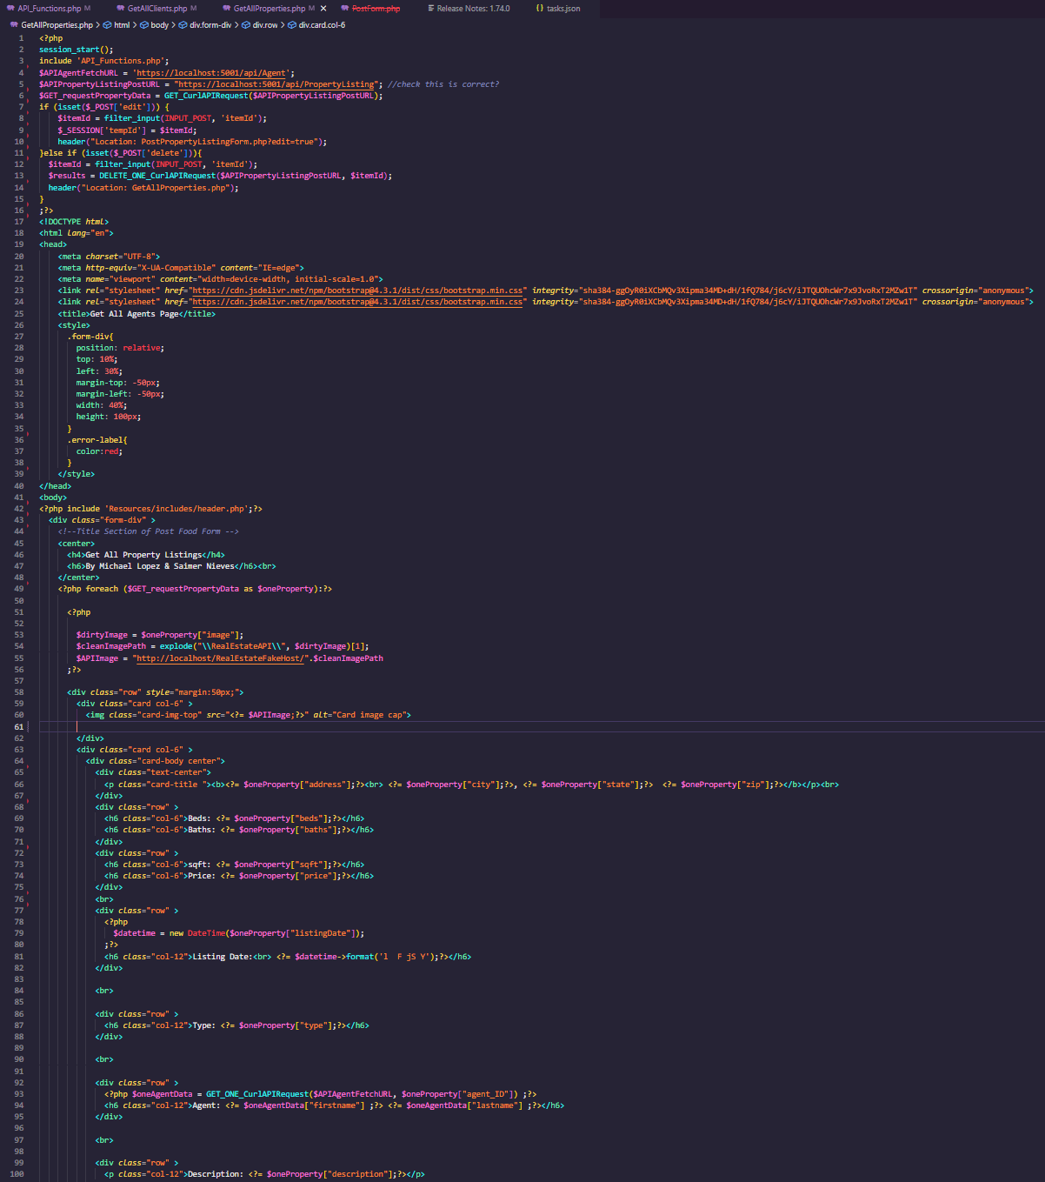

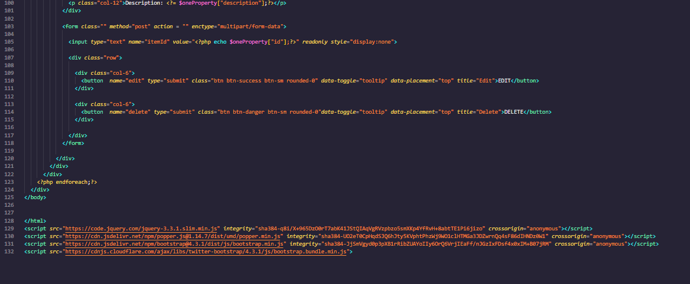

**PostAgent:**

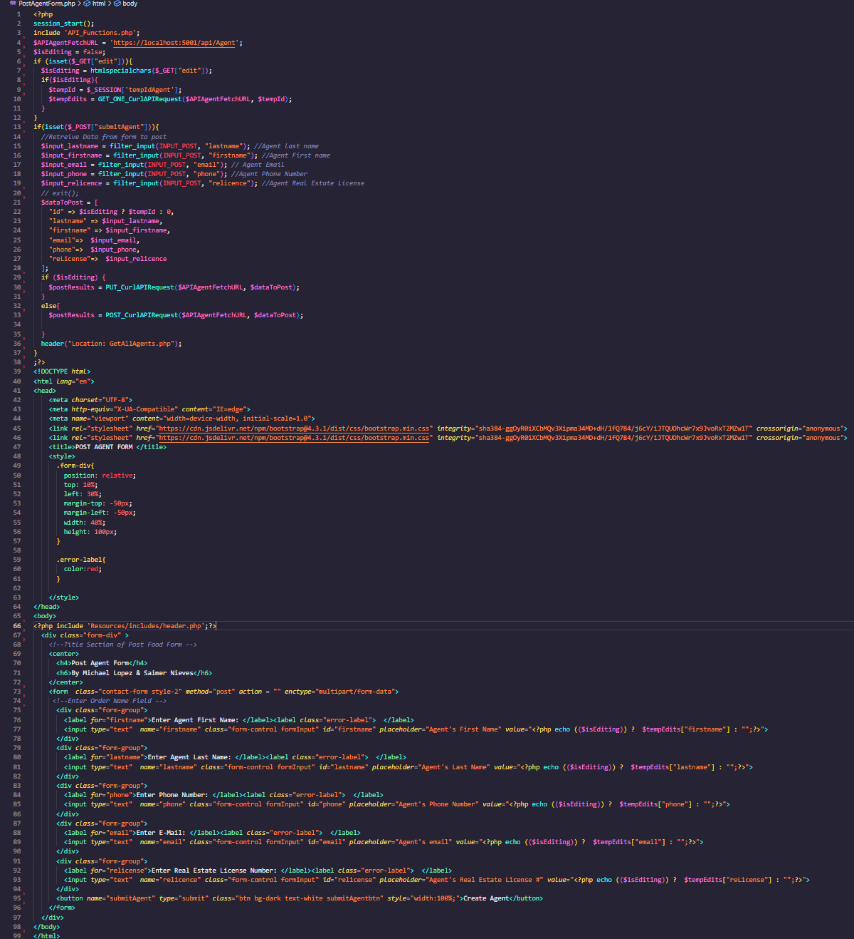

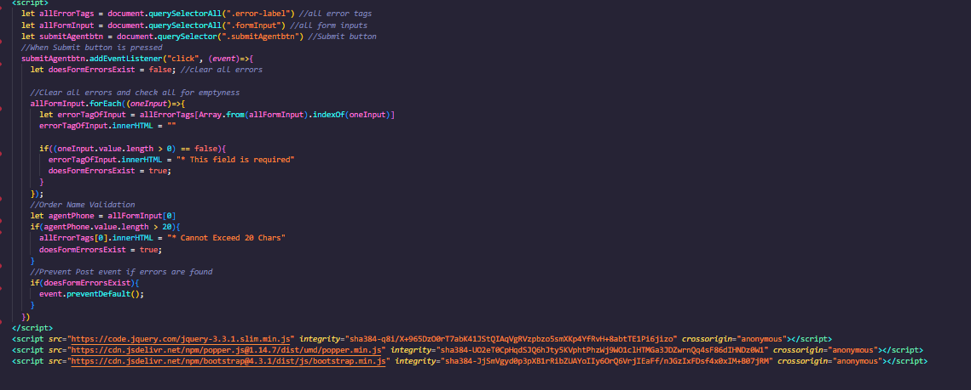

**PostBookingForm:**

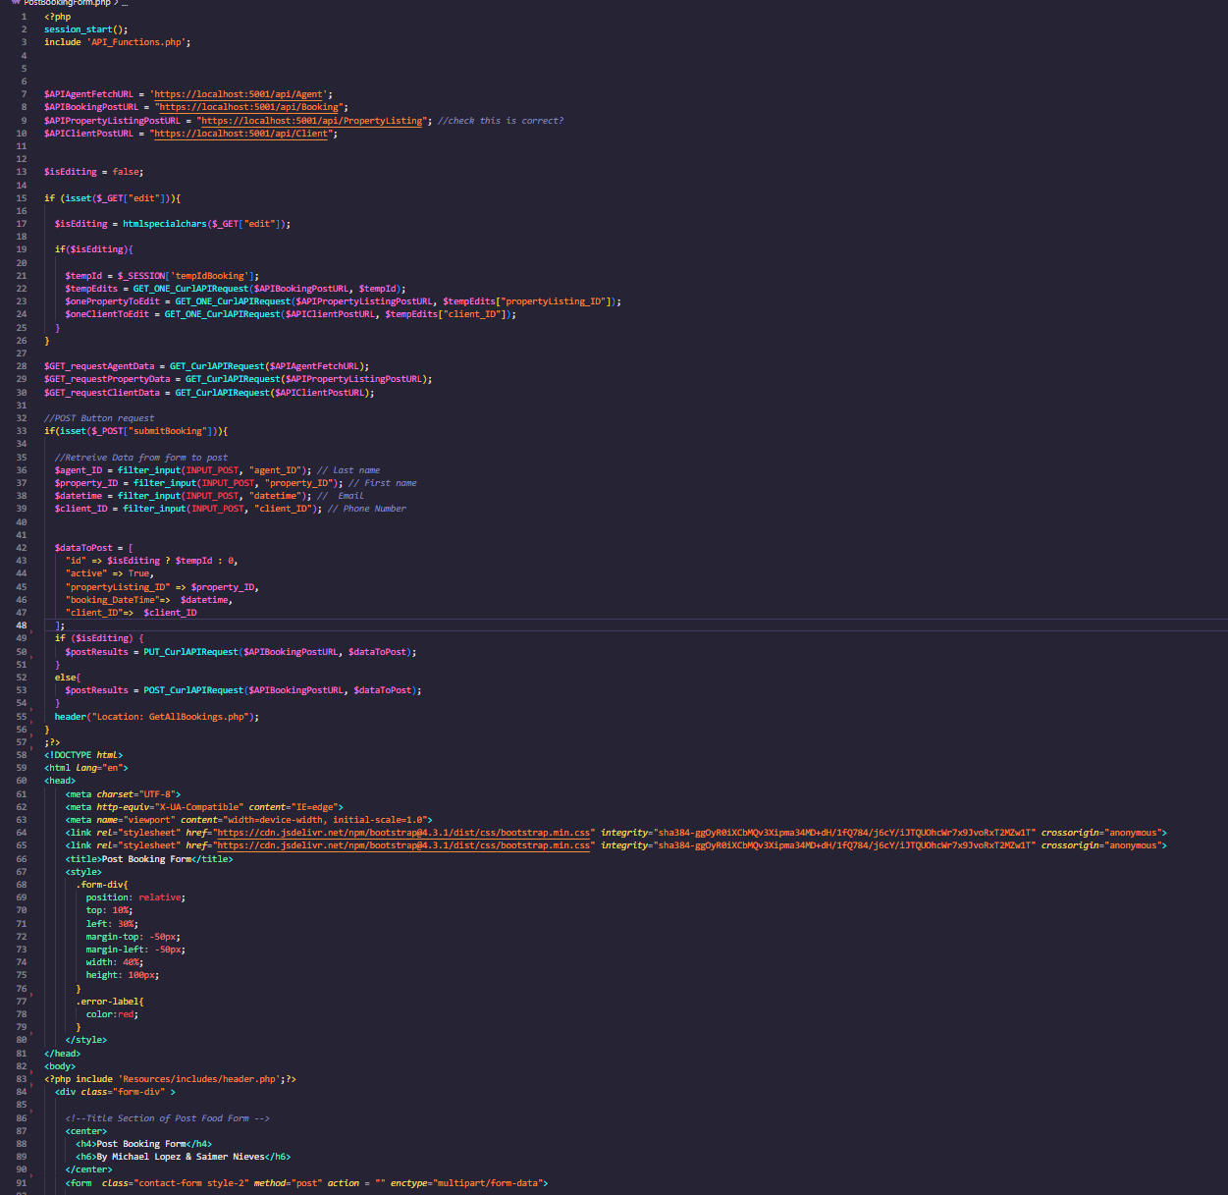

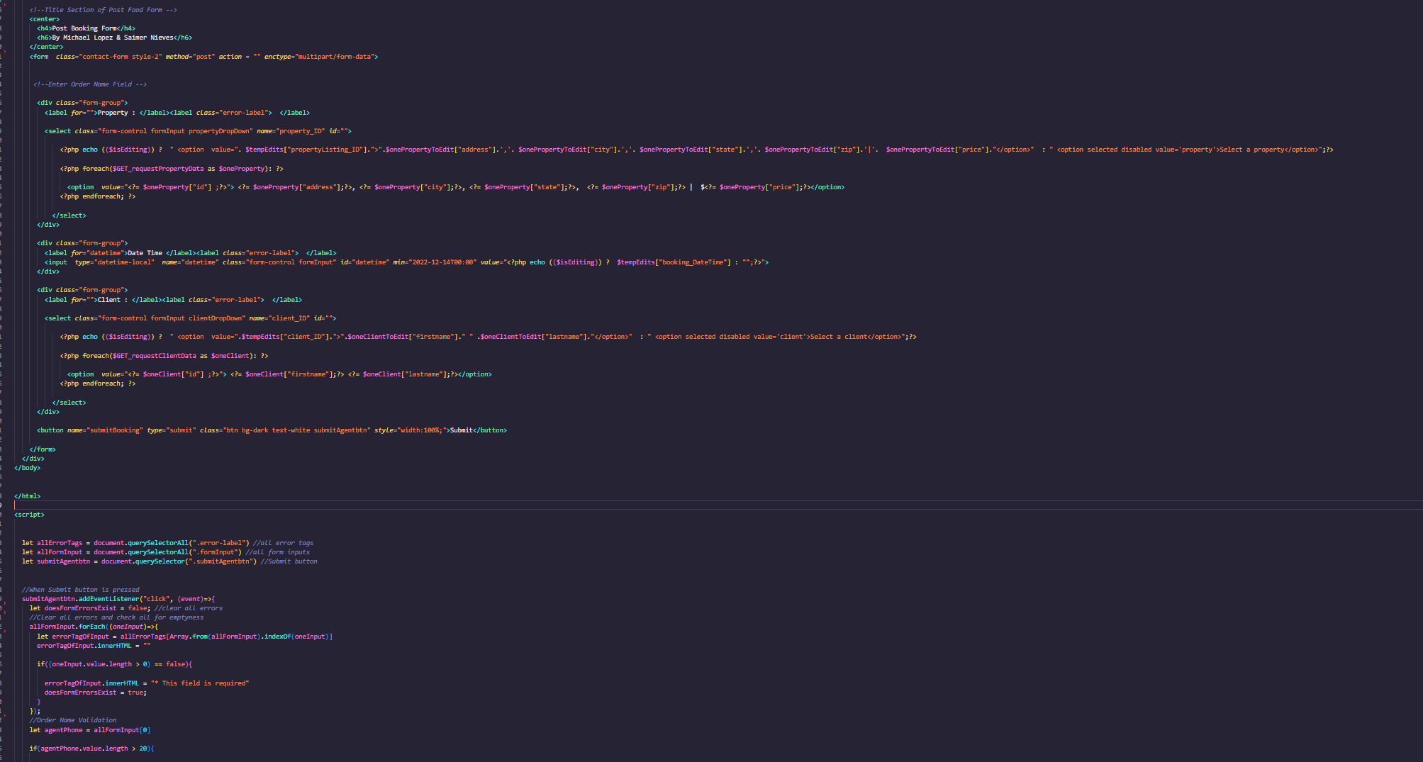

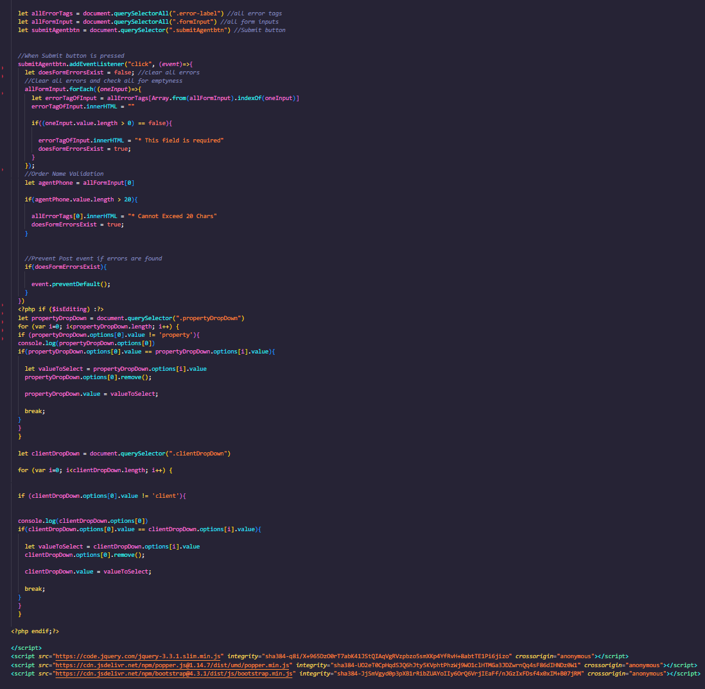

**PostClientForm:**

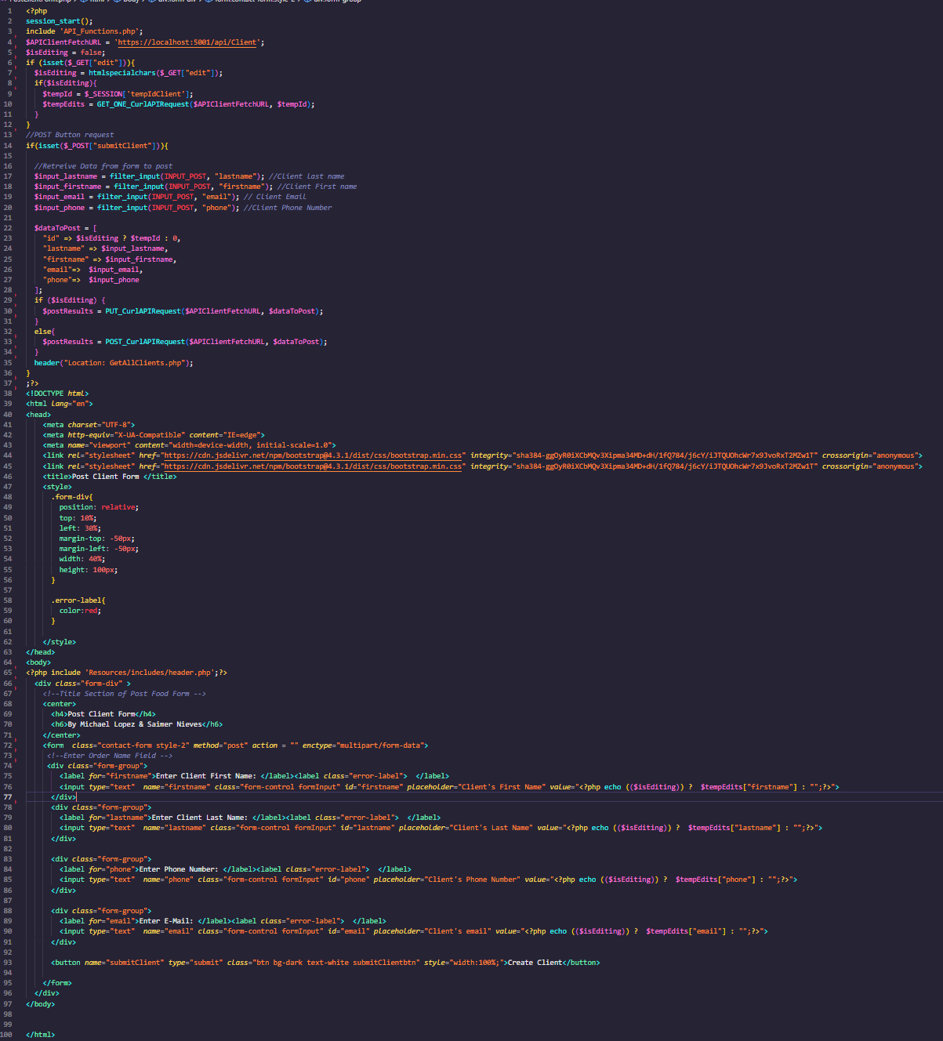

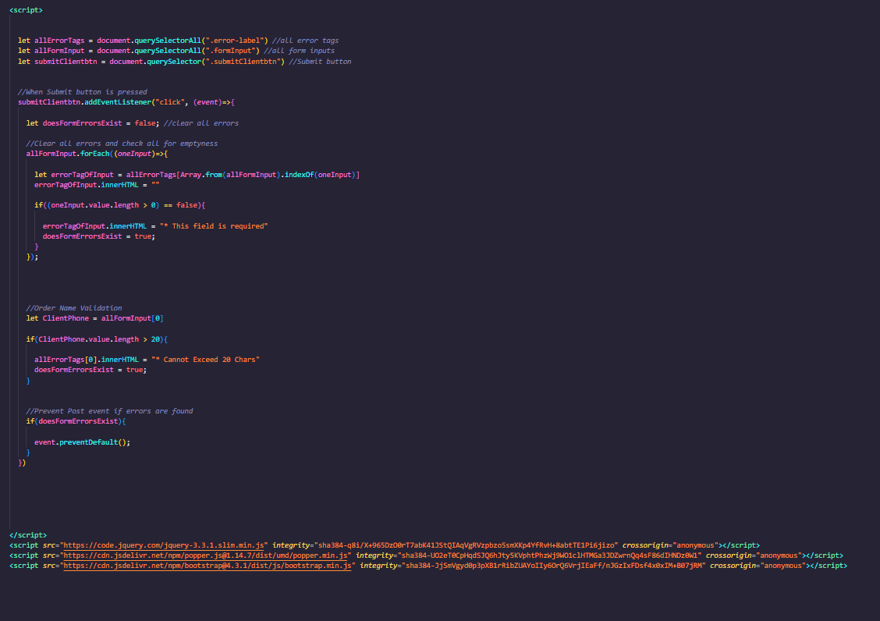

**PostProperty:**

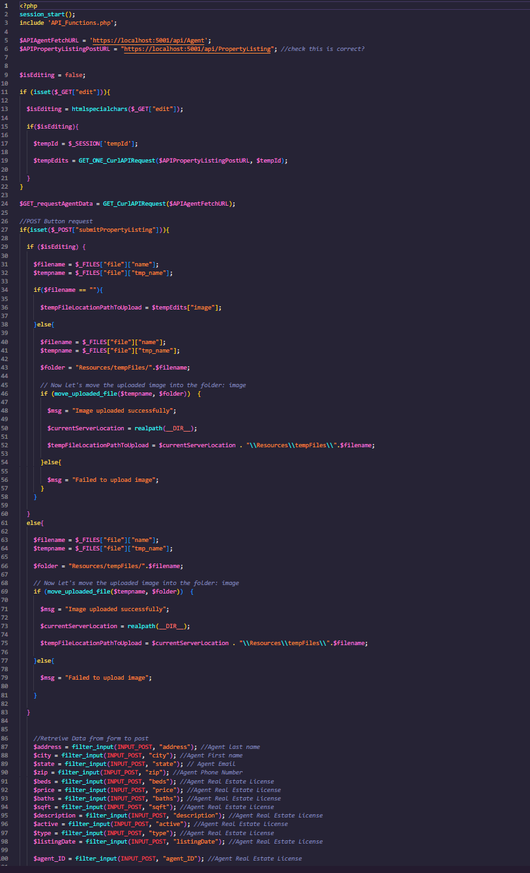

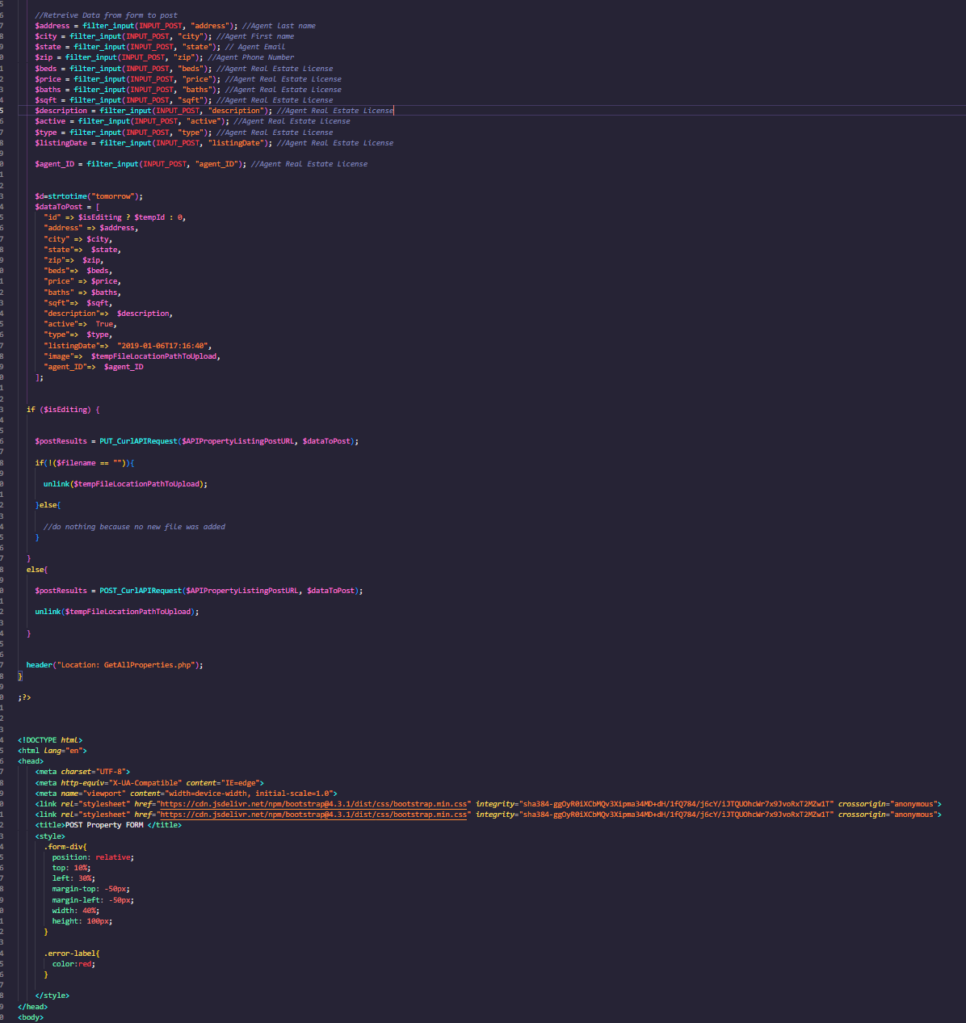

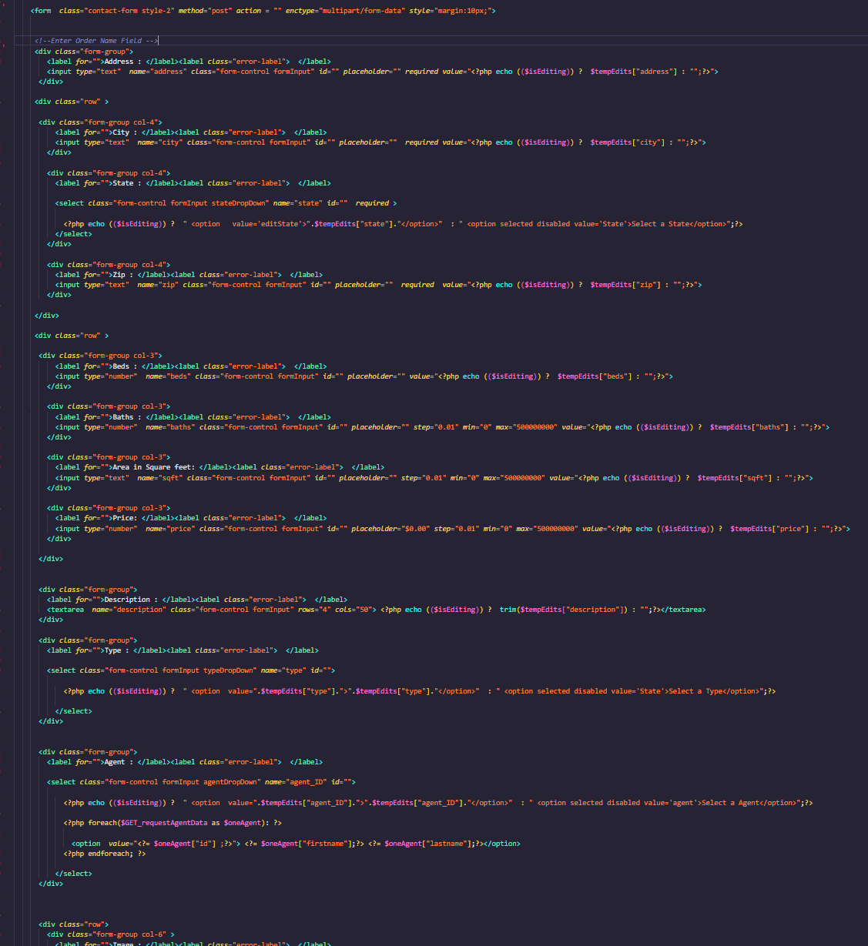

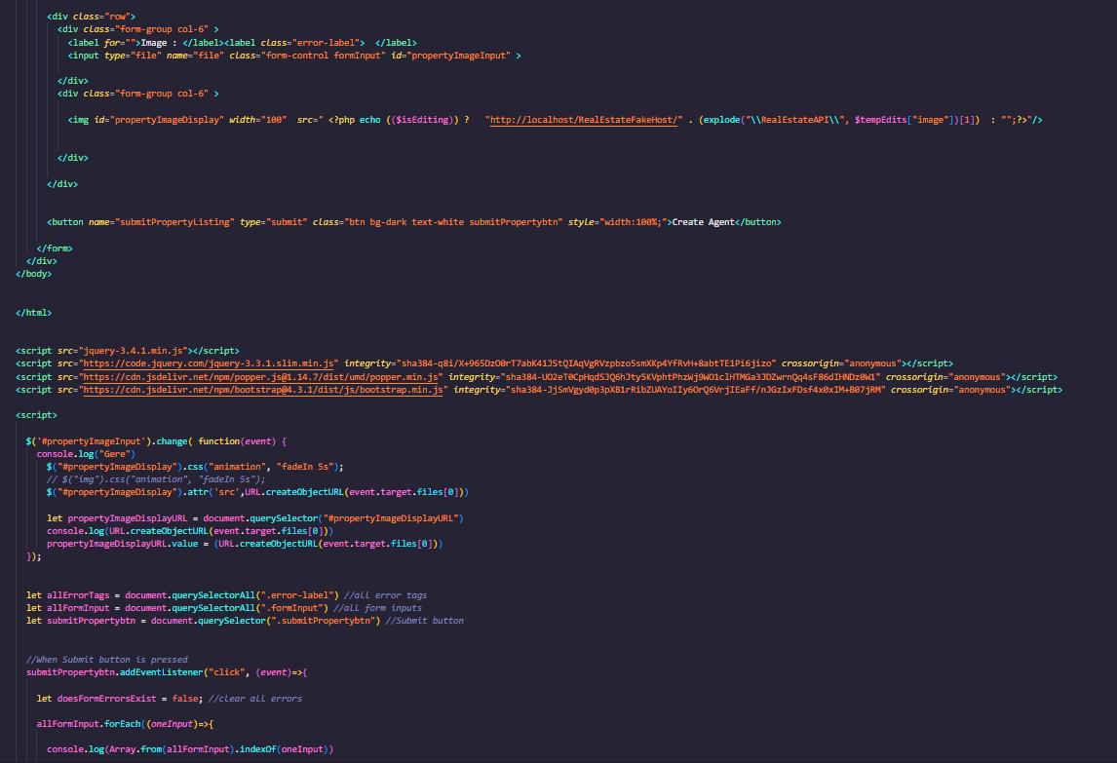

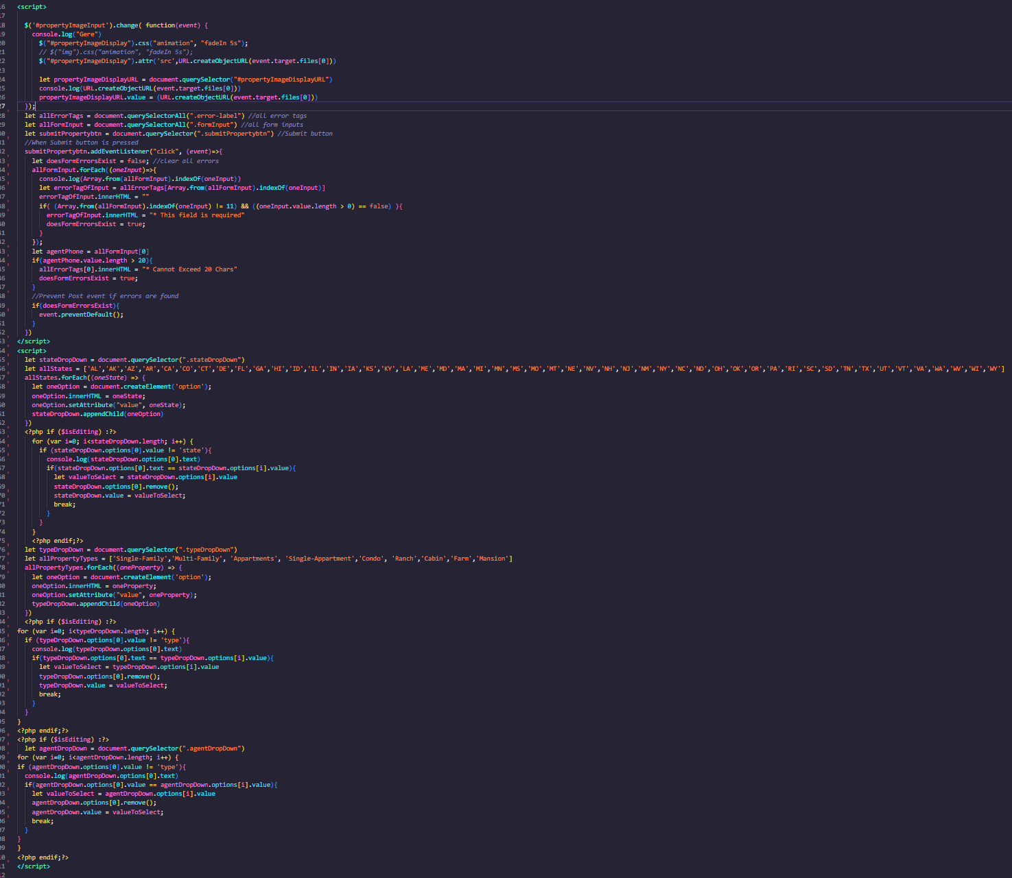

c) show successful and unsuccessful tests look within your App..

included in a separate word document.