Game Definition File Validator

<https://github.com/walbourn/directx-sdk-samples>

The **Game Definition File Validator** (GDFTrace.exe) utility is a debugging aid for working with Game Definition File Editor (GDF) files for Windows Vista, Windows 7, Windows 8, and Windows 8.1 Preview. It is a command-line tool for validating the XML against the schema, displaying a 'human readiable' summary, and generating validation warnings. It can be used either directly extracting the GDF from the containing EXE/DLL file, or against the 'raw' XML file.

# Description

If run without any command-line parameters, it displays the following help.

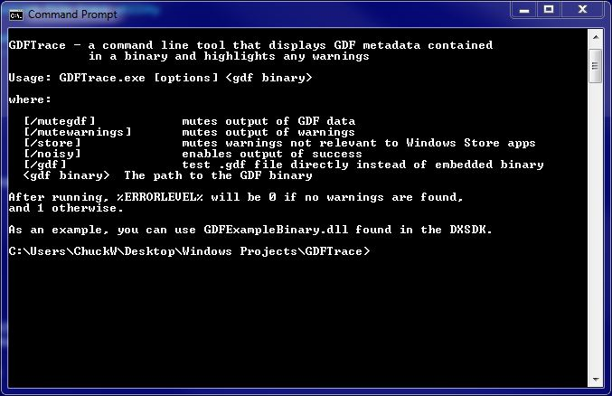

This utility was originally published as part of the legacy DirectX SDK. This version does not require the DirectX SDK to build and can be built using Visual Studio 2010 or later.

# Requirements

The GDFTrace.EXE must have the both the GamesExplorerBaseTypes.v1.0.0.0.XSD and GDFSchema.v1.0.0.0.XSD files located in the same directory as the EXE to fully validate the GDF files.

# More Information

[Windows Games Explorer](http://msdn.microsoft.com/en-us/library/windows/desktop/ee415240.aspx)

[Games Explorer](http://msdn.microsoft.com/en-us/library/windows/desktop/hh437965.aspx)

[Games for Windows Technical Requirements](https://docs.microsoft.com/en-us/windows/win32/dxtecharts/games-for-windows-technical-requirements-1-1-0006) (TR 1.1 and 1.2)

[Games for Windows Test Cases](https://docs.microsoft.com/en-us/windows/win32/dxtecharts/games-for-windows-test-requirements-1-0-0006) (TR 1.1 and 1.2)

[Where is the DirectX SDK (2015 Edition)?](https://walbourn.github.io/where-is-the-directx-sdk-2015-edition/)

[Games for Windows and DirectX SDK blog](https://walbourn.github.io/)