Windows Firewall Install Helper

<https://github.com/walbourn/directx-sdk-samples>

The FirewallInstallHelper.dll is a sample DLL that can be called from an installer to register an application with the Windows Firewall exception list.

 See the [Windows Firewall for Game Developers](http://msdn.microsoft.com/en-us/library/windows/desktop/ee417690.aspx) article for more details.

 The primary purpose is to avoid users seeing this dialog:

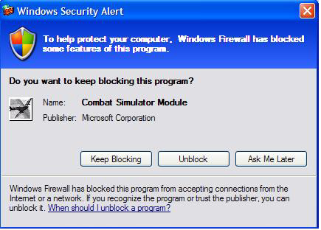

# FirewallInstallHelper.dll

The support DLL exports the following functions:

* AddApplicationToExceptionListW - This function adds an application to the exception list. It takes a complete path to the executable and a friendly name that will appear in the firewall exception list. This function requires administrator privileges.
* AddApplicationToExceptionListA - ANSI version of AddApplicationToExceptionListW
* RemoveApplicationFromExceptionListW - This function removes the application from the exception list. It takes in a complete path to the executable. This function requires administrator privileges
* RemoveApplicationFromExceptionListA - ANSI version of RemoveApplicationFromExceptionListW
* CanLaunchMultiplayerGameW - This function reports if the application has been disabled or removed from the exceptions list. It should be called every time the game is run. The function takes in a complete path to the executable. This function does not require administrator privileges.
* CanLaunchMultiplayerGameA - ANSI version of CanLaunchMultiplayerGameW

And three functions to simplify integration with Windows Installer (MSI)

* SetMSIFirewallProperties
* AddToExceptionListUsingMSI
* RemoveFromExceptionListUsingMSI

# More Information

[Games for Windows Technical Requirements](https://docs.microsoft.com/en-us/windows/win32/dxtecharts/games-for-windows-technical-requirements-1-1-0006) (TR 1.1 and 1.2)

[Games for Windows Test Cases](https://docs.microsoft.com/en-us/windows/win32/dxtecharts/games-for-windows-test-requirements-1-0-0006) (TR 1.1 and 1.2)

[Where is the DirectX SDK (2015 Edition)?](https://walbourn.github.io/where-is-the-directx-sdk-2015-edition/)

[Games for Windows and DirectX SDK blog](https://walbourn.github.io/)

[Visual Studio 2012 Update 1](https://walbourn.github.io/visual-studio-2012-update-1/)