**Aims**

The Centre aims to:

* Provide **first class tuition**, where learners achieve their full potential.
* Help learners develop their ambition and self esteem.

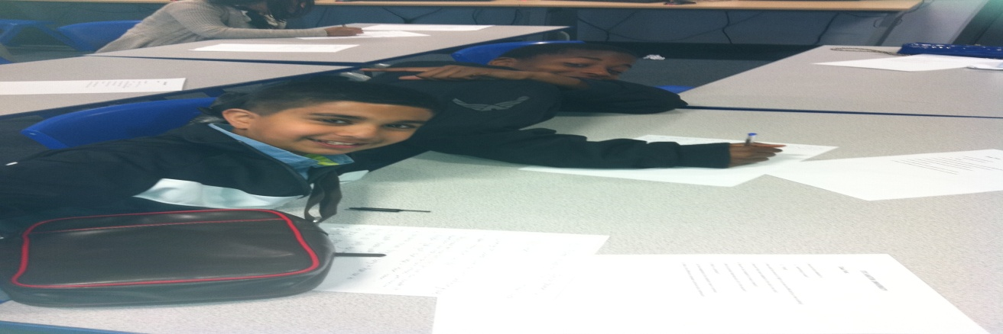

* Provide extra educational support to children in a friendly, caring environment taking account of their cultural and language needs.
* Help learners **improve their attainment** in school
* **Overcome barriers to Learning** and build their confidence.
* Provide children with tuition complementary to the Education received in school.
* Develop a **Working partnership with parents and mainstream schools.**
* Provide information on other relevant educational services and activities.
* Coach parents to help support their children academically.
* Provide organizational and interventional skills.

