**Services**

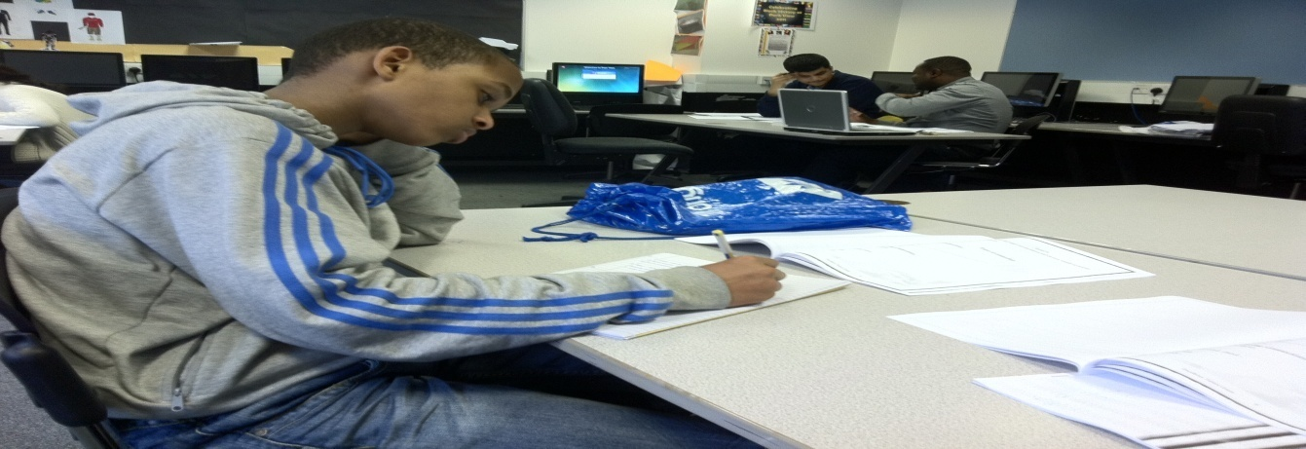

**Services Offered**

* SEN and EAL Support.
* Helping underachieving learners acess the National Curriculum.
* **11+ Preparation and SATS prepartion**
* **KS1, KS2 English, Maths, Science** & **German.**
* **KS3, KS4 English, Science**, Maths & **other subject Specialisms.**
* We offer GCSE tutoring, homework and revision support sessions to improve attainment.
* **Prepare learners for entrance and final exam by teaching as well** as well as **practicing exam styled questions** for confidence and proficiency.
* **Offer One- to – One tuition.**



**SEN and EAL Needs**

**We improve the support provided for children with special educational needs:**

* By personalising learning based on IEP’s (Individual Educational Plans) mostly supplied by their schools.
* **Differentiating teaching and learning resources, tailoring to meet their specific needs.**