API ClaimDi Bike Point

Tag : P1 + P3

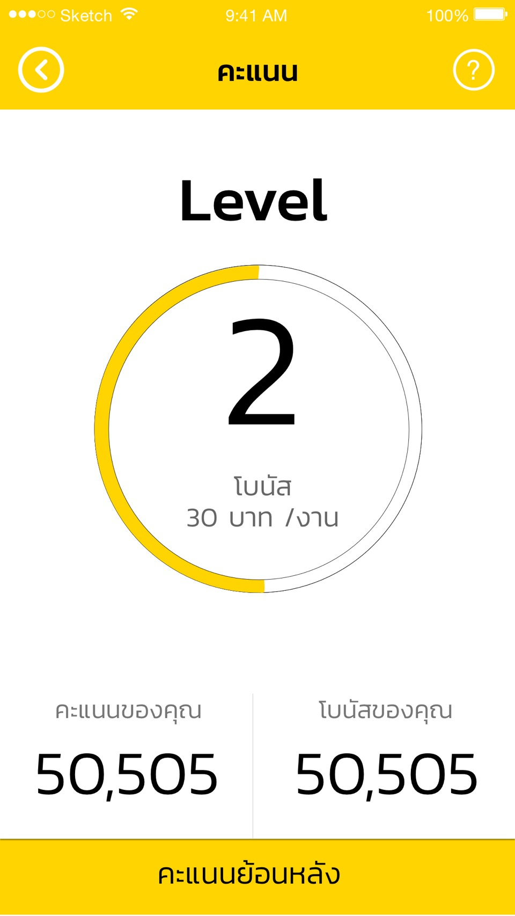

**API Current Point Of Month**

URL : [http://apiv2.claimdi.com/v2/surveyorpoint/current_point_of_month?acc_id={accId}](http://apiv2.claimdi.com/v2/surveyorpoint/current_point_of_month?acc_id=%7baccId%7d)

Param : accId

Method : GET

Response : {

"message_body": null,

"message_title": null,

"result": {

"bad_task": 0,

"bonus_total": 20,

"create_date_text": "มี.ค. 60",

"good_task": 1,

"id": 1,

"level_of_member": {

"bonus_of_level": 0,

"level_name": "Level1",

"level_of_member_id": 1,

"max_point": 600,

"min_point": 0

},

"normal_task": 0,

"point_month": 3,

"point_total": 100,

"point_year": 2017,

"ratio": 100,

"task_total": 1

},

"status_code": "200",

"system_error_message": null

Tag : P2

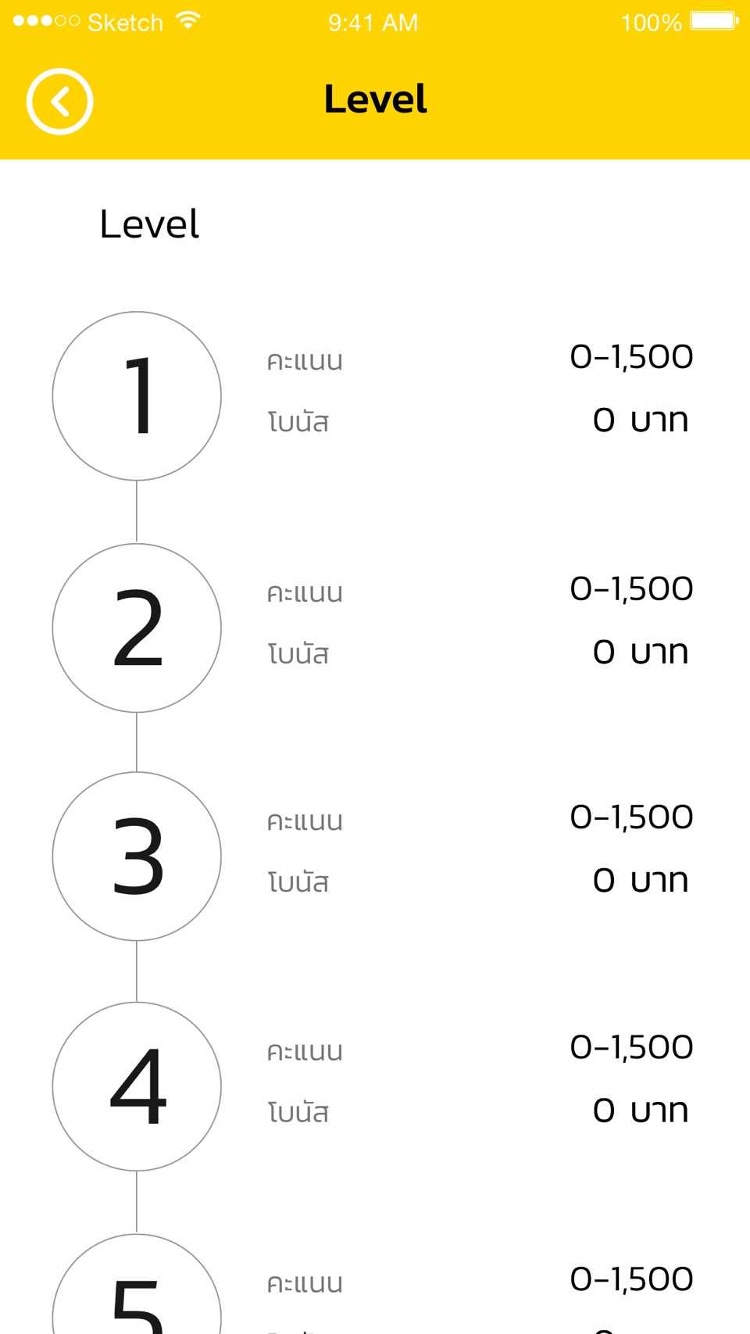

**API LevelOfMember**

URL : <http://apiv2.claimdi.com/v2/surveyorpoint/level_of_member>

Method : GET

Response : {

"message_body": null,

"message_title": null,

"result": {

"level_of_members": [

{

"bonus_of_level": 0,

"level_name": "Level1",

"level_of_member_id": 1,

"max_point": 600,

"min_point": 0

}

]

},

"status_code": "200",

"system_error_message": null

}

Tag : P4

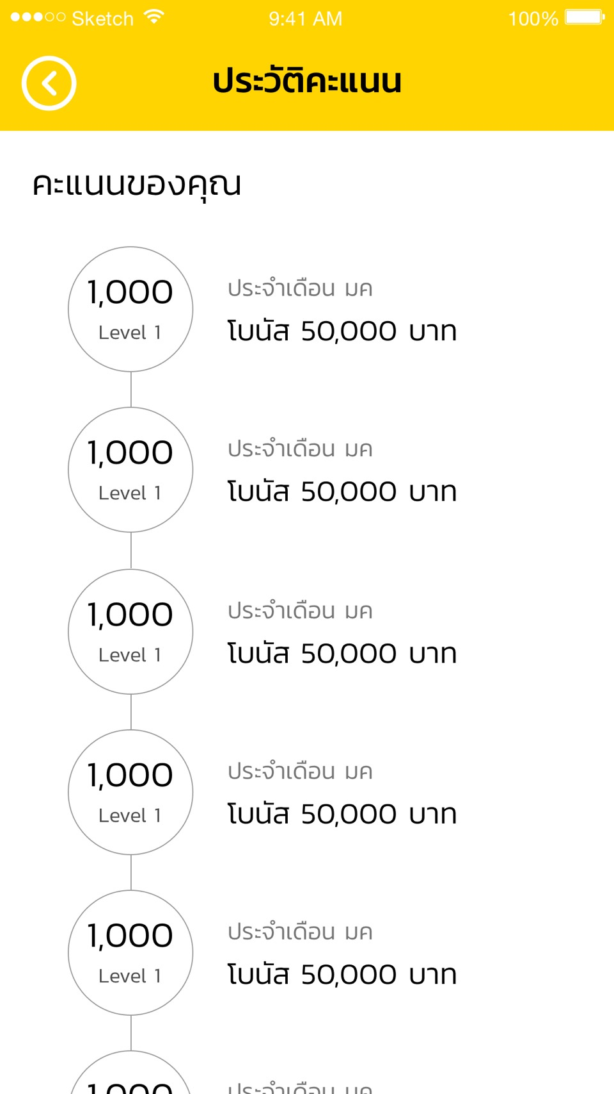

**API History Point Of Month**

URL : http://apiv2.claimdi.com/v2/surveyorpoint/history_point_of_month

Method : POST

Request : {

"acc_id":"6c0e909b-f805-4224-9dab-2cf878484665",

"page_index":1,

"page_size":20

}

Response : {

"message_body": null,

"message_title": null,

"result": {

"criteria": null,

"next_page": 1,

"page_size": 20,

"point_of_months": [

{

"bad_task": 0,

"bonus_total": 20,

"create_date_text": "มี.ค. 60",

"good_task": 1,

"id": 2,

"level_of_member": {

"bonus_of_level": 0,

"level_name": "Level1",

"level_of_member_id": 1,

"max_point": 600,

"min_point": 0

},

"normal_task": 0,

"point_month": 2,

"point_total": 100,

"point_year": 2017,

"ratio": 100,

"task_total": 1

}

],

"previous_page": 1,

"this_page": 1,

"total_record": 1

},

"status_code": "200",

"system_error_message": null

}

Tag : Task History

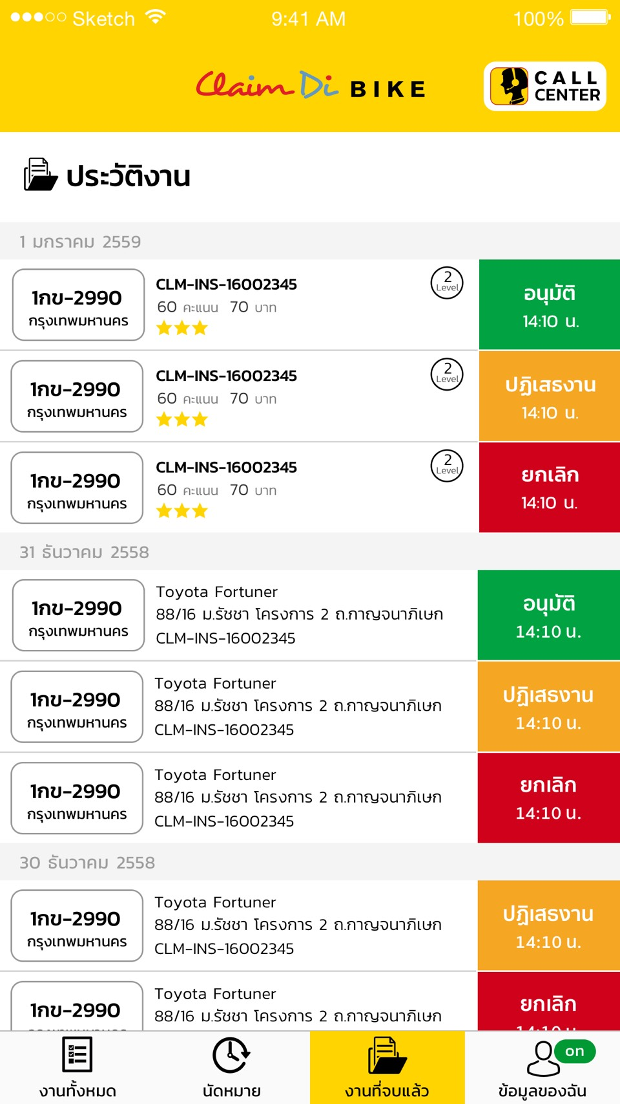

**API History Point Of Month [Bad 1ดาว, Normal 2 ดาว, Good 3 ดาว]**

URL : http://apiv2.claimdi.com/v2/task/list

Response : เพิ่มจากของเดิม ใน object task

"task_point": {

"bonus_of_level_member": 0,

"bonus_of_task_rate": 0,

"bonus_total": 0,

"level_of_member": {

"bonus_of_level": 0,

"level_name": "Level1",

"level_of_member_id": 1,

"max_point": 600,

"min_point": 0

},

"task_events”:null,

"task_rate": {

"max_point": 40,

"min_point": 30,

"rate_name": "bad",

"task_rate_id": 4

},

"task_summary_point": 5 }

Tag : Task Point History

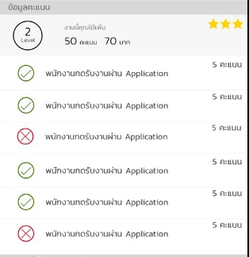

**API Task Point History**

URL : http://apiv2.claimdi.com/v2/task/details

Response : เพิ่มจากของเดิม ใน object task

"task_point": {

"bonus_of_level_member": 0,

"bonus_of_task_rate": 0,

"bonus_total": 0,

"level_of_member": {

"bonus_of_level": 0,

"level_name": "Level1",

"level_of_member_id": 1,

"max_point": 600,

"min_point": 0

},

"task_events": [

{

"event": {

"event_description": "พนักงานกดรับงานผ่าน App",

"event_id": 1,

"event_name": "พนักงานกดรับงานผ่าน App",

"event_point": 5,

"sort": 99

},

"point": 5

},

{

"event": {

"event_description": "พนักงานโทรศัพท์หาลูกค้าก่อนเริ่มเดินทาง",

"event_id": 2,

"event_name": "พนักงานโทรศัพท์หาลูกค้าก่อนเริ่มเดินทาง",

"event_point": 5,

"sort": 98

},

"point": 0

],

"task_rate": {

"max_point": 40,

"min_point": 30,

"rate_name": "bad",

"task_rate_id": 4

},

"task_summary_point": 5

}