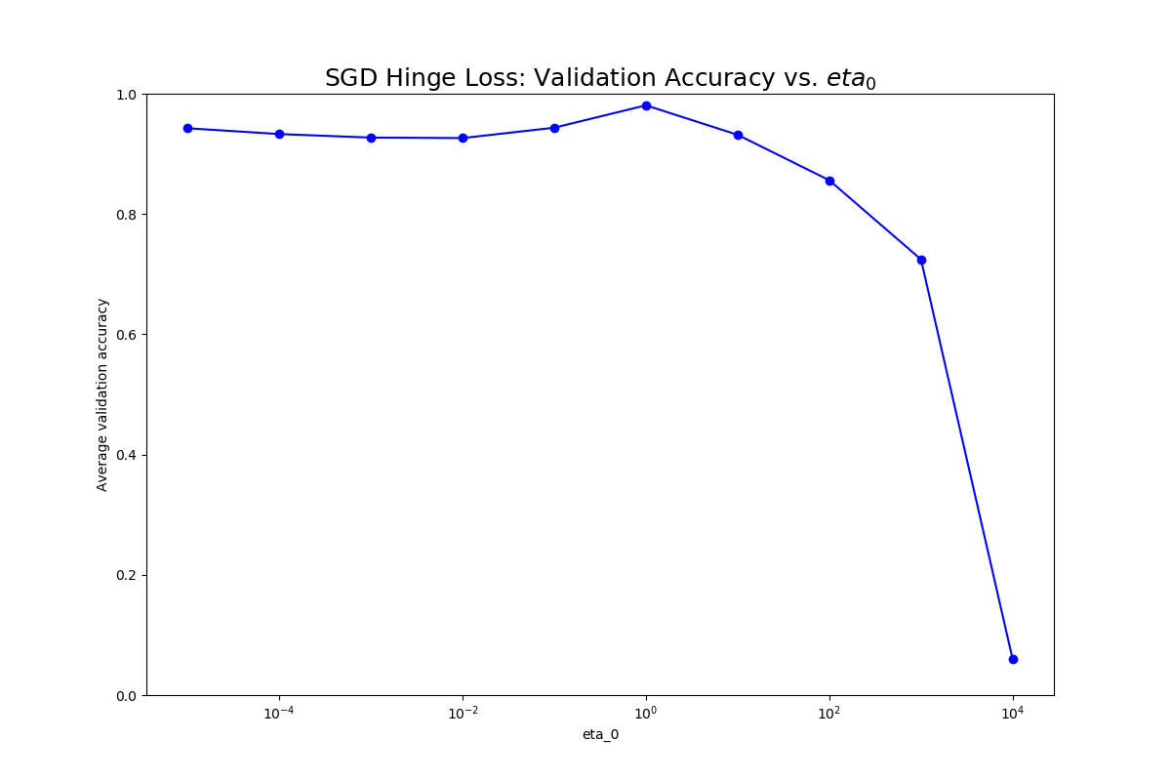

Best eta = 1

Best c is 0.0001

Test accuracy is 0.9928352098259979