Rough Design

Internet Connection

Profile Form
LocalHost Server
STEP:1

Firebase Server

STEP:2

No Internet Connection

Profile Form
LocalHost Server
STEP:1

Firebase Server

Gaining Internet Connection

LocalHost Server
Firebase Server

TimeStamp
F_TimeStamp

If(F_TimeStamp != TimeStamp)
LOCALHOST DATA
FIREBASE

insert

Things about Firebase:-

That Firebase can store in our case update the offline data when internet connection established again. According to the links given below the firebase can store the offline data of size 10MB.

https://www.quora.com/Can-Firebase-be-used-as-an-offline-database

TEST CASE

We went to Profile page and fill the following coloumns and turn off the net.
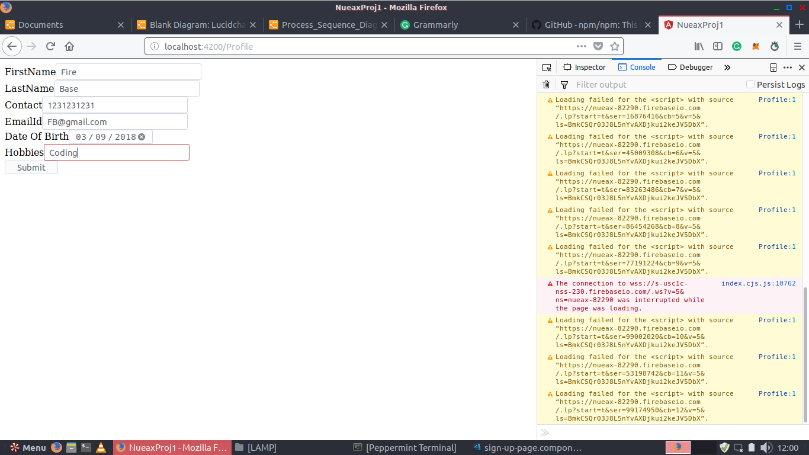
So we can saw on right hand side the Error of network connection in the image given blow.

The we submit the form and the form values get stored in the LocalHost.
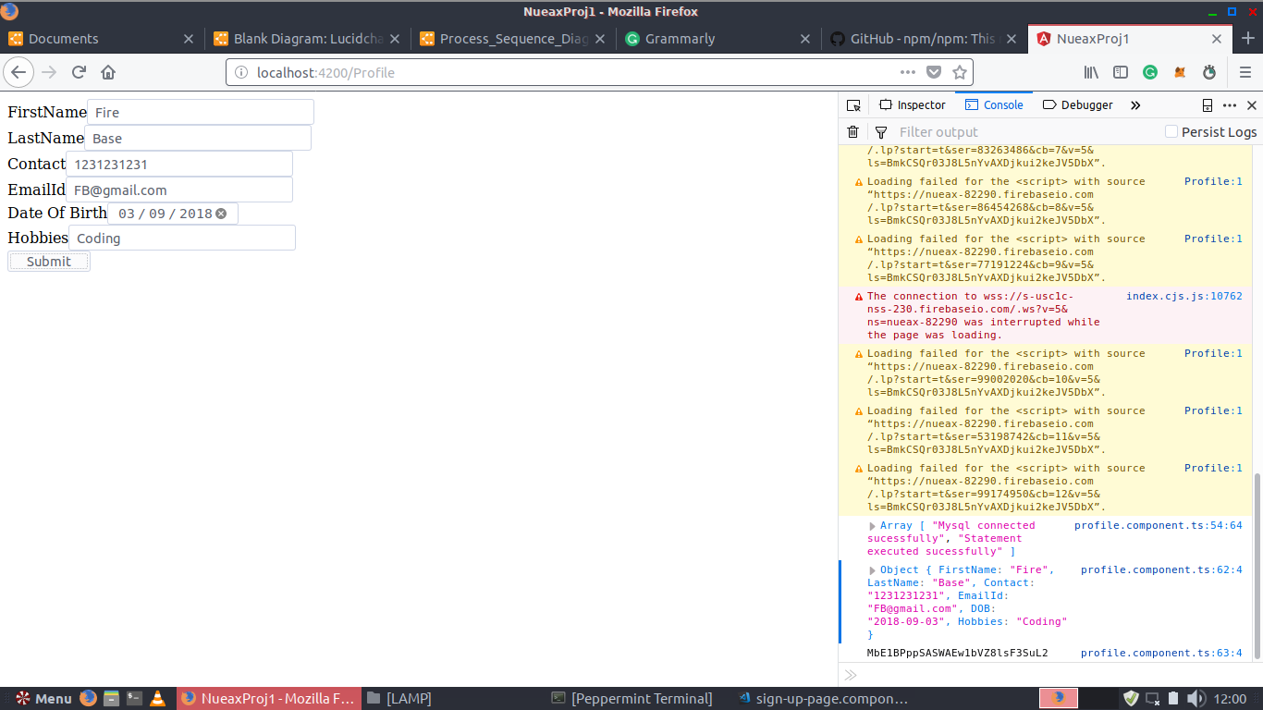

The First row is the value we have Submitted through the form.
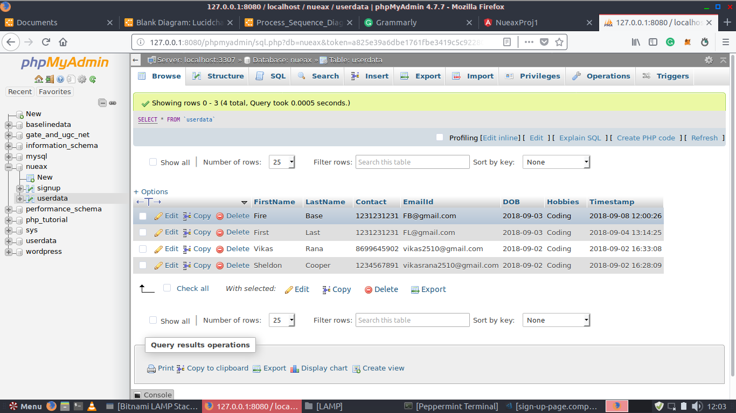

Then we terminate the app and check for the values of the form in firebase and those values are absent there.

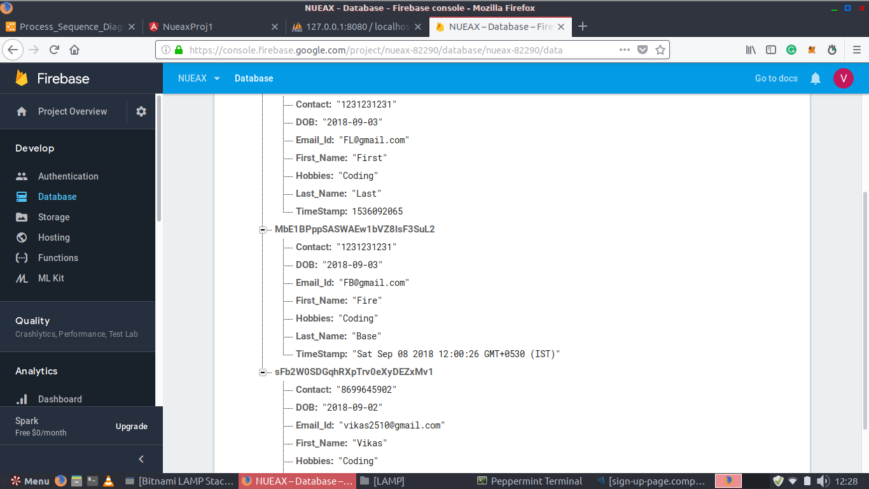

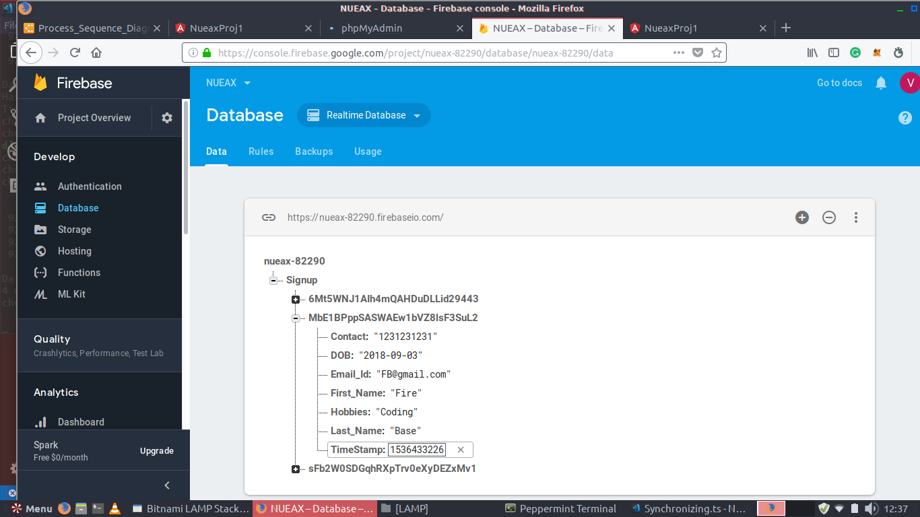
When we rastart the app the values are updated there by firebase as the feature of firebase which makes our syncronising program function disappear we can not configure out whether the update is done by our synchronizing code or the firebase.

To resolve this we have replace the Firebase TimeStamp Variable withe the LocalHost TimeStamp variable. Both have different structure. If the firebase contains it’s default Timestamp structure than the value is insert by firebase otherwise it will we done by our synchronising code.

The firebase time stamp structre can be seen in the above image and the loclhost timestamp can be seen in the image below.

Sequence Diagram

1.) Login Page

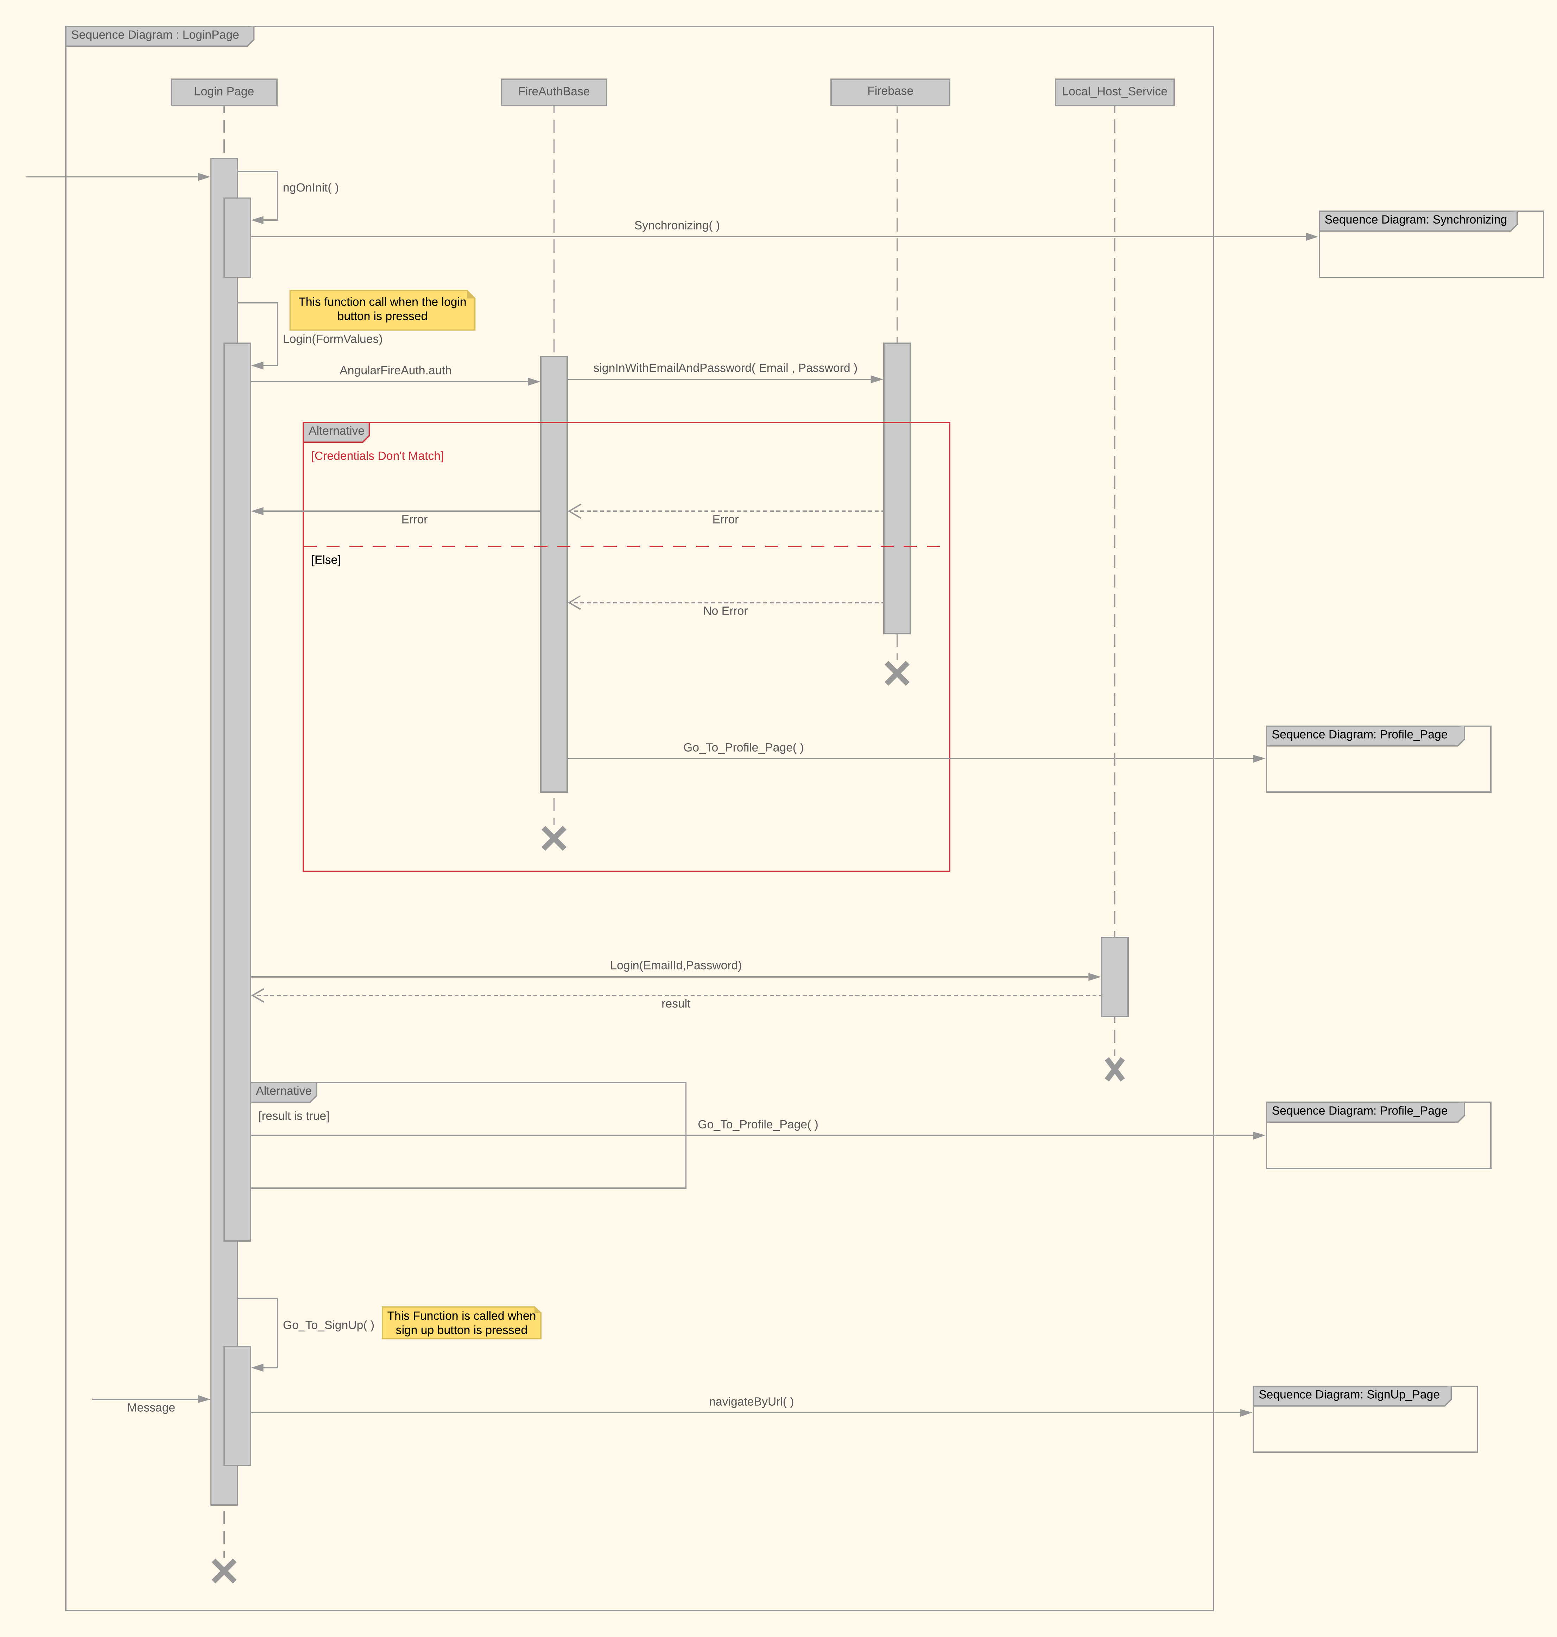

2.) SignUp Page

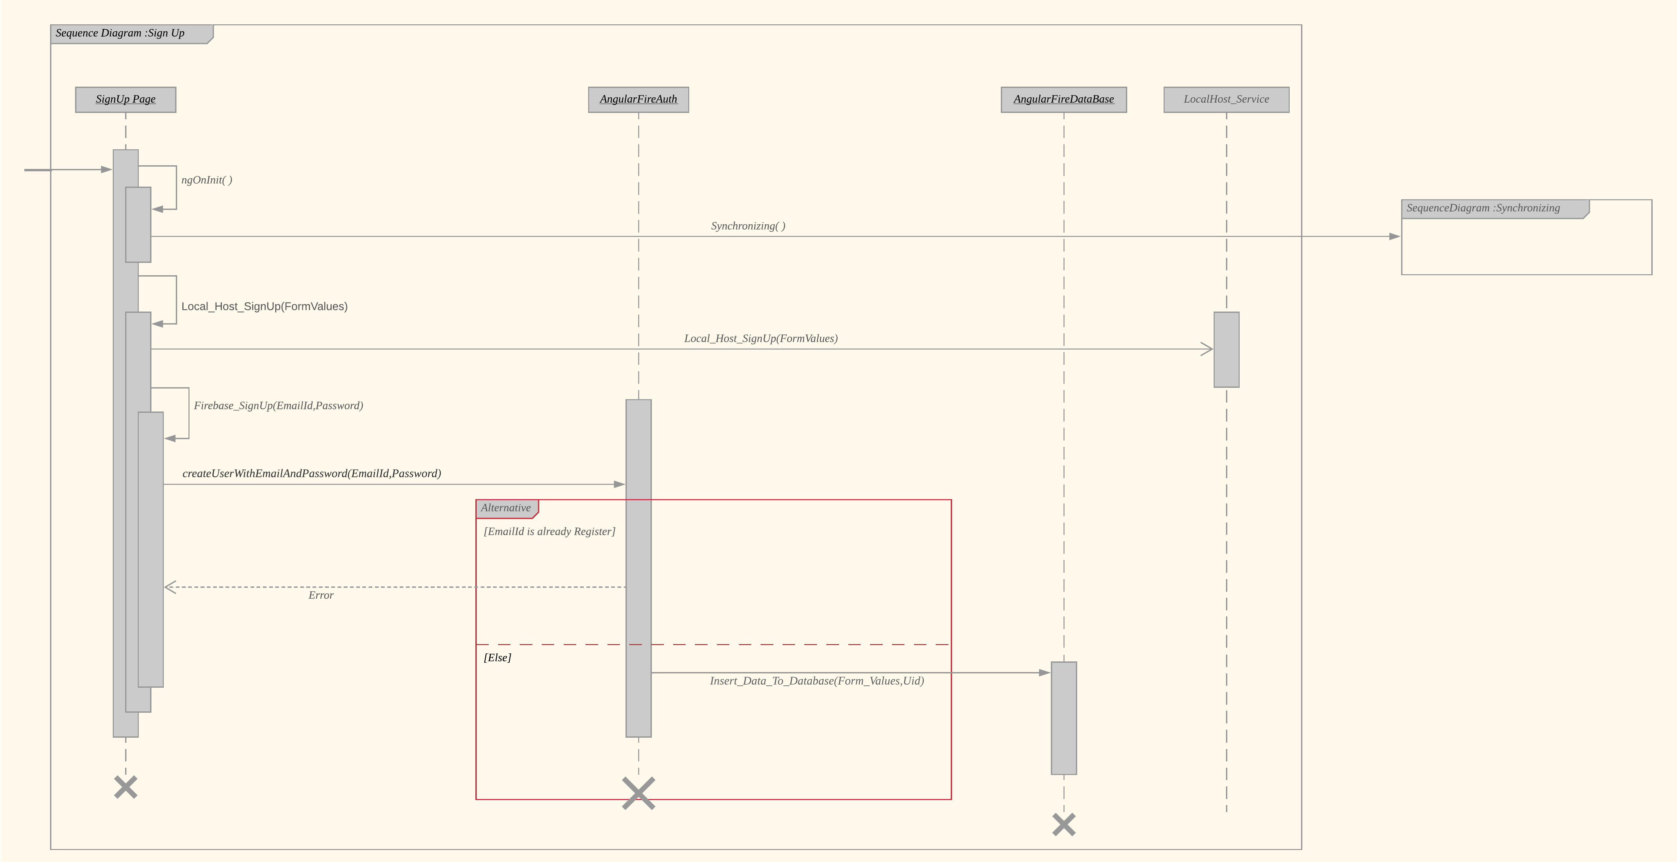

3.) Profile Page

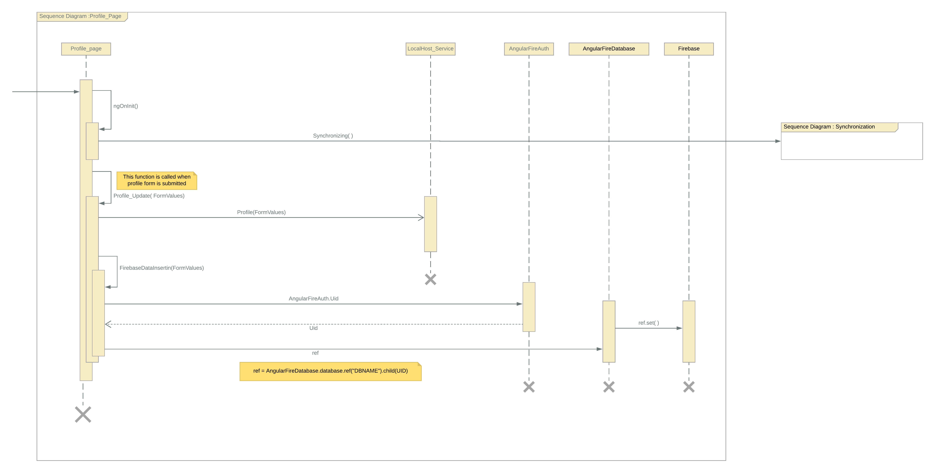

4.) Synchronization

