**Nuevos Caminos: Sistema auxiliador e informativo aos imigrantes em empregabilidade e moradia.**

*Nuevo’s Caminos: Auxiliary and informative system for immigrants in employability and housing.*

*Nuevos Caminos: Sistema auxiliar e informativo para inmigrantes en empleabilidad y vivienda.*

**Baneza Livia Coarite Manzaneda**

*baneza.manzaneda@etec.sp.gov.br*

**Diogo Marques Moreira**

*diogo.moreira4@etec.sp.gov.br*

**Henrique de Moraes Rodrigues**

*henrique.rodrigues97@etec.sp.gov.br*

**João Pedro da Silva Machado Felix**

*joao.felix20@etec.sp.gov.br*

|  |  |
| --- | --- |
| **Palavras-chave:**  *Imigrantes.*  *Brasil.*  *Moradias.*  *Empregabilidade.*  **Keywords:**  *immigrants.*  *Brazil.*  *Housing.*  *Employability.*  **Palabras clave:**  *Inmigrantes.*  *Brasil.*  *Vivienda.*  Empleabilidad*.*  **Apresentado em:**  05 dezembro, 2024  **Evento:**  7º EnGeTec  **Local do evento:**  Fatec Zona Leste  **Avaliadores:**  Avaliador 1  Avaliador 2  [Desenho com traços pretos em fundo branco e letras pretas em fundo branco  Descrição gerada automaticamente com confiança média](https://creativecommons.org/licenses/by-nc-sa/4.0/) | **Resumo:**  Nuevos Caminos visa auxiliar e informar sobre a empregabilidade e moradia aos imigrantes que pretendem vir ao Brasil. O foco do projeto é melhorar a compreensão do território brasileiro, contendo informações da empregabilidade e moradia, além de proporcionar um fórum interativo entre imigrantes, assim possibilitando tirar suas dúvidas, trocar informações e experiências vivenciadas. O desenvolvimento do projeto tem como propósito amenizar as causas de desafios e conflitos enfrentados pelos imigrantes. Com base na aprendizagem, serão utilizadas medidas de auxiliar e compreender os imigrantes que vêm ao território brasileiro, analisando possibilidades e situações que possam gerar suas dúvidas e preocupações, para podermos auxiliar esse imigrante em tal cenário, dúvida, preocupação ou outros conflitos que o deixam desorientados no novo ciclo de sua vida. Ao final do projeto espera-se que os imigrantes se sintam mais confortável em sua nova jornada no território brasileiro, promovendo um ambiente seguro e confiável a todos.  **Abstract:**  First, *Nuevo’s Caminos* aims to assist and inform about employability and housing for immigrants who intend to come to Brazil. The focus of the project is to improve the understanding of Brazilian territory, containing information on employability and housing, in addition to providing an interactive forum for immigrants, thus making it possible to answer their questions and exchange information and experiences. The project's development aims to alleviate the causes of challenges and conflicts faced by immigrants. Based on learning, measures will be used to assist and understand immigrants who come to Brazilian territory, analyzing possibilities and situations that may generate their doubts and concerns so that we can help these immigrants in such scenarios, doubt, problems, or other conflicts that leave them disoriented in the new cycle of their life. At the end of the project, it is expected that immigrants will feel more comfortable in their new journey in Brazilian territory, promoting a safe and reliable environment for all.  **Resumen:**  Nuevos Caminos tiene como objetivo asistir e informar sobre la empleabilidad y la vivienda de los inmigrantes que tienen la intención de venir a Brasil. El objetivo del proyecto es mejorar la comprensión del territorio brasileño, conteniendo información sobre empleabilidad y vivienda, además de proporcionar un foro interactivo entre inmigrantes, permitiendo así hacer sus preguntas, intercambiar información y experiencias. El desarrollo del proyecto tiene como objetivo aliviar las causas de los desafíos y conflictos que enfrentan los inmigrantes. A partir del aprendizaje, se utilizarán medidas para ayudar y comprender a los inmigrantes que llegan a territorio brasileño, analizando posibilidades y situaciones que puedan generar sus dudas e inquietudes, de modo que podamos ayudar a este inmigrante en tal escenario, duda, preocupación u otros conflictos que lo dejen desorientado en el nuevo ciclo de su vida. Al final del proyecto, se espera que los inmigrantes se sientan más cómodos en su nuevo viaje en territorio brasileño, promoviendo un entorno seguro y confiable para todos. |

1. **Introduction**

*Nuevo’s Caminos* addresses the development of an information and support system aimed at facilitating employability and access to housing for immigrants arriving in Brazil. This project is extremely important for immigrants wishing to enter Brazil, with the intention of combating false news about Brazil.

According to Migalhas, Mara Pessoni, a lawyer specializing in immigration, says that immigrants have various housing problems in Brazil and a lack of job opportunities, because they are the most vulnerable group in Brazil (MIGALHAS, 2023). A survey carried out by the NGO World Vision revealed that a large proportion of immigrants are outside the labor market, representing 67.4%. Between 2011 and 2021, the number of immigrants in the labor market in Brazil was 62,000 unemployed. Currently, Brazil has around 1.5 million unemployed immigrants (Rodrigues, 2024). For Bepay Bank, immigrants come to Brazil with the main objective of improving their living conditions, income, job opportunities and studies (G1, 2024).

With this information and the realization of the project, the immigrants will have a new vision when they come to the Brazilian national territory, through information on how to have a prosperous and effective fresh start for their stay. It will teach them everything from how a Brazilian curriculum works to what each Brazilian state and its regions are like, as well as information on the Municipal Human Development Index (MHDI), according to the Brazilian states.

Immigrants face a number of problems when they arrive in Brazil, most of which are: difficulty entering the job market and difficulty finding a home.

So how can our system help and inform immigrants about the labor market and their housing while in Brazil?

The project aims to create a website and an information app for immigrants wishing to enter Brazil, improving their understanding of the country, containing information on housing and employability, as well as an interactive forum for users to clarify any doubts and exchange information and experiences.

In our next chapter, we will present several books by authors specializing in programming as a basis for guiding us in the development of the project. We will then highlight the main programming languages that we will use to develop the *Nuevo’s Caminos* project: HTML, CSS, JavaScript, PHP, Node.js, among others.

1. **Theoretical Foundation**

The theoretical background chapter aims to show all the theory used in the work, laying out all the technology used and the main topics for concluding the project. Throughout the article we will cover various technologies, including: HTML, which is a markup language that is the main language used in web development, as stated by Flatschart (2011) and Quierelli (2012). CSS helps to stylize the site, bringing a pleasant appearance to users, according to Albino (2023); Dueckett (2016) and Zemel (2015). JavaScript is one of the languages most used by websites because it helps other object-oriented languages, according to Flanagan (2012) and Morrison (2020). PHP facilitates back-end development with its ease of interaction with the database, according to Converse and Park (2003); Juliano Niederauer (2017) and David Tanskley (2002). Node.js allows JavaScript to be executed in real time outside the web browser, according to Moraes (2023); Pereira (2014) and Duarte (2024). NPM is one of the largest package managers in the world, managing Node.js packages, according to Pereira (2014). Expo is a tool for developing applications for both Android and iOS, according to Fuentes (2023). React is a JavaScript library that simplifies and speeds up high-performance user interface development, according to Silva (2021). React Native is a framework that provides various tools to speed up the development of mobile applications, according to Pinho and Escudelario (2020).

* 1. **HTML**

According to Flatschart (2011), the acronym HTML stands for *HyperText Markup* *Language* and is the main language used in web development.

HTML is a markup language used to create website pages with text and information. These pages can be accessed by anyone and by any type of browser, says Carril (2012).

According to Quierelli (2012), the structure of an HTML document consists of commands, which can also be called *tags*, which must be used in pairs most of the time.

HTML will be essential for developing the project's website. Below is an image of a website in pure HTML.

Figure 1 - Pure HTML “advice” page

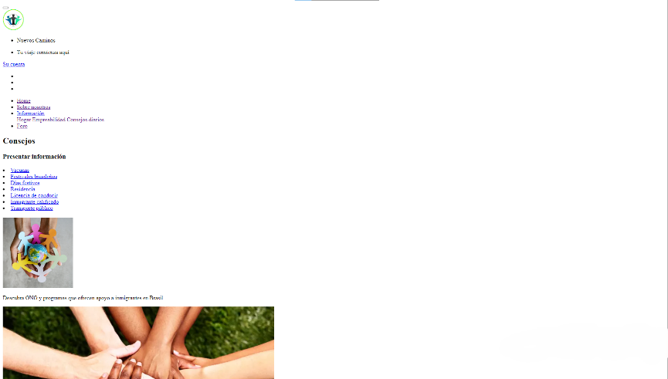

Source: From the author, 2024.

* 1. **CSS**

Cascading Style Sheets (CSS) is a language that, according to Albino (2023), helps to describe the shape and appearance of HTML elements, such as defining the style of the page, colors, fonts, as well as offering a better design for the website.

This language allows the developer to create standards to guide how an HTML element can be viewed, allowing the boxes of these elements to be changed, as stated by Duckett (2016).

According to Zemel (2015), there are selectors in CSS that can make it easier to code the design of pages, so that the browser's interpreter can find the instances, as well as the ID, class and type written in the file.

CSS is necessary for the development of the site to have a pleasant appearance for all users. Next, you will see an image of the project with a stylization.

Figure 2 - “Advice” page with CSS

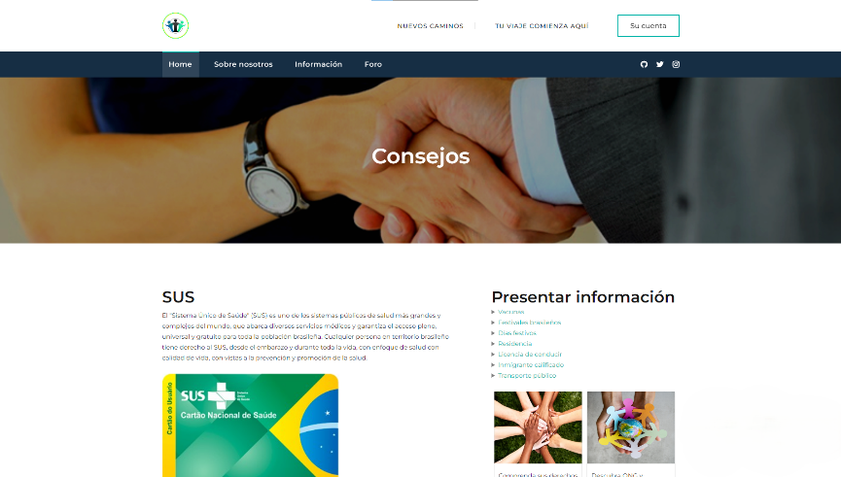

Source: From the author, 2024.

* 1. **JavaScript**

The JavaScript is used worldwide and is one of the three pillars of web development.

According to Flanagan (2012), JavaScript is a web programming language that most websites use because it is a cutting-edge, well-structured and complete language that helps other object-oriented languages.

However, we can't afford to do whatever we want, because in this language everything has its place of work and above all it is a specialist in storing, according to Morrison (2020).

JavaScript is crucial to the *Nuevos Caminos* project because it provides interaction and dynamism, making it easier to update content without having to reload the page.

* 1. **PHP**

According to Converse and Park (2003), the PHP language can facilitate *web* development. PHP stands for *Hypertext Preprocessor* and is a server-side *script* creation that can be added to the HTML language.

For Juliano Niederauer (2017), all the *scripts* written will be executed by the server, which can then be displayed as a processed page in the browser.

According to David Tanskley (2002), PHP is used to make a *back-end*, that is, a communication to the database, which is a server that stores information. PHP has excellent interaction with the database and can also be used with other databases.

PHP is fundamental to the project, as it will facilitate back-end web development, so the forum will have interaction with the database.

* 1. **Node.js**

According to Moraes (2023), Node.js is a real-time user of JavaScript, which is constantly used in *web* programming, as well as being able to run applications outside the *web* browser.

As pointed out by Pereira (2018), by adopting this language, your application will benefit greatly from working with file processing, having a non-blocking architecture, which makes it simple and practical.

According to Duarte (2024), Node.js is not a language, as it is developed using JavaScript, but more of an application platform, allowing full use of JavaScript.

Node.js will be used in the mobile application to process data in real time, as well as ensuring efficient communication with the server, allowing smooth operation on the back end of the application.

* 1. **NPM**

According to Pereira (2014), NPM is one of the largest package managers in the world, becoming the node.js package manager from its first versions, simplifying the lives of developers and causing many projects to migrate to node.js.

NPM will be fundamental to the Expo framework, so it will play a role in making React and React Native work properly, by managing packages and helping to develop the application.

* 1. **Expo**

According to Fuentes (2023), Expo is a tool for developing applications for both Android and iOS. Expo makes it possible to emulate the application developed by the developer on Android, iOS and also on a physical cell phone.

For the realization of the project, Expo is essential for the development of the application.

* 1. **React**

For Samy Silva (2021), *React* is a JavaScript library that simplifies and speeds up high-performance user interface development. The library's tools have practical methods for web development.

React will be used to develop the project's application, as it simplifies the performance of the user interface at a high level, thus facilitating programming with its library of various methods.

* 1. **React Native**

According to Pinho and Escudelario (2020), *React Native* is a *framework* that provides various tools to speed up the development of mobile applications, making it easier to create mobile apps.

React Native is important for the project because it speeds up the creation of the mobile application. Below is an image of the application.

Figure 3 - Nuevo's Caminos application

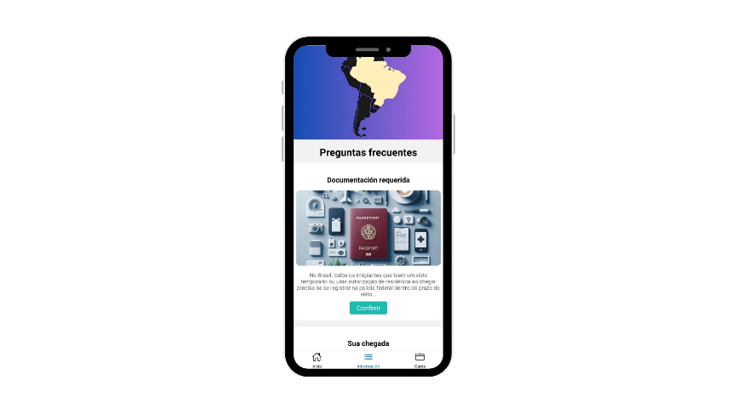

Source: From the author, 2024.

1. **Method**

In the previous chapter, we looked at the main technologies to develop the project. In the current chapter, we will cover the process to create the Nuevos Caminos project.

* 1. **Problematic**

To Lakatos (2003), methodology is characterized by scientific methods, which are not exclusive to science, and can achieve these activities more effectively and reliably, leading to the objective that they aim to achieve, containing valid and truthful knowledge.

In this situation, the qualitative research method was adopted as an approach to understanding the challenges and conflicts faced by immigrants in the contemporary Brazilian context. This consists of capturing their individual narratives in order to understand their experiences in relation to Brazilian territory.

Based on the exploratory study, ways of helping and understanding immigrants will be measured, exploring possibilities and scenarios in which they generate their doubts or concerns, gathering data from research carried out, in order to discuss the objective or problems identified, providing the construction of hypotheses with a strategic planning afterwards.

Considering these aspects, clarifying this research is essential in order to find or have a main or secondary point. With qualitative data provided, as well as analyzed through meetings, newspapers and research in general, the objective of the problem in question will be visualized from this data, giving an understanding of the main focuses that should have special attention, to subsequently make the realization of an application with essential methods, which can help the immigrant in such a scenario, doubt, concern or other conflicts that leave the immigrant, totally or temporarily, disoriented.

1. **Results and Discussions**

With With the development of the *Nuevo's Caminos* web and mobile application, a functional and accessible platform was created for immigrants who are planning to come to Brazil or who are already in the country.

The main results of the project are highlighted below:

Vernacular and Accessible: The web platform and app is being developed with support entirely in Spanish (Castilian), guaranteeing accessibility for the main target audience, who are Spanish-speaking immigrants. In addition, the app works completely offline to access essential information, which is an important differentiator since many users may not have constant access to the internet when they arrive in the country.

Centralized information: One of the main results was the fully verified search containing information on housing, employability, local services (education, health, transportation) and a detailed guide to obtaining essential documents, such as CPF (Cadastro de pessoa física) and CRNM (Carteira de registro nacional immigratório). This will facilitate quick and organized access to information that was previously scattered and difficult to obtain.

User interaction: The creation of a forum section on the website, where users can exchange tips and experiences, will be effective in promoting mutual support among immigrants. This collaborative network will strengthen the sense of belonging and trust among users.

User Tests: During the first tests with groups of immigrants who have recently arrived or are already present in the territory, a website satisfaction rate of more than at least 85% will be expected, with user evaluations especially regarding the usefulness of the functionalities aimed at access to housing and information on documentation, as well as the forum present.

The success of *Nuevos Caminos* will highlight the importance of digital tools aimed at the inclusion of immigrants in Brazil. The following questions were raised and discussed based on the expected results:

Accessibility and Digital Inclusion: The fact that the website is in the vernacular language along with the app and works offline and for immigrants was considered a major differentiator. Many immigrants arrive in Brazil unfamiliar with the language or without an internet connection, and this functionality removes a significant barrier. However, the addition of other languages may be considered in future updates to cater for non-Hispanic-speaking immigrant groups.

Centralization of Information: The centralization of essential information on housing, employability and public services is a differentiator, which is reflected in the high demand for use of the platform. The fragmentation of this information in different sources made integration difficult for immigrants, who often got lost in the bureaucratic process. The project has managed to unite and meet this demand, but there is a continuous need to update this information, taking into account the dynamics of laws, migration policies and fully updated information according to feedback.

Reducing misinformation: The project will also be effective in reducing misinformation, one of the biggest barriers faced by immigrants. The web platform offers accurate and up-to-date data, thanks to which false or incorrect information about Brazilian territory is replaced by the rumors that often circulate among immigrant groups. However, constantly updating the database of the website and app will be a challenge in the long term, especially if the scope is expanded to include more services or regions.

Challenges in Expansion and Sustainability: A constant challenge that has been identified is the long-term sustainability of the platform. Continuously adding new functionalities, integrating with new cities and updating data on local services, housing and employability will require ongoing investments in technological infrastructure and partnerships. In addition, there is the challenge of keeping the platform free and accessible to immigrants, without compromising its quality, and it could be considered a source code platform - open to users.

Social Impact: From the positive social impact of *Nuevos Caminos*, we will create a bridge between immigrants and the local resources needed for their integration in Brazil. However, the creation of a more formal support network, such as partnerships with NGOs, local governments and employers, could further increase the platform's impact.

International Expansion Potential: With the initial success in Brazil, the platform could be adapted to other countries facing similar challenges in receiving immigrants. This potential for international replication will open up new development possibilities for *Nuevos Caminos*, becoming a global tool for supporting immigrants in various countries around the world.

1. **Conclusion**

The results of the *Nuevo’s Caminos* project have shown relevance and effectiveness in assisting immigrants arriving in Brazil. Bearing this in mind, the app will not only fill these information gaps, because as the app's target audience are immigrants arriving in Brazil, the mobile app will have continuous updates according to the feedback reported on the website, and the forum would promote social and economic interactions for these individuals, offering a practical solution to the bureaucratic and cultural barriers they face in Brazil.

**References**

ALBINO, Igor Cacerez**. Dominando O Css**. [S. l.] Clube de Autores, 2023.

BAZZI, Cláudio Leones. **Introdução à Banco de dados**. 22. ed. Curitiba: ed. UTFPR. 2013.

BENTO, Junior Evaldo. **Desenvolvimento Web com PHP e MySQL.** 1. ed. São Paulo: Casa do Código, 2013.

CARRIL, Marly. **HTML – Passo a Passo.** 1**.** ed. Clube de Autores, 2012.

CONVERSE, Tim; PARK, Joyce. **PHP - a Bíblia**. 2. ed. São Paulo: Elsevier Editora Ltda., 2003.

DUARTE, Luiz. **Node.js e Microservices: Um guia prático**. 5. ed. LuizTools. 2024. E-book.

DUCKETT, Jon**. HTML e CSS: projete e construa websites**. 1. ed. São Paulo: Alta Books, 2016.

ELMASRI, Ramez. **Sistema de banco de dados**.São Paulo: Pearson Addison Wesley, 2005.

ESCULADEIRO, Bruna; PINHO, Diego. **React Native: Desenvolvimento de aplicativos mobile com React.** 1. ed. São Paulo: Editora Casa do Código, 2020.

FLANAGAN, David. **Javascript: O guia definitivo**. 6. ed. Porto Alegre: BOOKMAN Editora, 2012.

FLATSCHART, Fábio. **HTML 5 – Embarques Imediato**. 1. ed. São Paulo: Brasport, 2011.

Fuentes, Guilherme Cardoso. **LightLow: Aplicativo simulador de consumo energético residencial.** 2023.

LAKATOS, E. M.; MARCONI, M. A. **Fundamentos de metodologia científica**. 5. ed. São Paulo: Atlas 2003.

MATOS, Ecivaldo de Souza; ZABOT, Diego. **Aplicativos com Bootstrap e Angular: Como Desenvolver Apps Responsivos**.1. ed. São Paulo: Editora Érica, 2020.

MILANI, André. **MySQL – Guia do Programador.** 1. ed. São Paulo: Novatec Editora, 2007.

MORAES, Willian Bruno. **Construindo aplicações com NodeJS**. 1. ed. São Paulo: Novatec Editora Ltda. 2015.

MORRISON, Michel. **Use a cabeça! JavaScript**. 1. ed. São Paulo: Alta Books. 2020.

NIEDERAUER, Juliano. **Desenvolvendo websites com PHP: Aprenda a criar websites dinâmicos e interativos com PHP e banco de dados**. 3. ed. São Paulo: Novatec Editora, 2016.

PEREIRA, Caio Ribeiro. **Node.js: Aplicações web real-time com Node.js**. 1. ed. Casa do Código. 2014. E-book.

PRESCOTT, Preston. **Programação em Javascript**. [S. l.] Babelcube Inc. 2016.

PRESCOTT, Preston. **SQL para Iniciantes**. [S.l]: babelcube inc., 2015.

QUIERELLI, David Antonio. **Criando sites com html-css-php**. [S. l.] Santa Catarina: Clube de Autores, 2012.

SAMY, Maurício Silva. **React Aprenda Praticando: Desenvolva aplicações web reais com uso da biblioteca React e de seus módulos auxiliares.** 1. ed. São Paulo: Editora Novatec, 2021.

TANSKLEY, David. **Como criar web pages rápidas e eficientes usando php e Mysql**. 1. ed. Rio de Janeiro: Editora Ciência Moderna, 2002.

ZEMEL, Tárcio**. CSS eficiente: técnicas e ferramentas que fazem a diferença nos seus estilos**. São Paulo: Casa do Código, 2015.

GONZATTO, R. F.; COSTA, K. da C. ARQUITETURA DE INFORMAÇÃO SEM WIREFRAME. **Perspectivas em Gestão &amp; Conhecimento**, *[S. l.]*, v. 1, p. 160–181, 2011. Disponível em: <https://periodicos.ufpb.br/ojs2/index.php/pgc/article/view/10793>. Acesso em: 06 ago. 2024.

BEPAYBANK. **Imigração no Brasil: os desafios financeiros e a dificuldade no envio de remessas.** G1globo, 2024.Disponível em: <https://g1.globo.com/sp/campinas-regiao/especial-publicitario/bepay-bank/bepay-bank-transferencias-internacionais/noticia/2024/03/11/imigracao-no-brasil-os-desafios-financeiros-e-a-dificuldade-no-envio-de-remessas.ghtml>**.** Acesso em: 29 mar. 2024.

CLOUD. **O que é um banco de dados relacional (RDBMS)?** Disponível em: <https://cloud.google.com/learn/what-is-a-relational-database?hl=pt-br>. Acesso em: 07 mai. 2024.

IBM. **O que é um banco de dados relacional?**. [S. I.]: ibm. Disponível em: <https://www.ibm.com/br-pt/topics/relational-databases>. Acesso em: 06 mai. 2024.

MICROSOFT. **O que é um Banco de Dados SQL?**. Microsoft. Disponível em: <https://azure.microsoft.com/pt-br/resources/cloud-computing-dictionary/what-is-sql-database>. Acesso em: 15 mai. 2024.

PESSONI, Mara. **Os maiores desafios enfrentados pelos imigrantes**. Migalhas, 2023. Disponível em: <https://www.migalhas.com.br/depeso/394964/os-maiores-desafios-enfrentados-pelos-imigrantes>. Acesso em: 28 mar. 2024.

ORACLE. **O que é um banco de dados relacional (RDBMS)?**. [S. I.]: Oracle. Disponível em: <https://www.oracle.com/br/database/what-is-a-relational-database/>. Acesso em: 06 mai. 2024.

RODRIGUES, F. No Brasil, maioria dos imigrantes está fora do mercado de trabalho, identifica estudo. Disponível em: <https://portalverdade.com.br/no-brasil-maioria-dos-imigrantes-esta-fora-do-mercado-de-trabalho-identifica-estudo/>. Acesso em: 13 out. 2024.