**mymalloc() Metadata Design:**

* Certain blocks of memory are dedicated to metadata about user data.
* Throughout the 4096 bytes of memory, there are alternating sections of metadata, followed immediately by user data.

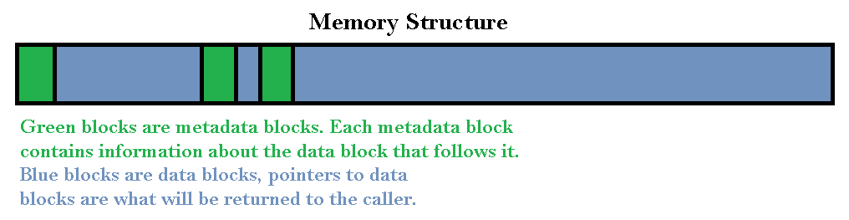

* Metadata blocks are represented through unsigned short integers.
  + By using unsigned short integers, there is enough space to store all the metadata about a block of user data in only two bytes.
* Each metadata block is required to store two pieces of information
  + The size of the user data that is represented by the metadata block.
  + A flag that indicates whether the block of memory is free to be allocated or not.
* The highest bit of each metadata block indicates whether the block is free or not.
* The 15 lower bits of each metadata block are used to indicate the size of the user data.

