6. Demonstrate virtualization by Installing Type-2 Hypervisor in your device, create and configure VM image with a Host
Operating system (Either Windows/Linux) using virtual box.

AIM:
To demonstrate virtualization by installing type-2 hypervisor in your device, create and configure VM image with a host operating system (either window / linux).

PROCEDURE:
STEP 1: Download VMware workstation and installed as type 2hypervisor.
STEP 2: Download ubuntu or tiny OS as iso image file.
STEP 3: In VMware workstation->create new VM.
STEP 4: Do the basic configuration settings.
STEP 5: Created tiny OS virtual machine.
STEP 6: Launch the VM.

IMPLEMENTATION

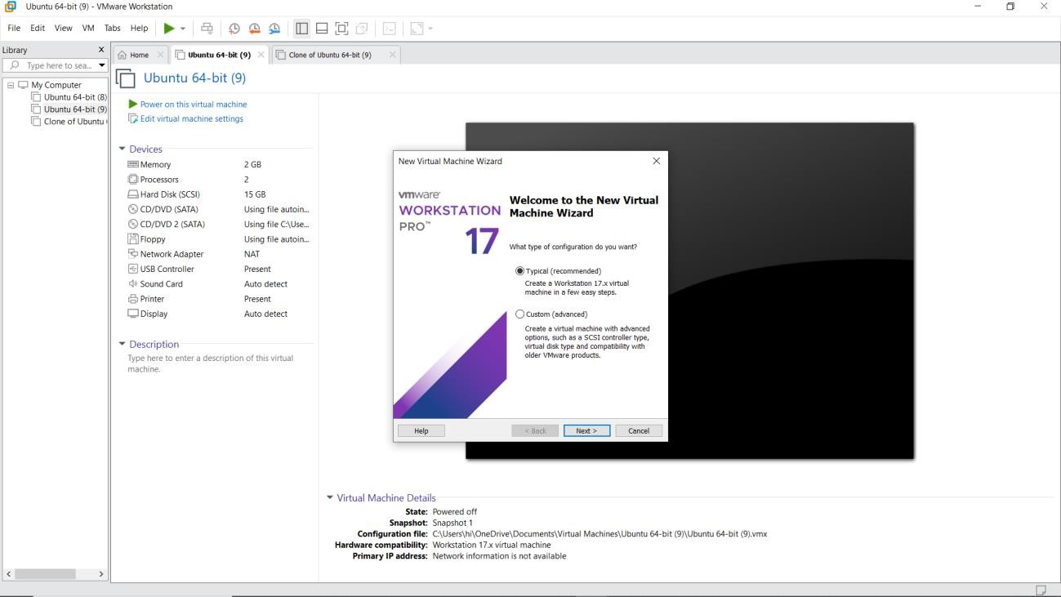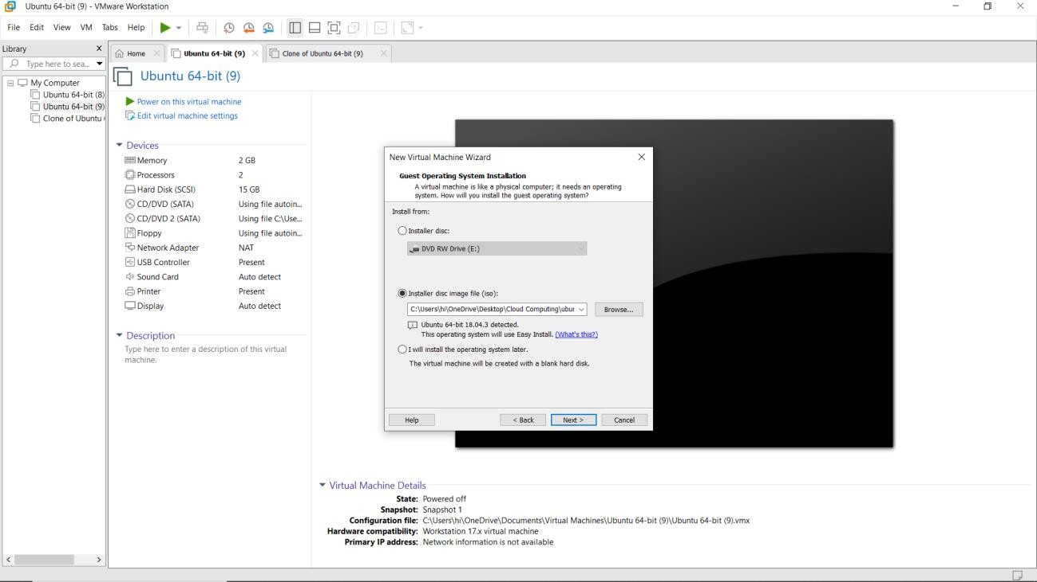

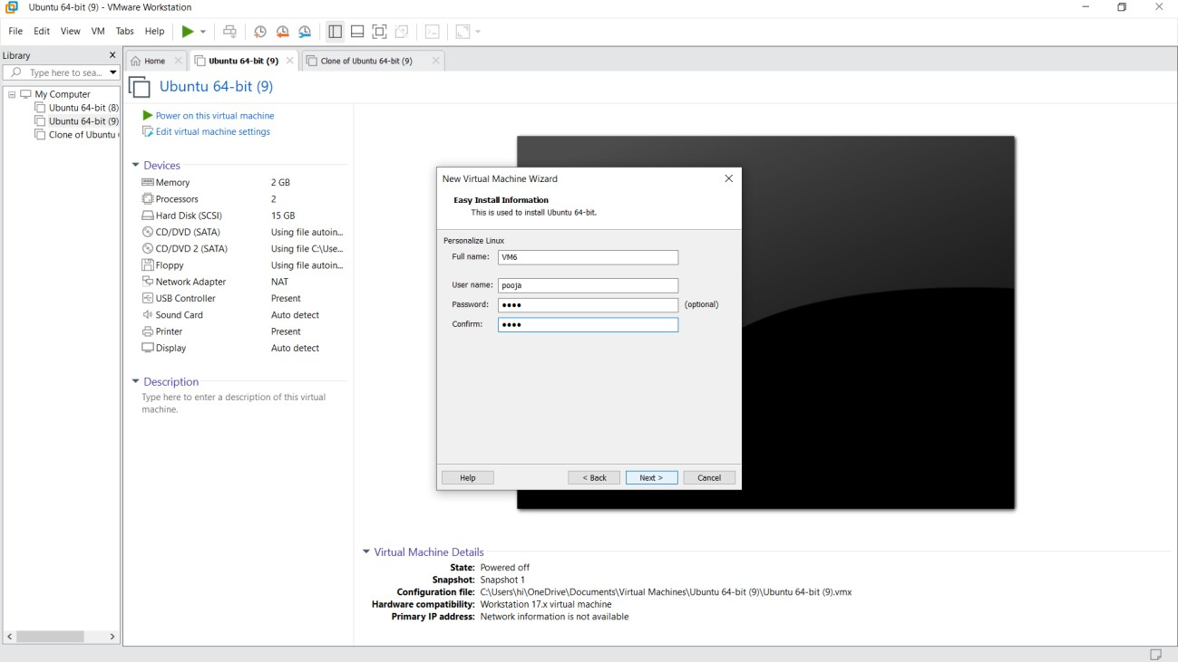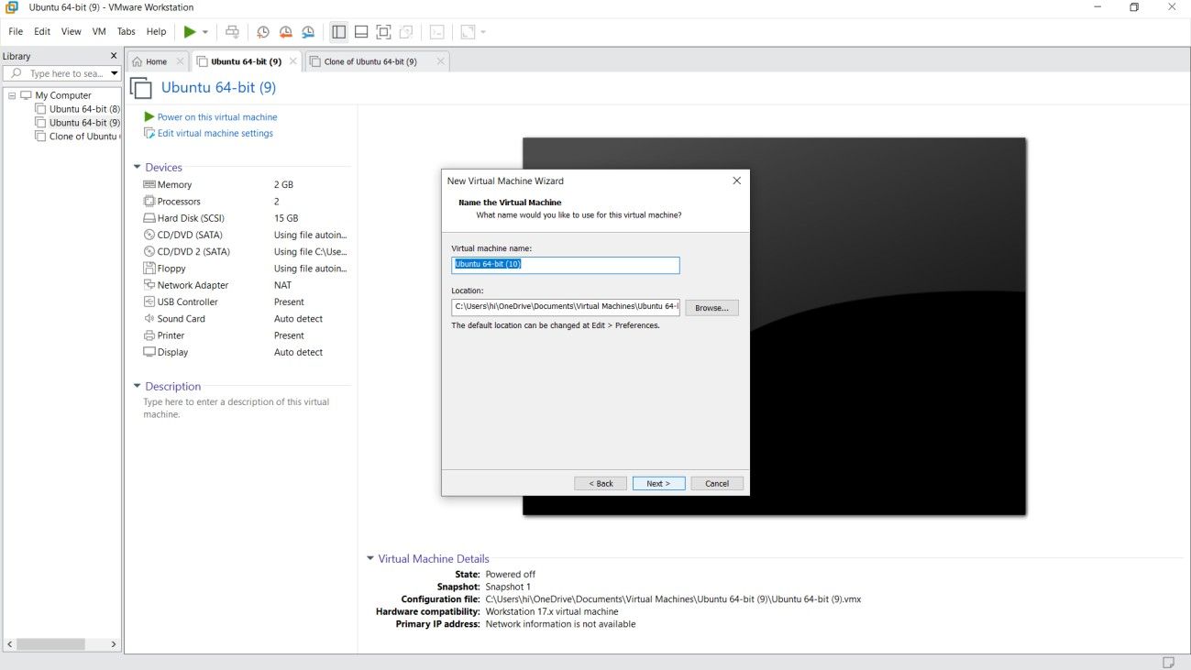

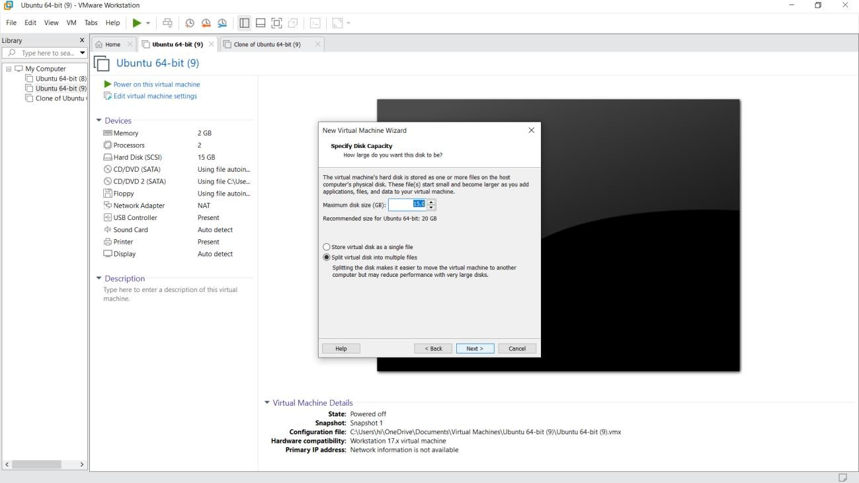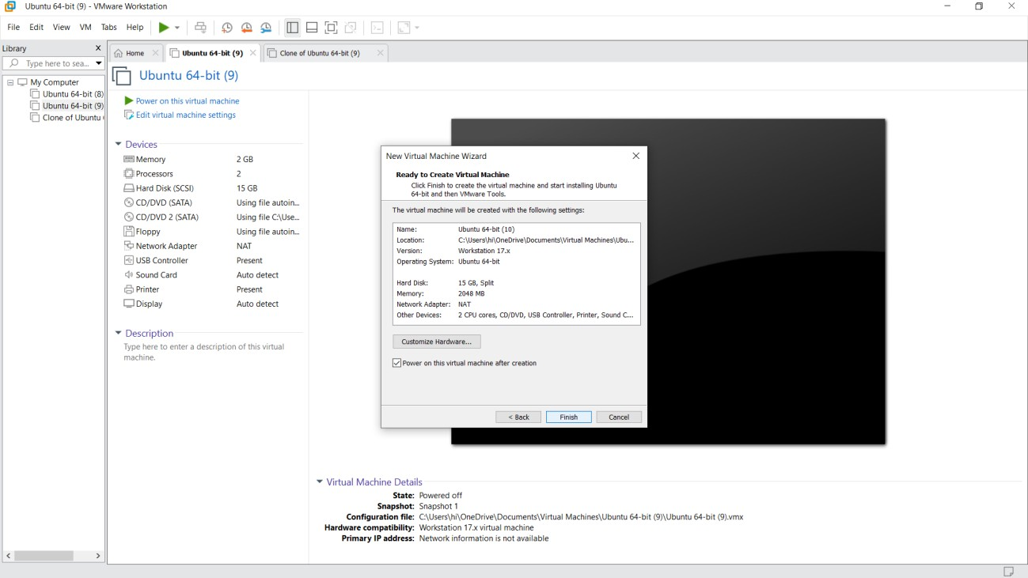

RESULT:
Virtualization by installing type-2 hypervisor in your device, create and configure VM image with a host operating system (either windows/linux) has been demonstrated.

