EXP NO 7: DEMONSTRATE VIRTUALIZATION BY INSTALLING TYPE-2 HYPERVISOR IN YOUR DEVICE, CREATE AND CONFIGURE VM IMAGE WITH A HOST OPERATING SYSTEM (EITHER WINDOWS/LINUX).
AIM:
To demonstrate virtualization by installing type-2 hypervisor in your device, create and configure VM image with a host operating system (either windows/linux).
PROCEDURE:
STEP 1: Download VMware workstation and installed as type 2 hypervisor.
STEP2: Download ubuntu or tiny OS as iso image file.
STEP 3: In VMware workstation->create new VM.
STEP 4: Do the basic configuration settings.
STEP 5: Created tiny OS virtual machine.
STEP 6: Launch the VM.
IMPLEMENTATION:
STEP 1: DOWLOAD VMWARE WORKSTATION AND INSTALLED AS TYPE 2 HYPERVISOR
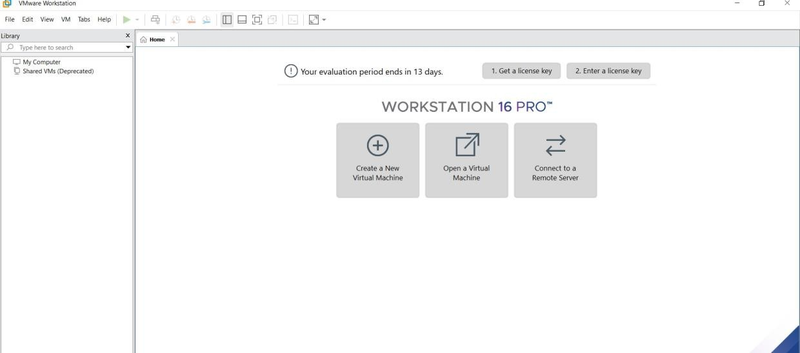
STEP2: DOWLOAD UBUNTU OR TINY OS AS ISO IMAGE FILE

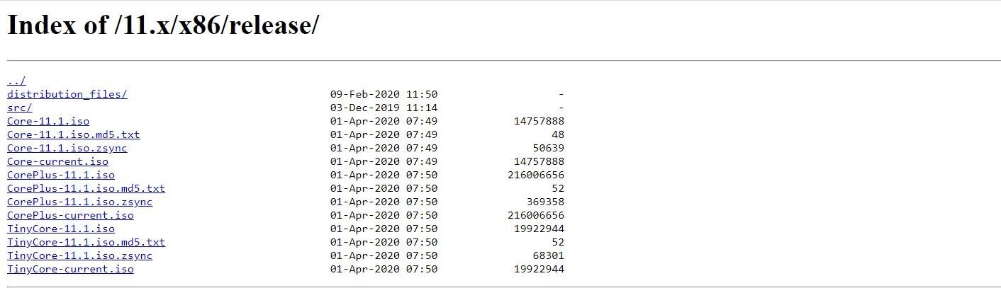

STEP 3: IN VMWARE WORKSTATION->CREATE NEW VM
STEP 4: DO THE BASIC CONFIGURATION SETTINGS.
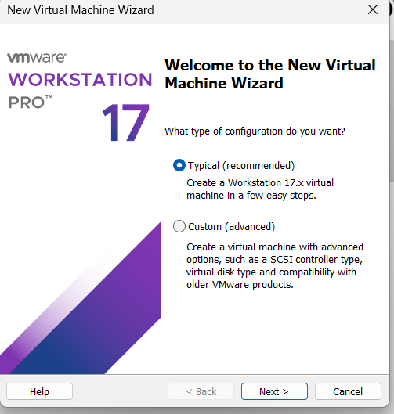
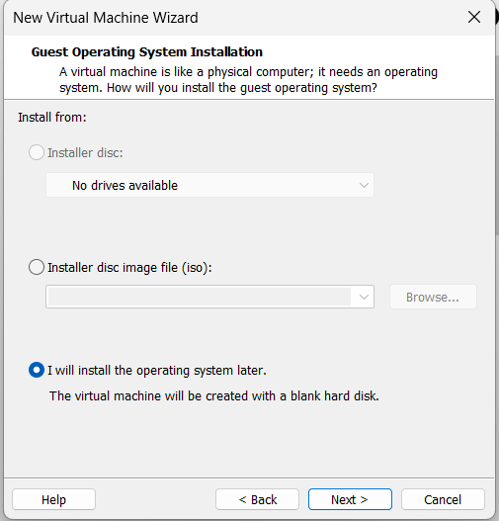

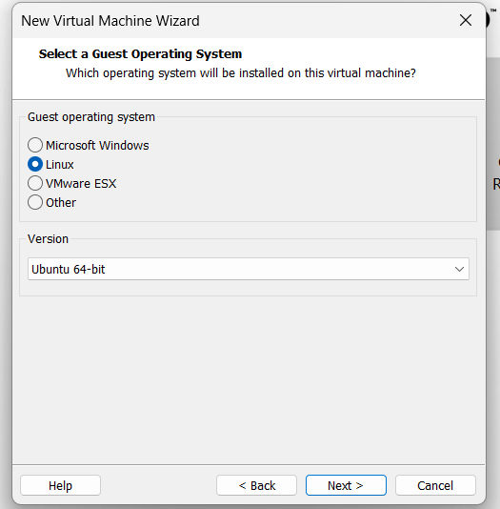
STEP 5: CREATED TINYOS VIRTUAL MACHINE AND LAUNCH THE VM
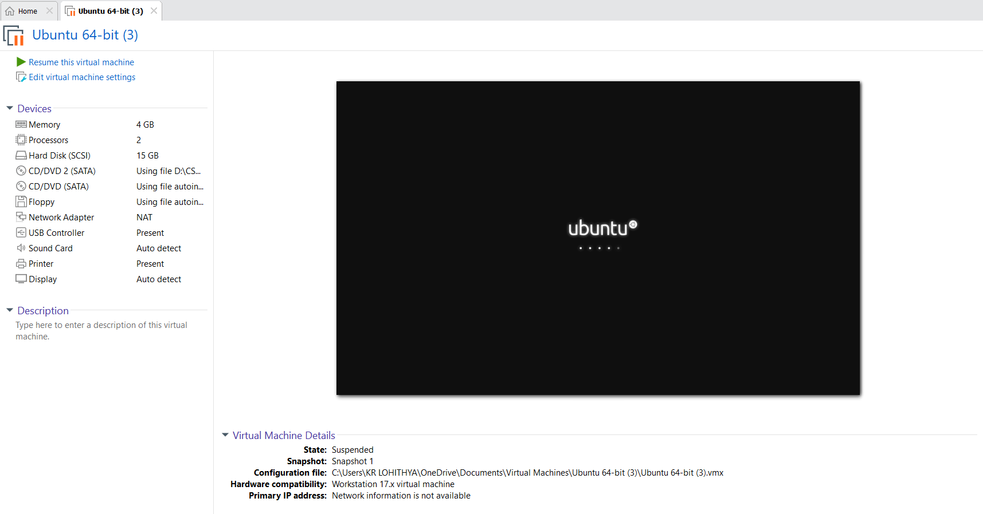
RESULT:
A Type-2 hypervisor (VirtualBox/VMware) was successfully installed on the host system. A virtual machine with the Linux/Windows operating system was created, configured, and executed successfully.

