EXP13: Demonstrate Infrastructure as a Service (IaaS) by creating a resources group using a Public Cloud Service Provider (Azure), configure with minimum CPU, RAM, and Storage.
Aim: To create a Virtual Machine with 1 CPU, 2GB RAM, and 15GB storage using Type-2 virtualization software (VMware Workstation).

Procedure:
- Launch VMware Workstation Player or Pro on your host operating system.
- Click on 'Create a New Virtual Machine'.
- Select 'Installer disc image file (iso)' and browse to select your guest OS ISO file (e.g., Ubuntu or Windows).
- Choose the guest operating system type and version (e.g., Linux > Ubuntu 64-bit).
- Provide a name for the virtual machine and select the storage location.
- Set the disk size to 15 GB and choose 'Store virtual disk as a single file'.
- Click on 'Customize Hardware' and adjust the settings:
- Memory: 2048 MB (2 GB)
- Processors: 1 core
- Ensure the network adapter is set to NAT or Bridged.
8.Click 'Close' to save the hardware configuration, then click 'Finish' to create the virtual machine.
9.Start the virtual machine and proceed with the installation of the selected operating system.

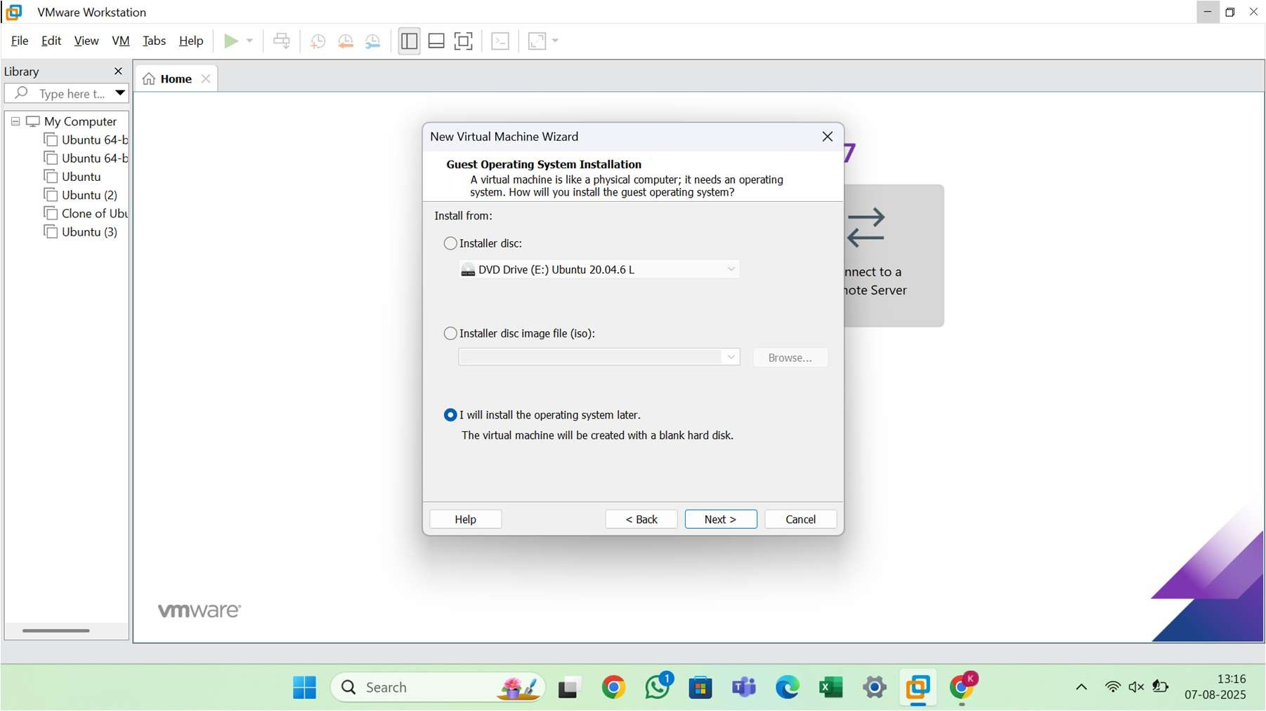

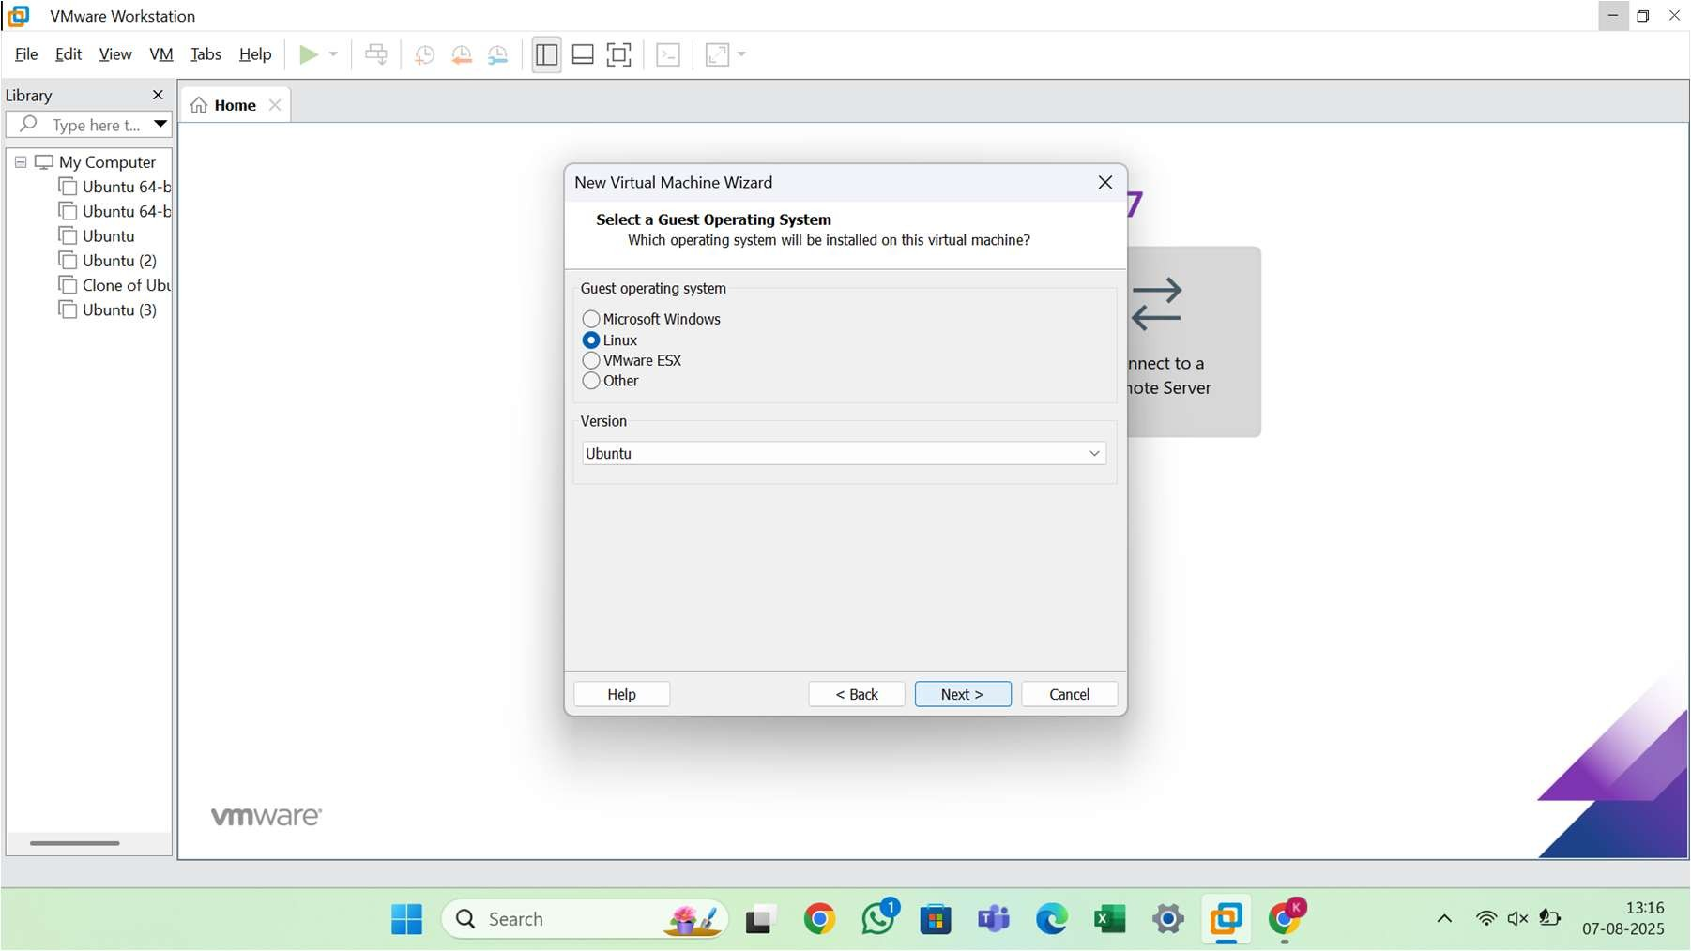
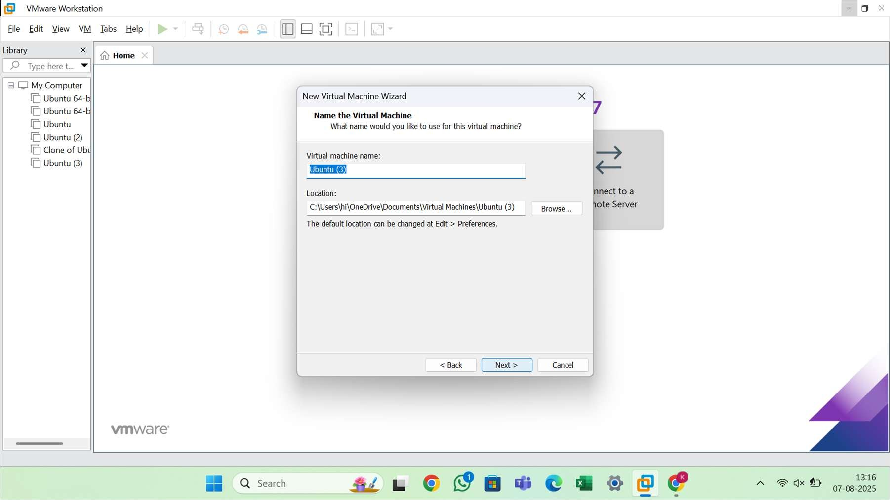

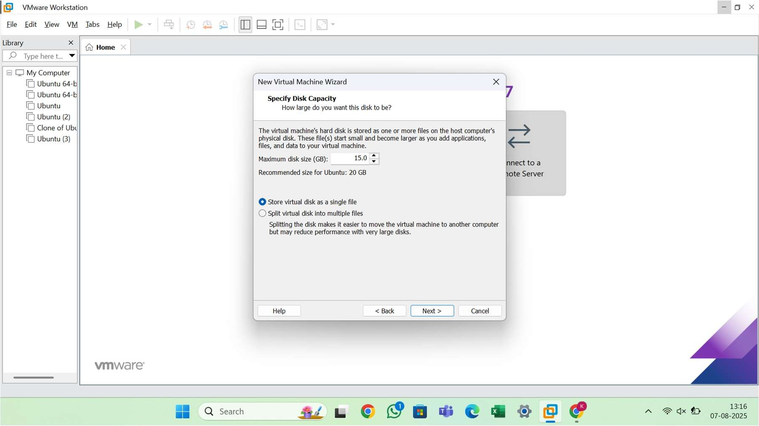

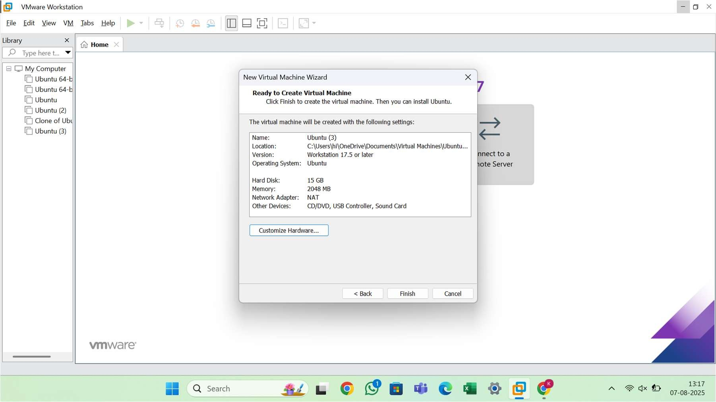

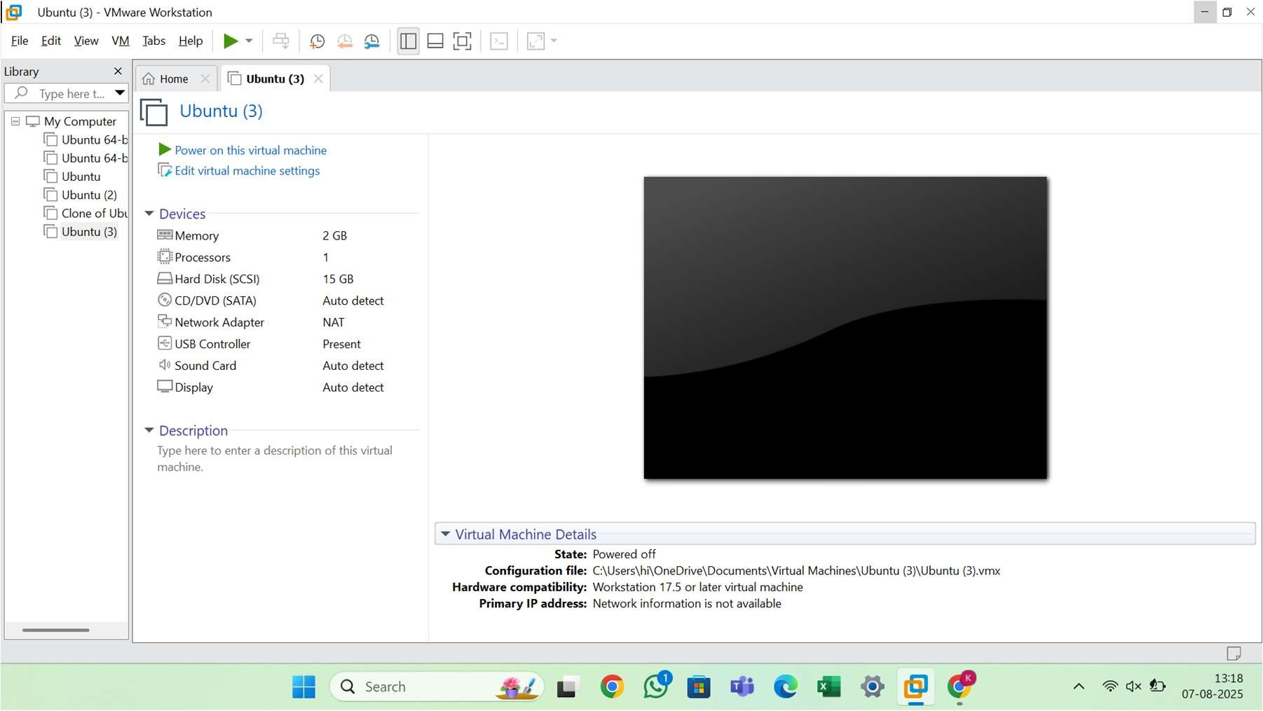


Result
A virtual machine was successfully created using VMware Workstation. The VM is configured with 1 CPU, 2GB RAM, and a 15GB virtual hard disk. The guest operating system was installed and is operational.

VM Hardware Configuration
- CPU: 1 Core
- RAM: 2 GB (2048 MB)
- Storage: 15 GB Virtual Disk
- Network Adapter: NAT or Bridged
- Guest OS: (User-selected ISO, e.g., Ubuntu 22.04 LTS or Windows 10)

