
Yarmouk Private University
Faculty of Informatics and
Communication Engineering


AI-Powered Career Development Platform

Prepared by:
Ayham Kefo Nawrz Qal Amr Barakat

Supervisor:
Dr. Gassan Saba Eng. Anas Mokhallalati

Semester: 2025/2026-1

Abstract
Nuhoud is a distributed microservices-based platform designed to support all Syrians. including refugees, returnees, and residents—in developing their skills, improving employability, and receiving personalized career development plans powered by AI. The platform evaluates users’ current skill sets, matches them with relevant job opportunities, and generates individualized development plans using an AI pipeline orchestrated through n8n and connected to a stateless large language model (Google Gemini).

The system is implemented using a scalable architecture based on NestJS microservices and MongoDB, with asynchronous workflows supported through Kafka for decoupled event-driven communication. User media such as profile images is stored using S3-compatible object storage (MinIO) to reduce database growth and improve scalability. An NGINX API Gateway provides a unified entry point to backend services and applies gateway-level best practices such as routing, rate limiting, and security headers. The notification subsystem supports multiple channels, including email/WhatsApp and real-time push notifications via Firebase Cloud Messaging for mobile users.

Users complete detailed profiles, which are analyzed to produce job recommendations and tailored growth plans. Overall, Nuhoud emphasizes usability, modularity, and personalization, demonstrating that combining AI-driven guidance with scalable service-oriented infrastructure can meaningfully assist career development and employment integration.

الملخص
نهوض هي منصة مبنية على بنية الخدمات المصغّرة (Microservices)، تهدف إلى دعم جميع السوريين بمن فيهم اللاجئون والعائدون والمقيمون في تطوير مهاراتهم، وتحسين فرصهم في التوظيف، والحصول على خطط تطوير شخصية مدعومة بالذكاء الاصطناعي. تركز المنصة على تقييم المهارات الحالية للمستخدمين، ومطابقتها مع فرص عمل مناسبة، ثم توليد خطط تطوير فردية باستخدام خط أنابيب ذكاء اصطناعي مُدار عبر n8n ومتصل بنموذج لغوي كبير عديم الحالة (Google Gemini)
تم تنفيذ النظام وفق معمارية قابلة للتوسع تعتمد على خدمات NestJS وقاعدة بيانات MongoDB، مع دعم تدفقات عمل غير متزامنة عبر Kafka لتحقيق تواصل قائم على الأحداث وتقليل الترابط بين الخدمات. كما يتم تخزين ملفات المستخدمين مثل صور الملف الشخصي باستخدام تخزين كائنات متوافق مع S3 عبر MinIO للحد من تضخم قاعدة البيانات وتحسين قابلية التوسع. ويوفر NGINX بوابة API ونقطة دخول موحدة لخدمات النظام مع تطبيق أفضل الممارسات مثل التوجيه، وتحديد معدل الطلبات (Rate Limiting)، وإضافة رؤوس الحماية الأمنية. إضافةً إلى ذلك، يدعم نظام الإشعارات عدة قنوات تشمل البريد الإلكتروني/واتساب وإشعارات الدفع الفورية عبر Firebase Cloud Messaging لمستخدمي تطبيق.
يقوم المستخدمون بإكمال ملفاتهم الشخصية، ثم يتم تحليلها لإنتاج توصيات وظيفية وخطط نمو وتطوير مخصصة. وتُظهر نتائج المشروع أن دمج الإرشاد المعتمد على الذكاء الاصطناعي مع بنية خدمات قابلة للتوسع يمكن أن يساهم بشكل فعّال في دعم التطور المهني والاندماج في سوق العمل.
كلمة شكر
بسم الله الرحمن الرحيم
}وَأَنزَلَ اللَّهُ عَلَيْكَ الْكِتَابَ وَالْحِكْمَةَ وَعَلَّمَكَ مَا لَمْ تَكُن تَعْلَمُ ۚ وَكَانَ فَضْلُ اللَّهِ عَلَيْكَ عَظِيمًا{
صدق الله العظيم

وتشاء أنت من البشائر قطر ويشاء ربك أن يغيثك بالمطر
‏وتشاء أنت من الأماني نجمة ويشاء ربك أن يناولك القمر

الحمد لله حتى يبلغ الحمد منتهاه

Acknowledgments
We extend our heartfelt gratitude to Dr. Hiyam Khaddam and Eng. Anas Mukhalati, our esteemed supervisors, for her invaluable guidance and mentorship, and to Dr. Moutasem Shafaumri, the esteemed Dean of our Faculty, for fostering a culture of innovation and scholarly pursuit. Their wise advice and unwavering support have been instrumental in the development of the NOHOUD project.
Additionally, we are deeply grateful to our families and friends for their continuous encouragement and emotional support. This achievement would not have been possible without their constant backing.

Table of Contents
Contents
Abstract 1
Acknowledgments 4
Table of Contents 5
Table of Figures 9
List of Tables 11
List of Abbreviation and Terminology 12
Chapter 1: Introduction 13
1.1 Motivation 14
1.2 Problem Description: 14
1.3 Project Objectives 15
Chapter 2: Background 16
2.2 Related Works 17
Chapter 3: Project Management & Methodology 18
3.1 Development Methodology: Agile Scrum 19
3.1.1 Why Agile Scrum Fits This Project 19
3.1.2. Roles and Responsibilities 19
3.1.3. Sprint Planning and Execution 20
3.1.4. Self-Organizing Team Structure 20
3.1.6. Iteration Structure and Feature Lifecycle 20
3.1.7. Code Publication & Versioning Strategy 21
2.2. Remote Pair Programming for Complex Tasks 21
3.2.1 Purpose and Benefits 21
3.2.2 Setup and Approach 21
2.3. Managing a Multi-Service Platform with Scrum 22
3.4. Project Management Tools: Jira 22
3.4.1. Epics, User Stories, and Tasks 22
3.4.3. Visual Artifacts from Jira Workspace 23
3.5. Version Control Strategy 24
2.6. Communication and Collaboration 25
3.6.1 Primary Communication Channels 25
3.6.2 Meeting Cadence 25
Chapter 4: Requirements Engineering 26
4.1 Requirements Elicitation 27
4.2 Functional Requirements 27
4.2.1 User Management 27
4.2.2 Job Application Flow 28
4.2.3 Notification & Alerts 28
4.2.4 AI Recommendations 28
4.3 Non-Functional Requirements 29
4.4 Use Case Diagram 31
4.5 Use Case Specifications 32
Chapter 5: System Design and Architecture 41
5.1. Architectural Style: Microservices 42
5.1.1. Rationale for Choosing Microservices 42
5.1.2. Service Decomposition and Granularity 43
5.2. High-Level System Architecture Diagram 45
5.3. Core Design Principles 46
5.3.1. SOLID Principles Application 46
5.3.2. Design Patterns 47
5.4. Inter-Service Communication 48
5.4.1. Communication Patterns 48
5.4.2. Asynchronous Communication with Apache Kafka 49
5.4.3. Synchronous Communication with gRPC 49
5.4.4 API Gateway and Reverse Proxy (NGINX) 50
5.5. Data Management Strategy (Database-per-Service + plus MinIO for files ) 50
5.6. Class Diagram 52
5.7. sequence diagrams 53
5.8. AI Service Integration using n8n 58
5.8.1 Overview 58
5.8.2 Objectives of the System 58
5.8.3 System Components & Flow 58
5.8.4 Workflow Architecture 60
5.9 Mobile Application Architecture 61
5.9.1 Overview 61
5.9.2 Navigation and Routing 61
5.9.3 User Interface & UX Design 61
5.9.4 Core Screens and Navigation Flow 61
5.9.5 State Management 62
5.9.6 Communication with Backend Services 62
5.9.7 Local Data Persistence 62
5.8.9 MVVM Clean Architecture Diagram 62
Chapter 6: Technology Stack and Rationale 64
6.1. Programming Language & Runtime: Node.js 65
6.2. Backend Framework: NestJS 66
6.3. API Documentation: Swagger 66
6.4. Database and ODM: MongoDB with Mongoose 67
6.5. Object Storage for Media 67
6.6. Messaging/Event-Driven Architecture: Apache Kafka 68
6.7. RPC Communication: gRPC with Protocol Buffers 68
6.8. Containerization & Orchestration: Docker Compose 69
6.9. Kafdrop Monitoring Tool: Kafdrop 69
6.10. API Gateway / Reverse Proxy NGINX was added as a reverse proxy and API Gateway to provide a single entry point for the system. It improves maintainability by centralizing routing rules and reducing the need for clients to know internal service addresses/ports. NGINX also implements gateway-level best practices including request size handling for uploads, gzip compression, security headers, and IP-based rate limiting. This provides an initial security and performance layer before traffic reaches backend services. 70
6.11. Notifications 70
6.7 AI Services and Language Models 71
6.7.1. Google Gemini (PaLM) 71
6.7.2. LangChain Agents (n8n Integration) 71
6.7.3. Prompt Engineering 72
6.7 Why AI Was Necessary 72
6.7.1. Understanding Diverse User Profiles 72
6.7.2. Generating Contextual Job Titles 72
6.7.3. Filtering and Matching Jobs Intelligently 72
6.7.4. Automated Career Planning 73
6.7.5. Scalability and Automation 73
6.8. Frontend Framework and Dashboard: React.js 73
6.9. Mobile Development Framework: Flutter 74
6.9.1 State Management: Bloc & Cubit 74
6.9.2. Navigation: GoRouter 74
6.9.3 Networking: Dio 75
6.9.4. Local Data Persistence: SharedPreferences 75
Chapter 7: Implementation 76
7.1. administrators and employers Interfaces 77
7.2. Mobile Application Interfaces 85
Chapter 8: Testing 102
8.1 Unit Testing 103
8.2 Integration Testing 103
8.3 System Testing 103
8.4 User Acceptance Testing (UAT) 104
8.5 Functional Test Cases Report 104
8.5.1 Authentication and User Login 104
8.5.2 Job Offers 106
8.5.3 Applications 107
8.5.4 User and Profile Management 108
Chapter 9: Conclusion and Future Work 109
9.1. Conclusion 110
9.2. Future Enhancements 110
9.2.1. Practical Enhancements 110
9.2.2 Research-Oriented Enhancements 111
9.3 Resources 112

Table of Figures
Figure 3.1 iteration structure 20
Figure 3.2 iterations 21
Figure 3.4 Jira Board example 23
Figure 3.3 Jira Backlog example 23
Figure 3.5 Github organization 24
Figure 4.1 Use Case diagram 31
Figure 5.1 high level system design daigram 45
Figure 5.2 entity daigram 51
Figure 5.3 class diagram 52
Figure 5.4 register sequence diagram 53
Figure 5.5 Reset Password sequence diagram 54
Figure 5.6 add Profile info sequence diagram 55
Figure 5.7 submit application sequence diagram 56
Figure 5.8 change application status sequence diagram 57
Figure 5.9 N8N workflow 60
Figure 5.10 MVVM Diagram 62
Figure 6.1. Nodejs architecture 65
Figure 7.1 admin and employer login page 77
Figure 7.2 admin dashboard - statistics 78
Figure 7.3 admin dashboard – manage users 78
Figure 7.5 admin dashboard - create employer 79
Figure 7.4 admin dashboard – manage joboffers 79
Figure 7.7 employer dashboard – browse his joboffers 80
Figure 7.6 employer dashboard - statistics 80
Figure 7.9 employer dashboard - profile 81
Figure 7.8 employer dashboard - create job offer 81
Figure 7.11 Application details - employer ui 82
Figure 7.10 applications for job offer - employer ui 82
Figure 7.12 application details 2 83
Figure 7.13 application details 3 83
Figure 7.14 application details 4 84
Figure 7.16 OTP interface 85
Figure 7.15 register interface 85
Figure 7.17 Login interface 86
Figure 7.18 Reset password ui 86
Figure 7.20 watsapp alert- otp and application status change 87
Figure 7.19 email alert - OTP 87
Figure 7.21 emil alert for user - new application created 88
Figure 7.22 email alert to employer - new application created 88
Figure 7.24 logout ui 89
Figure 7.23 email alert for user - application status changed 89
Figure 7.26 onboarding 2 ui 90
Figure 7.25 onboarding 1 ui 90
Figure 7.27 onboarding 2 ui 91
Figure 7.28 onboarding 3 ui 91
Figure 7.29 onboarding 4 ui 92
Figure 7.30 onboarding 5 ui 92
Figure 7.32 profile ui 93
Figure 7.31 onboarding 6 ui 93
Figure 7.34 edit profile - education ui 94
Figure 7.33 edit profile - basic info ui 94
Figure 7.35 edit porfile - certifications ui 95
Figure 7.36 edit profile - experiences ui 95
Figure 7.38 edit profile - job preferences ui 96
Figure 7.37 edit profile - goals and interests ui 96
Figure 7.39 edit profile - skills ui 97
Figure 7.40 home page ui 97
Figure 7.42 job offer filtring ui 98
Figure 7.41 job offer details ui 98
Figure 7.43 job offer filtring ui 99
Figure 7.44 search results ui 99
Figure 7.45 development plan for user 1 100
Figure 7.46 development plan for user 2 100
Figure 7.47 development plan for user 4 101
Figure 7.48 development plan for user 3 101

List of Tables
Table 4.1 register usecase specification 32
Table 4.2 user login use case specification 33
Table 4.3 admin user creation use case specification 33
Table 4.4 reset password use case specification 34
Table 4.5 user account deletion use case specification 34
Table 4.6 add profileinfo use case specification 35
Table 4.7 update profile info use case specification 35
Table 4.8 post job offer use case specification 36
Table 4.9 update job offer satus use case specification 37
Table 4.10 search for job offer use case specification 37
Table 4.11 view job offer details use case specification 38
Table submit application use case specification 38
Table 4.13 track application use case specification 39
Table 4.14 browse job offer applications usecase specification 39
Table 4.15 update application status use case specification 40
Table 8.1 Authentication and User Login 104
Table 8.2 Job Offers testing 106
Table 8.3 applications testing 107
Table 8.4 user and profile management testing 108

List of Abbreviation and Terminology
Term | Definition
AI | Artificial Intelligence; used for job matching and generating development plans.
API | Application Programming Interface; a set of rules for building software applications.
DDD | Domain-Driven Design; an approach to software development for complex needs.
gRPC | Google Remote Procedure Call; a high-performance framework for inter-service communication.
JWT | JSON Web Token; used for secure session management.
LLM | Large Language Model; an AI model (like Google Gemini) used for understanding and generating text.
n8n | A workflow automation tool used to orchestrate the AI pipeline.
ODM | Object Data Modeling; a tool (like Mongoose) for working with MongoDB in Node.js.
OTP | One-Time Password; used for secure user account verification.
SOLID | A set of five design principles for object-oriented programming.

Chapter 1: Introduction

This chapter introduces the motivation, problem domain, and objectives of the Nuhoud project. It outlines the challenges faced by Syrian job seekers and the rationale behind building an AI-driven, microservices-based platform.

1.1 Motivation
Syria’s civil war has created a massive displacement crisis, leaving millions of skilled individuals unemployed due to broken labor market connections. Modern technologies, like AI for job matching and microservices for scalable platforms, offer a solution. The Nohoud project leverages these innovations to provide personalized job recommendations and career development plans, helping Syrians rebuild their livelihoods.

1.2 Problem Description:
Despite the clear need, existing support systems for Syrian job-seekers are fragmented and incomplete. Most humanitarian job platforms or job boards are either basic registries of openings or manual counseling programs; they typically do not personalize matches or guide users on skills development.
Technically, most current platforms suffer from rigidity and poor scalability. Traditional systems are often monolithic (single-unit) applications that are hard to maintain or extend. Communication between services can be slow or unreliable, especially across regions with limited network infrastructure.
no existing system holistically solves the problem of guiding all Syrians — whether in camps, urban centers, or abroad — through a personalized pathway from skill assessment to employment. Nohoud is designed to fill these gaps. It identifies three core problems: (1) lack of personalized matching: existing platforms do not use AI or user profiling to adapt to individual needs; (2) lack of integrated skill development: refugees need guidance on training/certification, not just job listings; and (3) poor system design for scale: many solutions cannot easily add features or handle high loads. By targeting these issues, Nohoud aims to overcome the shortcomings of current practice and effectively support Syrian livelihoods.


1.3 Project Objectives
Nuhoud logo
The Nohoud system has the following specific, actionable objectives:
AI-driven Job Matching using n8n workflow: Develop an intelligent recommendation engine that matches each user’s profile (skills, experience, preferences) to relevant job openings and opportunities. The matching will leverage including large language model to analyze curricula vitae and job descriptions for optimal alignment.
Personal Development Plans using n8n workflow: For every user, generate a customized career development plan outlining recommended training, courses, or certifications. These plans will be tailored using the user model and labor-market insights, enabling users to systematically build employable skills over time.
Microservices Architecture: Implement the platform as a set of distributed microservices (using NestJS) so that each major function (e.g. user management, job search, recommendation, content delivery) is an independent service. This will ensure the system is scalable, maintainable, and fault-tolerant.
Efficient Communication: Use gRPC (Protocol Buffers over HTTP/2) for inter-service communication to maximize performance. Studies show gRPC can significantly outperform traditional REST APIs (e.g. 7–10× faster throughput in benchmark tests), which will allow Nohoud to handle high volumes of requests across components.
Flexible Data Storage: Use MongoDB as the primary data store, taking advantage of its schemaless document model to handle diverse user profiles and job data. This will allow the system to evolve (e.g. adding new user attributes or content types) without disruptive schema migrations.

Chapter 2: Background

This chapter presents a review of existing platforms and solutions in the domain of job recommendation and career development. It highlights the gaps in current systems and explains how Nuhoud aims to fill them through focused innovation.

2.2 Related Works

In the domain of professional networking and recruitment, numerous platforms exist, with LinkedIn being the most prominent market leader. To position the Nuhoud system, it is essential to conduct a comparative analysis.
LinkedIn: As a global professional social network, LinkedIn offers a vast array of features, including profile creation, networking, content sharing, online courses (LinkedIn Learning), and a comprehensive job board. Its primary strength lies in its massive user base and the network effect it creates, making it an indispensable tool for both recruiters and job seekers.
linkedin logo
Nuhoud System - A Comparative Analysis:
The Nuhoud system, while operating in the same general domain as LinkedIn, is designed with a more focused objective and a distinct architectural philosophy.
• Scope and Focus: LinkedIn serves as a broad professional social media platform where job hunting is one of several key activities. In contrast, Nuhoud is purpose-built as a dedicated career development and job application portal. Its features are tightly integrated around the core workflow of enhancing a user's qualifications, finding suitable employment, and managing the application process. It deliberately omits the broader social networking aspects to provide a more streamlined and goal-oriented user experience.
• AI-Driven Guidance: While LinkedIn uses AI for job recommendations, Nuhoud proposes a more proactive and personalized AI implementation. The getPersonalPlanAndRecommendation and getRecommendedSkills functionalities are core features, designed to act as a personal career advisor. This system analyzes a user's profile and career goals to create a tangible development roadmap, suggesting specific skills and career steps. This is a significant differentiator from LinkedIn's more passive recommendation engine.
• Architectural Approach: The Nuhoud system is explicitly designed using a microservices architecture. This technical choice emphasizes scalability, resilience, and maintainability. By decomposing the system into smaller, independent services (e.g., User Management, Job Offers, Notifications, AI Recommendations), Nuhoud is engineered for agility and independent deployment of features. While LinkedIn also employs microservices, highlighting this as a foundational design principle for Nuhoud is a key technical distinction.

Chapter 3: Project Management & Methodology
This chapter describes the development methodology, team organization, and project management tools used throughout the project. It emphasizes the adoption of Agile Scrum to manage complexity and iterative delivery.

3.1 Development Methodology: Agile Scrum
We adopted Agile Scrum as the development methodology for this project due to its flexibility, iterative nature, and proven effectiveness in managing complex projects with evolving requirements. With a team of three members possessing diverse skills, ranging from backend development to AI services. Scrum enabled us to deliver functionality incrementally while continuously adapting to new insights.

3.1.1 Why Agile Scrum Fits This Project
- Adaptability to Changing Requirements: Our platform targets nuanced needs of migrants and refugees. As we progressed and understood our users better, our requirements evolved. Scrum allows backlog reprioritization between sprints without derailing the project plan.
- Iterative and Incremental Delivery: We used 1-week sprints. At the end of each sprint, we delivered a working increment—whether a functional endpoint, a microservice, or a UI
feature—allowing for constant feedback and continuous validation.
- Hands-on Collaboration: As a small team, we benefitted from close communication and fast decision-making. The daily standups (virtual or async) enabled full visibility of who was working on what, and reduced blockers.

3.1.2. Roles and Responsibilities
While a formal Scrum team has distinct roles (Scrum Master, Product Owner, Development Team), we streamlined responsibilities for our context:
- Scrum Facilitator: Ensured Scrum events happened on time, facilitated
planning, and managed progress tracking.
- Product Ownership (shared): Prioritized backlog items based on user impact and project goals. Decisions were made collaboratively.
- Development Team: All three members contributed to development across all services, splitting work based on technical strength and availability.

3.1.3. Sprint Planning and Execution
• We held sprint planning at the start of each sprint to:
- Define the Sprint Goal.
- Select user stories from the Product Backlog.
- Break them down into tasks and estimate effort (using relative sizing).
• We executed in short, focused iterations, allowing us to continuously adjust course based on learnings or blockers.
• Example Sprint Goal: "Implement authentication service and integrate user role-based
routing for the job platform."

3.1.4. Self-Organizing Team Structure
Our team operated as a self-organizing unit:
- Autonomy: Each member owned their tasks. Work was pulled, not pushed.
- Cross-fertilization: Our team members had varied skills (backend, frontend, AI, DevOps), allowing diverse input across the board.
- Requisite Variety: When tasks demanded new approaches, team members quickly adapted and experimented (e.g., new workflows for handling async communication or CI scripts).
- Learning to Learn: Retrospectives were used to re-evaluate how we work, not just what we built.
- Self-evaluation: We reflected on velocity, quality, and team satisfaction every sprint and adjusted our flow.

3.1.6. Iteration Structure and Feature Lifecycle
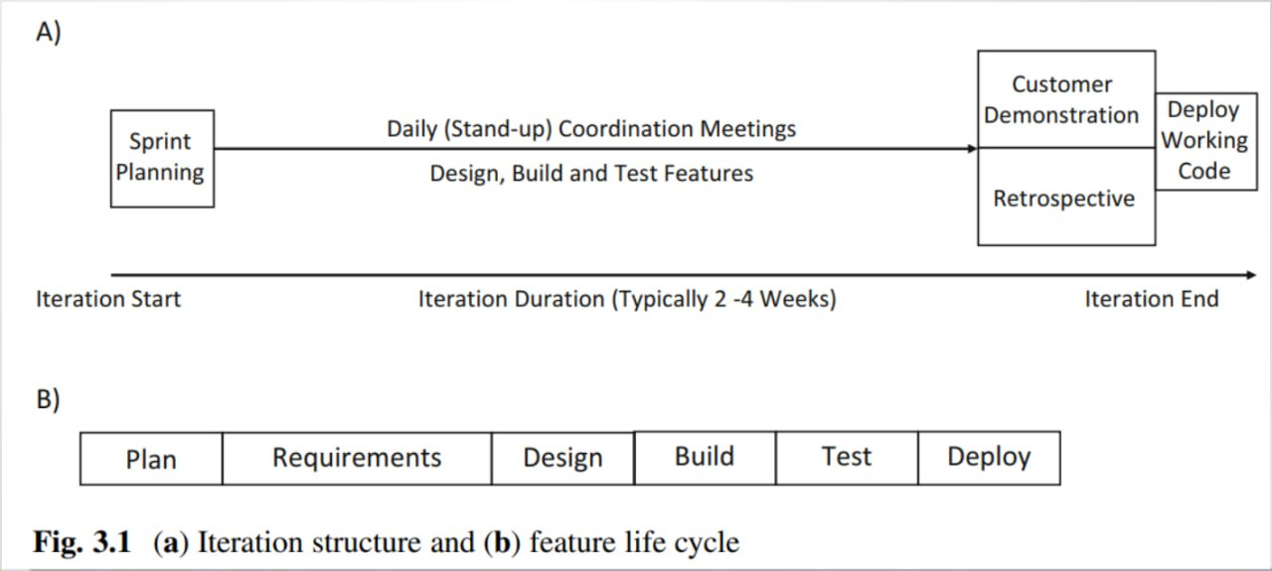
Figure 1: Figure 3.1 iteration structure

3.1.7. Code Publication & Versioning Strategy
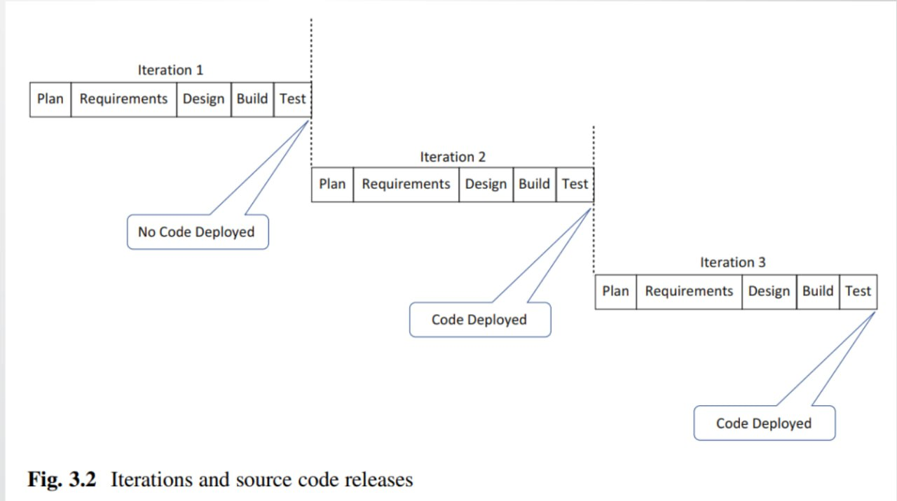
Figure 2: Figure 3.2 iterations

2.2. Remote Pair Programming for Complex Tasks
Although our team was small and partially co-located, we operated as a virtual team due to varying schedules and remote collaboration. To overcome the challenges of asynchronous development, we adopted Remote Pair Programming during critical implementation phases, especially for complex services like authentication, AI job matching logic, and cross-service integration.

3.2.1 Purpose and Benefits
- Tactical Collaboration: We used remote pair programming as a focused tactic to tackle complex logic, resolve integration bugs, or review sensitive code (e.g., security features, async flows, database interactions).
- Real-time Code Quality Feedback: One member acted as the Driver (writing the code), while the other was the Navigator (reviewing in real time, thinking about structure, edge cases, and design consistency).

3.2.2 Setup and Approach
- We used Google Meet for implementation sessions.
- Pairing was scheduled during sprint planning when high-risk or shared ownership tasks were identified.
- Sessions had clear goals and were time-boxed to avoid fatigue and maintain flow.
- We occasionally used the ping-pong method: one person wrote tests, the other wrote the implementation, and then roles were swapped.

2.3. Managing a Multi-Service Platform with Scrum
Our project consists of four core services, each with its own focus, but all contributing to a
unified platform. Scrum helped us manage this structure effectively:
- Single Product Backlog: Centralized and prioritized across all services. This ensured that we always focused on the most impactful items regardless of where they belonged in the system.
- Service-Focused Sprint Goals: Each sprint goal either cut across multiple services or focused on delivering complete functionality within one. This avoided context switching and maintained team focus.
- Example: One sprint focused on user authentication (Auth + Frontend), while another focused on job listing filtering and display logic (Job Service + Search Layer).

3.4. Project Management Tools: Jira

We used Jira as our main project management and tracking tool, configured to reflect Scrum best practices.
Jira is a project management and issue tracking
software developed by Atlassian. It is widely used by teams to plan, track, and manage tasks, bugs, and agile (Scrum &
Kanban) workflows.
jira
Key Features of Jira:
- Issue Tracking – Log and track bugs, tasks, and improvements.
- Agile Project Management – Supports Scrum and Kanban boards for sprint planning.
- Customizable Workflows – Adapt processes to team needs.
- Dashboards & Reports – Visualize progress with burndown charts, velocity reports, etc.
- Integration – Works with Confluence, Bitbucket, Slack, and other tools.

3.4.1. Epics, User Stories, and Tasks
- Epics: Represented large features or services (e.g., AI Recommendation, Job Matching,
Authentication).
- User Stories: Written in user-centric format and linked to the product goals.
- As a job seeker, I want to receive personalized job listings based on my profile so that I can find relevant opportunities faster.
- Tasks/Sub-tasks: Broke user stories down into actionable development items with effort
estimates.

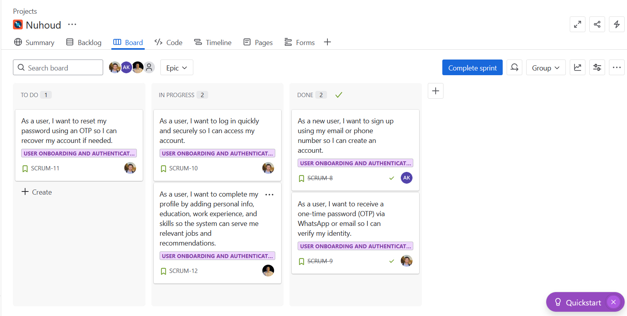
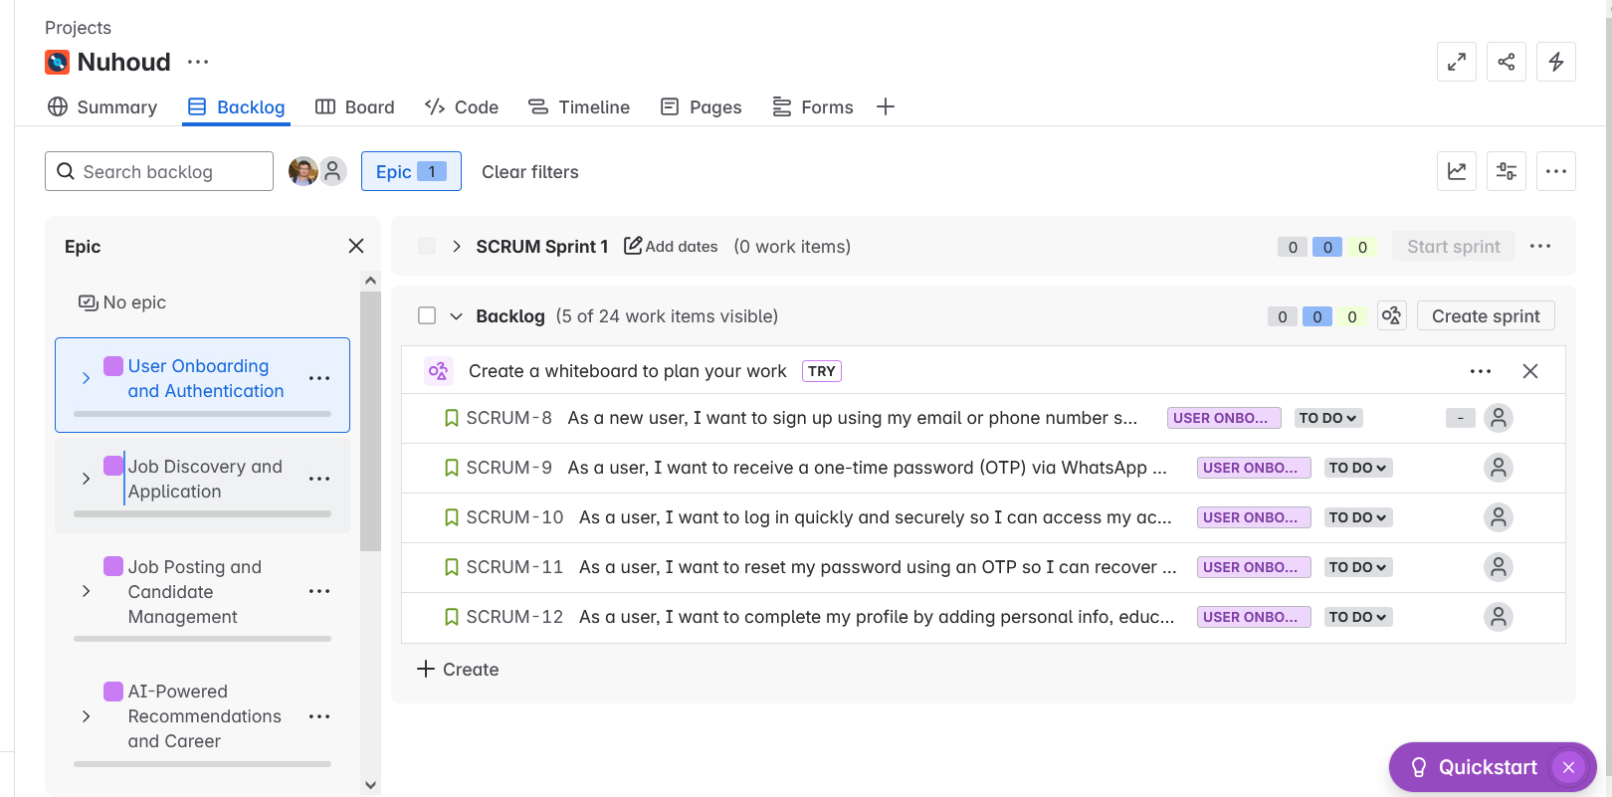
3.4.3. Visual Artifacts from Jira Workspace
Figure 3.4: Jira Board example
Figure 3: Figure 3.4 Jira Board example
Figure 4: Figure 3.3 Jira Backlog example

3.5. Version Control Strategy
Effective version control is the backbone of collaborative software development. For this project, we utilized Git, a distributed version control system, and managed our codebase within a centralized GitHub Organization. This approach provided a structured environment for code management, collaboration, and quality assurance.
https://github.com/Nuhoud
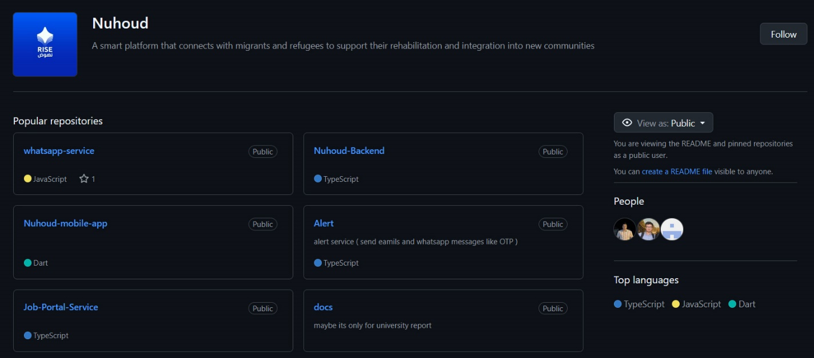
Figure 5: Figure 3.5 Github organization
By centralizing our repositories in one organization, we achieved a transparent overview of all ongoing work. Any team member could see the status of different services, track feature development, and understand the overall architecture at a glance. This was particularly crucial for our multi-service platform, as it helped us manage dependencies and coordinate cross-service integrations.

2.6. Communication and Collaboration
Effective communication and collaboration were essential to the success of our self-organizing team, especially given our hybrid work environment. We established clear communication channels and structured interactions to ensure transparency, accountability, and fast feedback.

3.6.1 Primary Communication Channels
- Google Meet: Used for real-time meetings such as sprint planning, sprint reviews, and occasional ad-hoc discussions.
- Telegram Group: Our central communication hub. We organized conversations into topic-specific threads to maintain clarity and focus:
  - #visual-identity: UI/UX and branding discussions.
  - #discussion: General project decisions, blockers, and coordination.
  - #files-and-docs: Shared links to documentation, files, and assets.

3.6.2 Meeting Cadence
- Weekly Sprint Meetings:
  - Sprint Planning at the start of each sprint.
  - Sprint Review/Demo at the end of the sprint.
- Daily Async Stand-ups:
  - Team members posted brief updates (what was done, what’s next, blockers) in the Telegram #discussion thread or via GitHub issue comments.

Chapter 4: Requirements Engineering

This chapter details how functional and non-functional requirements were gathered, structured, and validated. It also includes use case diagrams and specifications that define user interactions with the system.

4.1 Requirements Elicitation
The requirements for the Nuhoud system were defined through an iterative, collaborative process rooted in Agile-Scrum and Domain-Driven Design (DDD). Given the academic context and absence of real-world clients, the team relied on expert input, internal discussions, and the
socio-economic realities of post-war Syria..
Vision-Oriented Definition: Initial features were shaped by the team's understanding of key challenges-youth unemployment, lack of localized job platforms, and the need for structured skill development.
Supervisor and Advisor Feedback: Regular consultations with the project supervisor helped refine and validate requirements, ensuring alignment with academic goals and technical feasibility.
Agile Process: Using Scrum, requirements evolved across development sprints, each focusing on prioritized functionality such as user onboarding, job applications, and AI-driven recommendations.
Domain Modeling & Brainstorming: Structured brainstorming defined key service areas (User, Job, Alerts, AI). DDD principles guided service decomposition and responsibility allocation.
Competitive Benchmarking: A lightweight review of platforms like LinkedIn and Indeed revealed gaps in personalization and career guidance, justifying Nuhoud’s AI-centered features.
Model-Based Clarification: Use case diagrams and domain models were created to visualize system behavior and refine requirements, serving as blueprints during implementation.

4.2 Functional Requirements

4.2.1 User Management
- The system shall allow individuals to register as a 'Job Seeker' or 'Employer'.
- The system must enforce account verification via an OTP sent to the user's registered email or mobile number.
- Registered users must be able to log in securely with their credentials.
- The system shall provide a "Forgot Password" functionality that allows users to reset their password securely.
- Job Seekers shall be able to create and edit a detailed personal profile, which must include sections for personal information, education, work experience, certifications, and skills.
- Administrators shall have the capability to view a list of all users, modify user details, and delete user accounts from the system.
- The system shall allow users to upload and update a profile image.
- The system shall store profile images in an object storage service (S3-compatible / MinIO) and store only the image reference (URL/object key) in the user profile record.

4.2.2 Job Application Flow
- Employers shall be able to create, publish, and edit job offers, specifying details such as job title, description, required skills, experience level, and location.
- Job Seekers shall be able to search for job offers using keywords and apply filters based on criteria like job type, experience, and location.
- Job Seekers shall be able to view the complete details of any job offer.
- Job Seekers must be able to submit an application to a job offer, attaching their profile.
- Employers must be able to view a list of all applications received for each of their job offers.
- Employers shall be able to change the status of an application (e.g., "Viewed", "Under Review", "Shortlisted", "Rejected") and provide private feedback notes.
- Job Seekers must be able to view and track the status of all their submitted applications.

4.2.3 Notification & Alerts
- The system must send an automated notification to a user's registered email,WhatsApp or Firebase Cloud Messaging upon a change in their application's status.
- The system shall send a notification to an employer when a new application is submitted for their job offer.
- The system shall send OTPs for user verification and password reset procedures.
- The system may send periodic alerts to employers regarding job offers that are nearing their expiration date.
- The system shall store and manage a user’s device notification token to enable targeted push delivery.

4.2.4 AI Recommendations
- The system shall analyze a Job Seeker's complete profile, including their skills, experience, and stated career goals.
- The system shall generate a personalized career development plan, suggesting courses and improve skills steps.
- The system shall proactively recommend job offers to users that are a strong match for their profile.

4.3 Non-Functional Requirements
Non-functional requirements describe how the system operates and the quality attributes it must achieve (scalability, reliability, security, performance, interoperability, and maintainability).

Scalability: The system must scale to handle increasing numbers of users, employers, and job postings. A microservices architecture (separate services for user management, job management, alerts/notifications, and AI processing) enables horizontal scaling, allowing each service to scale independently based on workload.
To prevent database growth from file uploads, user media (e.g., profile images) is stored in MinIO (S3-compatible object storage) rather than in MongoDB. This avoids database bloat and allows storage capacity to scale independently from application services.
In addition, asynchronous workflows (such as notifications triggered by job application events) are supported through Kafka, which helps decouple services and improves throughput under load.

Availability & Reliability: Core services (authentication, OTP delivery, job search, job applications) must remain available with minimal downtime. Services are designed to be resilient through containerized deployment and health-based startup/operation.
The system uses health checks to verify service readiness, and restart policies to automatically recover failed components. At the gateway level, NGINX provides controlled request forwarding and includes a lightweight /health endpoint, enabling monitoring and rapid detection of failures. Timeout configurations on the reverse proxy prevent stuck connections and help the system fail fast when upstream services become unavailable.

Security: User data and system operations must be protected against unauthorized access and common web threats. Authentication is strengthened through OTP verification and strong password rules, while JWT is used for stateless session management between clients and backend services. Role-based access control ensures only authorized roles can access administrative or employer-specific endpoints. Sensitive values (passwords/tokens) are protected by secure hashing at rest, and data should be encrypted in transit when deployed with HTTPS.
To improve perimeter security, NGINX is used as an API Gateway that centralizes security controls such as: hiding server version information (server_tokens off), applying security headers (X-Frame-Options, X-XSS-Protection, X-Content-Type-Options), and enforcing rate limiting per client IP to reduce abuse, brute-force behavior, and basic DoS patterns. This provides an additional security layer before traffic reaches internal services.

Performance: The user-facing APIs should respond quickly under expected load. MongoDB queries are optimized using indexes and pagination to maintain performance as data grows. NGINX improves network efficiency by enabling gzip compression for common response payloads (e.g., JSON), and by using connection optimizations (keep-alive, efficient socket handling).
Large payload support (e.g., profile image uploads) is addressed via gateway configuration (e.g., client_max_body_size) to prevent upload failures. Storing media in MinIO also improves performance by keeping profile APIs lightweight (metadata in MongoDB, file content in object storage).

Interoperability: The system must integrate with external services and support multiple communication protocols. AI features integrate through standard external APIs (e.g., Google Gemini). Notifications integrate with messaging providers (email, WhatsApp) and were extended to support push notifications through Firebase Cloud Messaging (FCM) for mobile users.
Communication between internal components uses standard protocols: REST/HTTP for client APIs, Kafka for event-driven messaging (e.g., job application lifecycle events), and gRPC for low-latency internal calls such as OTP-related workflows. Standard data formats (JSON, protobuf) are used to keep integrations flexible and extensible.

Maintainability: The system must be easy to evolve, test, and extend. Microservices promote loose coupling and clear boundaries: each service encapsulates a business capability and exposes well-defined APIs, allowing independent development and deployment. The codebase follows clean architecture and Domain-Driven Design (DDD) principles so domain logic remains organized and understandable.
Centralizing cross-cutting concerns (routing, compression, basic security controls, and rate limiting) in NGINX reduces duplicated code across services. Automated unit and integration tests for critical workflows (authentication/OTP, applications, notifications) help ensure changes do not break existing functionality.

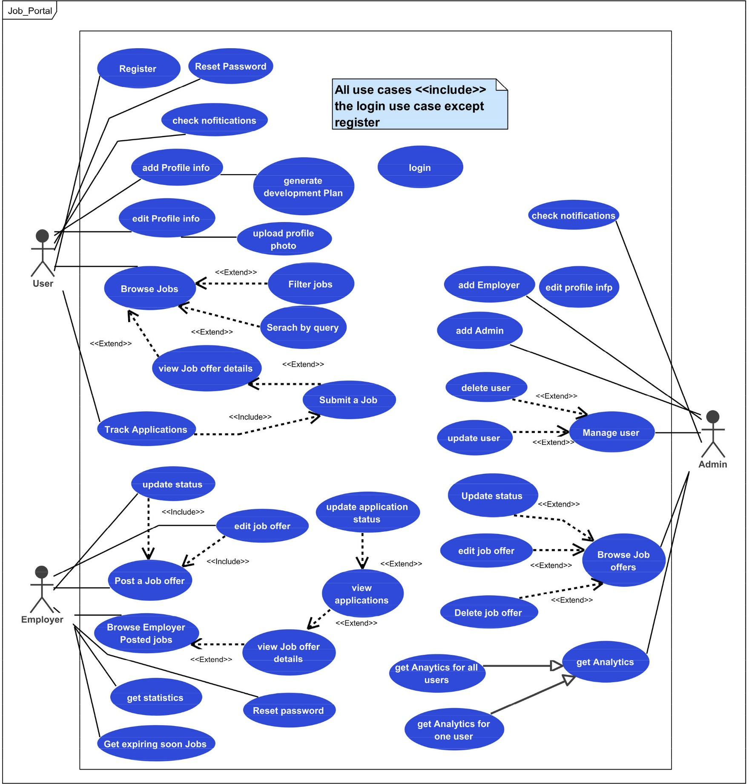
4.4 Use Case Diagram
Figure 6: Figure 4.1 Use Case diagram

4.5 Use Case Specifications
Title | User Registeration
Actor | New Userr
description | Allows new users to create an account in the system
precondition | User is not already registered
postcondition | User account is created and stored in the database
Flow event | actor | system
 | User enters registration information (email, password, mobile)
- Validates input data
- Checks if email/mobile already exists
- generta otp
- send otp
 | enter otp
- Validate otp
- delete otp
- Creates new user account
- Returns jwt token
Critical scenarios | scenario | System response
 | Duplicate email/mobile Response | returns error "Email/Mobile already exists"
 | Invalid input format | System returns validation error messages
 | Failed to send OTP | System logs error
 | Invalid OTP | System returns "Invalid OTP"
Table 1:Table 4.1 register usecase specification

Title | User Login
Actor | Registered User
description | Allows users to log in to their account
precondition | User has a registered account
postcondition | User is authenticated and receives access token
Flow event | actor | system
 | User enters email/mobile and password
- Validates credentials
- Checks if user exists
- Verifies password
- Generates and returns access token
Critical scenarios | scenario | System response
 | Invalid credentials | System returns "Invalid credentials"
 | Account not found | System returns " identfier or password not correct"
 | Invalid password | System returns "identfier or password not correct"
Table 2: Table 4.2 user login use case specification

Table 3: Table 4.3 admin user creation use case specification

Title | Add Admin
Actor | Admin
description | Allows admin to create new admin users
precondition | Actor is authenticated as sadmin
postcondition | New admin user is created with admin privileges
Flow event | actor | system
 | Provides admin user details
- Validates super privileges
- Creates admin user with specified permissions
- Returns success message
Critical scenarios | scenario | System response
 | Insufficient privileges | eturns "Unauthorized - admin required"
 | Duplicate admin email | System returns "Admin already exists"
 | Invalid input | returns validation errors

Title | Reset Password
Actor | User
description | allows users to reset their password using OTP verification
precondition | User has an existing account
postcondition | User's password is updated
Flow event | actor | system
 | Requests password reset
- Validates user existence
- Generates OTP and stores it
- Sends OTP via WhatsApp/Email
 | Receives OTP and enters it
 |  | -Validates OTP
 | Enters new password
 |  | Updates password and clears OTP
Critical scenarios | scenario | System response
 | User not found | returns "User not found"
 | Invalid OTP | returns "Invalid OTP"
 | OTP expired Response | returns "OTP expired"
Table 4: Table 4.4 reset password use case specification

Table 5: Table 4.5 user account deletion use case specification
Title | User Account Deletion
Actor | Admin
description | Allows admin to delete user accounts
precondition | Actor is authenticated as admin
postcondition | User account is deleted
Flow event | actor | Flow event
 | Selects user to delete
- Validates super privileges
- Creates admin user with specified permissions
- Returns success message
Critical scenarios | scenario | Critical scenarios
 | Insufficient privileges | returns "Unauthorized - Admin required"
 | User not found Response | returns "User not found"
 | Attempt to delete admin | returns "Cannot delete admin account"

Title | Add Profile Information
Actor | User
description | Allows users to set up their profile information in two steps
precondition | User is authenticated
postcondition | User's profile information is created
Flow event | actor | system
 | Provides basic profile details
- Validates input
- Stores basic information
- Suggest skills (using AI) and returns skills to user
 | enter skills
- Validates complete profile
- Finalizes profile creation
- retrun a AI-generated personal development plan
Critical scenarios | scenario | System response
 | Invalid basic information | System returns validation errors
 | Missing required fields | prompts for required information
Table 6: Table 4.6 add profileinfo use case specification

Table 7: Table 4.7 update profile info use case specification

Title | Update Profile Information
Actor | User
description | Allows users to update their profile information
precondition | User is authenticated and has a profile
postcondition | User's profile information is updated
Flow event | actor | system
- Selects profile section to edit
- Provides updated information
- Validates changes
- Updates profile information
- Returns updated profile
Critical scenarios | scenario | System response
 | Invalid updates | returns validation errors

Table 8: Table 4.8 post job offer use case specification

Title | Post a Job Offer
Actor | Employer
description | An employer posts a new job offer to the system. The job offer includes details such as title, description, required skills, and company information
precondition | The employer must be authenticated
postcondition | A new job offer is created in the system and is available for users to view and apply for.
Flow event | actor | system
- Navigates to the "Post a Job Offer" page
- Fills in the job offer details form
- Submits the form.
- Receives the request to create a new job offer.
- Validates the provided data.
- Creates a new job offer record in the database.
Returns a success message to the employer.
Critical scenarios | scenario | System response
 | Invalid data | returns validation errors
 | The employer is not authenticated | authorization error

Title | Update Job Offer Status
Actor | Admin/Employer
description | An admin or the employer who posted the job offer updates its status
precondition | The actor must be authenticated and have the necessary permissions
postcondition | The status of the job offer is updated in the database.
Flow event | actor | system
- Selects the new status.
- Confirms the update.

- Verifies the actor's permissions.
- Updates the job offer's status in the database.
- Returns a success message.
Critical scenarios | scenario | System response
 | job offer does not exist | returns a "not found" error
 | actor does not have permission | authorization error
Table 9: Table 4.9 update job offer satus use case specification

Table 10: Table 4.10 search for job offer use case specification

Title | Search for Job Offer
Actor | User/Employer/Admin
description | A user, employer, or admin searches for job offers using a query.
precondition | The actor is on a page with a search functionality.
postcondition | A list of job offers matching the search query is displayed.
Flow event | actor | system
 | - Enters a search query (e.g., keywords, location, company).
- Receives the search query.
- Searches the database for job offers that match the query.
- Returns the list of matching job offers.
Critical scenarios | scenario | System response
 | No job offers match the search query. | displays a message indicating that no results were found.

Title | View Job Offer Details
Actor | User/Admin/Employer
description | views the detailed information of a specific job offer.
precondition | The job offer exists in the system.
postcondition | The details of the selected job offer are displayed.
Flow event | actor | system
 | Selects a job offer from a list or search results.
- Retrieves the job offer information from the database.
- Displays the full details of the job offer..
Critical scenarios | scenario | System response
 | job offer does not exist | returns a "not found" error
Table 11: Table 4.11 view job offer details use case specification

Table 12: Table submit application use case specification
Title | Submit Application
Actor | User
description | A user submits an application for a job offer.
precondition | The user must be authenticated. The job offer must be open for applications.
postcondition | An application for the job offer is created and linked to the user's profile. The employer is notified of the new application.
Flow event | actor | system
 | - Clicks the "Apply" button.
- extract snapshoot of user info
- Creates a new application record in the database, associating it with the user and the job offer.
Sends a notification to the employer and user
Critical scenarios | scenario | System response
 | user is not authenticated | Authorization error
 | job offer is no longer accepting applications | The system displays a message that the job offer is closed
 | The user has already applied for this job offer | have already applied

Title | Track Application
Actor | User
description | A user tracks the status of their submitted applications and sees any notes from the employer
precondition | The user must be authenticated and have submitted at least one application.
postcondition | The user can view the current status and any employer notes for their applications.
Flow event | actor | system
 | - Navigates to their "My Applications" page
 |  | Retrieves the list of the user's applications from the database.
 | - Selects an application to view its status.
 |  | - Displays the applications with their current status (e.g., "Submitted," "Under Review," "Hired," "Not Selected") and any notes from the employer.
Critical scenarios | scenario | System response
 | user has not submitted any applications | message indicating that no applications have been submitted.
Table 13: Table 4.13 track application use case specification
Table 14: Table 4.14 browse job offer applications usecase specification

Title | Browse Job Offer Applications
Actor | Employer
description | employer browses the applications submitted for a job offer they posted.
precondition | The employer must be authenticated and be the owner of the job offer.
postcondition | The employer can view a list of applicants for their job offer.
Flow event | actor | system
- Navigates to the "My Job Offers" page.
- Selects a job offer to view its applications
- Retrieves all applications for the selected job offer.
- Displays a list of applicants with summary information.
Critical scenarios | scenario | System response
 | employer is not the owner of the job offer | Authorization error
 | There are no applications for the job offer | message indicating that no applications have been received yet

Table 15: Table 4.15 update application status use case specification

Title | Update Application status
Actor | Employer
description | An employer updates the status of an application and can add a note for the applicant.
precondition | The employer must be authenticated and be the owner of the job offer for which the application was submitted.
postcondition | The application's status is updated, and a note may be added. The applicant can see the new status and note.
Flow event | actor | system
- Selects an application to update.
- Chooses a new status from a dropdown list
- Adds a note for the applicant.
- submit
- Updates the application's status and adds the note in the database.
- Sends a notification to the applicant about the status change.
- Returns a success message to the employer.
Critical scenarios | scenario | System response
 | The employer does not have permission to update the application. | Authorization error

Chapter 5: System Design and Architecture

This chapter explains the architectural decisions and design principles behind the Nuhoud system. It covers microservices decomposition, communication patterns, data strategies, and integration of AI workflows.

5.1. Architectural Style: Microservices
What is Microservices Architecture?
Microservices architecture (often shortened to microservices) refers to an architectural style for developing applications. Microservices allow a large application to be separated into smaller independent parts, with each part having its own realm of responsibility. To serve a single user request, a microservices-based application can call on many internal microservices to compose its response.
Monolithic vs. microservices architecture
Traditional monolithic applications are built as a single, unified unit. All components are tightly coupled, sharing resources and data. This can lead to challenges in scaling, deploying, and maintaining the application, especially as it grows in complexity. In contrast, microservices architecture decomposes an application into a suite of small, independent services. Each microservice is self-contained, with its own code, data, and dependencies. This approach offers several potential advantages:
- Improved scalability: Individual microservices can be scaled independently based on their specific needs
- Increased agility: Microservices can be developed, deployed, and updated independently, enabling faster release cycles
- Enhanced resilience: If one microservice fails, it doesn't necessarily impact the entire application
- Technology diversity: The flexibility of microservices allows teams to use the most suitable technology for each service

5.1.1. Rationale for Choosing Microservices
The Nuhoud system uses a microservices architecture to maximize scalability and flexibility. Each microservice can be scaled independently – for example, if the Job Service experiences heavy load, only its instances need to be increased. This avoids over-provisioning and improves resource utilization. Microservices also enforce separation of concerns: distinct business
domains (user management, job postings, notifications, AI) reside in separate services, making each codebase smaller and more maintainable. Changes or faults in one service (say, the AI
Recommendation Service) do not directly affect others, improving fault isolation. Independent services can be deployed and updated on their own schedules, enabling faster iteration.
In practice, we organize teams and development pipelines around these bounded domains; for example, one team owns user/profile features while another owns job postings. Overall,
microservices offer the agility (parallel development, polyglot persistence), resilience, and
fine-grained scalability that suit Nuhoud’s requirements.
- Scalability: Each service can be scaled on demand (e.g. adding instances of the Job
Service) without scaling unrelated components.
- Separation of Concerns: Services are aligned to single business capabilities (following the Single Responsibility Principle) so they are cohesive and independently maintainable.
- Independent Deployment: Teams can deploy or upgrade services separately, reducing risk. The database-per-service pattern decouples data, so updates do not require
cross-database schema changes.
These factors make microservices well-suited for Nuhoud’s event-driven, domain-oriented
system. (As one guide notes, “Bounded Contexts (each BC correlates to a microservice)” when using DDD principles

5.1.2. Service Decomposition and Granularity
We decomposed Nuhoud according to Domain-Driven Design (DDD). Each microservice
corresponds to a bounded context, a coherent subdomain with its own data and logicIn Nuhoud, the main services are:
- Authentication & User Service: Manages the User domain. It handles registration, login (email or phone), profiles (personal info, experience, education, skills) and tracks each user’s job applications and development history. All user-related data is stored here. When an OTP is needed, it generate it and invokes the Alerts Service over gRPC to send it.
Profile images are stored in MinIO object storage and referenced in the user profile record (URL), reducing database size and improving scalability.
- Alerts & Notifications Service: Manages the Notifications domain. It exposes a gRPC interface for sending one-time passwords (used by Auth) via WhatsApp or email.
It subscribes to Kafka events (e.g. job application or status events) to notify users of job matches, application updates. In addition to WhatsApp/email, the Alerts Service also supports Firebase Cloud Messaging (FCM) to send push notifications to mobile users (e.g., application status updates)

- AI Recommendation Service: Handles the Recommendation domain. Orchestrated by an n8n workflow, it analyzes user profiles (skills, experience) and job data to generate
personalized job recommendations and Personal Development Plans. It relies on external AI model ( Gemini ).
- Job Service: Encapsulates the Job Posting domain. Employers post jobs here; users browse and apply. It tracks job status (Active, Closed, Draft, Expired) and application
status. When a user submits an application, this service records it and consume a
job.application.submit Kafka message to proccess it. when an application’s status changes, it emits job.application.statusChange Kafka event.
- NGINX API Gateway / Reverse Proxy: Acts as the single entry point for web and mobile clients. It routes requests to internal microservices (e.g., User Service and Job Service), applies basic protection such as rate limiting, and exposes internal tools like MinIO behind controlled paths. This improves security and simplifies client integration by providing one base URL.
- MinIO (S3-Compatible Object Storage): Used to store user profile images and uploaded files as objects instead of saving them inside MongoDB. The User Service stores only the object key/URL in MongoDB while the image itself is stored in MinIO.

Each service thus owns a single, well-defined domain. This decomposition follows best practices (DDD/Single-Responsibility) by grouping related functionality within one service. For example, all user authentication and profile logic stays in the User Service, and job logic stays in the Job Service. This keeps services highly cohesive and loosely coupled.

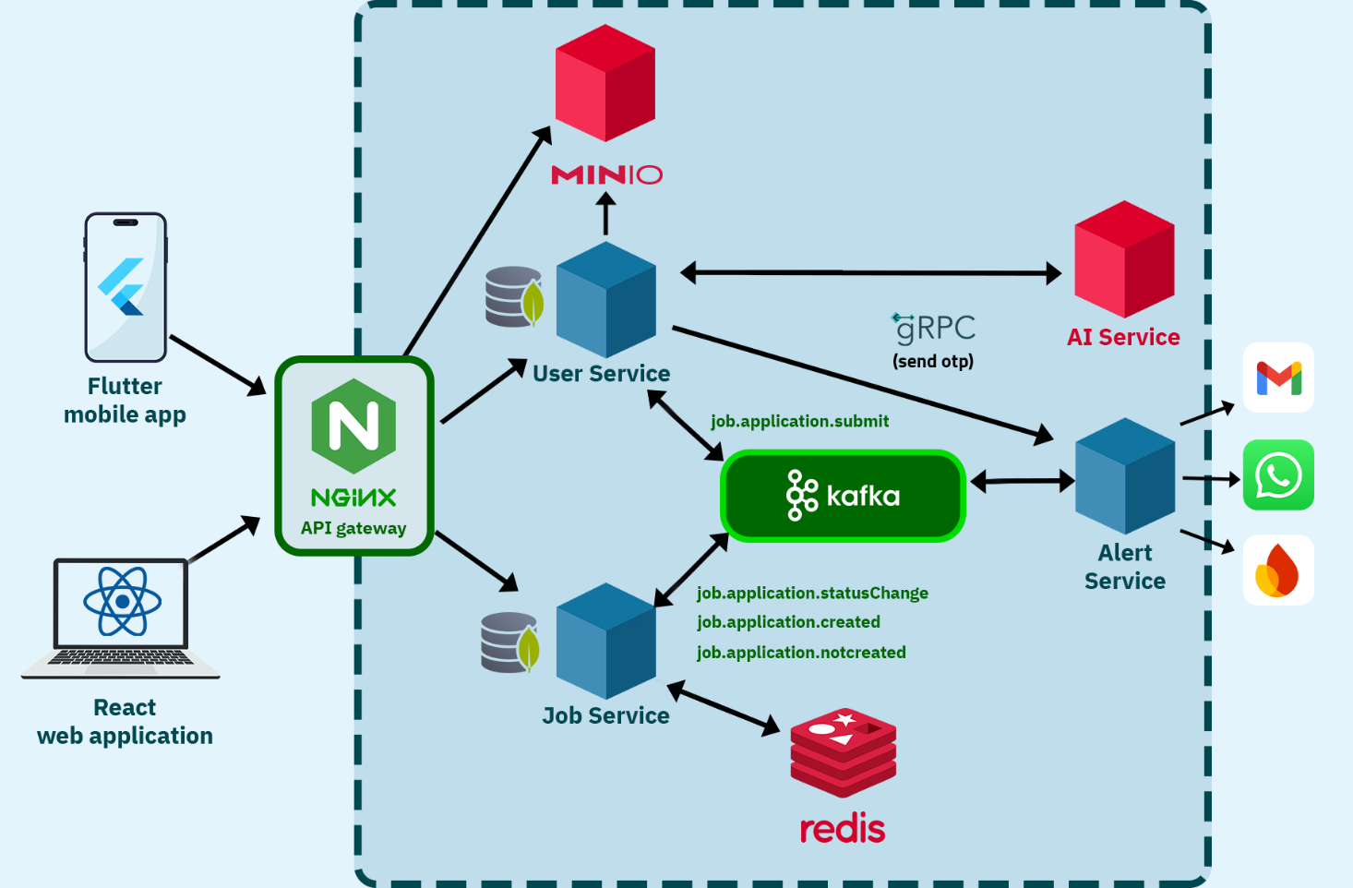
5.2. High-Level System Architecture Diagram

Figure 7: Figure 5.1 high level system design daigram

Web and mobile clients communicate with the system through an NGINX API Gateway, which works as a reverse proxy and single entry point. NGINX routes traffic to the User Service and Job Service, and also exposes the MinIO S3 API and MinIO Console through dedicated paths for object storage management.
Internally, services communicate using a hybrid approach: REST/HTTP for client-facing requests, Kafka for asynchronous domain events (e.g., job application lifecycle events), and gRPC for low-latency synchronous calls such as OTP delivery.
The User Service stores structured profile data in MongoDB while storing profile images in MinIO; the Alert Service consumes Kafka events to notify users via email/WhatsApp and push notifications.

5.3. Core Design Principles

5.3.1. SOLID Principles Application
The Nuhoud system demonstrates consistent adherence to the SOLID principles across its microservices. The architecture benefits from the structure and conventions of the NestJS framework, with good separation of concerns and use of dependency injection. The application of these principles is outlined below with emphasis on the User and Job Services.
Single Responsibility Principle (SRP):
SRP is effectively applied throughout the system. In both the User and Job services, controllers (e.g., job-offers.controller.ts, application.controller.ts) handle request/response logic, while service classes (e.g., job-offers.service.ts, users.service.ts) encapsulate business logic and data access. DTOs are used for input validation and data transfer, and entities define the persistence models. This clear separation aligns well with SRP. However, in the User service, classes such as AuthService and UsersService are beginning to accumulate multiple responsibilities
(e.g., authentication logic, role management, hashing), which may merit refactoring into more specialized components as complexity grows.
Open/Closed Principle (OCP):
OCP is evident in the consistent use of class extension and composition patterns. For example, UpdateJobOfferDto extends PartialType(CreateJobOfferDto), allowing behavior to be extended without modifying base structures. Decorators and guards in the authentication domain are also designed to be extended for new roles or permissions. In service logic, new functionality is generally introduced through new methods rather than altering existing ones, which preserves stability while enabling change.
Liskov Substitution Principle (LSP):
LSP is upheld through the use of well-structured DTOs and inheritance. Extended DTOs like UpdateJobOfferDto are used interchangeably in contexts where their base classes (CreateJobOfferDto) are expected. The system avoids violating substitutability by ensuring that extended types do not alter the expected behavior of their base types. No structural or behavioral violations were observed in the service or controller layers.
Interface Segregation Principle (ISP):
The codebase favors small, purpose-driven abstractions such as DTOs and Mongoose models. While explicit TypeScript interfaces are not widely used for services, each service class exposes narrowly scoped behavior aligned with a specific domain. There are no bloated or general-purpose interfaces forcing consumers to depend on unused methods. Future improvements could include formalizing interfaces for core services to further enhance testability and flexibility.
Dependency Inversion Principle (DIP):
DIP is strongly supported by the use of NestJS’s dependency injection mechanism. Services are injected into controllers and into one another via constructor injection, decoupling high-level modules from concrete implementations. For instance, the ApplicationService and JobOffersService inject Kafka clients and database models using NestJS providers. While the direct use of new this.model(...) is necessary for Mongoose models, all external services, such as messaging or notification services—could benefit from being abstracted behind interfaces to facilitate mocking and future replacement.

5.3.2. Design Patterns
This section outlines the design patterns currently implemented across the Job Service and User Service, evaluates how they are applied in the context of the NestJS framework
1. Dependency Injection Pattern
Dependency Injection (DI) is at the core of both services and is leveraged extensively through NestJS’s built-in DI system. Services, models, and external clients are injected using constructor injection with the @Injectable() decorator. Controllers consume these services without instantiating them manually, promoting clean separation of concerns and ease of testing.

2. Decorator Pattern
Both services rely heavily on the Decorator pattern. NestJS’s native decorators such as @Controller, @Post, @Body, @Injectable, and others are used throughout the application. Additionally, custom decorators like @Public() and @Roles() are used to encapsulate route-level metadata such as authentication and authorization requirements. DTO classes also use validation decorators from the class-validator library to enforce schema rules.
3. Observer / Event Pattern
The system implements the Observer pattern via Kafka. Events like job.application.submit and job.application.statusChange are emitted and consumed using @EventPattern, allowing asynchronous and decoupled communication between microservices. This pattern is particularly useful for maintaining the integrity of workflows like job applications and status updates without tight coupling.
4. Module Pattern
The application architecture is modular by design. Each feature domain (users, authentication, job offers, applications, etc.) is encapsulated in its own NestJS module. This promotes clean separation of responsibilities and makes the codebase scalable and easier to maintain.
5. Singleton Pattern
All services in the application are singletons by default due to NestJS’s service lifecycle. This ensures that shared dependencies such as database connections or utility classes are instantiated once and reused across the application lifecycle.

5.4. Inter-Service Communication

5.4.1. Communication Patterns
Nuhoud employs a hybrid communication model. Public-facing APIs use traditional REST/HTTP, allowing clients (web or mobile) to interact with services in a simple, standardized way.
For example, logging in or searching jobs are done via REST endpoints. Internally, synchronous calls between services use gRPC. gRPC offers high-performance RPC over HTTP/2 with Protocol Buffers, which is more efficient than JSON/HTTP for inter-service calls. We use gRPC for operations where low latency is important (such as sending OTPs or real-time status checks). For asynchronous workflows and loose coupling, we use Apache Kafka. Services publish events
(fire-and-forget) and other services subscribe to them. This event-driven approach ensures that services remain decoupled: a service emits an event and does not wait for a response.

5.4.2. Asynchronous Communication with Apache Kafka
Kafka works well as a replacement for a more traditional message broker. Message brokers are used for a variety of reasons (to decouple processing from data producers, to buffer unprocessed messages, etc). In comparison to most messaging systems Kafka has better throughput, built-in partitioning, replication, and fault-tolerance which makes it a good solution for large scale message processing applications.
Asynchronous, event-driven communication is handled by Apache Kafka. We define specific Kafka events for key domain activities. For example, when a user applies to a job, the Job Service publishes a job.application.submit event. When an application’s status changes (approved/rejected), it publishes job.application.statusChange. Other services subscribe to these events as needed.
Kafka provides a robust, scalable backbone for Nuhoud’s asynchronous communication, enabling reliable event delivery and independent service processing.

5.4.3. Synchronous Communication with gRPC
gRPC is a modern, high-performance, open-source framework for building APIs. It utilizes Remote Procedure Calls (RPC) for efficient communication between services, especially in microservices architectures. gRPC leverages HTTP/2 for transport and Protocol Buffers (protobuf) for serialization, resulting in faster and more lightweight communication compared to traditional REST APIs using JSON or XML.
Key Features and Benefits:
- High Performance:
gRPC utilizes HTTP/2 and protobuf, which leads to reduced latency and overhead compared to REST APIs.
- Language Agnostic:
gRPC supports various programming languages, allowing for polyglot microservice architectures.
- Contract-First API Development:
gRPC uses Protocol Buffers as an Interface Definition Language (IDL), ensuring a
well-defined contract between services.
- Streaming Support:
gRPC offers support for client, server, and bidirectional streaming, making it suitable for real-time and data-intensive applications.
For synchronous inter-service calls that require low latency, we use gRPC. Notably, the Auth Service calls the Alerts Service’s gRPC API to send OTPs to users. This choice was made for performance reasons: gRPC runs over HTTP/2 with binary serialization (Protocol Buffers), which significantly reduces overhead. As one analysis notes, gRPC/HTTP2 can transmit messages “up to 10 times faster” than traditional HTTP1.1/REST.

5.4.4 API Gateway and Reverse Proxy (NGINX)
Nuhoud uses NGINX as an API Gateway and reverse proxy to provide a unified entry point for clients and to protect backend services. Requests are routed by path to the appropriate service (e.g., /Nuhoud/ to the User Service and /NuhoudJob/ to the Job Service).
To improve resilience and security, NGINX applies rate limiting on public endpoints and adds standard security headers (e.g., X-Frame-Options, X-Content-Type-Options, and CSP).
NGINX also proxies MinIO endpoints, exposing the S3-compatible API and the admin console through /minio/ and /minio-console/ while keeping MinIO inside the internal network.

5.5. Data Management Strategy (Database-per-Service + plus MinIO for files )
We follow a database-per-service pattern using MongoDB for each service’s datastore. Each microservice has its own MongoDB instance or cluster and holds only its own data: the User Service stores users and profiles, the Job Service stores jobs and applications.
This encapsulation ensures loose coupling: a schema change in one service’s database has no impact on the others. All services use MongoDB (a document database) because our domain data (profiles, jobs, notifications) fits a flexible, schemaless model. Because services are isolated, we do not perform SQL-like joins across services. When data from another domain is needed, we use one of two approaches:
(1) the requesting service calls another service’s API synchronously, or (2) we replicate the necessary data asynchronously. To support efficient querying and avoid constant RPC calls, we do replicate selected data to read-optimized views.
In summary, each service owns its MongoDB data and there are no live joins between databases.Controlled duplication of data (eventual-consistent views) is used only where needed for performance.
Object/Binary Data Storage (MinIO): While MongoDB stores structured documents (users, profiles, jobs, applications), large binary data (e.g., profile images and user uploads) is stored in MinIO, an S3-compatible object store. The User Service saves only metadata in MongoDB (such as the object key, file name, or public URL), while the actual file is stored as an object. This reduces database growth, improves performance, and enables scalable file delivery.
5.5.1. Data Modeling: 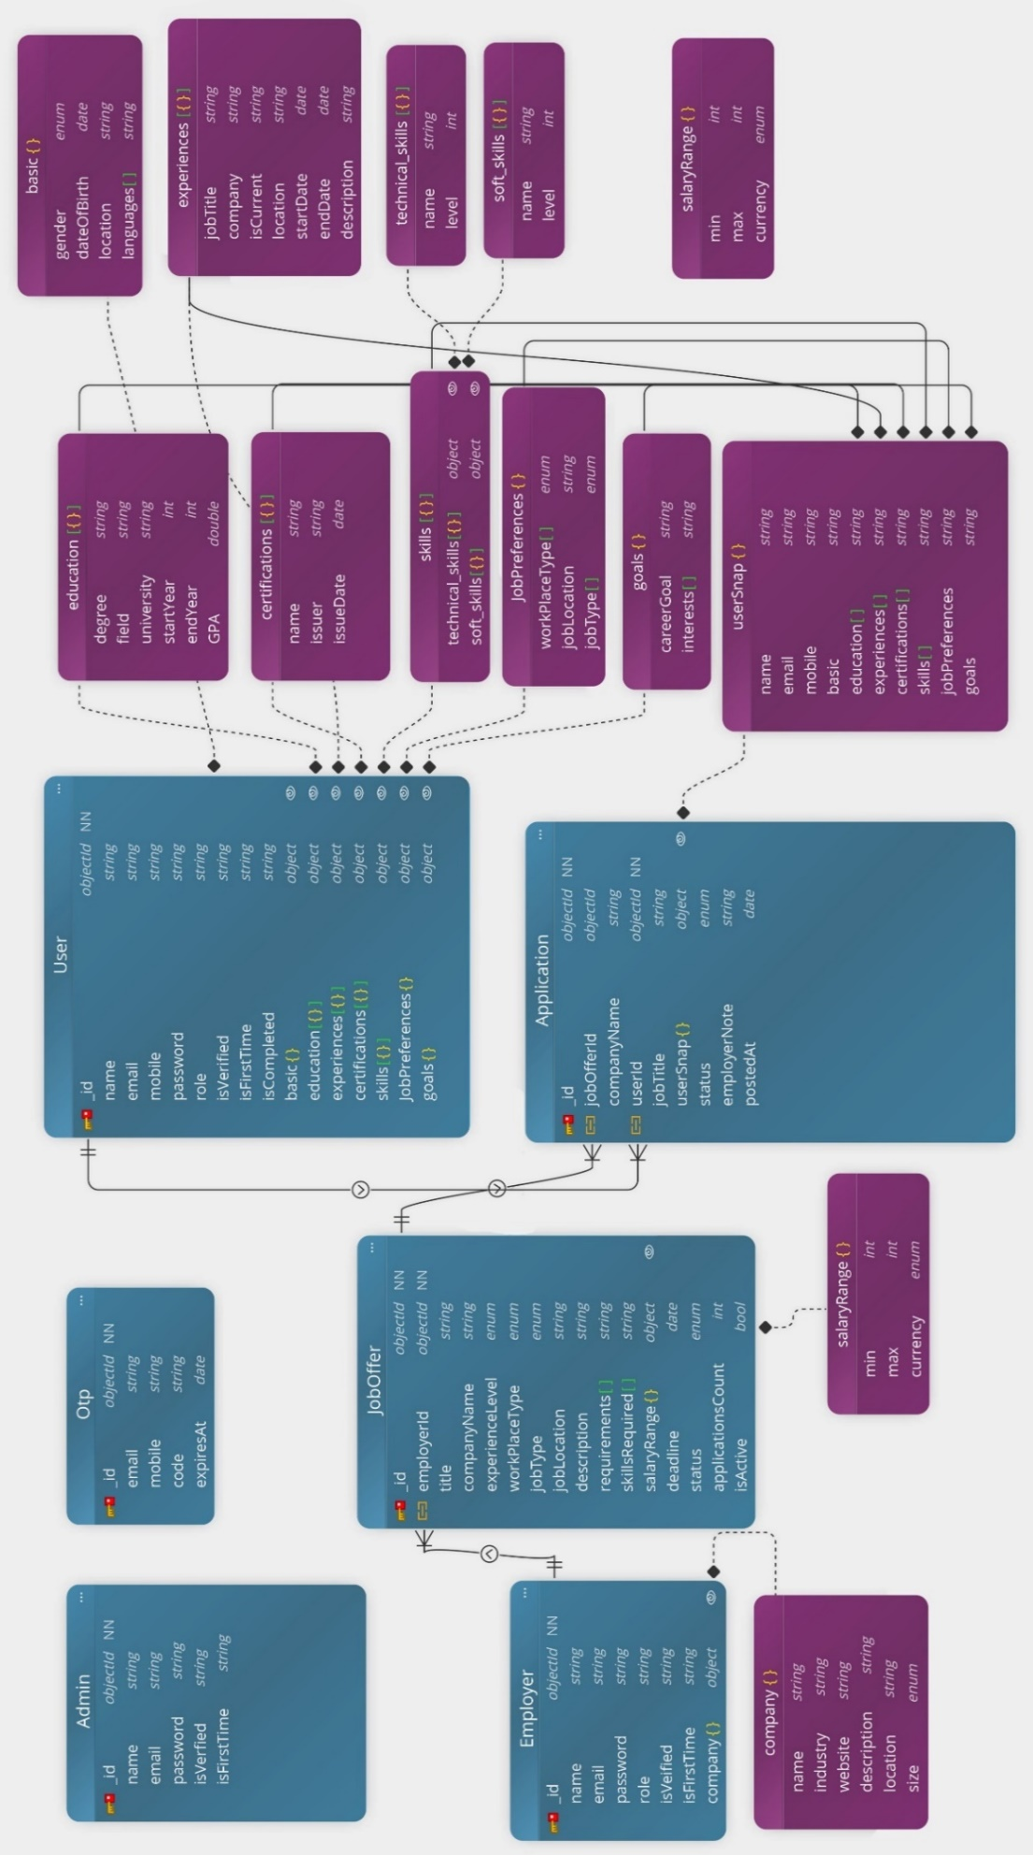
Figure 8: Figure 5.2 entity daigram

5.6. Class Diagram
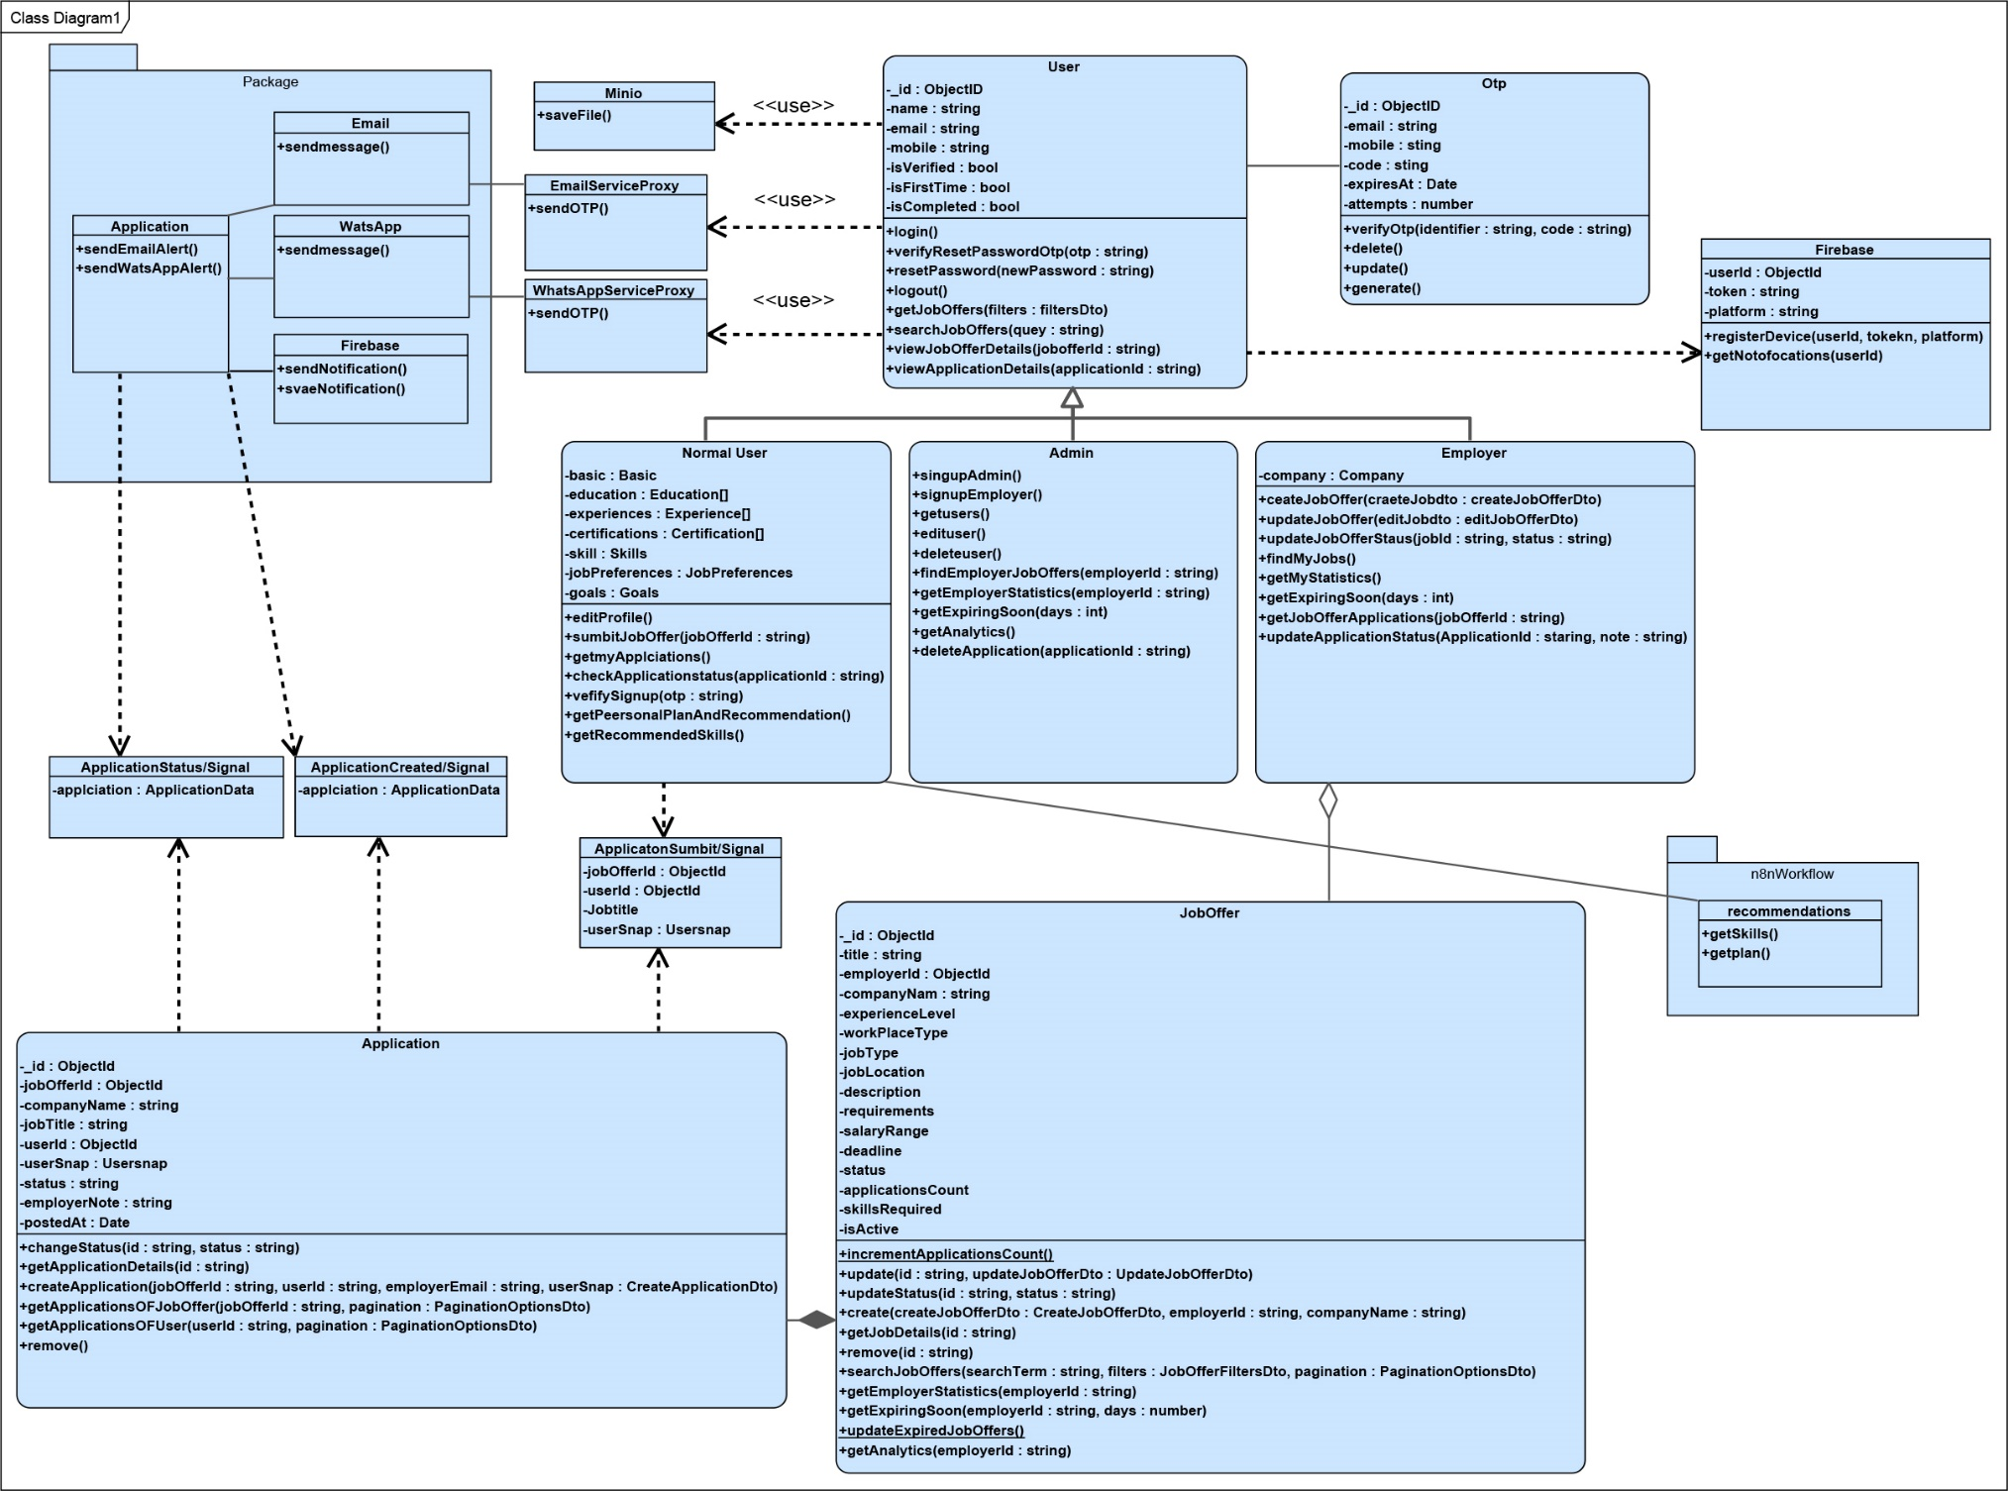
Figure 9: Figure 5.3 class diagram

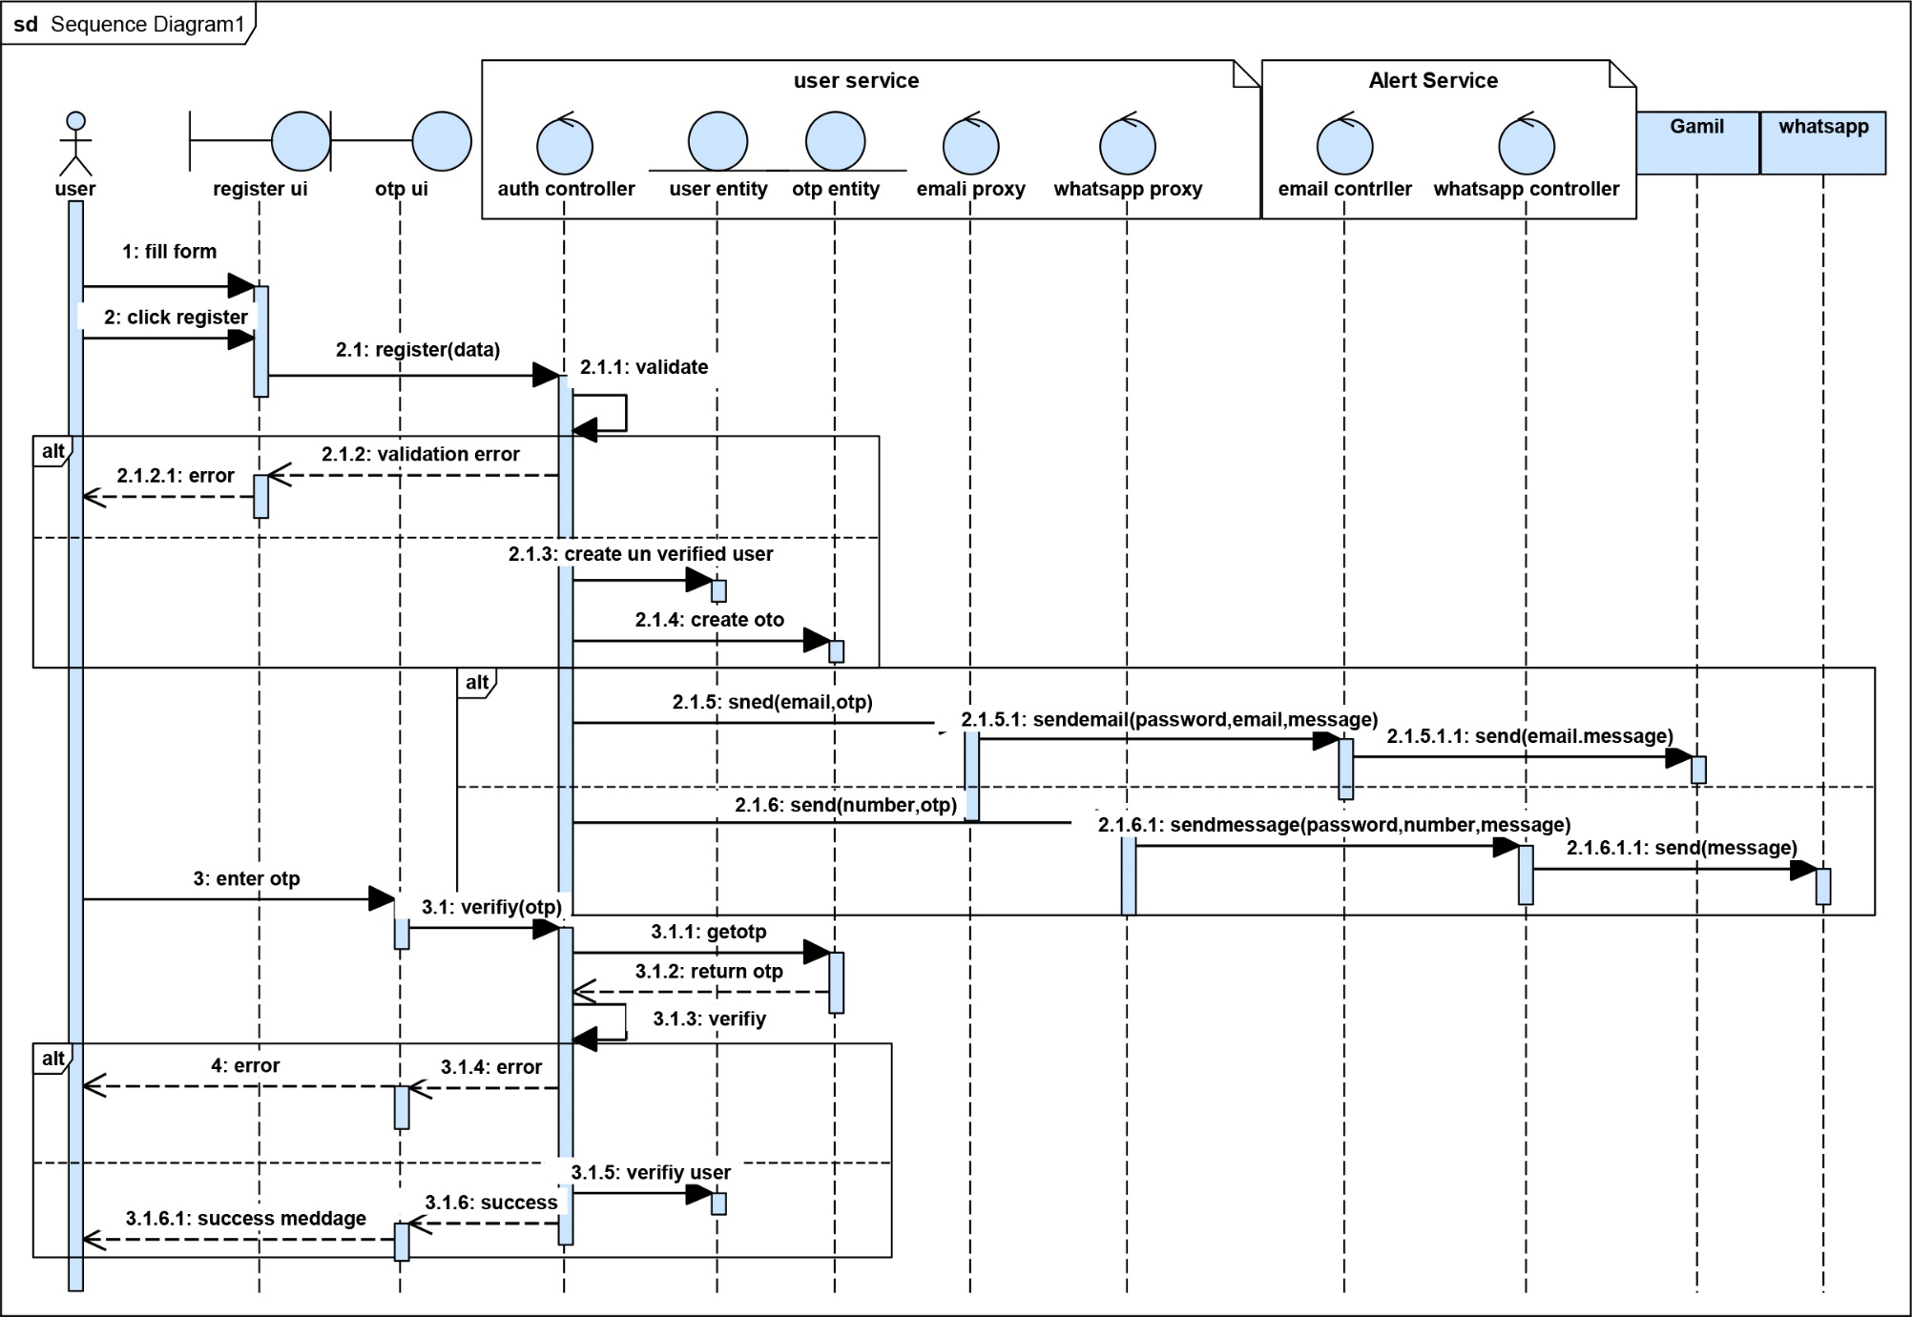
5.7. sequence diagrams
Figure 10: Figure 5.4 register sequence diagram
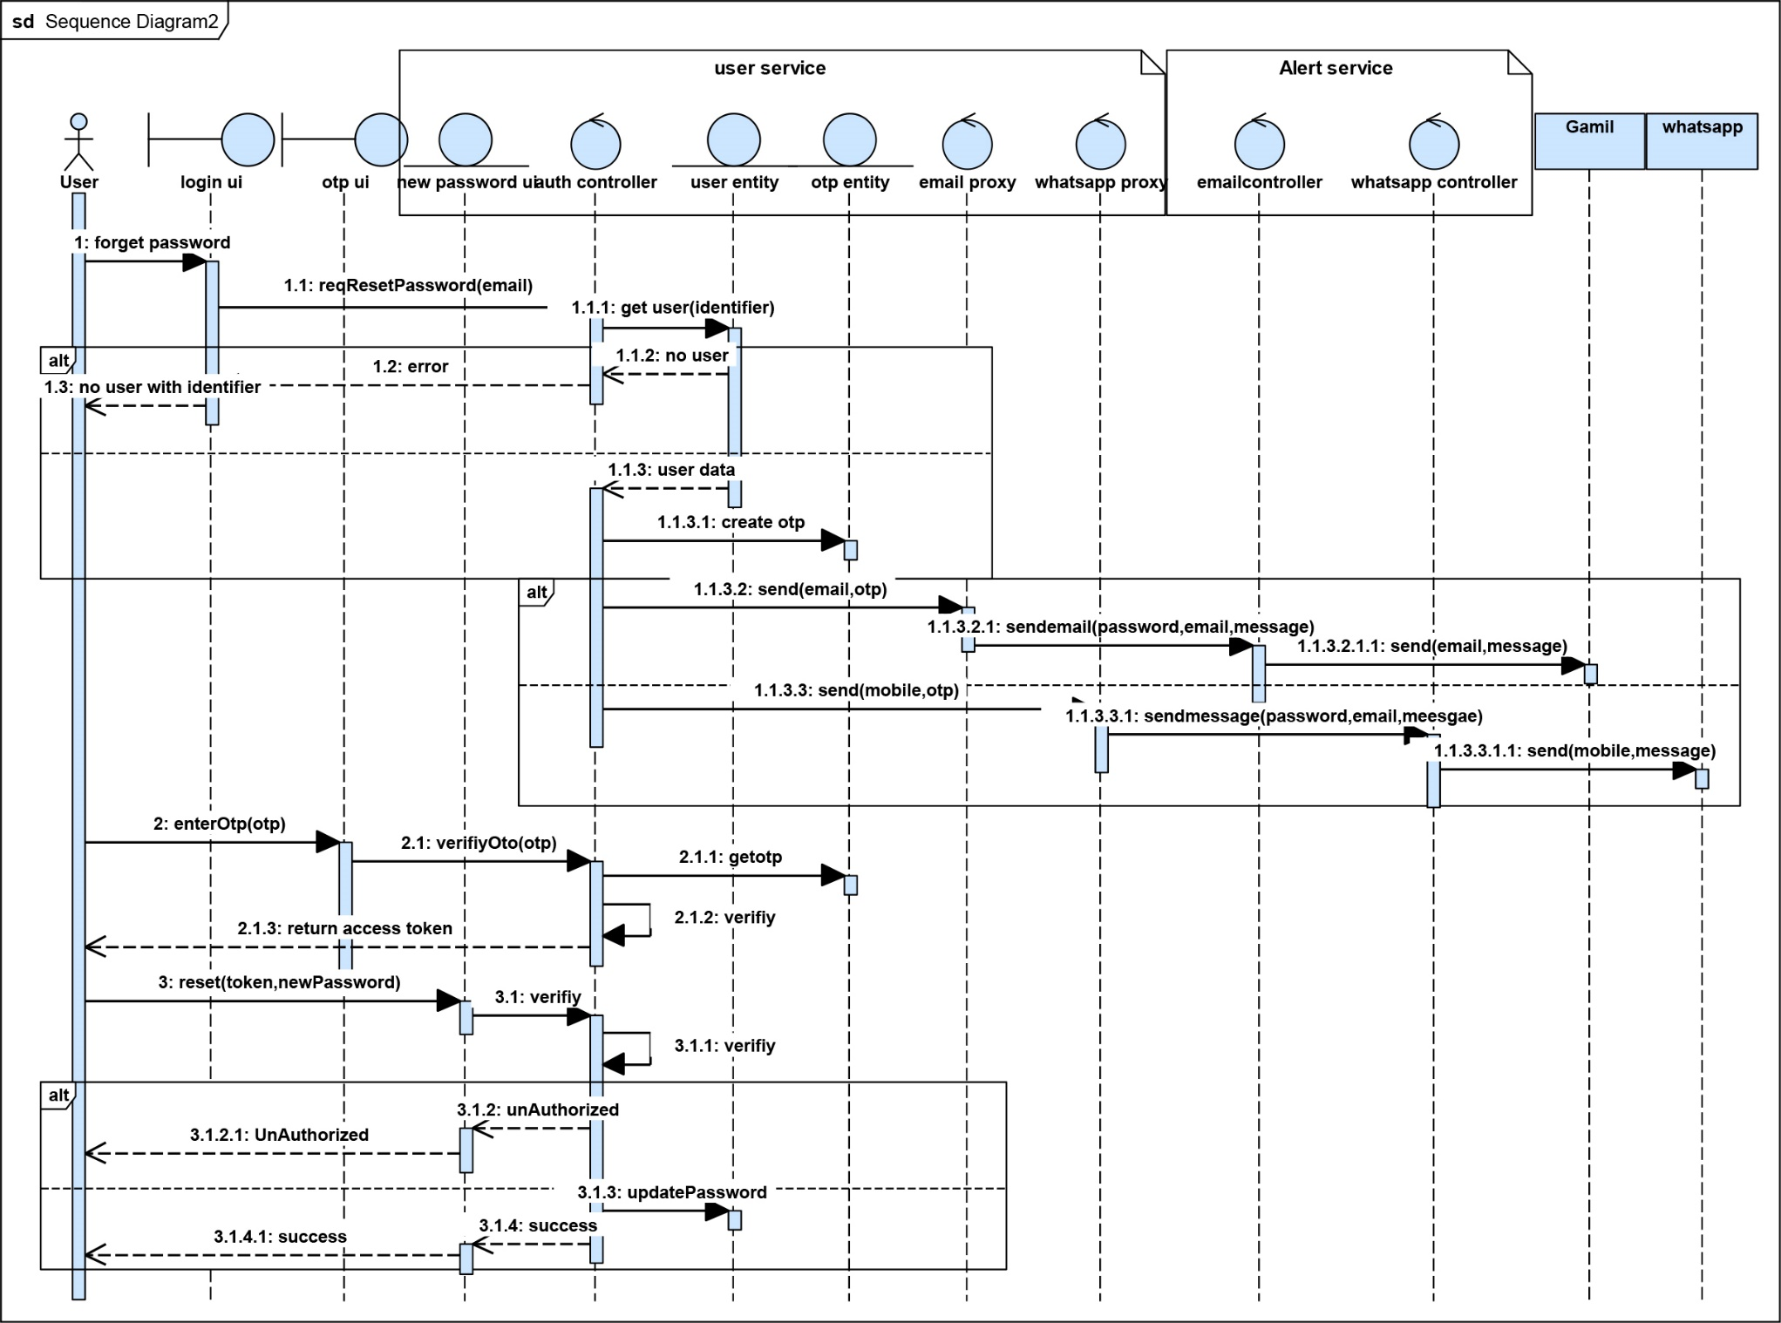
Figure 11: Figure 5.5 Reset Password sequence diagram
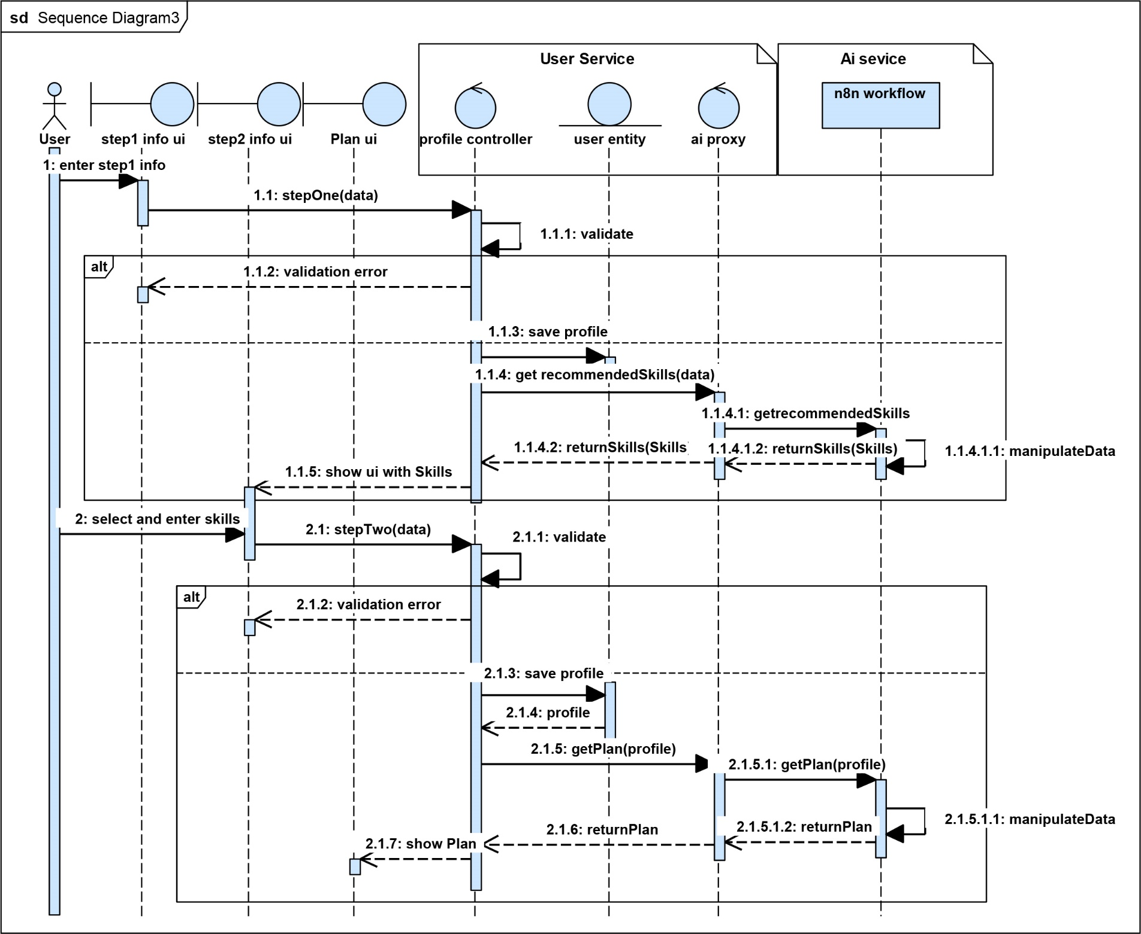
Figure 12: Figure 5.6 add Profile info sequence diagram

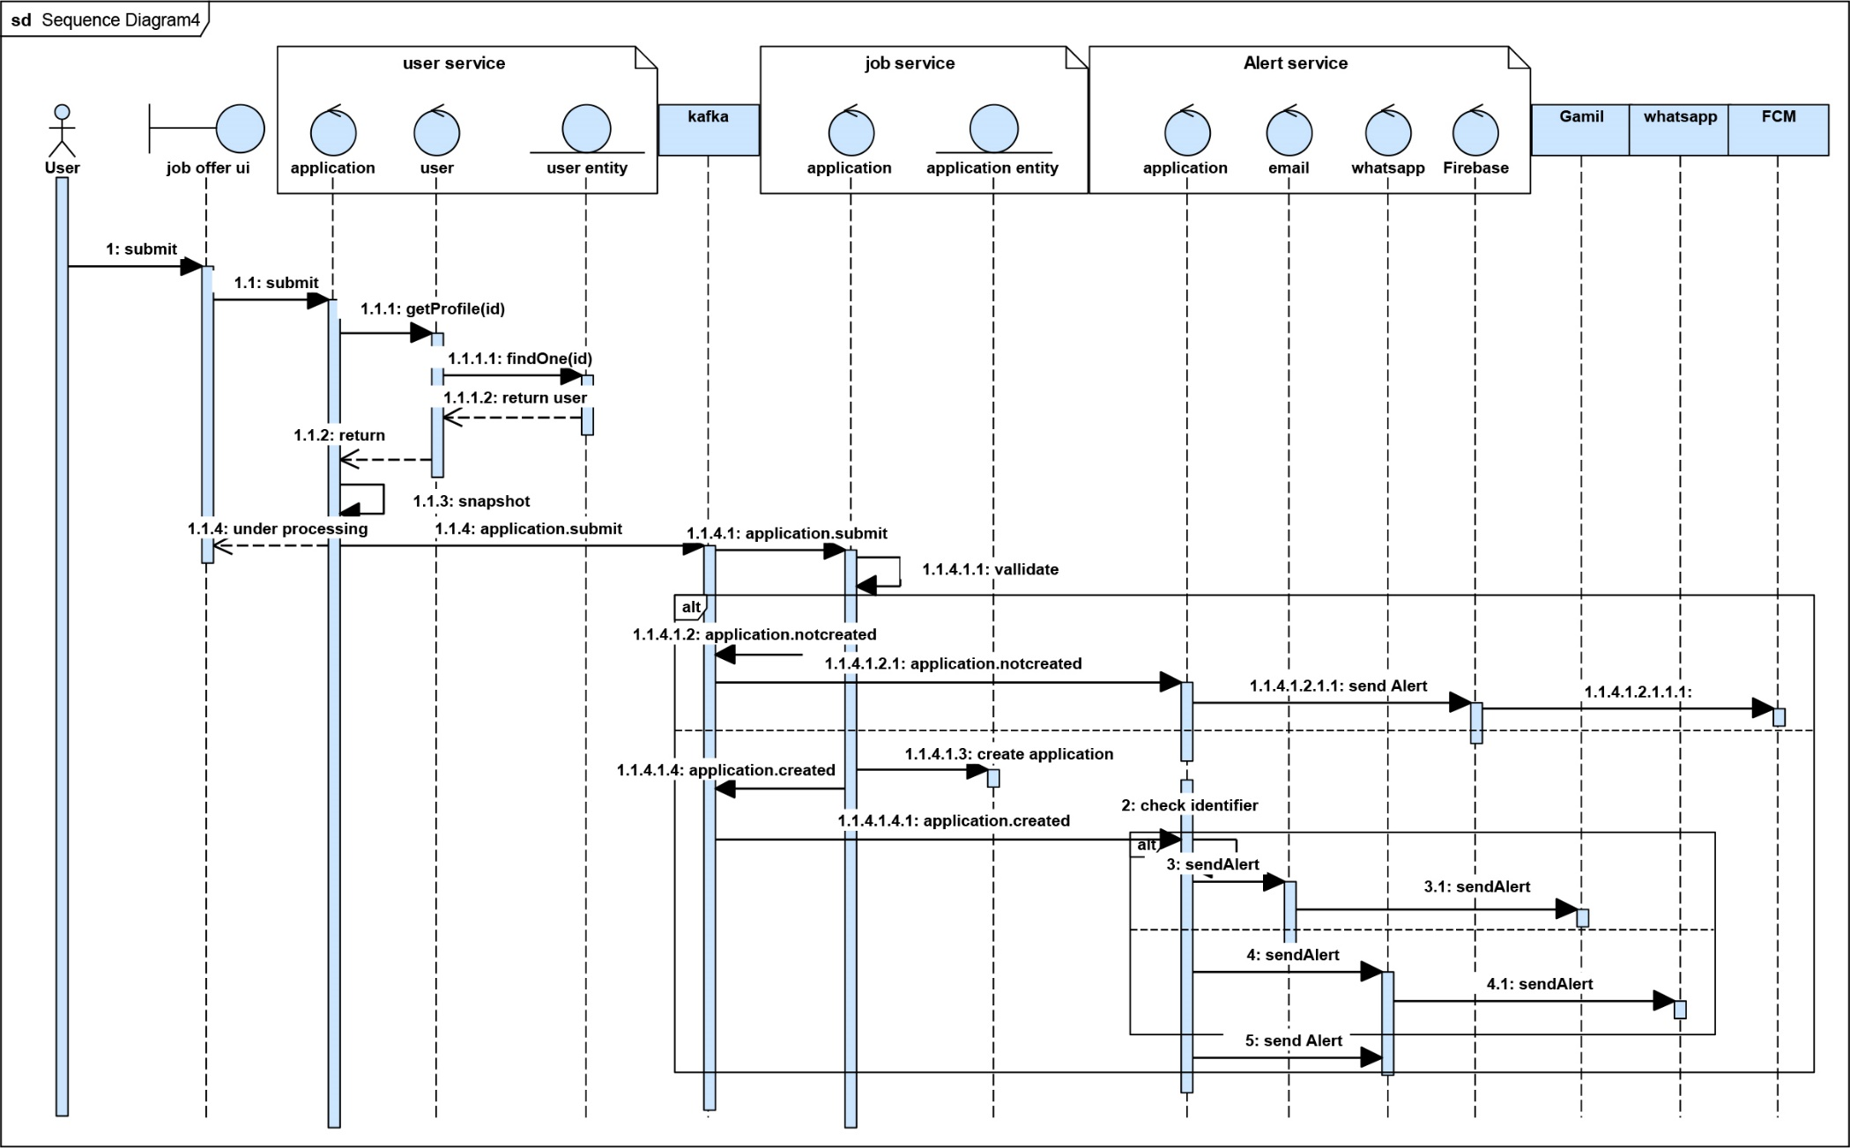
Figure 13: Figure 5.7 submit application sequence diagram

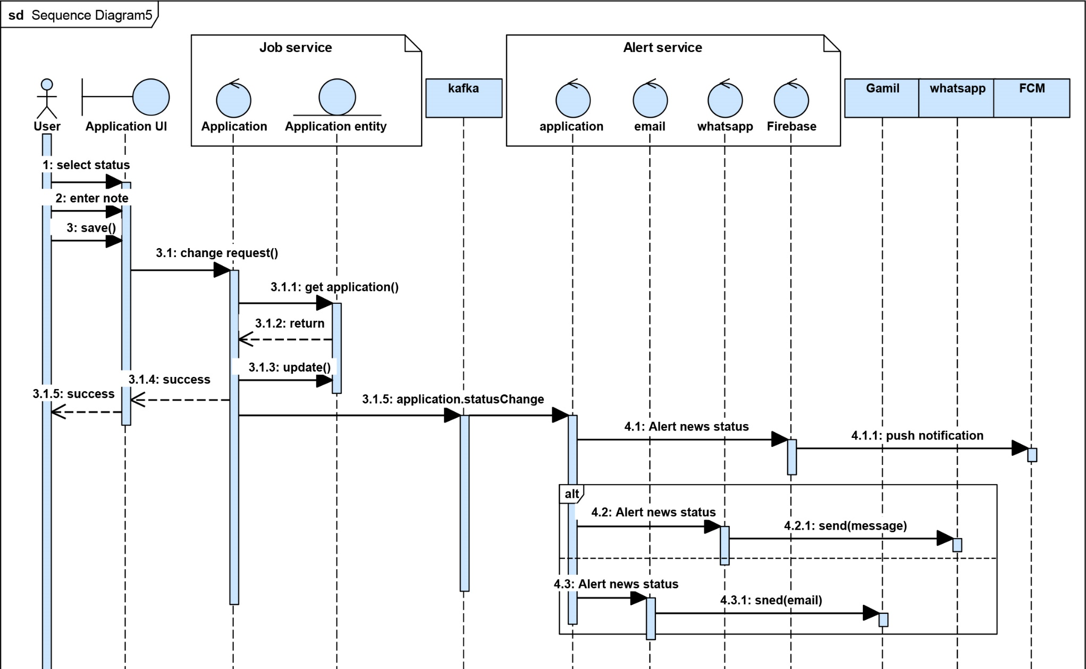
Figure 14: Figure 5.8 change application status sequence diagram

5.8. AI Service Integration using n8n

5.8.1 Overview
This chapter details the system architecture and AI-powered workflow designed using n8n, a powerful open-source workflow automation tool. The project integrates Google Gemini AI models, MongoDB, and a webhook-based user interface to deliver intelligent job recommendations and personalized career development plans based on user profiles.

5.8.2 Objectives of the System
- Accept structured user data via a webhook (e.g., CV or personal background).
- Generate relevant job titles using Google Gemini AI.
- Query a job database (MongoDB) based on those titles.
- Filter, score, and match jobs intelligently.
- Produce a 3-month tailored career development plan.
Send the final structured output to a backend endpoint for further use or storage

5.8.3 System Components & Flow
1. Webhook Trigger
- Purpose: Accepts incoming POST requests containing the user's profile.
- ID: Webhook
- Path: Unique webhook UUID
2. AI Agent (Step 1: Job Title Generation)
- Node: AI Agent
- Model: Google Gemini Chat Model
- Task: Extracts multilingual job titles (English and Arabic) from the user's profile using a prompt-based approach.
- Prompt Logic: Returns only a JSON object with two arrays: "en" and "ar" for job titles.
3. Data Cleaning & Query Construction
- Node: clean the data
- Purpose:
- Cleans AI output.
- Merges English and Arabic job titles.
- Constructs a MongoDB $in query on title.

4. Job Matching – MongoDB
- Node: MongoDB
- Query: Searches jobs whose titles match AI-generated job titles.
- Collection: jobs
5. Job Wrapping and Parsing
- Nodes:
- output of the jobs1 – Wraps MongoDB results.
- output of the jobs2 – Unwraps and flattens nested job data.
6. AI Agent1 (Step 2: Recommendation + Plan Generation)
- Node: AI Agent1
- Model: Google Gemini Chat Model2
- Prompt Task:
- Analyze the user profile and job list.
- Recommend up to 5 matching jobs.
- Create a 3-month structured development plan.
- Output the data in JSON with two keys: step1.jobs and step2.months.
7. Final Data Cleanup
- Node: clean the data1
- Task: Extracts valid JSON data from the AI response, stripping away any code formatting artifacts.
8. HTTP Request – Final Output Delivery
- Node: HTTP Request
- URL: http://192.168.1.109:5000/receive
- Payload: Sends two parameters:
- jobs: The AI-selected job matches.
- plan: The AI-generated 3-month development plan.

5.8.4 Workflow Architecture

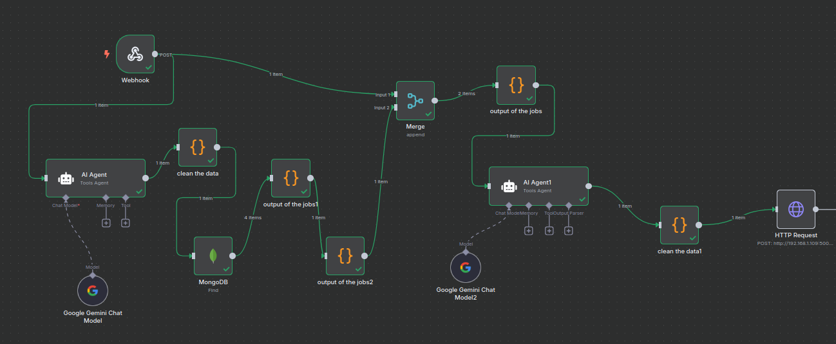
Figure 15: Figure 5.9 N8N workflow

5.9 Mobile Application Architecture

5.9.1 Overview
The mobile application is developed using Flutter, structured following the MVVM pattern combined with the Bloc state management approach. The codebase is organized into two primary layers:
- Data Layer: This includes repositories for API calls (using Dio) and models for data representation.
- Presentation Layer: This consists of Views (UI screens) and View Models (implemented as Cubits) that handle state management and business logic.
This separation ensures a clean, testable, and scalable architecture, supporting the maintainability of the mobile app as new features are added.

5.9.2 Navigation and Routing
The application uses the GoRouter package to manage navigation.
GoRouter provides a declarative, flexible routing system that supports deep linking, guarded routes (for authentication), and seamless navigation between screens.
All major flows — such as authentication, job listings, job details, and personalized roadmaps — are managed through clearly defined routes.

5.9.3 User Interface & UX Design
The mobile app follows Material Design guidelines, ensuring a consistent and intuitive user experience across Android and iOS.
Design principles emphasize:
- Responsiveness: The UI adapts to different screen sizes and orientations.
- Accessibility: Components are designed with standard Flutter accessibility practices in mind.

5.9.4 Core Screens and Navigation Flow
The mobile app consists of the following primary screens:
- Authentication Screens: Login, Register, Reset Password, OTP Verification
- Home Screen: Displays personalized recommendations and key actions
- Profile Screen: Allows users to view and edit their personal information
- Roadmap Screen: Shows the AI-generated personal development plan
- Job Details Screen: Displays detailed job offer information with the ability to apply directly

5.9.5 State Management
State is managed using the Bloc pattern with Cubits for individual features.
Each Cubit handles:
- API calls (via the Data Layer and Dio)
- State transitions (loading, success, error)
- Business logic specific to the feature (e.g., authentication, profile updates, job applications)
This approach keeps the UI reactive and the business logic testable and isolated.

5.9.6 Communication with Backend Services
The app communicates with the backend microservices using Dio, a robust and flexible HTTP client for Dart.
Key aspects include:
- JWT Authentication: Tokens are stored securely using SharedPreferences for session persistence.
- Error Handling & Interceptors: Dio interceptors manage headers, log requests, and handle timeouts or retries when needed.
- Endpoints: The app consumes RESTful APIs for user authentication, profile management, job browsing, and application submission.

5.9.7 Local Data Persistence
User session information (e.g., JWT tokens) and minimal user preferences are persisted locally using SharedPreferences.
This lightweight solution ensures the user remains logged in between sessions and improves user experience without a complex local database.

5.8.9 MVVM Clean Architecture Diagram
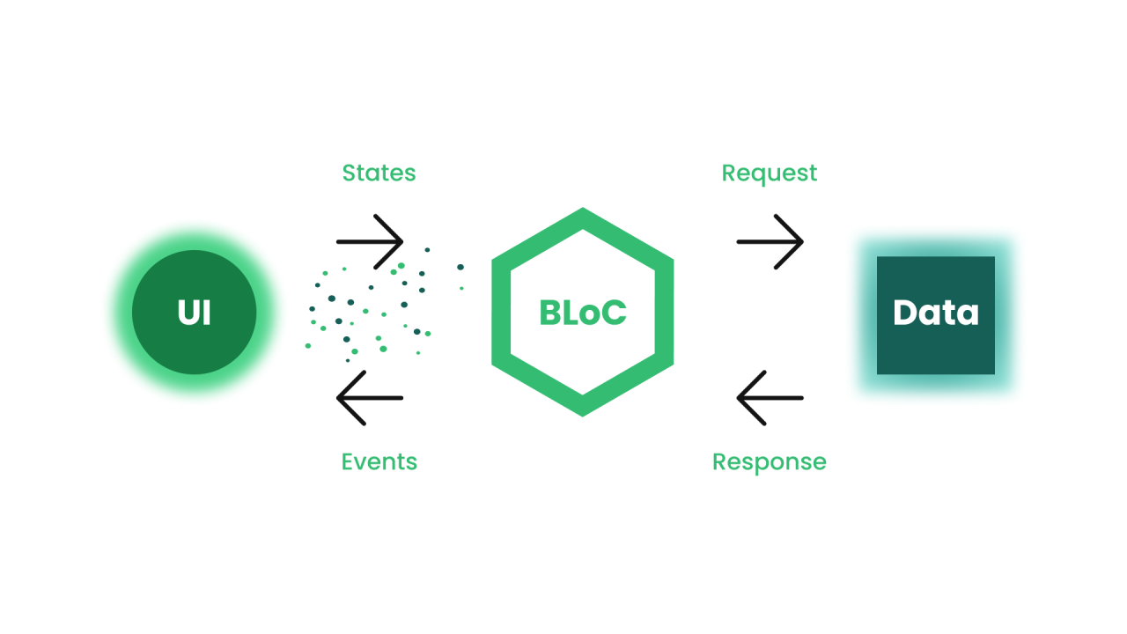
Figure 16: Figure 5.10 MVVM Diagram

5.9.8 Push Notifications with Firebase Cloud Messaging (FCM)
The mobile application integrates Firebase Cloud Messaging (FCM) to enable real-time push notifications.
FCM is a scalable and reliable cloud-based messaging service provided by Google, designed to deliver notifications and data messages across Android and iOS platforms efficiently.
This integration enhances user engagement by providing timely updates related to job opportunities, roadmap progress, application status, and system alerts.
Purpose and Benefits
The use of Firebase Cloud Messaging provides several key benefits:
- Real-Time User Engagement: Instantly notifies users about important events such as new job matches, application status updates, or roadmap milestones.
- Improved User Retention: Keeps users engaged with the platform even when the application is not actively running.
- Scalability: Capable of handling a large number of users without performance degradation.
- Backend-Driven Messaging: Notifications can be triggered directly from backend services based on business events.
Notification Types
The system supports multiple notification scenarios, including:
- Job recommendation notifications
- Application status updates (accepted, rejected, under review)
- General system announcements
Notifications can be sent as:
- Foreground notifications (while the app is open)
- Background notifications (while the app is running in the background)
- Terminated-state notifications (when the app is completely closed)
Integration Architecture
The FCM integration follows a clean and modular approach:
- The mobile app registers the device with Firebase and retrieves a unique FCM token
- This token is securely sent to the backend and associated with the authenticated user
- Backend microservices use Firebase Admin SDK to send targeted notifications
- Notifications are delivered through Firebase infrastructure to the device
This architecture ensures secure, user-specific, and event-driven notifications.

Chapter 6: Technology Stack and Rationale

This chapter provides an overview of the technologies selected for building Nuhoud and justifies their use. Each tool, language, or framework is linked to the specific needs of scalability, interoperability, and performance.

6.1. Programming Language & Runtime: Node.js
Node.js is the chosen runtime for the backend due to its asynchronous, event-driven architecture. It is a JavaScript runtime designed to build scalable network applications. Node.js employs a
non-blocking, single-threaded event loop that can handle many concurrent connections efficiently, making it well-suited to high-throughput server tasks. Furthermore, Node.js benefits from JavaScript’s popularity , it has been the most widely used language in recent developer surveys , and from a vast open-source ecosystem. In fact, npm (Node’s package manager) is the largest package registry in the world, providing ready-made modules that significantly accelerate development and improve maintainability. Together, these properties (high concurrency, rich ecosystem, and a large developer community) make Node.js a performant and productive choice for our microservice-based system.



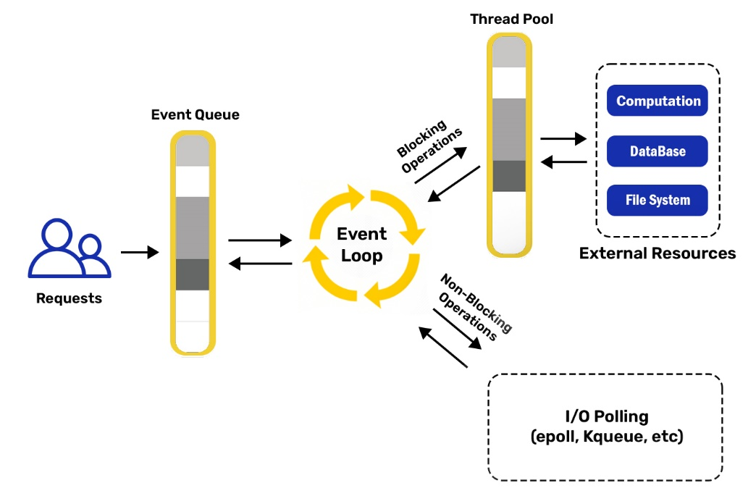
Figure 17: Figure 6.1. Nodejs architecture

6.2. Backend Framework: NestJS
NestJS is a progressive Node.js framework built with TypeScript, chosen to structure the backend services. NestJS is described as a “progressive Node.js framework for building efficient, reliable and scalable server-side applications”. It introduces a modular architecture (inspired by Angular) that organizes code into self-contained modules and services, streamlining development and maintenance. Its built-in dependency injection and strong TypeScript type safety help catch errors at compile time and promote clean, testable code.


TypeScript
nestjs

6.3. API Documentation: Swagger
the @nestjs/swagger module auto-generates a Swagger document from the code annotations. This approach provides an interactive, machine-readable API contract that is easy for developers and external clients to consume. Swagger’s advantages include automatic documentation generation (so that API docs stay in sync with code) and a built-in user interface for testing endpoints. As one source explains, “Swagger provides a unique and convenient platform to document, test, and write API structures”

swagger

6.4. Database and ODM: MongoDB with Mongoose


For data storage, MongoDB was selected as the primary database. MongoDB is a popular open-source NoSQL document database that stores data as JSON-like documents. This document oriented model provides a flexible schema, allowing the data model to evolve over time without rigid table definitions. MongoDB supports horizontal scaling (via sharding) and replication for high availability, enabling it to handle very large datasets and high traffic volumes. The JSON/BSON document format aligns naturally with JavaScript/Node.js, facilitating seamless data interchange between server and application code. To interface with MongoDB from Node, the Mongoose library (an Object Data Modeling – ODM – tool) was adopted. Mongoose enables developers to define schemas, models, and validation rules in Node.js, providing structure and consistency on top of MongoDB’s flexibility. According to MongoDB’s documentation, “Mongoose is an ODM (Object Data Modeling) library for MongoDB” that helps with data modeling, schema enforcement, model validation, and general data manipulation
MongoDB
mongoose

6.5. Object Storage for Media

MinIO (S3 Compatible Object Storage)
MinIO was introduced to store user media such as profile images and uploads. Storing binary files directly in a database increases storage cost and can degrade performance over time. MinIO provides a scalable object-storage layer using an S3-compatible API, enabling independent scaling of storage capacity. The User Service stores only metadata (object key/URL) in MongoDB while the actual media is stored in MinIO.
To ensure repeatable deployment, a MinIO initialization container (minio-init) was added to automatically create required buckets (e.g., avatars/uploads) and apply initial access policies at startup.
minio

6.6. Messaging/Event-Driven Architecture: Apache Kafka

Apache Kafka is a distributed streaming platform designed to handle large volumes of real-time data. It’s an open-source system used for stream processing, real-time data pipelines and data integration.
- Producer: A producer generates a large amount of data and writes this into Kafka.
- Consumer: Consumers act as end-users that read data from Kafka that comes from
producers.
kafka
- Topic: Topic is a category or label on which records are stored and published. All Kafka records coming from
producers are organized into topics. Consumer applications read from topics.
- Brokers: These are the Kafka servers that handle the data. Kafka brokers receives message from
producers and stores them on its data
- Partition: This is a unit of data storage. It’s a sequence of messages that is stored in a log and is
identified by a unique ID, known as the partition offset. Each partition is ordered and immutable, meaning that once a message has been written to a partition, it cannot be modified or deleted. A topic can have multiple partitions to handle a larger amount of data

6.7. RPC Communication: gRPC with Protocol Buffers
or inter-service RPC calls, gRPC with Protocol Buffers is employed. gRPC is a high-performance, open-source RPC framework developed by Google

gRPC was chosen for its efficiency and robust tooling: it provides high performance (HTTP/2 + Protobuf) and language-agnostic, type-safe service definitions, making it easier to build reliable, maintainable cross-service APIs
Grpc logo

6.8. Containerization & Orchestration: Docker Compose
Docker is a platform that uses containerization to package and run applications. It allows
developers to build, share, and run applications in isolated containers, ensuring consistency across different environments.
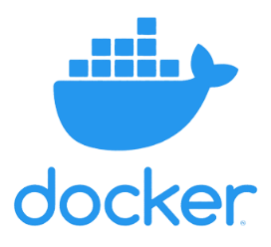
Docker Compose is used to containerize (Kafka, Kafdrop, NGINX, MinIO and minio-init ) as a unified system. Docker Compose is a tool for defining and running multi-container Docker applications. In a single YAML file, and the entire stack can be started or scaled with a single command
Docker

6.9. Kafdrop Monitoring Tool: Kafdrop
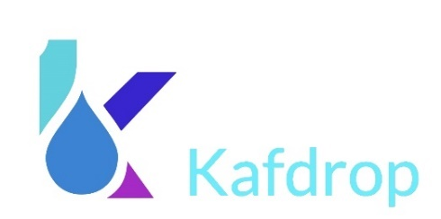
While Kafka itself is a robust and high-throughput distributed log system, it lacks a native graphical interface for introspection. Kafdrop fills this gap by offering an intuitive interface to monitor and inspect Kafka activity during development and testing. Developers can browse topic metadata, view live messages within partitions, inspect headers and payloads, and validate that events are being published and consumed correctly.
kafdrop

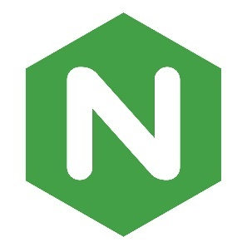
6.10. API Gateway / Reverse Proxy
NGINX was added as a reverse proxy and API Gateway to provide a single entry point for the system. It improves maintainability by centralizing routing rules and reducing the need for clients to know internal service addresses/ports.
NGINX also implements gateway-level best practices including request size handling for uploads, gzip compression, security headers, and IP-based rate limiting. This provides an initial security and performance layer before traffic reaches backend services.
nginx

6.11. Notifications

Firebase Cloud Messaging (FCM) is a free service by Google (Firebase) that lets you send notifications and data messages to users’ devices in real time.

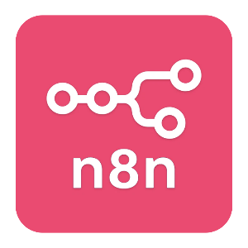
6.7 AI Services and Language Models
To enhance the intelligence and personalization of the system, multiple AI tools and frameworks were integrated into the backend via n8n. The core components of the AI stack are as follows:

6.7.1. Google Gemini (PaLM)
n8n logo

Google Gemini is a family of advanced large language models (LLMs) developed by Google DeepMind. In this system, the gemini-1.5-flash and gemini-1.5-flash-8b models were used via the LangChain integration in n8n.
Gemini
These models are responsible for:
- Generating multilingual job titles based on user CVs.
- Filtering and matching relevant job opportunities.
- Generating structured career development plans in both English and Arabic.
Gemini models were chosen for their fast response, high multilingual accuracy, and rich contextual understanding.
Google Gemini is a family of advanced large language models (LLMs) developed by Google DeepMind. In this system, the gemini-1.5-flash and gemini-1.5-flash-8b models were used via the LangChain integration in n8n.
These models are responsible for:
- Generating multilingual job titles based on user CVs.
- Filtering and matching relevant job opportunities.
- Generating structured career development plans in both English and Arabic.
Gemini models were chosen for their fast response, high multilingual accuracy, and rich contextual understanding.

6.7.2. LangChain Agents (n8n Integration)

LangChain provides the agent abstraction for orchestrating prompt logic, model calls, and chaining AI responses. In this system:
langchain
- One agent is used for multilingual job title extraction.
- Another agent is responsible for career advising and plan generation, involving multi-step reasoning and structured output.
These agents enable modular, prompt-based reasoning workflows that are easy to maintain and adapt.

6.7.3. Prompt Engineering
Custom prompts were carefully designed to guide the AI models toward generating highly structured and useful outputs, such as:
- JSON arrays with job titles.
- Scored job matches with justifications.
- Week-by-week 3-month learning plans.
Prompt design plays a critical role in output reliability and quality, and was iteratively refined through testing.

6.7 Why AI Was Necessary
The integration of artificial intelligence in this system was not merely an enhancement , it was a core necessity to achieve the system's goals of personalization, relevance, and automation. Traditional rule-based systems would have struggled with the following challenges:

6.7.1. Understanding Diverse User Profiles
User profiles can vary significantly in terms of structure, content, and language. AI models like Google Gemini can parse unstructured text (e.g., CVs, freeform descriptions) and extract meaningful insights such as:
- Skills
- Education
- Career goals
- Experience level
This semantic understanding is far beyond what regular expressions or static filters could achieve

6.7.2. Generating Contextual Job Titles
Instead of relying on a fixed taxonomy of job titles, AI dynamically suggests personalized titles that match the user's background. It can also:
- Translate titles into multiple languages (English and Arabic).
- Align suggestions with market trends and job-seeking behavior.

6.7.3. Filtering and Matching Jobs Intelligently
The job-matching process uses both hard filters (e.g., location, job type) and soft context-aware reasoning, such as:
- Relevance of job description to user interests.
- Match score based on language, degree, skills, and field.
- Justification for each recommendation.
Only AI could combine such a broad set of inputs and deliver interpretable matches at scale.

6.7.4. Automated Career Planning
Instead of presenting static advice, the system creates a week-by-week career development plan:
- Tailored to the user’s current skill level.
- Including tools, certifications, and tasks.
- Delivered in bilingual format.
This level of personalization and structured planning would require a human expert — but AI delivers it instantly and consistently.

6.7.5. Scalability and Automation
AI enables the system to handle hundreds or thousands of users without the need for manual intervention. It brings:
- Consistent quality of advice.
- Reduced cost per recommendation.
- 24/7 availability.

6.8. Frontend Framework and Dashboard: React.js

To build the user interface and dashboard for the system, React.js was selected as the primary frontend library. React is an open-source JavaScript library developed by Facebook for building fast and interactive user interfaces. It utilizes a component-based architecture, allowing developers to break down complex interfaces into reusable, self-contained components such as navigation bars, tables, charts, and forms.
ReactJS
React’s use of a virtual DOM improves performance by minimizing direct DOM manipulations and efficiently updating only the parts of the UI that change. This ensures a smooth and responsive experience for users, even when rendering dynamic content such as job recommendations, plan timelines, or real-time feedback.
The system's dashboard also benefits from React’s rich ecosystem, which includes:
- React Router for managing client-side routing in a single-page application (SPA) structure.
- Axios for performing HTTP requests to backend services.
- Tailwind CSS / SCSS for styling the interface responsively and consistently.
- Chart.js or Recharts to visualize AI-generated scores, plans, or statistics.
By using React, the development team was able to deliver a modern, modular, and maintainable dashboard that integrates seamlessly with backend AI APIs and real-time data services. The flexibility, ecosystem maturity, and widespread community support made React the natural choice for building the frontend layer of the platform

6.9. Mobile Development Framework: Flutter

For the mobile application, Flutter was selected as the primary development framework.
Flutter is an open-source UI toolkit developed by Google for building high-performance, cross-platform applications from a single codebase.
Its advantages include:
flutter
- Fast Development: Hot Reload allows quick iterations during UI and logic updates.
- Native Performance: Flutter compiles to native ARM code and uses a high-performance rendering engine (Skia).
- Consistent UI: The widget-based architecture ensures a consistent look and feel across Android and iOS.
This makes Flutter ideal for delivering a unified experience to users on different devices.

6.9.1 State Management: Bloc & Cubit

To manage the app’s state, the Bloc library was used, along with Cubit for simpler features.
Bloc provides a predictable state management pattern with clear separation of concerns between UI and business logic.
Benefits include:
Bloc library
- Scalability: Bloc scales well as features grow.
- Testability: Although not yet implemented, Bloc’s architecture makes it straightforward to write unit tests for Cubits and blocs.
- Community Support: Bloc is one of the most popular and well-documented state management solutions in Flutter.

6.9.2. Navigation: GoRouter
The application uses GoRouter for routing and navigation.
GoRouter is a declarative routing library that simplifies complex navigation flows and supports:
- Named Routes: Easy to manage and maintain.
- Deep Linking: Prepares the app for future support of universal links.
- Route Guards: Enables authenticated routing when needed.
This improves maintainability compared to Flutter’s built-in Navigator for larger apps.

6.9.3 Networking: Dio
Dio was chosen as the HTTP client for API calls due to its rich feature set:
- Interceptor Support: Allows adding authorization headers (JWT tokens) automatically.
- Advanced Error Handling: Helps catch server and connection errors.
- Timeouts & Retry Logic: Improves reliability for users in different network conditions.
This makes Dio a robust and flexible solution for handling all backend communications.

6.9.4. Local Data Persistence: SharedPreferences
For storing user session data (e.g., JWT tokens), SharedPreferences was implemented.
- It provides a simple key-value storage solution.
- Keeps the user logged in between sessions.
- Lightweight and easy to integrate for basic caching needs.
For now, this satisfies the requirements without adding the complexity of a full local database.

Chapter 7: Implementation

This chapter presents the implementation details of the Nuhoud system, focusing on the user interfaces developed to serve different user roles. The platform consists of a React-based web application designed for administrators and employers to manage job postings, applications, and platform moderation, alongside a Flutter-based mobile application tailored for job seekers to create profiles, explore job opportunities, and apply for positions. This chapter illustrates the main interfaces and explains how they align with the system’s functional requirements.

7.1. administrators and employers Interfaces
Figure 18: Figure 7.1 admin and employer login page
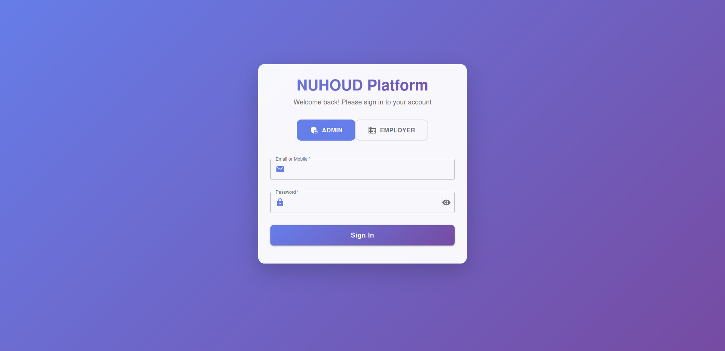

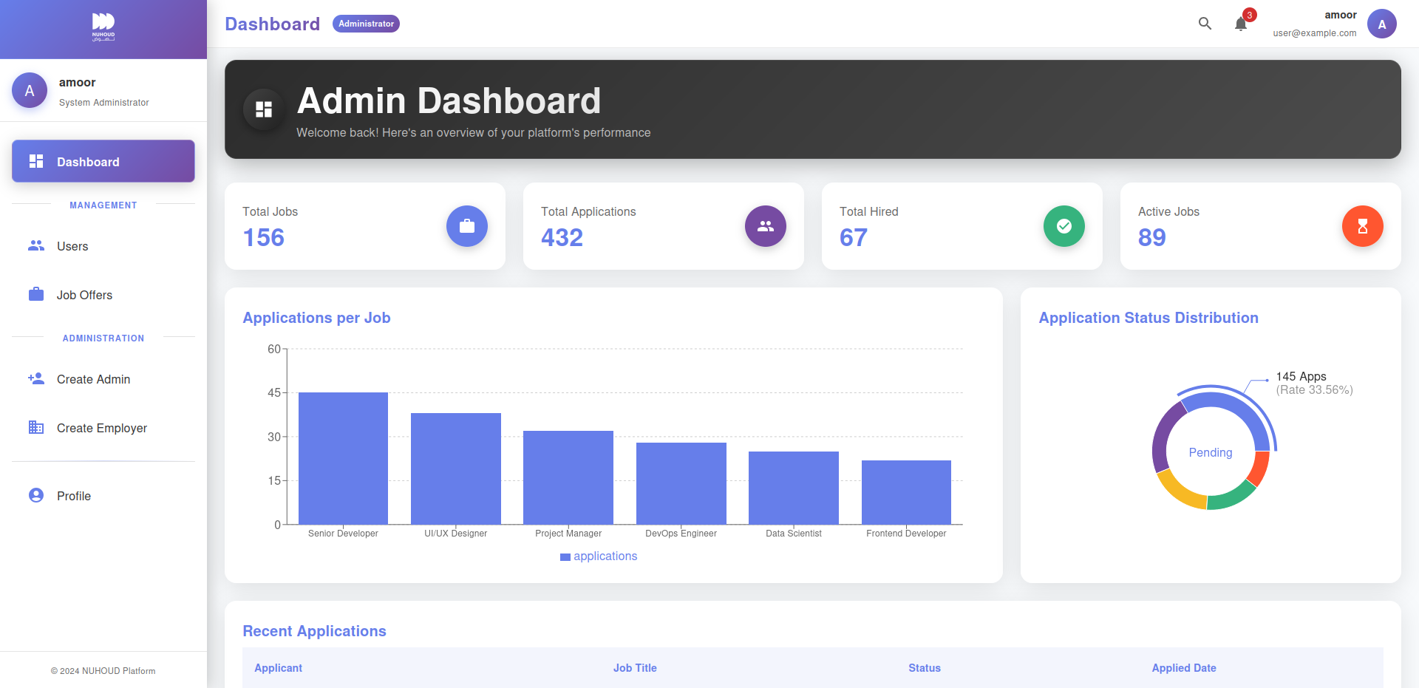
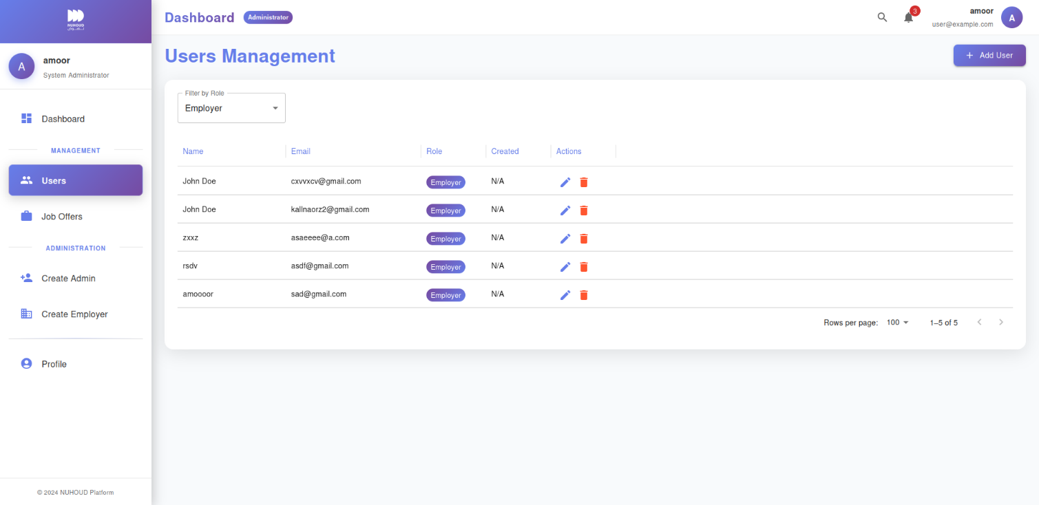
Figure 19: Figure 7.2 admin dashboard - statistics
Figure 20: Figure 7.3 admin dashboard – manage users
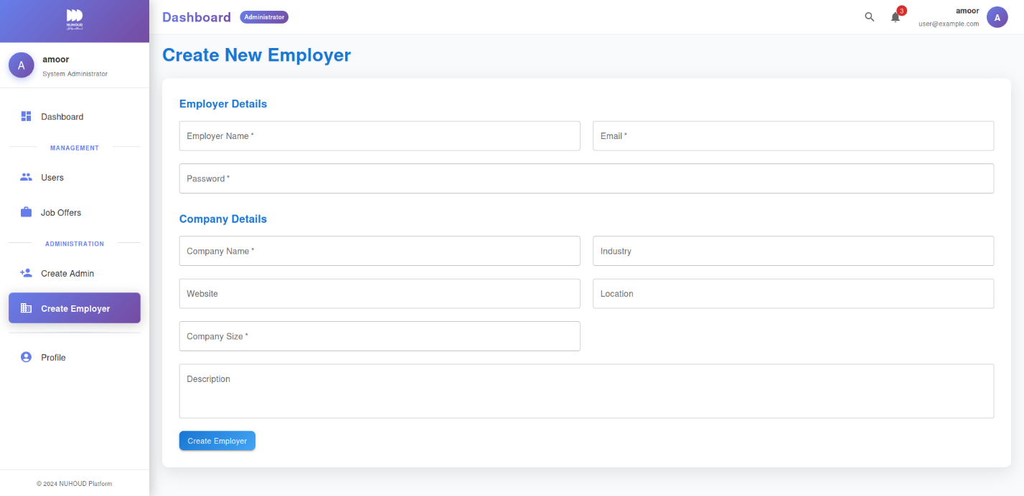
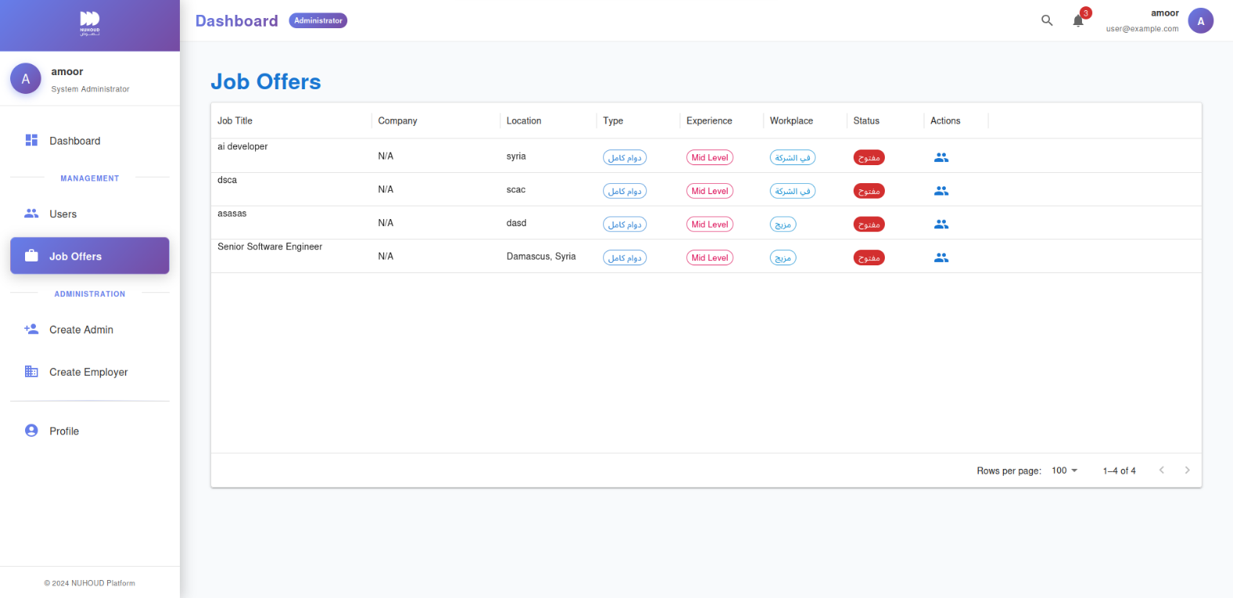
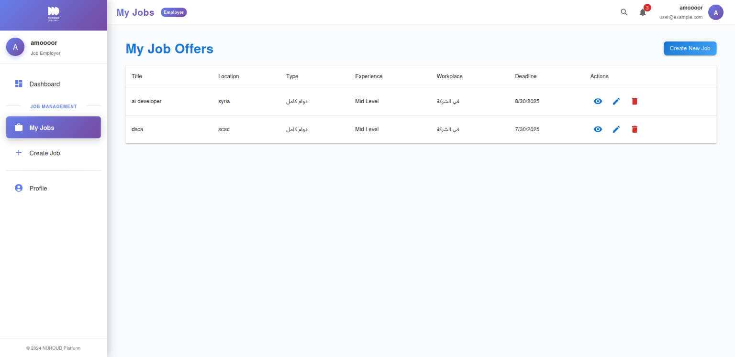
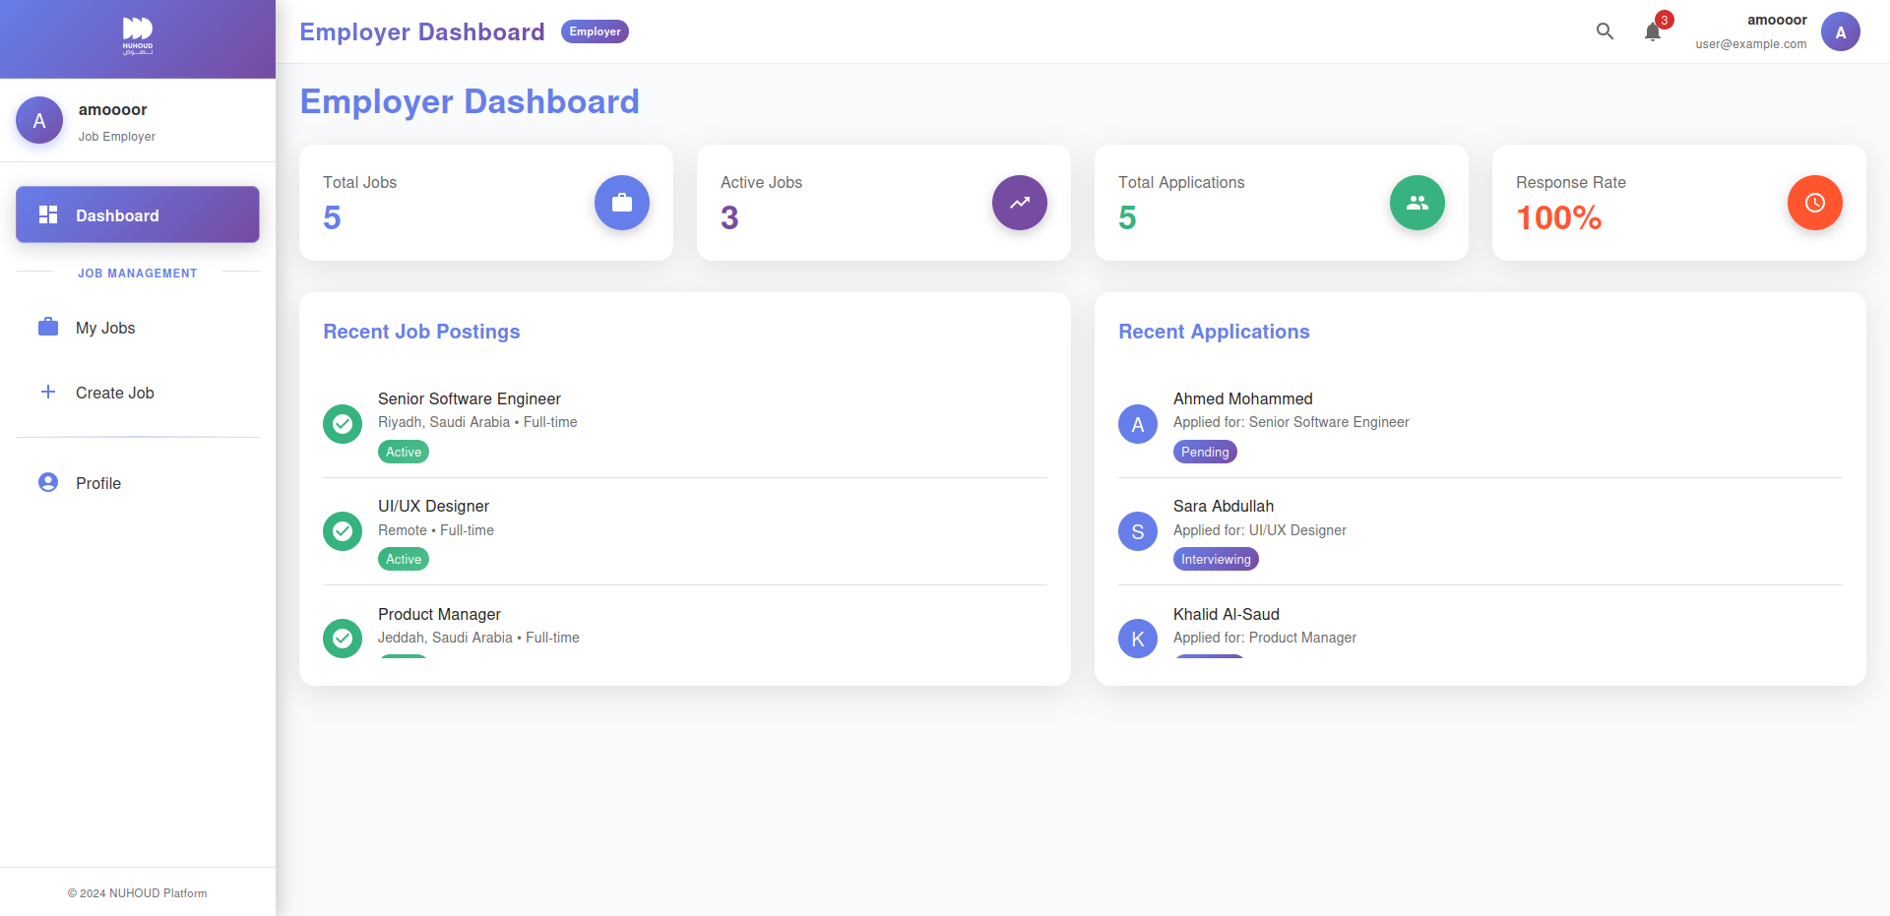
Figure 21: Figure 7.5 admin dashboard - create employer
Figure 22: Figure 7.4 admin dashboard – manage joboffers
Figure 23: Figure 7.7 employer dashboard – browse his joboffers
Figure 24: Figure 7.6 employer dashboard - statistics
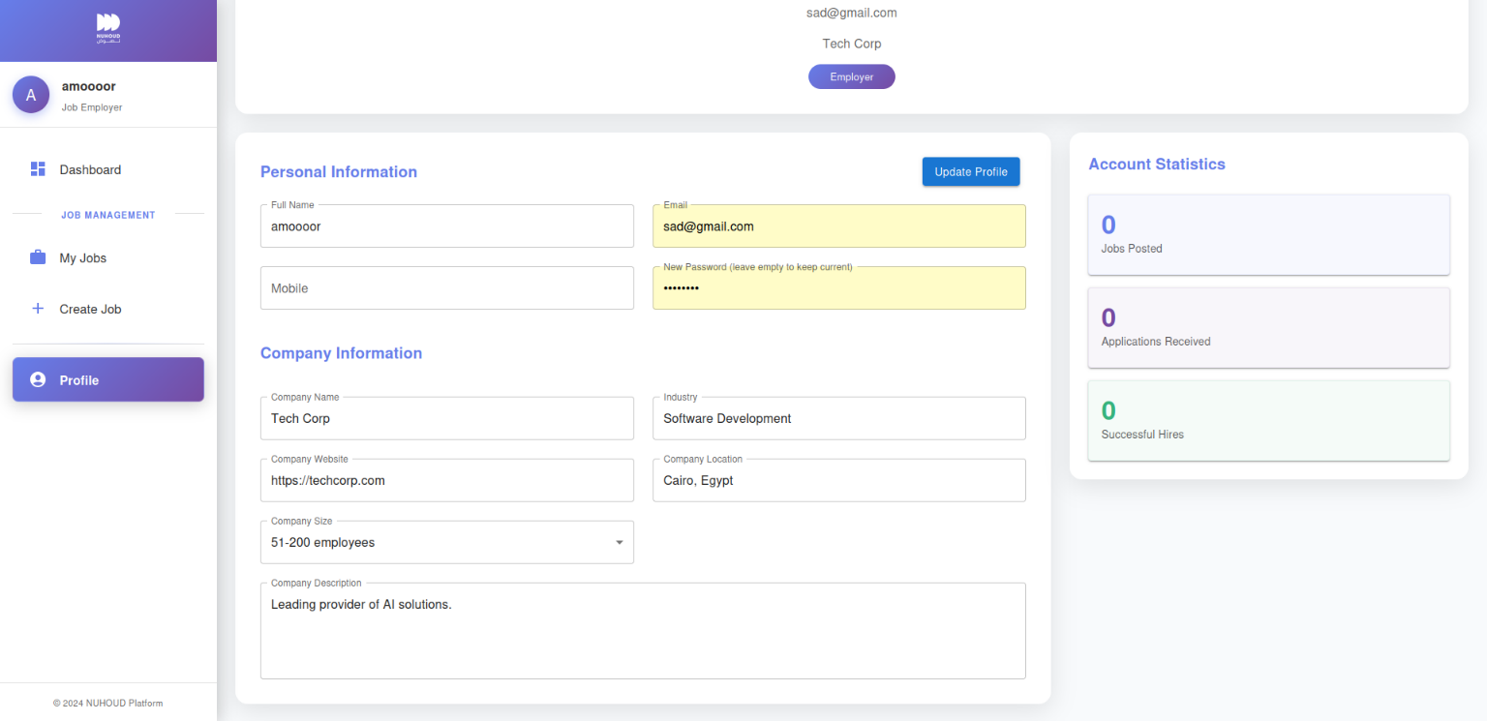
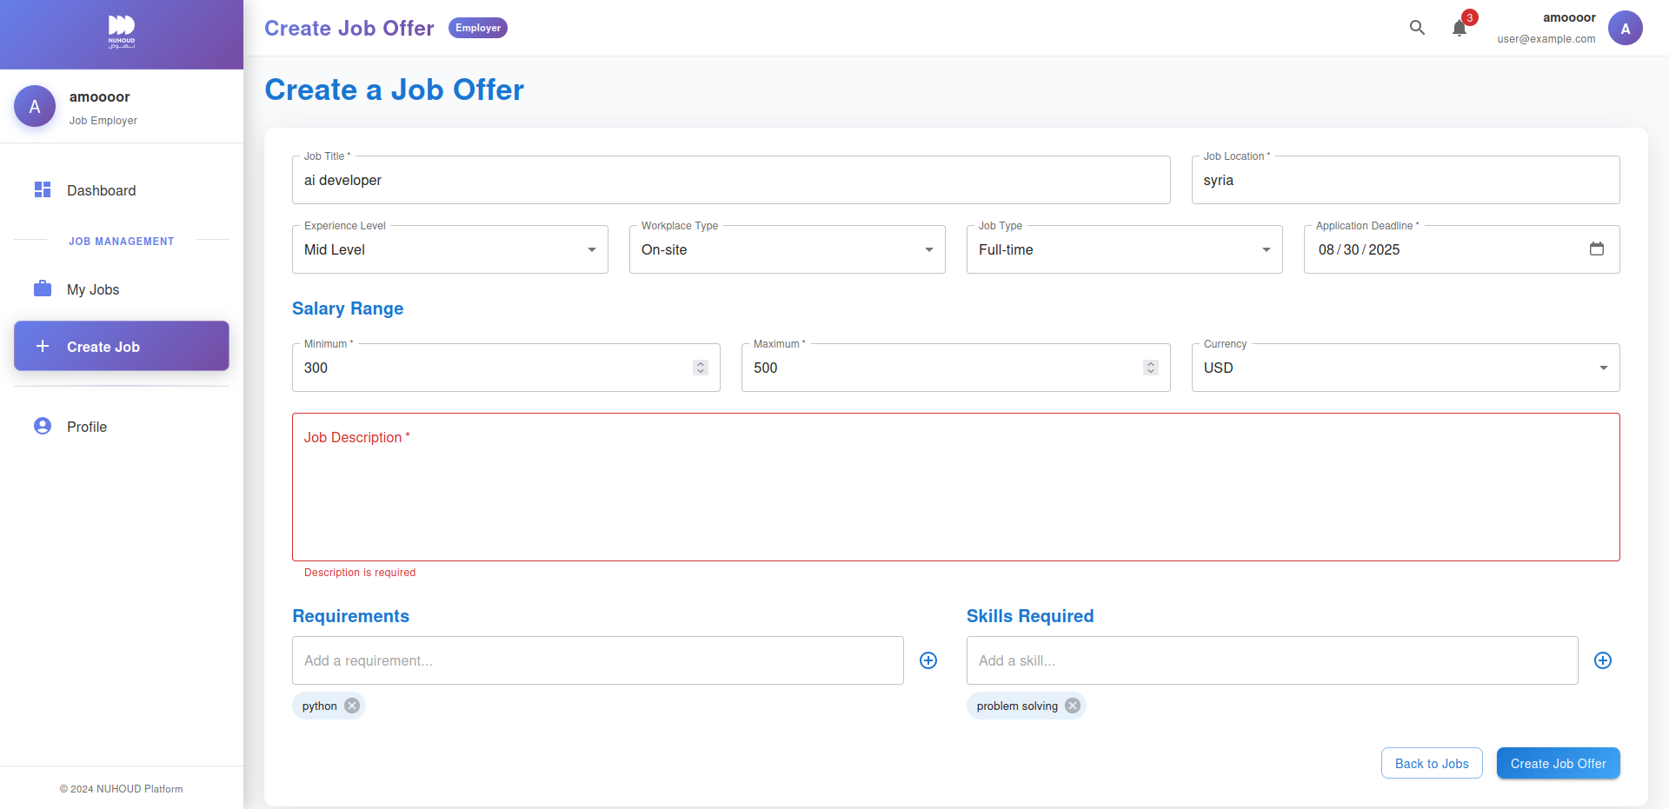
Figure 25: Figure 7.9 employer dashboard - profile
Figure 26: Figure 7.8 employer dashboard - create job offer

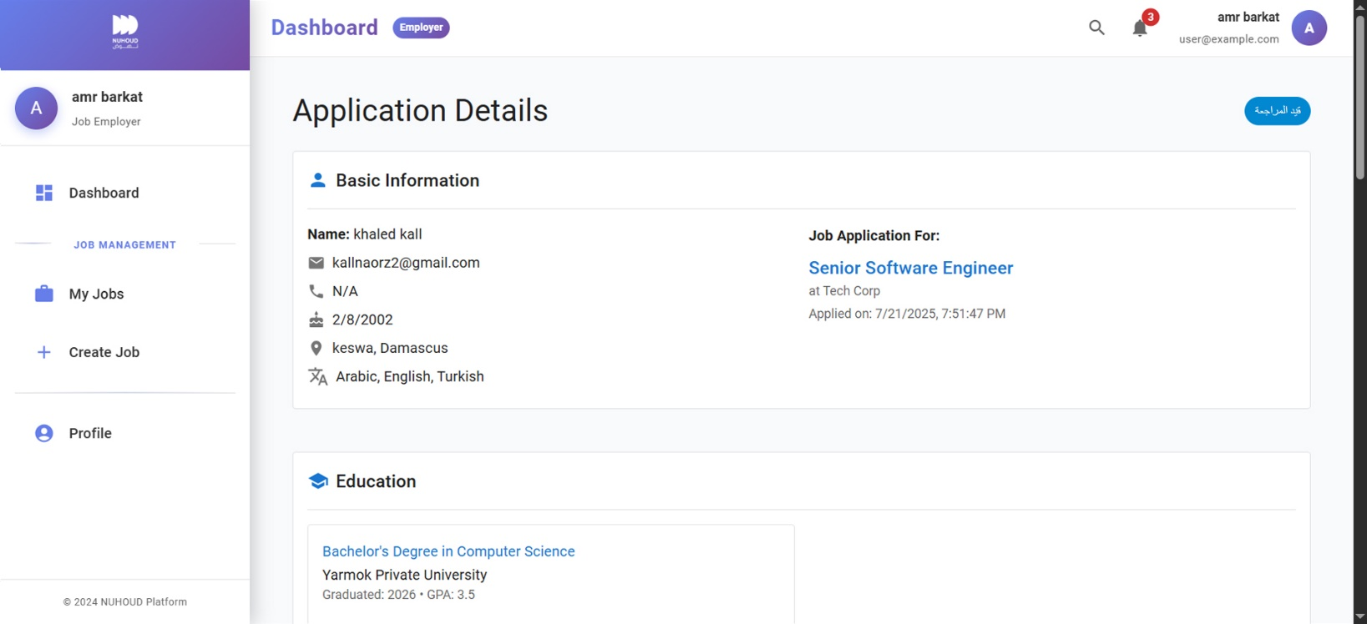
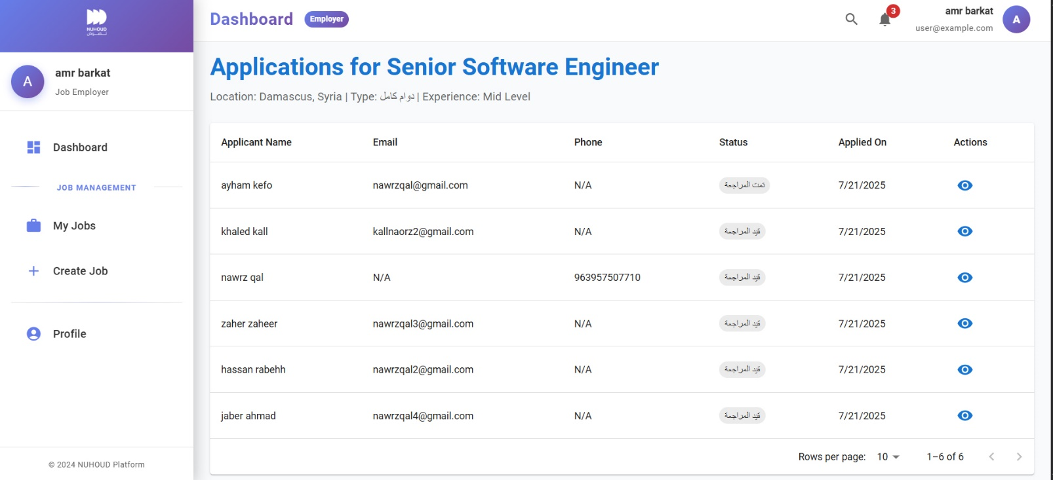
Figure 27: Figure 7.11 Application details - employer ui
Figure 28: Figure 7.10 applications for job offer - employer ui
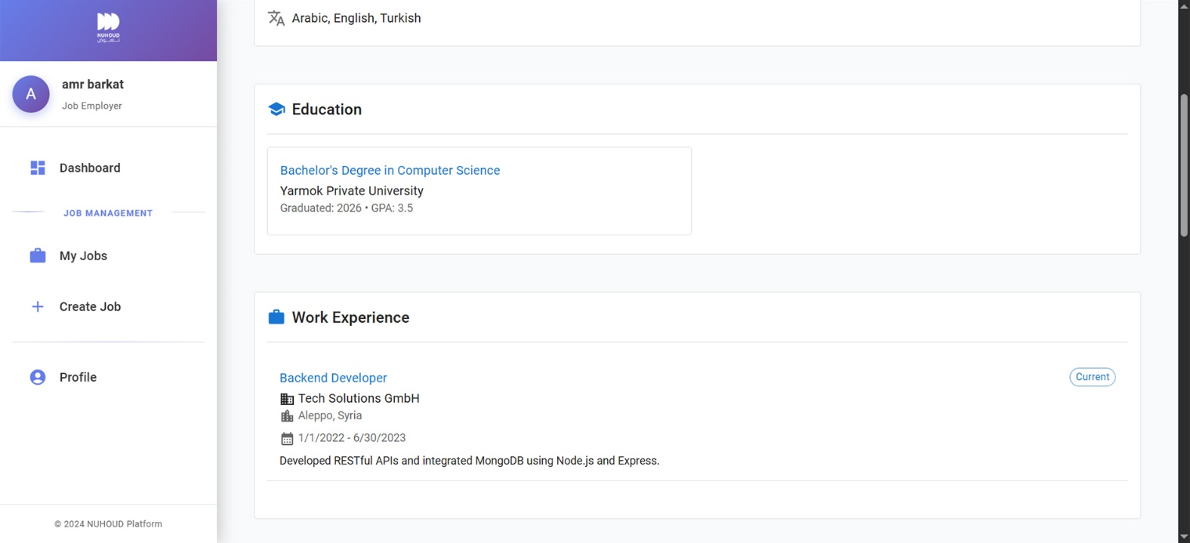
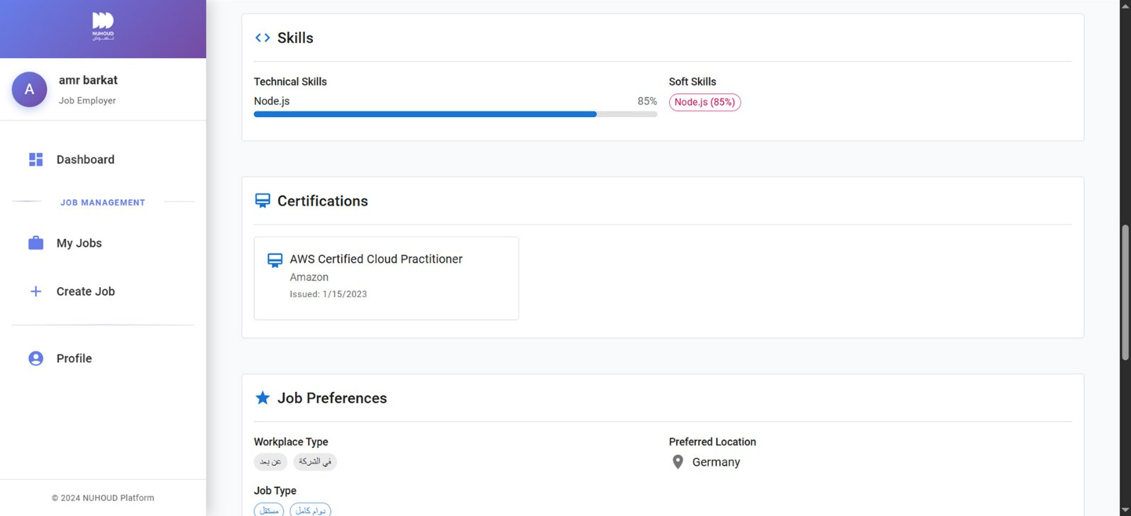
Figure 29: Figure 7.12 application details 2
Figure 30: Figure 7.13 application details 3

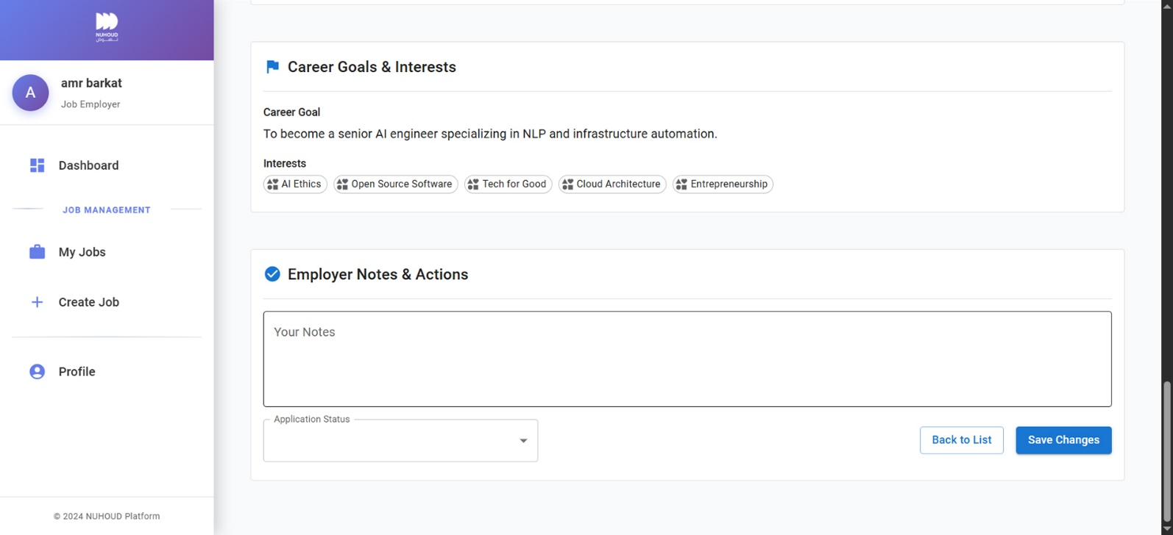
Figure 31: Figure 7.14 application details 4

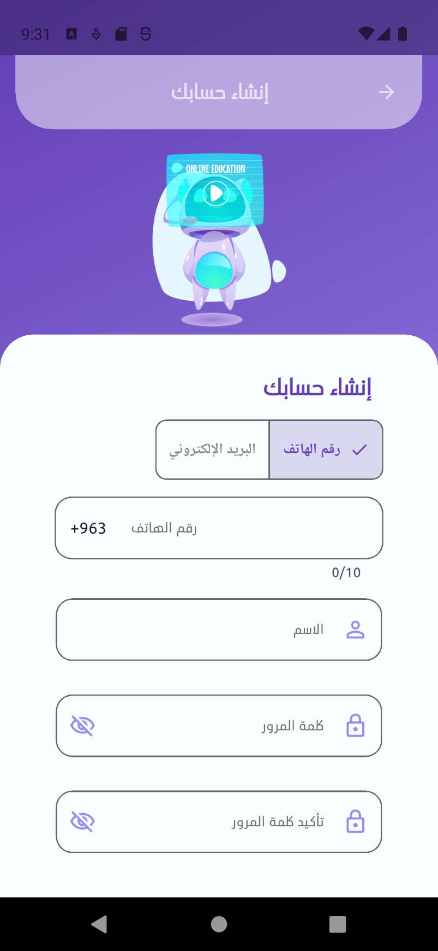
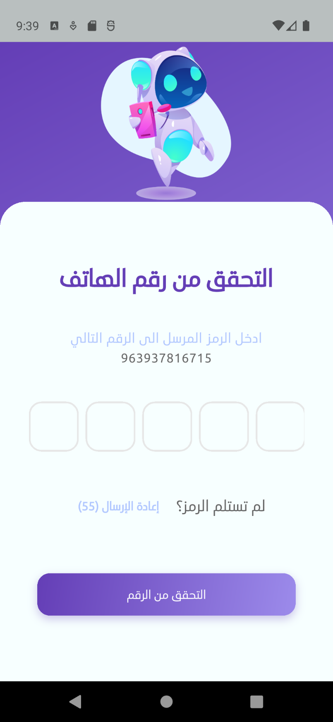
7.2. Mobile Application Interfaces
Figure 32: Figure 7.16 OTP interface
Figure 33: Figure 7.15 register interface

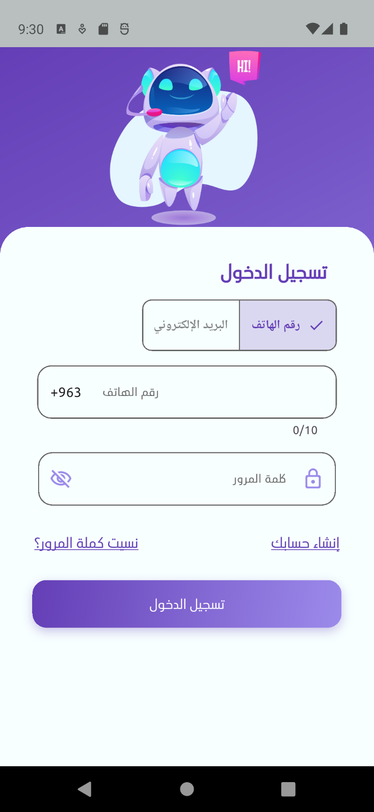
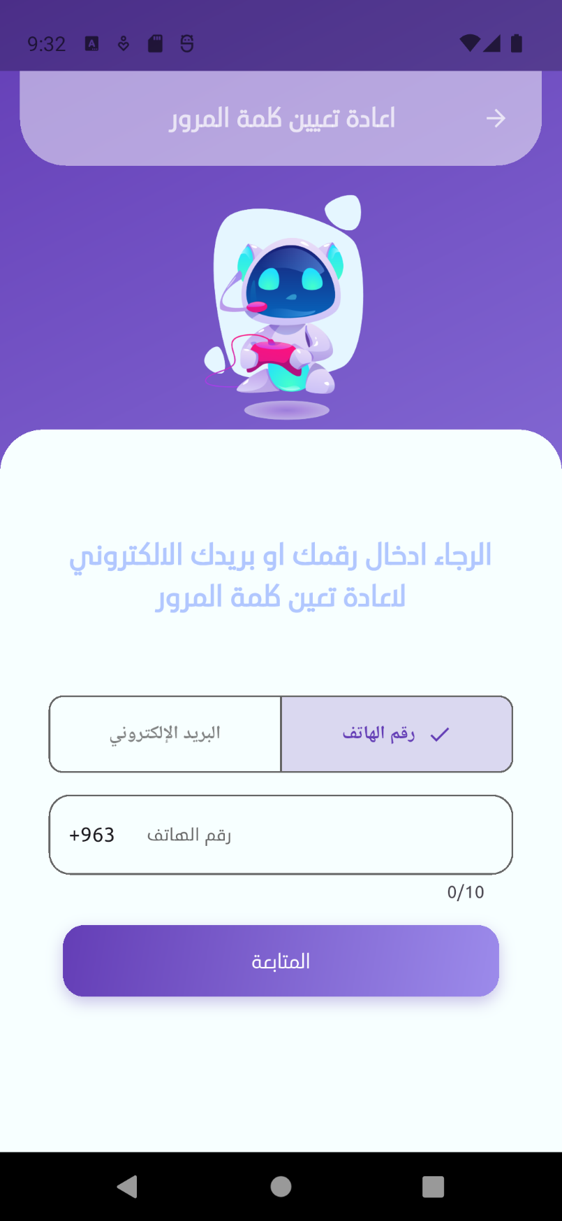
Figure 34: Figure 7.17 Login interface
Figure 35: Figure 7.18 Reset password ui

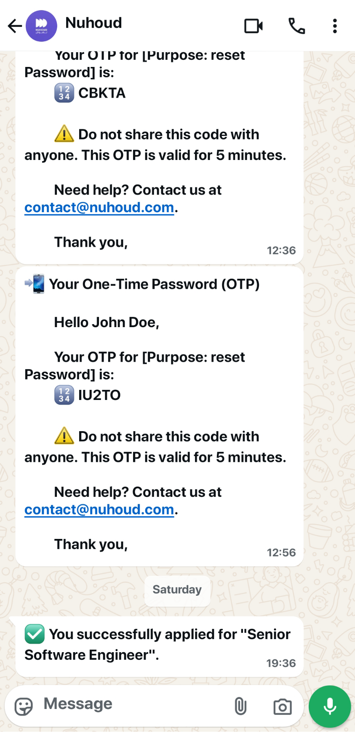

Figure 36: Figure 7.20 watsapp alert- otp and application status change
Figure 37: Figure 7.19 email alert - OTP
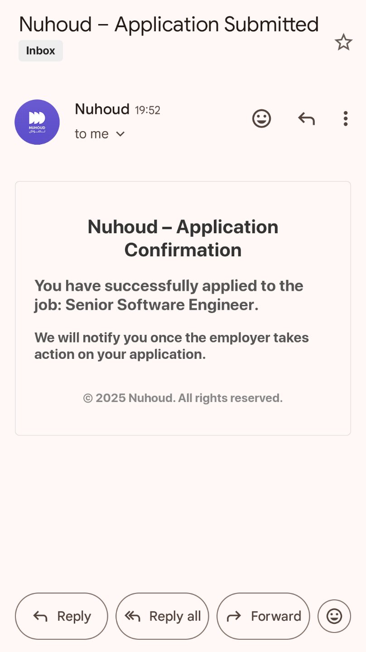
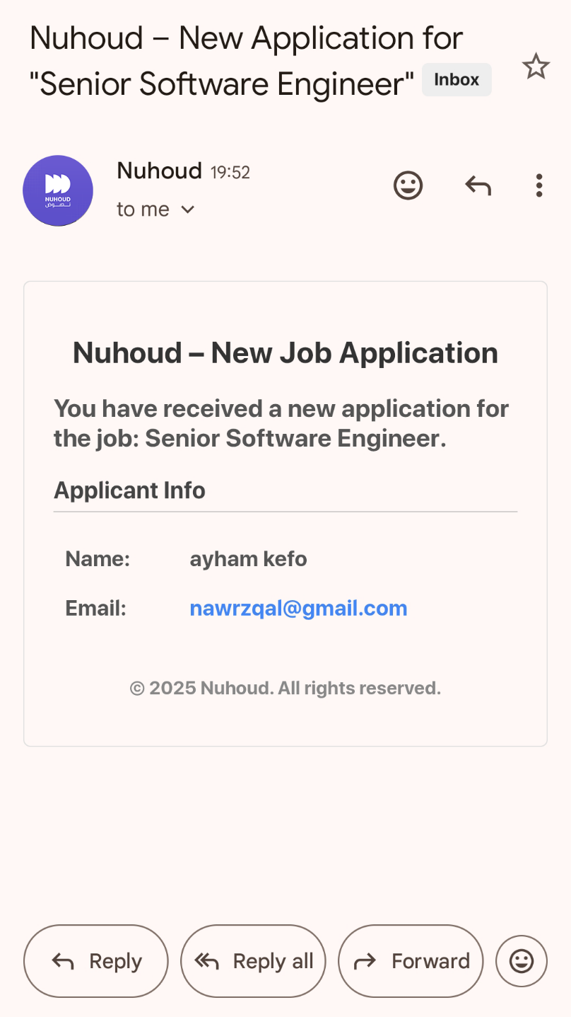
Figure 38: Figure 7.21 emil alert for user - new application created
Figure 39: Figure 7.22 email alert to employer - new application created
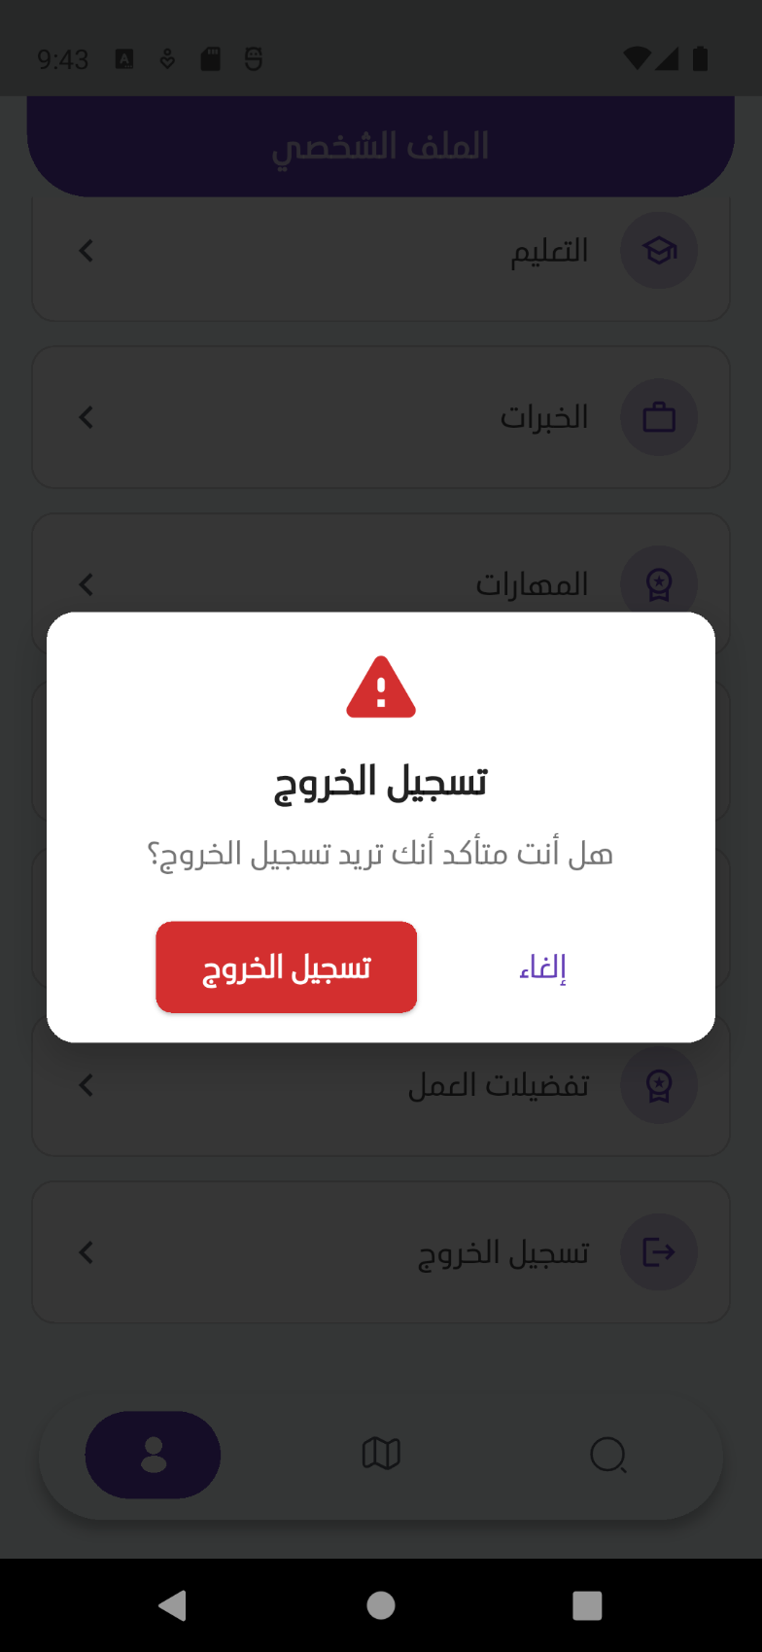
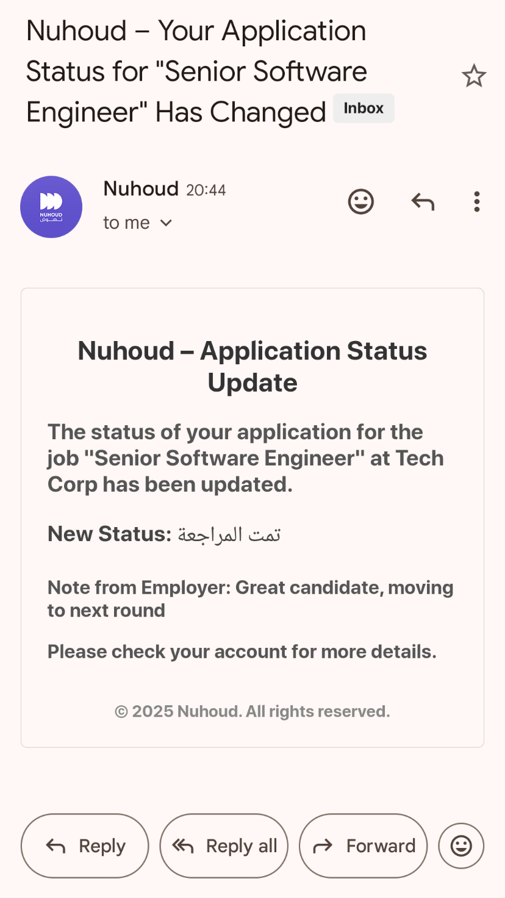
Figure 40: Figure 7.24 logout ui
Figure 41: Figure 7.23 email alert for user - application status changed

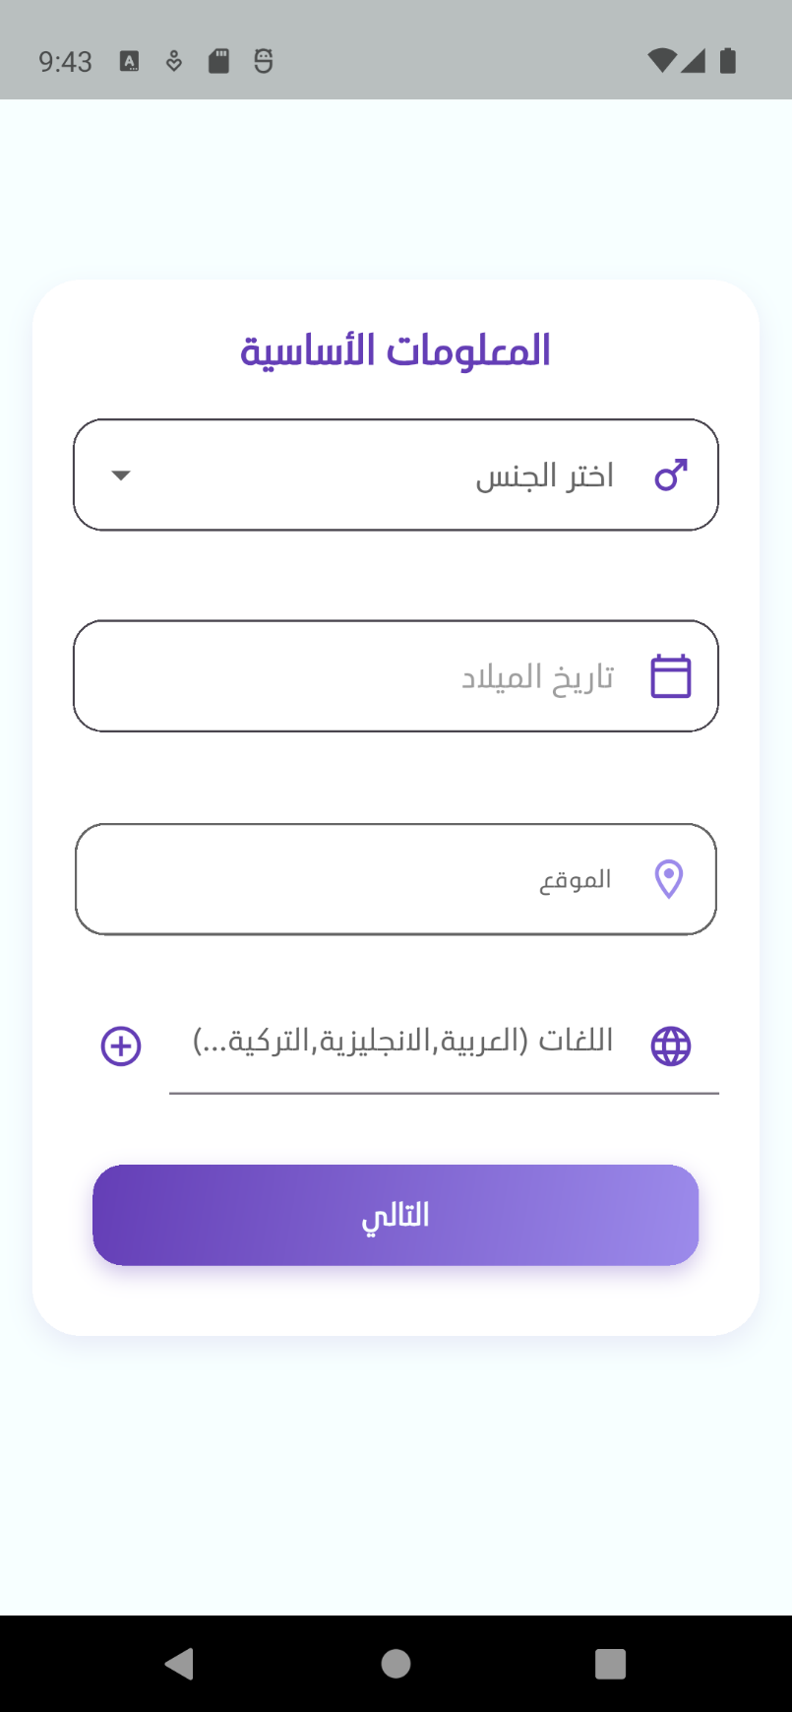

Figure 42: Figure 7.26 onboarding 2 ui
Figure 43: Figure 7.25 onboarding 1 ui

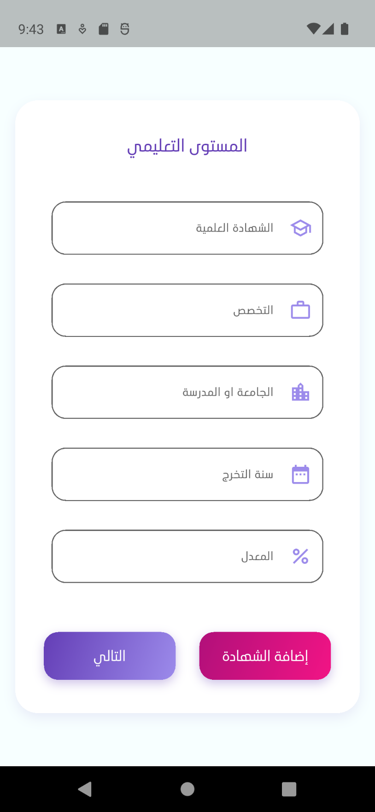
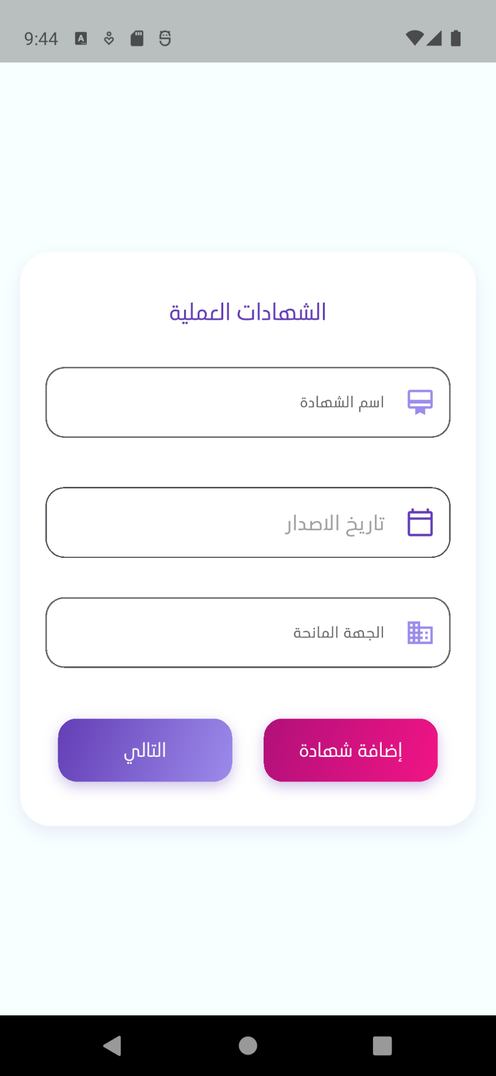
Figure 44: Figure 7.27 onboarding 2 ui
Figure 45: Figure 7.28 onboarding 3 ui
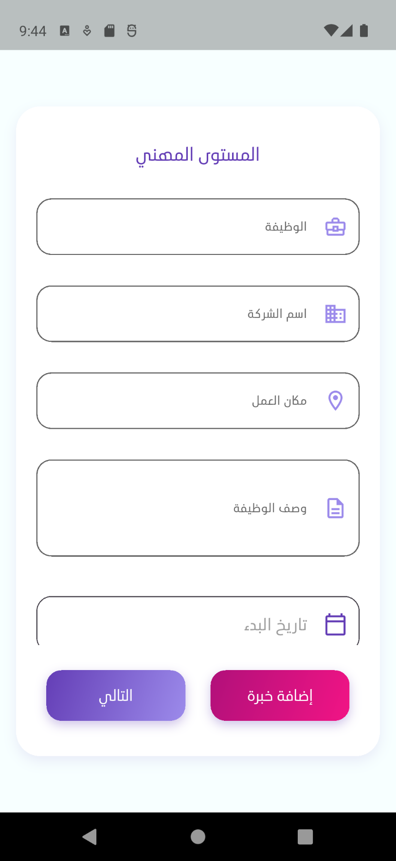
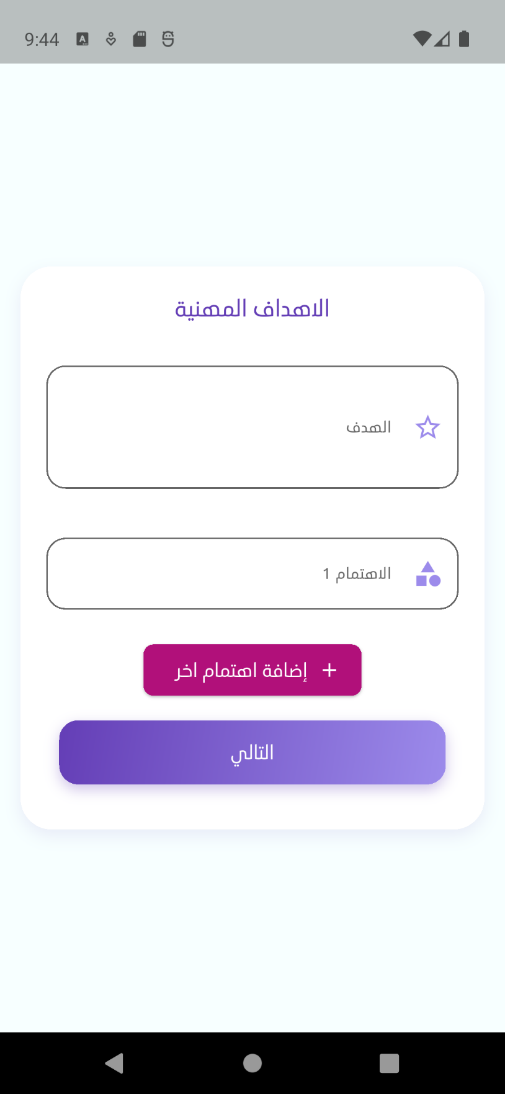
Figure 46: Figure 7.29 onboarding 4 ui
Figure 47: Figure 7.30 onboarding 5 ui

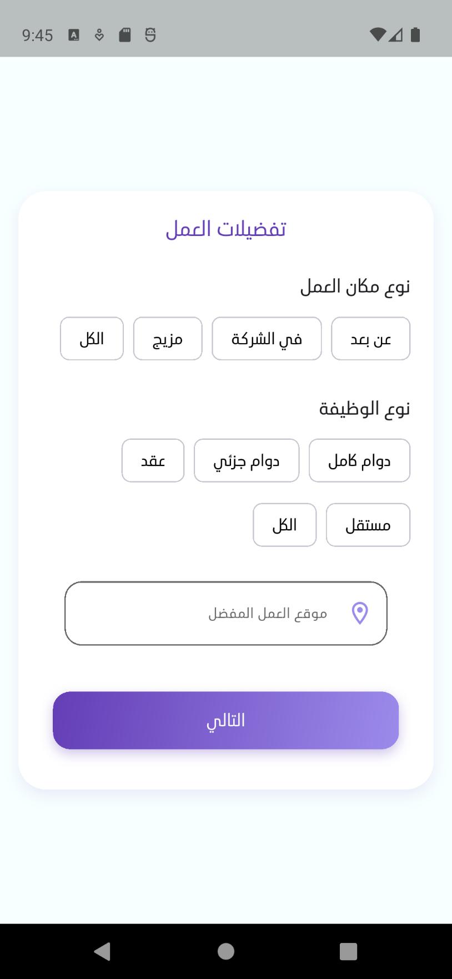
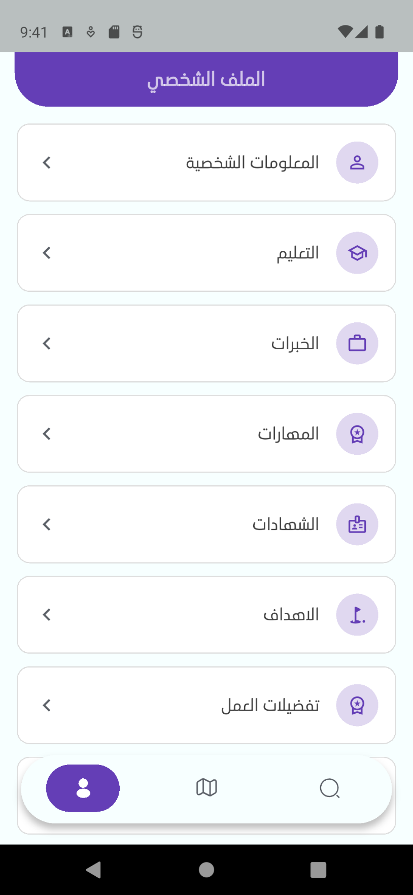
Figure 48: Figure 7.32 profile ui
Figure 49: Figure 7.31 onboarding 6 ui

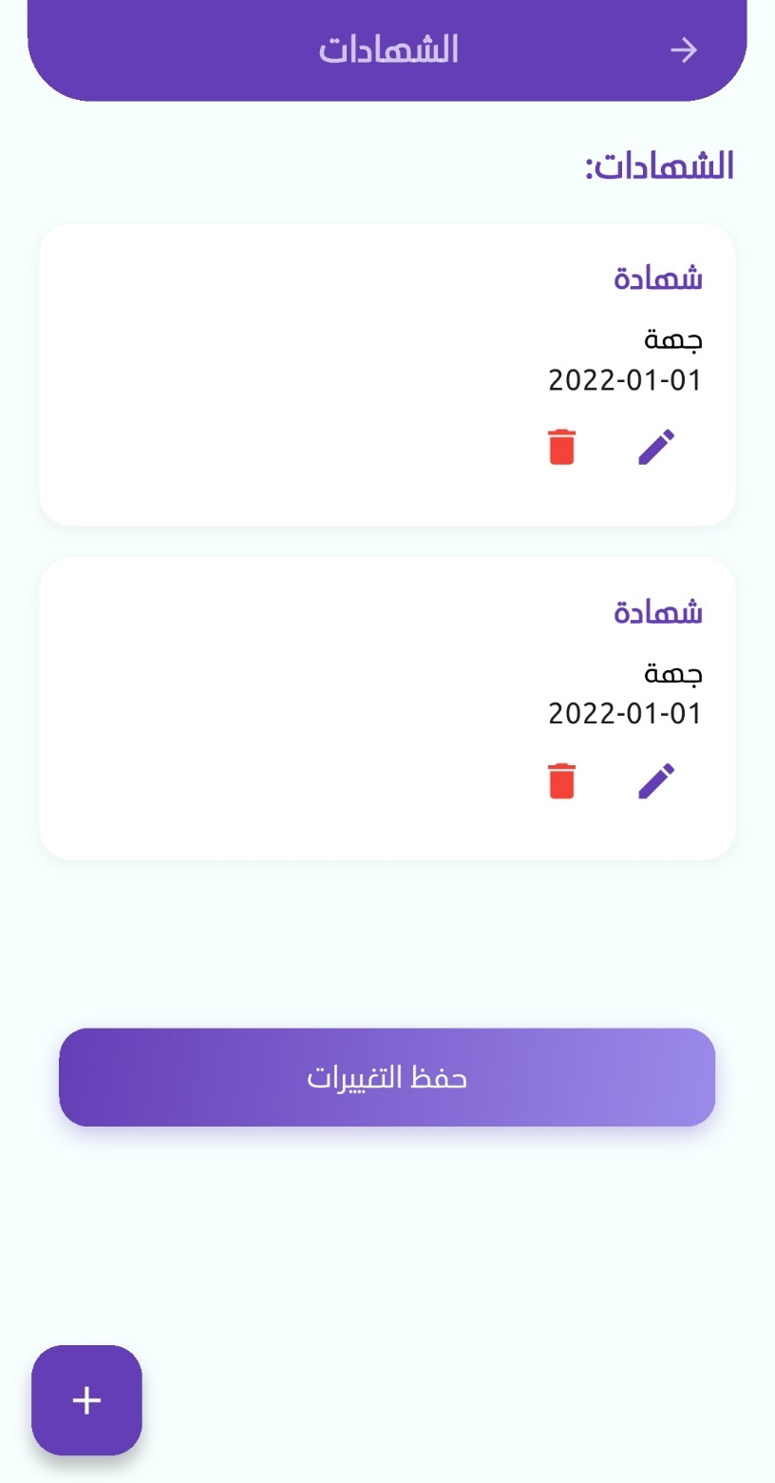
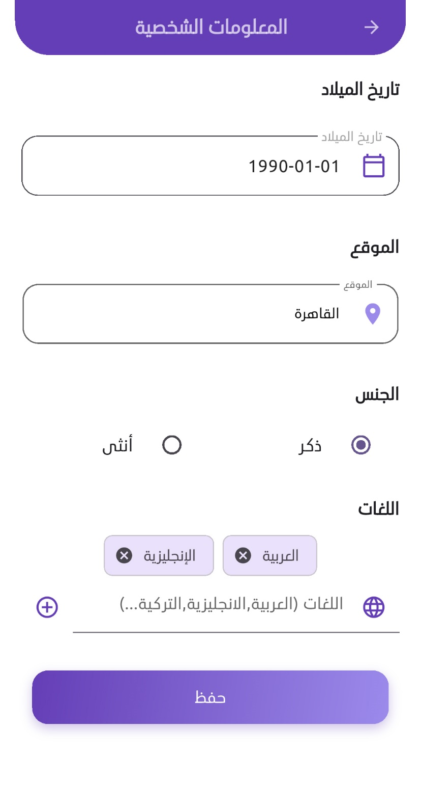
Figure 50: Figure 7.34 edit profile - education ui
Figure 51: Figure 7.33 edit profile - basic info ui
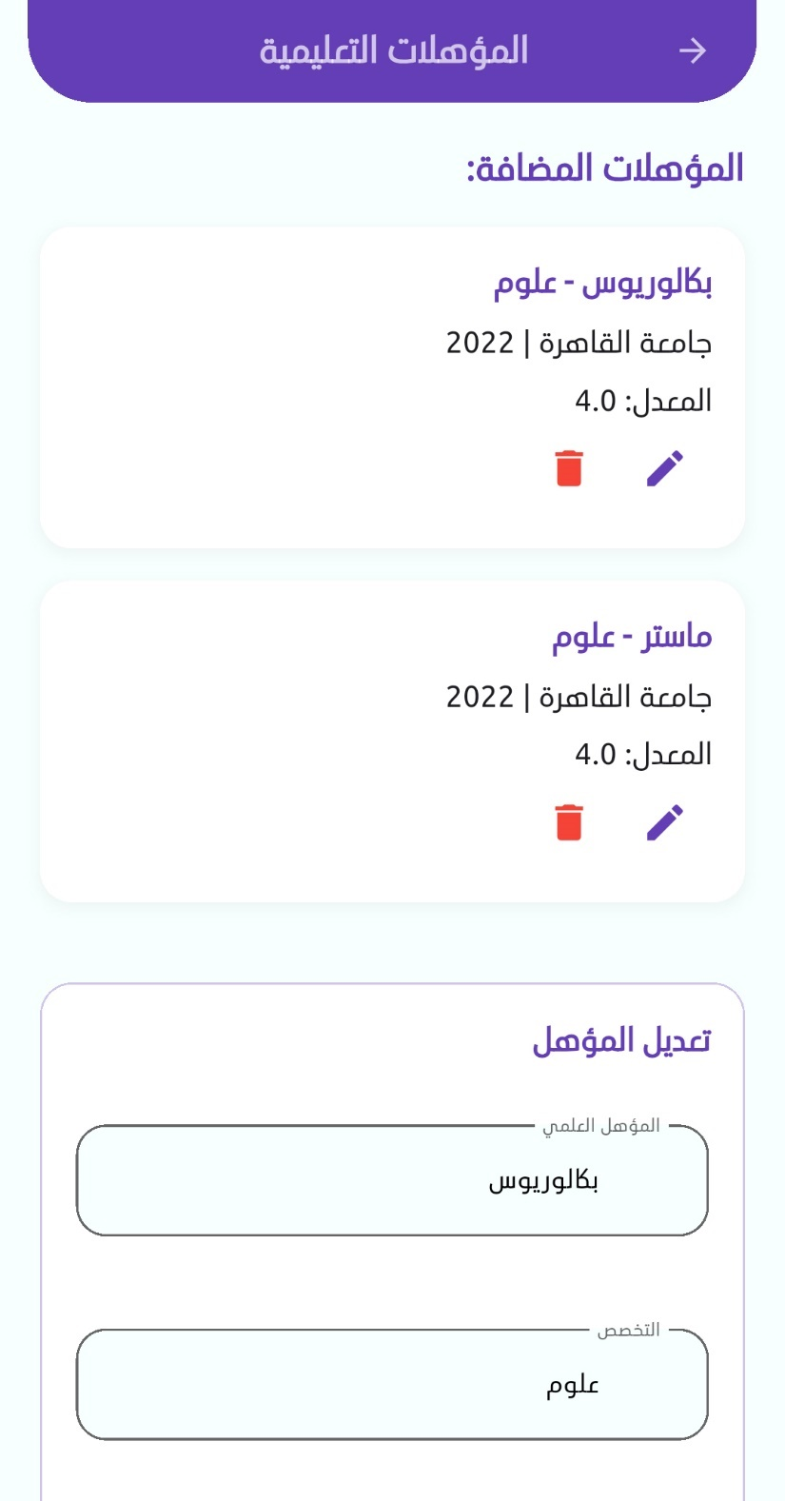
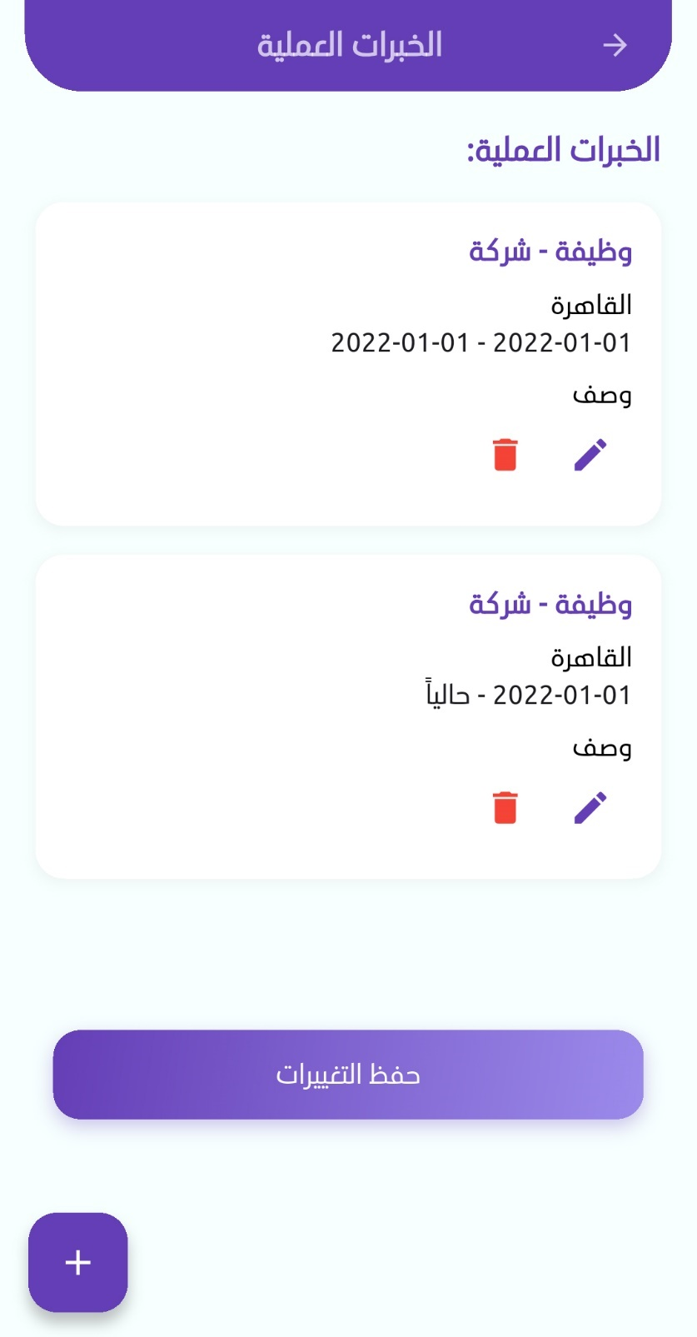
Figure 52: Figure 7.35 edit porfile - certifications ui
Figure 53: Figure 7.36 edit profile - experiences ui

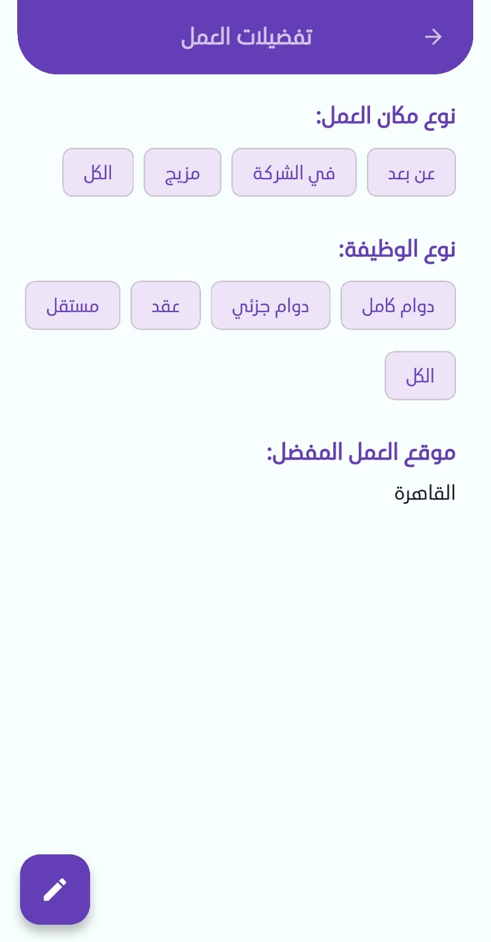
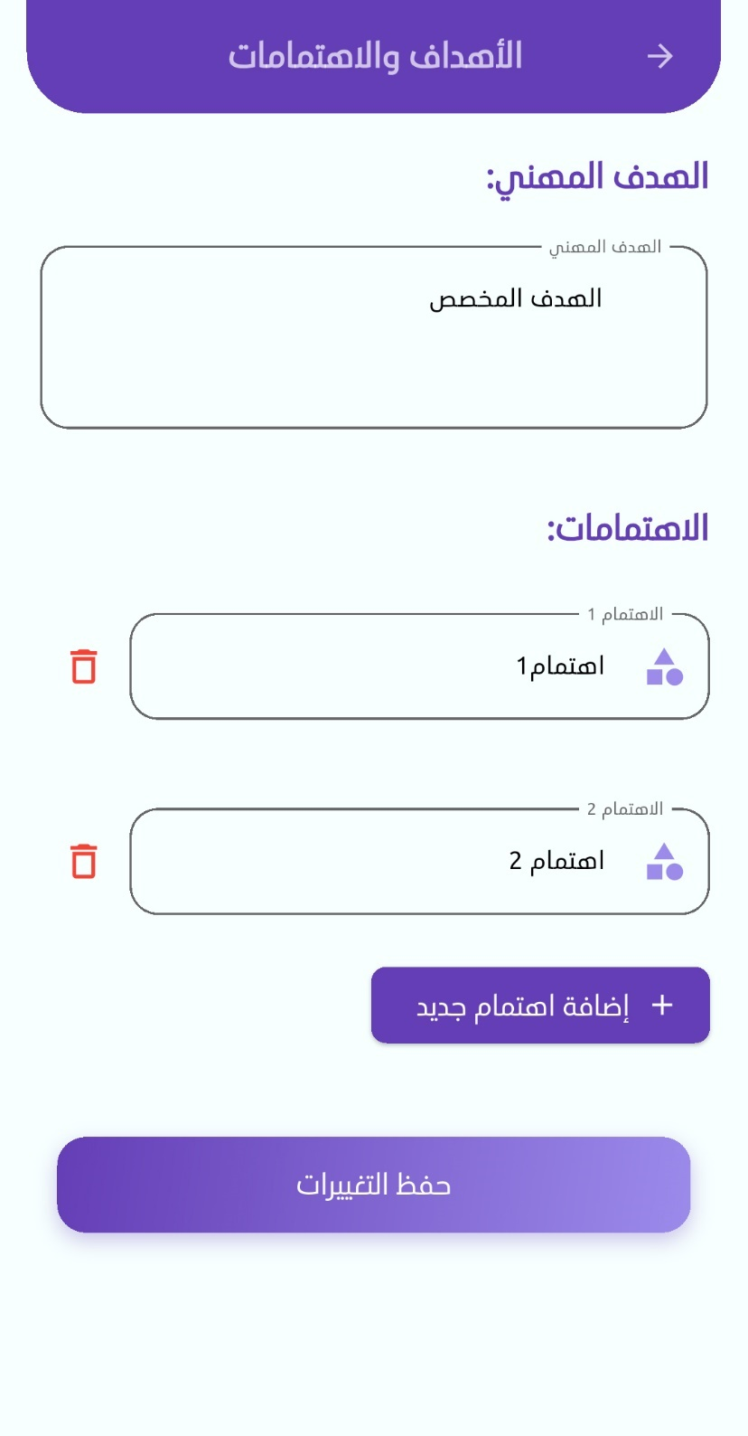
Figure 54: Figure 7.38 edit profile - job preferences ui
Figure 55: Figure 7.37 edit profile - goals and interests ui
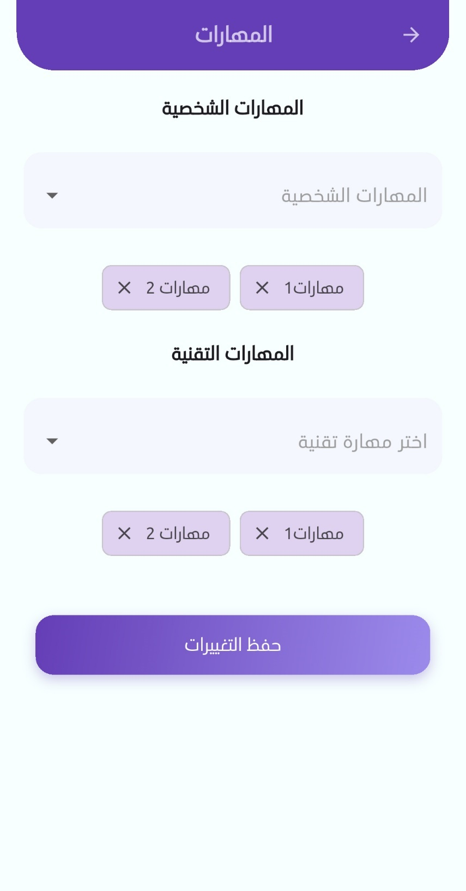
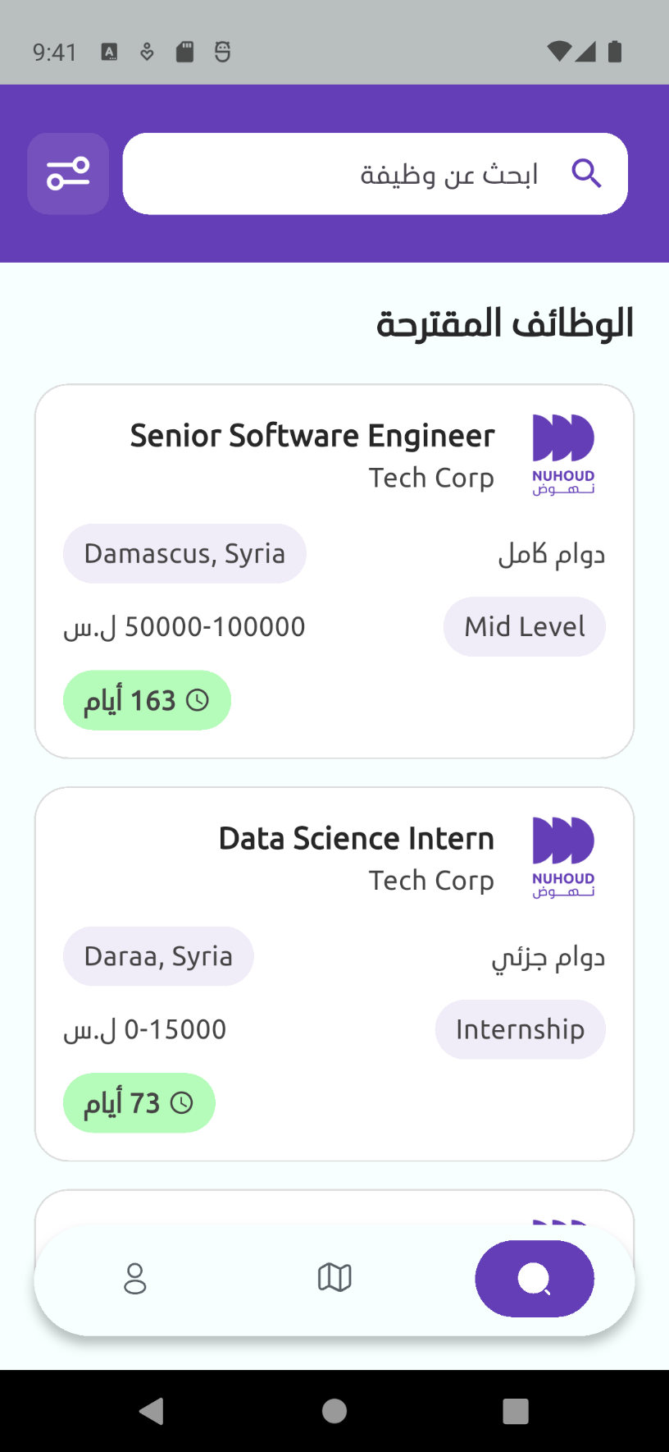
Figure 56: Figure 7.39 edit profile - skills ui
Figure 57: Figure 7.40 home page ui

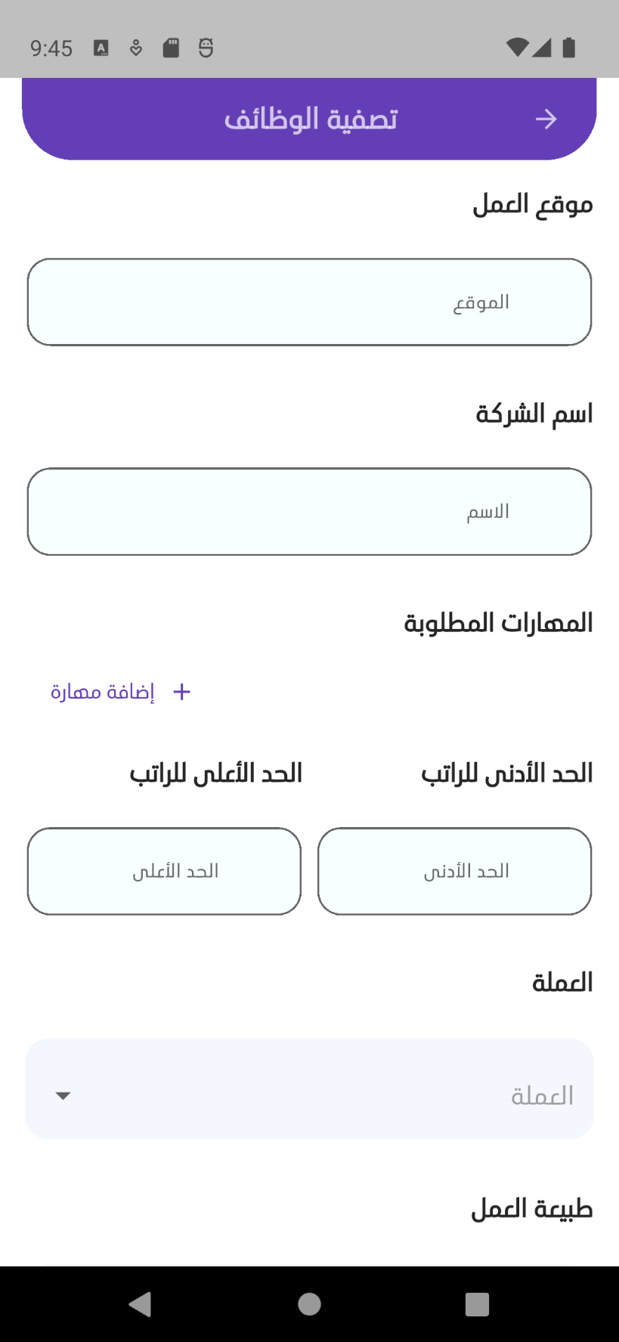

Figure 58: Figure 7.42 job offer filtring ui
Figure 59: Figure 7.41 job offer details ui

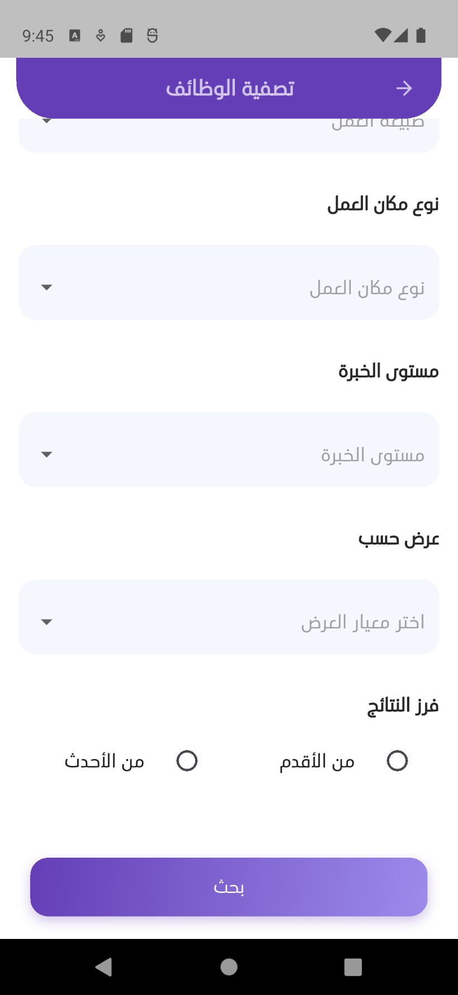
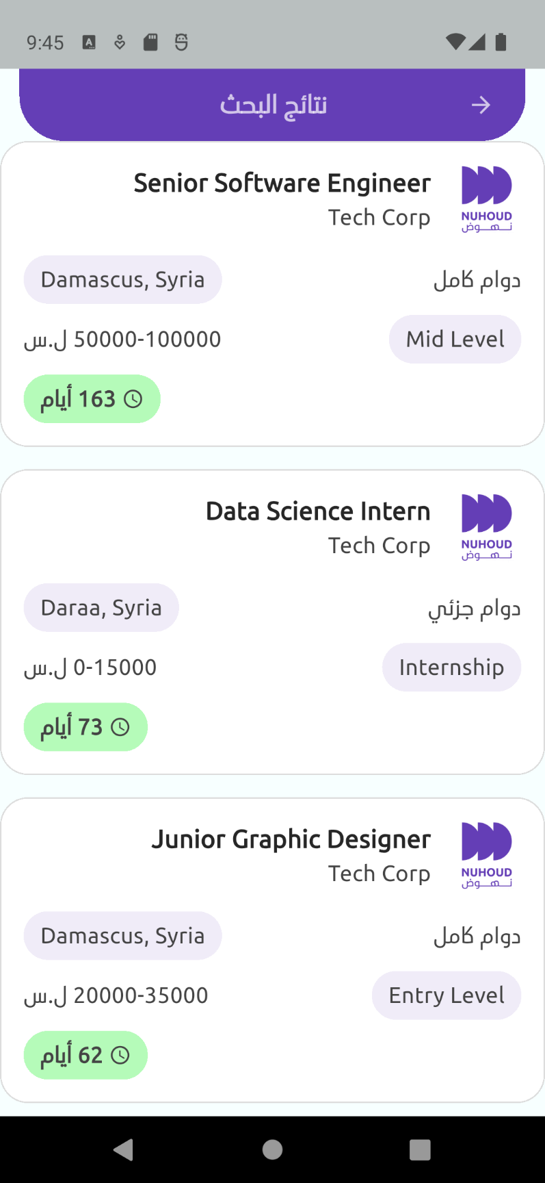
Figure 60: Figure 7.43 job offer filtring ui
Figure 61: Figure 7.44 search results ui


Figure 62: Figure 7.45 development plan for user 1
Figure 63: Figure 7.46 development plan for user 2


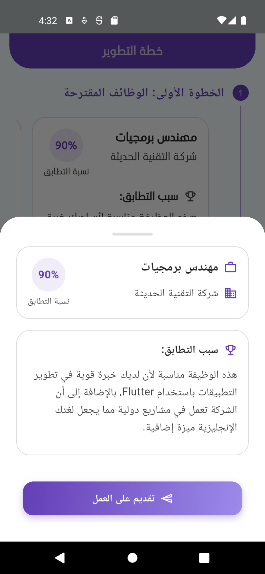
Figure 64: Figure 7.47 development plan for user 4
Figure 65: Figure 7.48 development plan for user 3

Chapter 8: Testing

This chapter explains the testing strategies employed to validate the functionality and reliability of the system. It covers unit, integration, system, and user acceptance testing across all critical features.

8.1 Unit Testing
Unit testing focused on verifying the correctness of individual components in isolation. Each unit, such as the user input validator, OTP logic, and AI request handler, was tested independently to ensure that it performs as expected.
Key examples include:
- Validation of email, password, and OTP inputs during signup and login
- Ensuring the recommendation engine receives and processes requests correctly
- Testing data models and transformation logic in services

8.2 Integration Testing
Integration testing ensured that various modules and microservices within the system worked together properly. It verified the flow of data between services and the ability to interact with the AI server, database, and external APIs.
Key tested interactions:
- Signup → Save user → Send OTP → Verify OTP
- Submit profile → Send to AI → Receive plan
- Post job offer → Fetch job offer list → Apply to a job
Database: MongoDB
Communication: gRPC, REST APIs

8.3 System Testing
System testing was performed to validate the entire system in a real deployment environment. It simulated complete user journeys and evaluated whether all subsystems work together as expected.
Common system-level scenarios:
- A job seeker signs up, completes profile steps, and receives a learning plan
- An employer registers, posts jobs, and receives applications
- An admin monitors user data and content publication

8.4 User Acceptance Testing (UAT)
User acceptance testing involved real users from different backgrounds, such as students, employers, and administrators. The goal was to validate usability, functionality, and overall satisfaction.
During UAT, we gathered feedback on:
- Ease of registration and login
- Clarity of the AI-generated plan
- Response time and performance
- Visual layout and accessibility
Improvements were made to flow logic and UI components based on user feedback.

8.5 Functional Test Cases Report

8.5.1 Authentication and User Login
This section documents the functional test cases related to the authentication and user login features of the AI-based job platform. The objective of these tests is to verify the correctness and reliability of the login, signup, OTP verification, and password reset functionalities to ensure a secure and smooth user experience.
Table 16: Table 8.1 Authentication and User Login
Test Case ID | Description | Preconditions | Test Steps | Expected Results | Actual Results | Status
1 | Valid User Login | User is registered | 1. Enter valid email and password  2. Click login | User is logged in and redirected | User logged in successfully | Pass ✅
2 | Invalid Login – Wrong Password | User exists | 1. Enter correct email  2. Enter wrong password  3. Click login | Error message "Invalid credentials" is shown | Error message displayed | Pass ✅
3 | Invalid Login – Non-existent User | Email not registered | 1. Enter unregistered email  2. Enter password  3. Click login | Error message "User not found" | Error message displayed | Pass ✅
4 | Valid User Signup with OTP Verification | None | 1. Submit signup form  2. Receive OTP  3. Verify OTP via /auth/verify-otp | User registered and account verified | Signup and verification successful | Pass ✅
5 | Signup with Already Registered Email | Email already registered | 1. Fill signup form with used email  2. Submit | Error message "Email already in use" | Correct error message shown | Pass ✅
6 | Signup Without OTP Verification | User signed up but not verified | 1. Signup  2. Skip OTP  3. Attempt login | Error "Account not verified" | Access blocked until verification | Pass ✅
7 | Admin Signup | None | 1. Submit data to /auth/signup-admin | Admin account is created | Admin created successfully | Pass ✅
8 | Employer Signup | None | 1. Submit data to /auth/signup-employer | Employer account is created | Employer created successfully | Pass ✅
23 | Request Password Reset | Email exists in system | 1. POST /auth/requestResetPassword with email | OTP sent to email | OTP received | Pass ✅
24 | Reset Password with Invalid OTP | OTP sent but invalid code | 1. POST /auth/verifyResetPasswordOtp with invalid code | Error "OTP invalid" | Error shown | Pass ✅
26 | Verify OTP for Signup | OTP was sent to user | 1. POST /auth/verify-otp with valid OTP | Account is verified | User marked as verified | Pass ✅
27 | Verify OTP – Invalid Code | OTP sent | 1. POST /auth/verify-otp with wrong code | Error shown | 400 or 401 response | Pass ✅
28 | Resend OTP | User signed up but not verified | 1. POST /auth/resend-otp with email | OTP re-sent | Email sent with OTP | Pass ✅

8.5.2 Job Offers
This section verifies the functionalities related to job offer creation, viewing, updating, and analytics for employers.

Table 17: Table 8.2 Job Offers testing
Test Case ID | Description | Preconditions | Test Steps | Expected Results | Actual Results | Status
12 | Create Job Offer (Employer) | Employer is logged in | 1. Send POST to /job-offers with valid data | Job offer is created successfully | Job is saved and returned | Pass ✅
13 | Create Job Offer with Missing Fields | Employer logged in | 1. POST to /job-offers with missing title or salary | 400 Bad Request with validation errors | Error received | Pass ✅
14 | View All Job Offers | At least one job exists | 1. GET /job-offers | List of job offers | Job list returned | Pass ✅
15 | Search Job Offers | Job offers available | 1. GET /job-offers/search?title=developer | Filtered jobs returned | Search results match keyword | Pass ✅
16 | Update Job Offer Status | Employer owns the job | 1. PATCH /job-offers/{id}/status to inactive | Status updated | Status updated correctly | Pass ✅
32 | Employer Views Their Job Offers | Employer logged in | 1. GET /job-offers/employer/my-jobs | Only employer’s jobs returned | Jobs shown correctly | Pass ✅
33 | Get Job Offers Expiring Soon | Job offers exist | 1. GET /job-offers/expiring-soon | Expiring jobs listed | List retrieved | Pass ✅
34 | Update Expired Job Offers | Some jobs are past expiry | 1. PATCH /job-offers/update-expired | Expired jobs updated | Correctly marked | Pass ✅
22 | Get Job Offer Analytics | Employer is logged in | 1. GET /job-offers/analytics | Analytics dashboard data returned | Data displayed correctly | Pass ✅

8.5.3 Applications
This section covers test cases related to job applications submitted by users and management of these applications by employers.

Table 18: Table 8.3 applications testing
Test Case ID | Description | Preconditions | Test Steps | Expected Results | Actual Results | Status
17 | Submit Job Application | Authenticated user, job active | 1. POST to /application/submit/{jobId} | Application is saved | Application submitted | Pass ✅
18 | Apply to Inactive Job | Job status = inactive | 1. POST to /application/submit/{jobId} | 403 Forbidden or error | Proper error returned | Pass ✅
19 | View My Applications | User logged in | 1. GET /application/my-applications | List of user’s applications | Applications returned | Pass ✅
35 | Employer Views Applications for Job | Applications exist | 1. GET /application/job-offer/{jobId} | List of applicants returned | Shown correctly | Pass ✅
36 | Update Application Status (Employer) | Application exists | 1. PATCH /application/{id}/status | Status updated | Change saved | Pass ✅
25 | Delete Application | Application exists | 1. DELETE /application/{id} | Application removed | Deleted successfully | Pass ✅

8.5.4 User and Profile Management
This section tests the user profile updates, admin user management, and retrieval of user information.

Table 19: Table 8.4 user and profile management testing
Test Case ID | Description | Preconditions | Test Steps | Expected Results | Actual Results | Status
20 | Update Profile Info – Step One | User logged in | 1. POST to /profile/profileInfoStepOne with valid data | Profile info saved | Info saved successfully | Pass ✅
21 | Delete User by Admin | Admin authenticated | 1. DELETE /users/{id} | User is deleted | User removed from DB | Pass ✅
29 | Get All Users (Admin) | Admin token present | 1. GET /users | List of users | Data retrieved | Pass ✅
30 | Get My Profile Info | User logged in | 1. GET /users/my-profile | User profile is returned | Info shown | Pass ✅
31 | Update User Info | User logged in | 1. PATCH /users/{id} with new info | Info updated | Response confirms change | Pass ✅

Chapter 9: Conclusion and Future Work

9.1. Conclusion
The Nuhoud project successfully achieved its primary objectives by designing and implementing a microservices-based job recommendation and career support platform. The system leverages NestJS for the backend, MongoDB for data persistence, Kafka for asynchronous event
communication, gRPC for real-time service interaction, and integrates AI services through n8n with Gemini for generating job recommendations and personalized development plans. Through this implementation, the project demonstrated the practical application of industry-standard architectural patterns including Domain-Driven Design, service decomposition, and event-driven architecture.
On a technical and personal level, this project provided valuable experience in microservice
communication, message brokers, containerization with Docker, and integrating AI with
automation platforms. It also reinforced the importance of clean architecture, separation of
concerns, and observability in distributed systems. The challenges faced during system
decomposition, managing distributed data consistency, and securing asynchronous flows were
instrumental in deepening our understanding of backend engineering and modern software
practices. Ultimately, the project delivered a functional system ready for further development and scaling.

9.2. Future Enhancements
Although Nuhoud has achieved its baseline objectives, there are several areas where the system could be expanded or improved, both from practical and research perspectives.

9.2.1. Practical Enhancements
- Implement rate limiting to protect public APIs from abuse and enhance system security.
- Introduce a load balancer to improve scalability and ensure high availability under increased user demand.
- Enhance security measures by adding more detailed audit logs, anomaly detection for suspicious behavior, and improving encryption standards.
- Develop a new microservice dedicated to courses and learning resources, allowing users to receive personalized training recommendations based on AI analysis.
- Build a comprehensive admin dashboard with real-time analytics, moderation tools, and detailed reporting capabilities.
- Integrate a full CI/CD pipeline for automated deployments and continuous integration.
- Improve the real-time user experience by adopting WebSocket-based updates for faster application status notifications.
- Optimize performance with caching (Redis) for frequently accessed queries (e.g., job searches, recommended jobs).
- Implement multi-language support for both the mobile app and dashboard to serve a broader audience.

9.2.2 Research-Oriented Enhancements
- Automated Candidate Ranking for Employers
Develop a scoring system to help employers automatically prioritize applications based on fit (skills, experience, education). This could improve recruitment efficiency and differentiate Nuhoud from basic job boards.
- AI Chatbot for Guidance and Support
Integrate an AI-powered chatbot to answer user questions, recommend jobs, suggest courses, and help with profile completion, improving engagement and reducing support load.
- Employer-Recommended Training Programs
Allow employers to recommend training for applicants or employees (e.g., "Complete this course before applying again") to align candidates better with job requirements.

9.3 Resources
- NestJS. (2025). NestJS Documentation. Retrieved July 13, 2025, from https://docs.nestjs.com
- MongoDB Inc. (2025). MongoDB Documentation. Retrieved July 13, 2025, from https://www.mongodb.com/docs
- Apache Kafka. (2025). Apache Kafka Documentation. Retrieved July 13, 2025, from https://kafka.apache.org/documentation
- Google. (2025). Protocol Buffers Documentation. Retrieved July 13, 2025, from
https://protobuf.dev
- gRPC Authors. (2025). gRPC Documentation. Retrieved July 13, 2025, from https://grpc.io/docs/
- OpenAI. (2025). OpenAI API Documentation. Retrieved July 13, 2025, from
https://platform.openai.com/docs
- Google. (2025). Gemini API Documentation. Retrieved July 13, 2025, from https://ai.google.dev/
- n8n. (2025). n8n Documentation. Retrieved July 13, 2025, from
https://docs.n8n.io
- Docker Inc. (2025). Docker Documentation. Retrieved July 13, 2025, from https://docs.docker.com
- Bitnami. (2025). Bitnami Kafka Container Documentation. Retrieved July 13, 2025, from https://bitnami.com/stack/kafka
- Kafdrop. (2025). Kafdrop Documentation. Retrieved July 13, 2025, from https://github.com/obsidiandynamics/kafdrop
- Typestack. (2025). Class Validator Documentation. Retrieved July 13, 2025, from https://github.com/typestack/class-validator
- Swagger. (2025). OpenAPI / Swagger Documentation. Retrieved July 13, 2025, from https://swagger.io/docs/
- Prometheus Authors. (2025). Prometheus Documentation. Retrieved July 13, 2025, from https://prometheus.io/docs
- Facebook, Inc. (2025). React – A JavaScript Library for Building User Interfaces. Retrieved July 13, 2025, from https://reactjs.org/
- Flutter Authors. (2025). Flutter Documentation. Retrieved July 13, 2025, from https://docs.flutter.dev
- NGINX, Inc. (2025). NGINX Documentation. Retrieved July 13, 2025, from https://nginx.org/en/docs/
- MinIO, Inc. (2025). MinIO Documentation. Retrieved July 13, 2025, from https://min.io/docs/minio
- Google. (2025). Firebase Cloud Messaging Documentation. Retrieved July 13, 2025, from https://firebase.google.com/docs/cloud-messagingGoogle. (2025). Firebase Admin SDK
- (Node.js) Documentation. Retrieved July 13, 2025, from https://firebase.google.com/docs/admin/setup
Note:
……………………………………………
……………………………………………
……………………………………………
……………………………………………
……………………………………………
……………………………………………
……………………………………………
……………………………………………
……………………………………………
……………………………………………
……………………………………………
……………………………………………
……………………………………………
……………………………………………
……………………………………………
……………………………………………

