**Yarmouk Private University**

**Faculty of Informatics and**

**Communication Engineering**



**Prepared by:**  
Ayham Kefo Nawrz Qal Amr Barakat

**Supervisor:**

Dr. Hiyam Khaddam  
Eng. Anas Mokhalati

Semester: 2024/2025-2

# Abstract

Nohoud is a distributed microservices-based platform designed to support all Syrians, including refugees, returnees, and residents, in developing their skills, improving employability, and building personalized development plans powered by AI.

The platform’s primary goal is to evaluate users’ current skill sets, match them with relevant job opportunities, and provide AI-generated personal development plans. It leverages a scalable architecture using NestJS microservices, MongoDB, and an AI pipeline orchestrated through n8n, connected to a stateless LLM (Gemini).

Users complete their profiles, which are then analyzed to produce job suggestions and tailored growth plans. The system emphasizes usability, modularity, and personalization, making it a practical solution for job seekers across the Syrian population—regardless of their background or displacement status. The results show that combining AI with scalable backend services can  
meaningfully assist in career development and employment integration.

# Acknowledgments

We extend our heartfelt gratitude to Dr. Hiyam Khaddam and Eng. Anas Mukhalati, our esteemed supervisors, for her invaluable guidance and mentorship, and to Dr. Moutasem Shafaumri, the esteemed Dean of our Faculty, for fostering a culture of innovation and scholarly pursuit. Their wise advice and unwavering support have been instrumental in the development of the NOHOUD project.

Additionally, we are deeply grateful to our families and friends for their continuous encouragement and emotional support. This achievement would not have been possible without their constant backing.

# Table of Contents

Contents

Abstract 1

Acknowledgments 2

Table of Contents 3

Table of Figures 6

List of Abbreviation and Terminology 7

Chapter 1: Introduction 8

1.1 Motivation 9

1.2 Problem Description: 9

1.3 Project Objectives 10

Chapter 2: Background 12

2.2 Related Works 13

2.3 The Proposed Solution 14

Chapter 3: Project Management & Methodology 15

3.1 Development Methodology: Agile Scrum 16

3.1.1 Why Agile Scrum Fits This Project 16

3.1.2. Roles and Responsibilities 16

3.1.3. Sprint Planning and Execution 17

3.1.4. Self-Organizing Team Structure 17

3.1.5. Scrum Ceremonies 17

3.1.6. Sustainable Engineering Practices 18

3.1.7. Iteration Structure and Feature Lifecycle 18

3.1.8. Code Publication & Versioning Strategy 19

2.2. Remote Pair Programming for Complex Tasks 19

3.2.1 Purpose and Benefits 19

3.2.2 Setup and Approach 20

2.3. Managing a Multi-Service Platform with Scrum 20

3.4. Project Management Tools: Jira 21

3.4.1. Epics, User Stories, and Tasks 21

3.4.2. Sprint Board and Burndown Charts 21

3.4.3. Visual Artifacts from Jira Workspace 22

3.5. Version Control Strategy 23

2.6. Communication and Collaboration 24

3.6.1 Primary Communication Channels 24

3.6.2 Meeting Cadence 24

Chapter 4: Requirements Engineering 25

4.1 Requirements Elicitation 26

4.2 Functional Requirements 26

4.2.1 User Management 26

4.2.2 Job Application Flow 26

4.2.3 Notification & Alerts 26

4.2.4 AI Recommendations 26

4.3 Non-Functional Requirements 27

4.4 Use Case Diagram 29

4.5 Use Case Specifications 30

Chapter 5: System Design and Architecture 31

5.1. Architectural Style: Microservices 32

5.1.1. Rationale for Choosing Microservices 33

5.1.2. Service Decomposition and Granularity 34

5.2. High-Level System Architecture Diagram 35

5.3. Core Design Principles 36

5.3.1. SOLID Principles Application 36

5.3.2. Design Patterns 37

5.4. Inter-Service Communication 39

5.4.1. Communication Patterns 39

5.4.2. Asynchronous Communication with Apache Kafka 39

5.4.3. Synchronous Communication with gRPC 40

5.5. Data Management Strategy (Database-per-Service) 41

5.5.1. Data Modeling: 41

5.6. Class Diagram 43

5.7. AI Service Integration using n8n 44

Chapter 6: Technology Stack and Rationale 45

6.1. Programming Language & Runtime: Node.js 46

6.2. Backend Framework: NestJS 47

6.3. API Documentation: Swagger 47

6.4. Database and ODM: MongoDB with Mongoose 48

6.5. Messaging/Event-Driven Architecture: Apache Kafka 48

6.5. RPC Communication: gRPC with Protocol Buffers 49

6.6. Containerization & Orchestration: Docker Compose 49

6.7. Kafdrop Monitoring Tool: Kafdrop 50

Chapter 7: Implementation 51

Chapter 8: Testing 53

Chapter 9: Conclusion and Future Work 54

9.1. Conclusion 55

9.2. Future Enhancements 55

9.3 Resources 55

Appendices 56

# Table of Figures

Figure 1:logo **Error! Bookmark not defined.**

Figure 2: Nodejs **Error! Bookmark not defined.**

Figure 3: Express js **Error! Bookmark not defined.**

Figure 4: Express architecture **Error! Bookmark not defined.**

Figure 5: MongoDB **Error! Bookmark not defined.**

Figure 6: Mongoose **Error! Bookmark not defined.**

Figure 7: scss **Error! Bookmark not defined.**

Figure 8: EJS template engine **Error! Bookmark not defined.**

Figure 9: Git **Error! Bookmark not defined.**

Figure 10: Github **Error! Bookmark not defined.**

Figure 11: Vs Code **Error! Bookmark not defined.**

Figure 12: Syria-Visa.sy **Error! Bookmark not defined.**

Figure 13: UseCase Diagram **Error! Bookmark not defined.**

Figure 14: class diagram **Error! Bookmark not defined.**

Figure 15: entity relationship diagram **Error! Bookmark not defined.**

Figure 16: Register Sequence diagram **Error! Bookmark not defined.**

Figure 17: book appointment Sequence diagram **Error! Bookmark not defined.**

Figure 18: Login Sequence diagram **Error! Bookmark not defined.**

Figure 19: logout Sequence diagram **Error! Bookmark not defined.**

Figure 20: Reset password Sequence diagram **Error! Bookmark not defined.**

Figure 21: check wallet Sequence diagram **Error! Bokmark not defined.**

Figure 22: add money Sequence diagram **Error! Bookmark not defined.**

Figure 23: Add Ddferment Sequence diagram **Error! Bookmark not defined.**

Figure 24: request state Sequence diagram **Error! Bookmark not defined.**Figure 27: change Request State Sequence diagram **Error! Bookmark not defined.**

Figure 28: Nodejs architecture **Error! Bookmark not defined.**

Figure 29: email notification **Error! Bookmark not defined.**

# List of Abbreviation and Terminology

|  |  |
| --- | --- |
| **Abbreviation/Term** | **Definition** |
|  |  |
|  | User Interface/User Experience; principles and practices involved in designing the interface and experience of the platform. |
|  |  |
|  |  |

# Chapter 1: Introduction

## 1.1 Motivation

Syria’s civil war has created a massive displacement crisis, leaving millions of skilled individuals unemployed due to broken labor market connections. Modern technologies, like AI for job matching and microservices for scalable platforms, offer a solution. The Nohoud project leverages these innovations to provide personalized job recommendations and career development plans, helping Syrians rebuild their livelihoods.

## 1.2 Problem Description:

Despite the clear need, existing support systems for Syrian job-seekers are fragmented and incomplete. Most humanitarian job platforms or job boards are either basic registries of openings or manual counseling programs; they typically do not personalize matches or guide users on skills development.

Technically, most current platforms suffer from rigidity and poor scalability. Traditional systems are often monolithic (single-unit) applications that are hard to maintain or extend. Communication between services can be slow or unreliable, especially across regions with limited network infrastructure.

no existing system holistically solves the problem of guiding all Syrians — whether in camps, urban centers, or abroad — through a personalized pathway from skill assessment to employment. Nohoud is designed to fill these gaps. It identifies three core problems: (1) lack of personalized matching: existing platforms do not use AI or user profiling to adapt to individual needs; (2) lack of integrated skill development: refugees need guidance on training/certification, not just job listings; and (3) poor system design for scale: many solutions cannot easily add features or handle high loads. By targeting these issues, Nohoud aims to overcome the shortcomings of current practice and effectively support Syrian livelihoods.

## 1.3 Project Objectives

The Nohoud system has the following specific, actionable objectives:

AI-driven Job Matching using n8n workflow: Develop an intelligent recommendation engine that matches each user’s profile (skills, experience, preferences) to relevant job openings and opportunities. The matching will leverage including large language model to analyze curricula vitae and job descriptions for optimal alignment.

Personal Development Plans using n8n workflow: For every user, generate a customized career development plan outlining recommended training, courses, or certifications. These plans will be tailored using the user model and labor-market insights, enabling users to systematically build employable skills over time.

Microservices Architecture: Implement the platform as a set of distributed microservices (using NestJS) so that each major function (e.g. user management, job search, recommendation, content delivery) is an independent service. This will ensure the system is scalable, maintainable, and fault-tolerant.

Efficient Communication: Use gRPC (Protocol Buffers over HTTP/2) for inter-service communication to maximize performance. Studies show gRPC can significantly outperform traditional REST APIs (e.g. 7–10× faster throughput in benchmark tests), which will allow Nohoud to handle high volumes of requests across components.

Flexible Data Storage: Use MongoDB as the primary data store, taking advantage of its schemaless document model to handle diverse user profiles and job data. This will allow the system to evolve (e.g. adding new user attributes or content types) without disruptive schema migrations.

# Chapter 2: Background

## 2.2 Related Works

In the domain of professional networking and recruitment, numerous platforms exist, with LinkedIn being the most prominent market leader. To position the Nuhoud system, it is essential to conduct a comparative analysis.

Figure 1

LinkedIn: As a global professional social network, LinkedIn offers a vast array of features, including profile creation, networking, content sharing, online courses (LinkedIn Learning), and a comprehensive job board. Its primary strength lies in its massive user base and the network effect it creates, making it an indispensable tool for both recruiters and job seekers.

Nuhoud System - A Comparative Analysis:

The Nuhoud system, while operating in the same general domain as LinkedIn, is designed with a more focused objective and a distinct architectural philosophy.

• Scope and Focus: LinkedIn serves as a broad professional social media platform where job hunting is one of several key activities. In contrast, Nuhoud is purpose-built as a dedicated career development and job application portal. Its features are tightly integrated around the core workflow of enhancing a user's qualifications, finding suitable employment, and managing the application process. It deliberately omits the broader social networking aspects to provide a more streamlined and goal-oriented user experience.

• AI-Driven Guidance: While LinkedIn uses AI for job recommendations, Nuhoud proposes a more proactive and personalized AI implementation. The getPersonalPlanAndRecommendation and getRecommendedSkills functionalities are core features, designed to act as a personal career advisor. This system analyzes a user's profile and career goals to create a tangible development roadmap, suggesting specific skills and career steps. This is a significant differentiator from LinkedIn's more passive recommendation engine.

• Architectural Approach: The Nuhoud system is explicitly designed using a microservices architecture. This technical choice emphasizes scalability, resilience, and maintainability. By decomposing the system into smaller, independent services (e.g., User Management, Job Offers, Notifications, AI Recommendations), Nuhoud is engineered for agility and independent deployment of features. While LinkedIn also employs microservices, highlighting this as a foundational design principle for Nuhoud is a key technical distinction.

In summary, while LinkedIn provides a comprehensive, network-focused platform, Nuhoud aims to carve a niche by offering a focused, AI-driven, and highly efficient tool dedicated to active career development and job placement

## 2.3 The Proposed Solution

The proposed solution is **Nuhoud**, a modern, intelligent job portal engineered on a microservices architecture. The system is designed to bridge the gap between job seekers and employers in a highly efficient and supportive manner, with a unique emphasis on personalized career growth through artificial intelligence.

Nuhoud serves three primary actors:

1. **Job Seekers (Normal Users):** Individuals seeking employment and career guidance. They can build detailed professional profiles, search for jobs, apply seamlessly, and track their application status in real-time.
2. **Employers:** Companies and recruiters looking to find qualified candidates. They can post and manage job offers, review incoming applications, and communicate with applicants.
3. **Administrators:** System overseers responsible for user management, platform integrity, and monitoring overall system analytics.

The core of the Nuhoud system is its **AI-powered recommendation engine**. This engine provides users with a personalized development plan, suggesting skills to acquire and career paths to follow based on their profiles and stated goals. This transforms the platform from a simple job board into a dynamic career development tool.

Technically, the system's foundation is a **microservices architecture**. Functionality is broken down into logical, independent services that communicate asynchronously through an   
event-driven model (e.g., using signals like ApplicationCreated/Signal). This design ensures that the system is scalable, resilient to partial failures, and allows for agile development and deployment of new features.

# Chapter 3: Project Management & Methodology

## 3.1 Development Methodology: Agile Scrum

We adopted **Agile Scrum** as the development methodology for this project due to its flexibility, iterative nature, and proven effectiveness in managing complex projects with evolving requirements. With a team of three members possessing diverse skills, ranging from backend development to AI services. Scrum enabled us to deliver functionality incrementally while continuously adapting to new insights.

### 3.1.1 Why Agile Scrum Fits This Project

* **Adaptability to Changing Requirements**: Our platform targets nuanced needs of migrants and refugees. As we progressed and understood our users better, our requirements evolved. Scrum allows backlog reprioritization between sprints without derailing the project plan.
* **Iterative and Incremental Delivery**: We used 1-week sprints. At the end of each sprint, we delivered a working increment—whether a functional endpoint, a microservice, or a UI

feature—allowing for constant feedback and continuous validation.

* **Hands-on Collaboration**: As a small team, we benefitted from close communication and fast decision-making. The daily standups (virtual or async) enabled full visibility of who was working on what, and reduced blockers.

### 3.1.2. Roles and Responsibilities

While a formal Scrum team has distinct roles (Scrum Master, Product Owner, Development Team), we streamlined responsibilities for our context:

* **Scrum Facilitator** (nawrz qal): Ensured Scrum events happened on time, facilitated

planning, and managed progress tracking.

* **Product Ownership** (shared): Prioritized backlog items based on user impact and project goals. Decisions were made collaboratively.
* **Development Team**: All three members contributed to development across all services, splitting work based on technical strength and availability.

### 3.1.3. Sprint Planning and Execution

• We held sprint planning at the start of each sprint to:

* Define the **Sprint Goal**.
* Select user stories from the Product Backlog.
* Break them down into tasks and estimate effort (using relative sizing).

• We executed in **short, focused iterations**, allowing us to continuously adjust course based on learnings or blockers.

• Example Sprint Goal: "Implement authentication service and integrate user role-based

routing for the job platform."

### 3.1.4. Self-Organizing Team Structure

Our team operated as a self-organizing unit:

* **Autonomy**: Each member owned their tasks. Work was pulled, not pushed.
* **Cross-fertilization**: Our team members had varied skills (backend, frontend, AI, DevOps), allowing diverse input across the board.
* **Requisite Variety**: When tasks demanded new approaches, team members quickly adapted and experimented (e.g., new workflows for handling async communication or CI scripts).
* **Learning to Learn**: Retrospectives were used to re-evaluate how we work, not just what we built.
* **Self-evaluation**: We reflected on velocity, quality, and team satisfaction every sprint and adjusted our flow.

### 3.1.5. Scrum Ceremonies

• **Daily Stand-ups**: Brief check-ins, async via chat or GitHub comments. Covered progress, blockers, and coordination.

• **Sprint Review**: Demoed completed features and gathered feedback (both internal and

supervisor input).

• **Sprint Retrospective**: Reviewed what went well, what didn’t, and what to improve. Actions were added to the next sprint’s plan.

### 3.1.6. Sustainable Engineering Practices

* We operated under the principle of **Sustainable Pace**. No team member worked nights or weekends. This led to higher-quality, more maintainable code, and consistent delivery.
* We enforced **Collective Code Ownership** through pull requests, shared knowledge of services, and agreed coding standards.
* No module or service was siloed—anyone could improve or refactor any part of the   
  system with proper testing and PR review.

### 3.1.7. Iteration Structure and Feature Lifecycle

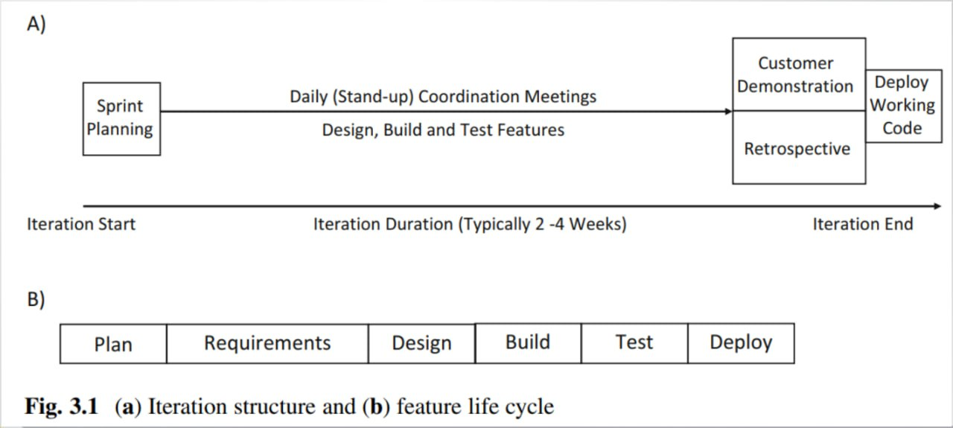

Figure 2

Iteration structure showing the lifecycle of features through Plan → Requirements → Design → Build → Test within each sprint.

This diagram reflects how we structured each 1-week sprint: we planned, broke down user stories, designed, built locally, and tested before merging.

### 3.1.8. Code Publication & Versioning Strategy

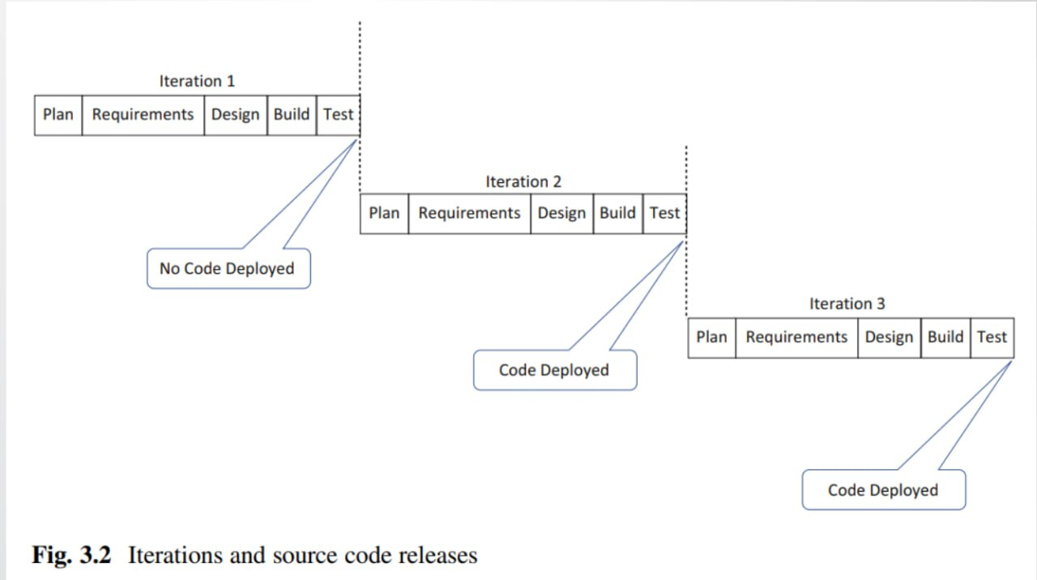

Figure 3

## 2.2. Remote Pair Programming for Complex Tasks

Although our team was small and partially co-located, we operated as a **virtual team** due to varying schedules and remote collaboration. To overcome the challenges of asynchronous development, we adopted **Remote Pair Programming** during critical implementation phases—especially for complex services like authentication, AI job matching logic, and cross-service integration.

### 3.2.1 Purpose and Benefits

* **Tactical Collaboration**: We used remote pair programming as a focused tactic to tackle complex logic, resolve integration bugs, or review sensitive code (e.g., security features, async flows, database interactions).
* **Real-time Code Quality Feedback**: One member acted as the **Driver** (writing the code), while the other was the **Navigator** (reviewing in real time, thinking about structure, edge cases, and design consistency).
* **Onboarding Support**: When a team member worked on an unfamiliar service, pair programming was used to onboard them quickly without long delays or documentation overhead.

### 3.2.2 Setup and Approach

* We used **Google Meet** for implementation sessions.
* Pairing was scheduled during sprint planning when high-risk or shared ownership tasks were identified.
* Sessions had **clear goals** and were time-boxed to avoid fatigue and maintain flow.
* We occasionally used the **ping-pong** method: one person wrote tests, the other wrote the implementation, and then roles were swapped.

## 2.3. Managing a Multi-Service Platform with Scrum

Our project consists of four core services, each with its own focus, but all contributing to a

unified platform. Scrum helped us manage this structure effectively:

* **Single Product Backlog**: Centralized and prioritized across all services. This ensured that we always focused on the most impactful items regardless of where they belonged in the system.
* **Service-Focused Sprint Goals**: Each sprint goal either cut across multiple services or focused on delivering complete functionality within one. This avoided context switching and maintained team focus.
* **Example**: One sprint focused on user authentication (Auth + Frontend), while another focused on job listing filtering and display logic (Job Service + Search Layer).

## 3.4. Project Management Tools: Jira

We used **Jira** as our main project management and tracking tool, configured to reflect Scrum best practices.

**Jira** is a **project management and issue tracking software** developed by **Atlassian**. It is widely used by teams to plan, track, and manage tasks, bugs, and agile (Scrum & Kanban)   
workflows.

**Key Features of Jira:**

* **Issue Tracking** – Log and track bugs, tasks, and improvements.
* **Agile Project Management** – Supports Scrum and Kanban boards for sprint planning.
* **Customizable Workflows** – Adapt processes to team needs.
* **Dashboards & Reports** – Visualize progress with burndown charts, velocity reports, etc.
* **Integration** – Works with Confluence, Bitbucket, Slack, and other tools.

### 3.4.1. Epics, User Stories, and Tasks

* **Epics**: Represented large features or services (e.g., AI Recommendation, Job Matching,

Authentication).

* **User Stories**: Written in user-centric format and linked to the product goals.
* As a job seeker, I want to receive personalized job listings based on my profile so that I can find relevant opportunities faster.
* **Tasks/Sub-tasks**: Broke user stories down into actionable development items with effort

estimates.

### 3.4.2. Sprint Board and Burndown Charts

* The Jira board had columns for To Do, In Progress, Code Review, and Done.
* **Burndown Charts** were used to track progress during each sprint. Irregularities in the burndown graph helped us identify underestimations or scope creep early.

### 3.4.3. Visual Artifacts from Jira Workspace

## 3.5. Version Control Strategy

Effective version control is the backbone of collaborative software development. For this project, we utilized Git, a distributed version control system, and managed our codebase within a centralized **GitHub Organization**. This approach provided a structured environment for code management, collaboration, and quality assurance.

<https://github.com/Nuhoud>

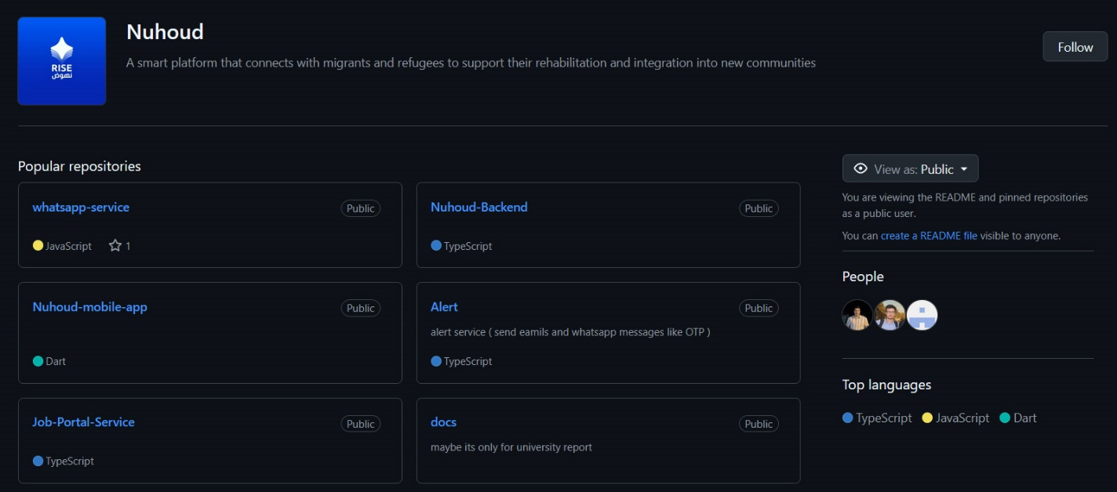

Figure 4

By centralizing our repositories in one organization, we achieved a transparent overview of all ongoing work. Any team member could see the status of different services, track feature development, and understand the overall architecture at a glance. This was particularly crucial for our multi-service platform, as it helped us manage dependencies and coordinate cross-service integrations.

## 2.6. Communication and Collaboration

Effective communication and collaboration were essential to the success of our self-organizing team, especially given our hybrid work environment. We established clear communication channels and structured interactions to ensure transparency, accountability, and fast feedback.

### 3.6.1 Primary Communication Channels

* **Google Meet**: Used for real-time meetings such as sprint planning, sprint reviews, and occasional ad-hoc discussions.
* **Telegram Group**: Our central communication hub. We organized conversations into topic-specific threads to maintain clarity and focus:
  + #visual-identity: UI/UX and branding discussions.
  + #discussion: General project decisions, blockers, and coordination.
  + #files-and-docs: Shared links to documentation, files, and assets.

### 3.6.2 Meeting Cadence

* **Weekly Sprint Meetings**:
  + Sprint Planning at the start of each sprint.
  + Sprint Review/Demo at the end of the sprint.
* **Daily Async Stand-ups**:
  + Team members posted brief updates (what was done, what’s next, blockers) in the Telegram #discussion thread or via GitHub issue comments.

# Chapter 4: Requirements Engineering

## 4.1 Requirements Elicitation

The requirements for the Nuhoud system were gathered through a multi-faceted process designed to ensure a comprehensive understanding of stakeholder needs and market opportunities.

1. **Stakeholder Identification:** The initial step was to identify the key stakeholders, which were categorized into three groups: Job Seekers, Employers, and System Administrators. The distinct needs and goals of each group formed the basis of the feature set.
2. **Competitive Analysis:** A thorough analysis of existing platforms, primarily LinkedIn, Indeed, and Glassdoor, was conducted. This helped in establishing a baseline of essential features for a job portal and, more importantly, in identifying gaps in the market. The analysis revealed an opportunity for a more personalized, guidance-oriented platform, which led to the conception of Nuhoud's AI-driven features.
3. **Brainstorming Sessions:** The project team held several brainstorming sessions to innovate on the core concept. These sessions focused on how to differentiate Nuhoud from its competitors, leading to the core ideas of providing personalized career plans and recommended skills.
4. **Modeling and Prototyping:** To clarify and refine the requirements, visual models were created. **Use Case Diagrams** were developed to map out the interactions between users and the system, while **Class Diagrams** were designed to define the data structures and relationships within the system. These models served as a blueprint for development and a tool for validating the system's logic and scope.

## 4.2 Functional Requirements

### 4.2.1 User Management

* The system shall allow individuals to register as a 'Job Seeker' or 'Employer'.
* The system must enforce account verification via an OTP sent to the user's registered email or mobile number.
* Registered users must be able to log in securely with their credentials.
* The system shall provide a "Forgot Password" functionality that allows users to reset their password securely.
* Job Seekers shall be able to create and edit a detailed personal profile, which must include sections for personal information, education, work experience, certifications, and skills.
* Administrators shall have the capability to view a list of all users, modify user details, and delete user accounts from the system.

### 4.2.2 Job Application Flow

* Employers shall be able to create, publish, and edit job offers, specifying details such as job title, description, required skills, experience level, and location.
* Job Seekers shall be able to search for job offers using keywords and apply filters based on criteria like job type, experience, and location.
* Job Seekers shall be able to view the complete details of any job offer.
* Job Seekers must be able to submit an application to a job offer, attaching their profile.
* Employers must be able to view a list of all applications received for each of their job offers.
* Employers shall be able to change the status of an application (e.g., "Viewed", "Under Review", "Shortlisted", "Rejected") and provide private feedback notes.
* Job Seekers must be able to view and track the status of all their submitted applications.

### 4.2.3 Notification & Alerts

* The system must send an automated notification to a user's registered email or WhatsApp upon a change in their application's status.
* The system shall send a notification to an employer when a new application is submitted for their job offer.
* The system shall send OTPs for user verification and password reset procedures.
* The system may send periodic alerts to employers regarding job offers that are nearing their expiration date.

### 4.2.4 AI Recommendations

* The system shall analyze a Job Seeker's complete profile, including their skills, experience, and stated career goals.
* Based on the profile analysis, the system's AI engine must generate and display a list of recommended skills.
* The system shall generate a personalized career development plan, suggesting courses and improve skills steps.
* The system shall proactively recommend job offers to users that are a strong match for their profile.

## 4.3 Non-Functional Requirements

Non-functional requirements focus on **how** the system performs and operates

• **Scalability**: The system must scale to handle growing numbers of users, employers, and job postings. A microservices architecture (e.g. separate services for user man-agement, job search, notifications, AI processing) provides horizontal scalability. Mi-croservices architectures are known to be easily scalable and highly resilient, enabling components to be scaled independently.

• **Availability** & **Reliability**: Core services (authentication, OTP delivery, job search) must be highly available (minimal downtime). We will deploy redundant instances across zones  
 (e.g. clustered databases, replicated message brokers). Health checks and auto-restart policies ensure that if a service instance fails (e.g. due to an exception), it can be recovered without user impact. A service should only accept traffic when it is healthy (readiness probes).

• **Security**: User data and transactions must be protected. Authentication uses OTP (de-livered securely via WhatsApp/email) and strong password rules. We will use JWT tokens for session management, ensuring stateless, tamper-evident authentication be-tween front-ends and   
back-ends. Access control is enforced by role (e.g. only admins access admin APIs, employers can only edit their own postings). Sensitive data (pass-words, tokens) is encrypted in transit (HTTPS) and at rest (hashed storage). Secure coding practices and dependency checks mitigate common vulnerabilities. (The OTP approach itself is standard security practice: OTPs are   
one-time codes that expire and are sent only to the verified user, providing strong two-factor assurance.)

• **Performance**: The user-facing APIs should respond quickly. Database queries should use indexes and pagination to meet performance goals under load.

• **Interoperability**: The system should integrate with external services. For AI features, we will use standard APIs to call external ML services (OpenAI GPT). The notification component must integrate with messaging gateways (e.g. WhatsApp Business API, email SMTP) via well-defined connectors. We will use standard data formats (JSON, protobuf) and APIs so that new channels or AI models can be added with minimal friction.

• **Maintainability**: Code and services must be easy to update and extend. A micro-services   
design inherently promotes loose coupling: each service encapsulates a busi-ness capability and has a well-defined interface. This means services (e.g. user service, job service, notification   
service) can be developed, tested, and deployed independently. The codebase will follow clean architecture and domain-driven design (DDD), so do-main logic is organized around business concepts. Automated unit and integration tests (including for critical flows like OTP and   
applications) ensure changes don’t break ex-isting functionality.

## 4.4 Use Case Diagram

Figure 5

|  |  |  |
| --- | --- | --- |
| Title | User Registeration | |
| Actor | New User | |
| description | Allows new users to create an account in the system | |
| precondition | User is not already registered | |
| postcondition | User account is created and stored in the database | |
| Flow event | actor | system |
| User enters registration information (email, password, mobile) |  |
|  | - Validates input data - Checks if email/mobile already exists  - generta otp  - send otp |
|  | enter otp |  |
|  |  | - Validate otp  - delete otp  - Creates new user account  - Returns jwt token |
| Critical scenarios | scenario | System response |
| Duplicate email/mobile Response | returns error "Email/Mobile already exists" |
|  | Invalid input format | System returns validation error messages |
|  | Failed to send OTP | System logs error |
|  | Invalid OTP | System returns "Invalid OTP" |
|  | Expired OTP | System returns "OTP expired" |

## 4.5 Use Case Specifications

|  |  |  |
| --- | --- | --- |
| Title | User Login | |
| Actor | Registered User | |
| description | Allows users to log in to their account | |
| precondition | User has a registered account | |
| postcondition | User is authenticated and receives access token | |
| Flow event | actor | system |
| User enters email/mobile and password |  |
|  | - Validates credentials - Checks if user exists  - Verifies password  - Generates and returns access token |
| Critical scenarios | scenario | System response |
| Invalid credentials | System returns "Invalid credentials" |
|  | Account not found | System returns " identfier or password not correct" |
|  | Invalid password | System returns "identfier or password not correct" |

|  |  |  |
| --- | --- | --- |
| Title | User Login | |
| Actor | Registered User | |
| description | Allows users to log in to their account | |
| precondition | User has a registered account | |
| postcondition | User is authenticated and receives access token | |
| Flow event | actor | system |
| User enters email/mobile and password |  |
|  | - Validates credentials - Checks if user exists  - Verifies password  - Generates and returns access token |
| Critical scenarios | scenario | System response |
| Invalid credentials | System returns "Invalid credentials" |
|  | Account not found | System returns " identfier or password not correct" |
|  | Invalid password | System returns "identfier or password not correct" |

|  |  |  |
| --- | --- | --- |
| Title | Reset Password | |
| Actor | User | |
| description | allows users to reset their password using OTP verification | |
| precondition | User has an existing account | |
| postcondition | User's password is updated | |
| Flow event | actor | system |
| Requests password reset |  |
|  | - Validates user existence - Generates OTP and stores it  - Sends OTP via WhatsApp/Email |
|  | Receives OTP and enters it |  |
|  |  | -Validates OTP |
|  | Enters new password |  |
|  |  | Updates password and clears OTP |
| Critical scenarios | scenario | System response |
| User not found | returns "User not found" |
|  | Invalid OTP | returns "Invalid OTP" |
|  | OTP expired Response | returns "OTP expired" |

|  |  |  |
| --- | --- | --- |
| Title | Admin User Creation | |
| Actor | Admin | |
| description | Allows admin to create new admin users | |
| precondition | Actor is authenticated as sadmin | |
| postcondition | New admin user is created with admin privileges | |
| Flow event | actor | system |
| Provides admin user details |  |
|  | - Validates super privileges - Creates admin user with specified permissions  - Returns success message |
| Critical scenarios | scenario | System response |
| Insufficient privileges | eturns "Unauthorized - admin required" |
|  | Duplicate admin email | System returns "Admin already exists" |
|  | Invalid input | returns validation errors |

# 

|  |  |  |
| --- | --- | --- |
| Title | Profile Information Setup | |
| Actor | User | |
| description | Allows users to set up their profile information in two steps | |
| precondition | User is authenticated | |
| postcondition | User's profile information is created | |
| Flow event | actor | system |
| Provides basic profile details |  |
|  | - Validates input - Stores basic information  - Suggest skills (using AI) and returns skills to user |
|  | enter skills |  |
|  |  | - Validates complete profile  - Finalizes profile creation  - retrun a AI-generated personal development plan |
| Critical scenarios | scenario | System response |
| Invalid basic information | System returns validation errors |
|  | Missing required fields | prompts for required information |

|  |  |  |
| --- | --- | --- |
| Title | Profile Information Update | |
| Actor | User | |
| description | Allows users to update their profile information | |
| precondition | User is authenticated and has a profile | |
| postcondition | User's profile information is updated | |
| Flow event | actor | system |
| - Selects profile section to edit  - Provides updated information |  |
|  | - Validates changes - Updates profile information  - Returns updated profile |
| Critical scenarios | scenario | System response |
| Invalid updates | returns validation errors |

|  |  |  |
| --- | --- | --- |
| Title | User Account Deletion | |
| Actor | Admin | |
| description | Allows admin to delete user accounts | |
| precondition | Actor is authenticated as admin | |
| postcondition | User account is deleted | |
| Flow event | actor | system |
| Selects user to delete |  |
|  | - Validates admin privileges - Deletes user account and associated data  - Returns confirmation |
| Critical scenarios | scenario | System response |
| Insufficient privileges | returns "Unauthorized - Admin required" |
|  | User not found Response | returns "User not found" |
|  | Attempt to delete admin | returns "Cannot delete admin account" |

|  |  |  |
| --- | --- | --- |
| Title | Post a Job Offer | |
| Actor | Employer | |
| description | An employer posts a new job offer to the system. The job offer includes details such as title, description, required skills, and company information | |
| precondition | The employer must be authenticated | |
| postcondition | A new job offer is created in the system and is available for users to view and apply for. | |
| Flow event | actor | system |
| - Navigates to the "Post a Job Offer" page  - Fills in the job offer details form  - Submits the form. |  |
|  | - Receives the request to create a new job offer. - Validates the provided data.  - Creates a new job offer record in the database.  Returns a success message to the employer. |
| Critical scenarios | scenario | System response |
| Invalid data | returns validation errors |
|  | The employer is not authenticated | authorization error |

|  |  |  |
| --- | --- | --- |
| Title | Update Job Offer Status | |
| Actor | Admin/Employer | |
| description | An admin or the employer who posted the job offer updates its status | |
| precondition | The actor must be authenticated and have the necessary permissions | |
| postcondition | The status of the job offer is updated in the database. | |
| Flow event | actor | system |
| - Selects the new status.  - Confirms the update. |  |
|  | - Verifies the actor's permissions. - Updates the job offer's status in the database.  - Returns a success message. |
| Critical scenarios | scenario | System response |
| job offer does not exist | returns a "not found" error |
|  | actor does not have permission | authorization error |

|  |  |  |
| --- | --- | --- |
| Title | Search for Job Offer | |
| Actor | User/Employer/Admin | |
| description | A user, employer, or admin searches for job offers using a query. | |
| precondition | The actor is on a page with a search functionality. | |
| postcondition | A list of job offers matching the search query is displayed. | |
| Flow event | actor | system |
| - Enters a search query (e.g., keywords, location, company). |  |
|  | - Receives the search query.  - Searches the database for job offers that match the query.  - Returns the list of matching job offers. |
| Critical scenarios | scenario | System response |
| No job offers match the search query. | displays a message indicating that no results were found. |

|  |  |  |
| --- | --- | --- |
| Title | View Job Offer Details | |
| Actor | User/Admin/Employer | |
| description | views the detailed information of a specific job offer. | |
| precondition | The job offer exists in the system. | |
| postcondition | The details of the selected job offer are displayed. | |
| Flow event | actor | system |
| Selects a job offer from a list or search results. |  |
|  | - Retrieves the job offer information from the database.  - Displays the full details of the job offer.  . |
| Critical scenarios | scenario | System response |
| job offer does not exist | returns a "not found" error |

|  |  |  |
| --- | --- | --- |
| Title | Submit Application | |
| Actor | User | |
| description | A user submits an application for a job offer. | |
| precondition | The user must be authenticated. The job offer must be open for applications. | |
| postcondition | An application for the job offer is created and linked to the user's profile. The employer is notified of the new application. | |
| Flow event | actor | system |
| - Clicks the "Apply" button. |  |
|  | - extract snapshoot of user info  - Creates a new application record in the database, associating it with the user and the job offer.  Sends a notification to the employer and user  - Returns a success message to the user. |
| Critical scenarios | scenario | System response |
| user is not authenticated | Authorization error |
|  | job offer is no longer accepting applications | The system displays a message that the job offer is closed |
|  | The user has already applied for this job offer | have already applied |

|  |  |  |
| --- | --- | --- |
| Title | Track Application | |
| Actor | User | |
| description | A user tracks the status of their submitted applications and sees any notes from the employer | |
| precondition | The user must be authenticated and have submitted at least one application. | |
| postcondition | The user can view the current status and any employer notes for their applications. | |
| Flow event | actor | system |
| - Navigates to their "My Applications" page |  |
|  | Retrieves the list of the user's applications from the database. |
|  | - Selects an application to view its status. |  |
|  |  | - Displays the applications with their current status (e.g., "Submitted," "Under Review," "Hired," "Not Selected") and any notes from the employer. |
| Critical scenarios | scenario | System response |
| user has not submitted any applications | message indicating that no applications have been submitted. |

|  |  |  |
| --- | --- | --- |
| Title | Browse Job Offer Applications | |
| Actor | Employer | |
| description | employer browses the applications submitted for a job offer they posted. | |
| precondition | The employer must be authenticated and be the owner of the job offer. | |
| postcondition | The employer can view a list of applicants for their job offer. | |
| Flow event | actor | system |
| - Navigates to the "My Job Offers" page.  - Selects a job offer to view its applications |  |
|  | - Retrieves all applications for the selected job offer.  - Displays a list of applicants with summary information. |
| Critical scenarios | scenario | System response |
| employer is not the owner of the job offer | Authorization error |
|  | There are no applications for the job offer | message indicating that no applications have been received yet |

|  |  |  |
| --- | --- | --- |
| Title | Browse Job Offer Applications | |
| Actor | Employer | |
| description | An employer updates the status of an application and can add a note for the applicant. | |
| precondition | The employer must be authenticated and be the owner of the job offer for which the application was submitted. | |
| postcondition | The application's status is updated, and a note may be added. The applicant can see the new status and note. | |
| Flow event | actor | system |
| - Selects an application to update.  - Chooses a new status from a dropdown list  - Adds a note for the applicant.  - submit |  |
|  | - Updates the application's status and adds the note in the database.  - Sends a notification to the applicant about the status change.  - Returns a success message to the employer. |
| Critical scenarios | scenario | System response |
| The employer does not have permission to update the application. | Authorization error |

# Chapter 5: System Design and Architecture

## 5.1. Architectural Style: Microservices

**What is Microservices Architecture?**

Microservices architecture (often shortened to microservices) refers to an architectural style for developing applications. Microservices allow a large application to be separated into smaller independent parts, with each part having its own realm of responsibility. To serve a single user request, a microservices-based application can call on many internal microservices to compose its response.

**Monolithic vs. microservices architecture**

Traditional monolithic applications are built as a single, unified unit. All components are tightly coupled, sharing resources and data. This can lead to challenges in scaling, deploying, and maintaining the application, especially as it grows in complexity. In contrast, microservices architecture decomposes an application into a suite of small, independent services. Each microservice is self-contained, with its own code, data, and dependencies. This approach offers several potential advantages:

* **Improved scalability:** Individual microservices can be scaled independently based on their specific needs
* **Increased agility:** Microservices can be developed, deployed, and updated independently, enabling faster release cycles
* **Enhanced resilience:** If one microservice fails, it doesn't necessarily impact the entire application
* **Technology diversity:** The flexibility of microservices allows teams to use the most suitable technology for each service

### 5.1.1. Rationale for Choosing Microservices

The Nuhoud system uses a microservices architecture to maximize scalability and flexibility. Each microservice can be scaled independently – for example, if the Job Service experiences heavy load, only its instances need to be increased. This avoids over-provisioning and improves resource utilization. Microservices also enforce **separation of concerns**: distinct business   
domains (user management, job postings, notifications, AI) reside in separate services, making each codebase smaller and more maintainable. Changes or faults in one service (say, the AI   
Recommendation Service) do not directly affect others, improving fault isolation. Independent services can be deployed and updated on their own schedules, enabling faster iteration.   
In practice, we organize teams and development pipelines around these bounded domains; for example, one team owns user/profile features while another owns job postings. Overall,   
microservices offer the agility (parallel development, polyglot persistence), resilience, and fine-grained scalability that suit Nuhoud’s requirements.

* **Scalability:** Each service can be scaled on demand (e.g. adding instances of the Job Service) without scaling unrelated components.
* **Separation of Concerns:** Services are aligned to single business capabilities (following the Single Responsibility Principle) so they are cohesive and independently maintainable.
* **Independent Deployment:** Teams can deploy or upgrade services separately, reducing risk. The database-per-service pattern decouples data, so updates do not require cross-database schema changes.

These factors make microservices well-suited for Nuhoud’s event-driven, domain-oriented system. (As one guide notes, “Bounded Contexts (each BC correlates to a microservice)” when using DDD principles

### 5.1.2. Service Decomposition and Granularity

We decomposed Nuhoud according to Domain-Driven Design (DDD). Each microservice corresponds to a bounded context – a coherent subdomain with its own data and logicIn Nuhoud, the main services are:

* **Authentication & User Service:** Manages the ***User*** domain. It handles registration, login (email or phone), profiles (personal info, experience, education, skills) and tracks each user’s job applications and development history. All user-related data is stored here. When an OTP is needed, it generate it and invokes the Alerts Service over gRPC to send it.
* **Alerts & Notifications Service:** Manages the ***Notifications*** domain. It exposes a gRPC interface for sending one-time passwords (used by Auth) via WhatsApp or email.   
  It subscribes to Kafka events (e.g. job application or status events) to notify users of job matches, application updates
* **AI Recommendation Service:** Handles the ***Recommendation*** domain. Orchestrated by an n8n workflow, it analyzes user profiles (skills, experience) and job data to generate personalized job recommendations and Personal Development Plans. It relies on external AI model ( Gemini ).
* **Job Service:** Encapsulates the ***Job Posting*** domain. Employers post jobs here; users browse and apply. It tracks job status (Active, Closed, Draft, Expired) and application status. When a user submits an application, this service records it and consume a   
  job.application.submit Kafka message to proccess it. when an application’s status changes, it emits job.application.statusChange Kafka event.

Each service thus owns a single, well-defined domain. This decomposition follows best practices (DDD/Single-Responsibility) by grouping related functionality within one service. For example, all user authentication and profile logic stays in the User Service, and job logic stays in the Job Service. This keeps services highly cohesive and loosely coupled.

## 5.2. High-Level System Architecture Diagram

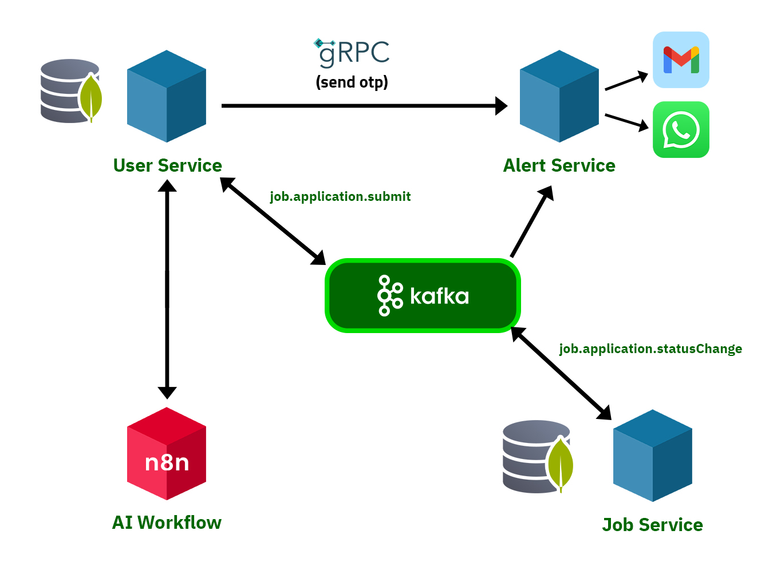

Figure 6

the diagram shows four main service blocks (User, Job, Alerts, AI) each connected to its own MongoDB, and lines between them indicating gRPC or Kafka links. Kafka occupies the center as the pub/sub backbone. External systems (WhatsApp, email, AI APIs) attach to the Alerts and AI services respectively. This topology illustrates how each service is a self-contained unit, with the grpc, Kafka, and http request enabling communication between them.

## 5.3. Core Design Principles

### 5.3.1. SOLID Principles Application

The Nuhoud system demonstrates consistent adherence to the SOLID principles across its microservices. The architecture benefits from the structure and conventions of the NestJS framework, with good separation of concerns and use of dependency injection. The application of these principles is outlined below with emphasis on the User and Job Services.

**Single Responsibility Principle (SRP):**

SRP is effectively applied throughout the system. In both the User and Job services, controllers (e.g., job-offers.controller.ts, application.controller.ts) handle request/response logic, while service classes (e.g., job-offers.service.ts, users.service.ts) encapsulate business logic and data access. DTOs are used for input validation and data transfer, and entities define the persistence models. This clear separation aligns well with SRP. However, in the User service, classes such as AuthService and UsersService are beginning to accumulate multiple responsibilities (e.g., authentication logic, role management, hashing), which may merit refactoring into more specialized components as complexity grows.

**Open/Closed Principle (OCP):**

OCP is evident in the consistent use of class extension and composition patterns. For example, UpdateJobOfferDto extends PartialType(CreateJobOfferDto), allowing behavior to be extended without modifying base structures. Decorators and guards in the authentication domain are also designed to be extended for new roles or permissions. In service logic, new functionality is generally introduced through new methods rather than altering existing ones, which preserves stability while enabling change.

**Liskov Substitution Principle (LSP):**

LSP is upheld through the use of well-structured DTOs and inheritance. Extended DTOs like UpdateJobOfferDto are used interchangeably in contexts where their base classes (CreateJobOfferDto) are expected. The system avoids violating substitutability by ensuring that extended types do not alter the expected behavior of their base types. No structural or behavioral violations were observed in the service or controller layers.

**Interface Segregation Principle (ISP):**

The codebase favors small, purpose-driven abstractions such as DTOs and Mongoose models. While explicit TypeScript interfaces are not widely used for services, each service class exposes narrowly scoped behavior aligned with a specific domain. There are no bloated or general-purpose interfaces forcing consumers to depend on unused methods. Future improvements could include formalizing interfaces for core services to further enhance testability and flexibility.

**Dependency Inversion Principle (DIP):**

DIP is strongly supported by the use of NestJS’s dependency injection mechanism. Services are injected into controllers and into one another via constructor injection, decoupling high-level modules from concrete implementations. For instance, the ApplicationService and JobOffersService inject Kafka clients and database models using NestJS providers. While the direct use of new this.model(...) is necessary for Mongoose models, all external services—such as messaging or notification services—could benefit from being abstracted behind interfaces to facilitate mocking and future replacement.

### 5.3.2. Design Patterns

This section outlines the design patterns currently implemented across the **Job Service** and **User Service**, evaluates how they are applied in the context of the NestJS framework

**1. Dependency Injection Pattern**

Dependency Injection (DI) is at the core of both services and is leveraged extensively through NestJS’s built-in DI system. Services, models, and external clients are injected using constructor injection with the @Injectable() decorator. Controllers consume these services without instantiating them manually, promoting clean separation of concerns and ease of testing.

**2. Decorator Pattern**

Both services rely heavily on the Decorator pattern. NestJS’s native decorators such as @Controller, @Post, @Body, @Injectable, and others are used throughout the application. Additionally, custom decorators like @Public() and @Roles() are used to encapsulate route-level metadata such as authentication and authorization requirements. DTO classes also use validation decorators from the class-validator library to enforce schema rules.

**3. Observer / Event Pattern**

The system implements the Observer pattern via Kafka. Events like job.application.submit and job.application.statusChange are emitted and consumed using @EventPattern, allowing asynchronous and decoupled communication between microservices. This pattern is particularly useful for maintaining the integrity of workflows like job applications and status updates without tight coupling.

**4. Module Pattern**

The application architecture is modular by design. Each feature domain (users, authentication, job offers, applications, etc.) is encapsulated in its own NestJS module. This promotes clean separation of responsibilities and makes the codebase scalable and easier to maintain.

**5. Singleton Pattern**

All services in the application are singletons by default due to NestJS’s service lifecycle. This ensures that shared dependencies such as database connections or utility classes are instantiated once and reused across the application lifecycle.

**6. Factory Pattern**

While not explicitly implemented with custom factory classes, the Factory pattern is present implicitly. NestJS and Mongoose rely on factories internally, for instance through SchemaFactory.createForClass() when defining schemas. The global exception handling pipeline also uses custom exceptionFactory functions to standardize error formats.

**7. Proxy Pattern**

The Proxy pattern is implemented indirectly through NestJS guards and interceptors. Guards such as AuthGuard and RolesGuard act as access control proxies that execute logic before reaching the actual route handler, enforcing authentication and authorization policies transparently.

## 5.4. Inter-Service Communication

### 5.4.1. Communication Patterns

Nuhoud employs a hybrid communication model. Public-facing APIs use traditional REST/HTTP, allowing clients (web or mobile) to interact with services in a simple, standardized way.

For example, logging in or searching jobs are done via REST endpoints. Internally, synchronous calls between services use gRPC. gRPC offers high-performance RPC over HTTP/2 with Protocol Buffers, which is more efficient than JSON/HTTP for inter-service calls. We use gRPC for operations where low latency is important (such as sending OTPs or real-time status checks). For asynchronous workflows and loose coupling, we use Apache Kafka. Services publish events (fire-and-forget) and other services subscribe to them. This event-driven approach ensures that services remain decoupled: a service emits an event and does not wait for a response.

### 5.4.2. Asynchronous Communication with Apache Kafka

Kafka works well as a replacement for a more traditional message broker. Message brokers are used for a variety of reasons (to decouple processing from data producers, to buffer unprocessed messages, etc). In comparison to most messaging systems Kafka has better throughput, built-in partitioning, replication, and fault-tolerance which makes it a good solution for large scale message processing applications.

Asynchronous, event-driven communication is handled by Apache Kafka. We define specific Kafka events for key domain activities. For example, when a user applies to a job, the Job Service publishes a job.application.submit event. When an application’s status changes (approved/rejected), it publishes job.application.statusChange. Other services subscribe to these events as needed.

Kafka provides a robust, scalable backbone for Nuhoud’s asynchronous communication, enabling reliable event delivery and independent service processing.

### 5.4.3. Synchronous Communication with gRPC

gRPC is a modern, high-performance, open-source framework for building APIs. It utilizes Remote Procedure Calls (RPC) for efficient communication between services, especially in microservices architectures. gRPC leverages HTTP/2 for transport and Protocol Buffers (protobuf) for serialization, resulting in faster and more lightweight communication compared to traditional REST APIs using JSON or XML.

Key Features and Benefits:

* High Performance:

gRPC utilizes HTTP/2 and protobuf, which leads to reduced latency and overhead compared to REST APIs.

* Language Agnostic:

gRPC supports various programming languages, allowing for polyglot microservice architectures.

* Contract-First API Development:

gRPC uses Protocol Buffers as an Interface Definition Language (IDL), ensuring a well-defined contract between services.

* Streaming Support:

gRPC offers support for client, server, and bidirectional streaming, making it suitable for real-time and data-intensive applications.

For synchronous inter-service calls that require low latency, we use gRPC. Notably, the Auth Service calls the Alerts Service’s gRPC API to send OTPs to users. This choice was made for performance reasons: gRPC runs over HTTP/2 with binary serialization (Protocol Buffers), which significantly reduces overhead. As one analysis notes, gRPC/HTTP2 can transmit messages “up to 10 times faster” than traditional HTTP1.1/REST.

## 5.5. Data Management Strategy (Database-per-Service)

We follow a database-per-service pattern using MongoDB for each service’s datastore. Each microservice has its own MongoDB instance or cluster and holds only its own data: the User Service stores users and profiles, the Job Service stores jobs and applications.

This encapsulation ensures loose coupling: a schema change in one service’s database has no impact on the others. All services use MongoDB (a document database) because our domain data (profiles, jobs, notifications) fits a flexible, schemaless model. Because services are isolated, we do not perform SQL-like joins across services. When data from another domain is needed, we use one of two approaches:

(1) the requesting service calls another service’s API synchronously, or (2) we replicate the necessary data asynchronously. To support efficient querying and avoid constant RPC calls, we do replicate selected data to read-optimized views.

. In summary, each service owns its MongoDB data and there are no live joins between databases.Controlled duplication of data (eventual-consistent views) is used only where needed for performance. This strategy maximizes service autonomy: each team can choose indexes and schemas suited to its needs, and the system remains scalable and fault-tolerant. Indeed, isolating data in this way helps ensure that the services are loosely coupled and supports independent scalability.

### 5.5.1. Data Modeling:

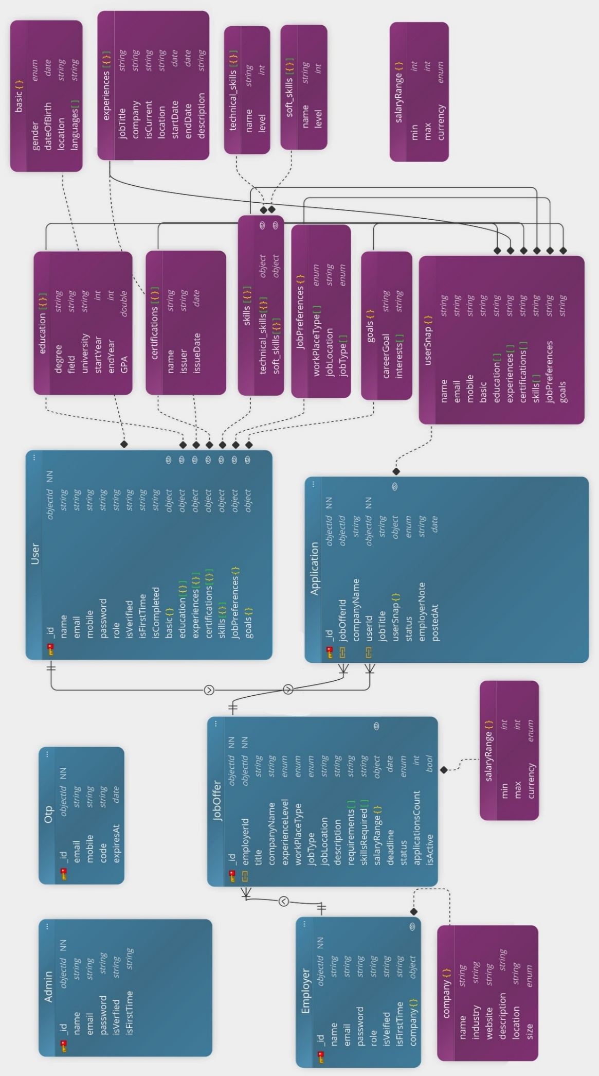

Figure 7

## 5.6. Class Diagram

Figure 8

## 5.7. AI Service Integration using n8n

# Chapter 6: Technology Stack and Rationale

## 6.1. Programming Language & Runtime: Node.js

Node.js is the chosen runtime for the backend due to its asynchronous, event-driven architecture. It is a JavaScript runtime designed to build scalable network applications. Node.js employs a non-blocking, single-threaded event loop that can handle many concurrent connections efficiently, making it well-suited to high-throughput server tasks. Furthermore, Node.js benefits from JavaScript’s popularity , it has been the most widely used language in recent developer surveys , and from a vast open-source ecosystem. In fact, npm (Node’s package manager) is the largest package registry in the world, providing ready-made modules that significantly accelerate development and improve maintainability. Together, these properties (high concurrency, rich ecosystem, and a large developer community) make Node.js a performant and productive choice for our microservice-based system.



Figure 9

Figure 10

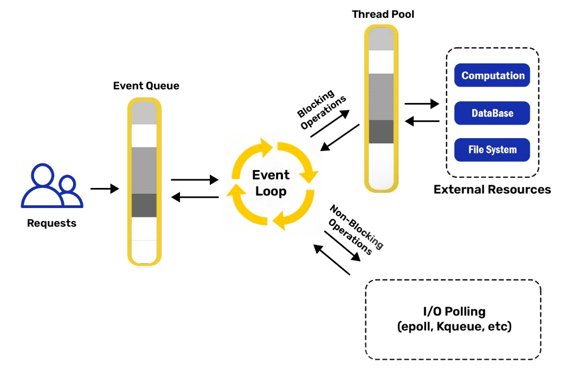

Figure 11

## 6.2. Backend Framework: NestJS

NestJS is a progressive Node.js framework built with TypeScript, chosen to structure the backend services. NestJS is described as a “progressive Node.js framework for building efficient, reliable and scalable server-side applications”. It introduces a modular architecture (inspired by Angular) that organizes code into self-contained modules and services, streamlining development and maintenance. Its built-in dependency injection and strong TypeScript type safety help catch errors at compile time and promote clean, testable code.



Figure 12

Figure 13

## 6.3. API Documentation: Swagger

the @nestjs/swagger module auto-generates a Swagger document from the code annotations. This approach provides an interactive, machine-readable API contract that is easy for developers and external clients to consume. Swagger’s advantages include automatic documentation generation (so that API docs stay in sync with code) and a built-in user interface for testing endpoints. As one source explains, “Swagger provides a unique and convenient platform to document, test, and write API structures”



Figure 14

## 6.4. Database and ODM: MongoDB with Mongoose

For data storage, MongoDB was selected as the primary database. MongoDB is a popular open-source NoSQL document database that stores data as JSON-like documents. This document oriented model provides a flexible schema, allowing the data model to evolve over time without rigid table definitions. MongoDB supports horizontal scaling (via sharding) and replication for high availability, enabling it to handle very large datasets and high traffic volumes. The JSON/BSON document format aligns naturally with JavaScript/Node.js, facilitating seamless data interchange between server and application code. To interface with MongoDB from Node, the Mongoose library (an Object Data Modeling – ODM – tool) was adopted. Mongoose enables developers to define schemas, models, and validation rules in Node.js, providing structure and consistency on top of MongoDB’s flexibility. According to MongoDB’s documentation, “Mongoose is an ODM (Object Data Modeling) library for MongoDB” that helps with data modeling, schema enforcement, model validation, and general data manipulation

Figure 15

Figure 16

## 6.5. Messaging/Event-Driven Architecture: Apache Kafka

[Apache Kafka](https://kafka.apache.org/) is a distributed streaming platform designed to handle large volumes of [real-time data](https://builtin.com/data-science/real-time-analytics). It’s an [open-source system](https://builtin.com/founders-entrepreneurship/open-source-future) used for stream processing, real-time [data pipelines](https://builtin.com/learn/tech-dictionary/data-pipeline) and data integration.

1. **Producer:** A producer generates a large amount of data and writes this into Kafka.
2. **Consumer:** Consumers act as end-users that read data from Kafka that comes from   
   producers.
3. 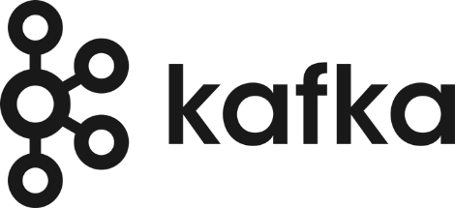**Topic:** Topic is a category or label on which records are stored and published. All Kafka records coming from   
   producers are organized into topics. Consumer applications read from topics.

Figure 17

1. **Brokers:** These are the Kafka servers that handle the data. Kafka brokers receives message from producers and stores them on its data
2. **Partition:** This is a unit of data storage. It’s a sequence of messages that is stored in a log and is   
   identified by a unique ID, known as the partition offset. Each partition is ordered and immutable, meaning that once a message has been written to a partition, it cannot be modified or deleted. A topic can have multiple partitions to handle a larger amount of data

## 6.5. RPC Communication: gRPC with Protocol Buffers

or inter-service RPC calls, gRPC with Protocol Buffers is employed. gRPC is a high-performance, open-source RPC framework developed by Google

Figure 18

gRPC was chosen for its efficiency and robust tooling: it provides high performance (HTTP/2 + Protobuf) and language-agnostic, type-safe service definitions, making it easier to build reliable, maintainable cross-service APIs

## 6.6. Containerization & Orchestration: Docker Compose

Docker is a platform that uses containerization to package and run   
applications. It allows developers to build, share, and run applications in isolated containers, ensuring consistency across different environments.

Figure 19

Docker Compose is used to containerize (Kafka and Kafdrop ) as a unified system. Docker Compose is a tool for defining and running multi-container Docker applications. In a single YAML file, and the entire stack can be started or scaled with a single command

## 6.7. Kafdrop Monitoring Tool: Kafdrop

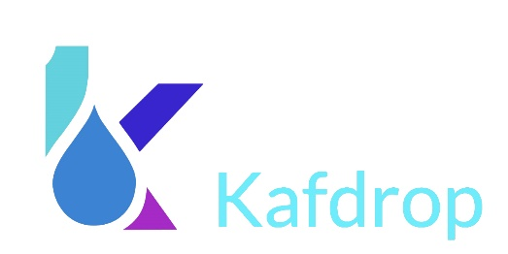While Kafka itself is a robust and high-throughput distributed log system, it lacks a native graphical interface for introspection. Kafdrop fills this gap by offering an intuitive interface to monitor and inspect Kafka activity during development and testing. Developers can browse topic metadata, view live messages within partitions, inspect headers and payloads, and validate that events are being published and consumed correctly.

Figure 20

# Chapter 7: Implementation

# Chapter 8: Testing

# Chapter 9: Conclusion and Future Work

## 9.1. Conclusion

## 9.2. Future Enhancements

## 9.3 Resources

# Appendices

Note:

……………………………………………

……………………………………………

……………………………………………

……………………………………………

……………………………………………

……………………………………………

……………………………………………

……………………………………………

……………………………………………

……………………………………………

……………………………………………

……………………………………………

……………………………………………

……………………………………………

……………………………………………

……………………………………………