**TANZANIA DRUG PREVENTION NETWORK (TDPN)**

**Campaign Concept Note**

**Title:** **Dawa za Kulevya Siyo Mchongo. Chukua Hatua, Linda Maisha Yako!**

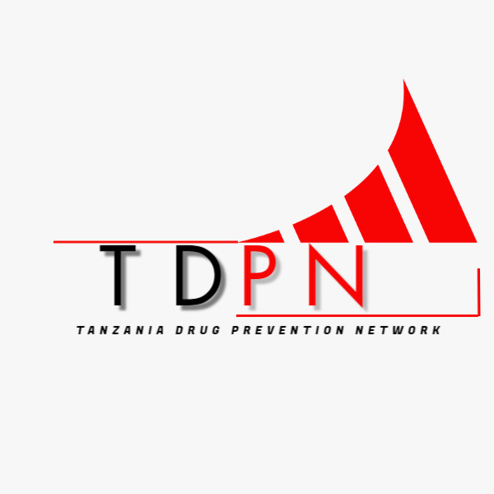

**Date: 25th November 2024**

**Prepared by**:

Tanzania Drug Prevention Network (TDPN)

**Contact Information:**

**Email**: Drugpreventiontanzania@gmail.com

**Phone**: +255 654 623 717 / +255 718 891 232

**Table of Contents**

1. Campaign Title ............................................................................................................ 2

2. Introduction ................................................................................................................ 2

3. Goal ............................................................................................................................. 2

4. Specific Objectives ...................................................................................................... 2

5. Target Audience .......................................................................................................... 2

6. Key Activities .............................................................................................................. 3

7. Expected Outcomes ................................................................................................... 4

8. Implementation Plan ................................................................................................. 4

9. Partnerships and Stakeholders .................................................................................. 4

10. Budget Estimate ...................................................................................................... 5

11. Monitoring and Evaluation ...................................................................................... 5

12. Conclusion ............................................................................................................... 6

**Concept Note**

**Campaign Title:**

Dawa za Kulevya Siyo Mchongo Chukua Hatua, Linda Maisha yako

**Introduction:**

Drug abuse is a growing concern in Tanzania, affecting individuals, families, and communities. It threatens the health, security, and socio-economic stability of our nation. Recognizing the urgency of this issue, the **Tanzania Drug Prevention Network (TDPN)** is launching a nation wide campaign titled **"Dawa za Kulevya Siyo Mchongo, Chukua Hatua, Linda Maisha Yako!** The campaign aims to empower Tanzanians, particularly the youth, to take decisive actions against drug abuse and promote a drug-free society.

**Goal:**

To create a nationwide awareness and action-oriented movement that educates, inspires, and mobilizes Tanzanians to protect themselves and their communities from the harmful effects of drug abuse.

**Specific Objectives:**

**1. Raise Awareness:** Educate the public on the dangers of drug abuse and its impact on individuals and communities.

**2. Behavioral Change:** Encourage positive lifestyle choices and the rejection of drug use.

**3. Community Engagement:** Involve community leaders, educators, health professionals, and law enforcement in collaborative efforts to combat drug abuse.

**4. Advocacy:** Strengthen national policies and strategies through stakeholder engagement and public support for anti-drug measures.

**Target Audience:**

**1.Primary Target:** Youth aged 15-35, who are at the highest risk of drug exposure.

**2. Secondary Target:** Parents, educators, community leaders, health professionals, law enforcement agencies, policymakers, and the general public.

**Key Activities:**

**1. Awareness Campaigns:**

Nationwide media outreach through TV, radio, newspapers, and social media platforms.

Creation and dissemination of jingles, short film posters, flyers, and educational materials.

**2. Community Engagement Events:**

Organizing interactive workshops, seminars, and forums in schools, universities, and communities.

Partnering with local artists, influencers, and public figures to amplify the message.

**3. Advocacy Drives:**

Collaboration with policymakers and stakeholders to strengthen anti-drug laws and policies.

Mobilizing public support for stricter enforcement of drug prevention measures.

**4. National Events:**

Hosting flagship events like **“Run for a Drug-Free Tanzania Marathon”** and **“Sing for a Drug-Free Tanzania Festival”** to engage and inspire the public.

Celebrating **“Award for a Drug-Free Tanzania Ceremony”** to recognize outstanding contributors to drug prevention efforts.

**Expected Outcomes:**

1. Increased public knowledge and understanding of the dangers of drug abuse.

2. Reduction in drug abuse cases among youth and other vulnerable groups.

3. Strengthened community and institutional collaborations in drug prevention efforts.

4. Enhanced public and private sector participation in creating a drug-free Tanzania.

**Implementation Plan:**

**Phase 1:** Planning and resource mobilization (1-2 months).

**Phase 2:** Media and material development (1 month).

**Phase 3:** Campaign rollout across Tanzania Mainland and Zanzibar (6-12 months).

**Phase 4:**  Monitoring, evaluation, and reporting (ongoing throughout and after the campaign).

**Partnerships and Stakeholders:**

The campaign will actively engage and collaborate with:

Government institutions (Drug control and Enforcement Authority - (DCEA), Prevention and Combating of Corruption Bureau - (PCCB)

Ministries of Education and Vocational Training, Health, Culture, Arts and Sports, President's Office, Regional Administration and Local Government Tanzania (PO-RALG)

and Home Affairs).

Civil society organizations and NGOs.

International organizations, UN Agencies, Embassy and donors.

Media houses, financial institutions, and mobile companies.

Faith-based organizations, Religious leaders and community leaders.

**Budget Estimate:**

The campaign requires an estimated budget of **Tsh 800,000,000/= (Eight Hundred Million Tanzanian Shillings.)**, allocated as follows:

Media and communication: 30%

Community events: 40%

Materials production: 15%

Logistics and coordination: 15%

**Monitoring and Evaluation:**

The campaign's impact will be measured through:

1. Surveys to assess changes in public awareness and attitudes.

2. Tracking participation in events and activities.

3. Evaluating reductions in drug abuse-related cases reported.

4. Reports from collaborating institutions and stakeholders.

**Conclusion:**

With its unique slogan and strategic activities, the campaign **"Dawa za Kulevya Siyo Mchongo. Chukua Hatua, Linda Maisha Yako!"** seeks to unify Tanzanians in the fight against drug abuse. By empowering individuals and communities, this initiative will contribute to a healthier, safer, and more prosperous Tanzania.