*Florida International University*

*School of Computing and Information Sciences*

Software Engineering Focus

Feature Document

User Story #**212 - Add more tools**

**Team Member:**

Justin Alvarez

**Product Owner(s)**:

Francisco Ortega

**Instructor**: Masoud Sadjadi

**User Story** Add more tools (to new Cinder integrated project)

* As a user, I would like to have a square creation tool, a circle creation tool. I would also like the save tool to actually work (finished from last sprint).

Acceptance Criteria

* All tools work
* All tools can be composed together
* Any other criteria specified in the sub-tasks are met

**Use Case** #**1 – Basic Drawing and transformations**

**Use Case Diagram**

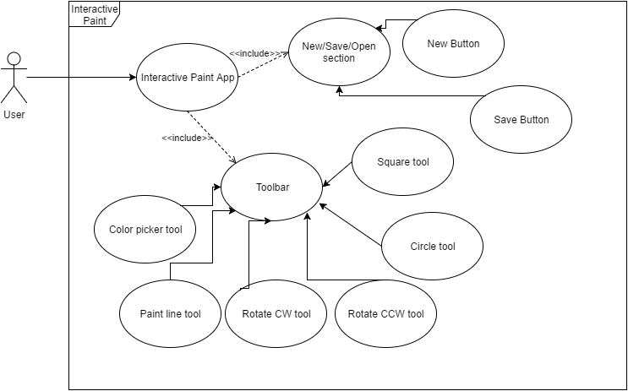

**Sequence Diagram**

Save files to disk:  


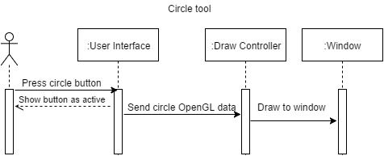

**Class Diagram**

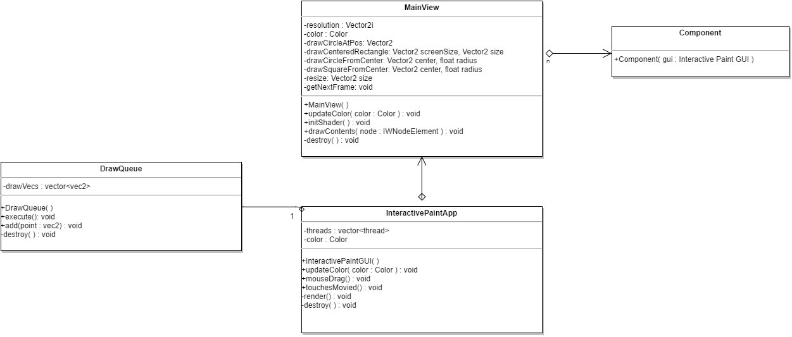

**Unit Test**

Test case: Draw circle

Purpose: Test to see if a circle is drawn properly

Preconditions: Color is set to a value c

Action: with circle tool active, press an initial position, O, and drag out a distance, r, from the center and release mouse

Expected result: Value of pixel at point r away from O should be the preset color c

Test case: Draw square

Purpose: Test to see if a square is drawn properly

Preconditions: Color is set to a value c

Action: with circle tool active, press an initial position, O, and drag out a distance, r, from the center and release mouse

Expected result: Value of pixel at point r away from O should be the preset color c

**Integration Test**

**Visual User Guide**

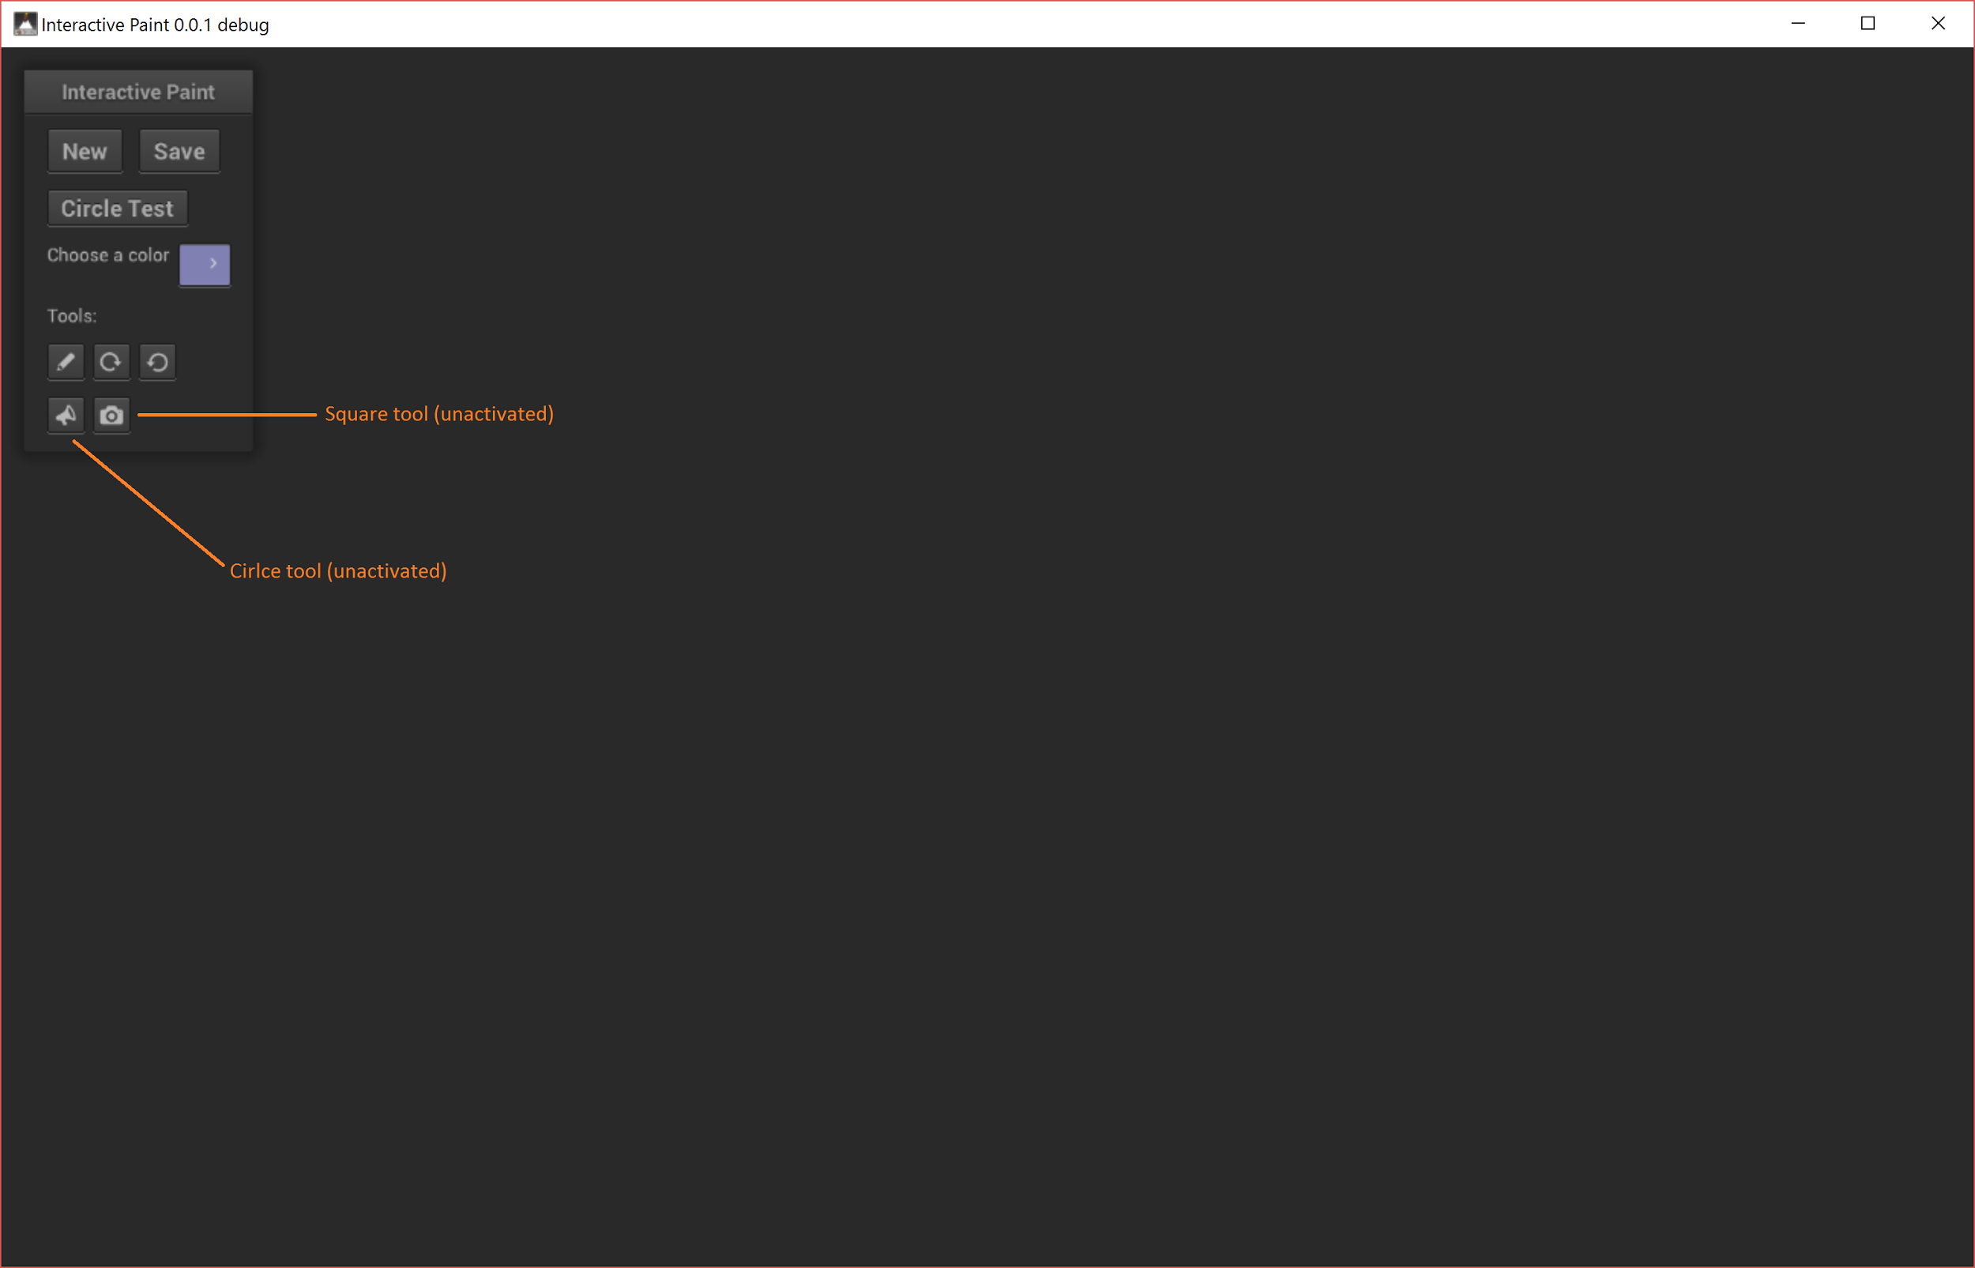

Drag your mouse with one of the tools selected to see a live preview. When released, a circle/square will be drawn

