*Florida International University*

*School of Computing and Information Sciences*

Software Engineering Focus

Feature Document

User Story #**241 - Integrate our work**

**Team Member:**

Justin Alvarez

**Product Owner(s)**:

Francisco Ortega

**Instructor**: Masoud Sadjadi

**User Story** Integrate our work

* As developers, Jose and I were working on slightly different things for the past sprints, but they need to be unified now so we can be ready for the final presentation

Acceptance Criteria

* Program compiles
* Both of our changes are working
* All merge conflicts are resolved

**Use Case #1 - Integrate code:**Use case starts when Developer(s) realize that their code can no longer be merged. Developer then refactors the code.

**Use Case Diagram**

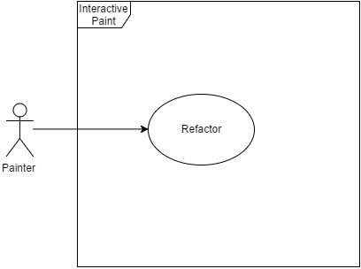

**Sequence Diagram**

This User Story was considered too simple for any sequence diagrams.

**Class Diagram**This is an updated class diagram after refactoring.



**Integration Tests**

The application was used on multiple machines and by multiple users before and after the refactoring and no changes were noticed.