*Florida International University*

*School of Computing and Information Sciences*

Software Engineering Focus

Feature Document

User Story #**242 - Add more tools (part 2)**

**Team Member:**

Justin Alvarez

**Product Owner(s)**:

Francisco Ortega

**Instructor**: Masoud Sadjadi

**User Story** Add more tools (part 2)

* As a user, I would like to have an endpoint select line tool, a text tool, and an open button.

Acceptance Criteria

* All tools work
* All tools work together
* Any other criteria specified in the sub-tasks are met

**Use Case #1 - Integrate code:**Use case starts when Developer(s) realize that their code can no longer be merged. Developer then refactors the code.

**Use Case Diagram**

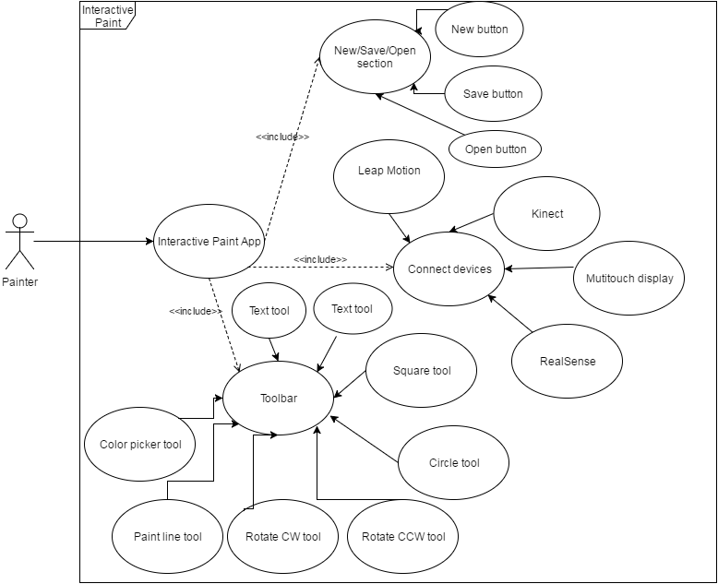

**Sequence Diagram**

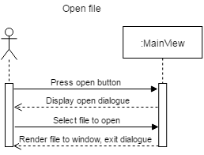

Text tool

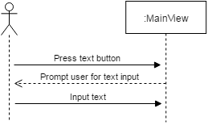

**Class Diagram**This is an updated class diagram after refactoring.

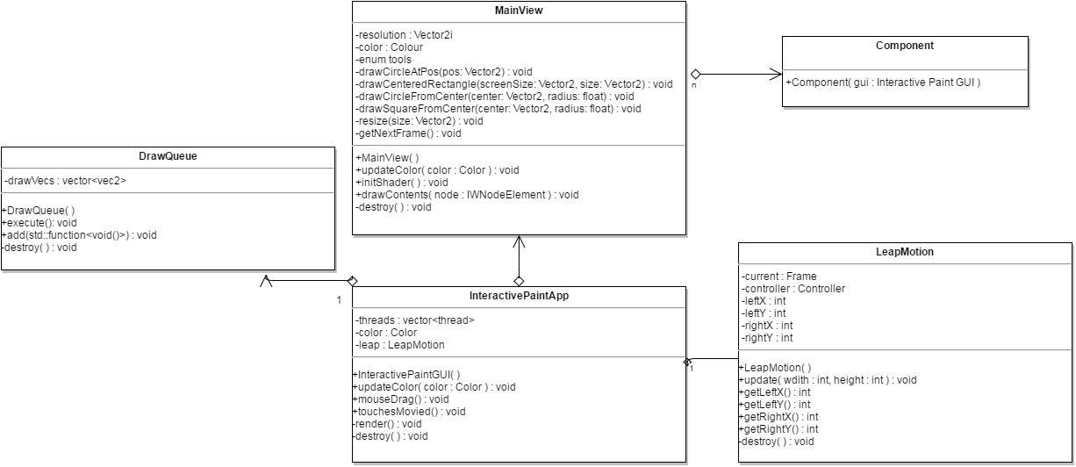

**Integration Tests**

The application was used on multiple machines and by multiple users before and after the refactoring and no changes were noticed.