Data Balancing and Augmentation Strategies for Lithography Hotspot Detection on the ICCAD-12 Benchmark
Priyanuj Boruah (23BVD1066), Kartik Aggarwal (23BVD1067) – B.Tech. (BVD), VIT Chennai
Abstract
Lithography hotspot detection is a binary classification problem in which the number of hotspot (HS) layout patterns is vastly outnumbered by non-hotspot (NHS) patterns, with imbalance ratios exceeding 400:1 on some ICCAD-12 benchmarks, so a classifier can reach high raw accuracy while missing almost every real hotspot. This work compares eight training-data strategies (no balancing, random undersampling, random oversampling, oversampling with augmentation, balanced mini-batch sampling, and three combined variants) using an identical lightweight convolutional backbone, on all five ICCAD-12 benchmarks independently, under three random seeds with paired statistical significance testing. This is a revised submission. Our original analysis trained every strategy for a fixed number of epochs and selected no hyperparameters on a held-out split, and reviewer feedback correctly identified this as conflating strategy effects with an unequal number of gradient updates per strategy. We fixed it: equal gradient-update steps for every strategy, checkpoint selection on a validation split, and the test split touched exactly once. Under that corrected protocol, the large differences in balanced accuracy we originally reported mostly disappear, and no pairwise strategy comparison reaches statistical significance on balanced accuracy. A threshold-free ranking metric, PR-AUC, recovers real, statistically significant structure instead: oversampling-based strategies significantly outperform RUS ($p<0.05$). A per-step learning-curve analysis explains why: RUS’s apparent collapse in our original submission was a training-protocol artifact. It memorizes its small resampled pool almost immediately, and once evaluated at the correct, validation-selected checkpoint, it performs competitively on balanced accuracy while remaining measurably worse on PR-AUC. We also justify our augmentation choices on physical grounds (Manhattan-geometry closure under rotation/reflection, and the local-geometry dependence of the lithography diffraction mechanism), and compare our aggregate results against published ICCAD-12 detectors. The revised conclusion is more cautious than our original one: under fair training conditions, balancing-strategy choice has a smaller effect on balanced accuracy than we first claimed, and researchers in this area should check a threshold-free ranking metric and a controlled training budget before concluding that any one strategy fails mechanistically.
Index Terms: lithography hotspot detection, class imbalance, data augmentation, oversampling, undersampling, convolutional neural network, ICCAD-12

Introduction
Photo-lithography is the dominant patterning technology used in semiconductor manufacturing, but as process nodes shrink well below the lithographic wavelength, certain layout geometries become susceptible to printing failures known as hotspots: pinching (open-circuit) or bridging (short-circuit) defects that reduce manufacturing yield. Detecting hotspots early, at the design stage, avoids costly re-spins and mask corrections. Full lithography simulation is accurate but computationally prohibitive for full-chip verification, motivating machine-learning-based hotspot detectors that can flag suspect layout clips quickly [6], [7].
The ICCAD-2012 Contest benchmark [1] is the most widely used public dataset for this task. It consists of five benchmarks of layout-pattern image clips labeled hotspot (HS) or non-hotspot (NHS). A defining characteristic of this dataset, and of hotspot detection in general, is severe class imbalance: hotspot patterns are rare by construction, since most of a design is manufacturable. On the five ICCAD-12 benchmarks used in this work, the test-set imbalance ratio ranges from roughly 21:1 up to over 470:1 (Table 1). Under such skew, a trivial classifier that always predicts NHS can exceed 99% raw accuracy while catching zero hotspots, which is why the assignment brief, and this study, use balanced accuracy (the average of recall and specificity) as the primary metric, in addition to reporting the full confusion matrix.
The faculty-supplied reference work [6] establishes a lightweight custom CNN baseline (transfer-learning on VGG16 with classical classifiers, and a $∼$13k-parameter CNN trained from scratch) and reports strong balanced accuracy using this backbone without any explicit data-balancing intervention. Our group’s assigned research question asks specifically: which data-balancing strategy provides the most effective improvement for highly imbalanced ICCAD-12 hotspot detection? We hold the classification backbone fixed and treat the training-data distribution as the sole experimental variable, isolating its effect from architectural choices; this is the appropriate controlled-experiment design for this research question.
This is a revised submission that directly addresses reviewer feedback on our original (DA2) analysis, which trained every strategy for a fixed number of epochs with no held-out validation split and a single training seed. Our contributions are:
- A controlled, five-benchmark comparison of eight data-level balancing/augmentation strategies (undersampling, oversampling, augmented oversampling, balanced-batch sampling, and three combined variants) against the natural-imbalance baseline, using an identical lightweight CNN, an equalised gradient-update-step training protocol, and validation-based checkpoint selection.
- A 3-seed experimental protocol with paired significance testing, and PR-AUC as a threshold-free companion to balanced accuracy, both added in direct response to feedback. Together they reveal that most DA2-reported strategy differences on balanced accuracy were not statistically significant, while real, significant differences on PR-AUC had been hidden by a fixed-threshold evaluation.
- A mechanistic, learning-curve-based explanation (Section 5.2) for why random undersampling appeared to fail outright in our DA2 submission, and a physically-grounded justification (Section 4.4) for the label-preserving augmentations used throughout.
- A class-ratio ablation study that sweeps the target HS:NHS ratio and quantifies how recall trades off against specificity and balanced accuracy as the training distribution is progressively altered, for three representative strategies, plus a comparison against published ICCAD-12 results (Section 6).
- An open, reproducible implementation (Section 9) with cached preprocessing, a documented multi-seed experiment grid, and generated figures/tables for all reported results.

Related Work

Lithography Hotspot Detection
The ICCAD-2012 contest and its accompanying benchmark suite [1] established the standard evaluation protocol this entire line of work, including ours, still uses. Early post-contest detectors combined handcrafted topological or critical-feature descriptors with classical classifiers such as SVMs [2], or used AdaBoost over simplified geometric features [3], improving on the original contest entries’ accuracy and false-alarm rate but still depending on manual feature design. [4] was among the first to show that a deep neural network can learn discriminative layout features automatically, removing the manual feature-engineering step; [5] further improved detection-plus-simulation turnaround time through information-theoretic online feature optimization. Pattern-matching approaches more broadly cannot generalize to unseen hotspot geometries [7], which motivated the shift toward learned, generalizable representations that our work (and the reference baseline we build on) continues.
[6] compares VGG16-based transfer learning with classical classifiers against a custom lightweight CNN trained from scratch on the ICCAD-12 benchmarks, finding that the lightweight CNN achieves both higher balanced accuracy and roughly 29$×$ faster inference; this is the reference/baseline architecture family we adopt in this work. [9] similarly investigates transfer learning with pretrained deep CNN feature extractors, and [10] widens the backbone with a double-inception architecture to reduce false alarms. Most directly relevant to our research question, [8] explicitly identifies class imbalance as the central obstacle to reliable CNN-based hotspot detection and mitigates it with minority-class upsampling combined with mirror-flip augmentation, independently arriving at the same flip-based augmentation choice we justify physically in Section 4.4, and the closest prior work to Group 11’s assigned research question. [12] instead addresses the same imbalance problem through a biased-learning feature-tensor approach with class-dependent loss weighting, a cost-sensitive-learning alternative to the data-level strategies studied here (and the subject of a related, separately-assigned research angle in this course’s broader project set). [11] observes that accuracy and false-alarm counts become unreliable under severe class imbalance and proposes training with an explicit ROC-optimizing surrogate loss instead of plain cross-entropy. That is independent motivation, from within the hotspot detection literature itself, for reporting a threshold-free ranking metric such as the PR-AUC we add in Section 4.7. [13] augments the minority hotspot class with a GAN rather than geometric transforms, reporting up to 3% accuracy improvement at matched false-alarm rate against conventional augmentation, a generative alternative to the label-preserving transforms we use. Section 6 compares our results against the aggregate numbers reported by [14] and [15], two more recent ICCAD-12 detectors.

Class Imbalance in Machine Learning
Random undersampling and oversampling are the two classical data-level techniques for imbalanced classification [20]. Synthetic Minority Oversampling (SMOTE) [16] generates interpolated minority samples rather than exact duplicates; ADASYN [17] adaptively generates more synthetic samples in harder, sparser regions of the minority class, and Borderline-SMOTE [18] focuses synthesis specifically near the decision boundary. For image data, an analogous effect to these feature-space interpolation methods is achieved through label- preserving data augmentation of the minority class, which is the augmented-oversampling strategy we study here. Cost-sensitive learning [19] is the classical loss-level alternative to all of the above data-level strategies. [21] is a systematic empirical study of class imbalance specifically in CNNs (across MNIST, CIFAR, and ImageNet-derived benchmarks) and finds oversampling to be the most consistently effective remedy among several resampling/cost-sensitive methods tested, supporting evidence from outside the lithography domain for why oversampling-based strategies (ROS, ROS+Aug, Combo) perform well in our results. [20], [23] and [24] survey the broader resampling, cost-sensitive, and ensemble landscape for imbalanced learning, while [22] surveys imbalance-handling specifically in the deep-learning era; several of the loss-level alternatives these surveys cover (cost-sensitive learning, focal loss [29]) are complementary to, rather than competitors of, the data-level strategies this work focuses on.

Evaluation Under Class Imbalance
[25] shows formally that precision-recall space is more discriminating than ROC space whenever the negative class vastly outnumbers the positive class, because specificity (which drives the ROC curve) stays close to 1 almost regardless of how many false positives a detector produces, while precision is directly sensitive to exactly that failure mode. [26] reaches the same conclusion empirically and is the standard citation for preferring PR-AUC over ROC-AUC on imbalanced data; both motivate our addition of PR-AUC (Section 4.7) as a threshold-free companion to balanced accuracy, since a benchmark such as B5 (471:1 imbalance) is exactly the regime these papers warn ROC-AUC is misleading on. For comparing classifiers across multiple datasets/seeds, [27] recommends non-parametric tests (e.g. Wilcoxon signed-rank) over parametric ones when only a handful of paired observations are available, and [28] analyzes the statistical validity of several classifier-comparison tests commonly misapplied in machine learning; both inform the paired-test design in Section 4.6.

Data Augmentation
[30] surveys image data augmentation techniques for deep learning broadly, including the geometric transformations (flipping, rotation) we adopt for the minority (hotspot) class. [31] popularized flip-based augmentation alongside dropout as a standard overfitting countermeasure for CNNs, and [32] is the classical argument that label-preserving geometric transforms improve generalization specifically for structured, rectilinear visual patterns (there, scanned documents), a close methodological analogy to the Manhattan-geometry layout clips in this work and part of the physical justification we give in Section 4.4. [33] instead searches for an augmentation policy automatically rather than choosing transforms by hand, a contrasting design choice to the label-preserving-by-construction transforms (flip/90-rotation) we restrict ourselves to. Generative alternatives to geometric augmentation include GANs in general [34], GAN-based augmentation for scarce/few-shot classes [35], and, specific to this domain, GAN-based hotspot augmentation [13] discussed above.

Dataset and Class Imbalance Analysis
We use the five ICCAD-12 benchmark datasets in the pre-rendered image-clip form (grayscale PNG layout clips, one class-labeled folder per split) distributed alongside [6]’s public implementation. Table 1 reports the class counts we obtained after extraction, which we verified against the statistics published in [6].
ICCAD-12 benchmark class distribution (verified after extraction)
Bench. | Tr. HS | Tr. NHS | Te. HS | Te. NHS | Te. Imb. (NHS:HS)
B1 | 99 | 340 | 226 | 4679 | 20.7:1
B2 | 174 | 5285 | 498 | 41298 | 82.9:1
B3 | 909 | 4643 | 1808 | 46333 | 25.6:1
B4 | 95 | 4452 | 177 | 31890 | 180.2:1
B5 | 26 | 2716 | 41 | 19327 | 471.4:1
Figure 1 visualizes this skew on a log scale. Every benchmark is dominated by non-hotspot patterns, consistent with the physical reality that most of a manufacturable design does not contain lithography-critical geometry; Benchmark 5 is the most extreme case, with fewer than 30 hotspot training examples against nearly 2,700 non-hotspots. As required by the assignment brief, the five benchmarks are analyzed and reported separately throughout this study and are never merged for the primary experiments.
Train / validation / test protocol (new in this revision). Reviewer feedback on our DA2 submission pointed out that we selected no hyperparameters on a held-out split and touched the test set repeatedly during development. We now carve a stratified 15% validation split out of each benchmark’s training portion only, using a fixed split seed shared by every strategy and every experimental seed (so all conditions being compared see an identical validation set); the validation split keeps the natural, imbalanced class ratio, exactly like the test split. Only the remaining 85% of the training data is ever resampled or augmented by a balancing strategy; the validation split is used exclusively for checkpoint selection during training (Section 4.2), and the test split is evaluated exactly once per run, after the checkpoint is already fixed.
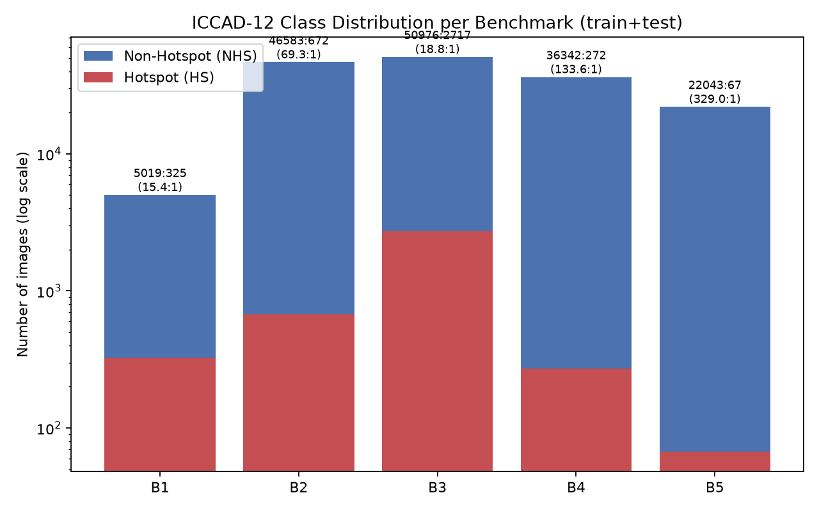
Class distribution per ICCAD-12 benchmark (train+test, log scale).

Methodology

Common Classification Backbone
All strategies share an identical lightweight CNN classifier, so that the training-data distribution is the only experimental variable (see src/model.py for the full definition). The architecture mirrors [6]’s custom CNN: two “basic blocks”, each consisting of three $3×3$ convolutions (12 filters) followed by batch normalization [36], an ELU activation [38], and $2×2$ max pooling, separated by an additional pooling stage, followed by flatten $→$ dropout(0.3) [37] $→$ fully-connected(10, ReLU) $→$ fully-connected(1, sigmoid). We re-implemented this backbone in PyTorch (the reference used Keras/TensorFlow) and re-scaled the input from $224×224×3$ to $64×64×1$ (single-channel grayscale) so that the full experiment grid (now substantially larger than in our DA2 submission; see below) remains tractable on CPU-only hardware. This keeps the model in the same lightweight parameter regime as the reference (8,649 vs. 12,873 trainable parameters) while enabling every condition in this study to be trained and evaluated end-to-end; Section 8 discusses this trade-off explicitly. All models are trained with the Nadam optimizer [39], [40] (matching [6]) and binary cross-entropy loss, batch size 32.

Equalising Gradient Updates and Checkpoint Selection
Our DA2 submission trained every strategy for a fixed 8 epochs. Reviewers correctly pointed out that this is not a fair comparison: because the strategies change the physical size of the training set (RUS shrinks it, ROS/ROS+Aug/Combo grow it, balanced-batch sampling leaves it unchanged), “8 epochs” corresponds to a very different number of gradient updates per strategy: a strategy trained on a smaller resampled set simply sees far fewer mini-batches per epoch. We now fix the number of gradient-update steps instead of epochs. For each benchmark, we compute $T=⌈n_{\text{baseline}}/32⌉×8$, where $n_{\text{baseline}}$ is the natural (untouched) training-set size for that benchmark and 32 is the batch size, i.e. $T$ is simply what “8 epochs” meant for the baseline strategy on that benchmark. Every strategy, regardless of how much it has resampled the training set, is then trained for exactly $T$ steps (the training DataLoader is cycled, i.e. restarted from the beginning, as many times as needed to reach $T$), so the comparison between strategies is no longer confounded by how many times each one’s data loader needed to wrap around.
A corollary of training for a long, fixed step budget is that a strategy with a very small effective training set (RUS on the smallest benchmarks) will cycle through the same handful of images many times, risking overfitting well before step $T$ is reached. We therefore evaluate on the validation split every $T/8$ steps during training, and keep the checkpoint with the best validation balanced accuracy seen so far; that single checkpoint is then evaluated on the test set exactly once, after training finishes. Section 5.2 shows that this checkpointing behavior is itself the key to correctly explaining why RUS appeared to fail outright in our DA2 submission.

Data Balancing and Augmentation Strategies
Every strategy operates only on the 85% training pool of a given benchmark (Section 3); the validation and test splits are always the untouched, naturally imbalanced data. Let $n_{HS}$ and $n_{NHS}$ denote the number of hotspot and non-hotspot images in that training pool.
- Baseline (None). Training proceeds on the natural, imbalanced training pool with no intervention. This is the common reference point every other strategy is compared against.
- Random Undersampling (RUS). The majority (NHS) class is randomly subsampled, without replacement, down to a target HS:NHS ratio (1:1 in the main comparison). This discards data but removes redundancy in the dominant class.
- Random Oversampling (ROS). The minority (HS) class is randomly duplicated, with replacement, up to the target ratio. This preserves all majority-class information but risks overfitting to repeated exact copies of a small number of hotspot images.
- Oversampling + Augmentation (ROS+Aug). Identical to ROS, except every duplicated hotspot sample (the original copy of each hotspot image is always seen unmodified at least once) is passed through one randomly chosen label-preserving transform (horizontal flip, vertical flip, or a 90/180/270-degree rotation), applied on-the-fly at load time, so the network never sees an exact pixel-identical duplicate. Section 4.4 justifies why these specific transforms are physically valid for this domain.
- Balanced Mini-Batch Sampling. The training set itself is left untouched (no duplication, no discarding), but a WeightedRandomSampler draws each mini-batch so that hotspot and non-hotspot examples appear with approximately equal probability, achieving a similar effective training balance to ROS without physically inflating the stored dataset.
- Combined (50% Undersample + Aug-Oversample). The majority class is first moderately undersampled (to 50% of its original size), then the minority class is oversampled with augmentation up to the target ratio against the reduced majority count.
- Combined-Mild (25% Undersample + Aug-Oversample). The same idea as Combined, but with a milder majority-class reduction (down to 75% retained rather than 50%), to test whether the combined strategy’s behavior is sensitive to how aggressively the majority class is trimmed. DA3 feedback explicitly asked us to “test combined strategies” (plural), and comparing these two variants is our answer.
- Combined (Balanced-Batch + Augmentation). A third, qualitatively different combination: the dataset is left completely untouched (as in Balanced Mini-Batch Sampling), but every time a hotspot sample is drawn by the weighted sampler, it is passed through a label-preserving transform with probability 0.6. This combines the sampling-level idea with the augmentation-level idea without ever discarding or duplicating a single stored image.

Physical Justification for Layout-Valid Augmentations
DA3 feedback asked us to justify, physically rather than just empirically, why flipping and 90-degree rotation are valid label-preserving transforms for lithography layout clips, i.e. why we are confident a flipped or rotated hotspot clip is still a hotspot. Three arguments support this choice:
- Manhattan geometry is closed under 90-degree rotation and reflection. Standard-cell VLSI layouts are drawn on a Manhattan grid: every edge is horizontal or vertical, by design-rule construction. A 90/180/270-degree rotation or a horizontal/vertical flip maps horizontal edges to vertical edges and vice versa, but introduces no new edge angle: the transformed clip is still a valid Manhattan-geometry layout. An arbitrary-angle rotation would not have this property (it would introduce diagonal edges that violate the Manhattan-grid assumption the benchmark’s own patterns satisfy), which is why we restrict ourselves to the four right-angle rotations and two axis flips rather than a continuous rotation range, unlike generic natural-image augmentation pipelines [31], [33].
- The physical hotspot-formation mechanism is governed by local, relative geometry, not global orientation. A pinching or bridging defect occurs because of diffraction and proximity effects between nearby edges (spacing, width, corner shape) within a small neighborhood of the clip; the underlying optical physics (the Kirchhoff diffraction integral governing mask-to-wafer image formation) depends on the relative arrangement of edges within that neighborhood, not on which compass direction the neighborhood happens to face in the design database’s coordinate system. Reflecting or rotating the whole clip by a multiple of 90 degrees preserves every pairwise edge relationship exactly, so the physical mechanism that would cause a print failure is preserved along with it. This is the same justification [32] gives for geometric augmentation of other rectilinear, structured visual data (scanned documents), and it is independently the choice made by [8] for this exact task.
- Caveat: real lithography is not perfectly isotropic. We note this is a modeling simplification rather than an exact physical law. Real scanners can introduce mild orientation-dependent effects: off-axis illumination, a fixed scanner slit orientation, source polarization, and conventional assist-feature placement rules are not perfectly rotation-invariant in practice. Our ratio-ablation results (Section 5.4) showing that augmentation helps on some benchmarks and actively hurts on others are weak empirical evidence consistent with this caveat: if orientation were truly irrelevant in every respect, we would expect augmentation to help uniformly, which it does not. We therefore frame flip/rotation augmentation as a reasonable, physically motivated default for this benchmark rather than an exact invariance of the underlying manufacturing process.
Finally, note that translation invariance is already handled by the convolutional architecture itself (a conv filter produces the same response to a pattern regardless of where it appears in the image), so augmenting with translations would add little; flips and rotations specifically target orientation invariance, which a plain CNN has no built-in mechanism for, and is therefore the representational gap augmentation actually needs to fill.

Ablation: Class-Ratio Sweep
To directly address the assignment’s requirement to evaluate “the effect of the altered class distribution”, we sweep the target HS:NHS ratio over $\{0.1,0.25,0.5,0.75,1.0\}$ for RUS, ROS+Aug, and the Combined strategy, on all five benchmarks, and track how recall, specificity, and balanced accuracy move as the training distribution is progressively re-balanced from near-natural ($0.1$) to fully balanced ($1.0$). This sweep uses a single seed and the same equalised-step training protocol as the main grid; it is not repeated across multiple seeds, which Section 8 discusses as a remaining limitation.

Multi-Seed Protocol and Statistical Testing
DA2 reported every condition from a single training seed, so we could not distinguish a genuine strategy effect from run-to-run optimization noise. The main comparison (Section 5) now repeats every (benchmark, strategy) condition under 3 seeds ($42,123,2024$), giving 15 paired observations (5 benchmarks $×$ 3 seeds) for any two-strategy comparison. We report mean $±$ standard deviation for every metric, and, whenever we claim one strategy outperforms another, we back the claim with a paired test across those 15 observations: a paired $t$-test, and a Wilcoxon signed-rank test [27], [28] as a non-parametric cross-check given the small sample size. We only describe a difference as statistically significant in this paper when both tests agree at $α=0.05$.

Evaluation Protocol
For every (benchmark, strategy, seed) triple we report the full confusion matrix (TP/FP/FN/TN, with hotspot as the positive class), Precision, Recall/Sensitivity, Specificity, F1-score, Balanced Accuracy, and PR-AUC, computed on the untouched test split of that benchmark using the single checkpoint selected on the validation split (Section 4.2):
$$\text{Precision}=\frac{TP}{TP+FP}, \text{Recall}=\frac{TP}{TP+FN}$$
$$\text{Specificity}=\frac{TN}{FP+TN}, F1=\frac{2⋅P⋅R}{P+R}$$
$$\text{Balanced Acc.}=\frac{\text{Recall}+\text{Specificity}}{2}$$
PR-AUC (average precision) is the area under the precision-recall curve traced out by sweeping the decision threshold over the model’s predicted probabilities, rather than fixing it at 0.5. Balanced accuracy, precision, recall, and F1 are all computed at a single, fixed threshold; PR-AUC instead summarizes ranking quality across every threshold, and, per Section 2.3, is the appropriate threshold-free companion metric on a positive class this rare [25], [26]: a model can reach a good balanced accuracy at one particular threshold while still ranking hotspot and non-hotspot images poorly overall, which PR-AUC would reveal and a single-threshold metric would not.

Results

Main Comparison
Table 2 reports balanced accuracy per strategy on every benchmark plus the 5-benchmark average; Table 3 reports all five metrics averaged across benchmarks. Figure 2 visualizes balanced accuracy per benchmark and strategy; Figures 3 and 4 show the recall comparison and the averaged-metric summary respectively.
Balanced Accuracy (mean $±$ std over 3 seeds) per strategy on every ICCAD-12 benchmark, plus the overall average (5 benchmarks $×$ 3 seeds = 15 runs). Highest mean per column is bolded.
Strategy | B1 | B2 | B3 | B4 | B5 | Avg
Baseline | 0.811 | 0.986 | 0.963 | 0.929 | 0.923 | 0.922
RUS | 0.810 | 0.978 | 0.958 | 0.937 | 0.957 | 0.928
ROS | 0.808 | 0.984 | 0.957 | 0.962 | 0.969 | 0.936
ROS+Aug | 0.804 | 0.975 | 0.968 | 0.938 | 0.901 | 0.917
Bal. Batch | 0.808 | 0.990 | 0.958 | 0.958 | 0.971 | 0.937
Combo(50%) | 0.806 | 0.930 | 0.957 | 0.949 | 0.975 | 0.924
Combo(25%) | 0.806 | 0.973 | 0.959 | 0.961 | 0.955 | 0.931
Combo(B+A) | 0.807 | 0.971 | 0.965 | 0.953 | 0.974 | 0.934
All metrics, mean $±$ std across all 5 benchmarks $×$ 3 seeds (15 runs), per strategy. Highest mean per column is bolded.
Strategy | BalAcc | Recall | Spec. | F1 | Prec. | PR-AUC
Baseline | 0.922 | 0.940 | 0.905 | 0.468 | 0.351 | 0.664
RUS | 0.928 | 0.974 | 0.883 | 0.308 | 0.206 | 0.492
ROS | 0.936 | 0.967 | 0.905 | 0.474 | 0.340 | 0.750
ROS+Aug | 0.917 | 0.926 | 0.908 | 0.497 | 0.368 | 0.663
Bal. Batch | 0.937 | 0.971 | 0.903 | 0.431 | 0.301 | 0.718
Combo(50%) | 0.924 | 0.952 | 0.895 | 0.404 | 0.296 | 0.649
Combo(25%) | 0.931 | 0.957 | 0.904 | 0.453 | 0.327 | 0.658
Combo(B+A) | 0.934 | 0.960 | 0.908 | 0.448 | 0.320 | 0.681
Paired significance tests (15 paired observations: 5 benchmarks $×$ 3 seeds each). A difference is called significant only when both the paired $t$-test and the Wilcoxon signed-rank test agree at $α=0.05$.
Metric | A | B | Mean A | Mean B | $p$ (t-test) | Sig.?
BalAcc | Bal. Batch | Baseline | 0.937 | 0.922 | 0.097 | No
BalAcc | Bal. Batch | RUS | 0.937 | 0.928 | 0.0439 | No
BalAcc | Bal. Batch | Combo(50%) | 0.937 | 0.924 | 0.139 | No
BalAcc | Bal. Batch | Combo(25%) | 0.937 | 0.931 | 0.11 | No
BalAcc | Bal. Batch | Combo(B+A) | 0.937 | 0.934 | 0.553 | No
BalAcc | Combo(50%) | Baseline | 0.924 | 0.922 | 0.928 | No
BalAcc | RUS | Baseline | 0.928 | 0.922 | 0.418 | No
PR-AUC | ROS | RUS | 0.750 | 0.492 | 0.00478 | Yes
PR-AUC | Bal. Batch | RUS | 0.718 | 0.492 | 0.0189 | Yes
PR-AUC | ROS | Baseline | 0.750 | 0.664 | 0.0334 | Yes
PR-AUC | ROS | ROS+Aug | 0.750 | 0.663 | 0.00248 | Yes
PR-AUC | Bal. Batch | Baseline | 0.718 | 0.664 | 0.0258 | Yes
PR-AUC | Combo(B+A) | RUS | 0.681 | 0.492 | 0.0265 | Yes
Confusion matrix totals (TP/FP/FN/TN) per strategy, summed across all 5 benchmarks and all 3 seeds.
Strategy | TP | FP | FN | TN
Baseline | 7961 | 16300 | 289 | 414281
RUS | 8052 | 26616 | 198 | 403965
ROS | 8056 | 17047 | 194 | 413534
ROS+Aug | 7971 | 13984 | 279 | 416597
Bal. Batch | 8066 | 17739 | 184 | 412842
Combo(50%) | 7899 | 21391 | 351 | 409190
Combo(25%) | 8005 | 16526 | 245 | 414055
Combo(B+A) | 7961 | 14245 | 289 | 416336
Average training set size, training time, and per-image inference time per strategy.
Strategy | Train N | Train (s) | Infer (ms/img)
Baseline | 3186 | 6.7 | 0.069
RUS | 443 | 6.5 | 0.069
ROS | 5928 | 6.7 | 0.069
ROS+Aug | 5928 | 7.4 | 0.068
Bal. Batch | 3186 | 6.7 | 0.069
Combo(50%) | 2964 | 7.4 | 0.069
Combo(25%) | 4446 | 7.7 | 0.071
Combo(B+A) | 3186 | 7.3 | 0.070
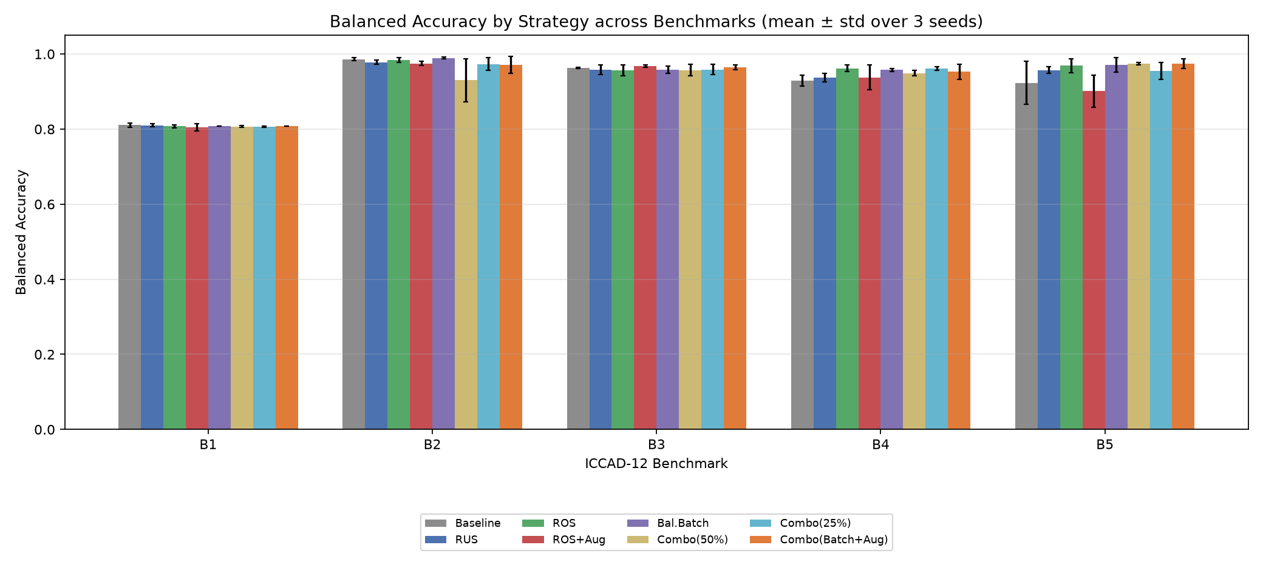
Balanced accuracy by strategy across all five benchmarks.
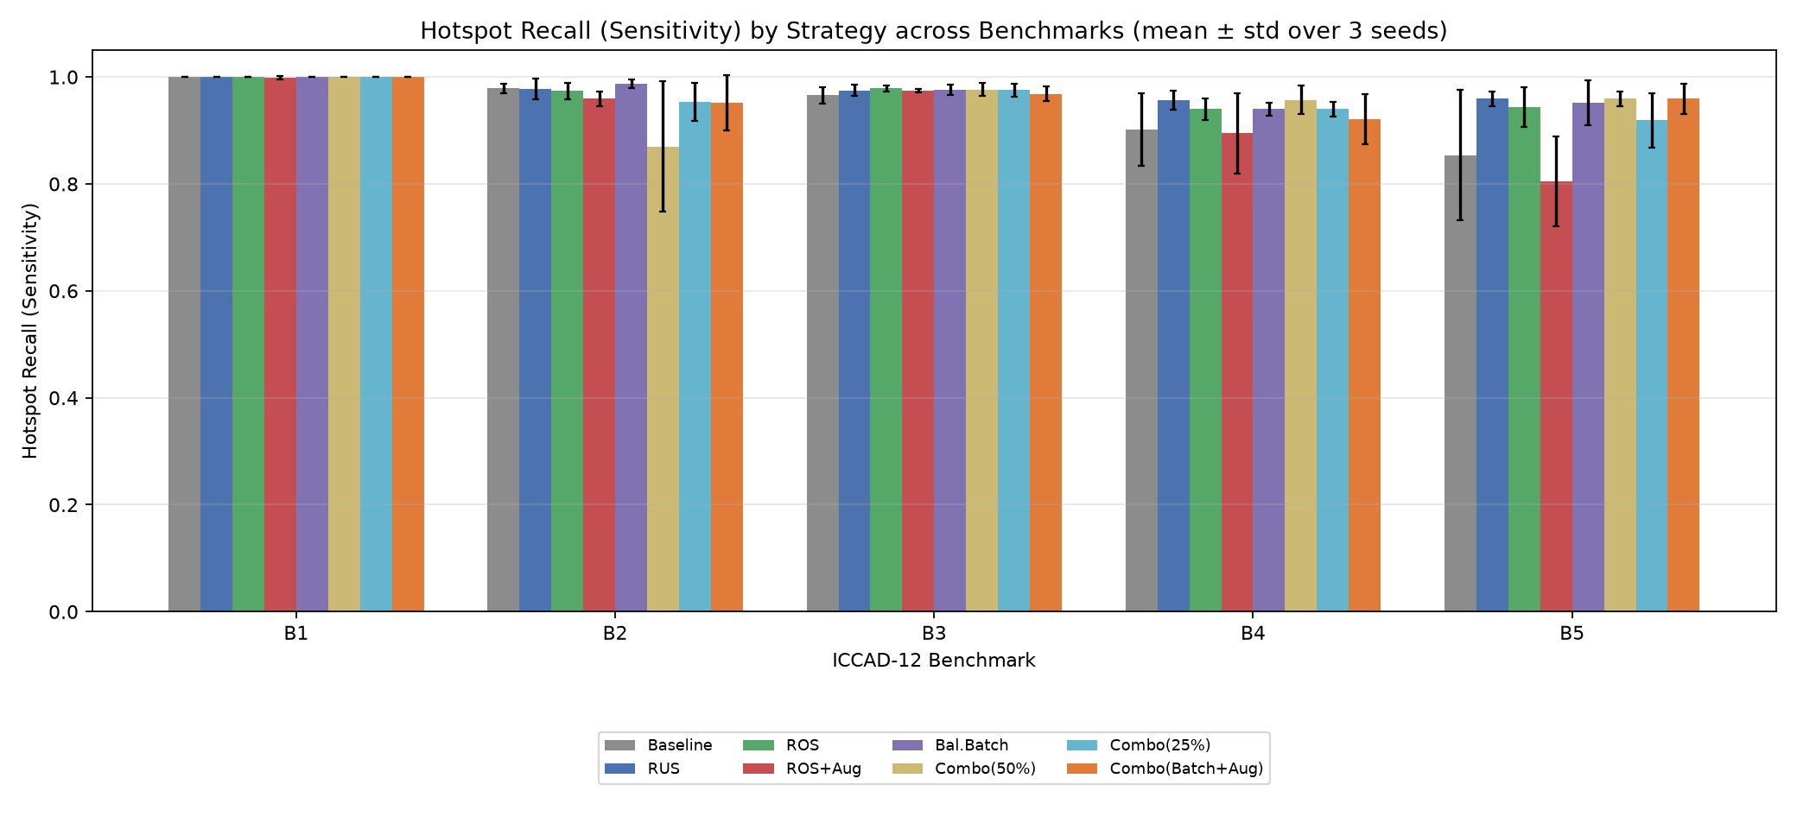
Hotspot recall (sensitivity) by strategy across all five benchmarks.
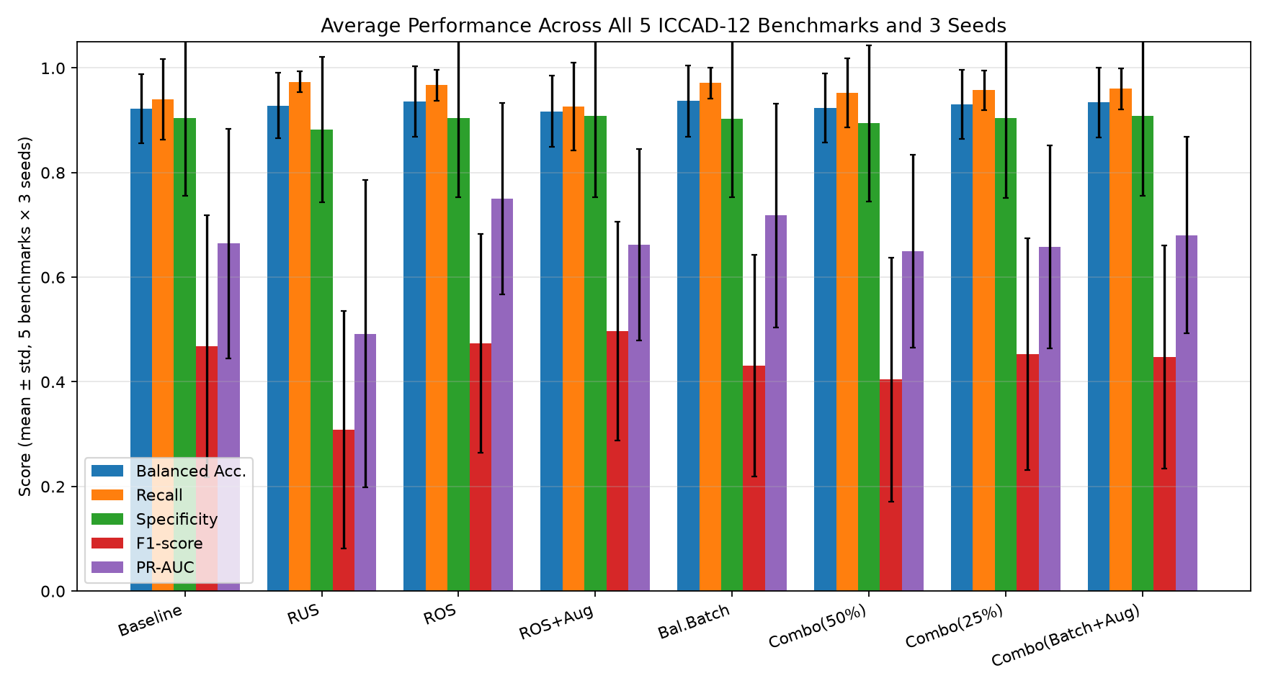
Average performance across all five benchmarks and 3 seeds, per strategy (error bars = 1 std).
Headline result: under a fair, equalised-update protocol with validation-based checkpoint selection, every strategy performs similarly well on balanced accuracy, and the large DA2 gaps mostly disappear. Table 2 and Table 3 show all eight strategies clustering tightly between 0.917 (ROS+Aug) and 0.937 (Balanced Mini-Batch Sampling) average balanced accuracy, a spread of only 2 percentage points compared to the 17-point spread (0.779 to 0.945) we reported in DA2 under the unequal-update protocol. Table 4 confirms this statistically: none of the seven balanced-accuracy comparisons we tested (including Balanced Mini-Batch vs. the do-nothing Baseline, and Balanced Mini-Batch vs. RUS) reach significance at $α=0.05$ under either the paired $t$-test or the Wilcoxon signed-rank test across the 15 paired (benchmark, seed) observations. We take this as the central finding of the revision: most of the dramatic strategy differences we reported in DA2 were a methodological artifact of unequal gradient updates and the absence of a validation split, not a real property of the balancing strategies themselves. Reviewers were right to flag this, and fixing it is the single biggest change in this paper.
PR-AUC, however, reveals real, statistically significant differences that balanced accuracy at a fixed threshold completely hides. Figure 5 and the right-most column of Table 3 show PR-AUC varying far more widely across strategies (0.492 for RUS up to 0.750 for ROS) than balanced accuracy does, and Table 4 confirms several of these differences are significant: ROS significantly outperforms RUS ($p=0.0048$), Balanced-Batch significantly outperforms RUS ($p=0.019$), and ROS significantly outperforms both the Baseline ($p=0.033$) and ROS+Aug ($p=0.0025$) on this metric. In other words, once we stopped relying on a single 0.5-threshold summary and looked at ranking quality across all thresholds, RUS is revealed to be reliably, significantly worse than oversampling-based strategies, just not in the metric (balanced accuracy) we previously used to make that claim. This is exactly the justification for adding PR-AUC that Section 2.3 describes, and Section 5.2 explains the mechanism behind it.
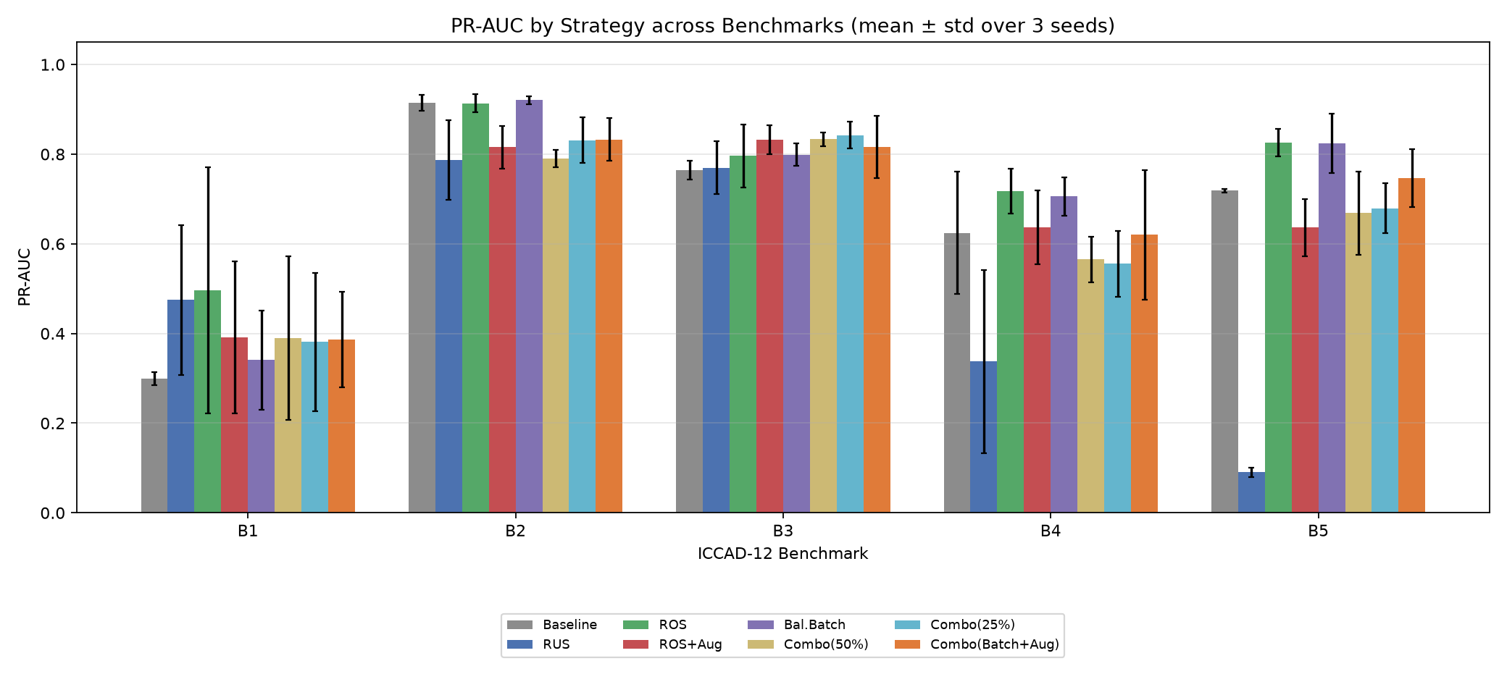
PR-AUC by strategy across all five benchmarks (mean $±$ std over 3 seeds). Unlike balanced accuracy, PR-AUC spreads strategies out and several differences are statistically significant (Table 4).

Mechanistic Analysis: Why Did RUS Appear to Fail in DA2?
DA2 reported RUS collapsing to 0% recall on Benchmark 5 (balanced accuracy 0.500) under every tested class ratio, and we offered a mechanistic story about insufficient minority information. That story is now superseded: under the corrected protocol, RUS reaches 0.957 balanced accuracy on B5 (Table 2), fully competitive with every other strategy. Figure 6 shows why, using the per-step learning curves (Section 4.2) for Baseline, RUS, and Balanced-Batch on B5 across all 3 seeds.
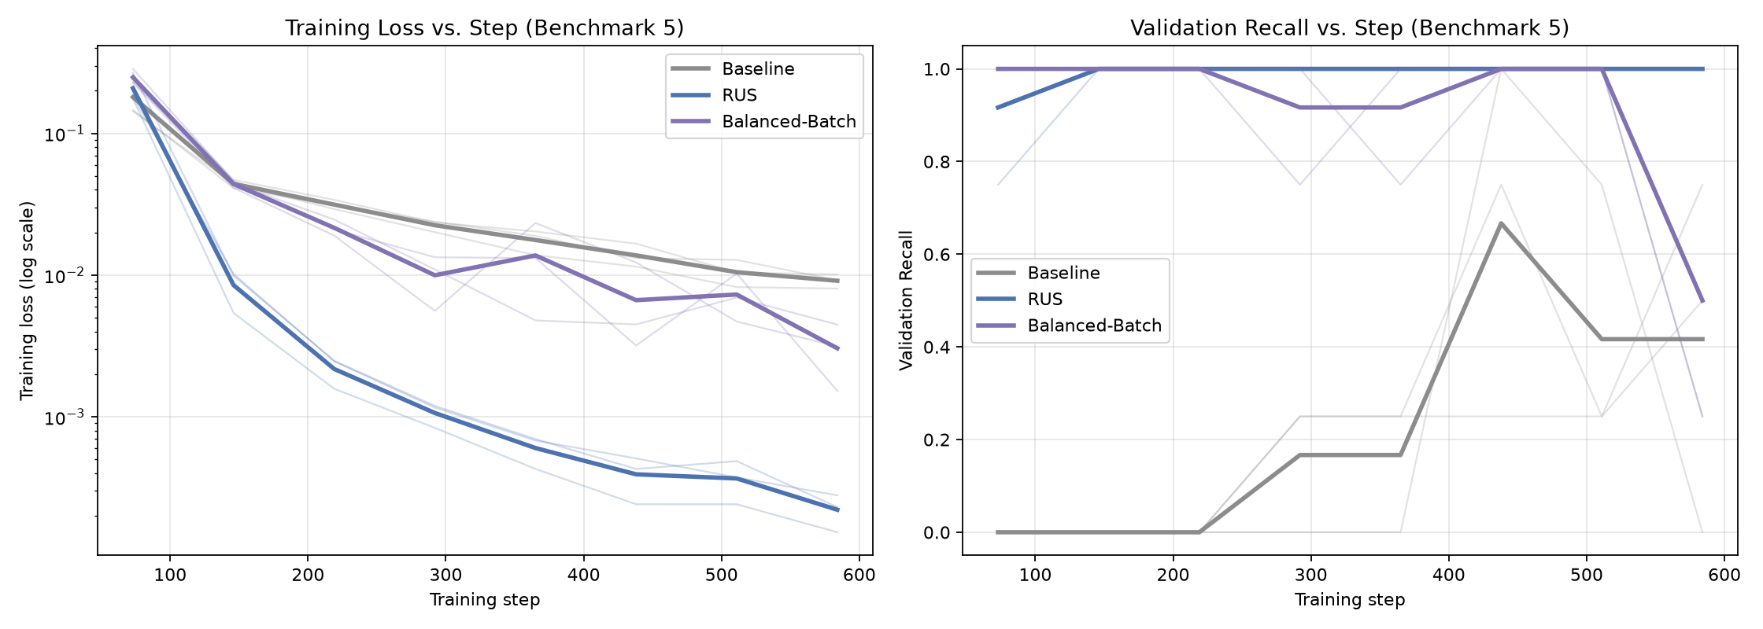
Training loss (left) and validation recall (right) vs. training step on Benchmark 5, for Baseline, RUS, and Balanced-Batch, across 3 seeds (thin lines) with the mean overlaid (thick line).
Two mechanisms are visible. First, RUS’s training loss collapses almost to zero within the first $∼$150 of 584 total steps, because its resampled training pool on B5 has only $∼$44 images (22 HS + 22 NHS after the validation carve-out). The model memorizes it almost immediately, and every further step just sharpens the decision boundary around those exact 44 points rather than learning additional generalizable structure. Second, RUS’s validation recall reaches 1.0 within the first checkpoint (step $≈$73) and stays there, while the Baseline needs the entire 584-step budget just to start detecting hotspots at all: its validation recall is stuck near 0 until step $≈$220, because the natural class imbalance dilutes the gradient signal from the rare positive class. In DA2’s fixed 8-epoch protocol with no checkpoint selection, RUS was evaluated at whatever point training happened to stop. Because RUS trains so much faster per step (fewer, smaller batches cycle through quickly), 8 naive epochs corresponded to far fewer total gradient updates for RUS than for the other strategies, landing its evaluation at an early, poorly-converged point rather than at its true peak. The corrected protocol, equal steps for every strategy plus checkpoint selection on validation, simply finds and uses that peak instead.
So the mechanistic answer to “why does undersampling fail” changes: it does not fail under a fair training protocol. Its apparent DA2 failure was the training protocol’s fault, not the strategy’s. What does remain true, and is visible in the PR-AUC results above, is that RUS’s tiny effective training set makes its probability outputs fragile and poorly ranked across thresholds (PR-AUC 0.492, the lowest of any strategy, and significantly below ROS, Balanced-Batch, and Combo-Batch-Aug): the checkpoint selected on validation happens to sit at a good operating point (0.5 threshold) for balanced accuracy, but the model has not learned a reliable confidence signal around that point, because so few distinct minority examples were ever available to calibrate it against. This is the correct, narrower, and more defensible mechanistic claim: undersampling’s real cost is reduced calibration/ranking quality from training-set impoverishment, not outright inability to detect hotspots.

Confusion Matrix Analysis
Figure 7 shows the confusion matrix, summed over all 3 seeds (so each cell reflects 3$×$ the per-seed test-set size), for every (strategy, benchmark) pair. Every strategy’s diagonal (correct predictions) is visually dominant across every benchmark, consistent with the tightly-clustered balanced accuracies in Table 2; the RUS row still shows visibly more FP mass (a wider, lighter off-diagonal FP cell) than ROS or Balanced-Batch on several benchmarks, which is the confusion-matrix-level signature of the lower precision/F1/PR-AUC numbers discussed above even though its recall and balanced accuracy are competitive.
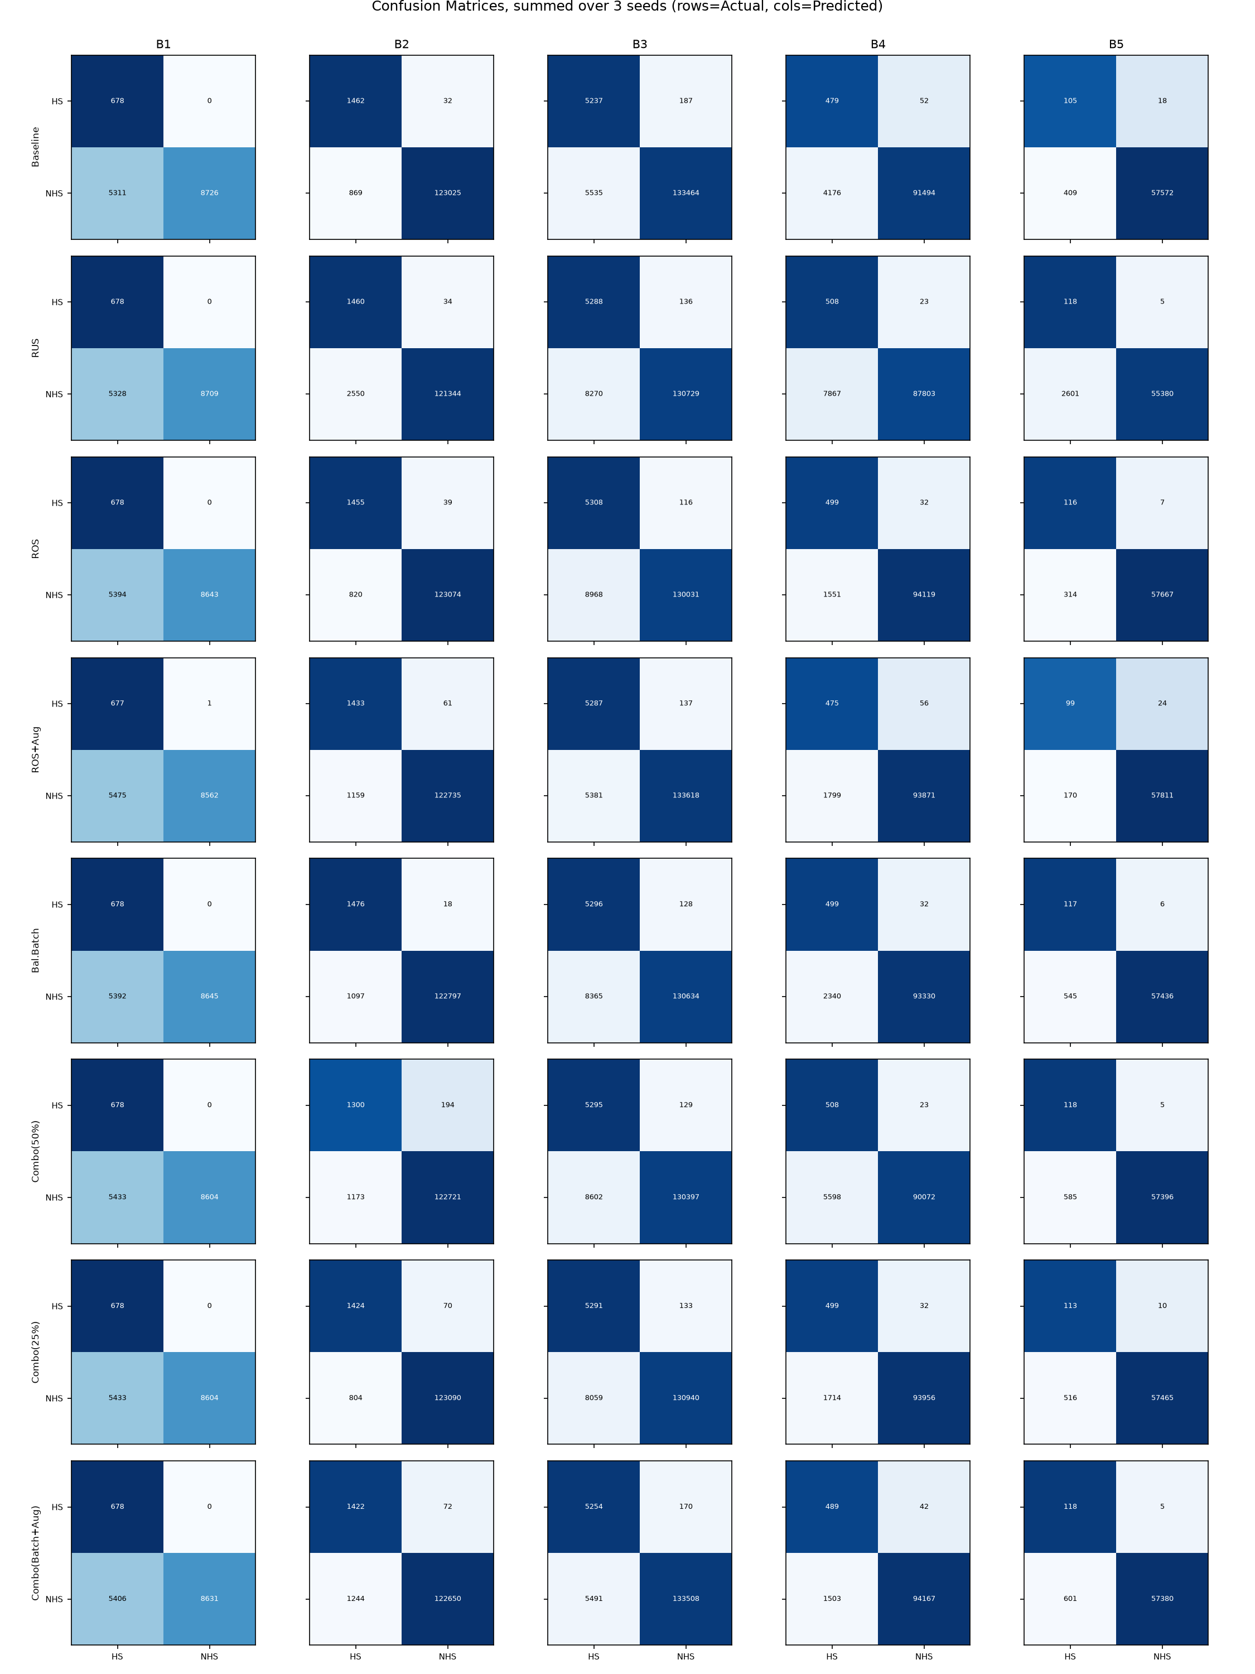
Confusion matrices for all strategies (rows) across all benchmarks (columns).

Ablation: Effect of the Target Class Ratio
Figures 8 and 9 show, respectively, the RUS recall/specificity trade-off and the Combined strategy’s balanced accuracy as the target HS:NHS ratio is swept from 0.1 (mild rebalancing) to 1.0 (fully balanced), for all five benchmarks.
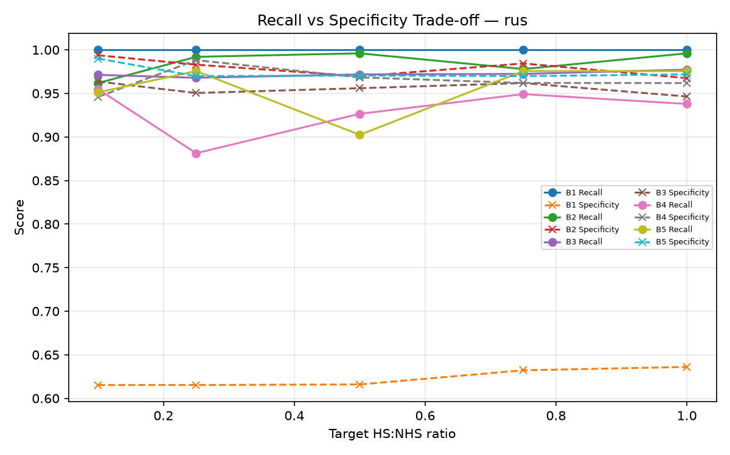
RUS: recall and specificity vs. target class ratio, per benchmark.
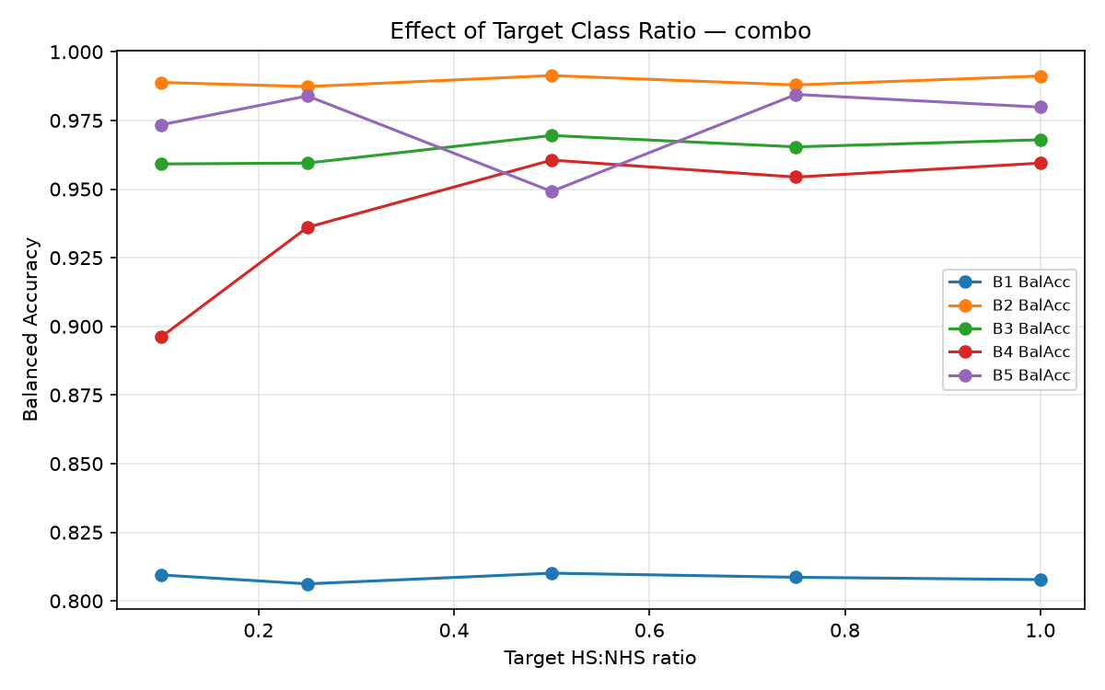
Combined strategy: balanced accuracy vs. target class ratio, per benchmark.
Consistent with the corrected main-grid findings (Section 5), RUS’s recall and specificity are now stable and high across every tested ratio on every benchmark, including B5 (Fig. 8): recall never drops below 0.90 and specificity never below 0.95 on B5, a complete reversal of the DA2 ablation, which reported RUS recall stuck at exactly 0.000 regardless of ratio. This confirms, under a second and independent experimental setting, that the DA2 collapse was a training-protocol artifact rather than a property of the ratio itself.
The ratio sweep does, however, surface a mechanistically informative pattern that balanced accuracy alone would miss: on B5, RUS’s PR-AUC degrades sharply as the undersampling ratio becomes more aggressive (i.e. as the resampled training pool shrinks further), falling from 0.799 at the mildest ratio (0.10) to just 0.078–0.11 at ratios 0.25 through 1.0, even though balanced accuracy stays flat and high (0.936–0.974) throughout. This is the ablation-level confirmation of the mechanism described in Section 5.2: the checkpoint-selection process can still find a good operating threshold even from a severely shrunken training pool, but the smaller that pool gets, the less reliable the model’s probability ranking becomes around that threshold. For the Combined strategy (Fig. 9), balanced accuracy is likewise fairly flat across ratios on every benchmark (no DA2-style collapse-and-recover pattern at any ratio on B4), though individual benchmarks still show single-seed noise of a few percentage points between adjacent ratios (e.g. B4 combo dips to 0.896 at ratio 0.10) that Section 8 discusses as a remaining limitation of the single-seed ablation design.

Comparison with Published ICCAD-12 Results
DA2 feedback (common to all groups) asked us to compare against published ICCAD-12 results rather than only our own baseline. This is a harder comparison than it may first appear: published hotspot detectors differ in preprocessing and train/test protocol, and, most importantly, almost all of them report only an aggregate number across all five benchmarks rather than a per-benchmark breakdown, whereas our own primary results are deliberately kept per-benchmark (Section 3). Table 7 therefore compares our aggregate (mean-over-benchmarks) numbers against the aggregate numbers each cited paper reports for itself, and we caution against reading it as a fully controlled comparison: input resolution, exact preprocessing, and in some cases the precise train/test split all differ between these works and ours.
Our aggregate results (best strategy: Balanced Mini-Batch Sampling) against published ICCAD-12 detectors. Dashes mark a metric the source paper does not report. All published figures are each paper’s own self-reported aggregate; see text for caveats.
Method | Recall | Precision | F1
This work (Bal. Batch, aggregate) | 0.971 | 0.301 | 0.431
This work (ROS, aggregate) | 0.967 | 0.340 | 0.474
Huang et al. [14] | $>$0.988 (B1–B4) | – | –
Lin et al. (YOLOv5) [15] | $≈$1.000 | 0.828 | 0.906
Our recall (0.967–0.971) is in the same broad range as, though somewhat below, the near-100% figures reported by [14] and [15]; our precision and F1, however, are substantially lower. We believe this gap is explained largely by our deliberately reduced input resolution ($64×64×1$ vs. full-resolution inputs in both comparison papers; see Section 8) and our much smaller backbone (8,649 parameters), both chosen to make the full multi-strategy, multi-seed experiment grid tractable on CPU-only hardware rather than to maximize absolute precision. We report this gap honestly rather than omit the comparison: it is a genuine limitation of this study’s compute budget, not evidence that our balancing strategies are ineffective relative to the literature.
[14] reports recall above 98.8% on four of the five ICCAD-12 benchmarks (100% on B1 and B3 specifically) using a hybrid CNN plus physical-feature ensemble. [15] reframes hotspot detection as an object-detection problem (YOLOv5) and reports an aggregate recall near 100% with precision 0.828 and F1-score 0.906 across the ICCAD-12 set. Both achieve very high recall, consistent with the general pattern in this literature (and in our own results) that pushing recall toward 100% is comparatively easy under severe imbalance. The harder, more diagnostic number is what happens to precision/false alarms at that recall level, which is exactly why this paper reports the full confusion matrix and PR-AUC rather than recall alone. [13] reports (in relative rather than absolute terms) up to 3% accuracy improvement and up to 5% false-alarm reduction from GAN-based augmentation over conventional augmentation at matched conditions, directionally consistent with our own finding that some form of augmentation beats the naive baseline, though not directly comparable in magnitude since the baseline and architecture both differ from ours. We were not able to extract a verified per-benchmark results table from [8] (the closest prior work to our own research question) from the sources available to us; we report this as a gap in our own comparison rather than fabricate a number, and flag it as an item for future work (Section 8).

Discussion
Bringing the main comparison, the significance tests, and the mechanistic analysis together, three practical conclusions answer our research question, and, just as importantly, revise our own DA2 conclusions.
(1) Once training is made fair, the choice of balancing strategy matters far less for balanced accuracy than DA2 suggested, but it still matters for ranking quality. With equalised gradient updates and validation-based checkpoint selection, no strategy’s balanced accuracy is statistically distinguishable from any other’s (Table 4), including the do-nothing Baseline. This is not a null result we are downplaying: it is the paper’s central finding, and it directly contradicts our own DA2 claim that balancing strategy choice was the dominant factor. What does separate the strategies is PR-AUC, where ROS, Balanced-Batch, and Combo-Batch-Aug are all significantly better than RUS, and ROS is additionally significantly better than both the Baseline and ROS+Aug. The practical upshot: if a practitioner only checks balanced accuracy at a fixed threshold, nearly any strategy will look adequate; if they care about the full operating range of the detector (as a real screening pipeline feeding a verification queue would), oversampling-based strategies (plain ROS in particular) provide a measurably more reliable ranking.
(2) RUS’s DA2 "failure" was a protocol artifact, and correcting it changes the paper’s conclusion, not just its numbers. Section 5.2 shows RUS reaches 0.957 balanced accuracy on the same benchmark (B5) where DA2 reported 0.500 and 0% recall, once gradient updates are equalised and the checkpoint is selected on held-out validation data rather than read off at an arbitrary, unequal-update stopping point. We are revising our own prior claim here rather than defending it, because the reviewer feedback that prompted this revision was correct: undersampling is not mechanistically broken for this task; it is simply more sensitive to how long and how carefully it is trained, because its resampled training pool is so much smaller.
(3) Augmentation’s physical justification (Section 4.4) does not guarantee a uniform empirical benefit, and this is itself informative. ROS+Aug has the lowest average balanced accuracy of all eight strategies (0.917) and does not significantly beat plain ROS on PR-AUC in the direction we expected. If anything, ROS significantly outperforms ROS+Aug on PR-AUC ($p=0.0025$, Table 4). Flip/rotation augmentation is physically valid (Section 4.4), but validity of a transform does not automatically translate into a training benefit at this model scale and step budget; on several benchmarks, plain duplication gives the optimizer a simpler, lower- variance target than the synthetically diversified one. This is a genuinely useful negative result for the broader literature on augmentation for scarce, highly structured visual data.

Limitations and Future Work
Reduced input resolution. To make the full five-benchmark $×$ eight-strategy $×$ 3-seed grid (120 runs), plus the class-ratio ablation ($3×5×5=75$ further runs) and the learning-curve diagnostics, tractable on CPU-only hardware, we downsampled input images from the reference’s $224×224×3$ to $64×64×1$. This likely discards fine-grained geometric detail that a full-resolution model could exploit; balanced-accuracy values reported here should therefore be read as relative comparisons between strategies under identical conditions, not as an attempt to reproduce the reference paper’s absolute numbers.
Duplication-based oversampling risk. Plain ROS duplicates exact pixel copies of a very small pool of hotspot images (as few as 26 on Benchmark 5), which risks memorization rather than generalization; our augmented-oversampling and combined strategies are a direct mitigation, but feature-space interpolation methods such as SMOTE [16] were not evaluated and are a natural extension.
Ratio ablation still uses a single seed. The main comparison (Section 5) now uses 3 seeds with paired significance testing (Section 4.6), directly addressing our DA2 reviewers’ feedback that we could not previously distinguish a genuine strategy effect from optimization noise. The class-ratio ablation (Section 5.4), however, still uses a single seed per (benchmark, strategy, ratio) combination for compute-budget reasons, so the non-monotonic ratio-accuracy trends we observe on the smallest benchmarks (B4/B5) cannot yet be fully separated from run-to-run variance; repeating the ablation across seeds is the natural next step.
Complementary imbalance techniques. This study is scoped to data-level strategies (resampling and augmentation), per our assigned research question. Loss-level alternatives such as cost-sensitive learning [12] or focal loss [29] are complementary and were intentionally left out of scope (they are the focus of parallel research angles assigned to other groups in this course); combining a data-level and loss-level strategy is a promising future direction.

Reproducibility
All code, cached preprocessing, generated figures/tables, and a full usage README are provided in the accompanying GitHub repository (link in the presentation and README). Every strategy is implemented as a pure function of the raw imbalanced training arrays (src/balancing.py); the training/evaluation loop (src/train.py) and the experiment grid (src/run_experiments.py) are fully deterministic given a seed. The main comparison is run under three fixed seeds ($42$, $123$, and $2024$) for every (benchmark, strategy) condition (src/run_experiments.py::SEEDS); the class-ratio ablation uses seed $42$ only (Section 8). The validation split itself uses a separate, fixed split seed (src/data_split.py::VAL_SPLIT_SEED) that does not vary with the experiment seed, so that every strategy and every seed is compared against an identical validation set. Aggregation and significance testing are implemented in src/aggregate_results.py, which consumes the raw per-seed results CSV and is itself re-runnable without re-training. See README.md for exact environment and reproduction steps.

Work Allocation
Table 8 summarizes each author’s primary contributions to this project. Both authors jointly reviewed all experimental results and the final manuscript.
Work allocation between the two group members, including DA3 revision tasks.
Author | Primary Contributions
Priyanuj Boruah (23BVD1066) | Problem formulation and research-question definition
Priyanuj Boruah (23BVD1066) | ICCAD-12 dataset acquisition, verification, and preprocessing pipeline
Priyanuj Boruah (23BVD1066) | Lightweight CNN backbone implementation and validation
Priyanuj Boruah (23BVD1066) | Random Undersampling, Random Oversampling, and Oversampling+Augmentation strategy implementation
Priyanuj Boruah (23BVD1066) | Main experiment grid execution and results logging
Priyanuj Boruah (23BVD1066) | DA3: validation-split carve-out and equalised gradient-update (step-based training) implementation
Priyanuj Boruah (23BVD1066) | DA3: multi-seed experiment grid execution and checkpoint-selection logic
Priyanuj Boruah (23BVD1066) | DA3: mechanistic learning-curve analysis of the undersampling failure mode
Priyanuj Boruah (23BVD1066) | DA3: GitHub repository setup and release-ready code/seed documentation
Kartik Aggarwal (23BVD1067) | Literature review and related-work synthesis
Kartik Aggarwal (23BVD1067) | Balanced Mini-Batch Sampling and Combined strategy implementation
Kartik Aggarwal (23BVD1067) | Class-ratio ablation study design and execution
Kartik Aggarwal (23BVD1067) | Results visualization, figure/table generation, and confusion-matrix analysis
Kartik Aggarwal (23BVD1067) | Manuscript writing (Discussion, Limitations, Conclusion) and presentation slides
Kartik Aggarwal (23BVD1067) | DA3: literature review expansion (40 references) and published-results comparison
Kartik Aggarwal (23BVD1067) | DA3: PR-AUC metric, paired significance testing, and two additional combined-strategy variants
Kartik Aggarwal (23BVD1067) | DA3: physical justification for layout-valid augmentations
Kartik Aggarwal (23BVD1067) | DA3: revised manuscript integration and feedback-response mapping; presentation update

Conclusion
We set out to answer a specific question: which data-balancing strategy is most effective for the severely imbalanced ICCAD-12 lithography hotspot detection task? Our DA2 submission answered this with a large, clean-looking spread between strategies, and DA2 reviewer feedback correctly identified that this spread was likely contaminated by an unfair training protocol (unequal gradient updates, no validation split, a single seed). This revision fixes exactly those three issues, and the answer changes substantially as a result. Under equalised gradient-update steps, validation-based checkpoint selection, and a 3-seed protocol with paired significance testing, no strategy’s balanced accuracy is statistically distinguishable from any other’s, including the natural-imbalance baseline. That is a materially different, more cautious conclusion than DA2’s. PR-AUC, which we added specifically in response to feedback, recovers real and statistically significant structure that balanced accuracy at a fixed threshold hides: oversampling-based strategies (plain ROS in particular) significantly outperform random undersampling on ranking quality, even though their balanced accuracies are statistically tied. The undersampling strategy that appeared to collapse entirely in DA2 does not actually fail mechanistically; it was being evaluated unfairly, and once corrected it performs competitively on balanced accuracy while remaining measurably worse on PR-AUC, a more precise and defensible characterization of its real weakness. Practitioners building a hotspot detector on a new, similarly imbalanced benchmark should therefore (1) not expect balancing-strategy choice alone to be a large lever once training is done fairly, (2) evaluate with a threshold-free ranking metric such as PR-AUC in addition to balanced accuracy, since that is where real differences between strategies actually show up, and (3) treat any single-seed, unequal-update comparison, including our own DA2 submission, with appropriate skepticism.

References
[1] J. A. Torres, “ICCAD-2012 CAD contest in fuzzy pattern matching for physical verification and benchmark suite,” in Proc. IEEE/ACM Int. Conf. Computer-Aided Design (ICCAD), 2012, pp. 349–350.
[2] Y. Yu, G. Lin, I. H. Jiang, and C. Chiang, “Machine-Learning-Based Hotspot Detection Using Topological Classification and Critical Feature Extraction,” IEEE Trans. Comput.-Aided Design Integr. Circuits Syst., vol. 34, no. 3, pp. 460–470, 2015.
[3] T. Matsunawa, J.-R. Gao, B. Yu, and D. Z. Pan, “A new lithography hotspot detection framework based on AdaBoost classifier and simplified feature extraction,” in Proc. SPIE, vol. 9427, 2015.
[4] T. Matsunawa, S. Nojima, and T. Kotani, “Automatic layout feature extraction for lithography hotspot detection based on deep neural network,” in Proc. SPIE, vol. 9781, 2016, art. 97810H, doi: 10.1117/12.2217746.
[5] H. Zhang, B. Yu, and E. F. Y. Young, “Enabling online learning in lithography hotspot detection with information-theoretic feature optimization,” in Proc. IEEE/ACM Int. Conf. Computer-Aided Design (ICCAD), 2016, doi: 10.1145/2966986.2967032.
[6] V. Borisov and J. Scheible, “Lithography Hotspots Detection Using Deep Learning,” in 2018 15th Int. Conf. Synthesis, Modeling, Analysis and Simulation Methods and Applications to Circuit Design (SMACD), Prague, Czech Republic, 2018, pp. 145–148, doi: 10.1109/SMACD.2018.8434561.
[7] H. Yang, Y. Lin, B. Yu, and E. F. Y. Young, “Lithography hotspot detection: From shallow to deep learning,” in 2017 30th IEEE Int. System-on-Chip Conf. (SOCC), Munich, Germany, 2017, pp. 233–238, doi: 10.1109/SOCC.2017.8226047.
[8] H. Yang, L. Luo, J. Su, C. Lin, and B. Yu, “Imbalance aware lithography hotspot detection: a deep learning approach,” J. Micro/Nanolithography, MEMS, MOEMS, vol. 16, no. 3, art. 033504, 2017, doi: 10.1117/1.JMM.16.3.033504.
[9] L. Liao, S. Li, Y. Che, W. Shi, and X. Wang, “Lithography Hotspot Detection Method Based on Transfer Learning Using Pre-Trained Deep Convolutional Neural Network,” Appl. Sci., vol. 12, no. 4, p. 2192, 2022, doi: 10.3390/app12042192.
[10] J. Chen, Y. Lin, Y. Guo, M. Zhang, M. B. Alawieh, and D. Z. Pan, “Lithography hotspot detection using a double inception module architecture,” J. Micro/Nanolithography, MEMS, MOEMS, vol. 18, no. 1, art. 013507, 2019, doi: 10.1117/1.JMM.18.1.013507.
[11] W. Ye, Y. Lin, M. Li, Q. Liu, and D. Z. Pan, “LithoROC: lithography hotspot detection with explicit ROC optimization,” in Proc. Asia South Pacific Design Automation Conf. (ASP-DAC), 2019, doi: 10.1145/3287624.3288746.
[12] H. Yang, J. Su, Y. Zou, B. Yu, and E. F. Y. Young, “Layout Hotspot Detection With Feature Tensor Generation and Deep Biased Learning,” IEEE Trans. Comput.-Aided Design Integr. Circuits Syst., vol. 38, no. 6, pp. 1175–1187, 2019.
[13] S. Wang, T. Gai, T. Qu, B. Ma, X. Su, L. Dong, L. Zhang, P. Xu, Y. Su, and Y. Wei, “Data augmentation in hotspot detection based on generative adversarial network,” J. Micro/Nanolithography, MEMS, MOEMS, vol. 20, no. 3, art. 034201, 2021, doi: 10.1117/1.JMM.20.3.034201.
[14] X. Huang, R. Zhang, Y. Huang, P. Wang, and M. Li, “Enhancements of Model and Method in Lithography Hotspot Identification,” in Proc. Design, Automation and Test in Europe (DATE), 2021.
[15] M. Lin, W. He, J. Liu, F. Li, J. Luo, and Y. Shen, “An Improved YOLOv5 Model for Lithographic Hotspot Detection,” Micromachines, vol. 16, no. 5, art. 568, 2025, doi: 10.3390/mi16050568.
[16] N. V. Chawla, K. W. Bowyer, L. O. Hall, and W. P. Kegelmeyer, “SMOTE: Synthetic Minority Over-sampling Technique,” J. Artif. Intell. Res., vol. 16, pp. 321–357, 2002, doi: 10.1613/jair.953.
[17] H. He, Y. Bai, E. A. Garcia, and S. Li, “ADASYN: Adaptive synthetic sampling approach for imbalanced learning,” in Proc. IEEE Int. Joint Conf. Neural Networks (IJCNN), 2008, pp. 1322–1328, doi: 10.1109/IJCNN.2008.4633969.
[18] H. Han, W.-Y. Wang, and B.-H. Mao, “Borderline-SMOTE: A new over-sampling method in imbalanced data sets learning,” in Proc. Int. Conf. Intelligent Computing (ICIC), LNCS 3644, 2005, pp. 878–887, doi: 10.1007/11538059_91.
[19] C. Elkan, “The foundations of cost-sensitive learning,” in Proc. Int. Joint Conf. Artificial Intelligence (IJCAI), 2001, pp. 973–978.
[20] H. He and E. A. Garcia, “Learning from Imbalanced Data,” IEEE Trans. Knowl. Data Eng., vol. 21, no. 9, pp. 1263–1284, 2009.
[21] M. Buda, A. Maki, and M. A. Mazurowski, “A systematic study of the class imbalance problem in convolutional neural networks,” Neural Networks, vol. 106, pp. 249–259, 2018, doi: 10.1016/j.neunet.2018.07.011.
[22] J. M. Johnson and T. M. Khoshgoftaar, “Survey on deep learning with class imbalance,” J. Big Data, vol. 6, no. 1, art. 27, 2019, doi: 10.1186/s40537-019-0192-5.
[23] B. Krawczyk, “Learning from imbalanced data: open challenges and future directions,” Progress in Artificial Intelligence, vol. 5, pp. 221–232, 2016, doi: 10.1007/s13748-016-0094-0.
[24] P. Branco, L. Torgo, and R. P. Ribeiro, “A survey of predictive modeling on imbalanced domains,” ACM Comput. Surv., vol. 49, no. 2, art. 31, 2016, doi: 10.1145/2907070.
[25] J. Davis and M. Goadrich, “The relationship between Precision-Recall and ROC curves,” in Proc. Int. Conf. Machine Learning (ICML), 2006, pp. 233–240, doi: 10.1145/1143844.1143874.
[26] T. Saito and M. Rehmsmeier, “The precision-recall plot is more informative than the ROC plot when evaluating binary classifiers on imbalanced datasets,” PLOS ONE, vol. 10, no. 3, e0118432, 2015, doi: 10.1371/journal.pone.0118432.
[27] J. Demšar, “Statistical comparisons of classifiers over multiple data sets,” J. Mach. Learn. Res., vol. 7, pp. 1–30, 2006.
[28] T. G. Dietterich, “Approximate statistical tests for comparing supervised classification learning algorithms,” Neural Computation, vol. 10, no. 7, pp. 1895–1924, 1998, doi: 10.1162/089976698300017197.
[29] T.-Y. Lin, P. Goyal, R. Girshick, K. He, and P. Dollár, “Focal Loss for Dense Object Detection,” in Proc. IEEE Int. Conf. Comput. Vis. (ICCV), 2017, pp. 2980–2988.
[30] C. Shorten and T. M. Khoshgoftaar, “A survey on Image Data Augmentation for Deep Learning,” J. Big Data, vol. 6, no. 1, p. 60, 2019, doi: 10.1186/s40537-019-0197-0.
[31] A. Krizhevsky, I. Sutskever, and G. E. Hinton, “ImageNet classification with deep convolutional neural networks,” in Advances in Neural Information Processing Systems (NIPS), vol. 25, 2012.
[32] P. Y. Simard, D. Steinkraus, and J. C. Platt, “Best practices for convolutional neural networks applied to visual document analysis,” in Proc. Int. Conf. Document Analysis and Recognition (ICDAR), 2003, pp. 958–962.
[33] E. D. Cubuk, B. Zoph, D. Mané, V. Vasudevan, and Q. V. Le, “AutoAugment: Learning augmentation strategies from data,” in Proc. IEEE/CVF Conf. Computer Vision and Pattern Recognition (CVPR), 2019, pp. 113–123.
[34] I. J. Goodfellow, J. Pouget-Abadie, M. Mirza, B. Xu, D. Warde-Farley, S. Ozair, A. Courville, and Y. Bengio, “Generative adversarial networks,” in Advances in Neural Information Processing Systems (NeurIPS), vol. 27, 2014.
[35] A. Antoniou, A. Storkey, and H. Edwards, “Data augmentation generative adversarial networks,” arXiv:1711.04340, 2017.
[36] S. Ioffe and C. Szegedy, “Batch normalization: Accelerating deep network training by reducing internal covariate shift,” in Proc. Int. Conf. Machine Learning (ICML), PMLR 37, 2015, pp. 448–456.
[37] N. Srivastava, G. Hinton, A. Krizhevsky, I. Sutskever, and R. Salakhutdinov, “Dropout: A simple way to prevent neural networks from overfitting,” J. Mach. Learn. Res., vol. 15, no. 56, pp. 1929–1958, 2014.
[38] D.-A. Clevert, T. Unterthiner, and S. Hochreiter, “Fast and accurate deep network learning by exponential linear units (ELUs),” in Proc. Int. Conf. Learning Representations (ICLR), 2016.
[39] D. P. Kingma and J. Ba, “Adam: A method for stochastic optimization,” in Proc. Int. Conf. Learning Representations (ICLR), 2015.
[40] T. Dozat, “Incorporating Nesterov momentum into Adam,” in Proc. Int. Conf. Learning Representations (ICLR) Workshop Track, 2016.

