CURRICULUM VITAE

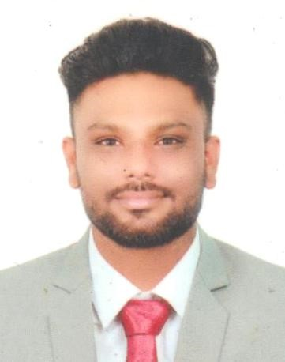

RAHUL S
Rethna Bhavan
Mylom P.O
Kottarakkara
Kollam, District Mob:+918848149842
Kerala,India.PIN–691560 E-mail:rahulkukku10000@gmail.com

CAREER OBJECTIVE

To obtain a position of responsibilities that utilizes my skills and experience, and also keen to work in an environment where I can enrich my knowledge.

EDUCATIONAL QUALIFICATIONS

Examination | Board/University | Year of passing
Retail sales associate  (RSA) | PMKVY | 2021
PlusTwo | Board of Higher Secondary Education,  Kerala | 2017
S.S.L.C. | Board of Public Examinations, Kerala | 2015

COMPUTER KNOWLEDGE

- MS Office
- SAP

EXPERIENCE

- 2 Year Experience In Assistant Store Manager Kottarakkara Van Heusen (Aditya Birlla)
- 1 Year Experience In Allensolly Kottarakkara (Aditya Birlla)

DUTIES
●                   | Leadership and management  Collecting customer feedback  Record inventory movement and assign associated value  Handling customer complaints  Implement inventory control measures, reducing shrink age  Provide better customer service  Manage cashregister and perform daily reconciliations  Cash Handling  Receive stock and replenish merchandise  Analyze sale data track inventory and submit reports to management
STRENGTHS
- Good communication skills
- Adaptable to any situation
- Strong drive to compete and win
- Supportive and active nature
- Obedient to higher authorities

HOBBIES

- Learning new skills
- Reading books
- Listening to music

PERSONALPROFILE
Gender | : | Male
DateofBirth | : | 15/05/1999
Father’sname | : | Sunil kumar K.B
Religion | : | Hindu
MaritalStatus | : | Single
Nationality | : | Indian
LanguagesKnown | : | Malayalam,English,Tamil, Hindi

DECLARATION

Ihere by affirm that all the information provided above are true andc orrect to the best of my knowledge and belief.
Place: Kottarakkara RAHUL .S
Date:

