# Database Essentials Home Assignment Documentation:

## Task 2:

Figure 1: The audio collection within `multimedia_db` database

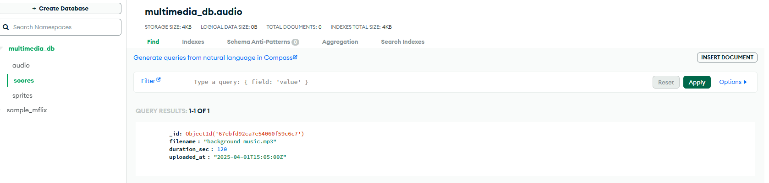

Figure31: The scores collection within `multimedia_db` database

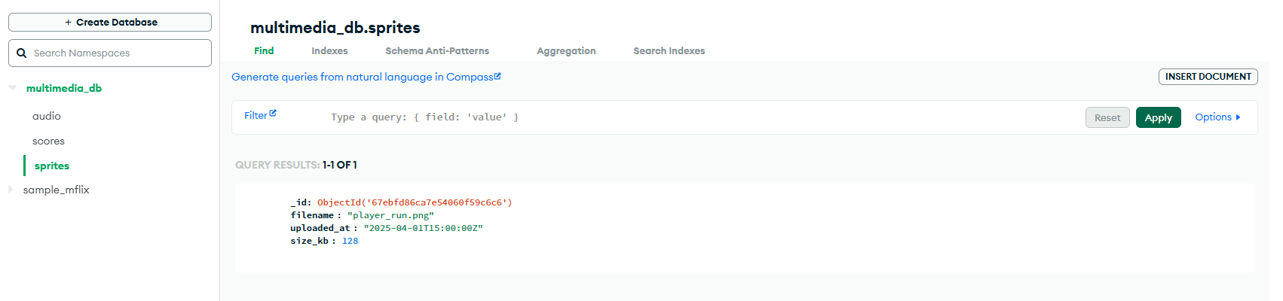

Figure 2: The sprites collection within `multimedia_db` database

## Task 3: Development of the Web API (20 marks):

1. ***Develop API endpoints (7 marks)****: Develop the endpoints that facilitate the uploading and retrieval of sprites, audio files and player scores. See appendix B.*
2. ***Host the API (5 marks)****: Ensure that the API is fully functional by testing it using Postman and publicly accessible online via the browser. See appendices E and F.*
3. ***Documentation (8 marks)****: Provide detailed code documentation, including explanations of how each endpoint operates and interacts with the database.*

### Testing:

This part presents evidence of the tests being conducted.

### Uploading and Retrieving a Sprite:

#### Uploading:

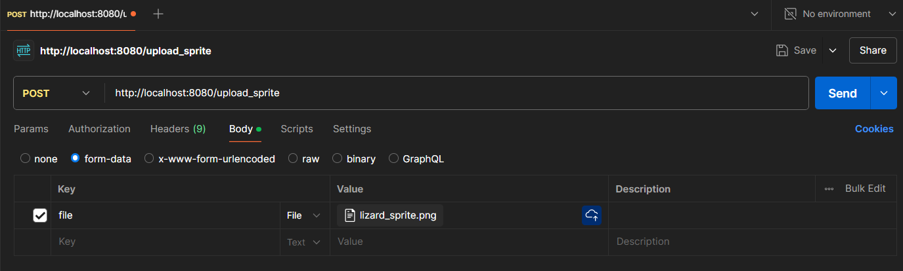



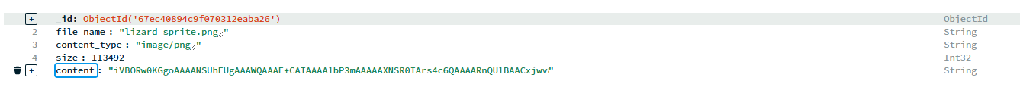

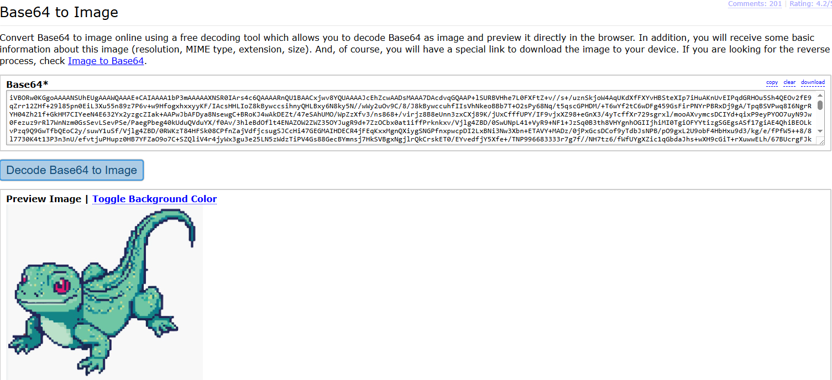

#### Retrieving:

### Uploading an Audio file:

