MSE-1 AI Powered CI/CD Containerizations

Name :Nishant Kumar
Roll no.: 202401100200214
Branch : CSE-C
Github Url : Null-Nishant/github-skills-challenge: MSE_1_CI/CD
Pull request URL : Validate CI workflows by Null-Nishant · Pull Request #1 · Null-Nishant/github-skills-challenge

Screenshot showing the GitHub Actions workflows
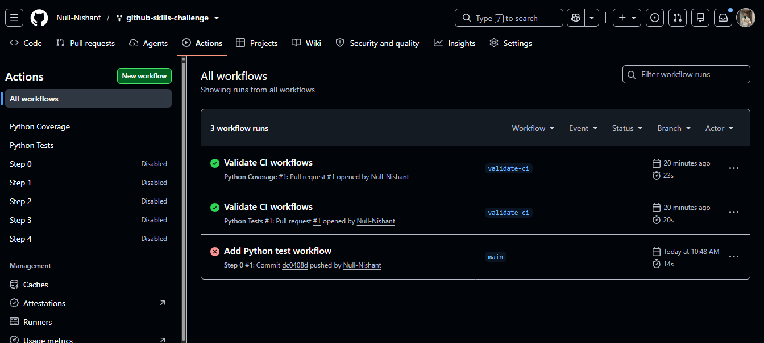

Screenshot showing a successful test workflow execution
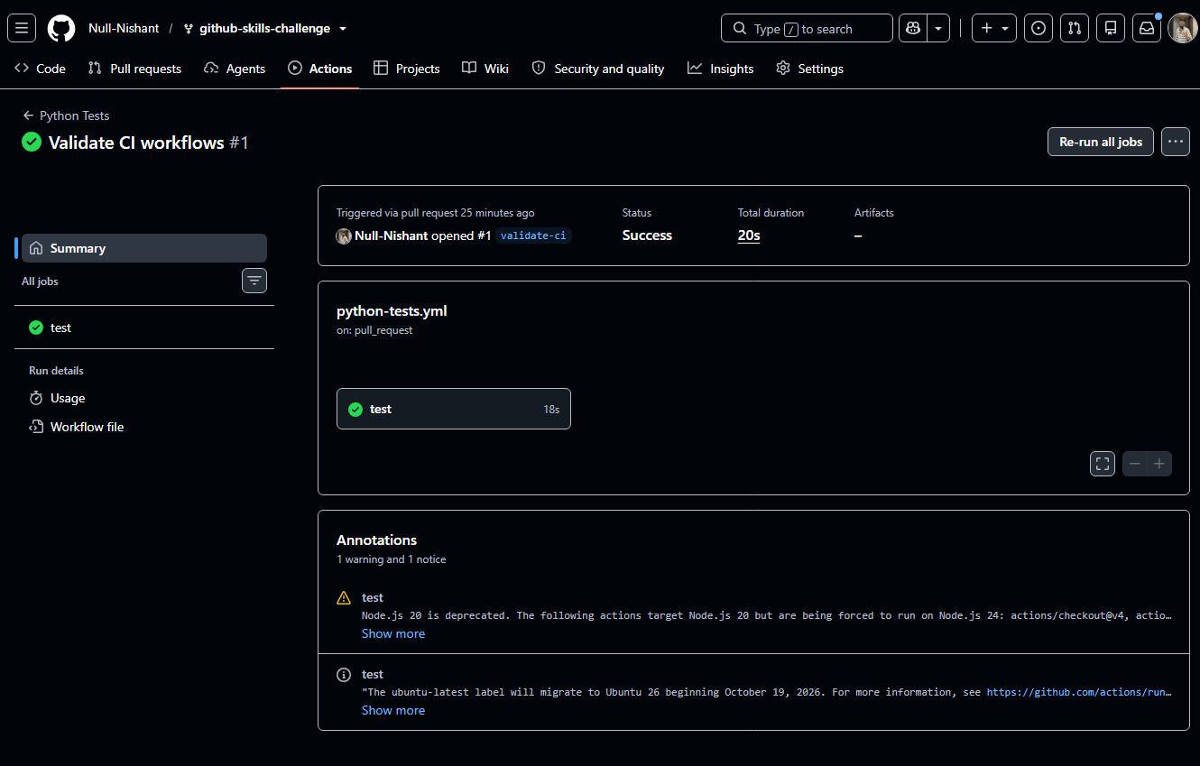
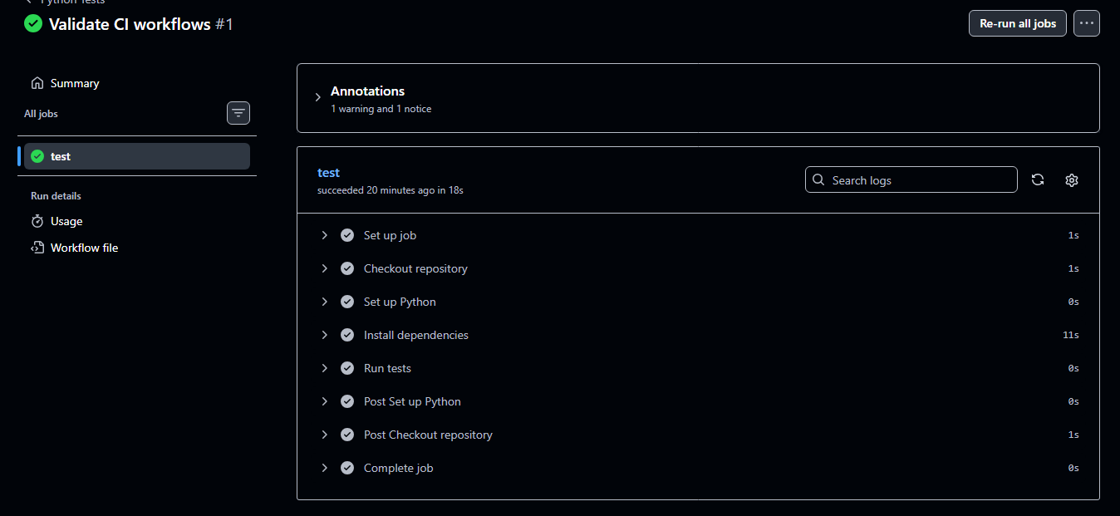
Screenshot showing the coverage result/comment on the pull request
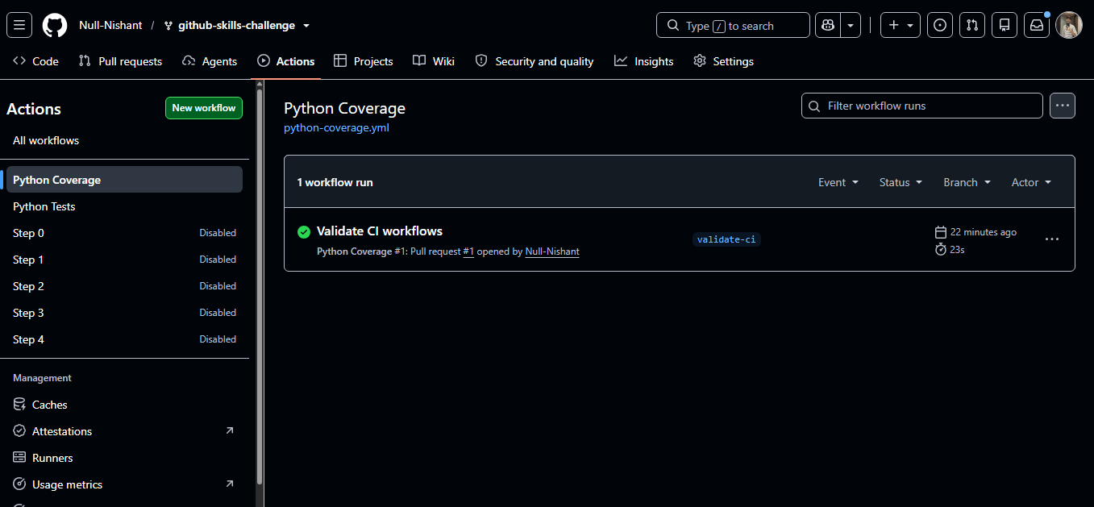

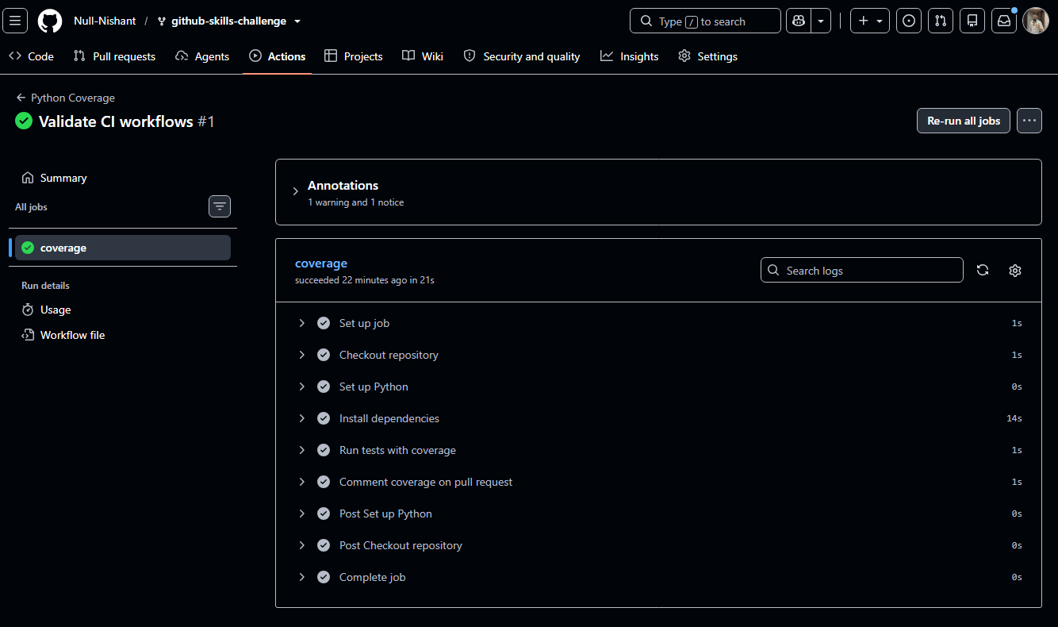

Screenshot showing the final repository/workflow files
