We will be given a website and where players need to change some headers to get the flag.

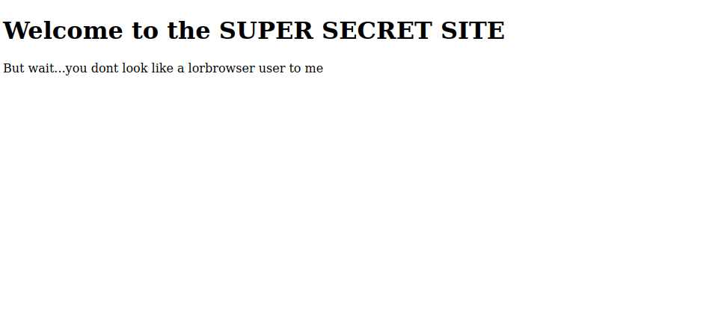

First, they need to change the User-Agent header to lorbrowser

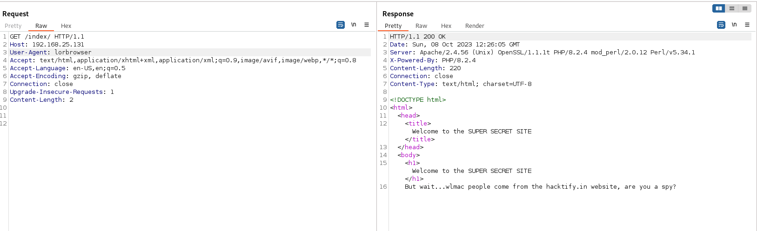

And then you need to add a header called Referer and the value is <https://hacktify.in/>

And then you need to add a header called Date and the value is 2043

Add another header called Upgrade-Insecure-Requests and the value is 10

And the last one you need a header called Downtime and set the value into a big number 999999999

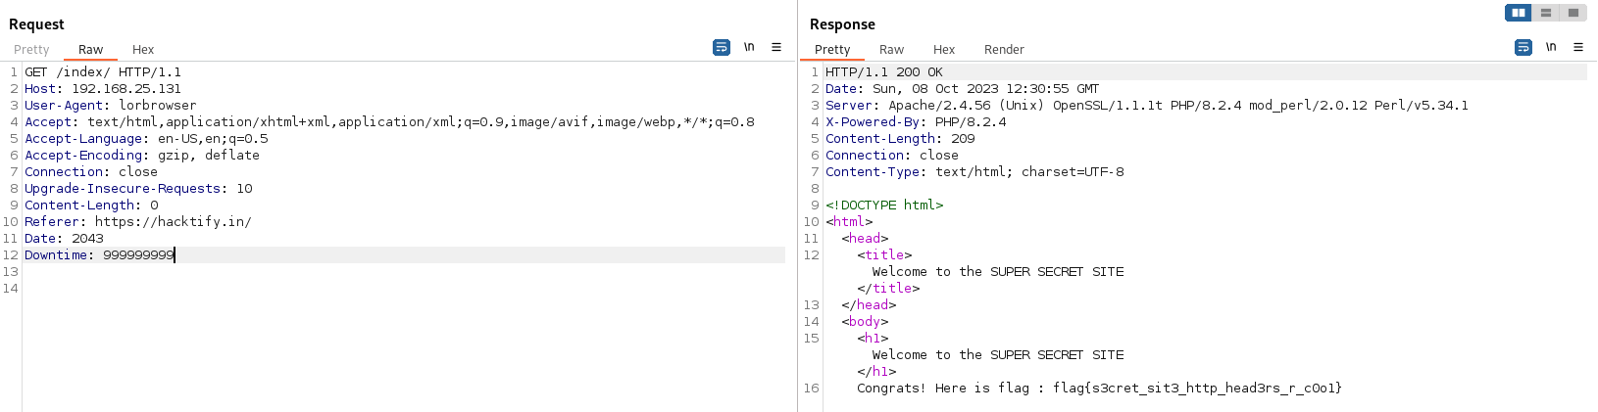

Flag{s3cret_sit3_http_head3rs_r_c0o1}