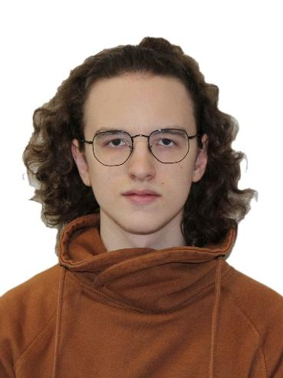**Fedorov Daniil. C++/C# Software Engineer.**

Birth Date: 07/10/2002

Current location: Moscow, Russia.

Passport Home Address: Gomel, Belarus.

Mobile phone number: +79208399312

Email: [adviventes@gmail.com](mailto:adviventes@gmail.com)

Linkedin: [Daniil Fedorov](https://www.linkedin.com/in/daniil-fedorov-529749205/)

Github: [NullOne01](https://github.com/NullOne01)

Habr: [@nullone](https://habr.com/ru/users/nullone/)

**General information:**

I am Junior Software Engineer with over 3+ years of programming experience (6-month work experience).

Languages I understand and use: C++, C#, Python.

I am currently looking for opportunities to develop my skills in using C++/C#. Especially, for backend development.

My hobby is game development.

**Skills:**

* **C++**. 2+ year experience. Have experience working with CMake, ImGUI, Protobuf, OpenGL, OpenCV, FFmpeg.
* **C#.** 3+ year experience. Have experience working with Zenject, WPF, Json.NET.
* Understanding fundamentals of **Java**, **Python**, **Bash**.
* Have experience working with **GDB** and other debuggers.
* Understanding of **OOP**, **SOLID, Computer Science, Agile.**
* Have experience working with **SQL**.
* Have experience working with **JIRA stack (JIRA, Confluence, BitBucket)**.
* Have experience working with **Git**. Have different projects on **GitHub**, **GitLab**, **BitBucket**.

**Languages:**

* Russian (Native speaker)
* English (Upper intermediate)

**Career Summary:**

**November 2021 – May 2022 - Internship. Software Engineer C++, “Yandex.Technologies”**

**Project:** Yandex advertisement engine.

My tasks:

* Maintaining code.
* Adding new features using C++, Protobuf. Example: adding new fields into logs, abstract structures.
* Debugging C++ code using GDB via SSH.
* Working with SQL to analyze engine’s behavior changes.
* Writing unit-tests using Python.
* Implementing iterative releases and A/B tests.

**Books and courses:**

* Book “Game Engine Architecture” by Jason Gregory

**Education**  
  
National Research University Higher School of Economics. Moscow, Russia.

Bachelor of Computer Science (BCompSc), Computer science. 2020-2024 (expected)