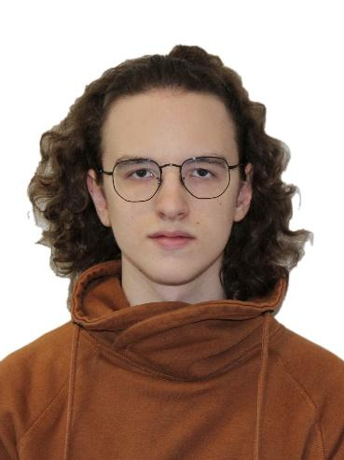**Fedorov Daniil. C++ Software Engineer.**

Birth Date: 07/10/2002

Current location: Moscow, Russia.

Passport Home Address: Gomel, Belarus.

Mobile phone number: +79208399312

Email: [adviventes@gmail.com](mailto:adviventes@gmail.com)

Linkedin: [Daniil Fedorov](https://www.linkedin.com/in/daniil-fedorov-529749205/)

Github: [NullOne01](https://github.com/NullOne01)

Habr: [@nullone](https://habr.com/ru/users/nullone/)

**General information:**

I am Junior Software Engineer with over 3+ years of programming experience (6-month work experience).

Languages I have experience with: C++, C#, Python. Game engines I have experience with: Unreal Engine 4/5, Unity.

I am currently looking for opportunities to develop my skills in game development industry. Preferably, C++-based projects. Preferably, both gameplay and game engine developer roles.

My own portfolio includes experience in developing Android apps, UE4 games, Unity games. Has everyday practice in coding in C++ and C#. Sometimes participate in game jams.

**Skills:**

* **Unreal Engine 4/5** (C++). 1+ year experience.
* **C++**. 2+ year experience. Have experience working with CMake, ImGUI, Protobuf, OpenGL, OpenCV, FFmpeg.
* **Unity** (C#)**.** 3+ year experience.
* **C#.** 3+ year experience. Have experience working with Zenject, WPF, Json.NET.
* Understanding fundamentals of **Java**, **Python**, **Bash**.
* Have experience working with **GDB** and other debuggers.
* Understanding of **OOP**, **SOLID, Computer Science, Agile.**
* Have experience working with **SQL**.
* Have experience working with **JIRA stack (JIRA, Confluence, BitBucket)**.
* Have experience working with **Git**. Have different projects on **GitHub**, **GitLab**, **BitBucket**.

**Languages:**

* Russian (Native speaker)
* English (Upper intermediate)

**Career Summary:**

**November 2021 – May 2022 - Internship. Software Engineer C++, “Yandex.Technologies”**

**Project:** Yandex advertisement engine.

My tasks:

* Maintaining code.
* Adding new features using C++, Protobuf. Example: adding new fields into logs, abstract structures.
* Debugging C++ code using GDB via SSH.
* Working with SQL to analyze engine’s behavior changes.
* Writing unit-tests using Python.
* Implementing iterative releases and A/B tests.

**Books and courses:**

* Book “Game Engine Architecture” by Jason Gregory
* Udemy course “[Unreal Engine 5 C++ Developer: Learn C++ & Make Video Games](https://www.udemy.com/course/unrealcourse/)”.

**Games I worked on:**

**April 2018 – Android mobile app. “Learn to survive”.**

This project was inspired by Pokemon GO game. It uses your current GPS location to place player’s gaming avatar. The world uses Google Maps API.

**URL:** <https://play.google.com/store/apps/details?id=com.nullone.realsurvival>  
**Technologies used**: Java, Groovy, XML, Google Maps API.

**February 2020 – Unity arcade mobile game. “The Mage's Path”.**

This is arcade Unity game for Android phones.

For this project I worked a lot with Google Play Game Services to add leaderboard and cloud saves systems. Also, it has ads.

**URL:** <https://play.google.com/store/apps/details?id=com.nullone.magespath>  
**Technologies used**: Unity, C#, AdMob API, Google Play Game Services API.

**February 2020 – Unity split-screen adventure desktop game. “Milky Engineers”.**

This project was made on Global Game Jam 2020.

I worked as programmer, game designer. My friend made models, animations, sound effects.

**URL:** <https://globalgamejam.org/2020/games/milky-engineers-8>  
**Technologies used**: Unity, C#.

**January 2021 – Unity FPS desktop game. “Lesser evil”.**

This project was made for Blackthornprod GAME JAM #3 in 2021.

I worked as programmer, game designer. My friend made models, animations, sound effects.

**URL**: <https://nullone.itch.io/lesser-evil>  
**Technologies used**: Unity, C#.

**Education**  
  
National Research University Higher School of Economics. Moscow, Russia.

Bachelor of Computer Science (BCompSc), Computer science. 2020-2024 (expected)