**Fiodarau Daniil Yurievich. Software Engineer.**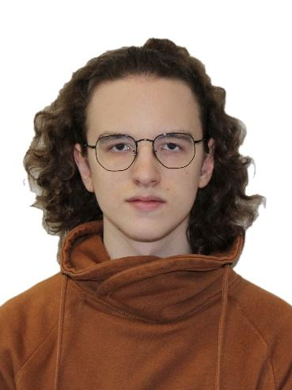

Birth Date: 07/10/2002

Current location: Moscow, Russia.

Passport Home Address: Gomel, Belarus.

Mobile phone number: +79208399312

Email: [adviventes@gmail.com](mailto:adviventes@gmail.com)

**General information:**

I am Junior Software Engineer with more than 2 years in IT industry, have reasonable mix of hard and soft skills.

I am currently studying in National Research University Higher School of Economics, looking for opportunities to develop my skills in game development industry.

My own portfolio includes experience in developing Android apps, Unity games, UE4 games. Has everyday practice in coding in C# and C++. Participated in Game jams: Global Game Jam 2020, Blackthornprod GAME JAM #3, Global Game Jam 2022.

**Skills:**

* Have great skills coding in **C#**, **C++**.
* Understanding fundamentals of **Java**, **Python**, **Bash**.
* Have experience working with **GDB** and other debuggers.
* About 2 years of experience working with **Unity**.
* Understanding fundamentals of **Unreal Engine 4**.
* Understanding of **OOP** and **SOLID**.
* Have experience working with **SQL**.
* Understanding fundamentals of working with **JIRA stack (JIRA, Confluence, BitBucket)**.
* Have experience working with **Git**. Have different projects on **GitHub**, **GitLab**, **BitBucket**.

**Languages:**

* Russian (Native speaker)
* English (Upper intermediate)

**Portfolio:**

**April 2018 – Android mobile app. “Learn to survive”.**

This project was inspired by Pokemon GO game. It uses your current GPS location to place player’s gaming avatar. The world uses Google Maps API. Different game objects are placed randomly, like: food, water, iron, wood. You should eat and drink to survive. Iron and wood are used for crafting and trading. Also, there are some random fighting encounters.

**URL:** <https://play.google.com/store/apps/details?id=com.nullone.realsurvival>  
**Technologies used**: Java, Groovy, XML, Google Maps API.

**February 2020 – Unity arcade mobile game. “The Mage's Path”.**

This is arcade Unity game for Android phones. A user should move between grey columns using bridges to gain points. The more user clicks, the longer bridge becomes. If bridge length is less or more than needed, then the user will lose the game. The user can spend these points to buy new skins or backgrounds.

For this project I worked a lot with Google Play Game Services to add leaderboard and cloud saves systems. Also, it has ads.

**URL:** <https://play.google.com/store/apps/details?id=com.nullone.magespath>  
**Technologies used**: Unity, C#, AdMob API, Google Play Game Services API.

**February 2020 – Unity split-screen adventure desktop game. “Milky Engineers”.**

This project was made on Global Game Jam 2020. The game was made in 2 days. This is a game for 2 players (1 keyboard) made on Unity for Windows PCs.

The goal is to get to the ship's engine and repair it by kicking it. The ship is filled with different puzzles and you need to cooperate with your teammate to pass them. Players can use buttons, kicks and even their own dead bodies to finish the game. Also, players can craft things (like chainsaw) by combining different items.

I worked as programmer, game designer. My friend made models, animations, sound effects.

**URL:** <https://globalgamejam.org/2020/games/milky-engineers-8>  
**Technologies used**: Unity, C#.

**January 2021 – Unity FPS desktop game. “Lesser evil”.**

This project was made for Blackthornprod GAME JAM #3 in 2021. The game was made in 3 days. This is a game for 1 player made on Unity for Windows PCs. The project was my first 3D game development experience.

The goal is to beat final boss and his allies. However, with each new group of allies player becomes much shorter. The shorter you are, the faster and weaker (less damage, less HP) you become. Although the player can find different weapons with different stats (damage, range, speed), they can't use them all the time, because short player can't handle big weapons (like 2-handed hammer).

I worked as programmer, game designer. My friend made models, animations, sound effects.

**URL**: <https://nullone.itch.io/lesser-evil>  
**Technologies used**: Unity, C#.

**Career Summary:**

**November 2021 – May 2022 - Internship. Software Engineer C++, “Yandex.Technologies”**

**Project:** Yandex advertisement engine.

My tasks:

• Maintaining code. Example: deleting unused parts of code.

• Adding new features using C++. Example: adding new fields into logs, abstract structures.

• Debugging C++ code using GDB via SSH.

• Working with SQL to analyze engine’s behavior changes.

• Writing unit-tests using Python.

**Education**  
  
National Research University Higher School of Economics. Moscow, Russia.

Bachelor of Computer Science (BCompSc), Computer science. 2020-2024 (expected)