White Board Turbo 2000

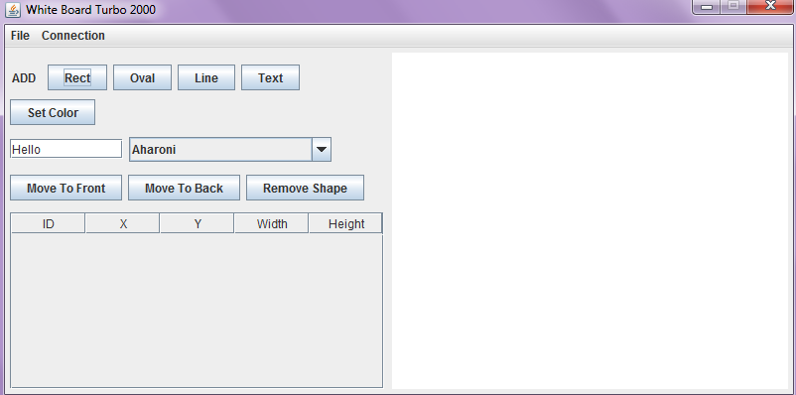

Usage

-javac WhiteBoard.java

-java WhiteBoard

Table of Contents

I. Working Features

A. Adding / Removing Shapes

B. Shape Manipulation

C. File I/O

D. Server / Client Connections

E. Data Table

II. Known Bugs

A. Line

B. Text

C. Special Server Case

Coded by Danny Mou, Brendan Kao, Roberto Aguilar, and Jesus Arechiga

**I. Working Features**

A. Adding / Removing Shapes

To add a shape to the Canvas, simply press one of the four buttons next to the word “Add” and the shape will appear with the default location (25, 25), size (25, 25), and color gray. The added shape will automatically become the selected shape. For text, a font and a custom string can be chosen to be added using the font selector and text field.

To remove a shape, you first need to select a shape and click the “Remove Shape” button.

B. Shape Manipulation

By selecting a shape, you can:

-Change the color of the selected shape by using the “Set Color” button.

-Move the shape by dragging it

-Resize the shape to make it bigger.

-Move it to the front/back of other shapes using the “Move to Front/Back” buttons

-Remove the shape

C. File I/O

Using the File Menu, you can reset the board by using the “New” menu selection. You can save the file in two formats, PNG and XML. The “Open XML” selection only reads XML files. You also do not need to type in the extension as it is added for you. Opening a XML will redraw the saved shapes from scratch.

D. Server / Client Connections

In the Connections Menu, you can start a Server by entering a port number between 100 and 25565. By entering Server Mode, a successful start will show a popup and a RED label that says “Server Mode” in the middle of the application on top of the font selector. The Connection menu will be disabled after starting. An unsuccessful start will result in termination of the program (bad way to handle, we know). The default port is 5555.

To join a server, select “Join a Server” and that will prompt you for an IP address and a port in the format of IP:PORT. A successful connection will show the label “Client Mode” and all the functions disabled except for File I/O.

E. Data Table

Data is manipulated on the table every time a shape is changed, whether it is moving / resizing / deletion. Selecting a row on the table does nothing.

**II. Known Bugs**

A. Line

A line is able to be added but resizing has weird voodoo functionality. Dragging one point will sometimes swerve the other and sometimes one point will stay constant.

B. Text

While different fonts are able to be chosen, the words are still able to extend past the boundary box if resized big enough.

C. Special Server Case

The Client does not properly display shapes IFF the server has manipulated the ordering of the Data Table (i.e. Data Table on Server has 1,3,2,4 then connecting the Client will have the table 1, 2, 3, 4). Changing anything on the server with this incorrect table will wipe all previous shapes.