# Jingbo Wang

# ping-pong.py

# A program to play a BO5 ping-pong ball game

from random import random

def main():

printIntro()

probA, probB = getInputs()

winsA, winsB, win_roundsA, win_roundsB = simNGames(probA, probB)

printSummary(winsA, winsB, win_roundsA, win_roundsB)

def printIntro():

print("This program simulates a game of ping-pong ball between two")

print('players called "A" and "B". The abilities of each player is')

print("indicated by a probability (a number between 0 and 1) that")

print("the player wins the point when serving. Player A always")

print("has the first serve.")

def getInputs():

# returns the two simulation parameters

a = float(input("What is the prob. player A wins a serve? "))

b = float(input("What is the prob. player B wins a serve? "))

return a, b

def simNGames(probA, probB):

# Simulates n games of ping-pong ball between players whose

# abilities are represented by the probability of winning a serve.

# Returns number of wins for A and B

winsA = winsB = 0

win_ roundsA =[] # To store each round for A

win_ roundsB =[] # To store each round for B

for i in range(5):

scoreA, scoreB = simOneGame(probA, probB)

if scoreA > scoreB:

winsA = winsA + 1

win_roundsA.append('W') # A wins this serve

win_roundsB.append('-') # B lose this serve

else:

winsB = winsB + 1

win_roundsA.append('-') # A lose this serve

win_roundsB.append('W') # B wins this serve

if winsA == 3 or winsB == 3:

break

return winsA, winsB, win_ roundsA, win_ roundsB

def simOneGame(probA, probB):

# Simulates a single game or ping-pong ball between players whose

# abilities are represented by the probability of winning a serve.

# Returns final scores for A and B

serving = "A"

scoreA = 0

scoreB = 0

while not gameOver(scoreA, scoreB):

if serving == "A":

if random() < probA:

scoreA = scoreA + 1

else:

serving = "B"

else:

if random() < probB:

scoreB = scoreB + 1

else:

serving = "A"

return scoreA, scoreB

def gameOver(a, b):

# A and B represent scores for a ping-pong ball game

# Returns Ture if the game is over, False otherwise.

return a==11 or b==11

def printSummary(winsA, winsB, win_ roundsA, win_ roundsB):

# Prints a summary of wins for each player.

n = winsA + winsB

print("\nGames simulated:", n)

if winsA == 3:

print("A is winner") # A is winner if A wins 3 serves

else:

print("B is winner") # B is winner if B wins 3 serves

# the total win serves for A and B

print("Wins for A: {0}".format(winsA))

print("Wins for B: {0}".format(winsB))

# each serves for A and B

print("A: ", *win_ roundsA)

print("B: ", *win_ roundsB)

main()

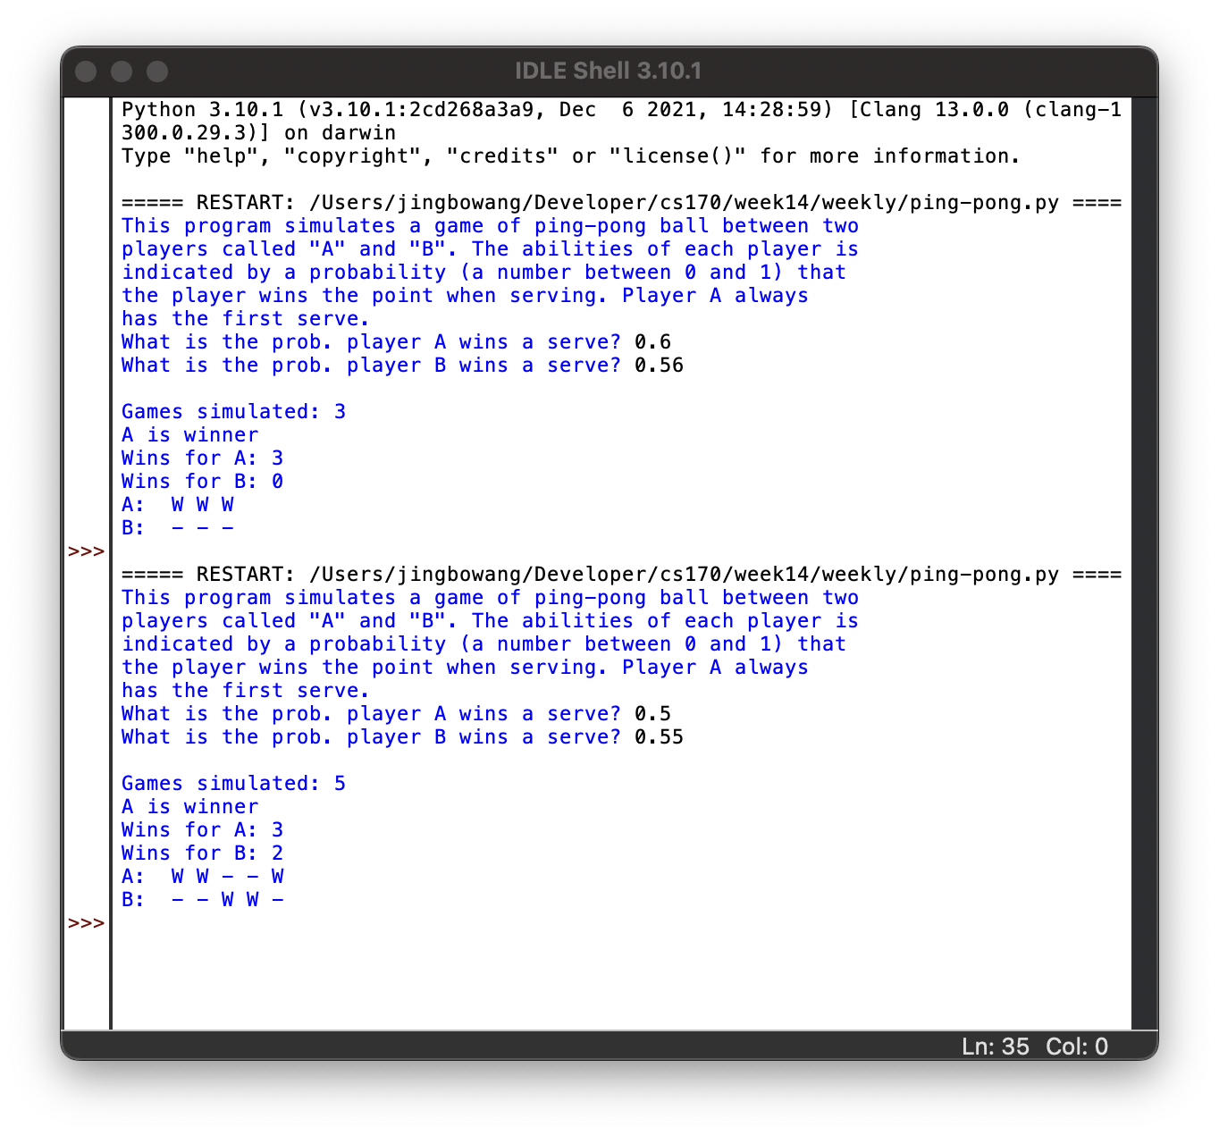

This program is to play a BO5 ping-pong game with two players A and B. User should input each player’s possibility of wining a serve, and then the program will product random number in each serve to determine who is the winner of the single game between players. If the player who wins 11 balls in a round firstly, then this player’s total wins of ping-pong ball rounds will plus one. If a player who wins 3 rounds at first, the game will be over, and print out the final result of ping-pong game, each round of the game.