**11.6**

**1**. Find a pushdown automaton for each of the following languages.

**a**. {*abn cdn* | *n* ≥ 0}.

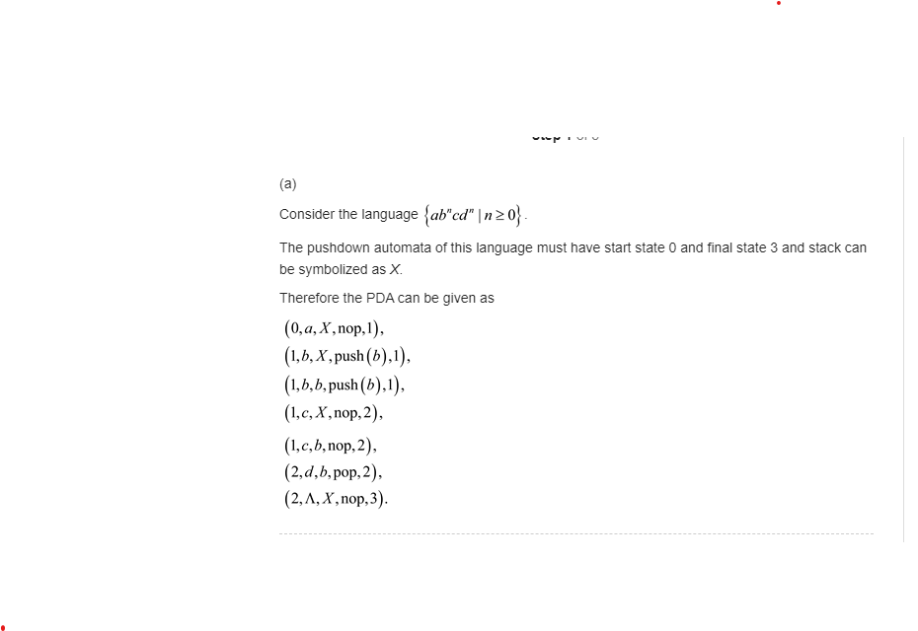

b. All strings over {*a, b*} with the same number of *a*’s and *b*’s.

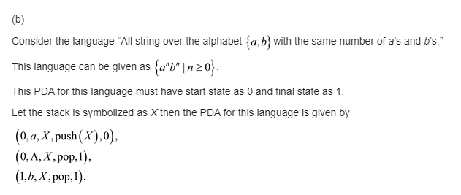

**12.1**

**1.** Construct a Turing machine to recognize the language of all

palindromes over {*a, b*}.